POC Evidence

Multi-source SCD2 effective date split
Execution evidence for poc_snowflake.sql, run against LM_POC_DB.POC_SCHEMA. The POC proves that when two SCD2 source tables both contribute attributes to one SCD2 target, the target timeline can be rebuilt correctly in set-based SQL - including retiring rows that a later run makes invalid.
Seven brokers are under test. BR001 to BR003 cover the main scenario and its two quiet cases. BR004 to BR007 were added afterwards to cover four harder variations of the same logic, each chosen because a plausible but wrong implementation would fail on it silently rather than raise an error.
Result: all twenty-six assertions PASS, and every evidence block matched the output predicted before the run.

Summary of test cases
Section | What we tested | Status
1. Day 1 source data | The starting state: two Zone1 history tables and the run 101 sourcing window | Loaded as planned
2. Day 1, Step 1 | Two source timelines combine into one instruction list without touching the target | PASS - 5 rows, all 'I'
3. Day 1, Steps 2 and 3 | The staged instructions land in the target exactly as staged | PASS - 5 live rows
4. Day 2 source changes | One source changes, the other does not, and one change must have no target effect | Loaded as planned
5. Day 2, Step 1 | Rebuilding the timeline when only one of the two sources moved | PASS - 4 'I' + 2 'D', all BR001
6. Day 2, Steps 2 and 3 | Superseded rows are retired, not overwritten, and the live timeline stays continuous | PASS - 9 rows, 7 live
7. Validation T01-T11 | Eleven assertions covering the Day 1 and Day 2 results | PASS - 11 of 11
8. Idempotence T12 | A re-run over a window with no newly refined rows changes nothing | PASS - empty stage
9. Part 9 setup (run 104) | Four brokers built to break a wrong implementation silently: BR004 repeat, BR005 gap, BR006 in-place correction, BR007 duplicate arrival | Loaded as planned
10. Run 104, Step 1 | The collapse under stress - a repeated value, a gap in cover, and a duplicate version | PASS - 8 rows: 3 / 3 / 1 / 1
11. Run 104, Steps 2 and 3 | The eight new rows reach the target and nothing already there is disturbed | PASS - 8 live rows
12. Run 105 setup | BR006's value is corrected while both of its dates stay exactly where they were | Loaded as planned
13. Run 105, Step 1 | Whether the diff notices a change that moved no dates - the case ROW_HASH exists for | PASS - 1 'D' + 1 'I', same dates
14. Run 105, Steps 2 and 3 | The correction is applied and the row it replaced is kept as an audit trail | PASS - corrected, history kept
15. Validation T13-T25 | Thirteen assertions covering the four harder cases | PASS - 13 of 13
16. Idempotence T26 | The re-run result still holds with seven brokers and fifteen live rows loaded | PASS - empty stage

1. Setup and Day 1 source data
What this tests: The starting state. Two Zone1 history tables hold three brokers between them, and the ABC sourcing window decides which of their rows run 101 is allowed to read.
Steps: Load the Day 1 rows into both source tables, then register one ETL_DATA_INGESTION_SOURCE_WINDOW row per source table for run 101.
Expected: Four party rows, three commission rows, and two window rows - both Completed and open from 1900-01-01, so the first run reads everything.
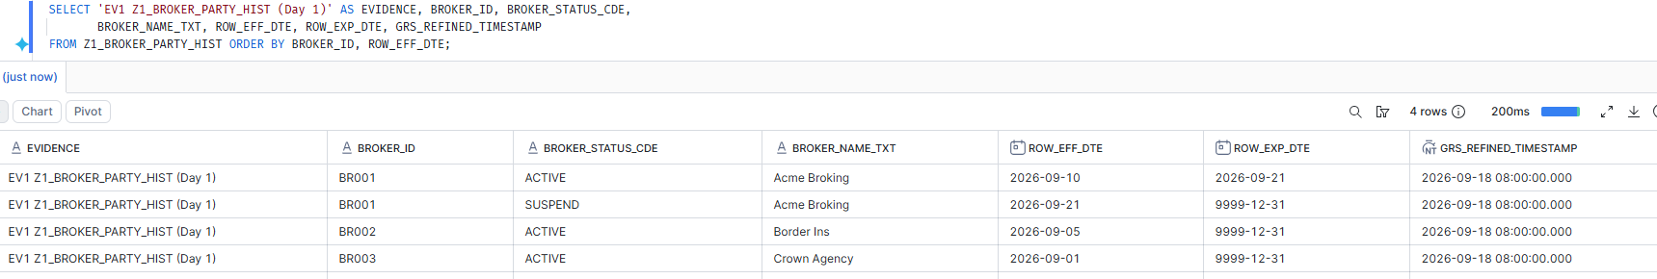
Z1_BROKER_PARTY_HIST on Day 1 — four rows. BR001 changes status on 10-Sep and again on 21-Sep; BR002 and BR003 have a single version each.
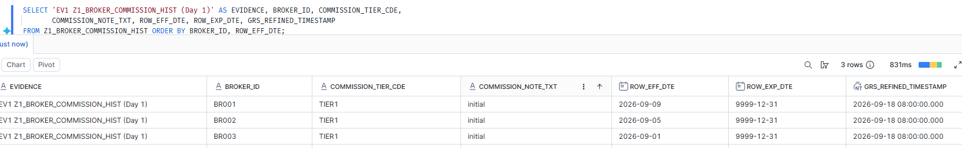
Z1_BROKER_COMMISSION_HIST on Day 1 — one commission version per broker. Note BR001's starts on 09-Sep, a day before its party record does.
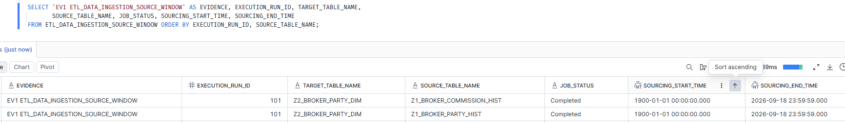
The sourcing window for run 101 — one row per source table, both Completed, both open from 1900-01-01 so the first run picks up everything.

2. Day 1, Step 1 - build the stage
What this tests: Whether Step 1 can turn two independent source timelines into one complete instruction list, without writing anything to the target yet.
Steps: Truncate the stage, run the Step 1 view into it, then read back its contents and its counts by action flag.
Expected: Five rows, all 'I' and no 'D' - a first load has nothing to supersede. BR001 should be cut into three intervals, at 09, 10 and 21-Sep.
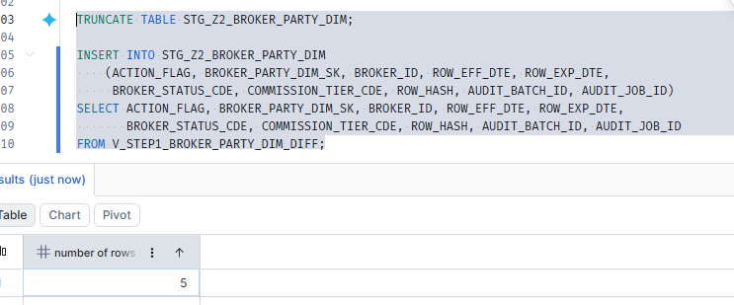
Step 1 writes 5 rows into the stage. The stage is truncated first, so every run is a clean rebuild rather than an accumulation.

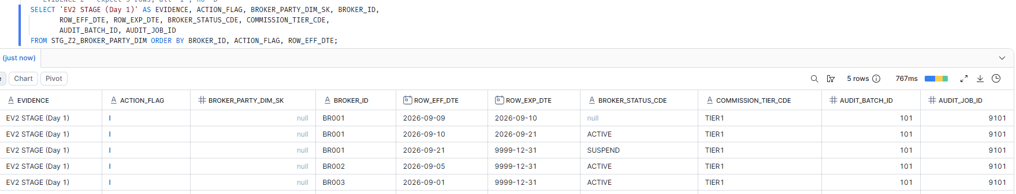
The Day 1 stage in full — all five rows are 'I'. BR001 is cut into three intervals at 09, 10 and 21-Sep, and the 09-Sep row correctly carries no BROKER_STATUS_CDE because the party record does not begin until 10-Sep.
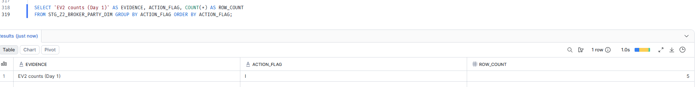
Count by action flag — five inserts and no deletes, which is what a first load should produce: there is nothing yet to supersede.

3. Day 1, Steps 2 and 3 - apply to the target
What this tests: Whether the staged instructions land in the Zone2 target exactly as the stage described them.
Steps: Run the soft-delete first (expected to do nothing on a first load), then the insert, then read the target back.
Expected: Step 2 updates 0 rows, Step 3 inserts 5, and the target holds five live rows stamped with AUDIT_BATCH_ID 101.
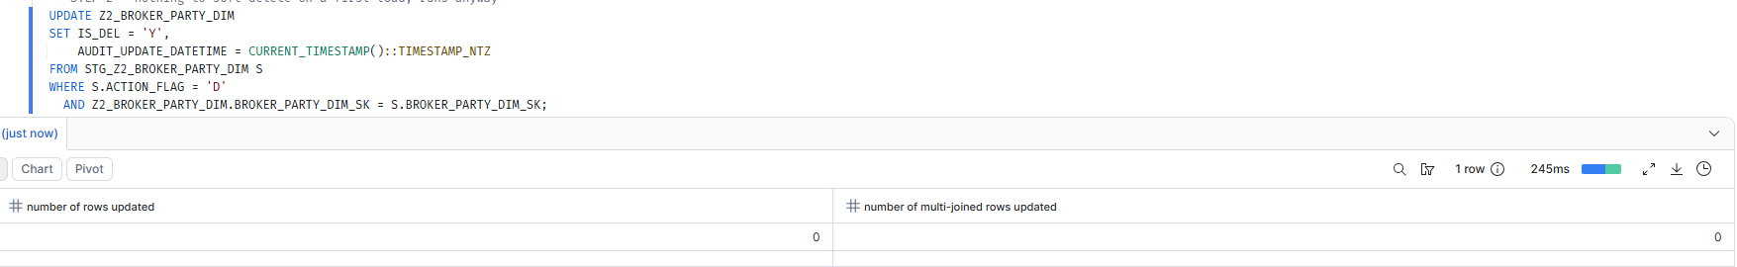
Step 2 updates 0 rows — correct on a first load: the stage holds no 'D' rows and the target is empty.
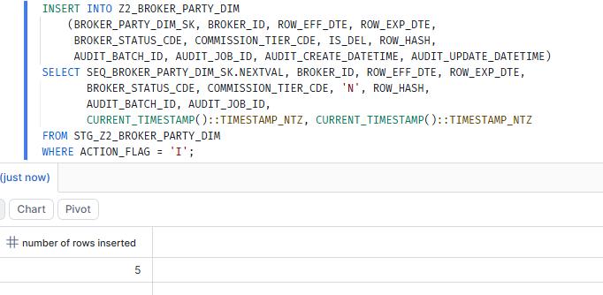
Step 3 inserts all five 'I' rows into the target.
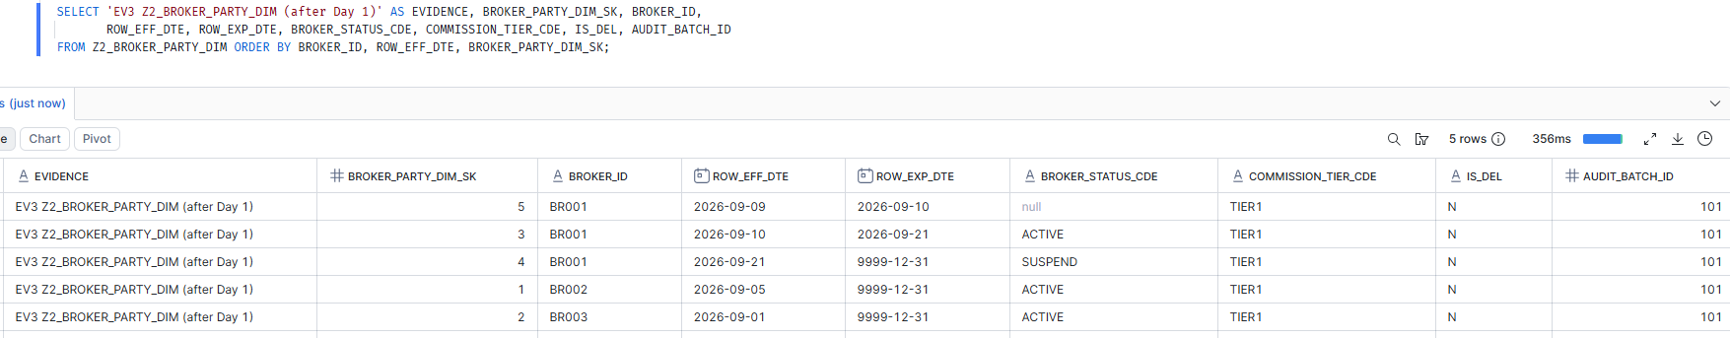
The Day 1 target — five rows, every one IS_DEL = 'N' and stamped with AUDIT_BATCH_ID 101.

4. Day 2 - source changes arrive
What this tests: A realistic second day in which one source changes and the other does not - including one change that must produce no target effect at all.
Steps: Close two open commission versions, insert three new ones, register the run 102 window, then read both source tables back to confirm the setup.
Expected: The commission table gains versions for BR001 and BR002 while the party table stays untouched, every refined timestamp still reading 18-Sep. BR002's change is confined to COMMISSION_NOTE_TXT, a column the target never carries.
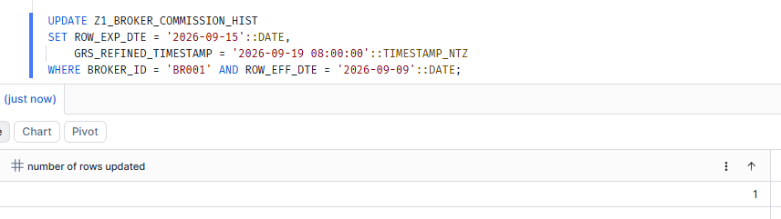
BR001's open commission version is closed at 15-Sep and re-stamped with a Day 2 refined timestamp.
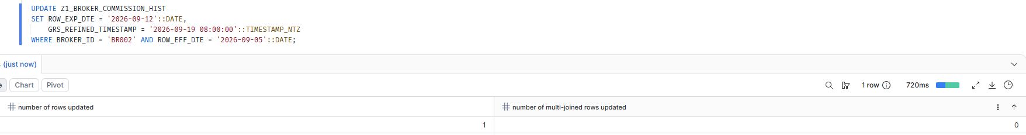
BR002's open commission version is closed at 12-Sep — but its tier will stay TIER1, which is the test that a change outside the target produces nothing.
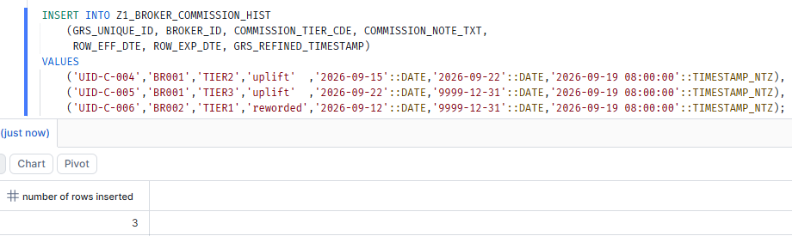
Three new commission versions arrive: BR001 moves to TIER2 then TIER3, while BR002 stays on TIER1 with only its note text reworded.
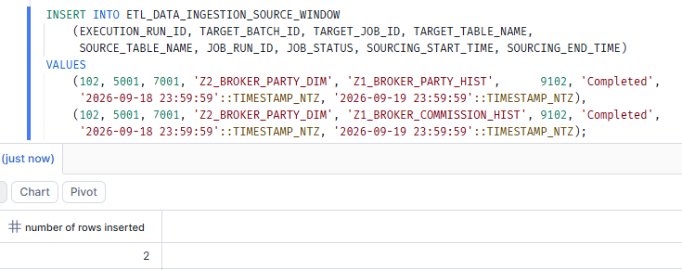
The sourcing window for run 102 — a fresh window per source table, covering only 18-Sep to 19-Sep.
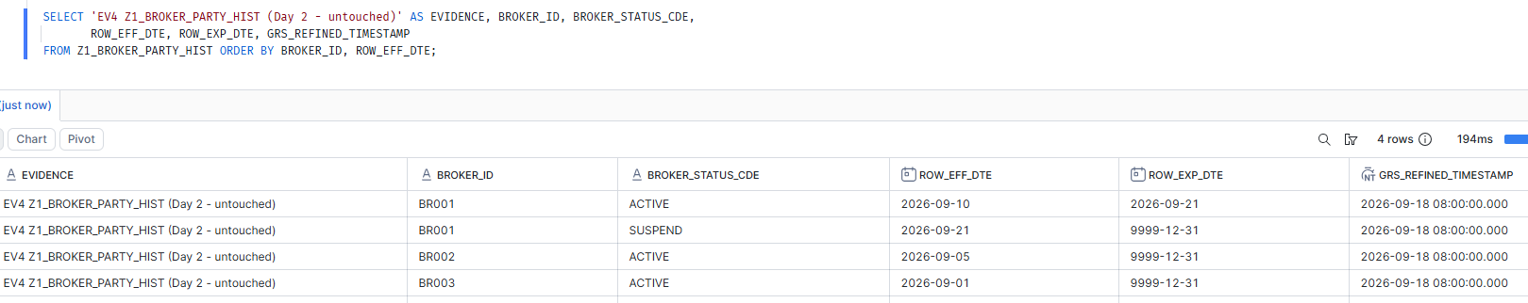
Z1_BROKER_PARTY_HIST is untouched on Day 2 — every refined timestamp still reads 18-Sep. This is what makes the Day 2 stage result meaningful.
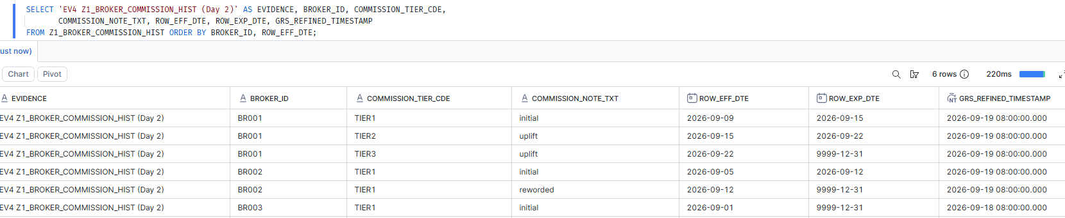
Z1_BROKER_COMMISSION_HIST after Day 2 — BR001 now has three versions, BR002 has two that differ only in note text, and BR003 keeps its Day 1 timestamp.

5. Day 2, Step 1 - the result that matters
What this tests: Whether rebuilding each impacted broker's timeline produces the right instructions when only one of the two sources changed.
Steps: Truncate and rerun the same Step 1 view, then read the stage and check both the row counts and which brokers appear.
Expected: Exactly 4 'I' and 2 'D', every one BR001 - even though BR001's party table did not change. Nothing for BR002, because the collapse removes its change, and nothing for BR003, which falls outside the window.
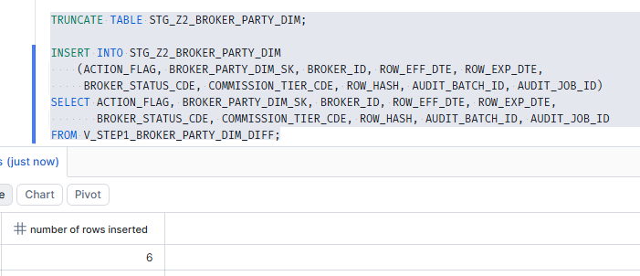
Step 1 writes 6 rows on Day 2 — two more than the four new target versions, because two existing target rows also have to be retired.
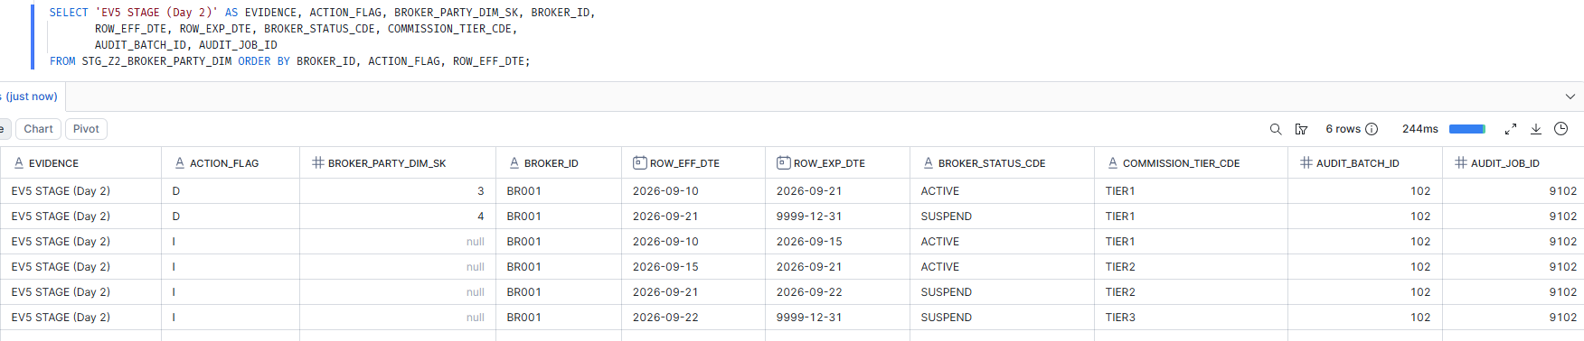
The central result of the POC. Four 'I' and two 'D', every one BR001 — even though BR001's party table did not change. The two 'D' rows carry surrogate keys 3 and 4, the Day 1 rows being superseded. Nothing appears for BR002, so the collapse worked; nothing for BR003, so the sourcing window worked.

6. Day 2, Steps 2 and 3 - apply and inspect
What this tests: Whether the target ends up holding both the corrected timeline and an audit trail of what it replaced.
Steps: Soft-delete, then insert, then read the target twice - once in full, once filtered to live rows only.
Expected: Two rows soft-deleted and four inserted, leaving nine rows in total, with BR001's live timeline running unbroken from 09-Sep to the high end date.
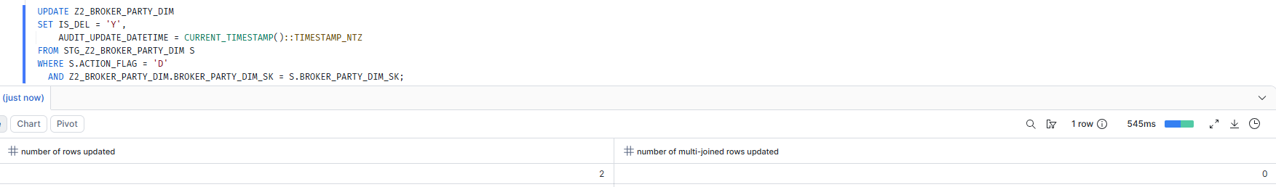
Step 2 soft-deletes exactly 2 rows, and reports 0 multi-joined rows updated — confirming the surrogate-key match is unambiguous and no row was hit twice.
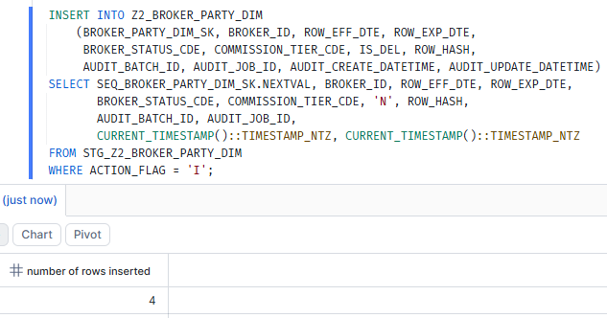
Step 3 inserts the four new versions.
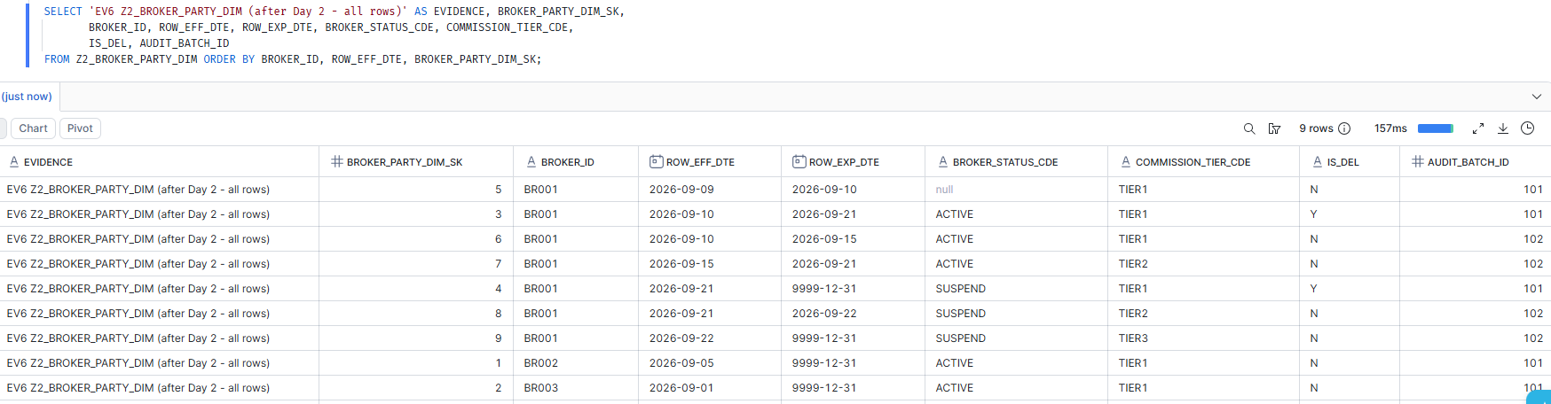
The full target after Day 2 — nine rows. BR001's two superseded rows keep IS_DEL = 'Y' and AUDIT_BATCH_ID 101, while its four new rows carry 102, so every row is traceable to the run that wrote it.
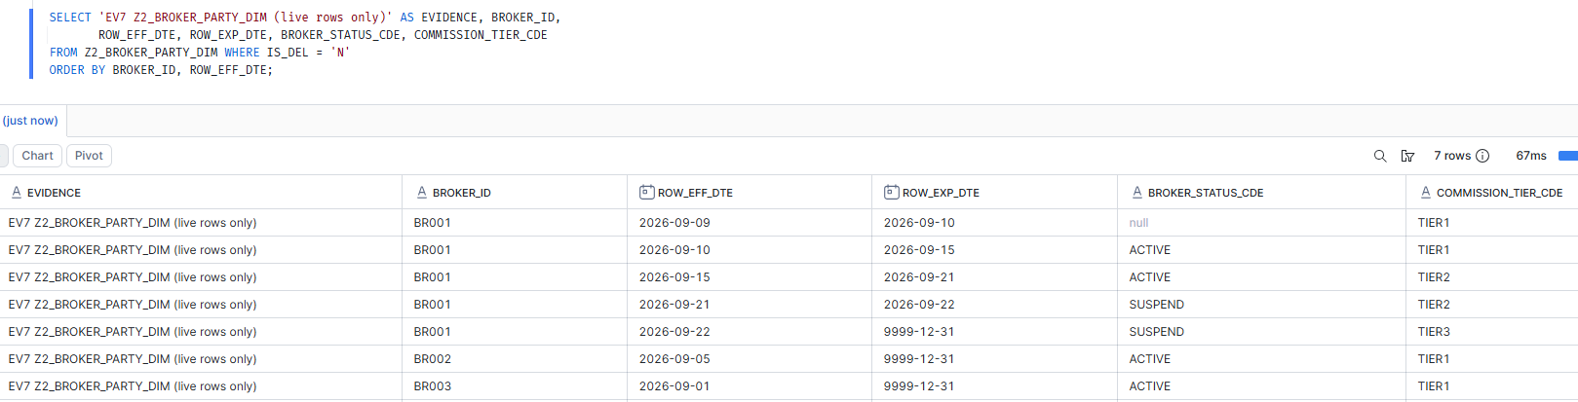
The live timeline consumers actually see — seven rows, with BR001 running continuously from 09-Sep to the high end date with no gap and no overlap.

7. Validation - assertions T01 to T11
What this tests: Replaces reading tables by eye with explicit assertions, each printing PASS or FAIL against a stated expected value.
Steps: Run the assertion block and read the RESULT column.
Expected: Every row reads PASS.
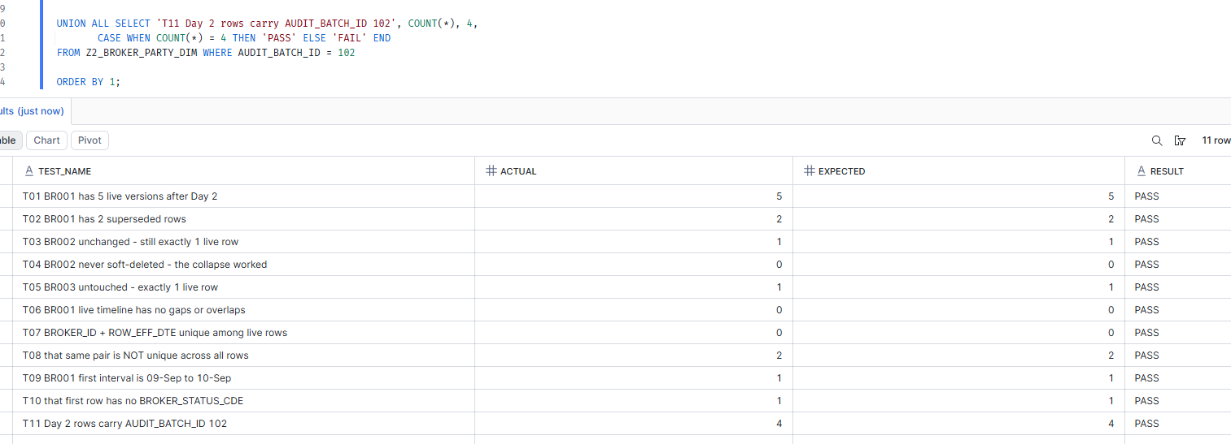
All eleven assertions PASS. T04 confirms BR002 was never soft-deleted, which is the collapse working. T07 and T08 together pin down the consequence that BROKER_ID + ROW_EFF_DTE is unique only among live rows, and deliberately not across all rows.

8. Idempotence - safe to re-run
What this tests: Whether the design is safe to restart - a run whose window contains no newly refined rows must change nothing at all.
Steps: Register a third sourcing window covering a quiet period, rerun Step 1, and confirm the stage comes back empty.
Expected: Step 1 writes 0 rows, and T12 reads PASS.

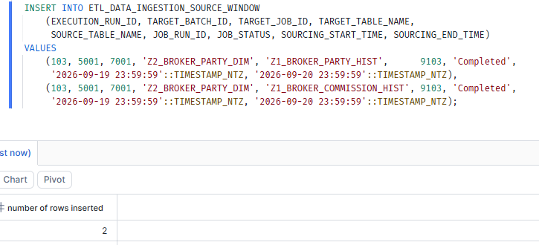
A third sourcing window, run 103, covering 19-Sep to 20-Sep — a period in which nothing was refined in either source.
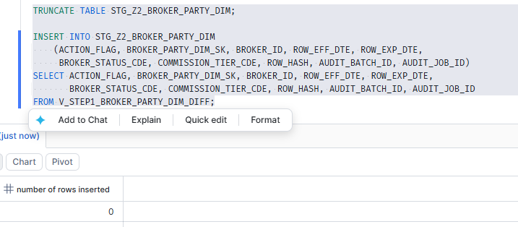
Step 1 writes 0 rows. No broker falls inside the window, so no timeline is rebuilt and no instruction is produced.
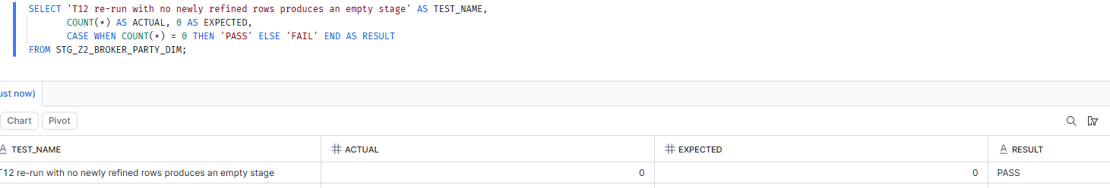
T12 PASS — the empty stage confirms that a re-run with no new data produces no change. This is what makes the load restartable without unwinding anything.

9. Part 9 - the four harder cases arrive (run 104)
What this tests: Sections 1 to 8 exercise the collapse only in its easiest form. Part 9 adds four brokers, each built so that a plausible but wrong implementation would fail silently rather than error: BR004 returns to an earlier value with a different one in between, BR005 has a gap in cover with the same value either side, BR006 will have a value corrected without its dates moving, and BR007 arrives twice inside a single window.
Steps: Insert the four brokers into both source tables, register the run 104 window, then read both tables back to confirm what was loaded.
Expected: Eight party rows - two of which share a key and effective date - four commission rows, and two window rows covering 20-Sep to 21-Sep so that only the new brokers fall inside.
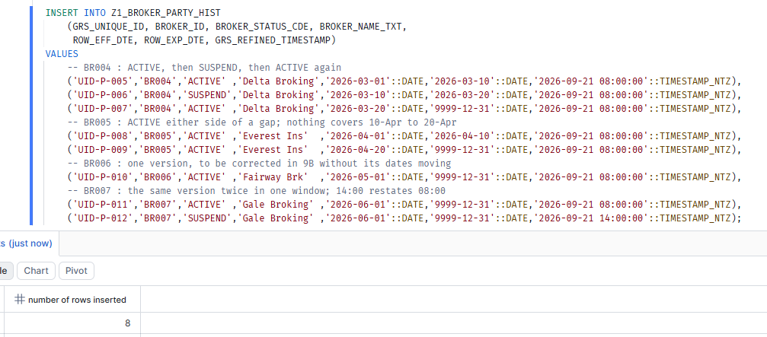
Eight party rows inserted. BR004's three versions return to ACTIVE after a spell on SUSPEND; BR005's two leave 10-Apr to 20-Apr uncovered; BR007's two carry the same key and effective date, the 14:00 row restating the 08:00 one.
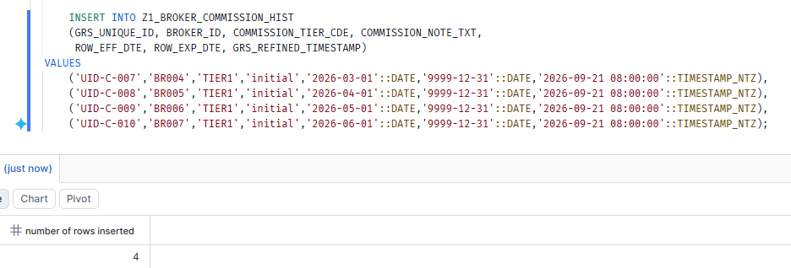
One commission version per new broker, all TIER1 and all left open - so whatever happens to the target timeline comes from the party table alone.
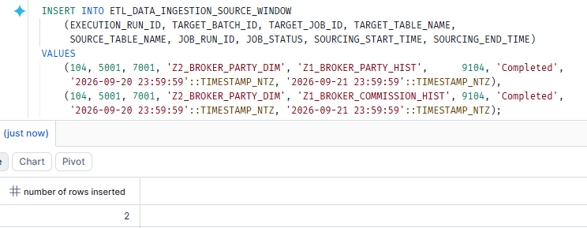
The run 104 window, covering 20-Sep to 21-Sep. Only the four new brokers were refined in that period, so BR001 to BR003 cannot be pulled back in.
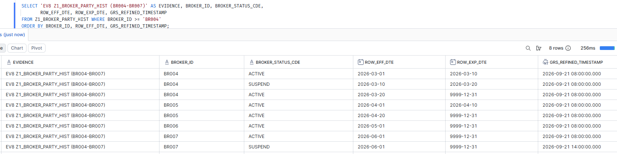
EV8 confirms the party table as loaded. BR007's two rows share BROKER_ID and ROW_EFF_DTE and differ only by refined timestamp, 08:00 against 14:00 - the duplicate the dedup has to resolve.
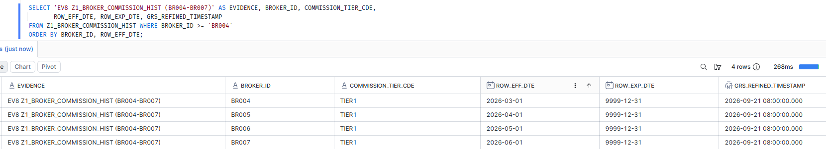
EV8 confirms the commission table - four rows, one per broker, each spanning that broker's whole timeline.

10. Run 104, Step 1 - the collapse under stress
What this tests: The central Part 9 test: whether the collapse keeps two runs of the same value separate when a different value sits between them, keeps a gap open when the value either side matches, and picks exactly one row when the same version arrives twice.
Steps: Truncate the stage and run the same Step 1 view, unchanged from Parts 1 to 8.
Expected: Eight rows, all 'I' - three for BR004, three for BR005, one each for BR006 and BR007 - and BR005's middle row carrying no status. Any other count means a wrong implementation: four for BR004 or two for BR007 would be a fan-out, and one for BR005 would mean the gap had been collapsed away.
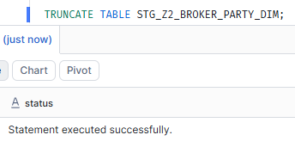
The stage is cleared first, so run 104 is a clean rebuild rather than an accumulation on top of run 103.
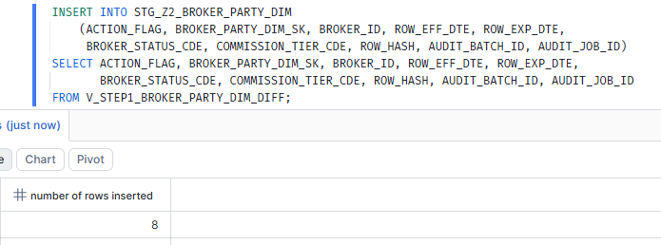
Step 1 writes 8 rows, matching the prediction exactly. A different number here would have meant the collapse or the dedup was wrong.
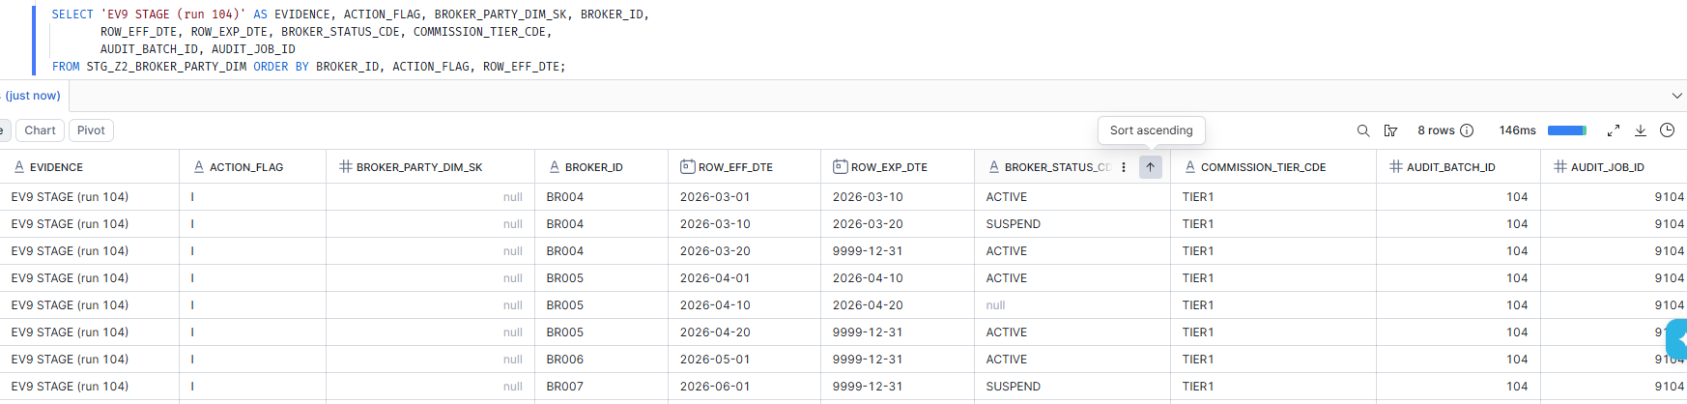
The Part 9 result in one screen. BR004 keeps its two ACTIVE runs separate because SUSPEND sits between them; BR005's 10-Apr to 20-Apr row carries a null status because neither source covers it; and BR007 produced a single row carrying SUSPEND, the 14:00 restatement having won.
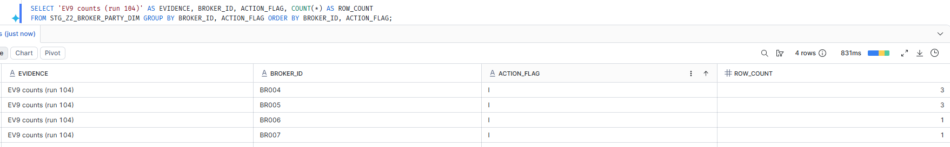
Counts per broker - 3, 3, 1, 1, every row 'I'. This is the shape that separates a correct collapse from a fan-out.

11. Run 104, Steps 2 and 3 - apply to the target
What this tests: That the eight new rows reach the target and that nothing already in it is disturbed.
Steps: Soft-delete, then insert, then read the target for the four new brokers.
Expected: Step 2 updates 0 rows, because these brokers are new and nothing is being superseded, and Step 3 inserts 8.
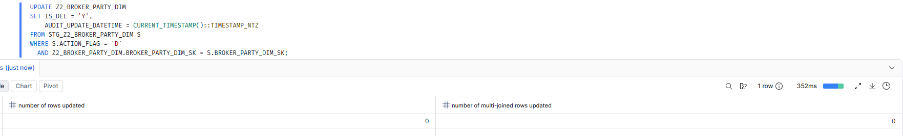
Step 2 updates 0 rows and reports 0 multi-joined rows. Correct: the stage holds no 'D' rows, because none of these brokers existed in the target before.
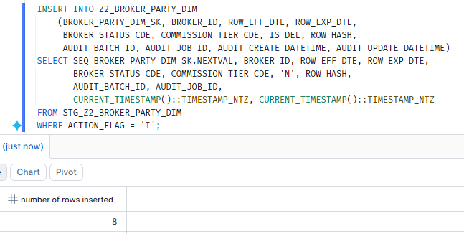
Step 3 inserts all eight rows.
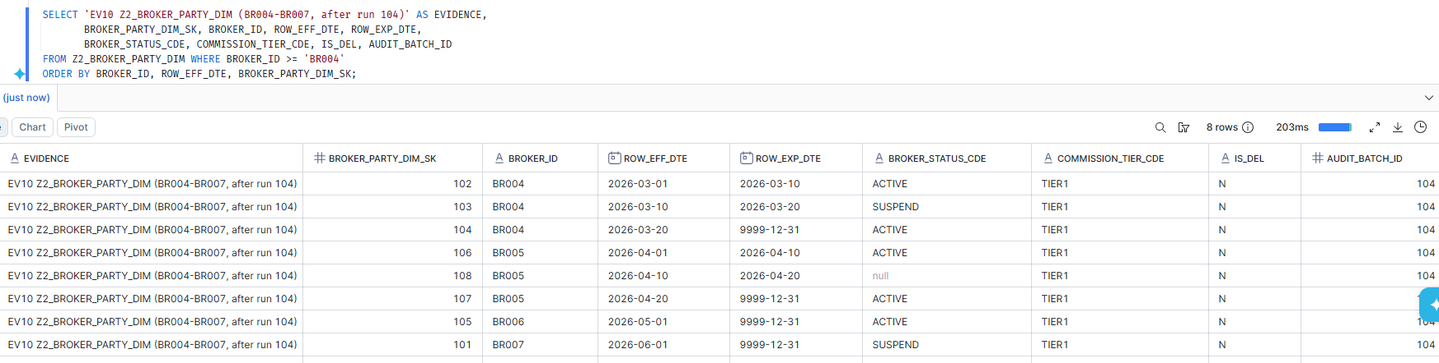
The target for BR004 to BR007 - eight live rows, all stamped AUDIT_BATCH_ID 104. BR005's uncovered window survives into the target as a row with no status, rather than being filled in or dropped.

12. Run 105 - a value corrected without its dates moving
What this tests: The case ROW_HASH exists for. BR006's source row is restated from ACTIVE to SUSPEND while both of its dates stay exactly where they were, so the dates alone cannot tell the old row from the new one.
Steps: Update BR006's party row in place, re-stamp its refined timestamp, register the run 105 window, then read the row back.
Expected: One source row updated - still 01-May to the high end date, now reading SUSPEND.
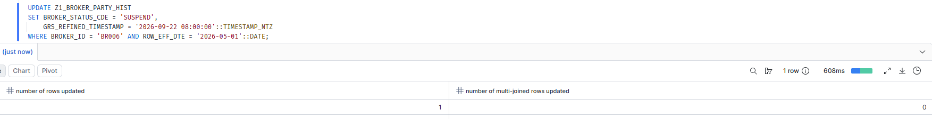
BR006's party row is corrected in place: the status becomes SUSPEND and the refined timestamp moves to 22-Sep, but neither ROW_EFF_DTE nor ROW_EXP_DTE changes.
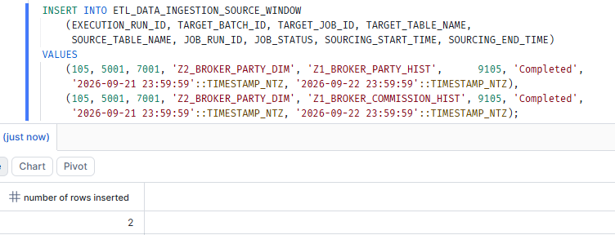
The run 105 window, 21-Sep to 22-Sep. Only BR006's corrected row falls inside it, so the other three new brokers are not re-read.
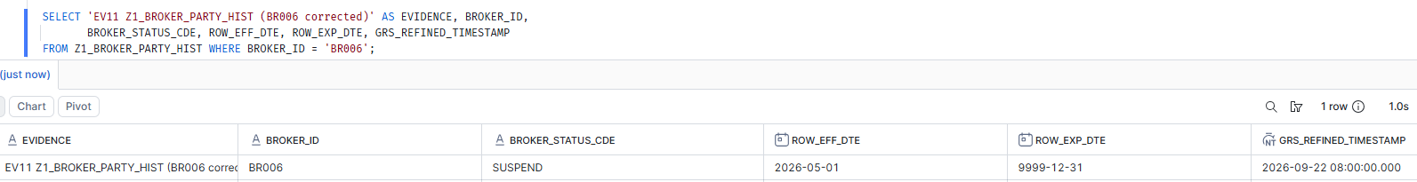
EV11 confirms the correction: same key, the same two dates as before, SUSPEND instead of ACTIVE. Nothing about the dates signals that anything changed.

13. Run 105, Step 1 - whether the diff notices
What this tests: Whether the diff detects a change that moved no dates. A diff joining on dates alone would match the old row to the new one, stage nothing, and leave the stale ACTIVE value in the target permanently - with no error to show for it.
Steps: Truncate the stage and run the same Step 1 view.
Expected: Exactly two rows, both BR006 - one 'D' carrying the existing surrogate key and one 'I' carrying SUSPEND - on identical effective and expiration dates. An empty stage here would be the silent failure.
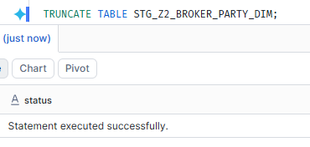
The stage is cleared before run 105.
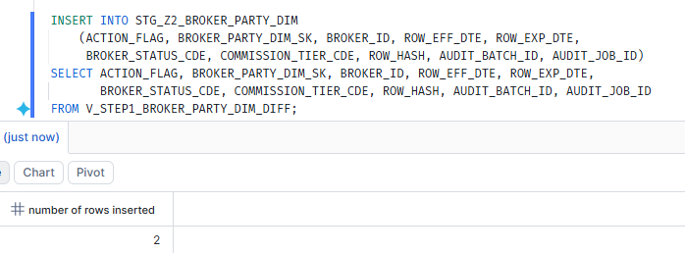
Step 1 writes 2 rows: the correction was noticed. Had the diff compared dates only, this would read 0 and the failure would have passed unremarked.
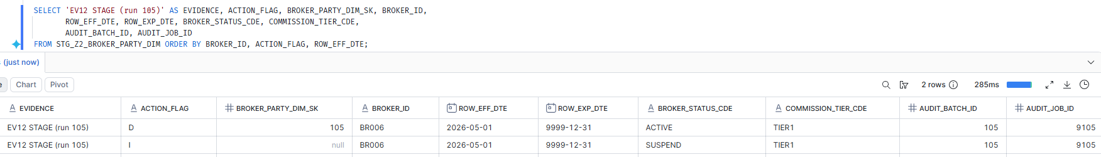
The discriminating result. One 'D' carrying surrogate key 105 and one 'I' carrying SUSPEND, both on 01-May to 9999-12-31. The two rows are identical but for their value, which is exactly what ROW_HASH is in the join to catch.

14. Run 105, Steps 2 and 3 - apply and inspect
What this tests: That the corrected row replaces the stale one, and that the row it replaced stays in the target as an audit trail rather than being overwritten.
Steps: Soft-delete, then insert, then read BR006 in full and the live timeline for all four new brokers.
Expected: One row soft-deleted and one inserted, leaving BR006 with two rows on the same dates: the retired ACTIVE one and the live SUSPEND one.
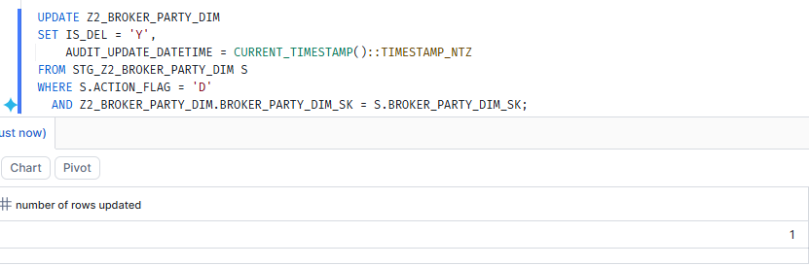
Step 2 soft-deletes exactly one row, the stale ACTIVE version.
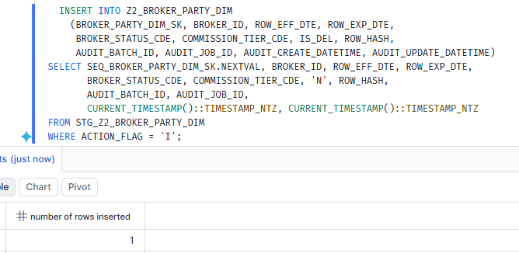
Step 3 inserts the corrected version.
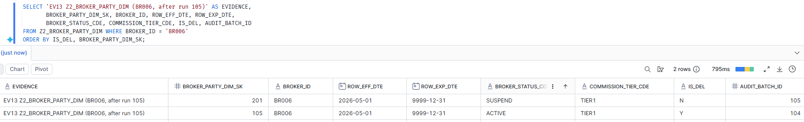
BR006 now holds both rows on identical dates: surrogate key 201 live with SUSPEND under run 105, and surrogate key 105 retired with ACTIVE under run 104. The correction is recorded rather than hidden.
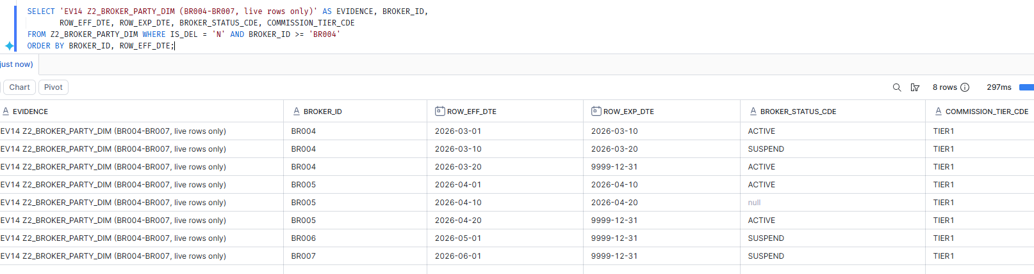
The live timeline for the four new brokers - eight rows, one per interval, with BR006 now reading SUSPEND.

15. Validation - assertions T13 to T25
What this tests: Thirteen assertions covering the four harder cases, each stating its expected value so that the result does not depend on reading a table by eye.
Steps: Run the Part 9 assertion block and read the RESULT column.
Expected: Every row reads PASS.
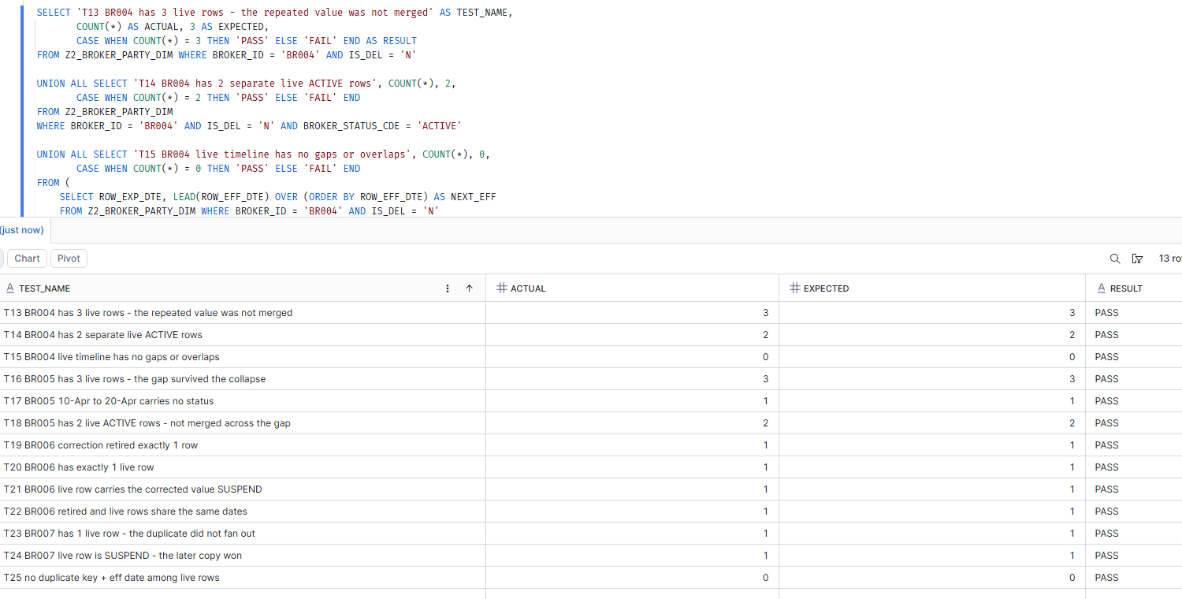
All thirteen assertions PASS. T13 and T14 confirm BR004's repeated value was not merged; T16 to T18 that BR005's gap survived the collapse; T19 to T22 that BR006's in-place correction was caught and its history kept; T23 and T24 that BR007's duplicate resolved to a single row carrying the later copy.

16. Idempotence with all seven brokers loaded
What this tests: That the earlier idempotence result still holds now the target carries seven brokers and fifteen live rows, rather than three brokers and seven.
Steps: Register a fourth sourcing window covering a quiet period, rerun Step 1, confirm the stage is empty, then read the finished target.
Expected: Step 1 writes 0 rows, and T26 reads PASS.
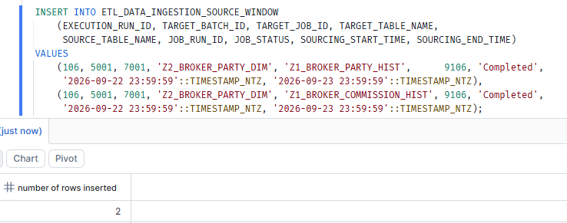
A fourth window, run 106, covering 22-Sep to 23-Sep - a period in which nothing was refined in either source.
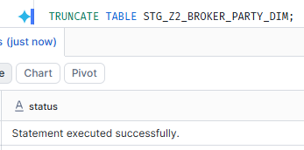
The stage is cleared before the re-run.
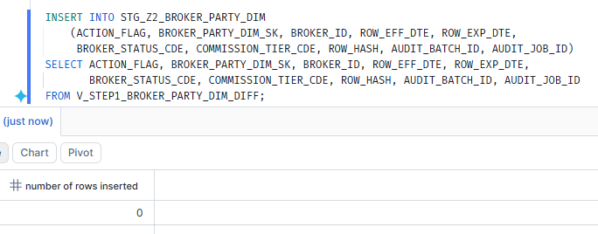
Step 1 writes 0 rows. No broker falls inside the window, so no timeline is rebuilt and no instruction is produced.
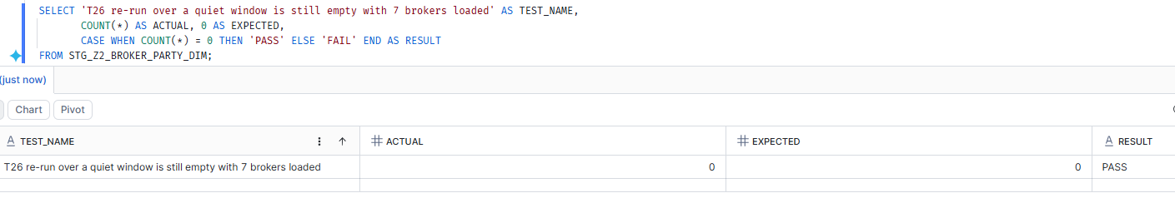
T26 PASS - the load is still restartable at the larger scale.
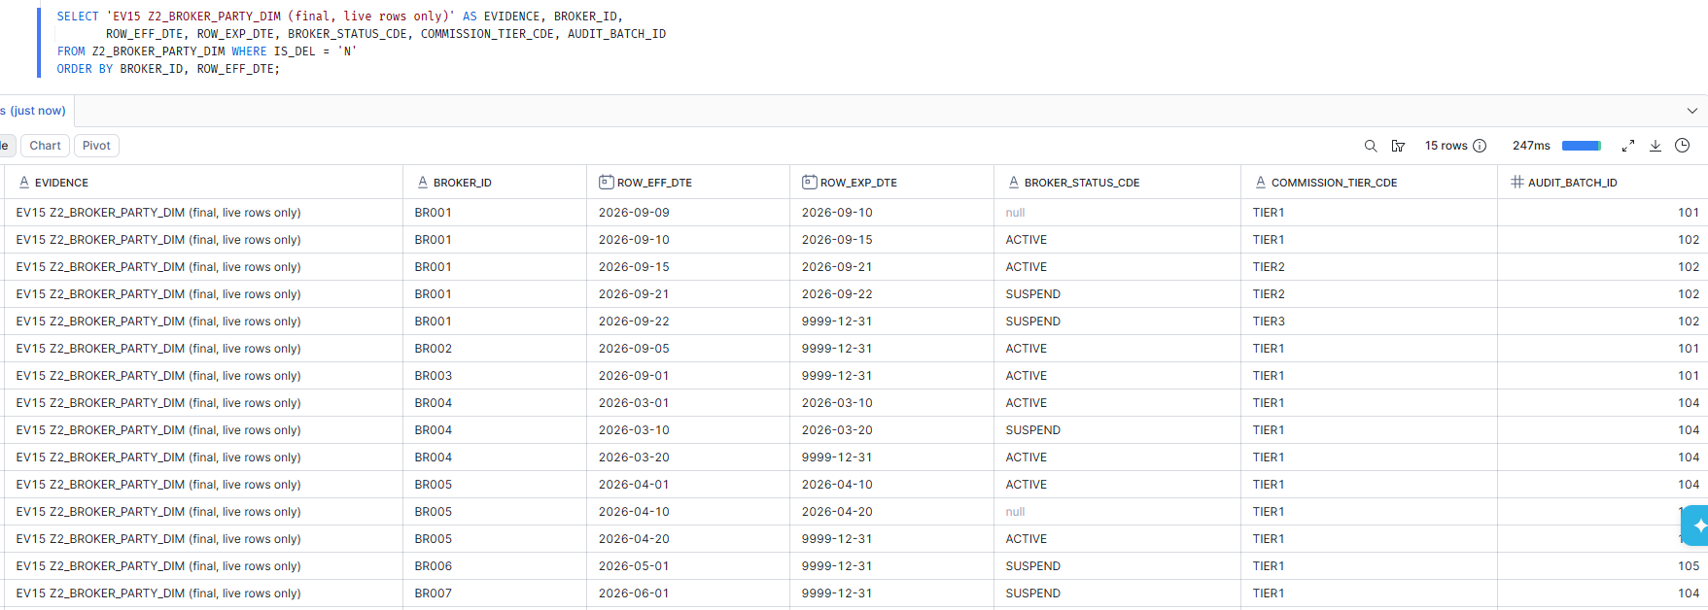
The finished target: fifteen live rows across all seven brokers, each stamped with the run that wrote it. Every timeline is continuous, and the only blanks are the two intervals no source covers - BR001's 09-Sep row and BR005's gap.

Conclusion
All twenty-six assertions pass, and every evidence block matches the output the design predicted before the run - including the four results that were hardest to be confident about on paper: a change in a non-target column producing no target change at all (BR002); a value returning later without being merged across the different value between them (BR004); a gap in cover surviving a collapse that compares values either side of it (BR005); and a correction that moved no dates still being caught (BR006).
Each of those four was written down as an expected row count before the SQL was run, and in each case the run produced exactly that count. Three of them were also checked against a deliberately broken version of the logic beforehand, to confirm the assertions would actually fail if the implementation were wrong rather than passing by coincidence.
What this does not yet prove: that a SQL override of this size still pushes down fully in IDMC rather than pulling data out to the agent, and whether Steps 2 and 3 can share one Snowflake transaction. Both are listed in solution_design.md section 11 and still need a spike against a real mapping. The business table and column names in the POC are illustrative and flagged as such in the script header; the real Zone1 and Zone2 names still have to be substituted.

