**CHAPTER 1**

**INTRODUCTION**

Organ donation is a process of removing tissues or organs from live recently dead person to another person. The former is the donor and latter is the recipient. People of all ages can become donors.you must have been donating food,money,shelter etc during your lifetime .Organ donation gives you the chance to enhance that spirit by recycling yourself even after death.

The Organ Donation management system is a simple mini project which consists of the information about the donor and organization that are related to donating the organs.people who are in need or the people who wish to donate their organs can register through this system .

This system consists of donor registration,patient list organ details availability of organs.After the registration process the application will be processed by the administrator , he will be having his own login details to login into the system, admin is the main authority and any modification like insertion,deletion can be done only by the admin.

At present ,most of organ transplants come from living donors,as a result only a small percentage of organ seekers get compatible and keen donors.due to extremely low number of decreased donations,most of people awaiting transplant breathe their last

The information of organs which is available is stored in organ bank ,which is available organs in our project ,the availability can be checked through the patient list which includes heart list,lungs list,liver list ,kidney list,eyes list.

Admin first checks the availability of organs needed for person with the help of organ id and blood group , then if organ is available and matches to the blood group of the person who is need of organ and process it.if the person is dead then the information is directly stored in available organs table

**Overview of the project**

Our proposed “organ donation management system” is for organ donors and organ seekers. Before doing anything first we got to know the information that in India every year nearly 500,000 people die because of non-availability of organs and this number is expected to grow due to scarcity of organ donors .This system will help to improve the performance of current situation and overcomes the problems arising nowadays

**Objectives**

* The main objective of this project is to design and develop a user friendly efficient computerized Organ Donation Management System
* To provide graphical user interface for easier access of data
* The entire system is developed keeping in view of distributed client server computing technology
* Computerization helps by means of time an

**CHAPTER 2**

**SYSTEM ANALYSIS AND DESIGN**

System analysis is the activities that comprise process in the production of software,the activities are similar to those within the system analysis and design of software depending upon the methodology used ,the activities can be arranged differently.System design is a process of defining elements of subsystems modules and their interfaces data for the system based on specified requirements it is the process of designing and developing

**2.1 EXISTING SYSTEM**

Whenever we implement new system it is developed to remove the shortcomings of an existing system.The computerized has more edge over the manual system.As we are done with project “Donor Management System”.so firstly we will introduce the exiting system,the existing system is based on manual system,which takes lots of time to get performance of the test. As existing system is manually maintains system .here records are to be maintained for the details of each donor details,organ details,organ list,patient list,available organs.All these details are entered and retrieved manually.It is time consuming,helps in updating process also it has inaccuracy of data.

**2.2 PROPOSED SYSTEM**

In proposed system,the management or administrator need not to keep any type of records, the proposed system is a computerized version of the existing system and all the details are stored in the computer database .It provides flexibility to the user to transfer the data in database very easily by compressing the large amount of file.Dual entries are done quickly ,working through old systems are time consuming when compared to proposed system. As ultimate feasibility,consideration of proposed system will fulfil the specified requirements and decides whether the proposed system coves all operational feasibility.Some of the merits of proposed system is it is accurate,time saving,provides security

**2.3 OBJECTIVES OF PROPOSED SYSTEM**

The system analyst must be aware of exactly what the user requires from the new system.that is management grades as objectives must be fully known and understood .After reviewing the objectives of current system.It is quite possible that he or she may be aware of computer capabilities that can be can be utilized to develop the system which can fulfil the requirements. The main objectives of the proposed system are as follows

* To save time.
* To reduce paper and file work.
* To speed up the procedure.
* To relive the management from repetitive work.
* To enable efficient and accurate reporting
* To have a flexible system that can adjust changes in future.
* For fast retrieval of information
* For better presentation report
* To make decision making process easy for administrator or management

.

**CHAPTER 3**

**SYSTEM REQUIREMENTS**

The software and hardware requirements are very important and is generally required to the and the work is being done in accordance to the matter for designing a particular computer architecture.

**3.1 SOFTWARE REQUIREMENTS**

* Microsoft Windows7 & above
* Eclipse or may be java IDE
* PHPMyAdmin or any SQL handler
* Virtual Server(Ex. XAMPP)

**3.2 HARDWARE REQUIREMENTS**

* Processor : dual core CPU(2GHz and above)
* RAM : 2 GB and above
* Disk space : 1 GB free space HDD/SSD

**CHAPTER 4**

**SYSTEM DESIGN**

**4.1 DATA DESIGN**

Data design creates a model of data or information that is represented in high level of abstraction. The structure of data has been an important software design.The data design activity translates these elements of required model and translates it into data structure at the software component level.

**4.1.2 SCHEMA DIAGRAM**

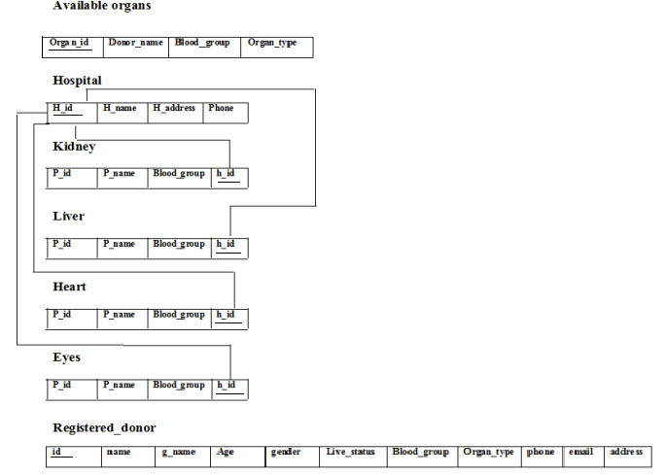

**Fig.4.1.1 SCHEMA DIAGRAM**

**4.1.2 ENTITY RELATIONSHIP DIAGRAM**

An entity relationship model describes interrelated things of interest in a specific domain of knowledge. A ER model is composed of entity types and specifies relationships that can exist

Between the instances of entity types. They are related using .

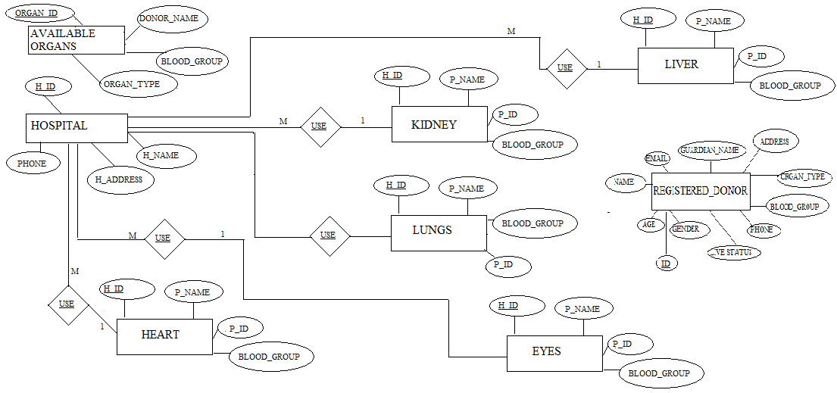

**FIG 4.1.2 ER DIAGRAM**

**4.1.3 DATA FLOW DIAGRAM**

The data flow diagram is the graphical representation of the flow of data through an information system ,it is often used as preliminary step to create the overview of the system without going into great detail.

**FIG 4.1.3 DATA FLOW DIAGRAM**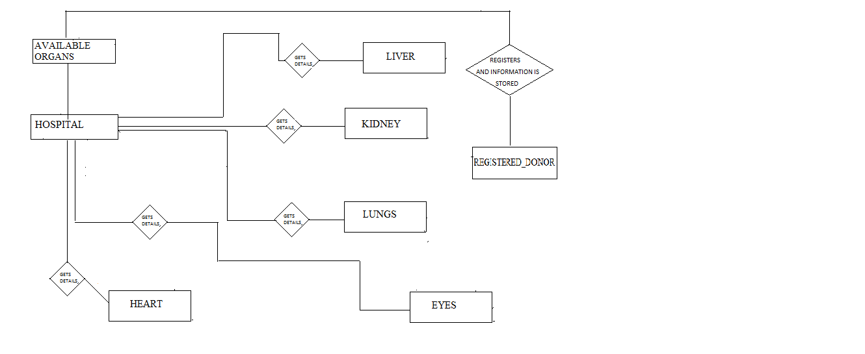

**4.2 IMPLEMENTATION**

Implementation is the realization of application ,or execution of plan,idea,model, design,

application ,standards,algorithm,or policy. In other words, an implementation is a realization

of technical specification or algorithm as a program,software component, or other computer

System through programming.Many implementations may exits for the given specification

or standards

Implementation is one of the important phase of the Software Development Life Cycle(SDLC). it encompasses all processes involved in getting new software or hardware operating properly in its environment,including installation configuration,running,testing and making necessary changes.Specifically,it involves coding the system using a particular programming language and transferring the design into actual working system.

This phase of system is conducted with the idea that whatever is designs should be implemented,keeping in mind that it fulfills user requirements,objectives and scope of the system. The implementation phase produces the solution to the user problem

**4.2.1 MODULE DESCRIPTION**

**MODULE 1**

Home Page: It displays the project title and the manager sign in here(FIG 6.1)

**MODULE 2**

Login Page:it has organ bank login form here the admin or the manager can login here if the user name and password is correct it displays a successful message(FIG 6.2)

Login Successful: if the password and username is successful message is displayed(FIG 6.3)

Reset: clears the entered value

Exit : closes the login form

**MODULE 3**

Welcome page: it welcomes and consists the buttons like new donor register ,patients list,available organ and the donor list(FIG 6.4)

**MODULE 4**

Donor Registration : it is a page where donors can register by filling their required details(FIG 6.5)

Clear : it is used to clear the text entered

Back : by clicking on this it goes to previous page

**Module 5**

Patient List; here it contains patient details and organ details(FIG 6.6)

Kidney list: here you can view patient details who are in hospital and needs the organ kidney.(FIG 6.7)

lungs list: here you can view patient details who are in hospital and needs the organ lungs(FIG 6.8)

Liver list: here you can view patient details who are in hospital and needs the organ liver

(FIG 6.9)

Heart list: here you can view patient details who are in hospital and needs the organ heart.(FIG 6.10)

Eyes list: here you can view patient details who are in hospital and needs the organ eyes

(FIG 6.11).

Back : by clicking on this it goes to previous page

**MODULE 6**

Available_organs : here you can see the organs id ,donor name and details of organs which are available.(FIG 6.12)

Match: here it checks the availability of the organ with the help of blood group of donor and the patient. (FIG 6.13)

Back : by clicking on this it goes to previous page.

**MODULE 7**

Registered Donors: it contains information and details of donors who are registered

(FIG 6.14)

Back : by clicking on this it goes to previous page.

Move to available organ: here if person is dead the details of donar is directly added to available organ module

**CHAPTER 5**

**TESTING**

Software testing is a process of evaluation a software item to detect differences between given input ad expected output,also to access the feature of software item.testing accesses the quality of the product.Software testing is a process that should be done during the development process.In other words,software testing is a verification and validation process

Verification is the process to make sure that the product satisfies the condition imposed at the start of the development phase.In other words,to make sure that product behaves the way we want it to.

Validation is the process that product satisfies the specifies requirements at the end of development phase.In other words ,to make sure project is built as per customer requirements

The Organ Donation Management System was tested using the following two techniques of application testing:

**Performance testing:**

performance testing is the testing to access the speed and effectiveness of the system and to make sure it is generating results within a specified time as in performance requirements

**Unit testing:**

* In the line of strategy entire individuals function modules were put into test
* By following all the errors in coding were identified and corrected
* The following were the test carried out for Graphical User Interface(GUI).
* It was seen that the pages open properly based on related menu commands
* It was tested whether all relevant menus,buttons ,icons and other controls are available and properly displayed

|  |  |  |  |  |
| --- | --- | --- | --- | --- |
| **SL.NO** | **TEST CASE TITLE** | **DESCRIPTION** | **EXPECTED**  **OUTCOME** | **RESULT** |
| 1 | Homepage | Project starts with the homepage | Homepage should be displayed with sign in button | Successful |
| 2 | Login page | It consists of login form where you can log in and is is done only by admin and has login exit and reset buttons | Login page must be displayed and if password is correct a successful message must be displayed and clicking on reset must reset values and clicking on exit  Login form should close | Successful |
| 3 | Welcome page | It consists of four buttons that is new donor registration,patient list.available organs,patient list | On clicking particular button respective page or module must be displayed | Successful |
| 4 | Donor register | Project must have registration page to register people it has clear ,back and register buttons | On clicking on register button the person must get registered and by clicking on clear the form should be empty and by clicking back previous page must be displayed | Successful |
| 5 | Patient list | It has list of patients and organs and their details | On selecting this list of organs must be displayed | Successful |
| 6 | Liver list | Has details of patients with their details | Must display patients  list with their information and on clicking back button previous page must be displayed | Successful |
| 7 | Lungs list | Has details of patients with their details | Must display patients  list with their information and on clicking back button previous page must be displayed | Successful |
| 8 | Eyes list | Has details of patients with their details | Must display patients  list with their information and on clicking back button previous page must be displayed | Successful |
| 9 | Heart list | Has details of patients with their details | Must display patients  list with their information and on clicking back button previous page must be displayed | Successful |
| 10 | Kidney list | Has details of patients with their details | Must display patients  list with their information and on clicking back button previous page must be displayed | Successful |
| 11 | Available organs | Checking the available organs | It must display the organs available and on clicking on match button it displays match page and clicking back button displays previous page | Successful |
| 12 | Match | Has match option and back button | Matching organ which is available must be displayed | Successful |
| 13 | View donor list | Has list of donors  and move to available organ | Must display list of donors who are registered and must go to previous page on clicking the back button and if the person is dead on clicking add to available organ list the details of the donor must be deleted in this page and it must be updated in available organ page | Successful |

**Table 5.1 unit testing**

**CHAPTER 6**

**SNAPSHOTS**

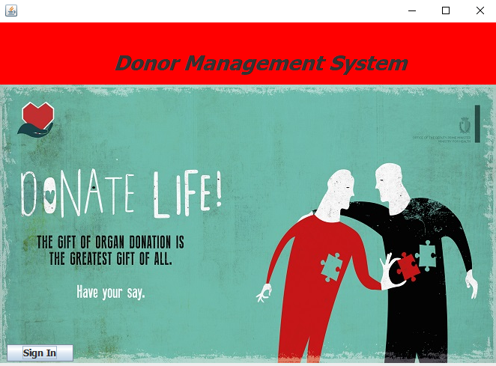

**FIG 6.1 HOMEPAGE**

**This is the homepage of organ donation management system**

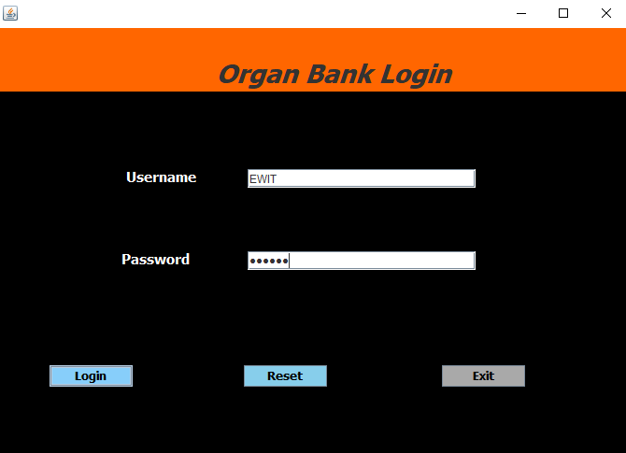

**FIG 6.2 LOGIN PAGE**

In this page organ bank manager can log in with the password and username

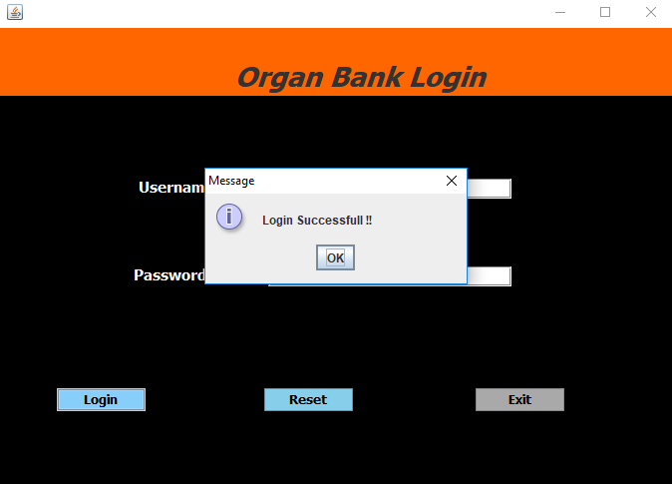

**FIG 6.3 SUCCESSFUL LOGIN**

This page displays successful message if the password and user name is correct

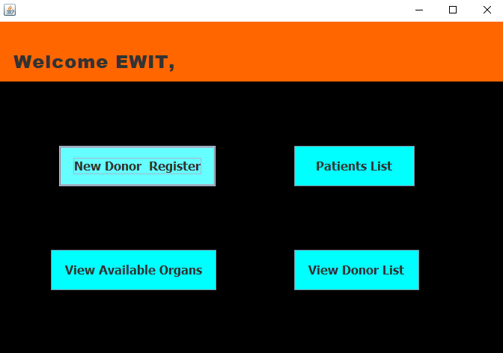

**FIG 6.4 WELCOME PAGE**

This page consists of 4 buttons by selecting the required one display the next page

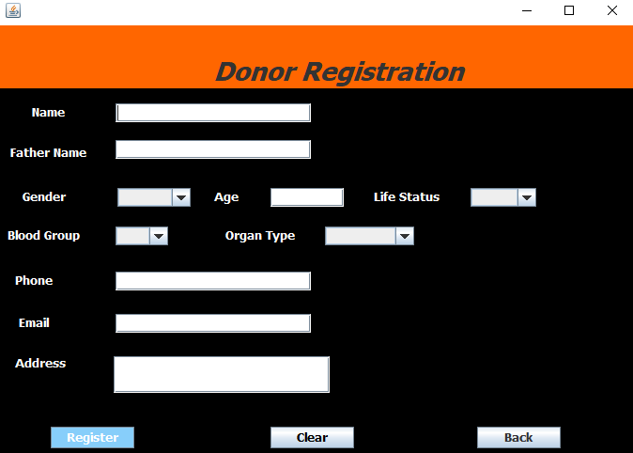

**FIG 6.5 REGISTERATION PAGE**

This is a page where donor registration takes place

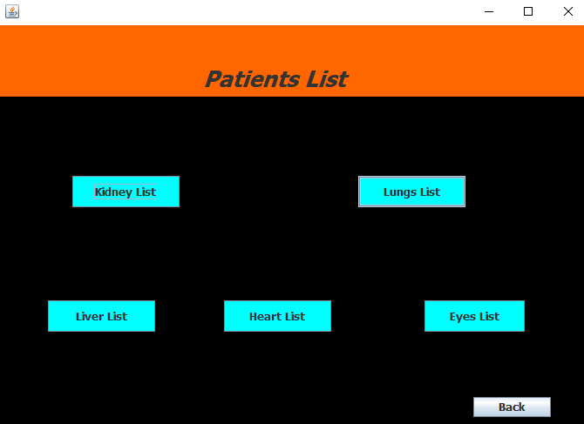

**FIG 6.6 PATIENT LIST**

Page consists of information of the patient and their details

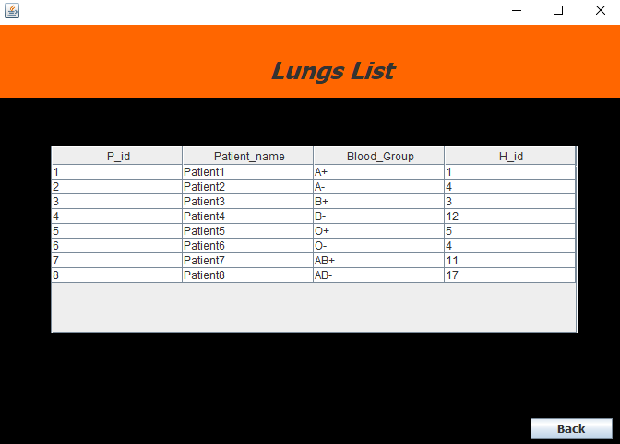

**FIG 6.7 LUNGS LIST**

This page displays list of patients and their details who are in need of organ lungs

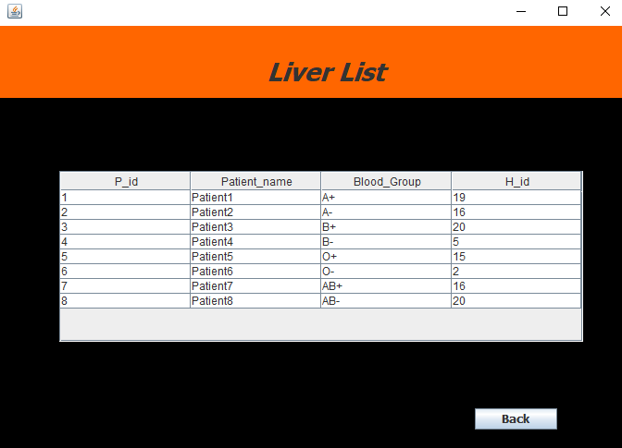

**FIG 6.8 LIVER LIST**

This page displays list of patients and their details who are in need of organ lungs

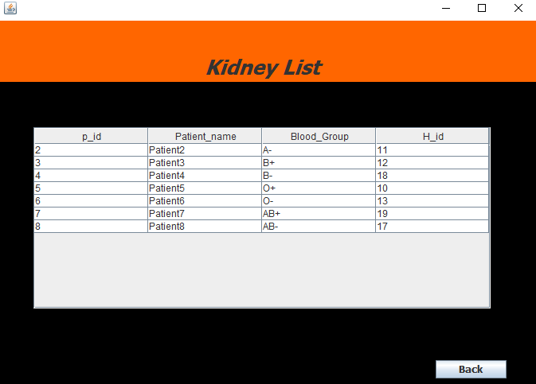

**FIG 6.9 KIDNEY LIST**

This page displays list of patients and their details who are in need of organ kidney

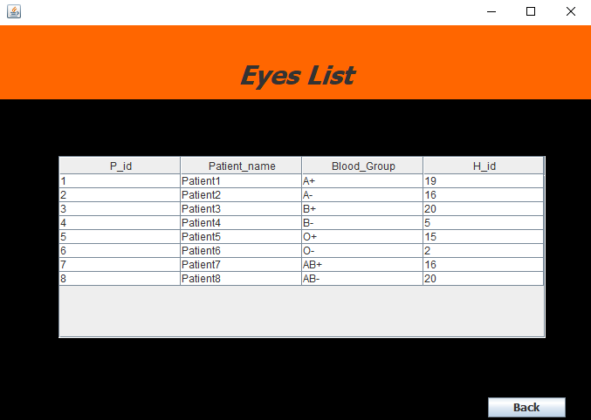

**FIG 6.10 EYES LIST**

This page displays list of patients and their details who are in need of organ eyes

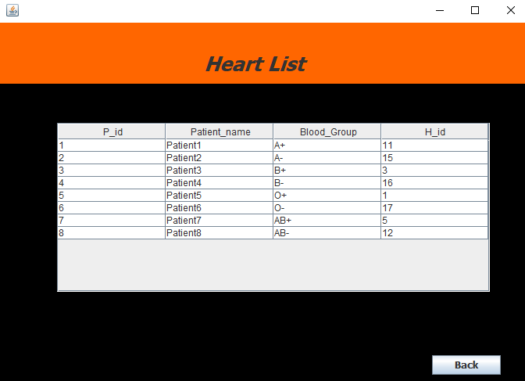

**FIG 6.11 HEART LIST**

This page displays list of patients and their details who are in need of organ heart

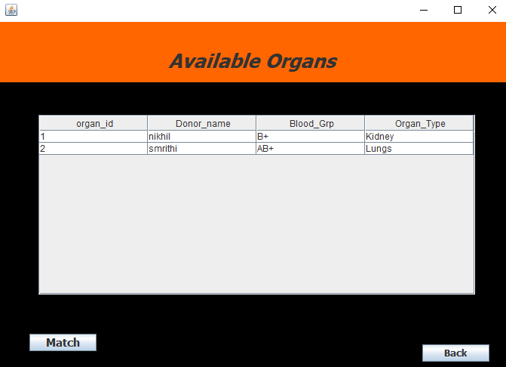

**FIG 6.12 available organs**

This page displays list of organs which are available and its details

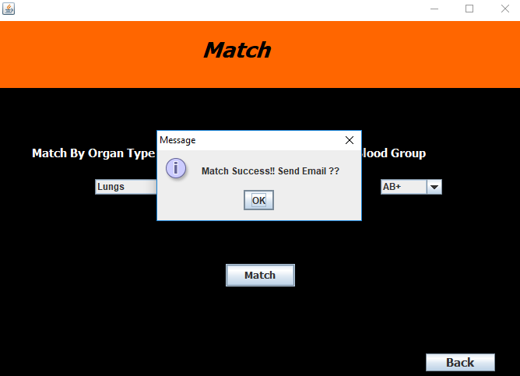

**FIG 6.13 Match successful**

If the blood group of the requires organ mates any one f of organ in available list it displays successful message and an email is sent

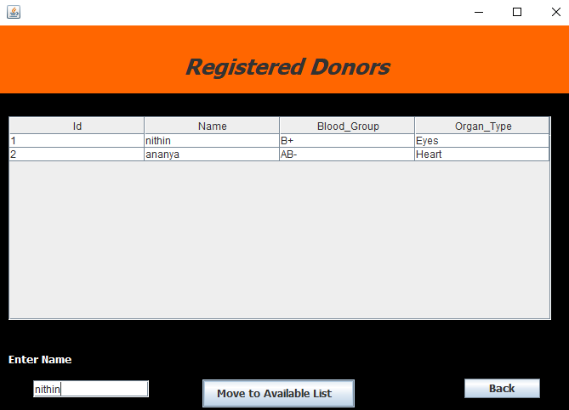

**FIG 6.14 REGISTERED DONORS**

This page displays list of donors who are registered and their details

**CONCLUSION**

Organ donation is a gift of one’s boy parts from a person who is recently dead or from a living donor, for the purpose of transplantation. In this “organ donation management system”the admin or the organ bank manager can log in to the organ bank by user name and password and only he can update delete insert data and do modifications.new donas can register here and also this system helps in matching terequired organ for the person with the help of blood group ,here you can also know check the organs available ,patient details ,and donor details.The main aim of this system is to save the patient life by organ transplantation.

You must have been donating food ,money,shelter etc,during lifetime but organ donation gives you the chance to enhance that spirit by recycling yourself evev after death.”THE GIFT OF ORGAN IS THE GRETESR GIFT OF ALL”.