MEDTECH INDUSTRIES

End-to-end medical and institutional solutions.

ABOUT

Novuss MedTech Industries, based in Panchkula, Haryana, is a registered MSME and Udyam-certified enterprise specializing in the supply and distribution of high-quality medical, laboratory, and scientific instruments. With a commitment to precision, performance, and trust, Novuss serves hospitals, research institutions, and government organizations across North India. Our portfolio includes advanced diagnostic devices, laboratory instruments, and institutional science kits designed to meet the highest standards of accuracy and durability.

Laborato
UiDment

Centrifuge Machines

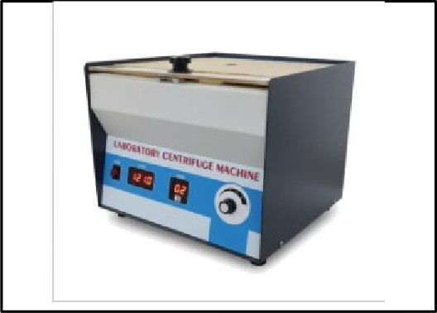
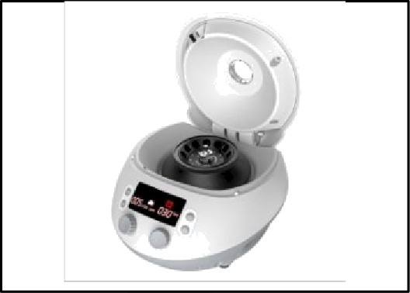
Digital Laborato | High-speeds Centrifuge

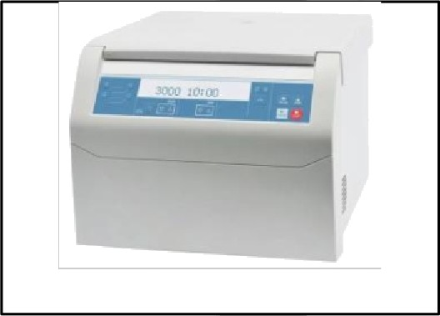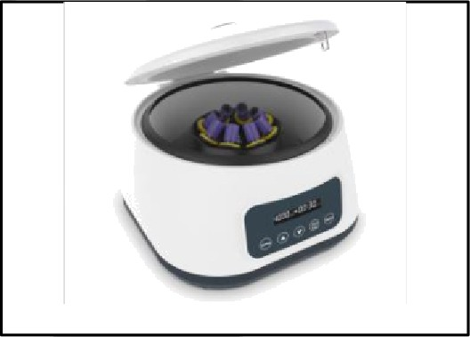

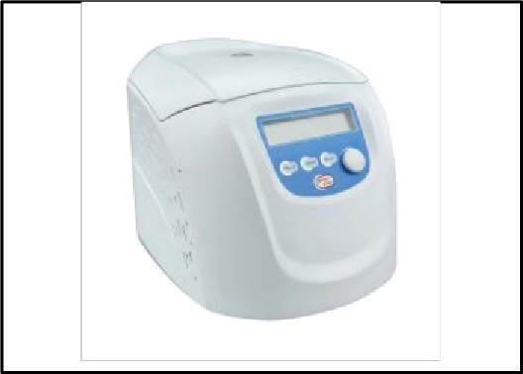
Refrigerated Cent

Hematocrit Centrifuge
Bench fuge
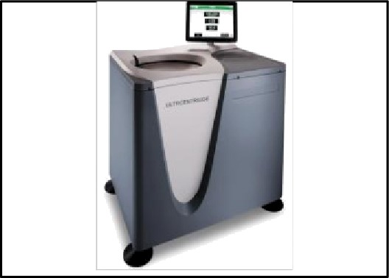
Ultracentrifuge

Incubators & Ovens
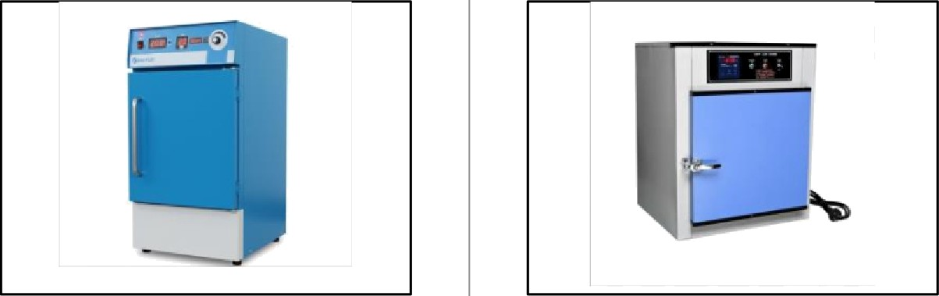
BOD Incubator Hot Air Oven
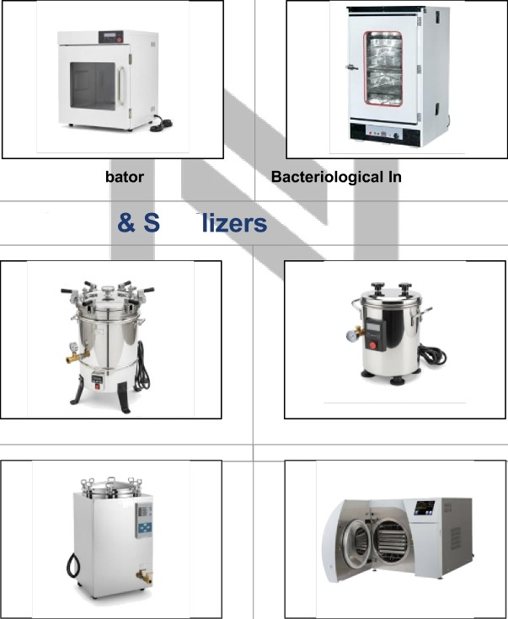
Laboratory Incu
cubator
Autoclaves
teri
Vertical Autoclave
Portable Autoclave
Digital Autoclave Pre-Vacuum Autoclave

Microscopes

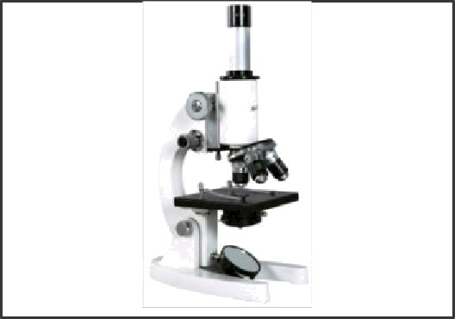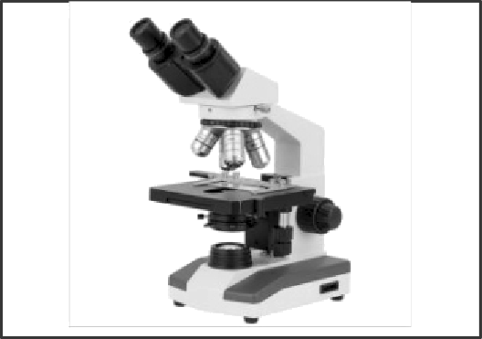

Student Microscope
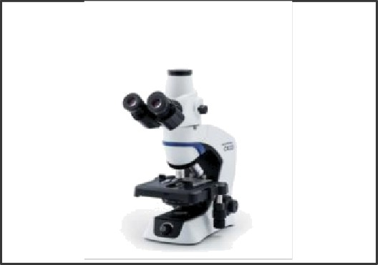
Trinocular Microscope

Analytical Instruments
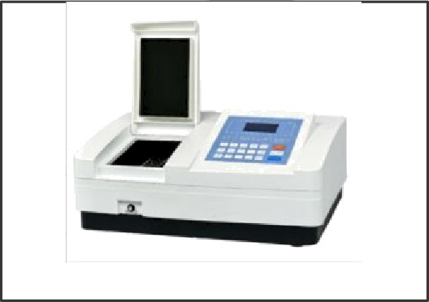
Spectrophotometer
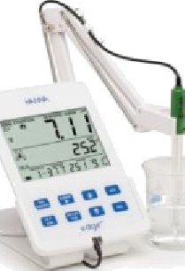
pH Meter Digital (Portable)
Binocular Microscope
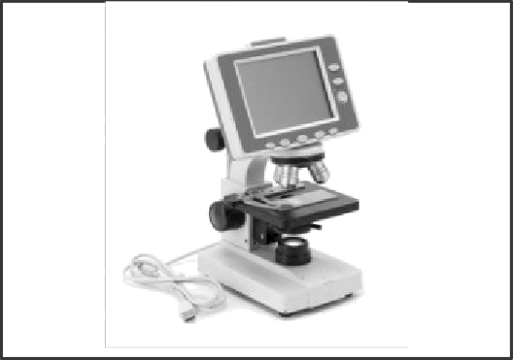
Digital Microscope

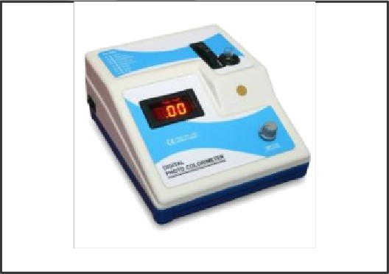
Colorimeter
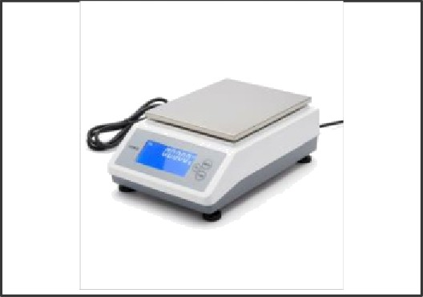
Precision Electronic Balance

General Lab Equipment

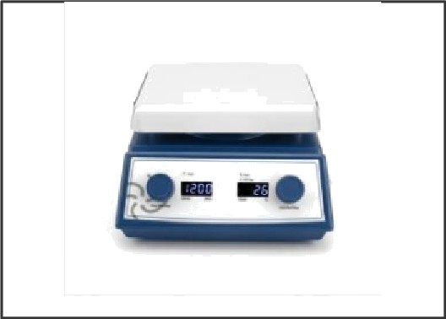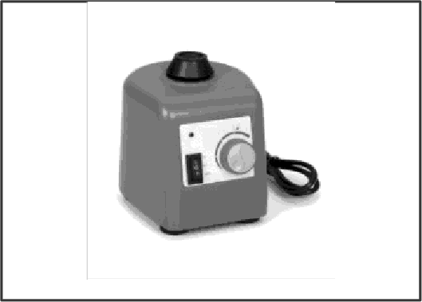

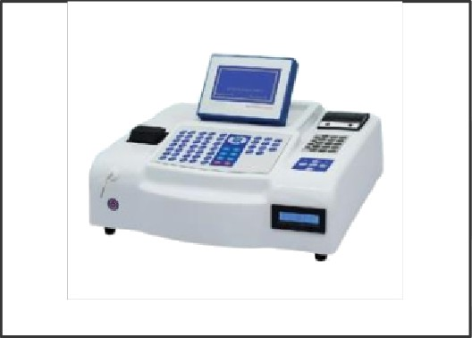
Hot Plate Stirrer

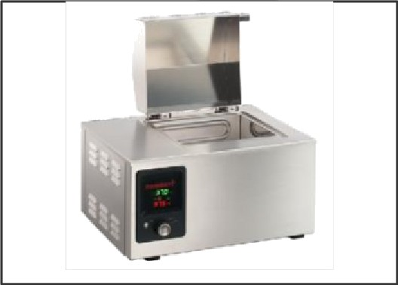
Analyzer Machines

Water Bath
Vortex Shaker
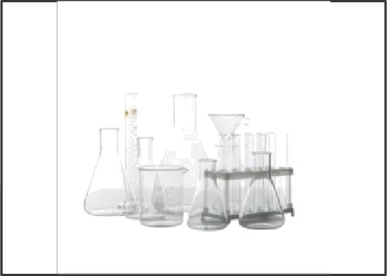
Laboratory Glassware Set
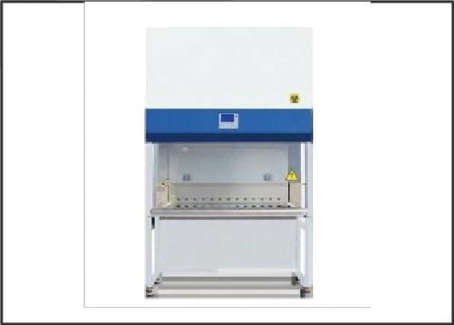
Biosafety Cabinet

Dia nostic Instruments

ECG Machines
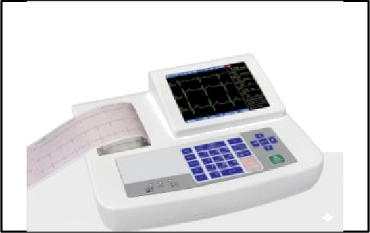
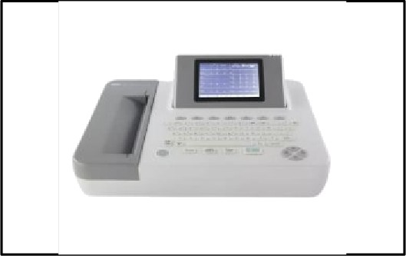
Digital ECG Machine 12-Channel ECG
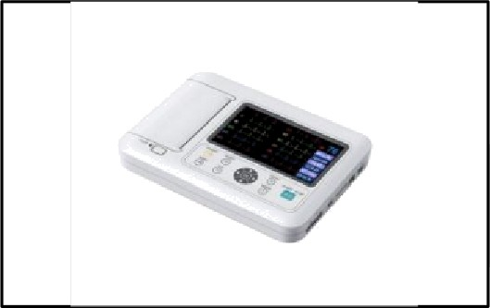
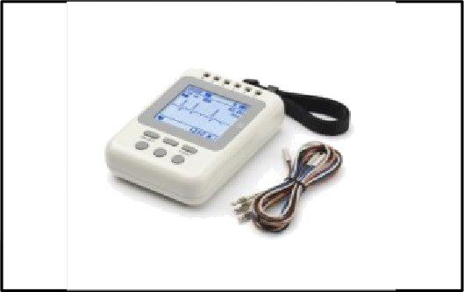

Patient Monitors

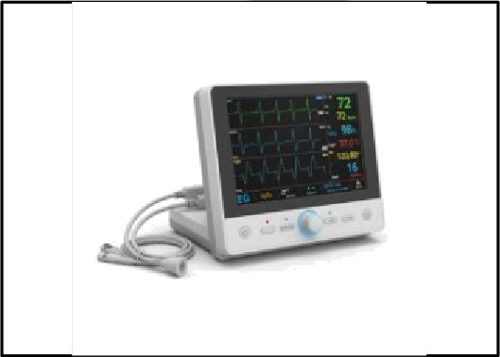

. t”” “
‘

Multi Parameter Monitor
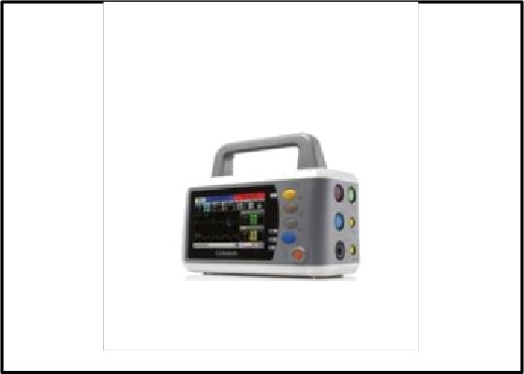

Portable Patient Monitor
Vital Signs Monitor
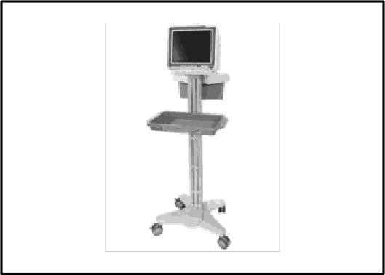
Mobile Patient Monitor Cart

BP Apparatus & Basic Diagnostics

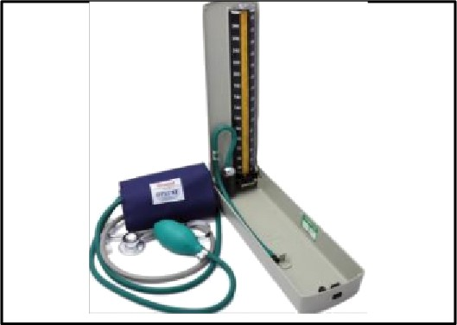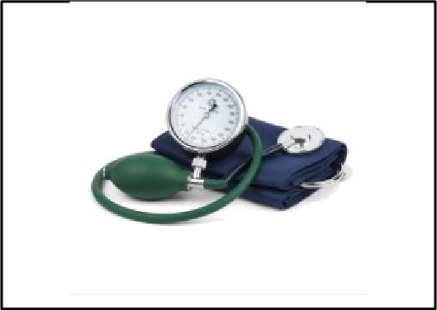

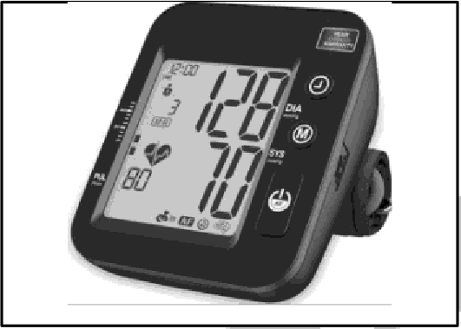
Mercury BP Apparatus

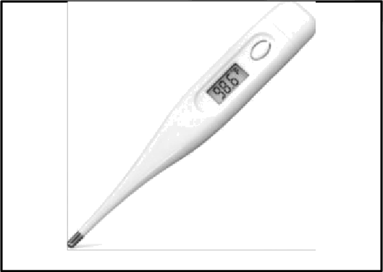
Digital BP Monitor

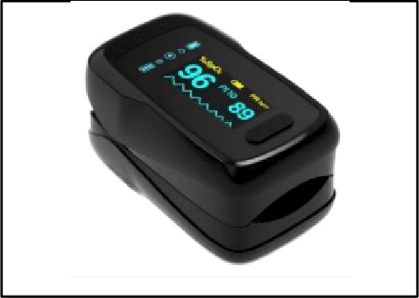
Digital Thermometer

Pulse Oximeter
Aneroid BP Apparatus

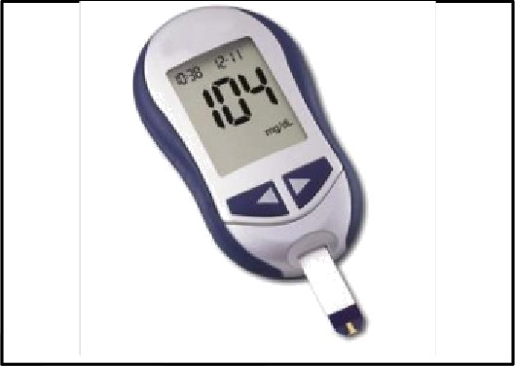
Glucometer
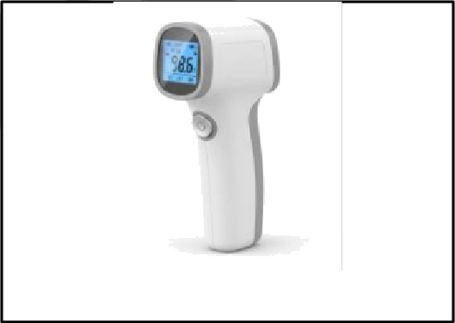
Infrared Thermometer

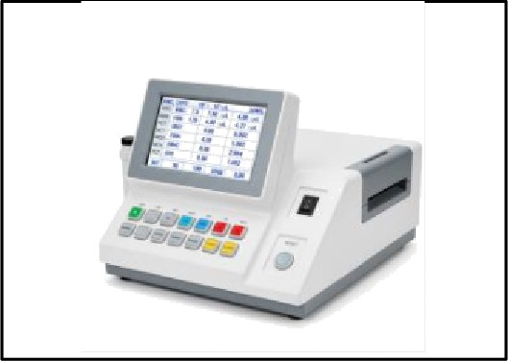
Blood Cell Counter (Export Quality)

Respiratory Support Equipment
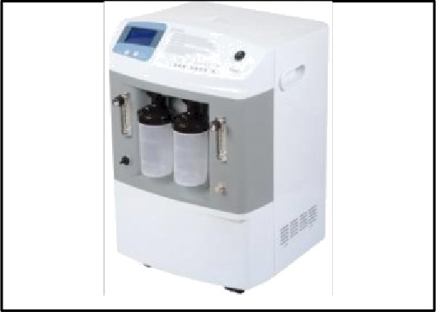
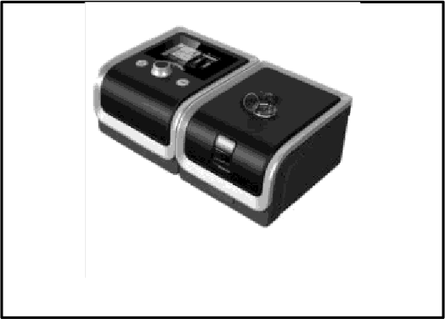
Oxygen Concentrator BiPAP Machine
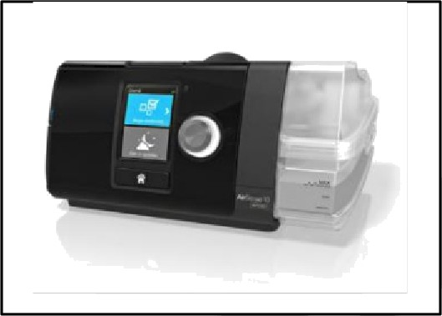
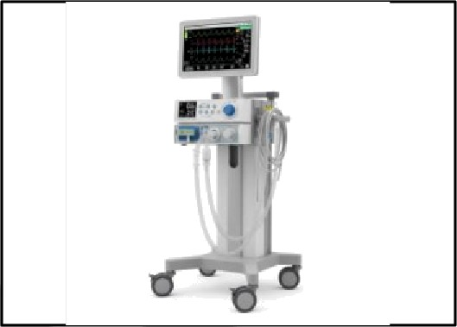
CPAP Machine Mr

Hospital Beds
Nos ital Furniture & Infrastructure
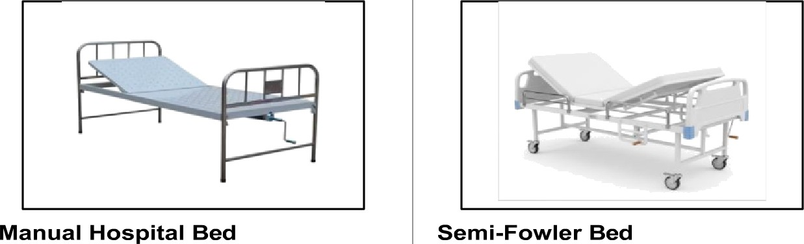
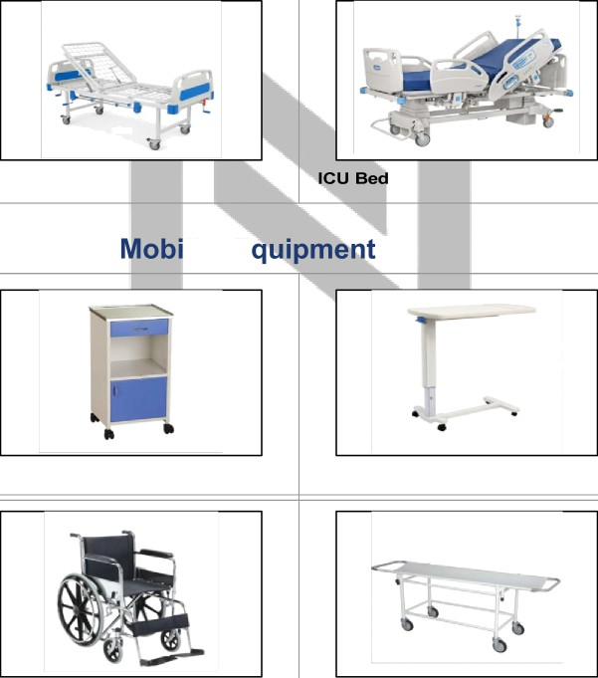
Fowler Bed
Furniture &
lily E
Bedside Locker
Overbed Table

Wheelchair Stretcher

Medical Trolleys & Infrastructure


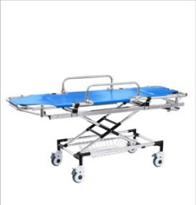
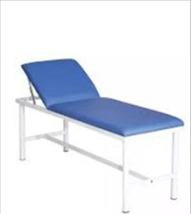
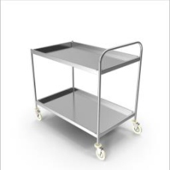
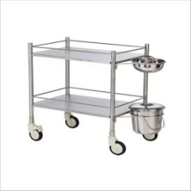
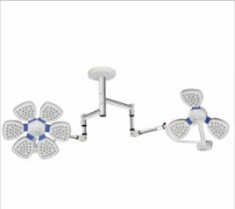
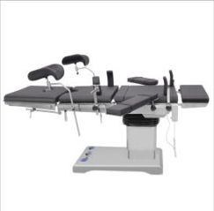
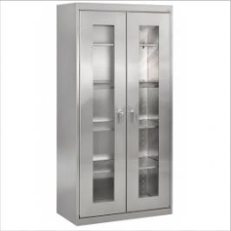
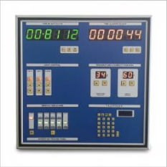
Dressing Trolley

OT Table

Modular OT Control Panel

Examination Table
Instrument Trolley

OT Light

Hospital Almirah

Collapsible Ambulance Stretcher

Surgical Instruments & Sets
Suroical & S ecialized Instruments

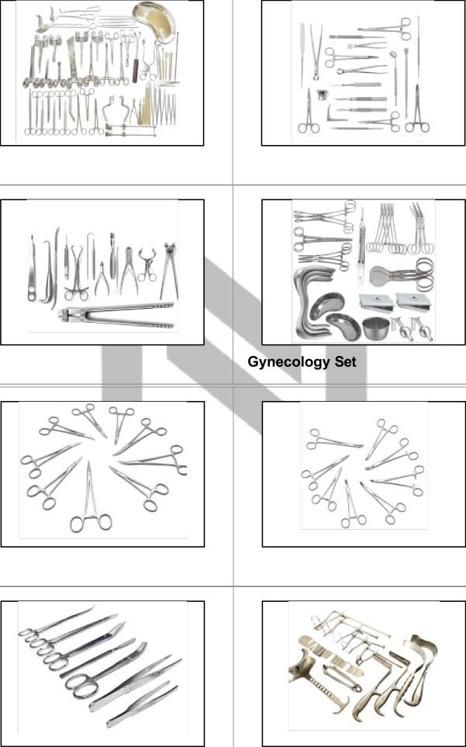
General Surgical Set

Orthopedic Set

Surgical Scissors

Surgical Clamps
ENT Surgical Set

Surgical Forceps

Retractors

ENT Equipment

ENT Diagnostic Set

Laryngoscope

Ophthalmic Equipment

Ophthalmoscope
Otoscope

ENT Examination Unit

Retinoscope


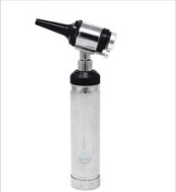
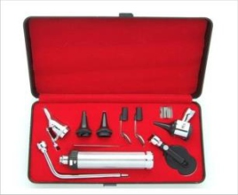
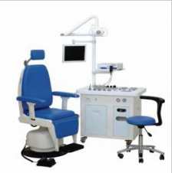
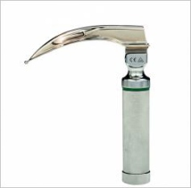
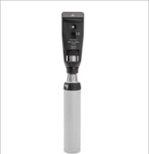
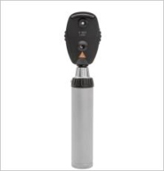
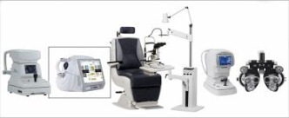
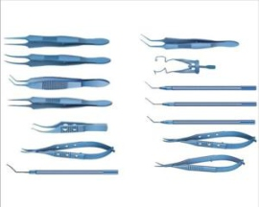

Ophthalmic Surgical Instruments Ophthalmic Equipment Station

Dental Equipment


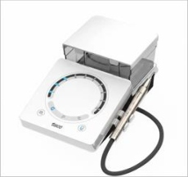
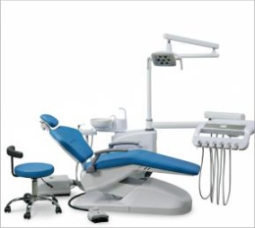
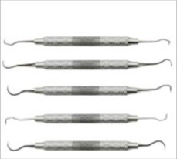
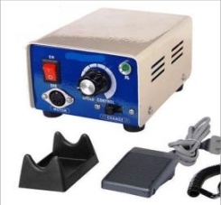
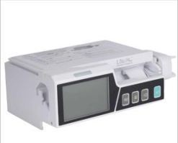
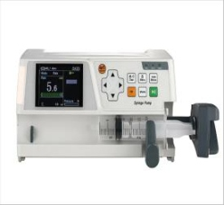
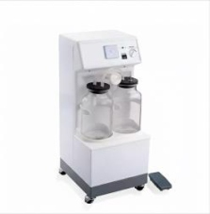
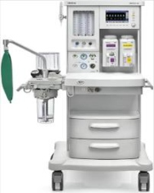
Dental Chair

Micromotor

Critical Care Equipment

Syringe Pump

Anesthesia Workstation
Ultrasonic Scaler

Dental Instrument Set

Infusion Pump

Suction Machine

Educational & Research Equipment

Physics Apparatus
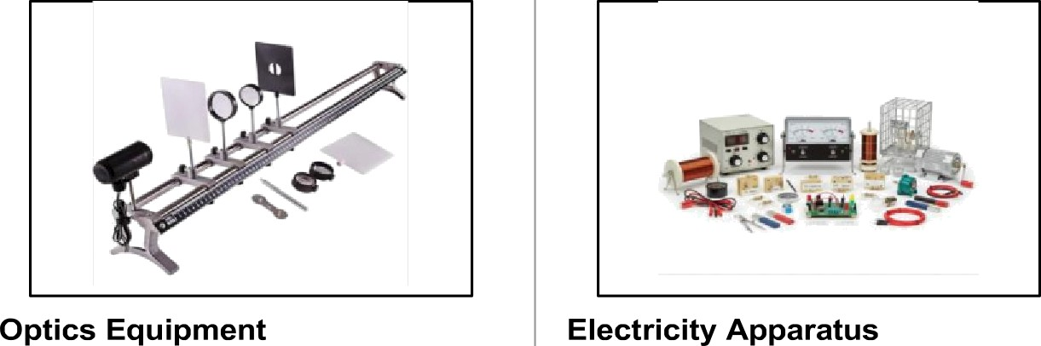

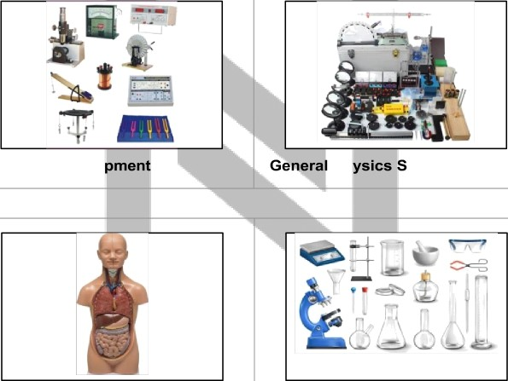
Mechanics Equi
Ph
et

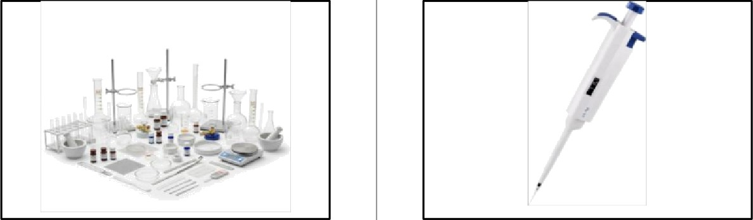
Anatomical Models

Chemistry Lab Equipment
Biology Lab Equipment

Micro Pipettes (Different Ranges)

Weighing & Measurement Equipment
General Nos ital Utilities & Su
lies

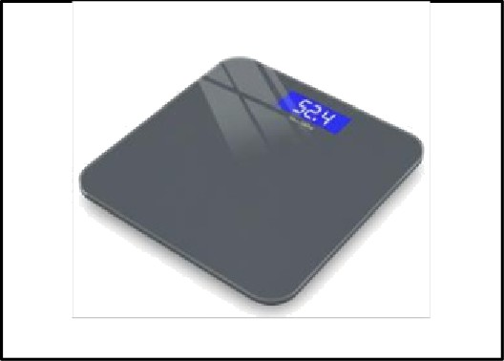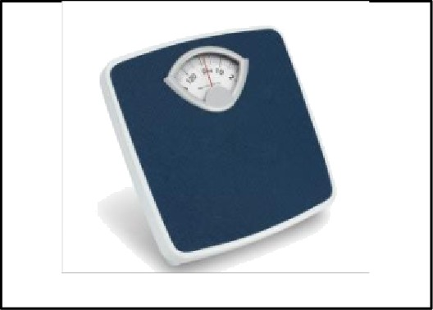

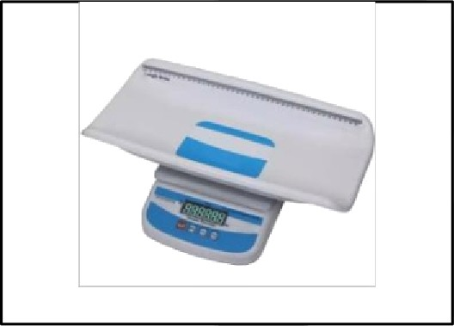
Digital Weighing

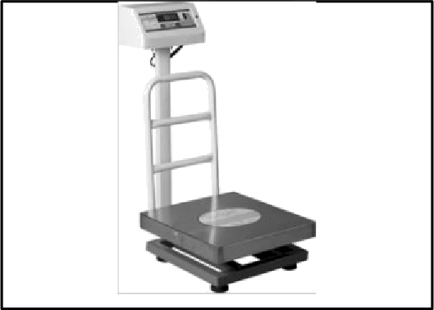
Baby Weighing

Platform Scale

Mechanica{,§g§}p
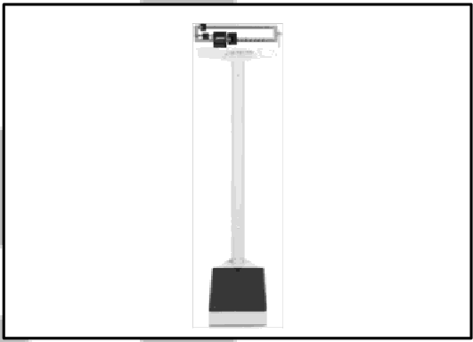

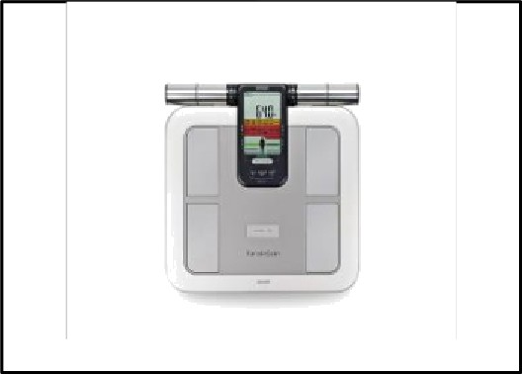

Body Composition Monitor

Basic Medical Supplies

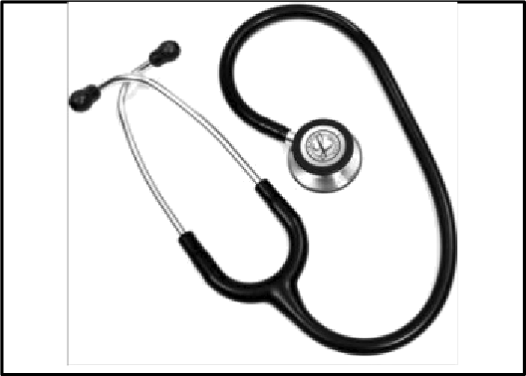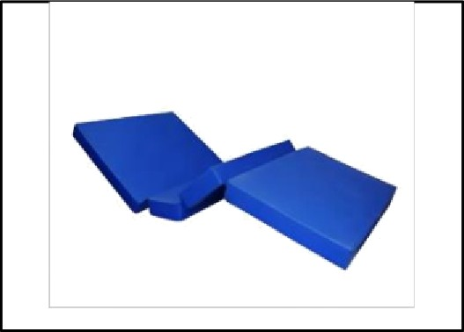

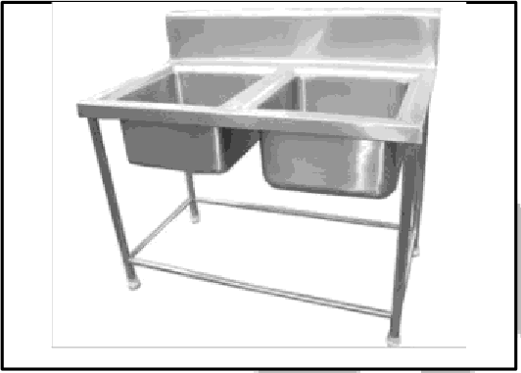
Stethoscope

Wash Basin
Hospital Mattress and Linens

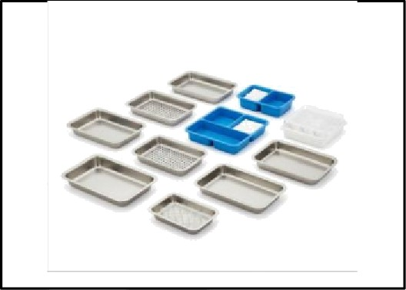
Medical Trays

Gas Cylinders & Storage
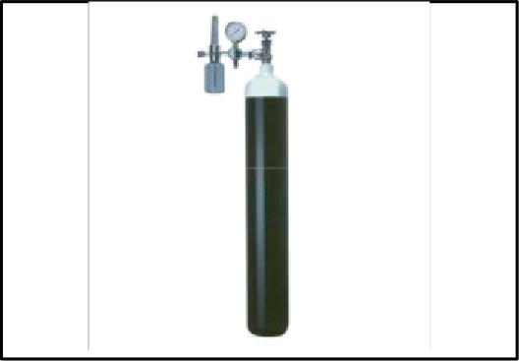
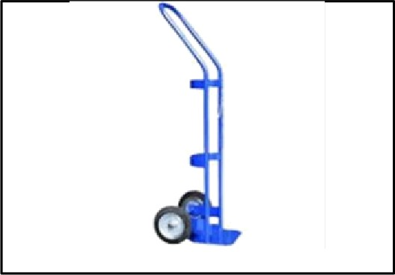
Oxygen Cylinder Heavy Duty Cylinder Trolley
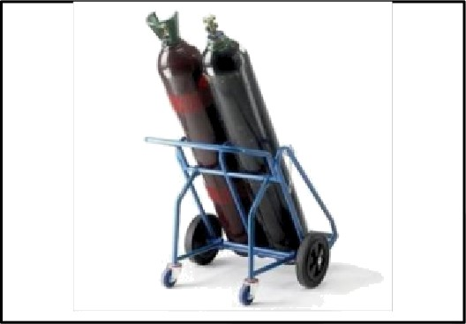
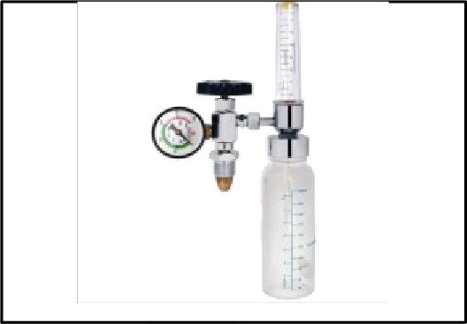
Double Cylinder Trolley Flowmeter with Humidifier

Disposable Medical Items

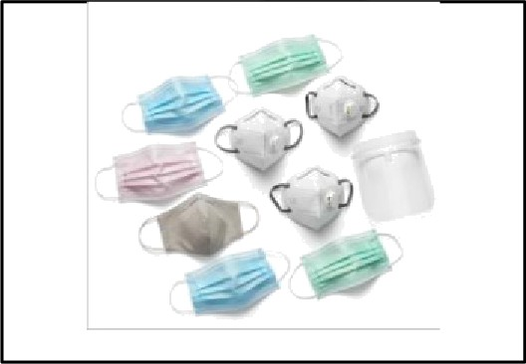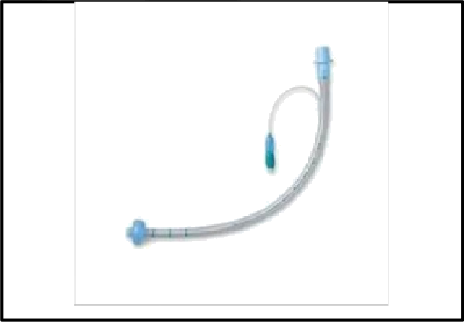

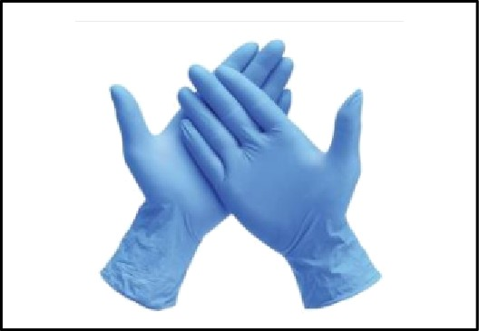
Surgical Masks

Surgical Gloves
ETT (Endotracheal Tube)
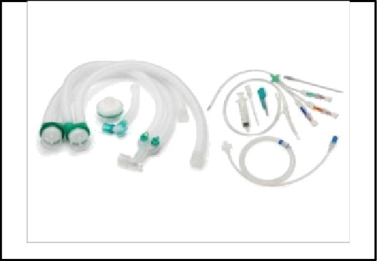
Ventilator, Catheter, IV sets

Tender & Custom Solutions
We provide comprehensive tender management and custom solutions tailored to your institution's specific requirements. Our services include bulk procurement support, annual maintenance contracts, and warranty solutions for all medical equipment.



Institution-Specific Kit Customization
Bulk Procurement Support

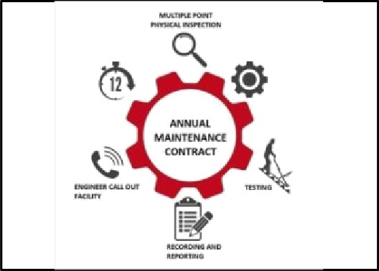
Annual Maintenance Contracts Warranty Solutions


\’ - GeM
— e Market ptace
Government Tender Support Custom Equipment Configuration

Contact Us

Company: Location: Phone: Email:
Website:
NOVUSS MEDTECH INDUSTRIES

Panchkula, Haryana, India

8264989685, 9878240340

novussmedtechindustries@gmail.com

www.novussmedtech.in

Certifications & Registrations



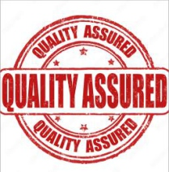
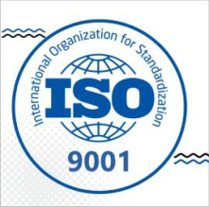
MSME Registered

ISO Compliant
GeM Registered

Quality Assured

