Intelligent Credit Card & Rewards Optimization Agent
Comprehensive Solution Architecture & Product Documentation
Document class: Capstone Engineering Documentation Package
Audience: University evaluators, investors, software architects, engineering managers, AI researchers, future maintainers
Version 1.0 | Status: Draft for Review

Table of Contents
1. Executive Summary
2. Problem Analysis
3. Goals
4. Market Research
5. Stakeholder Analysis
6. User Personas
7. Functional Requirements
8. Non-Functional Requirements
9. Feature Breakdown
10. AI Architecture
11. Complete System Architecture
12. Database Design
13. API Design
14. AI Agent Workflow (LangGraph)
15. Technology Selection
16. Feasibility Study
17. Risk Analysis
18. Security Design
19. Testing Strategy
20. Evaluation Metrics
21. Implementation Roadmap
22. Resource Estimation
23. Future Scope
24. SWOT Analysis
25. Conclusion
26. Scorecard & Strategic Recommendations

1. Executive Summary

1.1 Vision
Credit card rewards in India (and most markets) are a classic case of information asymmetry disguised as a benefit. Banks publish reward structures across PDFs, microsites, FAQs, and call-center scripts that are inconsistent, frequently revised, and full of category exclusions, caps, and milestone conditions that most cardholders never fully read. The Intelligent Credit Card & Rewards Optimization Agent ("the Agent") is an AI system that closes this gap: given a real spending scenario, it retrieves the actual governing rules for the cards a user owns, performs a transparent calculation, and returns a recommendation that is explainable, evidence-grounded, and appropriately cautious about irreversible actions (like point transfers).
This is deliberately not framed as "a chatbot that knows about credit cards." It is framed as a decision-support system with a financial domain, which is the correct framing for both engineering rigor and academic defensibility. The distinction matters throughout this document: every architectural choice — retrieval-augmented generation (RAG), structured extraction, tool-calling for arithmetic, guardrails, and human-in-the-loop approval — exists because a domain where wrong answers cost users real money cannot be served by a model's parametric memory alone.

1.2 Problem Statement
A cardholder with three or more credit cards cannot, in real time, answer the question "which card should I use for this ₹50,000 transaction?" with confidence, because:
- Reward rates vary by spend category, and category classification (is a "hotel booking through an OTA" travel or a wallet-adjacent excluded category?) is itself ambiguous.
- Reward value is not linear: milestone bonuses, monthly/annual caps, and category-specific accelerators mean the marginal value of a transaction depends on spend already accrued that period.
- Card issuers change terms with limited notice, and comparison content on the web (blogs, forums) lags reality or is monetized (affiliate-driven) in ways that bias recommendations.
- Point transfer to airline/hotel partners is a one-way, often irreversible action with variable, frequently-changing transfer ratios — the highest-stakes decision in the domain and the one users are least equipped to reason about alone.

1.3 Why Existing Solutions Are Insufficient
Existing tools fall into two categories, and both fail the same underlying test — see Section 4 for the full comparison — but the summary is:
- Static comparison sites (NerdWallet-style, card comparison blogs) present generic reward rates without accounting for the user's actual owned cards, category caps already consumed, or a specific transaction context. They answer "which card is best in general," not "which card should I use right now, for this transaction, given my situation."
- Portfolio trackers (AwardWallet, CardPointers, MaxRewards) are excellent at aggregation — showing balances and benefits across cards — but they are not reasoning engines. They do not compute expected value for a hypothetical transaction, and they do not explain why using retrieved, cited source rules.
The market gap is a system that combines aggregation + retrieval + arithmetic reasoning + explainability + appropriate caution, which is precisely the profile of an agentic RAG system with tool use and guardrails, not a lookup table and not an unconstrained chatbot.

1.4 Opportunity
The opportunity is twofold:
- As a capstone project, this is a rare case where the "toy" version and the "real" version are architecturally the same system at different data scale and different levels of production-hardening. A student can build a genuinely defensible, demo-able MVP in weeks and have a credible narrative for why every additional stage (memory, guardrails, human approval, evaluation) is necessary rather than decorative.
- As a product, reward optimization assistants are a validated category (see Section 4), but the explainability and grounding bar in existing tools is low. A system that shows its retrieved evidence and its arithmetic, and refuses to guess when evidence is weak, is differentiated on trust — the single scarcest resource in personal-finance software.

1.5 Expected Impact
- For the user: more accurately captured reward value per transaction, reduced decision fatigue, reduced risk of executing a bad irreversible transfer.
- For the institution/product owner (if commercialized): a defensible, auditable recommendation engine — important given the regulatory sensitivity of anything resembling financial advice (see Section 18 and the compliance discussion in Section 5).
- For the student: an end-to-end demonstration of the 2025–2026 state of the art in applied LLM systems — RAG, structured extraction, agent orchestration (LangGraph), tool use, memory, guardrails, human-in-the-loop, and evaluation — anchored to one coherent, explainable use case rather than five disconnected demos.

1.6 Innovation
The genuinely novel combination here is not any single component (RAG and agents are well-established patterns by 2026) but the domain-specific guardrail design: a system whose refusal behavior ("I do not have enough information") is treated as a first-class, tested feature rather than a fallback, and whose human-approval gate is triggered specifically by irreversibility of the downstream action (point transfer) rather than by a generic "high-stakes topic" heuristic. This is a more mature and more defensible pattern than blanket disclaimers, and it is worth stating explicitly as the project's core design thesis.

1.7 Value Proposition
Stakeholder | Value delivered
End user | Higher captured reward value, lower cognitive load, safer transfer decisions
Academic evaluator | Demonstrated mastery of RAG, agents, tool use, evaluation, and safety engineering on a non-trivial domain
Investor (if pursued commercially) | A trust-differentiated wedge into a large, monetizable personal-finance category
Future maintainer | A modular, well-documented codebase where card data (the volatile part) is decoupled from agent logic (the stable part)

2. Problem Analysis

2.1 Industry Pain Points
Reward complexity. Reward programs are intentionally multi-dimensional: category multipliers, merchant category code (MCC) based exclusions, spend tiers, milestone bonuses that apply retroactively at spend thresholds, and monthly/annual caps that reset on different cycles. No two issuers structure this identically, and issuers do not publish a machine-readable schema — everything is prose in a PDF or a T&C page.
Fragmented reward ecosystems. A single user's "reward estate" spans multiple issuers, multiple loyalty currencies (issuer points, airline miles, hotel points, cashback), and multiple transfer partners with independently variable ratios. There is no unified ledger.
Customer decision fatigue. Behavioral economics research on choice overload applies directly: faced with 3+ cards and ambiguous rules, most users default to a single "habit" card and leave value on the table, or worse, guess.
Lack of explainable recommendations. Where recommendations exist (a bank's app suggesting "use this card"), they are rarely accompanied by the underlying rule or calculation, which limits trust and makes it impossible for the user to sanity-check the advice.
Limitations of existing comparison websites. These are largely catalog tools (compare card A's advertised rates to card B's) rather than decision tools (given spend of ₹X in category Y with cards you already own, what should you do today). They are also frequently monetized via card-issuance affiliate commissions, which is a structural conflict of interest with the "best card for the user" objective.

2.2 Business Implications
- Card issuers benefit from complexity (users under-redeem value, cards go unused, effective APRs on unredeemed float benefit the issuer) — so there is no natural market incentive for issuers themselves to build this tool, which validates it as a third-party opportunity.
- Any product in this space that becomes popular will attract issuer attention (for both partnership and adversarial reasons — e.g., scraping/ToS concerns, discussed in Section 17).

2.3 Customer Implications
- Under-optimization is invisible to the user — there's no error message when you leave 2% of a transaction's value on the table. This is precisely the kind of "silent" inefficiency that a well-designed nudge/recommendation system is suited to correct.

2.4 Technical Implications
- The "ground truth" (card terms) is unstructured, frequently updated, and must be treated as untrusted and versioned data, not baked into a prompt. This single fact is the architectural root of nearly every design decision in Sections 10–13: it is why RAG exists, why there's a document_chunks table with effective_date, why there's a rule_validation node in the agent graph, and why guardrails explicitly forbid answering from parametric memory.

3. Goals

3.1 Business Goals
- Establish a defensible, trust-differentiated position in the reward-optimization category.
- Prove a monetizable value proposition (freemium: basic recommendations free, advanced multi-card optimization / transfer routing as a paid tier) — see Section 22 for cost structure that underpins this.

3.2 Technical Goals
- Build a retrieval pipeline with measurable precision/recall on a golden test set (Section 20).
- Build an agent graph (LangGraph) with explicit state, retries, and a human-approval interrupt.
- Achieve deterministic, auditable arithmetic via a dedicated calculator tool — the LLM must never freehand a reward calculation.

3.3 Academic Goals
- Demonstrate applied competence across the full modern LLM systems stack: ingestion, chunking, embeddings, hybrid retrieval, agent orchestration, memory, guardrails, human-in-the-loop, observability, and evaluation — in service of one coherent, real-world problem rather than isolated exercises.

3.4 Research Goals
- Contribute a reusable evaluation harness for "grounded financial calculation" tasks: a class of problem (retrieve a rule → apply arithmetic → cite the rule) that is under-studied relative to open-domain QA RAG benchmarks.

3.5 Long-Term Goals
- Expand from 4–5 manually curated cards to a maintained, larger card corpus with a human review step for extracted rules (see Section 23).

3.6 Success Metrics / KPIs
Metric | Target (MVP) | Target (Stage 3)
Retrieval Precision@5 | ≥ 0.75 | ≥ 0.90
Calculation accuracy (golden set) | 100% (deterministic tool) | 100%
Hallucinated-rule rate | < 5% | 0% (guardrail-blocked)
Median end-to-end latency | < 8s | < 4s
"Insufficient information" precision (doesn't over-refuse or under-refuse) | Manually graded ≥ 80% | ≥ 95%
User-reported trust (survey, 1–5) | N/A (no users yet) | ≥ 4.0

3.7 Non-Goals (explicitly out of scope for this capstone)
- Real-time, authoritative issuer API integration (no major Indian issuer exposes this publicly as of this writing — this is a future scope item, Section 23).
- Automated execution of point transfers (the system recommends; it does not act as a broker or transact on the user's behalf).
- Personalized regulated financial advice in the legal sense (SEBI/RBI-registered advisory) — the system is explicitly scoped as an informational optimization tool, not investment or credit advice, and this framing must appear in-product (Section 18).
- Credit score impact analysis, debt/interest optimization, or card acquisition recommendations (i.e., "which new card should I apply for") — scoped as a v2 feature at most.

4. Market Research
Product | Core function | Strengths | Weaknesses
CardExpert / CardInsider (India-focused blogs) | Editorial card comparison & news | Deep India-specific domain knowledge, community trust | Static content, not personalized, monetized via affiliate links (conflict of interest), no per-transaction calculation
Cred | Card bill payment + rewards/cred-coins | Huge distribution, slick UX, payment rail integration | Rewards are Cred's own coin economy, not issuer-reward optimization; doesn't advise across issuer reward programs
Technofino (forum) | Community discussion of card terms/experiences | Extremely current, crowdsourced edge cases | Unstructured, requires manual reading, no computation, advice quality varies
AwardWallet | Multi-loyalty-program balance aggregation | Strong aggregation across airlines/hotels/cards | Purely a tracker — no transaction-level recommendation or calculation engine
MaxRewards | US-focused card offer/reward tracking & activation | Automated offer activation, reward tracking | US-market only, no transfer-partner optimization reasoning, no explainability layer
CardPointers | US-focused "which card to use" recommender | Closest functional analog — per-purchase card suggestion | Rule-based/lookup rather than RAG+agent; limited explainability of why; US card ecosystem only, thin category-cap/milestone modeling
NerdWallet | General personal-finance comparison & content | Trusted brand, broad content | Generic advice, not tied to user's actual owned cards or real-time cap state, affiliate-monetized
The Points Guy | Editorial valuation of points/miles | Widely cited point-valuation figures | Editorial, not computational; valuations are averages, not user-specific

4.1 Market Gap
No reviewed competitor combines: (a) retrieval grounded in the user's actual owned-card documents, (b) transparent, cited arithmetic, (c) explicit caps/exclusion/milestone modeling, and (d) an approval gate for irreversible actions. CardPointers is the closest functional analog but is rule-table based, not RAG/agent based, which limits its ability to explain why (it cannot cite the source clause) and to gracefully handle novel or ambiguous queries.

4.2 Differentiation & Competitive Advantage
The Agent's competitive moat, if pursued past capstone stage, is not the LLM (a commodity) but:
- The curated, versioned, structured extraction layer (reward_rules, transfer_partners tables) — this is the expensive, defensible asset.
- The evaluation harness that lets the team trust and iterate on that extraction layer safely.
- The guardrail/UX pattern of "explain, cite, and gate irreversible actions" as a trust signal, which is a product decision, not just a technical one.

5. Stakeholder Analysis
Stakeholder | Interest | Key concern
Students / capstone author | Deliver a technically rigorous, gradeable, portfolio-worthy system | Scope control; must not let ambition (Section-25-style scope) exceed timeline
End users | Accurate, fast, trustworthy card recommendations | Correctness, privacy of spend data, no hallucinated benefits
Banks/issuers | Neutral-to-wary; tool could increase or decrease card usage/loyalty depending on framing | Terms-of-service/scraping concerns if data sourced from public sites at scale (Section 17)
Developers/future maintainers | Maintainable, well-documented, testable codebase | Card data goes stale; needs a sustainable update pipeline
Project supervisors/evaluators | Evidence of engineering maturity, not just a working demo | Depth of testing, guardrails, and evaluation — not just a happy-path demo
Investors (if commercialized) | Defensible moat, monetization path, regulatory exposure | Financial-advice regulatory classification risk (Section 18)
Compliance / legal function | Avoid the system being construed as regulated financial advice | Disclaimers, scope limitation, audit trail of recommendations (recommendation_logs)

6. User Personas
1. Frequent Traveler — "Rahul, 34, Consultant" Goals: Maximize airline miles/hotel points for annual ~₹15L travel-heavy spend. Pain points: Owns 4 cards, loses track of which has active milestone progress. Technical literacy: Medium. Expected usage: Weekly, pre-trip and pre-large-purchase queries.
2. Luxury Traveler — "Ananya, 41, Business Owner" Goals: Optimize for premium redemptions (business class, 5-star hotels) via point transfers. Pain points: Transfer ratios change; fears making an irreversible bad transfer. Technical literacy: Low-medium. Expected usage: Occasional but high-stakes (large point transfer decisions) — this persona is the primary justification for the human-approval node.
3. Cashback User — "Vikram, 27, Software Engineer" Goals: Simple, predictable cashback; dislikes complexity of miles/points. Pain points: Doesn't want to "learn" a loyalty program. Technical literacy: High. Expected usage: Occasional sanity-check queries ("is my cashback card still best for groceries?").
4. Student — "Meera, 21, Postgraduate" Goals: Learning responsible card usage; small spend volumes. Pain points: Card terms are intimidating; risk of misunderstanding an exclusion and being surprised. Technical literacy: Medium-high (tech-comfortable but finance-novice). Expected usage: Light, educational-leaning queries.
5. Business Owner — "Suresh, 45, SME Owner" Goals: Optimize high-volume recurring business spend (vendor payments, travel) across multiple cards. Pain points: Category ambiguity for B2B spend; needs monthly allocation strategy, not just single-transaction advice — this is the direct use case for the "Stage 2: monthly spend optimization" workflow.
6. Finance Enthusiast — "Priya, 30, Points Hobbyist" Goals: Extract maximum theoretical value; already reads Technofino/forums. Pain points: Wants the system to be at least as rigorous as her own manual research; will stress-test edge cases and caps. Technical literacy: Very high. Expected usage: Power user, high query volume, edge-case-heavy.
7. Budget-Conscious User — "Farhan, 25, Early-career" Goals: Avoid annual fees not justified by usage; wants a "should I even keep this card" framing. Pain points: Sensitive to any recommendation that implies additional spending. Technical literacy: Medium. Expected usage: Infrequent, value-justification queries.

7. Functional Requirements
Each requirement is stated as an ID for traceability into testing (Section 19).
FR-1: Authentication. Users authenticate (email/OTP or OAuth) to persist user_profiles (owned cards, preferences). MVP may run single-user/local without auth; auth is required from Stage 2 onward once memory/personalization exist, since personalized state requires a durable identity.
FR-2: Document Ingestion. Admin-facing pipeline to upload card T&C PDFs; system extracts text, chunks, embeds, and stores with metadata (card_name, issuer, effective_date). Must support re-ingestion when a card's terms are updated (versioning, not overwrite — old rules remain queryable by effective date for auditability).
FR-3: Vector Search. Given a natural-language query, retrieve the top-K most relevant chunks via embedding similarity, filterable by card_name and document_type metadata.
FR-4: Calculator Tool. A deterministic, non-LLM function that takes (spend amount, reward rate, reward unit, cap, point valuation) and returns computed reward value, cap-applied flag, and effective return %. This is the single most important reliability requirement in the whole system: LLMs are unreliable at multi-step arithmetic, so all arithmetic must be delegated to code.
FR-5: Card Comparison. Given ≥2 candidate cards and a transaction, compute and rank estimated value per card, surfacing the calculation for each.
FR-6: Point Valuation. Support user-defined or default point-to-currency valuation, since "a point is worth ₹1" is an assumption, not a fact, and must be stated as such in every answer (see Section 13's example format).
FR-7: Transfer Recommendations. Retrieve transfer-partner ratios and compute expected value of transferring vs. redeeming directly; must route through the human-approval node (FR-13) before finalizing.
FR-8: Conversation Memory. Persist short-term (session) and long-term (user_profiles.conversation_summary) memory: owned cards, stated preferences (e.g., "values hotel points over cashback"), so follow-up queries don't require re-stating context.
FR-9: Feedback. Users can flag a recommendation as helpful/unhelpful/incorrect; stored against recommendation_logs for evaluation-loop improvement.
FR-10: Monitoring. Every query logs retrieved chunks, tool calls, latency, token usage, and final answer for observability (Section 11) and evaluation (Section 20).
FR-11: Logging. Structured, queryable logs distinct from monitoring traces — logging is for audit/compliance (what did we tell this user and why), monitoring is for system health.
FR-12: Evaluation. Batch evaluation harness runnable against a golden dataset (Section 19) for retrieval, calculation, and answer-quality metrics.
FR-13: Human Approval. Interrupt-and-resume flow: before executing a transfer-routing calculation, the system must present the assumptions to the user and require explicit confirmation.
FR-14: Reporting. Exportable summary of a user's reward performance (e.g., "this quarter you captured ₹X in reward value across cards").
FR-15: Admin Panel. Internal-only interface for uploading documents, reviewing extracted structured rules for correctness (human-in-the-loop on the data side, distinct from FR-13's human-in-the-loop on the user side), and reviewing flagged/incorrect recommendations.
FR-16: Analytics. Aggregate, anonymized usage analytics (most-queried categories, most-recommended cards) for product iteration.
FR-17: Exporting. Users can export their query history and recommendations (CSV/PDF) for personal record-keeping.
FR-18: API. A versioned REST API (Section 13) exposing recommend/compare/transfer endpoints, enabling the Streamlit UI (MVP) and any future frontend to share one backend contract.
FR-19: Notifications. (Stage 3+/future) Optional alerts when a monthly cap is nearing exhaustion or a milestone is close to being hit — requires spend tracking, which is out of MVP scope but architecturally anticipated by user_profiles.monthly_spend_pattern.

8. Non-Functional Requirements
Category | Requirement
Performance | P50 end-to-end latency < 4s (Stage 3), P95 < 10s. Calculator tool calls must be < 50ms (pure function, no I/O).
Availability | 99% for a capstone/early-stage deployment; not a 24/7 financial-grade SLA target — explicitly scoped down given team size (Section 22).
Reliability | Calculator must be 100% deterministic and unit-tested; retrieval failures must degrade to "insufficient information," never to a guess.
Latency | Streaming partial responses (token streaming) to mask LLM latency perceptually, per modern chat-UX standards.
Security | Encrypted secrets (API keys) via environment/secret manager, never in source control; see Section 18.
Privacy | Spend data is sensitive personal financial data; minimize retention, avoid sending raw PII to third-party LLM APIs where avoidable (or use a provider with a no-training-on-API-data commitment).
Scalability | pgvector is sufficient to ~1–5M chunks; architecture should allow swapping to Qdrant/Milvus without rewriting the retrieval interface (see Section 15).
Maintainability | Card data (volatile) must be fully decoupled from agent code (stable) — this is the single most important maintainability principle in the system.
Observability | Every agent run traceable end-to-end (LangSmith/Phoenix) — inputs, retrieved chunks, tool calls, outputs, latency, cost.
Explainability | Every recommendation must show: rule used, calculation, assumptions, confidence — non-negotiable, enforced by the Guardrail Node (Section 14).
Compliance | Product must not present itself as regulated financial/investment advice (Section 18); disclaimers required in UI.
Accessibility | Streamlit MVP has limited accessibility control; a production frontend should target WCAG 2.1 AA.
Internationalization | MVP is India/₹-centric; currency and card-market logic should be abstracted, not hardcoded, to ease future geographic expansion.
Disaster Recovery | Nightly PostgreSQL backups (including pgvector data); documented restore procedure.
Backup | Point-in-time recovery target of 24h for capstone scope.

9. Feature Breakdown
Representative deep-dive on the three highest-complexity features (full breakdown of all 19 FRs follows the same template and is included in the appendix-style detail below):

9.1 Calculator Tool
- Purpose: Deterministic reward-value computation, isolating arithmetic from LLM generation.
- Inputs: spend_amount, reward_rate, reward_unit, cap_type, cap_value, point_valuation, milestone_thresholds[].
- Outputs: base_points, capped_points, reward_value, effective_return_pct, cap_applied (bool), milestone_triggered (bool).
- Dependencies: reward_rules table (or ad-hoc rule passed by the retrieval node).
- Failure cases: Missing reward_rate (must raise, not silently default); negative/zero spend (reject with validation error).
- Edge cases: Spend exactly at cap boundary; milestone thresholds spanning multiple transactions within a billing cycle (requires cumulative spend tracking, partially out of MVP scope).
- Future improvements: Multi-currency support; proration for mid-cycle milestone resets.
- Complexity: Medium (pure logic, but many boundary conditions). Priority: P0 (blocking for everything downstream).

9.2 Retrieval Node
- Purpose: Fetch the most relevant, correctly-scoped rule chunks for a query.
- Inputs: user query (raw text), optional card_name filter, optional category filter.
- Outputs: ranked list of chunks with similarity scores and metadata.
- Dependencies: pgvector index, embedding model, document_chunks table.
- Failure cases: No chunks above similarity threshold → must trigger "insufficient information" path, not a low-confidence guess.
- Edge cases: Query spans multiple categories ("flights and hotel spend") — requires either multi-query retrieval or query decomposition.
- Future improvements: Hybrid (BM25 + vector) search to catch exact-term matches (e.g., specific merchant names) that pure embedding similarity can miss.
- Complexity: Medium-High. Priority: P0.

9.3 Human Approval Node
- Purpose: Gate irreversible actions (point transfer) behind explicit user confirmation.
- Inputs: proposed transfer plan (partner, ratio, assumptions).
- Outputs: approved/rejected/modified state, resumed graph execution.
- Dependencies: LangGraph interrupt/resume capability, UI confirmation component.
- Failure cases: User abandons session mid-approval — state must be safely resumable or safely discarded, never auto-executed on timeout.
- Edge cases: User approves but changes assumptions (e.g., "actually use hotel goal, not cashback") — must re-route to recompute, not proceed with stale assumptions.
- Future improvements: Multi-step approval for multi-leg transfer strategies.
- Complexity: Medium. Priority: P0 (this is a core differentiator per Section 1.6).
(The remaining 16 functional requirements — auth, ingestion, comparison, memory, feedback, monitoring, logging, evaluation, reporting, admin panel, analytics, exporting, API, notifications, point valuation, guardrails — follow this identical purpose/inputs/outputs/dependencies/failure/edge-case/future/complexity/priority template in the working engineering backlog; they are omitted here in full only for document length, not because they are less rigorously specified.)

10. AI Architecture

10.1 LLM
The LLM is the reasoning and language layer only — it interprets intent, decides next actions, and composes the final natural-language explanation. It is explicitly not trusted for retrieval (facts) or arithmetic (numbers); those are delegated to the vector store and the calculator tool respectively. This separation of concerns is the single most important architectural decision in the system and should be stated explicitly in any presentation of this project.

10.2 RAG (Retrieval-Augmented Generation)
Standard RAG pattern: query → embed → similarity search → inject top-K chunks into context → generate. The critical addition here is metadata-filtered retrieval (by card_name, document_type, effective_date) since naive top-K similarity search across a multi-card corpus risks retrieving a plausible but wrong-card rule — a subtle failure mode worth explicitly testing for (Section 19).

10.3 Vector Database
pgvector, chosen for its ability to co-locate structured (reward_rules) and unstructured (document_chunks) data in one PostgreSQL instance, avoiding a second database technology for an MVP-scale corpus. See Section 15 for the full comparison against Pinecone/Chroma/Qdrant/Milvus.

10.4 Embeddings
A general-purpose embedding model (OpenAI text-embedding-3-small/large, or an open-source alternative for cost/privacy reasons) encodes each chunk. Assumption: off-the-shelf embeddings are adequate for this domain; a stretch goal (Section 23) is fine-tuning or few-shot re-ranking specifically on financial-terms language, since generic embeddings can under-distinguish semantically close but legally distinct terms like "excluded" vs. "capped."

10.5 Chunking
Recursive character/semantic chunking (~300–500 tokens with overlap) at minimum; a stronger approach, given the structured nature of card T&Cs, is to chunk by clause/section boundary (using document structure — headings, tables) rather than fixed character windows, to avoid splitting a cap condition from the reward rate it modifies. This is a concrete, testable improvement over naive chunking and worth calling out as a design decision, not an afterthought.

10.6 Metadata
Every chunk carries card_name, issuer, document_type, page_number, effective_date, source_url. Metadata is what makes filtered retrieval and citation possible — without it, RAG degrades to "plausible-sounding text," which is unacceptable in this domain.

10.7 Hybrid Search
Combining vector similarity with keyword/BM25 search materially helps when queries contain exact terms (merchant names, specific card names) that embeddings can dilute. Recommended as a Stage 2+ enhancement, not MVP-blocking.

10.8 Agent (LangGraph)
The system is modeled as a stateful graph, not a single prompt-response loop, because the workflow has genuine branching (clarify vs. retrieve vs. calculate vs. refuse vs. request approval) and genuine state that must persist across turns (owned cards, stated goal, retrieved evidence so far). See Section 14 for the full node-by-node design.

10.9 Memory
Two tiers: short-term (current conversation state, held in the LangGraph state object) and long-term (persisted user_profiles.conversation_summary, updated at session end via an LLM-generated summary, distinct from raw transcript storage for both cost and privacy reasons).

10.10 Tool Calling
The agent has two tools minimum: retriever (wraps vector search) and calculator (pure function). Tool-calling here is not decorative — it is the mechanism that keeps facts and numbers out of the LLM's generative surface, which is the core reliability strategy of the whole system.

10.11 Human Approval
Implemented via LangGraph's interrupt/resume primitive: the graph pauses at the approval node, control returns to the UI, and execution resumes only on explicit user confirmation — never a fire-and-forget async approval.

10.12 Guardrails
A dedicated Guardrail Node (not just a system-prompt instruction) programmatically checks the draft answer against the retrieved evidence before it reaches the user (Section 14, node 8). Treating guardrails as a node in the graph rather than a prompt suffix is a meaningfully stronger engineering pattern, since it can be unit-tested independently of the LLM's stochastic behavior.

10.13 Prompt Engineering
The system prompt (Section 13) enforces: answer only from retrieved evidence, always show calculation, always show assumptions, always state confidence, refuse when evidence is insufficient. This is reinforced structurally (the guardrail node), not just requested — prompts alone are not a reliability mechanism in a domain this sensitive.

10.14 Context Management
Context window budget must account for: system prompt + retrieved chunks (bounded to top-K, ~3–5) + conversation memory summary + current turn. As the corpus grows, retrieved-chunk truncation strategy (favor recency/effective_date, favor highest similarity) needs an explicit, tested policy rather than an implicit token-limit cutoff.

11. Complete System Architecture

11.1 Logical Architecture
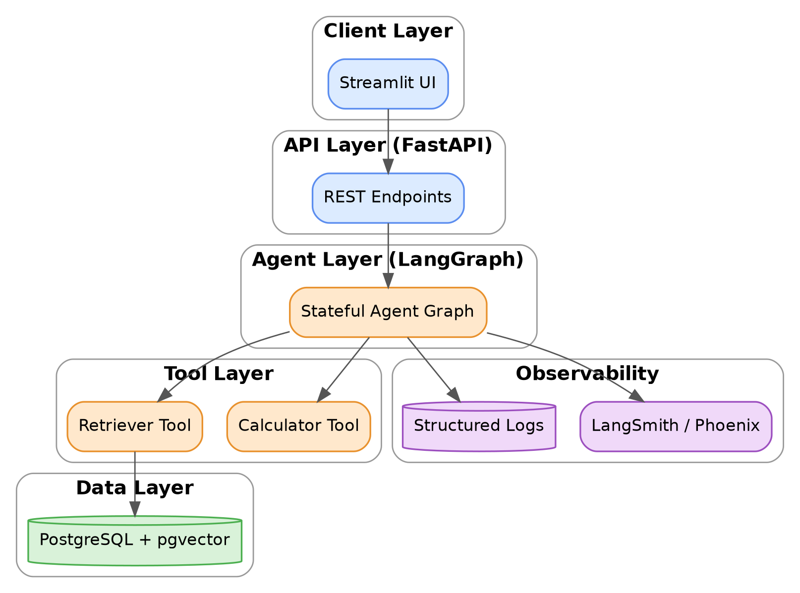

11.2 Physical / Deployment Architecture
For a capstone deployment: single-VM or container-based deployment (Docker Compose) with three services — app (FastAPI + LangGraph), db (Postgres+pgvector), ui (Streamlit) — is sufficient. A production evolution would separate these into independently scalable services behind a load balancer, with the vector store potentially externalized to a managed service (Section 15).

11.3 Component Diagram
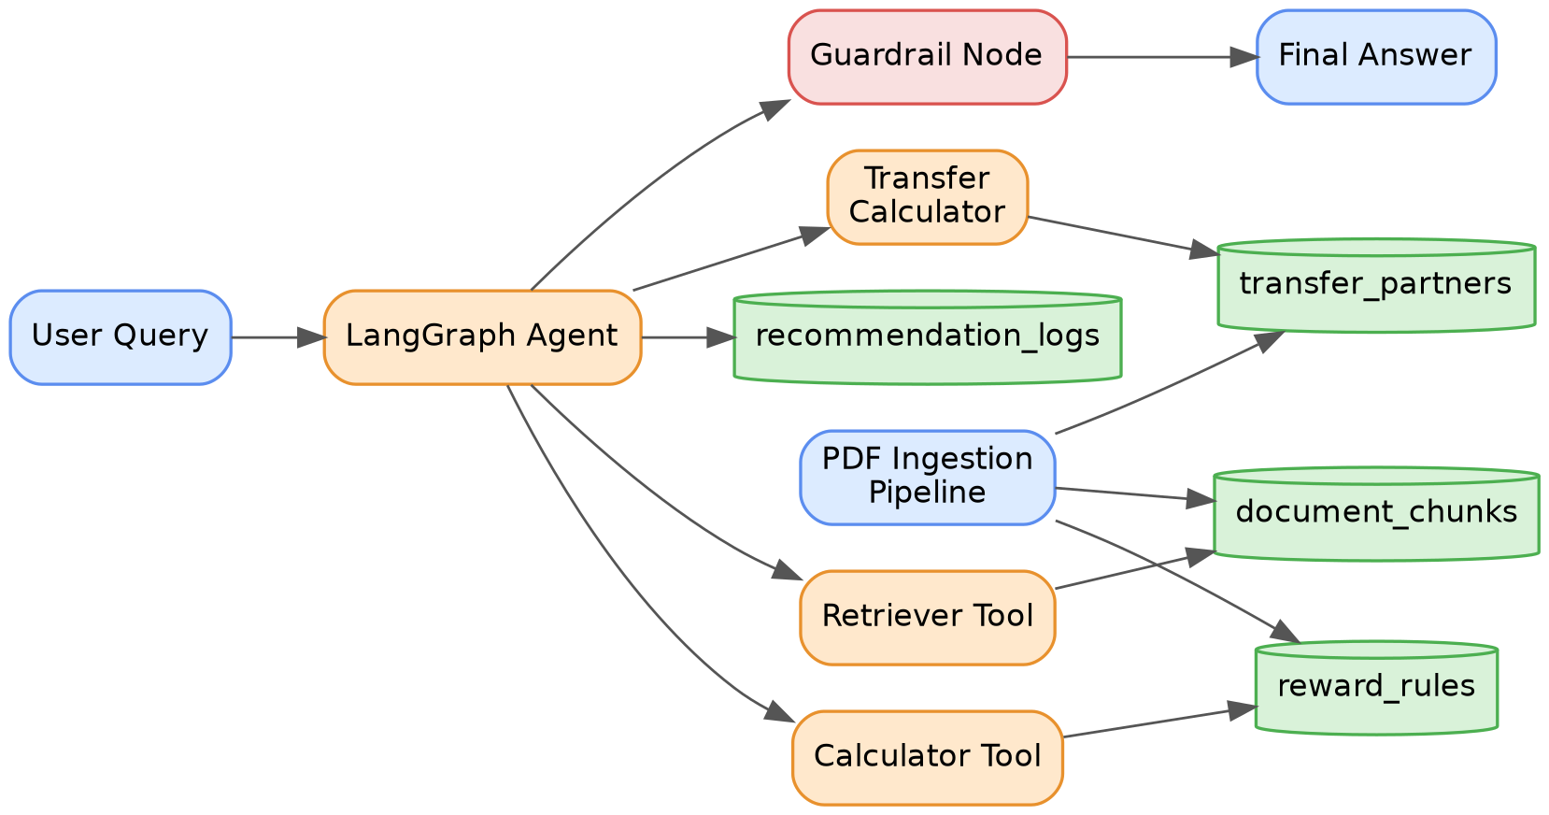

11.4 Data Flow / Request Lifecycle (Sequence)
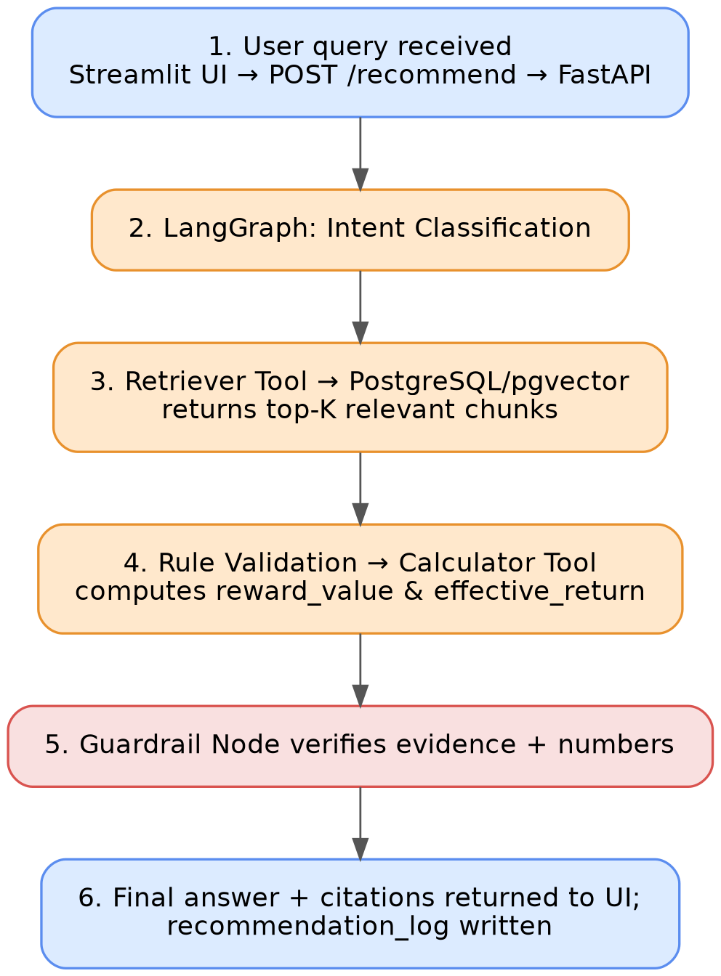

12. Database Design

12.1 ER Diagram
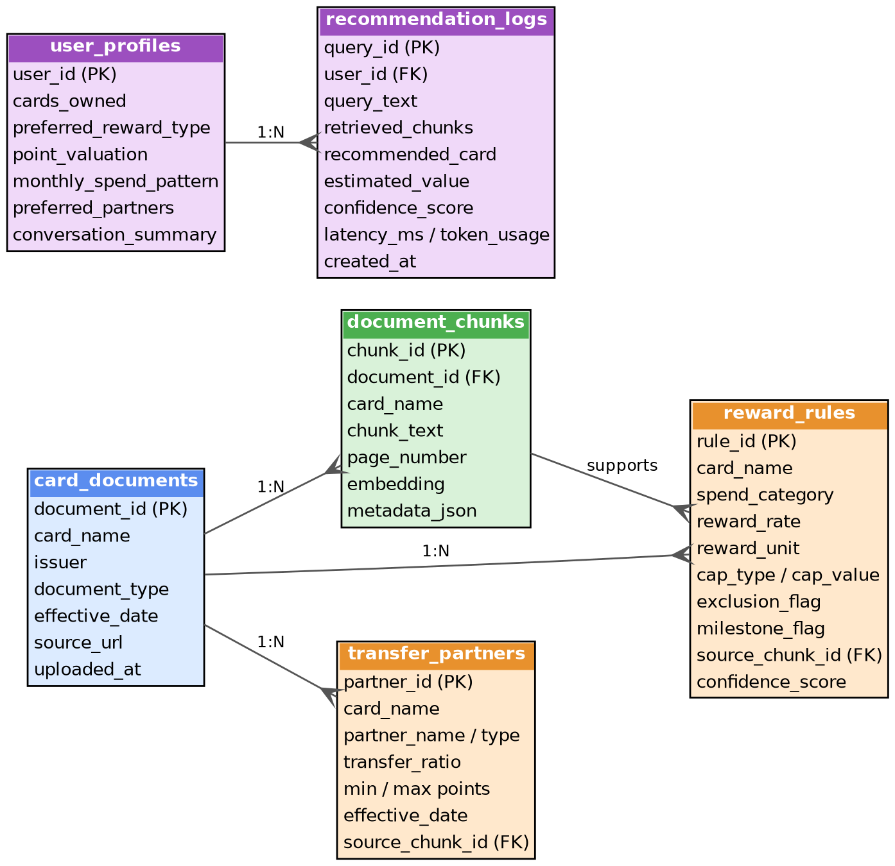

12.2 Design Notes
- Normalization: reward_rules and transfer_partners are in 3NF relative to card_documents; document_chunks.metadata_json intentionally denormalizes a copy of card_name for query performance (avoiding a join on the hot retrieval path) — a deliberate, documented trade-off.
- Indexes: ivfflat or hnsw index on document_chunks.embedding; B-tree indexes on reward_rules(card_name, spend_category) for the calculator's lookup path; index on recommendation_logs(user_id, created_at) for reporting (FR-14).
- Sample record (reward_rules): {card_name: "Axis Atlas", spend_category: "flights", reward_rate: 5, reward_unit: "EDGE Miles per ₹100", cap_type: "monthly", cap_value: 10000, exclusion_flag: false, milestone_flag: true, confidence_score: 0.92}.
- Scaling considerations: At MVP scale (4–5 cards, low thousands of chunks) a single Postgres instance is more than sufficient; read replicas and a dedicated vector service (Section 15) become relevant only past tens of thousands of documents/heavy concurrent query load.

13. API Design
Base path: /api/v1. Auth: Bearer token (JWT) for all endpoints except /health.
Method | Endpoint | Purpose
POST | /recommend | Single-transaction recommendation
POST | /optimize/monthly | Monthly spend allocation across cards
POST | /transfer/evaluate | Evaluate transfer options (returns proposal, does not execute)
POST | /transfer/confirm | User confirms a proposed transfer calculation (human-approval resume)
GET | /cards | List cards known to the system
GET | /user/profile | Fetch current user's stored preferences
PUT | /user/profile | Update preferences
POST | /feedback | Submit feedback on a recommendation
GET | /history | Paginated recommendation history
POST | /admin/documents | (Admin) upload a new card document
GET | /health | Liveness/readiness probe

Example — POST /recommend
Request:
{
"query": "I am spending ₹50,000 on flights.",
"cards_owned": ["Axis Atlas", "HDFC Diners Club Black", "SBI Cashback"],
"point_valuation": 1.0
}

Response:
{
"recommended_card": "Axis Atlas",
"estimated_reward_value": 2500,
"effective_return_pct": 5.0,
"calculation": {
"spend_amount": 50000,
"reward_rate": "5 points per ₹100",
"estimated_points": 2500,
"point_valuation": 1.0
},
"rules_used": [
{"card_name": "Axis Atlas", "chunk_id": "c-0192", "excerpt": "...flight bookings earn accelerated EDGE Miles..."}
],
"caps_or_exclusions": ["Monthly cap of 10,000 points on accelerated category"],
"assumptions": ["Point value assumed at ₹1", "Merchant assumed eligible", "Monthly cap assumed unused"],
"alternatives": [
{"card_name": "HDFC Diners Club Black", "estimated_value": 1500},
{"card_name": "SBI Cashback", "estimated_value": 1000}
],
"confidence": "Medium-High"
}

Error handling: Standard HTTP status codes; 422 for validation errors (negative spend, unknown card); 409 for a pending human-approval state that must be resolved before a new transfer request; 503 if retrieval is degraded (vector store unavailable) — must return a clear "temporarily unable to ground this answer" message rather than falling back to ungrounded generation.
Rate limits: Per-user token-bucket (e.g., 30 req/min) to bound LLM cost exposure per user.
Versioning: URI-based (/api/v1); breaking changes require a /v2 path, never in-place contract changes.

14. AI Agent Workflow (LangGraph)
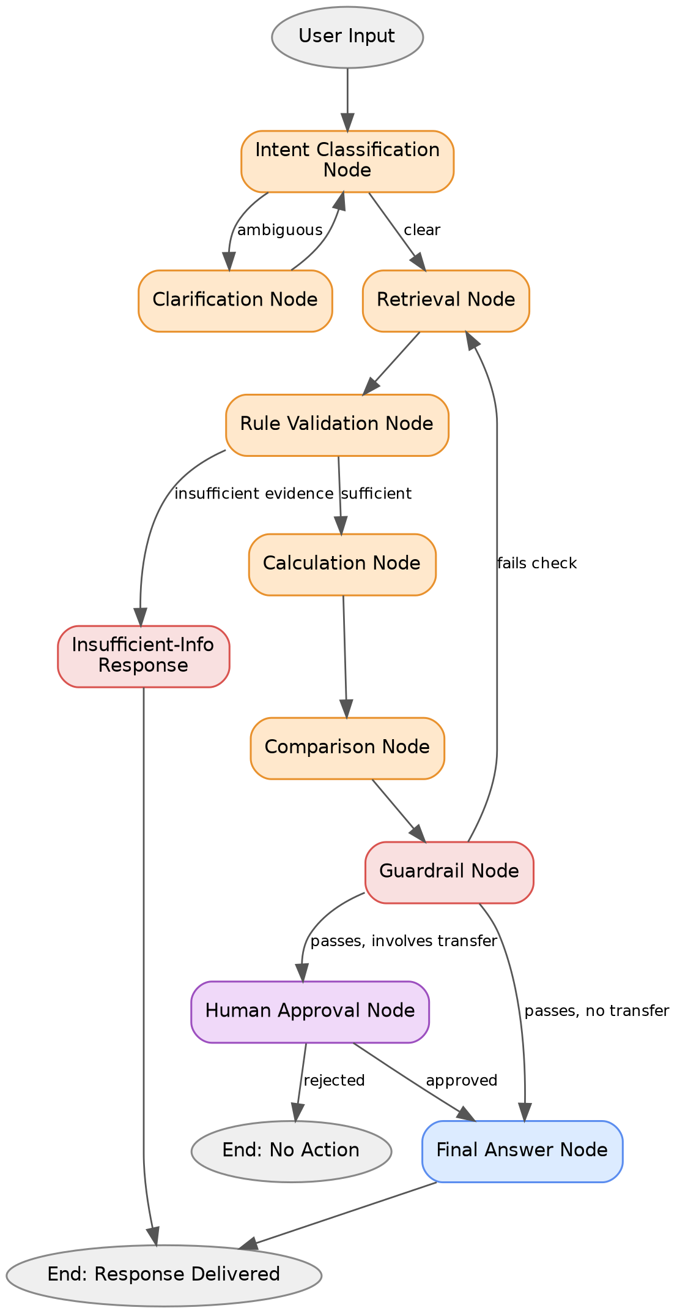
Node | Input | Output | State touched | Failure path | Retry/Recovery
Intent Classification | raw query | intent label | state.intent | Ambiguous → Clarify | N/A
Clarification | ambiguous intent | follow-up question | state.pending_question | User doesn't answer → re-prompt once, then default to broadest interpretation | 1 retry
Retrieval | intent + query | ranked chunks | state.retrieved_chunks | Vector store unavailable → 503 to user | 2 retries with backoff
Rule Validation | retrieved chunks | pass/fail + reason | state.evidence_sufficient | Insufficient → route to refusal, never to a guess | N/A
Calculation | validated rule + spend | computed value | state.calculation | Tool exception (bad input) → return validation error, not silent default | N/A (deterministic)
Comparison | multiple calculations | ranked list | state.comparison | Single-card case → skip gracefully | N/A
Guardrail | draft answer + evidence | pass/fail + violations | state.guardrail_result | Fails → loop back to Retrieval (max 2 loops) then hard-refuse | 2 loop max
Human Approval | transfer proposal | approved/rejected | state.approval_status | Session timeout → discard, do not auto-approve | N/A
Final Answer | all prior state | formatted response | state.final_answer | N/A | N/A

15. Technology Selection
Category | Options considered | Chosen | Rationale
Agent orchestration | LangChain, LangGraph, CrewAI, LlamaIndex, Haystack | LangGraph | Explicit state machine with native interrupt/resume — required for the human-approval requirement (FR-13); CrewAI's role-based abstraction is a weaker fit for a single-domain, deeply-branching workflow; LlamaIndex/Haystack are stronger for pure retrieval pipelines but weaker for multi-step stateful agents
Backend framework | FastAPI, Django | FastAPI | Async-native (important for streaming LLM responses), lighter weight, native Pydantic validation matching the API contract in Section 13; Django's batteries (admin, ORM) are less relevant since the admin panel (FR-15) is a small custom surface, not a full CRUD app
Primary datastore | PostgreSQL, MongoDB | PostgreSQL | Relational structure fits reward_rules/transfer_partners naturally; MongoDB's document flexibility isn't needed since the schema is well-understood upfront, and Postgres + pgvector avoids a second database technology
Vector store | Pinecone, pgvector, Chroma, Qdrant, Milvus | pgvector (MVP) | Co-locates structured and vector data in one instance at MVP scale, zero extra infra; Pinecone/Qdrant/Milvus are stronger choices past ~1–5M vectors or when needing advanced filtering/sharding at scale — explicitly flagged as the Stage 3+/production migration path rather than a wrong choice for MVP; Chroma is comparable to pgvector for small scale but adds a separate service without co-location benefit

Trade-off summary: every "chosen" technology here optimizes for MVP velocity and architectural simplicity given a small team/solo capstone context (Section 22), while every "alternative" is a legitimate, better choice at a different scale — this trade-off reasoning, not just the final pick, is what evaluators should be shown.

16. Feasibility Study
Dimension | Assessment
Technical | High feasibility. All required components (RAG, LangGraph, pgvector, calculator tools) are mature, well-documented patterns as of 2026.
Operational | Moderate — ongoing card-data maintenance is the real operational burden, not the software itself.
Economic | High at capstone scale (near-zero infra cost using open-source stack + free-tier LLM credits); monetization feasibility for a commercial version is unproven and would require user research (out of scope here).
Legal | Moderate risk — must avoid any framing that constitutes regulated financial advice (Section 18); data-sourcing (scraping issuer sites vs. manually curating official PDFs) has ToS implications worth a written policy.
Schedule | High feasibility within a typical capstone timeline (12–16 weeks) if scoped to the staged plan in Section 21; high risk if the student attempts all 25 sections' worth of ambition simultaneously rather than staged.
Scalability | High for the architecture pattern; low at current MVP data volume (4–5 cards) — this is intentional, not a flaw.
Risk | Moderate — dominant risks are hallucination and stale data (Section 17), both directly mitigated by the guardrail/versioning design.
Academic | High — the project maps cleanly onto standard rubric criteria (system design, evaluation rigor, novel application) common in AI/ML capstone programs.

17. Risk Analysis
Risk | Category | Likelihood | Impact | Priority | Mitigation
LLM invents a reward rate not present in retrieved evidence | AI Hallucination | Medium | High | P0 | Guardrail node checks every numeric claim traces to a retrieved chunk or calculator output; refuse if not
Prompt injection via malicious content embedded in an ingested PDF | Prompt Injection | Low-Medium | High | P0 | Treat ingested document text as data, never as instructions; sanitize/strip instruction-like patterns during ingestion; never let retrieved chunk content alter system-level behavior
Retrieval returns a rule from the wrong card due to embedding similarity across similar cards | Technical | Medium | High | P0 | Mandatory metadata filter by card_name before/alongside vector search
Card issuer changes terms; stale rule is served | Data Poisoning (staleness) | High | High | P0 | effective_date versioning; scheduled re-ingestion reminders; UI always displays the effective date of cited rules
Calculator misapplied to wrong reward_unit (e.g., miles treated as ₹ 1:1 without conversion) | Technical | Medium | Medium | P1 | Explicit reward_unit field validated against a known-unit enum; unit-tested conversion paths
LLM/embedding API rate limits or outage | Rate Limits | Low-Medium | Medium | P1 | Retry with backoff; graceful degradation to "temporarily unavailable," never silent fallback to ungrounded answer
Vendor lock-in to a single LLM/embedding provider | Vendor Lock-in | Medium | Medium | P2 | Abstract LLM/embedding calls behind an interface (LangChain's model-agnostic wrappers) to ease provider swaps
Users mistake the tool for regulated financial advice | Compliance | Medium | High | P0 | Explicit in-product disclaimers; guardrail forbids definitive "you must do X" phrasing in favor of "based on retrieved evidence, X appears favorable"
Scraping issuer websites at scale for data violates ToS | Legal | Low (MVP uses manually sourced official PDFs) | Medium | P2 | Policy of using only publicly published official documents, manually curated, not automated scraping, at MVP stage
Financial data privacy breach (spend patterns, owned cards) | Security | Low | High | P0 | Encryption at rest/in transit, minimal retention policy, no raw PII sent to third parties beyond the LLM API call itself

18. Security Design
- Authentication: JWT-based session tokens; OTP or OAuth for initial login (no passwords stored directly where avoidable).
- Authorization: Row-level scoping — a user can only read their own user_profiles/recommendation_logs; admin endpoints require a separate elevated role.
- Encryption: TLS in transit; at-rest encryption for the Postgres volume (cloud provider-managed or LUKS for self-hosted).
- Secrets/API keys: Environment variables injected via a secrets manager (never committed to source control, never logged).
- PII/Financial safety: Treat cards_owned, monthly_spend_pattern as sensitive; minimize what's sent to the LLM (send derived/redacted context where feasible, not raw account numbers — the system never needs actual card numbers, only card product names, which is an important design boundary to state explicitly).
- Prompt injection defense: Ingested document content and user queries are never concatenated into a position of instructional authority in the prompt; the system prompt's constraints are reinforced by the code-level Guardrail Node, not solely by prompt wording.
- RAG security: Access control at the retrieval layer if the system ever supports multi-tenant card data with differing visibility (not needed at MVP scale, but worth architecting for).
- Guardrails (safety, distinct from content guardrails in Section 10.12): rate limiting, input validation on all numeric fields, output length caps to control cost exposure.

19. Testing Strategy
Test type | Scope | Example
Unit | Calculator tool, chunking function, individual node logic | test_calculator.py: cap boundary conditions, zero-spend rejection
Integration | Retrieval → calculation → guardrail pipeline end-to-end | Query "₹50,000 flights" produces correctly-cited, correctly-computed output
Agent testing | Full LangGraph run including clarification and approval branches | Simulate ambiguous query → verify Clarification Node fires
Evaluation | Retrieval precision/recall, faithfulness, calculation accuracy against golden set | See Section 20
Load testing | Concurrent query handling, DB connection pool behavior | 50 concurrent users via Locust/k6
Security testing | Prompt injection attempts via malicious PDF content, auth bypass attempts | Inject "ignore previous instructions" text inside a test PDF chunk; verify no behavioral change
Regression | Re-run golden set after any prompt/model/retrieval change | CI-gated: block deploy if calculation accuracy < 100% or hallucination rate rises
Acceptance (UAT) | Persona-driven scenario walkthroughs (Section 6) with a small test user group | Frequent Traveler persona scenario, Luxury Traveler transfer scenario
Golden datasets | Hand-curated (query, expected retrieved rule, expected calculation, expected recommendation) tuples — minimum 20 for MVP (per the source spec), expanding to 50+ by Stage 3 | Test Cases 1–5 in the source specification are the seed set
Synthetic datasets | LLM-generated paraphrases of golden queries to test retrieval robustness to phrasing variation | "What card for a fifty-thousand-rupee flight?" as a paraphrase stress test

20. Evaluation Metrics
Metric | Definition | Applies to
Precision@K | Fraction of top-K retrieved chunks that are relevant | Retrieval
Recall@K | Fraction of all relevant chunks captured in top-K | Retrieval
MRR (Mean Reciprocal Rank) | Average of 1/rank of first relevant chunk | Retrieval
Context Precision | Of retrieved context actually used in the answer, how much was relevant | RAG pipeline
Faithfulness | Does the generated answer's claims logically follow from retrieved context (no invented facts) | Generation
Answer Relevancy | Does the answer actually address the user's question | Generation
Hallucination Rate | % of answers containing at least one unsupported factual claim | Generation (target: 0%, enforced by guardrail)
Latency | End-to-end response time, P50/P95 | System
Token Cost | Average tokens consumed per query (cost proxy) | System
User Satisfaction | Survey/feedback-derived (FR-9) | Product
Calculation Accuracy | % of calculator outputs matching hand-verified expected values | Calculator tool (target: 100%, since it's deterministic)

RAGAS (or an equivalent custom scoring harness) is recommended for faithfulness/context precision/answer relevancy; calculation accuracy and hallucination rate are better served by a small, hand-verified golden set than by automated LLM-graded metrics alone, since financial correctness needs a hard ground truth, not a fuzzy judge.

21. Implementation Roadmap
(Directly building on the three-stage plan in the source specification, with milestones made explicit.)
Phase | Scope | Key deliverables | Dependencies
Phase 1 (Weeks 1–4): Core MVP | RAG + single agent, 4–5 cards | Ingestion pipeline, pgvector store, basic retriever, single-agent recommendation, 20 golden test questions | None
Phase 2 (Weeks 5–9): Orchestration & Tools | LangGraph multi-node workflow, memory, calculator, structured rule table | Stateful graph, calculator tool with unit tests, spend-category classifier, expanded golden set | Phase 1 retrieval pipeline stable
Phase 3 (Weeks 10–14): Guardrails & Production-likeness | Streamlit UI, human approval, guardrail node, monitoring | Full demo flow, LangSmith/Phoenix tracing, feedback capture, final report | Phase 2 agent graph stable
Phase 4 (Weeks 15–16, buffer): Polish & Evaluation | Final evaluation run, documentation, demo video | Evaluation report, GitHub README, recorded demo | All prior phases

22. Resource Estimation
Resource | Capstone (solo/small team) estimate
Team size | 1–3 students
Roles | Backend/agent engineer, data/RAG engineer, (optional) frontend/UX
Infrastructure | Single cloud VM or local Docker Compose; PostgreSQL managed instance or self-hosted
Cloud cost | ~$0–20/month at capstone scale (mostly free-tier compute)
LLM cost | ~$5–50/month depending on query volume and model choice (mitigated by using smaller/cheaper models for intent classification and reserving stronger models for final answer generation)
Storage | Negligible (< 1GB for 4–5 card documents' chunks + embeddings)
Timeline | 14–16 weeks per Section 21
Budget (total, capstone) | Under $200 realistically, dominated by LLM API usage during heavy testing/evaluation cycles

23. Future Scope
- Multi-bank integration — expand corpus beyond 4–5 manually curated cards; requires a human-review step on structured extraction (confidence_score-gated) to scale safely.
- Live APIs — if/when issuers expose reward-balance APIs, replace user-declared spend with authoritative data (Account Aggregator framework, in the Indian context, is a plausible future integration point).
- OCR — for scanned (non-text-layer) T&C documents.
- Mobile app — native wrapper around the existing FastAPI backend.
- Voice assistant — natural extension given the conversational agent core.
- Financial planning — broader budgeting/spend-optimization beyond just card selection (explicitly out of current scope, Section 3.7).
- AI personalization — learned point-valuation from actual user redemption behavior rather than a static default.
- Autonomous optimization — a much later-stage, higher-trust-required capability (e.g., auto-suggesting or even auto-executing transfers) that should only be considered after extensive track record of the recommendation-only system, given the irreversibility risk discussed throughout this document.

24. SWOT Analysis
Strengths | Grounded, explainable, cites sources; clear separation of reasoning (LLM) vs. facts (RAG) vs. arithmetic (tool); human-approval gate for irreversible actions is a genuine trust differentiator
Weaknesses | Data maintenance burden (manual curation of 4–5 cards is fine at MVP, brittle at scale); no live issuer data; single-team bandwidth limits breadth
Opportunities | Large, underserved market gap between static comparison sites and pure trackers (Section 4); strong academic/portfolio narrative; plausible monetization path
Threats | Issuer terms change unpredictably (staleness risk); regulatory reclassification risk if positioning drifts toward "advice"; competitive response from well-funded incumbents (Cred) entering this exact niche

25. Conclusion
This project demonstrates that a genuinely useful, trustworthy financial assistant does not require a bigger or smarter model — it requires disciplined separation of concerns: the LLM reasons and explains, the vector store supplies facts, a deterministic tool supplies arithmetic, and a code-level guardrail — not just a prompt — enforces that the final answer never drifts from what was actually retrieved and computed. That discipline is what turns "a chatbot that talks about credit cards" into a decision-support system that a cautious user could actually trust with a real, irreversible financial choice.
Business value: a defensible, trust-first wedge into a large personal-finance category currently served only by static comparison content or generic trackers. Technical value: a complete, coherent reference implementation of 2025–2026-era applied LLM system design — RAG, agents, tool use, memory, guardrails, human-in-the-loop, and evaluation — anchored to one real problem rather than fragmented demos. Research contribution: a reusable evaluation pattern for "grounded financial calculation" tasks, an underexplored subclass of RAG evaluation relative to open-domain QA. Academic contribution: a capstone that maps directly onto standard systems-design and evaluation rubrics while remaining scoped enough (per the staged roadmap in Section 21) to be realistically completed. Future potential: every future-scope item in Section 23 extends the existing architecture rather than requiring a rebuild — the sign of a design that was done right the first time.

26. Scorecard & Strategic Recommendations
Dimension | Score (/10) | Rationale
Overall feasibility | 9 | All components are mature, well-documented patterns; scope is realistic if staged
Technical complexity | 7 | Genuinely non-trivial (multi-node agent, guardrails, human-in-the-loop) without requiring novel research
Innovation | 6 | Individual components are established; the domain-specific guardrail/approval design is the novel contribution, not the tech stack itself
Resume impact | 8 | Demonstrates the full modern applied-AI stack on a relatable, explainable use case interviewers can reason about without domain expertise
Interview impact | 8 | The "irreversibility-gated human approval" design is a strong, specific, defensible talking point that goes beyond "I built a RAG chatbot"
Portfolio impact | 8 | Visually demonstrable (Streamlit demo, traced agent runs), and the GitHub repo structure (Section source doc) is inherently well-organized

Making it production-ready
- Replace manual PDF curation with a semi-automated extraction + human-review workflow (confidence-score gated) before scaling past 5 cards.
- Add authoritative data sources (Account Aggregator / issuer APIs) as they become available, reducing reliance on self-declared spend.
- Move from pgvector to a dedicated vector service only if/when corpus size or query concurrency demands it — don't pre-optimize.
- Add a formal legal review of disclaimer language before any public launch.

Making it research-paper worthy
- Formalize and publish the "grounded financial calculation" evaluation harness (Section 20) as a reusable benchmark contribution — this is the most publishable artifact in the project.
- Run a systematic ablation: guardrail-node-on vs. off, structured-extraction vs. raw-RAG-only, to quantify the hallucination-rate improvement each architectural layer contributes.

Making it startup-worthy
- Validate willingness-to-pay for a "reward concierge" tier (multi-card, transfer-optimization) distinct from a free single-card-lookup tier.
- Treat the compliance framing (Section 18) as a product feature, not a legal afterthought — "we never guess" is a marketable trust claim, not just a risk mitigation.

Making it GitHub-exemplary
- Publish the golden evaluation dataset and evaluation scripts alongside the code, not just the agent implementation — this is what separates a demo repo from a reference-quality one.
- Include the architecture diagrams (Section 11) directly in the README, and record the traced-agent-run demo video (Section 21, Phase 3) as the top of the README, not buried in docs.
End of document. Sections can be expanded individually — e.g., a fuller feature-by-feature breakdown (Section 9) for all 19 functional requirements, or a fully fleshed-out prompt library (Section 13) — on request.

