**Assignment-2**

**Nikhil Bonala- 700745888**

**Question 1:**

1. Use a python code to display the following star pattern using the for loop

**Solution:**

#question1

n=5

#divided pattern in to 2 parts , first 5 lines and next 4 lines

#1st part

for i in range(0,n): #for loop(i) to iterate through lines

for j in range(0,i+1): #for loop(j) to print stars in the line

print("*",end="")

print()

#2nd part

for i in range(0,n-1): #for loop(i) to iterate through lines

for j in range(n-1,i,-1): #for loop(j) to print stars in the line

print("*",end="")

print()

**Screenshot:**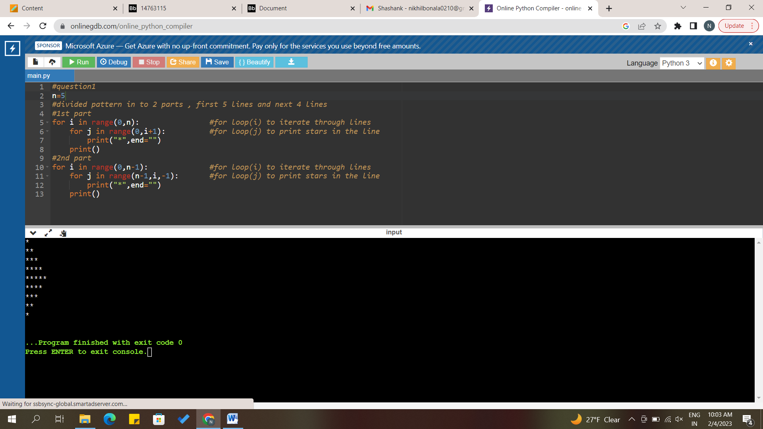

**Description:**

Divided the pattern in to 2 parts, first 5 lines and next 4 lines. For the first part and second part used 2 for loops. for loop(i) to iterate through lines and for loop(j) to print stars in the line.

**Question2:**

Use looping to output the elements from a provided list present at odd indexes. my_list = [10, 20, 30, 40, 50, 60, 70, 80, 90, 100]

**Solution:**

#question2

my_list = [10, 20, 30, 40, 50, 60, 70, 80, 90, 100]

for i in range(0,len(my_list)): #used len() to find length and itearted through indexes

if(i%2!=0): #checking if index i is odd or not

print(i,"index -",my_list[i])

**Screenshot:**

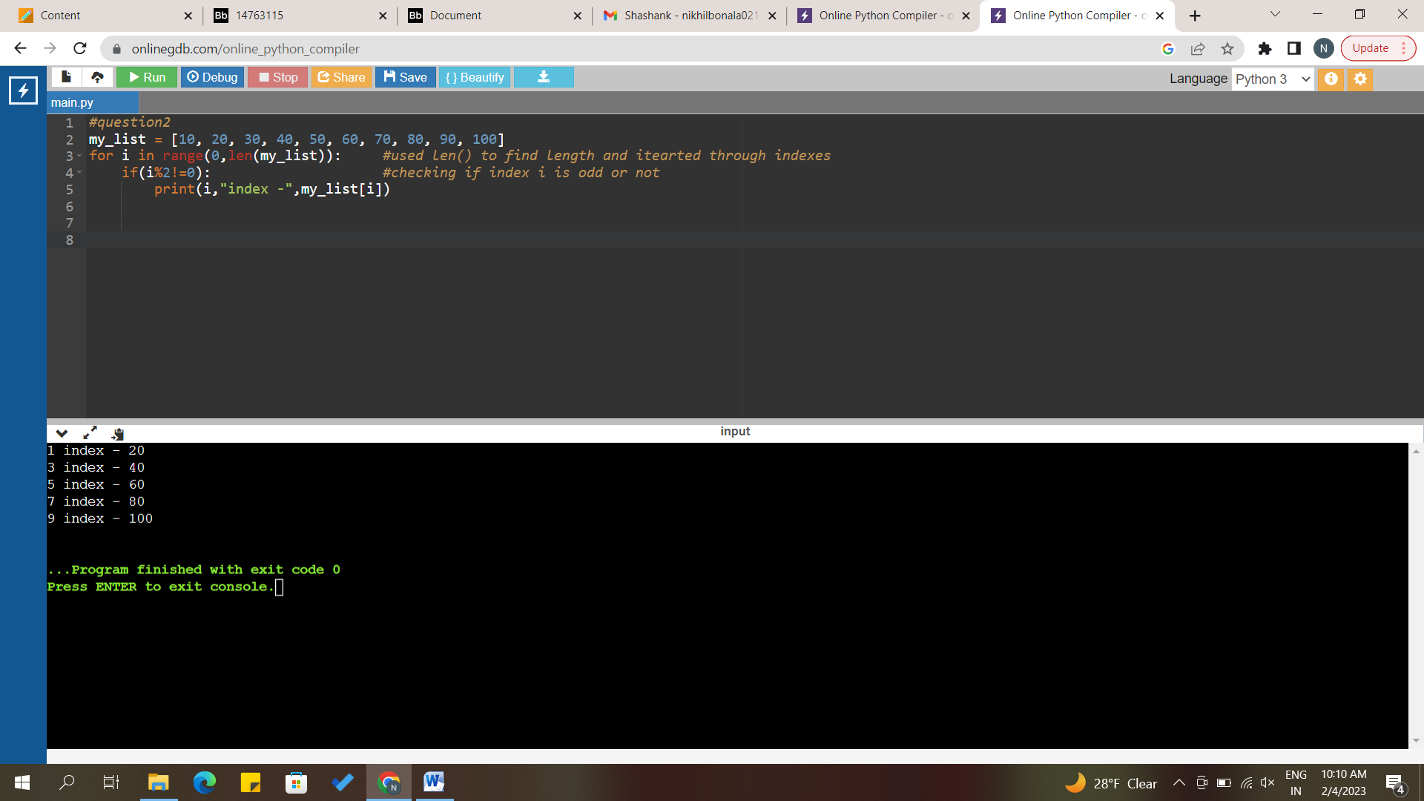

**Description:**

Used for loop to iterate through indexes and checked if index is odd printed that element.

**Question 3:**

Write a code that appends the type of elements from a given list.

Input x = [23, ‘Python’, 23.98]

**[<class 'int'>, <class 'str'>, <class 'float'>]**

**Solution:**

#question3

x = [23, "Python", 23.98]

result=[]

for i in x: #iterating through list x

result.append(type(i)) #using type functon to find data type and adding into result list

print(x)

print(result)

**Screenshot:**

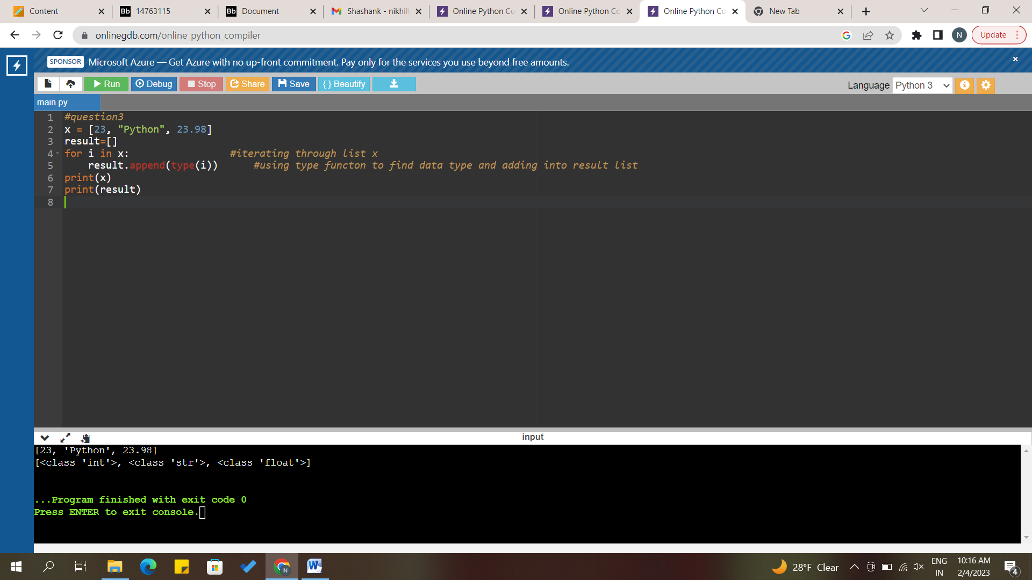

**Description:**

Used for loop to iterate through list x and checked type of every element and added to new result list.

**Question 4:**

Write a function that takes a list and returns a new list with unique items of the first list. Sample List: [1,2,3,3,3,3,4,5] Unique List: [1, 2, 3, 4, 5]

**Solution:**

SampleList= [1,2,3,3,3,3,4,5]

#created a function name uniquelist

def uniquelist(l):

result=set(l) #converting list to set to extract unique elements in the list

return list(result) #returning the result by converting to list

print(SampleList)

print("unique elements:",uniquelist(SampleList)) #function-call

**Screenshot:**

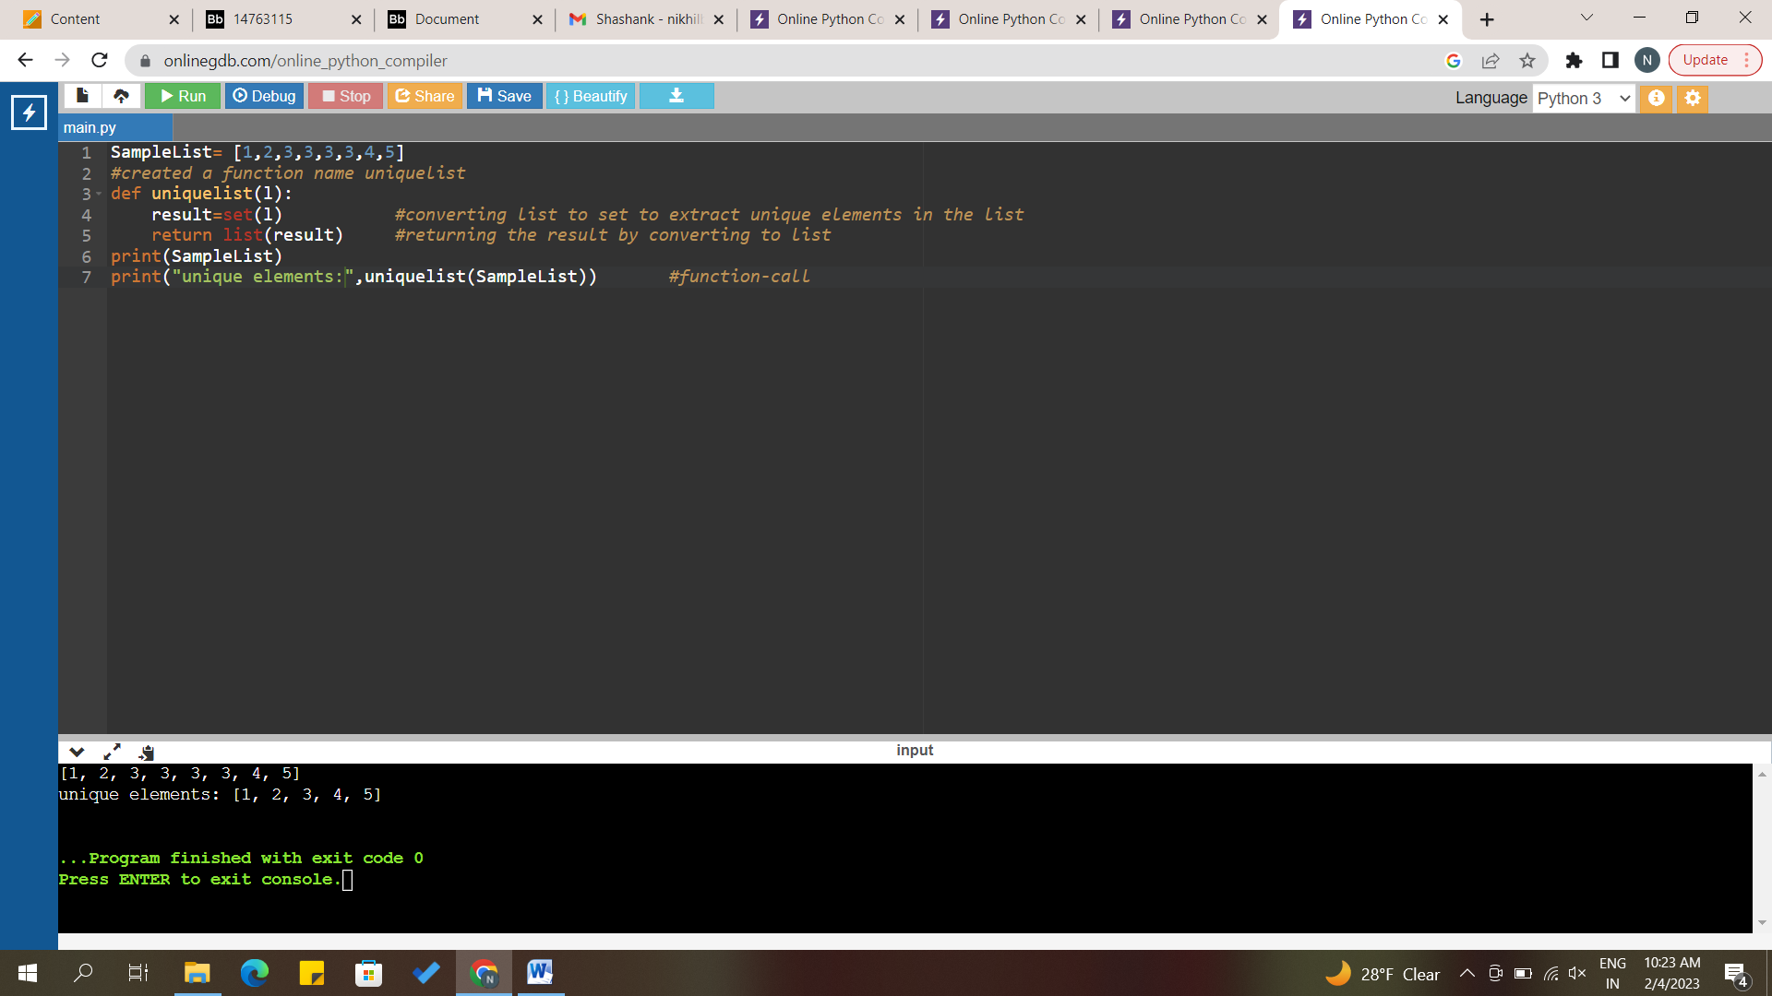

**Description:**

Created a function name uniquelist. converting list to set to extract unique elements in the list in the function. Returning the result by converting to list.

**Question 5:**

Write a function that accepts a string and calculate the number of upper-case letters and lower-case letters.

Input String: 'The quick Brow Fox'

Expected Output:

No. of Upper-case characters: 3

No. of Lower-case Characters: 12

**Solution:**

#question5

string="The quick Brow Fox"

upper=0 #counter to store upper letters

lower=0 #counter to store lower letters

for i in string: #for loop to iterate through string

if(i==" "): #skip if encounter space

continue

if(i.isupper()): #isupper return true if string is in upper case

upper=upper+1

else: #else case is islower case

lower=lower+1

print("lower=",lower)

print("upper=",upper)

**Screenshot:**

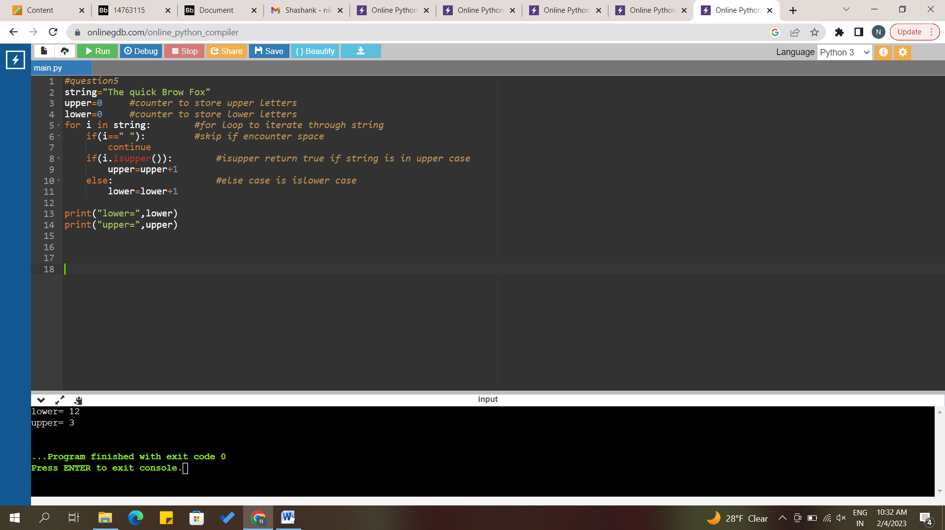

**Description:**

Created 2 counters lower and upper, counter to store upper letters, counter to store lower letters. Used for loop to iterate through string. Skipped if encounter with space and used isupper function to find string upper or not. If not moved to else block and increased lower count.