**Assignment-3**

**Nikhil Bonala- 700745888**

**Github:**

**Video: https://drive.google.com/file/d/1ZNsgP_5ma1dDVxCNyNl-IKqxeVaCtAJg/view?usp=share_link**

**Question1**

1. **Using NumPy create random vector of size 15 having only Integers in the range 1-20. 1. Reshape the array to 3 by 5 2. Print array shape. 3. Replace the max in each row by 0**

**Program:**

import numpy as np

#randint method to create random numbers with range 1-20 of size 15

arr = np.random.randint(20,size=(15))

print("array of random numbers from range 1 to 20:")

print(arr)

x=arr.reshape(3,5)

print("after reshape:")

print(x)

print("shape: ",x.shape)

print("max number in all rows changed to 0:")

#returning array of max values in every horizontal axis row

max1 = x.max(axis=1).reshape(-1, 1)

#changing max values to 0 and keeping other values undisturbed

res = np.where(x == max1, 0,x)

print(res)

**Screenshot:**

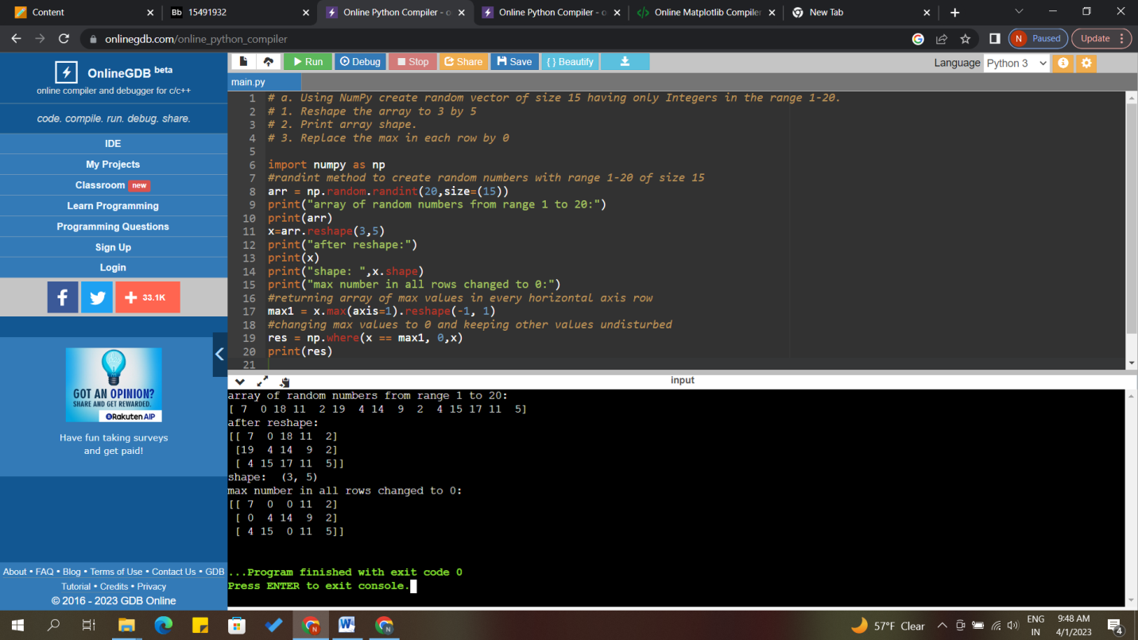

**Question:**

**Create a 2-dimensional array of size 4 x 3 (composed of 4-byte integer elements), also print the shape, type and data type of the array.**

**b. Write a program to compute the eigenvalues and right eigenvectors of a given square array given below: [[ 3 -2] [ 1 0]]**

**c. Compute the sum of the diagonal element of a given array. [[0 1 2] [3 4 5]]**

**d. Write a NumPy program to create a new shape to an array without changing its data. Reshape 3x2: [[1 2] [3 4] [5 6]] Reshape 2x3: [[1 2 3] [4 5 6]]**

**Program**

# 2-dimensional array of size 4 x 3

import numpy as np

x = np.array([[1,2,3], [4,5,6], [7,8,9], [10,11,1]], np.int32)

print(type(x))

print(x.shape)

print(x.dtype)

# B. program to compute the eigenvalues and right eigenvectors of a given square array given below

arr = np.array([[3, -2],[1, 0]])

#using eig method from linear algebra (linalg)

values, vectors = np.linalg.eig(arr)

print("Eigen values: ",values)

print("Right eigenvectors :",vectors)

# C. sum of the diagonal element of a given array

arr1 = np.arange(6).reshape(2,3)

result = np.trace(arr1)

print("Sum of the diagonal element in given matrix:")

print(result)

# D. Write a NumPy program to create a new shape to an array without changing its data

a = np.array([1, 2, 3, 4, 5, 6])

b = a.reshape(3,2)

print("Reshape to 3x2:",b)

c = a.reshape(2,3)

print("Reshape to 2x3:",c)

**Screenshot:**

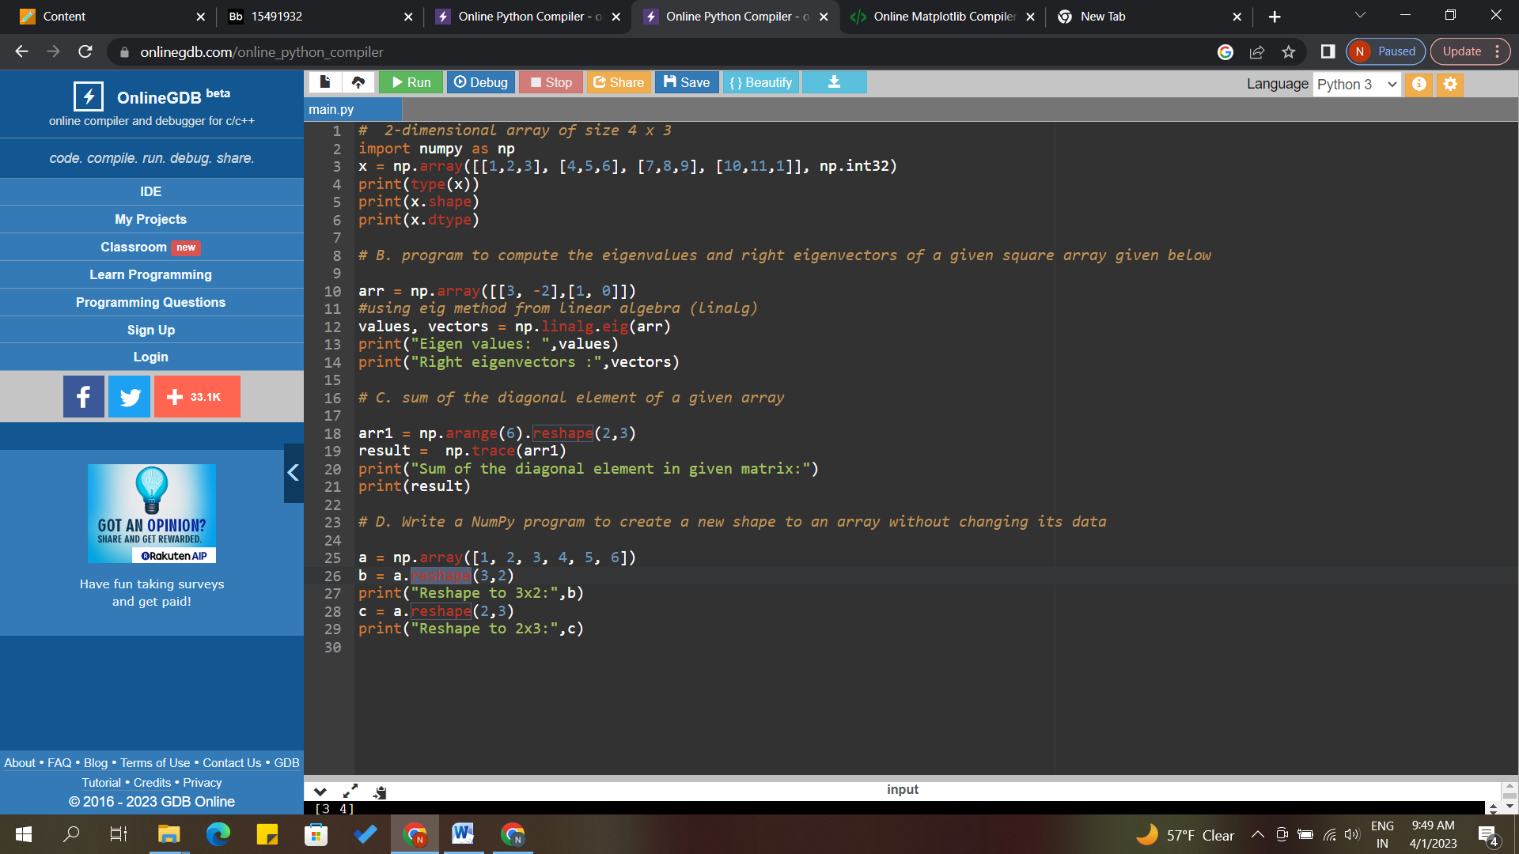

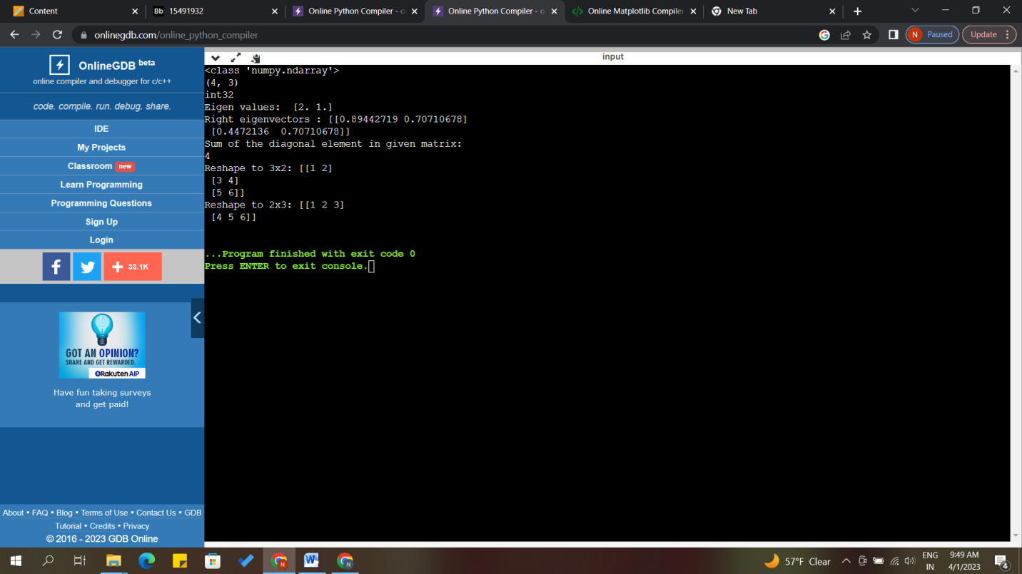

**Question:**

**Matplotlib**

1. **Write a Python programming to create a below chart of the popularity of programming Languages.**
2. **2. Sample data: Programming languages: Java, Python, PHP, JavaScript, C#, C++ Popularity: 22.2, 17.6, 8.8, 8, 7.7, 6.7**

**Program:**

import matplotlib.pyplot as plt

import numpy as np

y = np.array([22.2, 17.6, 8.8, 8, 7.7, 6.7])

mylabels = ["Java", "Python", "PHP", "JavaScript","C#","C++"]

plt.pie(y,labels=mylabels, shadow=True,explode=(0.1, 0, 0, 0,0,0), autopct='%1.2f%%')

plt.show()

**Screenshot:**

