DevOps Project

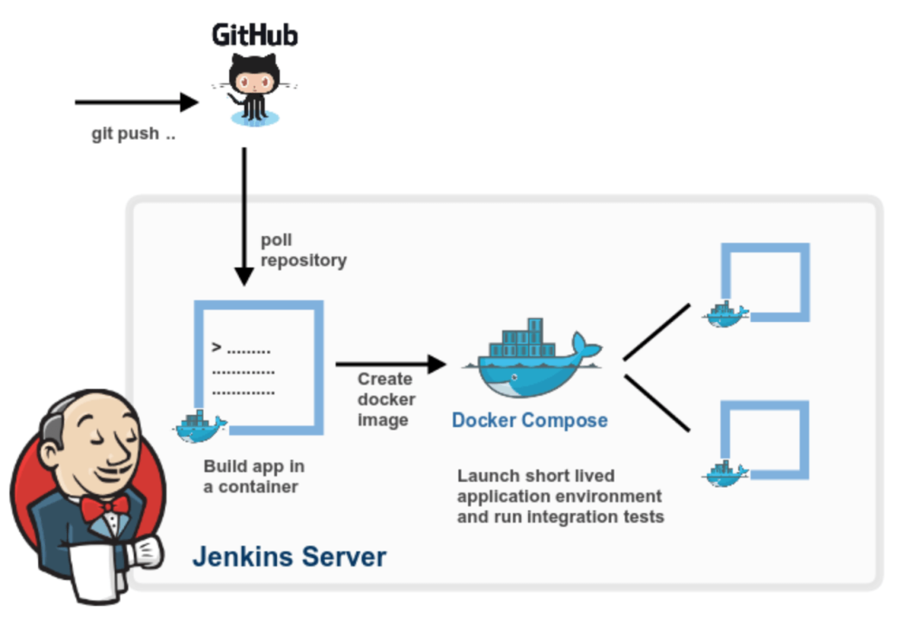

Installation: GIT , Jenkins , Docker

Git link=https://github.com/nikhilc890/HTML/tree/main

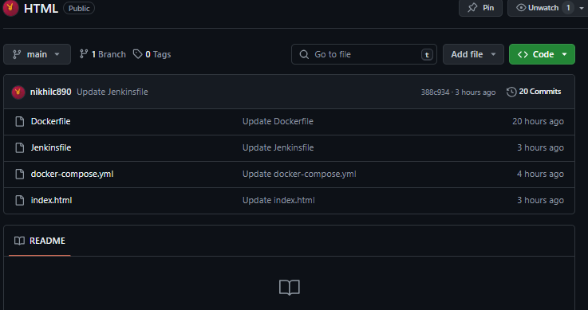



After pushing all file into git repository, web-hook is set in git for getting updated code

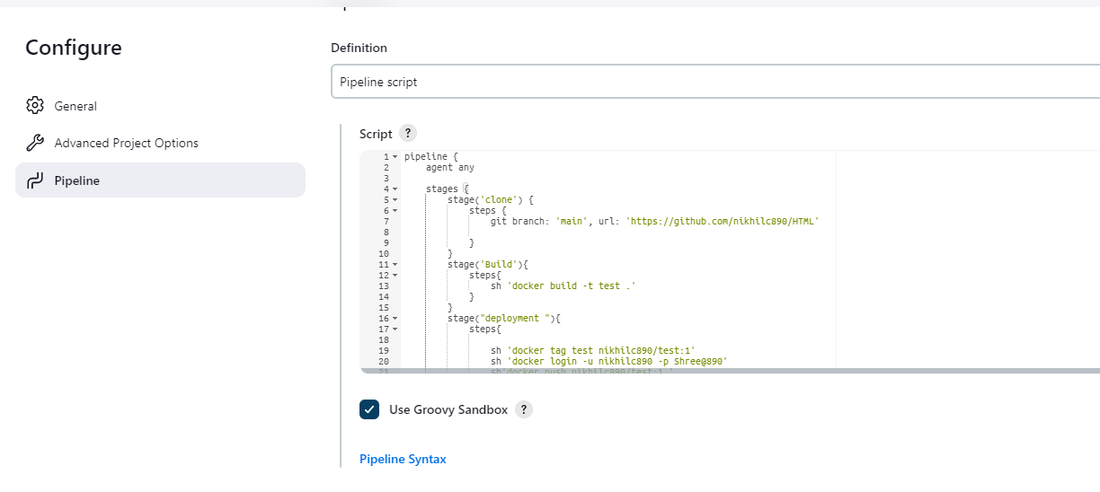

In Jenkins created pipeline name DEV
This is a pipeline writes in dev

pipeline {
agent any

stages {
stage('clone') {
steps {
git branch: 'main', url: 'https://github.com/nikhilc890/HTML'

}
}
stage('Build'){
steps{
sh 'docker build -t test .'
}
}
stage("deployment "){
steps{

sh 'docker tag test nikhilc890/test:1'
sh 'docker login -u nikhilc890 -p ____0'
sh'docker push nikhilc890/test:1 '
sh 'docker compose down && docker compose up -d'
}

}
}

Step 1= cloning git repository
Step 2 = building image throw provided Dockerfile
Step 3 = push that image on Dockerhub
Step 4 =running docker container using docker compose file

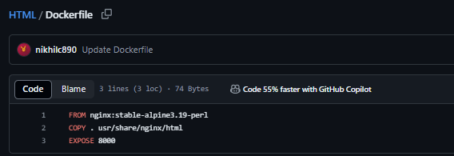

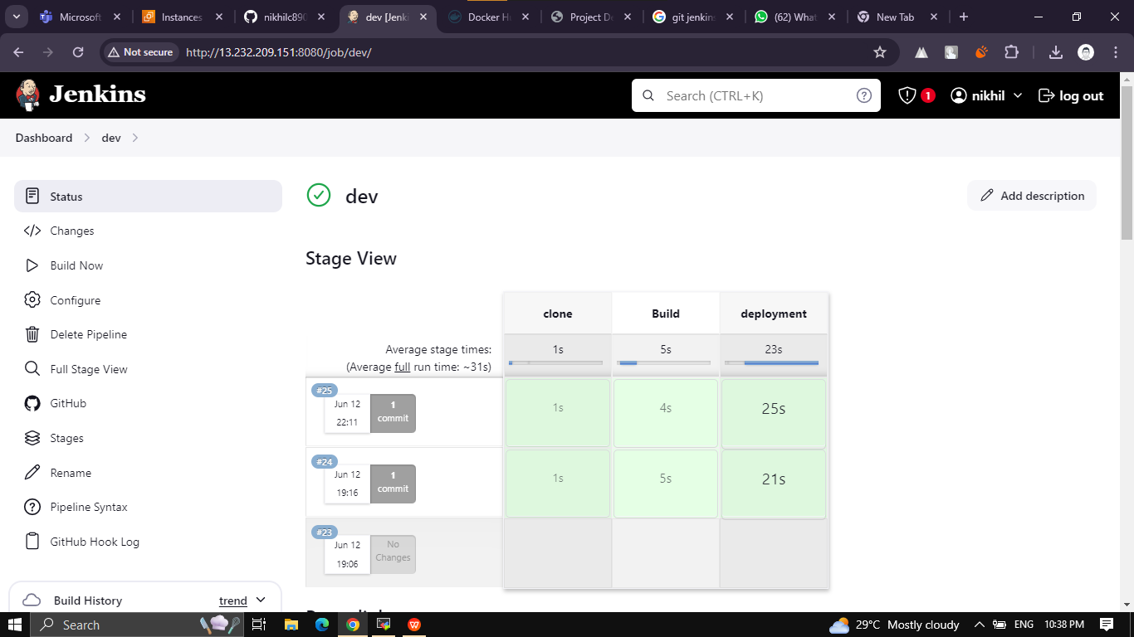

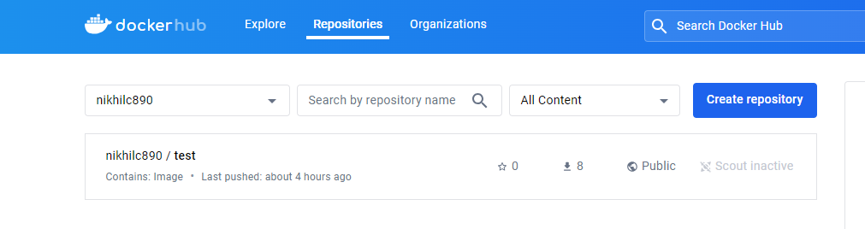

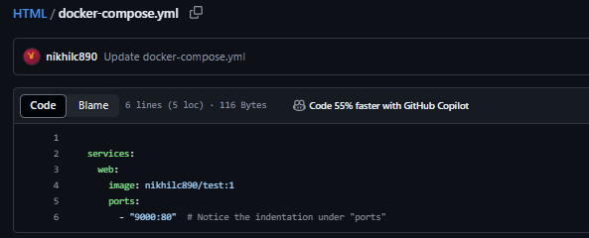

If you update on code,pipeline will trigger automatically and start new container with updated code and expose that on 9000 port

