EVA
Elo Value Added
A Cross-Era Framework for Measuring Performance Relative to Expectation in NHL History, 1917–2023
Statistic version 1.0
Data source: NHL ELO Odyssey (66,118 games, 40 franchises, 1917-12-19–2023-06-13)

Abstract
Pregame Elo ratings answer "how good is this team." They do not answer whether a team is converting that quality into standings points at the rate its own rating implies. We introduce EVA (Elo Value Added), a game-level statistic equal to a team’s actual standings points earned minus the points its pregame Elo rating implied it should earn, aggregated to the season and career level. Applying EVA to 106 seasons of NHL play (1917–2023, 66,118 games) surfaces a genuine data artifact: the source dataset’s expected-points formula assumes a modern three-point game structure retroactively for every season, which biases raw EVA by roughly −0.12 points per team-game in eras that had ties and no overtime-loss point. We correct for this with a season-mean-centered variant, EVA+, and show it removes the bias entirely in the post-2005-06 era where the model’s assumption and reality coincide. Using EVA+ we identify the most over- and under-performing franchises and seasons in NHL history, a playoff-specific "clutch" variant, and a reproducible specification intended to keep the statistic’s definition from drifting as it is extended.

1. Introduction
Elo-style ratings have become the standard public method for quantifying team strength across a full league history, popularized for hockey and other sports by projects such as FiveThirtyEight’s Elo ratings. A rating answers a narrow question well: given everything observed about a team’s results to date, how strong is it right now? It does not answer a related but distinct question that fans, front offices, and historians actually care about: is a team getting more, or fewer, standings points out of its games than that same rating says it should?
A team can be elite by rating and still be leaving points on the table in close games. A team can be mediocre by rating and still be unusually good at winning the games its rating says are close to 50/50. Neither pattern is visible from the rating alone — it requires comparing the rating’s own implied probabilities against what actually happened, game by game, over enough games that noise washes out. That comparison is what EVA measures.

2. Data
The analysis uses NHL_ELO_Odyssey.csv (66,118 games, seasons 1918–2023 by end-year convention, 40 franchise identities, 24 columns) and NHL_ELO_Odyssey_latest.csv, a 1,400-row extract of the 2022–23 season carrying two additional game-context fields not populated for earlier seasons. Full column-by-column documentation, including which fields are populated for which eras, is provided in the accompanying Data Dictionary and is not reproduced here. Two properties of the schema materially shape the methodology and are worth stating up front:
- home/away_team_expected_points is a precomputed field, not raw win probability — its formula had to be reverse-engineered (Section 3.1) rather than assumed.
- game_importance_rating and game_overall_rating are populated for exactly one season (2022–23) and blank for the other 105 — a genuine coverage gap, not a missing-data artifact, confirmed directly against the file.

3. Methodology

3.1 Reverse-engineering the expected-points formula
Fitting home_team_expected_points and away_team_expected_points against home_team_winprob, away_team_winprob, and overtime_prob recovers, to five significant figures:
E[points] = 2·P(win) + P(game reaches OT/SO)·P(opponent wins)
This is the standard three-point-game convention used since the 2005–06 season (regulation or OT/SO win = 2, OT/SO loss = 1, regulation loss = 0). Critically, the dataset applies this formula uniformly back to the 1917–18 season — seasons in which ties were a real result and no overtime-loss point existed. This is a known simplification in cross-era Elo projects that keep ratings comparable over time; it is not a data error, but it means the "expected" side of any actual-minus-expected comparison is quietly using rules that only actually applied for the most recent third of NHL history.

3.2 Actual points under era-correct rules
To avoid compounding the source data’s modern-rules assumption, actual points are derived from the final score and the overtime indicator using the point system that actually applied in that season: a regulation win/loss splits 2–0; a tie (equal score, no OT winner) splits 1–1 for all seasons through 2003–04, when ties were abolished; an overtime or shootout loss earns the loser 1 point only from the 1999–2000 season onward, and 0 points before that, matching the actual history of the NHL points system.

3.3 EVA and the discovered era bias
Game-level EVA is actual points minus expected points, computed once per team per game. Averaged across all 66,118 games under the rules in §3.1–§3.2, raw EVA is not centered on zero within era — it is systematically negative before the rules the source model assumes were actually in effect, and centers on zero once they are:
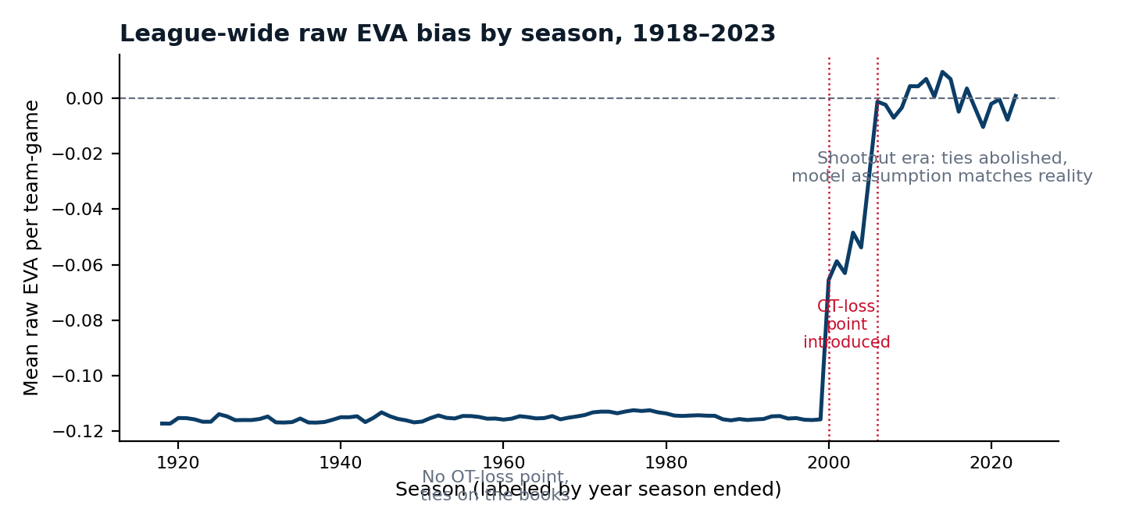
Figure 1. League-wide mean raw EVA per team-game by season. The dataset’s expected-points formula assumes 2006-era rules for every season; actual mean bias tracks the real rule changes almost exactly — flat around −0.116 through 1999, roughly −0.06 during the transitional 2000–2004 overtime-loss-point-but-still-ties period, and effectively 0 from 2006 onward.
This is a substantive finding, not a footnote: any historical leaderboard built on raw actual-minus-expected without this correction would systematically penalize every team that played before 2006, making cross-era "who overperforms" claims invalid by construction rather than by chance.

3.4 EVA+: era-adjusted correction
EVA+ removes the bias identified in §3.3 by centering every game on its own season’s league-wide mean raw EVA (the "season bias" series plotted in Figure 1), rather than by hand-coding rule-era boundaries. This is a within-dataset normalization — it uses only values already computed from the data — and it is robust to any other structural biases in the source expected-points formula that might exist but were not hypothesized in advance. EVA+ is the metric used for every cross-era comparison in this paper; raw EVA is retained only for single-season, single-era analysis where the correction would have no effect.

3.5 Clutch and playoff variants
A full importance-weighted Clutch EVA (weighting each game’s EVA+ by game_importance_rating) is defined in the accompanying specification but is only computable for the 2022–23 season given the coverage gap noted in Section 2. For all 106 seasons, Playoff EVA+ — EVA+ restricted to games flagged playoff = 1 — serves as the historical clutch proxy used throughout this paper.

4. Results

4.1 Most under- and over-rated franchises (career, min. 1,000 games)
Ranking all 40 franchises by average pregame Elo and separately by career EVA+ per game exposes teams whose results and whose reputations (as proxied by rating) diverge most. The Anaheim Ducks rank 20th in average Elo across 29 seasons but 8th in EVA+ per game — a consistent gap between rated strength and points actually earned. The effect direction reverses for the New York Rangers, who rank 9th in average Elo across 96 seasons but 19th in EVA+.
Franchise | Seasons | Games | Avg Elo (rank) | EVA+ / game (rank)
Anaheim Ducks | 29 | 2437 | 1494 (#20) | +0.008 (#8)
Florida Panthers | 29 | 2358 | 1482 (#27) | -0.003 (#18)
Nashville Predators | 24 | 2020 | 1503 (#11) | +0.020 (#4)
Dallas Stars | 55 | 4727 | 1496 (#19) | +0.002 (#13)
St. Louis Blues | 55 | 4753 | 1499 (#15) | +0.007 (#9)
Carolina Hurricanes | 43 | 3586 | 1483 (#26) | -0.004 (#20)
Minnesota Wild | 22 | 1827 | 1505 (#10) | +0.009 (#6)
Tampa Bay Lightning | 30 | 2572 | 1492 (#21) | -0.001 (#17)
Table 1. Most underrated franchises: high EVA+ rank relative to Elo rank.
Franchise | Seasons | Games | Avg Elo (rank) | EVA+ / game (rank)
New York Rangers | 96 | 7269 | 1506 (#9) | -0.003 (#19)
Buffalo Sabres | 52 | 4365 | 1506 (#7) | +0.000 (#15)
New York Islanders | 50 | 4271 | 1502 (#13) | -0.005 (#21)
Chicago Blackhawks | 96 | 7272 | 1499 (#17) | -0.017 (#24)
Calgary Flames | 50 | 4204 | 1508 (#6) | +0.004 (#12)
Detroit Red Wings | 96 | 7347 | 1510 (#5) | +0.005 (#11)
Ottawa Senators | 46 | 3077 | 1487 (#22) | -0.024 (#26)
San Jose Sharks | 31 | 2679 | 1497 (#18) | -0.006 (#22)
Table 2. Most overrated franchises: low EVA+ rank relative to Elo rank.

4.2 Best and worst single seasons by EVA+ (min. 60 games)
The single greatest EVA+ season in the dataset belongs to the 1973–74 Philadelphia Flyers. The worst belongs to the Quebec Nordiques’ 1989–90 season — recorded in this dataset under the franchise’s current identity, "Colorado Avalanche," per the franchise-continuity convention documented in the Data Dictionary.
Franchise | Season | Actual W | Expected W | EVA+
Philadelphia Flyers | 1973–74 | 62 | 55.5 | +27.3
Montreal Canadiens | 1975–76 | 70 | 64.1 | +26.5
Carolina Hurricanes | 2005–06 | 68 | 54.3 | +26.3
Buffalo Sabres | 1974–75 | 59 | 54.7 | +25.1
Montreal Canadiens | 1976–77 | 72 | 68.6 | +24.4
Calgary Flames | 1988–89 | 70 | 65.4 | +23.0
San Jose Sharks | 1993–94 | 40 | 34.2 | +23.0
Anaheim Ducks | 2002–03 | 55 | 47.2 | +22.6
Table 3. Highest single-season EVA+.
Franchise | Season | Actual W | Expected W | EVA+
Colorado Avalanche | 1989–90 | 12 | 28.5 | -30.2
Colorado Avalanche | 2016–17 | 22 | 33.3 | -30.0
Buffalo Sabres | 2013–14 | 21 | 33.9 | -27.6
Washington Capitals | 1974–75 | 8 | 22.4 | -27.5
San Jose Sharks | 1992–93 | 11 | 24.6 | -26.9
Chicago Blackhawks | 1953–54 | 12 | 27.3 | -25.7
Philadelphia Flyers | 2006–07 | 22 | 35.5 | -25.6
Carolina Hurricanes | 2002–03 | 22 | 40.1 | -25.0
Table 4. Lowest single-season EVA+.

4.3 Playoff EVA+ leaders
Isolating playoff games only, the 1991–92 Pittsburgh Penguins — en route to their second consecutive Stanley Cup — posted the strongest single-postseason EVA+ in the dataset among teams with at least 10 playoff games.
Franchise | Season | PO Games | Playoff EVA+ | Per Game
Pittsburgh Penguins | 1991–92 | 21 | +12.0 | +0.57
New York Rangers | 1978–79 | 18 | +11.3 | +0.63
New Jersey Devils | 1994–95 | 20 | +11.3 | +0.56
Anaheim Ducks | 2002–03 | 21 | +10.8 | +0.51
Montreal Canadiens | 1992–93 | 20 | +10.3 | +0.51
Colorado Avalanche | 1995–96 | 22 | +9.8 | +0.44
Anaheim Ducks | 2006–07 | 21 | +9.7 | +0.46
Los Angeles Kings | 2011–12 | 20 | +9.5 | +0.47
Table 5. Highest single-postseason Playoff EVA+, minimum 10 playoff games.

4.4 The 2022–23 season
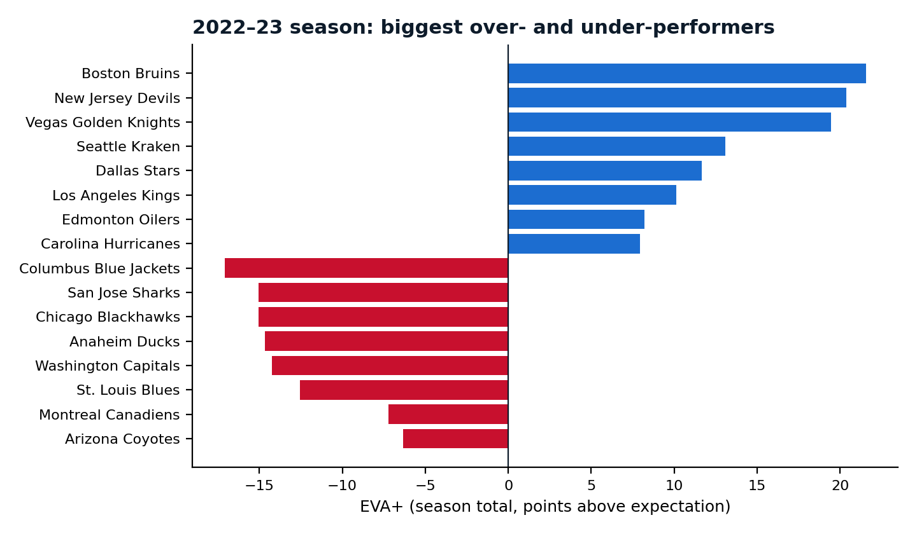
Figure 2. 2022–23 season, EVA+ by team (top and bottom 8 shown).
The Boston Bruins, who set the all-time NHL record for points in a single season in 2022–23, also lead the league in EVA+ that season — a useful sanity check that the statistic is not simply inverse to team quality; the best team by Elo can also be the best team relative to its own already-high bar.
Franchise | Actual W | Expected W | EVA+
Boston Bruins | 68 | 57.0 | +21.6
New Jersey Devils | 57 | 45.6 | +20.4
Vegas Golden Knights | 67 | 57.3 | +19.5
Seattle Kraken | 53 | 44.5 | +13.1
Dallas Stars | 57 | 54.7 | +11.6
Los Angeles Kings | 49 | 44.3 | +10.1
Edmonton Oilers | 56 | 52.5 | +8.2
Carolina Hurricanes | 60 | 56.8 | +7.9
Toronto Maple Leafs | 55 | 53.4 | +6.9
Buffalo Sabres | 42 | 37.7 | +5.2
Table 6. Top 10 by EVA+, 2022–23 season.

5. Limitations
- EVA+ corrects the average era bias per season; it cannot correct within-season heterogeneity if overtime rates vary unusually within a single season.
- Pregame Elo already incorporates some mean reversion, so multi-season EVA+ and Elo trajectory are not fully independent measurements over long windows.
- Full importance-weighted Clutch EVA is presently a single-season (2022–23) metric due to data coverage; any historical "clutch" claim in this paper uses the Playoff EVA+ proxy, not the importance-weighted definition.
- Franchise-level career comparisons inherit the dataset’s franchise-continuity convention (relocated/renamed franchises appear under their current identity throughout their history).

6. Future Work
Two extensions follow directly from this dataset once more seasons carry the game_importance_rating field: (1) a fully importance-weighted Clutch EVA computed identically to the playoff proxy used here, and (2) a study of how quickly EVA+ mean-reverts within a franchise, which would clarify how much of a single season’s EVA+ is signal versus variance. A companion case-study collection and an interactive explorer accompany this paper and are referenced in the appendix materials distributed alongside it.

7. Conclusion
EVA and EVA+ reframe "how good is this team" (Elo) as a second, complementary question: "is this team earning what its own rating says it should?" Applied across 106 seasons, the framework surfaces both a genuine methodological artifact in the source data — a uniform modern-rules assumption that biases raw comparisons across NHL rule eras — and a set of concrete, falsifiable historical claims (the most under/overrated franchises, the best and worst single seasons, and the top playoff performances) that are reproducible directly from the published specification.

Appendix: Reproducibility
All figures and tables in this paper are generated directly from NHL_ELO_Odyssey.csv using the formulas specified in STATISTIC_SPECIFICATION.md v1.0, distributed alongside this document. No values in this paper were manually adjusted after computation.

