The NFL Consistency Index (NCI)

Does Cross-Dimensional Statistical Balance Predict Future NFL Success?
Data: 672 NFL team-seasons, 2003–2023 (pro-football-reference.com, via Kaggle)

1. Introduction
Traditional NFL statistics — wins, point differential, yards — measure how good a team is. They don't measure how balanced a team's statistical profile is across the different phases of the game: passing, rushing, defense, ball security, and discipline.
This project develops the NFL Consistency Index (NCI): a measure of how evenly a team performs across five statistical dimensions, independent of how good the team is overall. It then tests whether that balance predicts next-season success.
Research question: Does cross-dimensional statistical consistency predict a team's win percentage the following season, beyond what current win percentage and point differential already predict?

2. Data
The dataset contains 35 variables across 672 team-seasons (32 teams × 21 seasons, 2003–2023), covering team record, passing, rushing, penalties, turnovers, and scoring. Two columns (mov, ties) had complementary missing values traced to a scraping/table-layout artifact across seasons rather than genuine gaps; mov duplicates points_diff/games exactly and neither was needed for this analysis.

3. Methodology

3.1 Redundancy check
A correlation matrix on 24 candidate performance variables (excluding outcome variables like wins and points) found multiple highly correlated clusters (|r| > 0.75): passing volume stats (completions, attempts, yards, first downs), turnover-related stats, and penalty-related stats. Building the index from all 35 raw variables would have counted the same underlying signal multiple times.

3.2 Dimension construction
Based on the redundancy analysis, five statistical dimensions were defined, each built from standardized component variables rather than a single raw stat:
Dimension | Component variables
Passing | Net yards/attempt, TD passes, interceptions (reversed)
Rushing | Yards/attempt, rushing TDs, rush attempts
Defense | Points allowed (reversed)
Ball Security | Turnover % (reversed)
Discipline | Penalty yards (reversed)

A sixth candidate dimension ("Explosiveness/Efficiency", built from yards/play and expected points) was dropped after the correlation check showed it substantially overlapped with Passing and Rushing rather than capturing independent information.

3.3 Standardization
Each component variable was z-scored within its own season (not across the full 2003–2023 span), so a team is compared to its contemporaries rather than to teams from a different rules era. "Lower is better" variables (interceptions, points allowed, turnover %, penalty yards) were sign-reversed so that higher always means better performance. Each dimension score is the mean of its (direction-corrected) component z-scores.

3.4 The consistency formula
Two concepts were deliberately kept separate, since conflating them was identified as the central risk of this kind of index:
- Performance Level — how strong a team's overall statistical profile is (mean of the five dimension scores).
- Performance Balance — how evenly that performance is distributed across the five dimensions (dispersion of the five dimension scores).
Dispersion was measured as the standard deviation across a team-season's five dimension scores. A mean-absolute-deviation alternative was also tested and correlated with the standard deviation at r = 0.97, confirming the choice of formula was not sensitive to that decision.
Critically, dispersion and performance level were essentially uncorrelated (r = -0.011), confirming NCI captures something distinct from "how good is this team" rather than simply re-deriving team quality.

3.5 Scaling
NCI is dispersion converted to a 0–100 percentile rank across all 672 team-seasons, where 100 = most balanced. Because it is a percentile rank, the distribution of NCI itself is uniform by construction; the underlying raw dispersion score (Figure 1) is the one with informative shape.
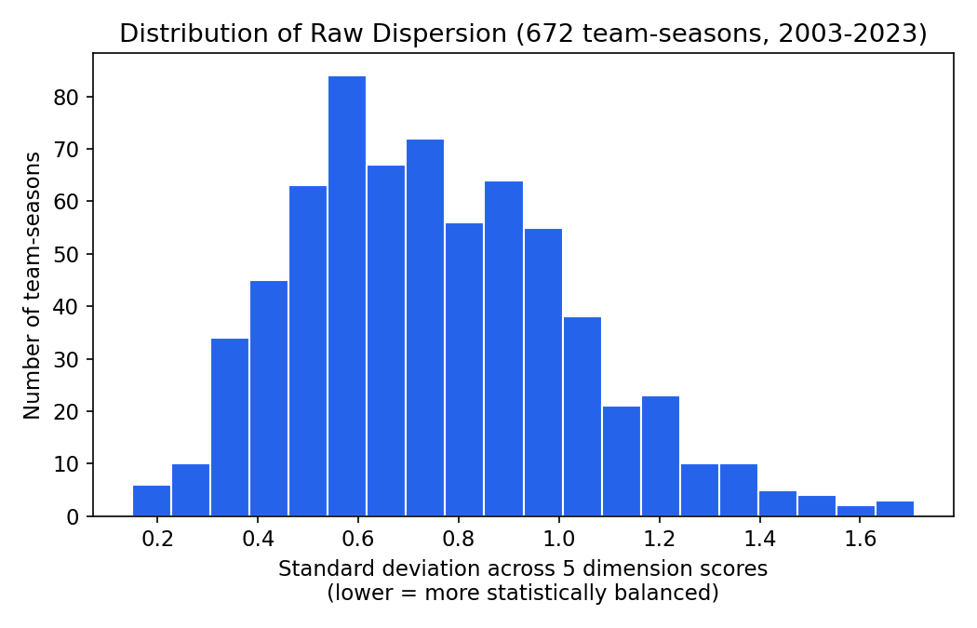
Figure 1. Distribution of raw dispersion across the five dimensions. Most team-seasons cluster around moderate imbalance; very few teams are near-perfectly balanced across all five dimensions.

4. Results

4.1 NCI vs. current team quality
As designed, NCI shows no relationship with a team's own current-season win percentage (r ≈ -0.01) — confirming it measures balance, not quality.
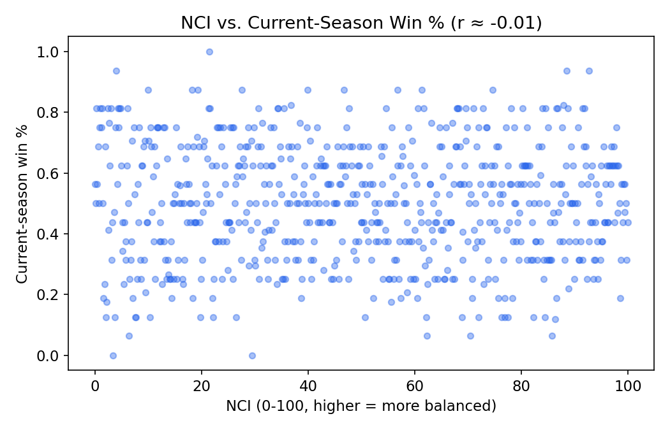
Figure 2. NCI vs. current-season win percentage.

4.2 Top and bottom team-seasons
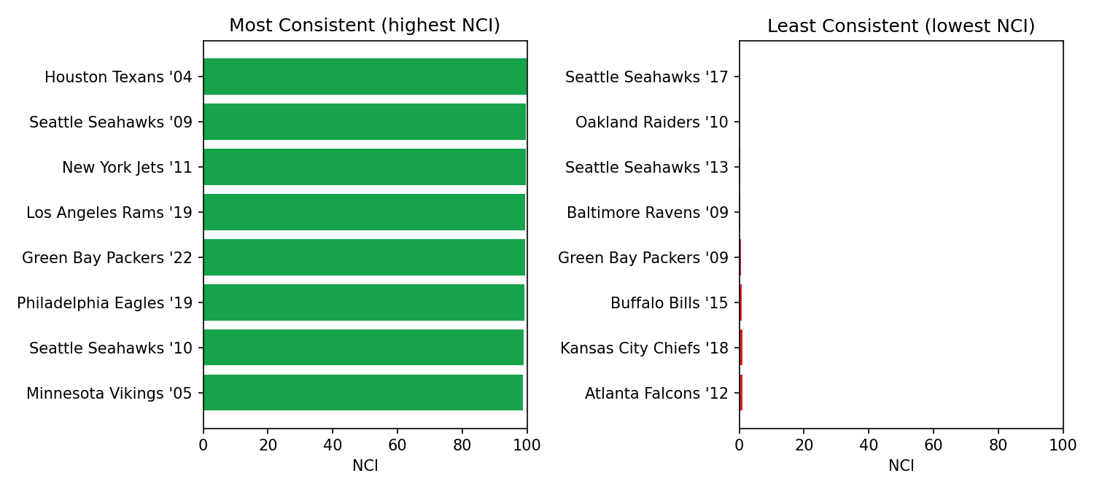
Figure 3. Most and least statistically consistent team-seasons in the dataset. Note that several of the least-consistent teams (2013 Seahawks, 2012 Falcons) were very good teams that leaned heavily on one strength, while several of the most-consistent teams were mediocre (2004 Texans 7-9, 2015 Browns 3-13) — both patterns are consistent with balance being independent of quality.

4.3 Does NCI predict next-season success?
For each of 635 team-seasons with a following season available (2023 excluded, no 2024 data), next-season win percentage was regressed on current win percentage, current point differential, and NCI.
Predictor | Correlation with next-season win% (r) | p-value
NCI (current season) | -0.081 | 0.040
Current win % | 0.342 | <0.001
Current point differential | 0.390 | <0.001
Performance Level (overall quality) | 0.307 | <0.001

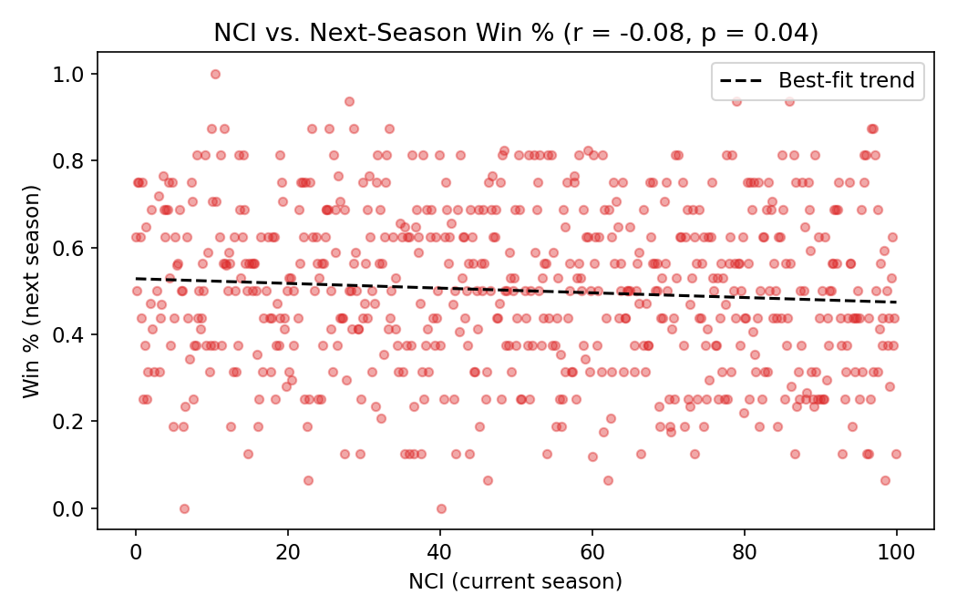
Figure 4. NCI vs. next-season win percentage. No visible trend — the near-flat, slightly negative best-fit line reflects the weak, marginal correlation.
In a multiple regression predicting next-season win percentage from standardized win%, point differential, and NCI, adding NCI improved R² from 0.153 to 0.158 — a 0.005 improvement — and its coefficient was not significant at the conventional 0.05 threshold (p = 0.058), with a slightly negative sign. An out-of-sample test (training on 2003–2017 seasons, testing on 2018–2022 seasons) showed effectively no improvement in prediction error from adding NCI (RMSE 0.1683 → 0.1671).

4.4 Does NCI protect against decline or volatility instead?
An alternative hypothesis — that consistency doesn't predict the level of next-season performance but does protect against large year-over-year swings — was also tested. NCI showed no correlation with the magnitude of year-over-year win percentage change (r = -0.027), and the rate of a large decline (win% dropping by more than 0.25) was nearly identical across NCI terciles (11.3% low-NCI, 10.4% mid-NCI, 12.7% high-NCI teams).

5. Discussion
The central finding is a clean negative result: cross-dimensional statistical consistency, as constructed here, does not meaningfully predict next-season NFL success, and does not protect against decline or reduce year-over-year volatility. It adds essentially nothing over a team's current win percentage and point differential.
This does not mean the underlying construct is invalid — the validation step confirmed NCI genuinely measures something distinct from team quality (r ≈ 0 correlation with current performance level). It means that, at least measured this way, statistical balance is not the missing ingredient for forecasting NFL team trajectories. Point differential and current record remain the strongest simple predictors available in this dataset, consistent with prior published research on the same 2003–2023 dataset.
A literature check did not surface an existing NFL metric constructed the same way — measuring dispersion across standardized passing, rushing, defense, turnover, and discipline dimensions within a single team-season. Existing uses of "consistency" in football analytics (e.g., Success Rate) describe play-to-play repeatability of a single stat, and existing uses of "balance" (e.g., the Noll-Scully metric) describe parity between teams across a league, not balance within one team's own statistical profile. This search cannot establish that no such metric exists anywhere, only that none was found.

6. Limitations
- Regular season data only; no playoff performance.
- No opponent-adjusted stats — a team's raw numbers aren't adjusted for strength of schedule.
- Defense is represented by a single variable (points allowed); the dataset has no opponent passing/rushing yardage to build a richer defensive dimension.
- No injury, roster continuity, or coaching-change data, all of which plausibly affect next-season trajectory more than statistical balance.
- 2023 team-seasons could not be used for next-season prediction since 2024 data is not in this dataset.
- The choice of which variables constitute each dimension is a judgment call; a different reasonable choice could yield a different formula.

7. Conclusion
Statistical consistency, defined as low dispersion across passing, rushing, defense, ball security, and discipline dimensions, is not a meaningful predictor of NFL team success the following season in this dataset. It is a well-validated, quality-independent construct, but it does not carry predictive signal beyond a team's current record and point differential — a legitimate and useful negative result.

