Cross-Sport Athletic Transfer: A Simulation of Cricket ↔ Baseball Skill Migration
A comprehensive simulation framework inspired by the Million Dollar Arm experiment
Research-model version 1.0 • 260 curated athletes • 4,000 Monte Carlo trials/player/training stage

Abstract
This project asks a deliberately difficult sports-science question: if elite cricket players were given a structured pathway into baseball, and elite baseball players were given a structured pathway into cricket, which athletes would transfer best—and why? The project builds a two-way player-transfer model using a common latent attribute space rather than treating native statistics as interchangeable. The model evaluates power, contact, discipline, hand-eye coordination, reaction, vision, throwing velocity, throwing accuracy, speed, agility, endurance, sport-specific ball skill, fielding, game intelligence, and adaptability. A 220-player curated pool is used as a starting laboratory. The simulation applies role-specific transfer equations, learning curves, uncertainty, and Monte Carlo sampling to estimate likely performance trajectories.

1. Background and Motivation
The inspiration is the real Million Dollar Arm story. Dinesh Patel and Rinku Singh were discovered in India and eventually signed professional contracts with the Pittsburgh Pirates despite having no prior baseball experience; MLB's account notes that the pair had actually specialized in javelin rather than cricket. Their story demonstrates both the possibility and the danger of athletic-transfer experiments: exceptional raw throwing ability can create an opportunity, but unfamiliar perceptual and tactical demands remain major barriers.
Research supports treating cricket and baseball as partially related rather than identical. Comparative throwing research found baseball players threw faster and more accurately than cricket players in a controlled task, while both groups showed a speed–accuracy trade-off. Biomechanical work also identifies similarities in overhead throwing while documenting sport-specific differences. Cricket batting research emphasizes biomechanics, perceptual skill, practice design, and skill acquisition.

2. Research Questions
- Which cricket players are predicted to have the strongest transfer potential to baseball?
- Which baseball players are predicted to have the strongest transfer potential to cricket?
- Which underlying attributes—not native sport statistics—drive successful transfer?
- How does training time change the probability of reaching a high-performance threshold?
- How sensitive are rankings to reasonable changes in transfer weights?
- Can the framework be calibrated with real cross-sport trial data?

3. Conceptual Model
The model has two layers. Layer A is transferable physical/perceptual capacity. Layer B is sport-specific technique and experience. A cricket batter may possess elite hand-eye coordination and reaction time but still need to learn baseball pitch geometry, the strike zone, defensive positioning and baseball tactics. Conversely, an MLB hitter may possess elite bat-to-ball skill but need to learn cricket's bounce, crease management, shot selection and bowling-style recognition. The simulation therefore applies a specialization penalty and a learning curve rather than directly converting one sport's statistics into the other.

4. Dataset Design
The main dataset contains 260 curated players: 115 baseball players and 145 cricket players. It includes hitters, pitchers, catchers, infielders, outfielders, wicketkeepers, specialist bowlers, batters and all-rounders. It is a research sample rather than an official ranking.
Each player has 15 estimated 20–99 attributes: power, contact, discipline, hand-eye coordination, reaction, vision, throwing-velocity proxy, throwing-accuracy proxy, speed, agility, endurance, specialist-ball skill, fielding, game intelligence and adaptability. It also stores native role, a native metric proxy, three cross-sport transfer scores, recommended target role, adaptation time and uncertainty.
Critical limitation: the transfer attributes and transfer scores are model estimates. They are intended to be transparent simulation inputs, not official scouting grades. A production version should replace them with player-level event and tracking data.

5. Transfer Equations
Cricket → baseball batting:
B = 0.28(H) + 0.18(P) + 0.15(C) + 0.12(R) + 0.10(V) + 0.07(S) + 0.05(IQ) + 0.05(A)
Cricket → baseball pitching:
P = 0.28(TV) + 0.22(TA) + 0.15(BS) + 0.12(Power) + 0.10(E) + 0.08(IQ) + 0.05(A)
Baseball → cricket uses the same latent variables but reweights them for cricket batting, bowling and fielding. The point of using explicit equations is interpretability: a ranking can be explained by the attributes that produced it, and every coefficient can later be estimated from experimental data.

6. Learning Curve and Monte Carlo Simulation
Transfer performance approaches an athlete-specific ceiling using adaptation(t) = 1 − exp(−t/τ). τ is derived from adaptability. Each checkpoint is then sampled from a distribution centered on the adapted performance with a player-specific uncertainty term. The simulation evaluates 0, 6, 12, 18, 24 and 36 months.

7. Results and Visualizations

Attribute profiles
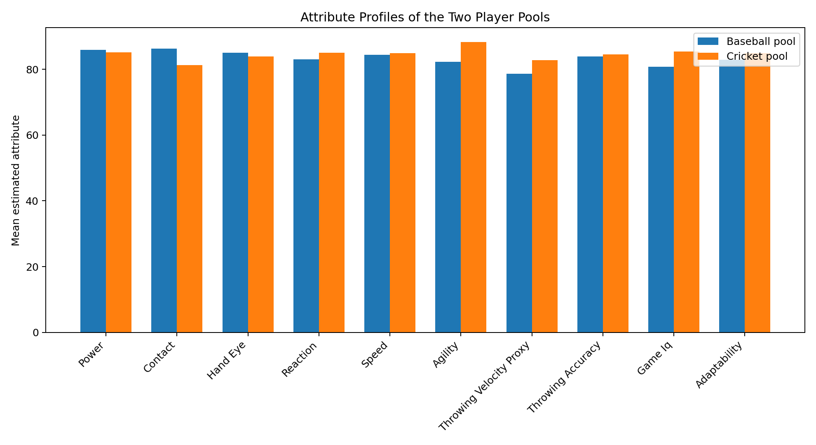
Mean estimated attribute profiles of the two source pools.

Top candidates
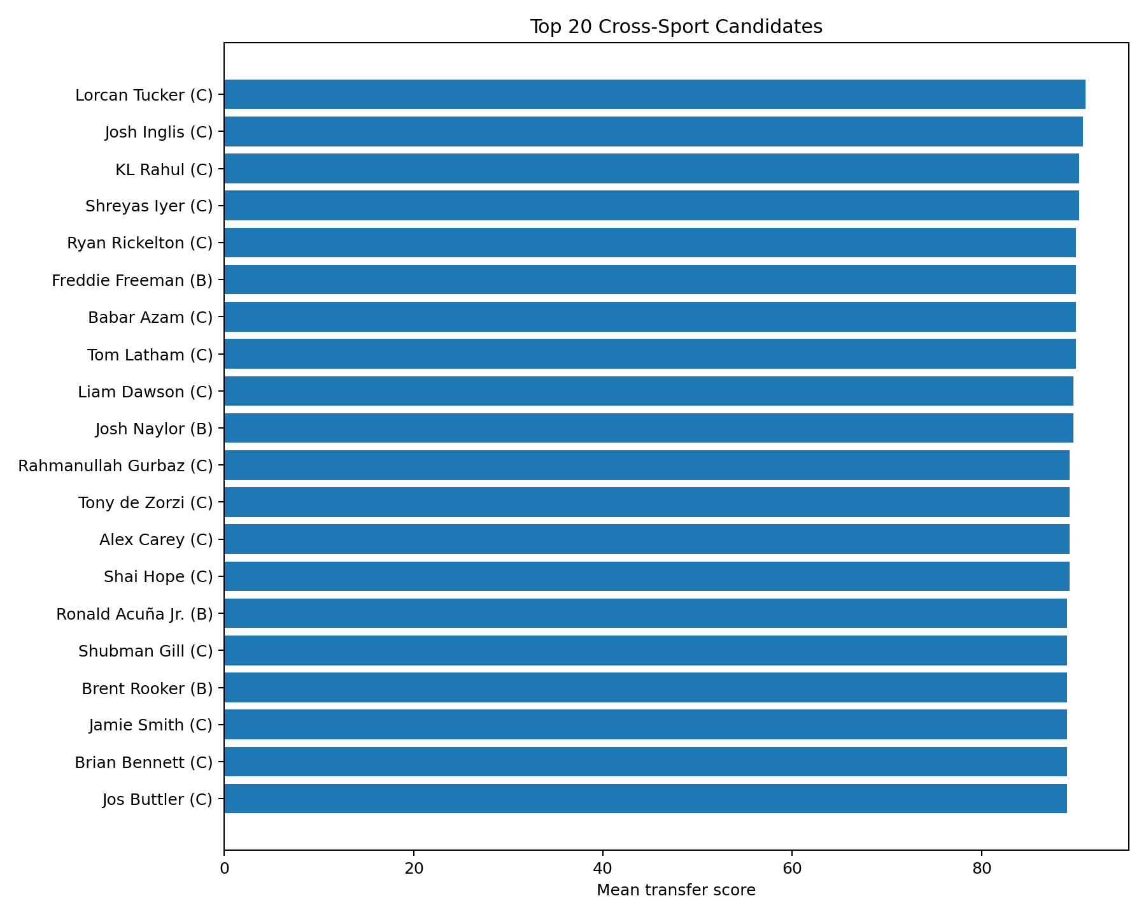
Top 20 transfer candidates by mean cross-sport transfer score.

Score distribution
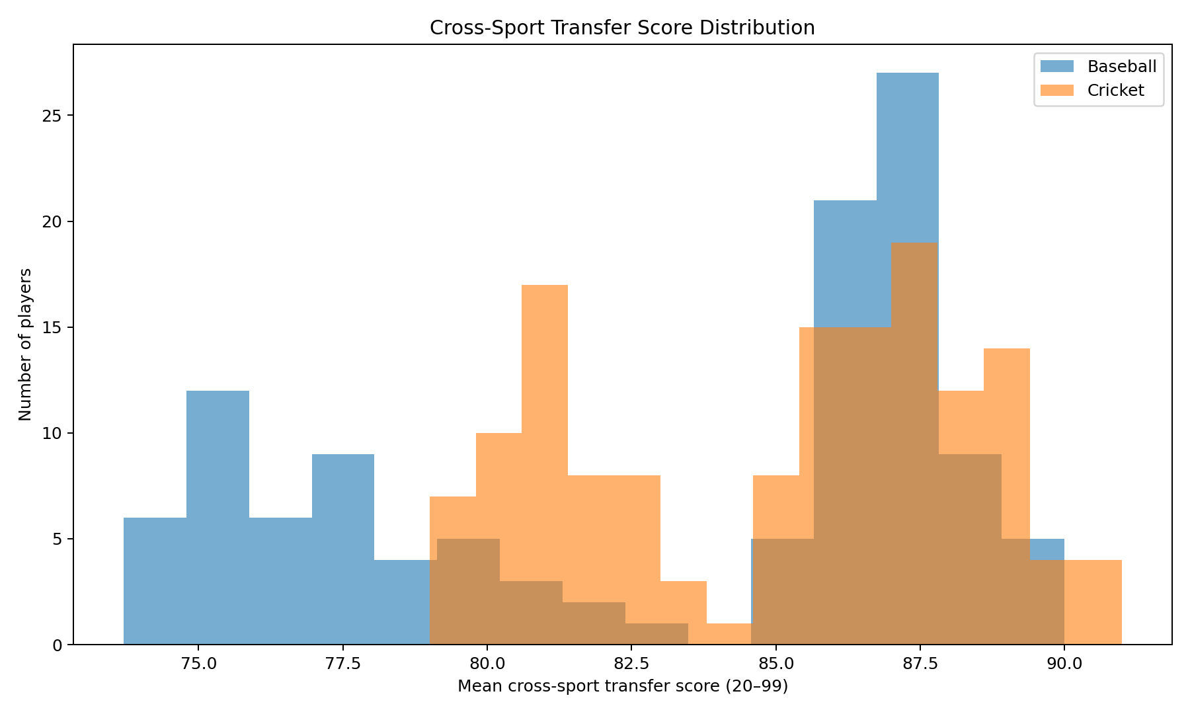
Distribution of mean transfer scores across the player pools.

Adaptation curves
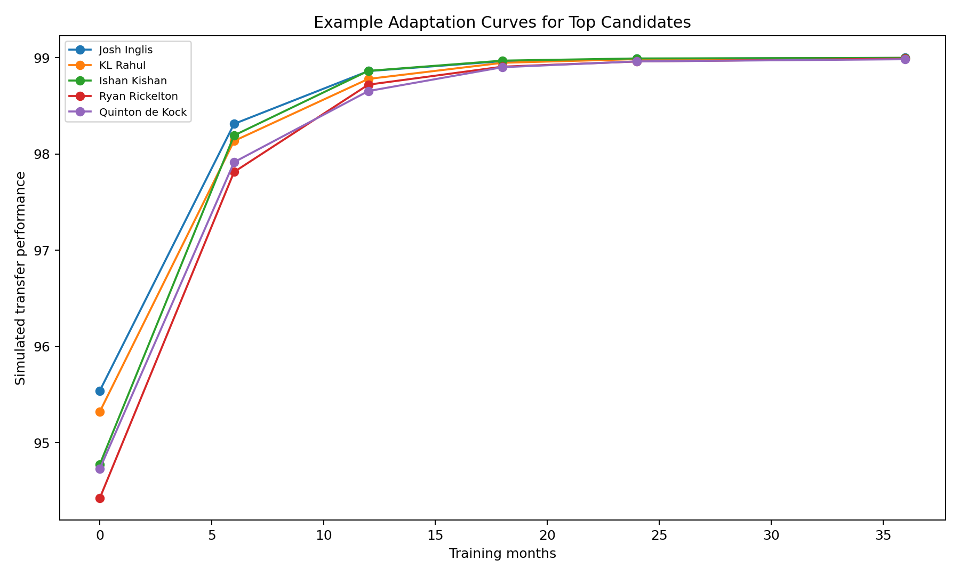
Example learning trajectories for high-ranked candidates.

Threshold probability
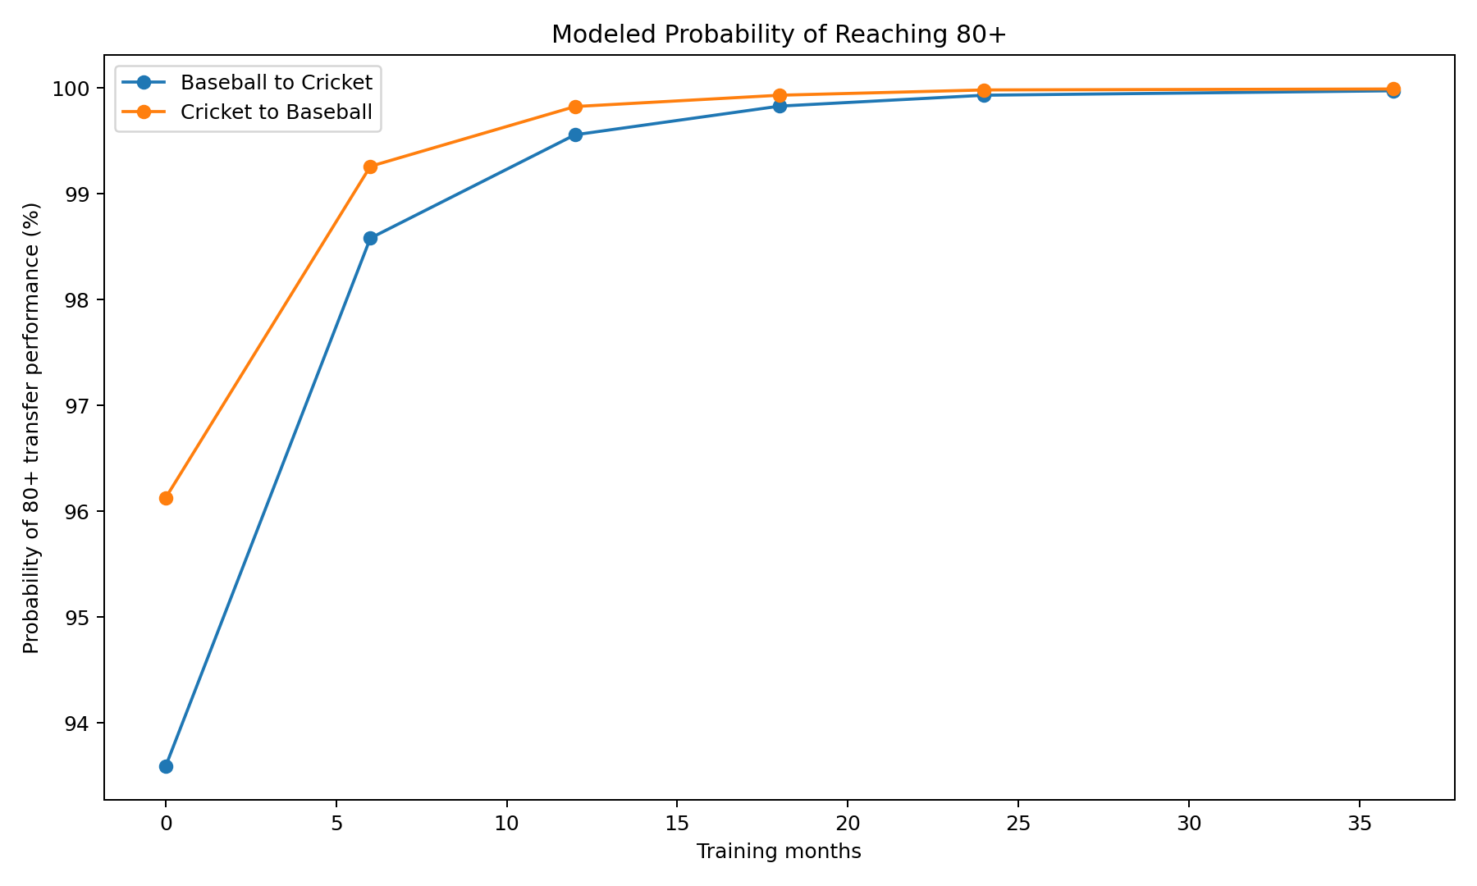
Modeled probability of reaching an 80+ transfer-performance threshold.

Correlation structure
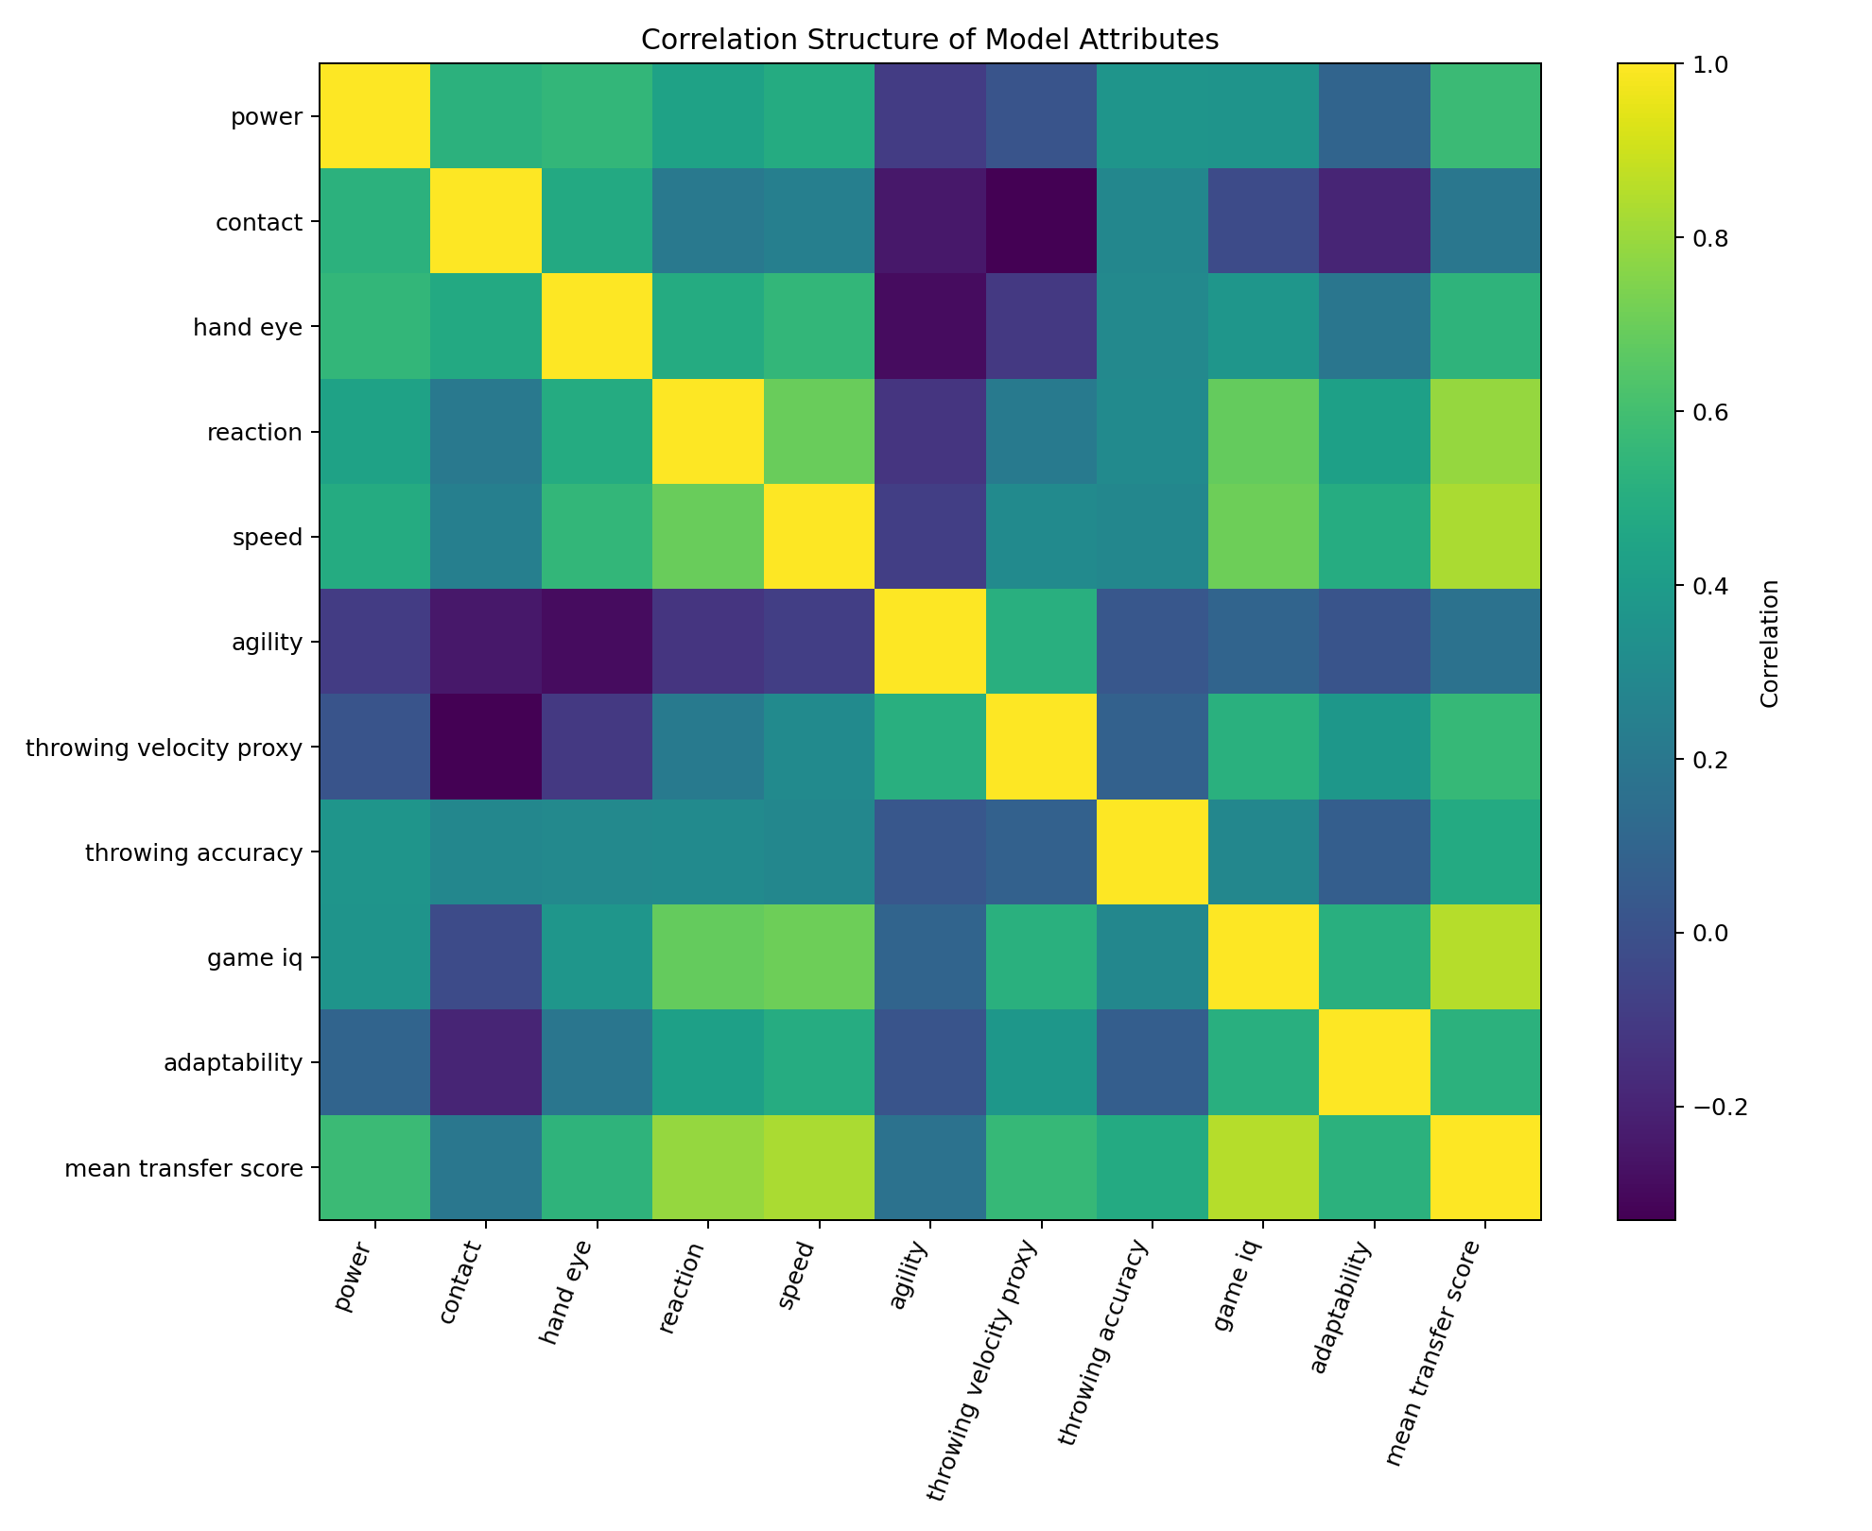
Correlation structure among model attributes and aggregate transfer score.

8. Position-Specific Transfer Experiments

Cricket batter → baseball hitter
Test whether timing, hand-eye coordination and power translate to contact quality, exit velocity and chase control. The largest penalty should be unfamiliarity with baseball pitch movement and the shorter decision window.

Cricket fast bowler → baseball pitcher
The most Million Dollar Arm-like pathway. Measure arm speed, accuracy, repeatability and kinetic sequencing while imposing a large initial mechanics penalty.

Cricket wicketkeeper → baseball catcher
Model receiving, blocking, rapid transfer, throwing and tactical decision-making separately.

Baseball pitcher → cricket fast bowler
Test whether throwing velocity and repeatable mechanics create a high ceiling after accounting for the legal bowling action and cricket-specific run-up/release.

Baseball hitter → cricket batter
Test whether bat speed, hand-eye coordination and pitch recognition transfer to bounce prediction and shot selection.

Baseball outfielder/infielder → cricket fielder
Test reaction, sprinting, catching, throwing accuracy and decision-making under cricket's spatial demands.

9. Real-World Validation Experiment
A rigorous follow-up would recruit 20–40 athletes from each sport, stratified by role and skill level. Participants would complete standardized tests before training, then receive 6, 12, 18 and 24 months of cross-sport training. Tests should include throwing velocity/accuracy, sprint and agility, bat speed, reaction time, ball tracking, sport-specific hitting/bowling/pitching tasks and game-like decision tasks. Matched native-sport control groups would establish expected development without transfer.
The measured outcomes could be used to fit the transfer coefficients with hierarchical regression or Bayesian models. Predictive validity should be evaluated with held-out athletes rather than only in-sample fit.

10. Sensitivity Analysis
Increase or decrease individual weights by 10–20% and rerun the rankings. If the same candidates remain near the top, the result is robust. If rankings change dramatically, the uncertainty should be reported. A stronger extension is Latin-hypercube sampling across all transfer weights, producing a distribution of rankings rather than one ranking.

11. Threats to Validity
- Selection bias: the sample intentionally contains high-level and famous athletes.
- Measurement mismatch: cricket and baseball do not define all skills identically.
- Age and career stage can dramatically affect the transfer ceiling.
- Role mismatch means a cricket all-rounder is not automatically equivalent to a baseball two-way player.
- Equipment and field dimensions alter the demands of each sport.
- Training access and coaching quality are not fully modeled.
- Psychological adaptation is only approximated by the adaptability variable.
- Injury risk and long-term durability are not fully modeled.
- Famous players are easier to evaluate, creating survivorship and availability bias.

12. Future Research
- Replace estimated inputs with official MLB/Statcast and official cricket data.
- Add age, height, weight, handedness, sprint tests, jump tests and other measurable athletic variables.
- Add pitch/delivery tracking: velocity, movement, spin, release and location.
- Fit transfer coefficients using actual cross-sport training trials.
- Build separate models for T20, ODI and Test cricket and for MLB pitcher/hitter/fielding roles.
- Add economics: signing probability, development cost, time-to-minors and expected career value.
- Create an interactive scouting dashboard with player comparison and training-plan controls.
- Add counterfactual training plans to identify which training block has the highest expected return.

13. Reproducibility
The CSV is the core player-level dataset. The XLSX contains the player pool, data dictionary and model parameters. transfer_simulation_results.csv contains Monte Carlo outputs for leading candidates at multiple training durations. The simulation is seeded for reproducibility in this version.

14. References
- Major League Baseball. MLB player statistics and Statcast resources.
- Baseball Savant. Statcast glossary and metrics documentation.
- International Cricket Council. Official cricket rankings and player/competition information.
- Cooper, J. (2013). Tale of pitchers from India gets Hollywood treatment. MLB.com.
- Freeston, J., & Rooney, K. (2014). Throwing speed and accuracy in baseball and cricket players. Perceptual and Motor Skills, 118(3), 637–650.
- Cook, D. P., & Strike, S. C. (2000). Throwing in cricket. Journal of Sports Sciences, 18(12), 965–973.
- Dutton, M., Gray, J., Prins, D., Divekar, N., & Tama, N. (2020). Overhead throwing in cricketers. Journal of Sports Sciences, 38(10), 1096–1104.
- Portus, M. R., & Farrow, D. (2011). Enhancing cricket batting skill. Sports Biomechanics, 10(4), 294–305.
- Gray, R. (2017). Transfer of Training from Virtual to Real Baseball Batting. Frontiers in Psychology.

Appendix A. Dashboard Specification
Source sport → target sport → role → player → attribute profile → transfer score → uncertainty distribution → 0/6/12/18/24/36-month trajectory → comparable players → training-plan simulator.

Appendix B. Pseudocode
for player in players:
attributes = normalize(native_stats, athletic_tests)
scores = role_specific_transfer_model(attributes)
for months in [0, 6, 12, 18, 24, 36]:
ceiling = scores[target_role]
adaptation = 1 - exp(-months / tau(player))
mean = baseline + ceiling_gain * adaptation
outcome = Normal(mean, uncertainty(player))
store(outcome)
rank_players_by(expected_value, probability_above_threshold, risk_adjusted_value)

