What Drives Athletic Performance?
Identifying the Physical and Training Factors Associated with Athletic Performance in College Athletes
A Statistical Investigation of 15,000 College Athletes Across Eight Sports
Performance Science Research Project
September 2026

Abstract
This study examines which measurable physical attributes and training behaviors are most strongly associated with athletic performance among college athletes. Using a dataset of 15,000 college-aged athletes across eight sports (Athletics, Badminton, Basketball, Cricket, Football, Swimming, Tennis, and Volleyball), we tested the association between eleven physical, physiological, and training variables and a five-level performance classification (Low, Moderate, High, Very High, Excellent). Sprint speed (ρ = 0.59), muscular strength (ρ = 0.55), and jumping ability (ρ = 0.52) showed the strongest associations with performance category, followed by endurance (ρ = 0.30) and flexibility (ρ = 0.21). Training-related variables (session duration, intensity, and weekly frequency) were positively but weakly associated with performance (ρ = 0.10–0.14), and resting heart rate showed a small negative association (ρ = −0.11). A random forest classifier trained on all physical and training variables predicted performance category with 54.8% cross-validated accuracy, more than 2.7 times better than chance (20% baseline for five balanced classes), with the largest misclassifications occurring between adjacent middle categories (Moderate, High) rather than between distant ones. Contrary to expectation, the physical predictors of performance were remarkably consistent across all eight sports, suggesting a generalized athleticism factor rather than sport-specific performance profiles in this dataset. We discuss these findings in the context of performance science and note important limitations related to the dataset's cross-sectional, single-population design.

1. Introduction
Understanding what separates high-performing athletes from their peers is a central question in sport and exercise science. Performance is commonly attributed to some combination of innate physical capacity (speed, strength, power, endurance) and acquired training adaptations (volume, intensity, and consistency of practice). However, the relative importance of these factors, and whether they operate similarly across different sports, remains an empirical question that depends heavily on the population and measures studied.
This study uses a large, structured dataset of college athletes to ask a focused research question:
Which measurable physical and training characteristics are most strongly associated with athletic performance in college students?
The dataset used here is well suited to this question. It contains 15,000 athlete records with 18 variables spanning demographic information (age, gender, height, weight, BMI), physical performance tests (running time, sprint speed, jumping ability, flexibility, muscular strength, endurance), a physiological measure (resting heart rate), training behavior (session duration, activity intensity, weekly frequency), sport category, and an overall performance classification. Performance is expressed as one of five ordered categories: Low, Moderate, High, Very High, and Excellent, with exactly 3,000 athletes in each category.

1.1 Hypotheses
Building on established performance-science reasoning, we tested five hypotheses:
- H1: Greater sprint speed will be associated with higher performance.
- H2: Greater muscular strength will be associated with higher performance.
- H3: Greater endurance will be associated with higher performance.
- H4: Training frequency and intensity will show positive associations with performance.
- H5: The physical characteristics most associated with performance will differ across sports.

2. Methods

2.1 Data Source
The dataset comprises 15,000 college-aged athletes (source population described as Chinese college students), ages 17–25 (M = 20.99, SD = 2.58), with a near-even gender split (7,720 male, 7,280 female). Athletes are distributed across eight sports: Volleyball (n = 1,956), Badminton (n = 1,916), Swimming (n = 1,912), Football (n = 1,909), Tennis (n = 1,858), Athletics (n = 1,831), Basketball (n = 1,825), and Cricket (n = 1,793). The dataset contained no missing values across any of the 18 variables.

2.2 Variables
Fourteen numeric variables were analyzed: age, height, weight, BMI, running time, sprint speed, jumping ability, flexibility, muscular strength, endurance, resting heart rate, training duration, activity intensity, and exercise frequency per week. The outcome variable, performance category, is an ordered five-level classification (Low < Moderate < High < Very High < Excellent), which we additionally coded as an integer rank (0–4) for correlation and modeling purposes.

2.3 Analytic Strategy
Because the outcome is ordinal and several physical variables were non-normally distributed, we used Spearman rank correlations to quantify bivariate associations between each predictor and performance rank, and Kruskal–Wallis tests to compare each predictor's distribution across the five performance groups. We examined the speed–strength–power relationship using pairwise Spearman correlations among sprint speed, muscular strength, and jumping ability. To test whether predictor–performance relationships differed by sport (H5), we recomputed the correlation between each of the five strongest predictors and performance rank separately within each of the eight sports. Finally, to assess how well performance category could be predicted from the full set of physical and training measures, we trained a random forest classifier (300 trees, max depth 8, five-fold cross-validation, 75/25 train-test split with stratification) and extracted feature importances; we cross-checked these against standardized multinomial logistic regression coefficients. All analyses were performed in Python using pandas, scipy, and scikit-learn.

3. Results

3.1 Descriptive Overview
Table 1 summarizes the physical, physiological, and training variables across the full sample.
Variable | Mean | SD | Min | Max
Age (years) | 20.99 | 2.58 | 17.0 | 25.0
Height (cm) | 168.61 | 8.56 | 145.0 | 197.5
Weight (kg) | 64.30 | 11.16 | 40.0 | 104.5
BMI | 22.66 | 3.78 | 15.0 | 35.0
Running time (sec) | 14.99 | 1.79 | 10.0 | 21.0
Sprint speed (km/h) | 21.58 | 2.88 | 14.0 | 32.0
Jumping ability (cm) | 43.11 | 9.39 | 20.0 | 76.9
Flexibility (cm) | 30.00 | 5.97 | 15.0 | 55.0
Muscular strength (kg) | 50.79 | 13.93 | 20.0 | 100.0
Endurance (min) | 42.07 | 9.97 | 15.0 | 78.3
Heart rate (bpm) | 149.96 | 11.98 | 115.0 | 190.0
Training duration (min) | 119.75 | 35.03 | 30.0 | 252.0
Activity intensity (0–10) | 6.00 | 1.39 | 1.0 | 10.0
Exercise frequency (days/wk) | 4.02 | 1.48 | 1.0 | 7.0
Table 1. Descriptive statistics for all numeric variables (N = 15,000).

3.2 Physical Attributes and Performance
All physical performance variables were significantly associated with performance category (Kruskal–Wallis p < .001 for every variable). Sprint speed showed the strongest association (ρ = 0.59), followed by muscular strength (ρ = 0.55), jumping ability (ρ = 0.52), endurance (ρ = 0.30), and flexibility (ρ = 0.21). Running time, which is inversely related to speed, showed the expected negative association (ρ = −0.22). Figure 1 shows the full correlation structure among predictors and performance rank.
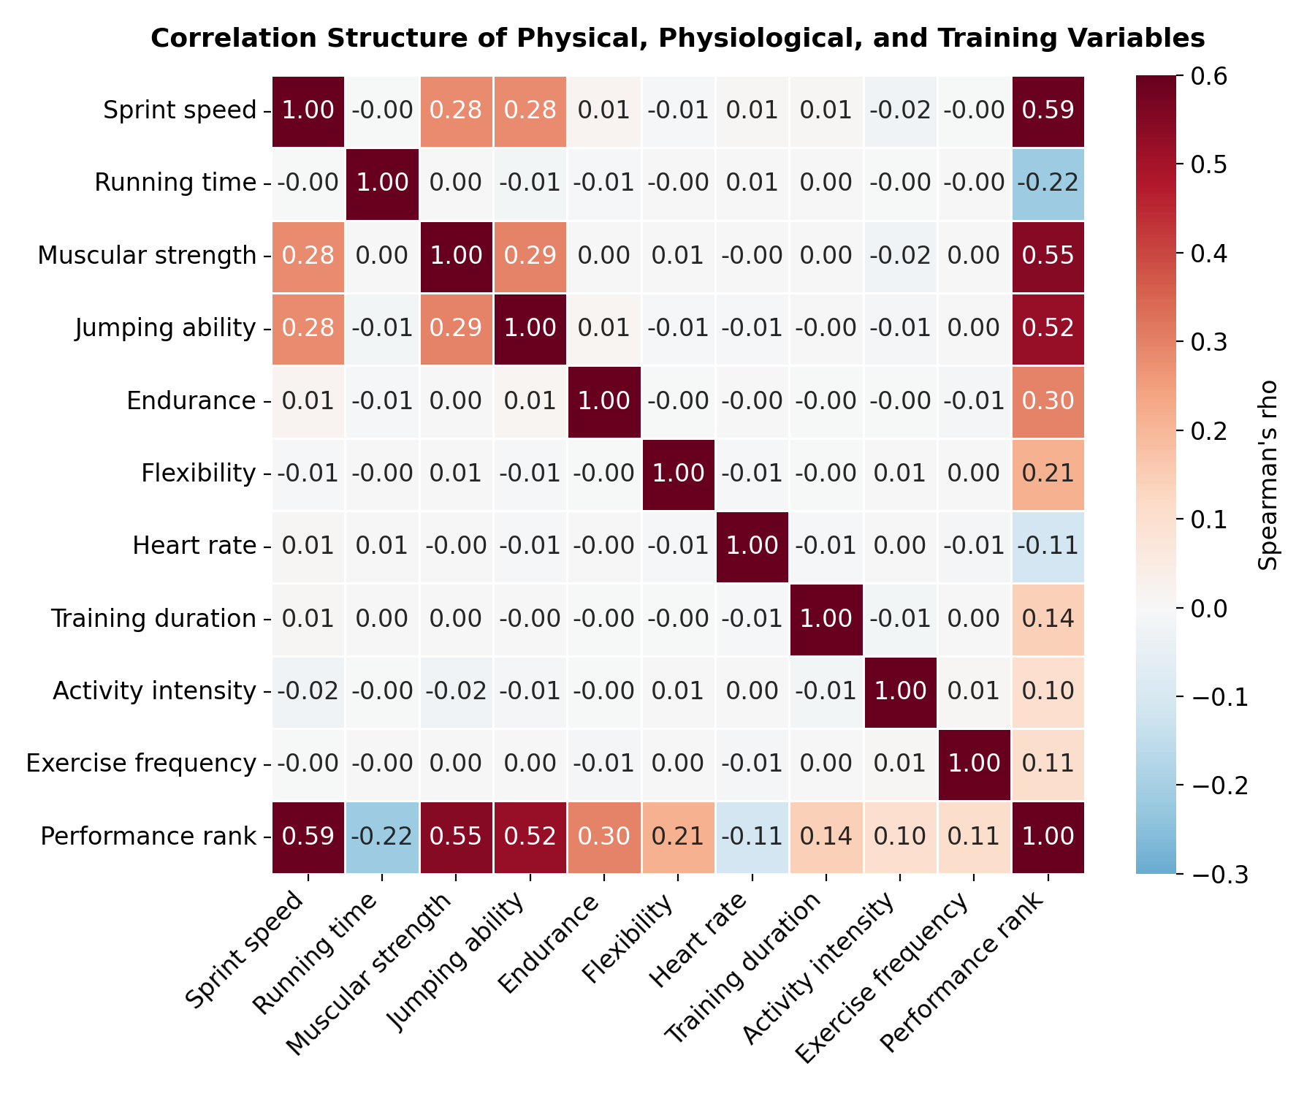
Figure 1. Spearman correlation matrix of physical, physiological, and training variables with performance rank.
Figure 2 shows how the four strongest predictors are distributed across each performance category. Each shows a clear, monotonic increase from Low to Excellent, supporting H1, H2, and H3.
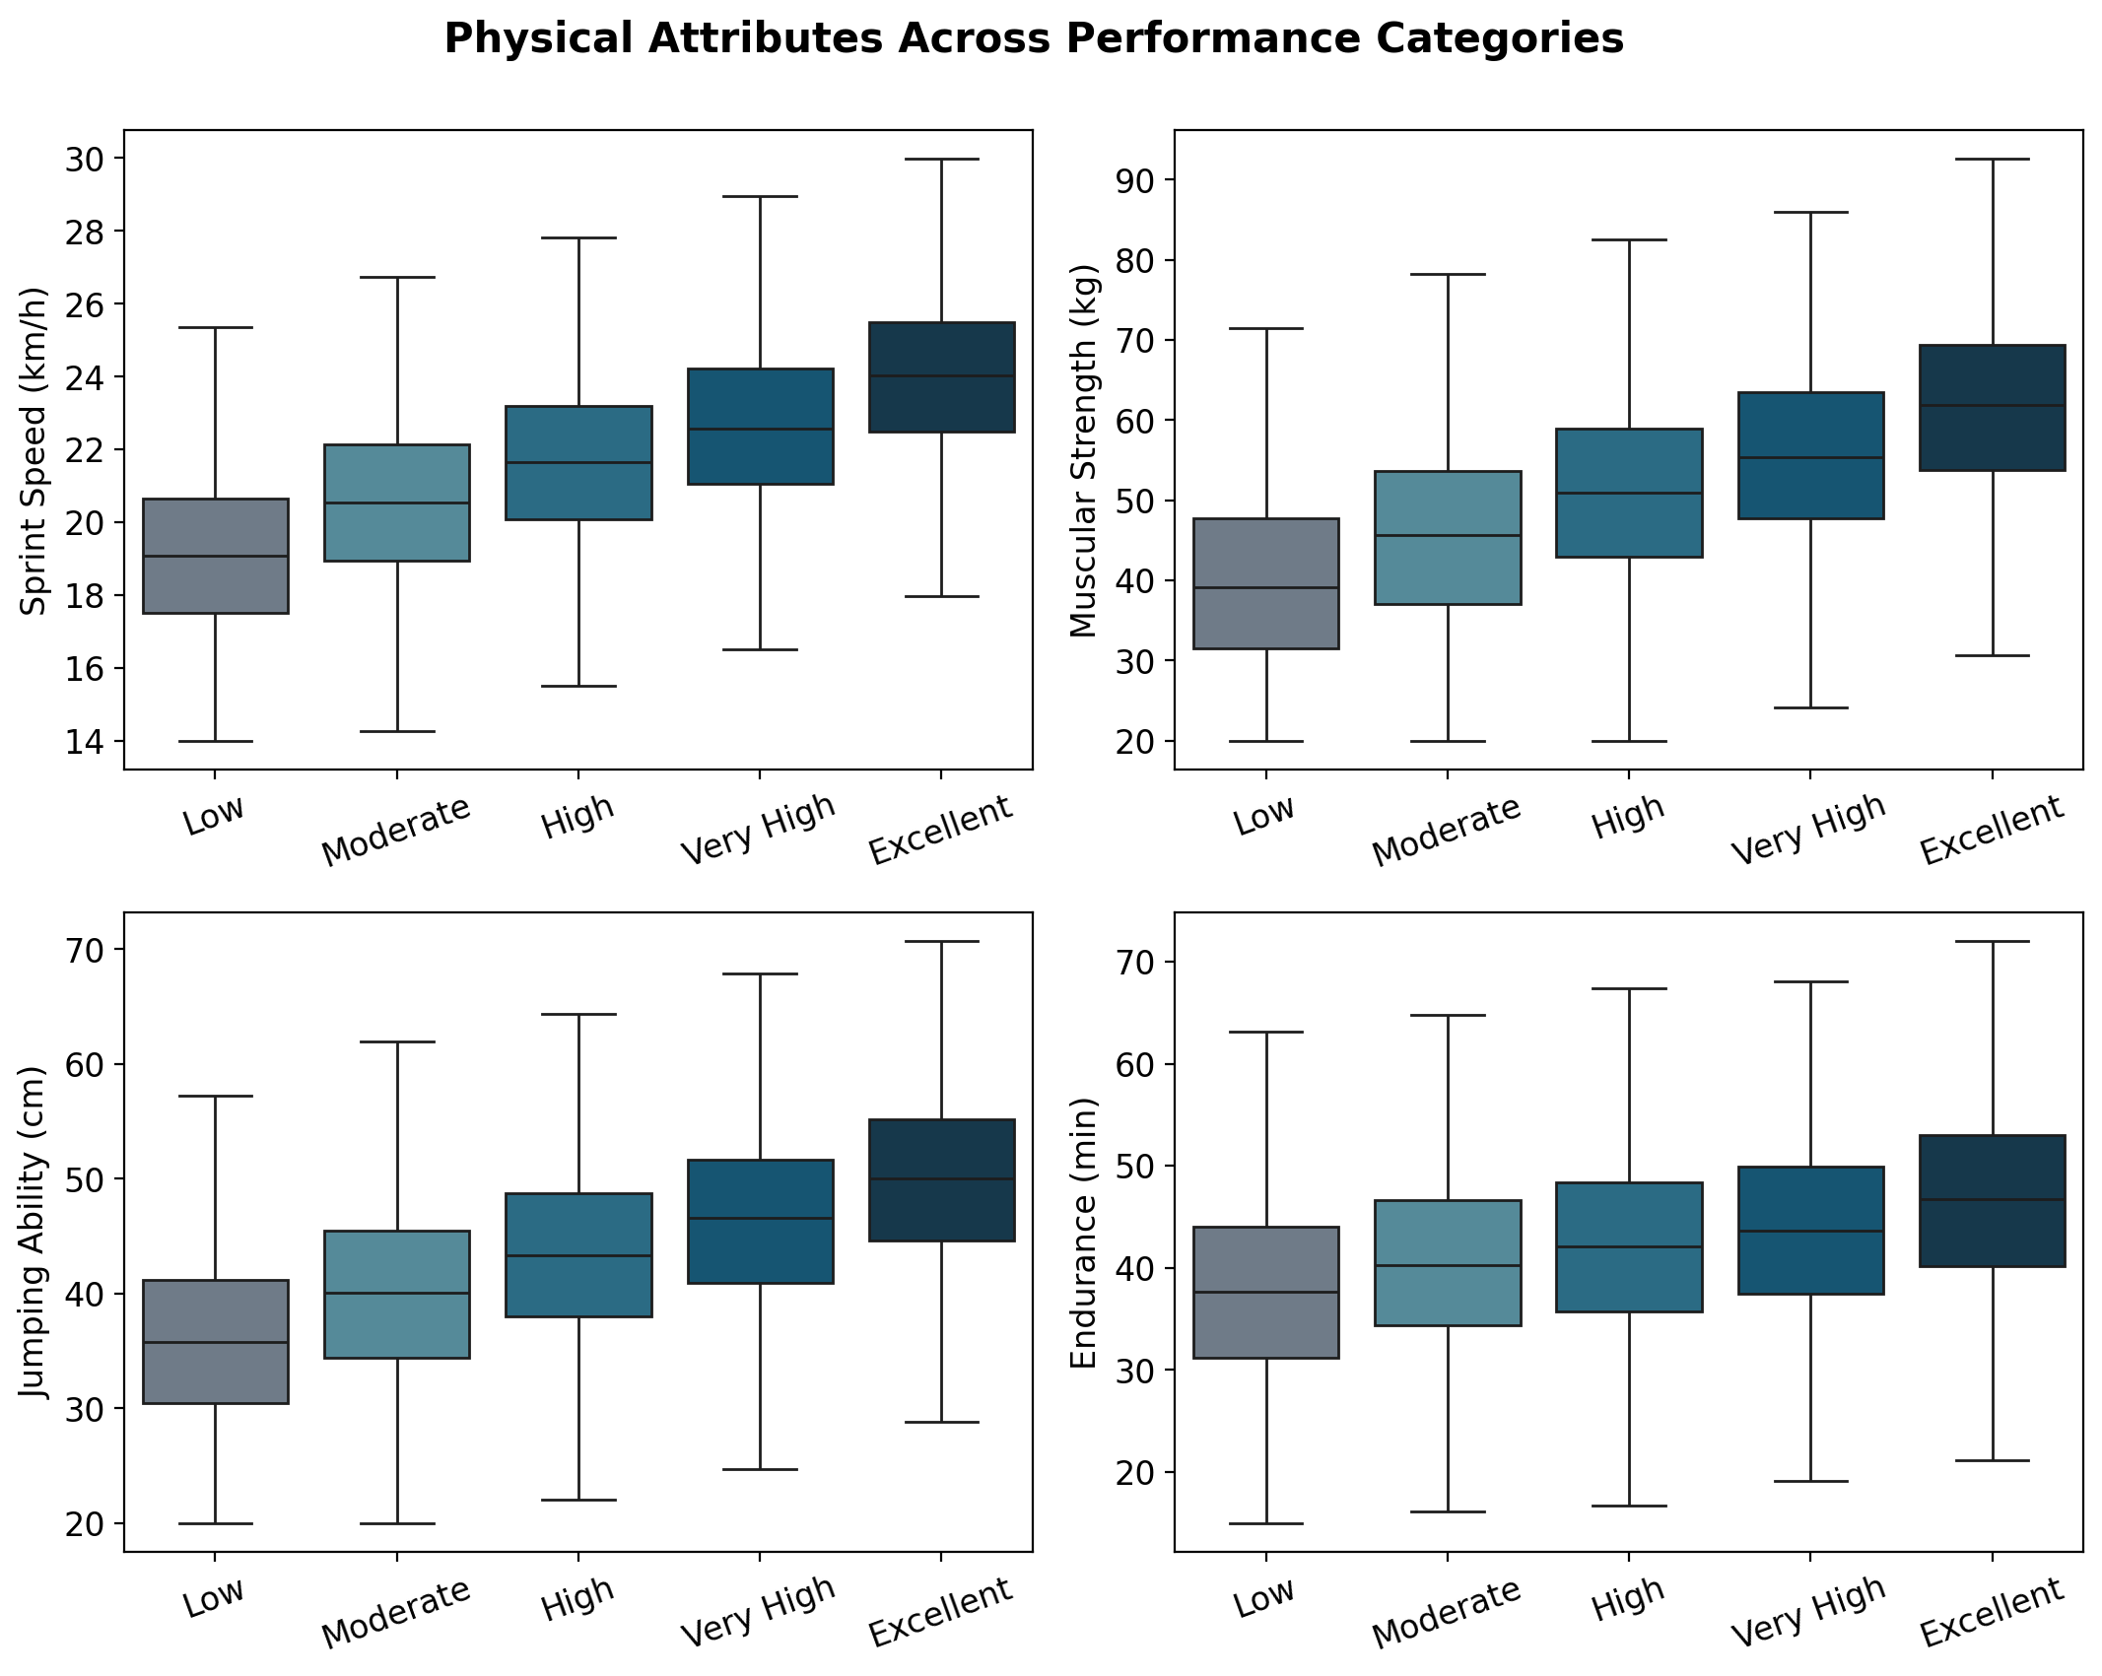
Figure 2. Distribution of sprint speed, muscular strength, jumping ability, and endurance across the five performance categories.

3.3 The Speed–Strength–Power Connection
Consistent with performance-science expectations, sprint speed, muscular strength, and jumping ability were positively intercorrelated (ρ = 0.28–0.29 for all three pairs; Figure 3), indicating a shared underlying power/explosiveness component even though each also carries independent variance related to performance.
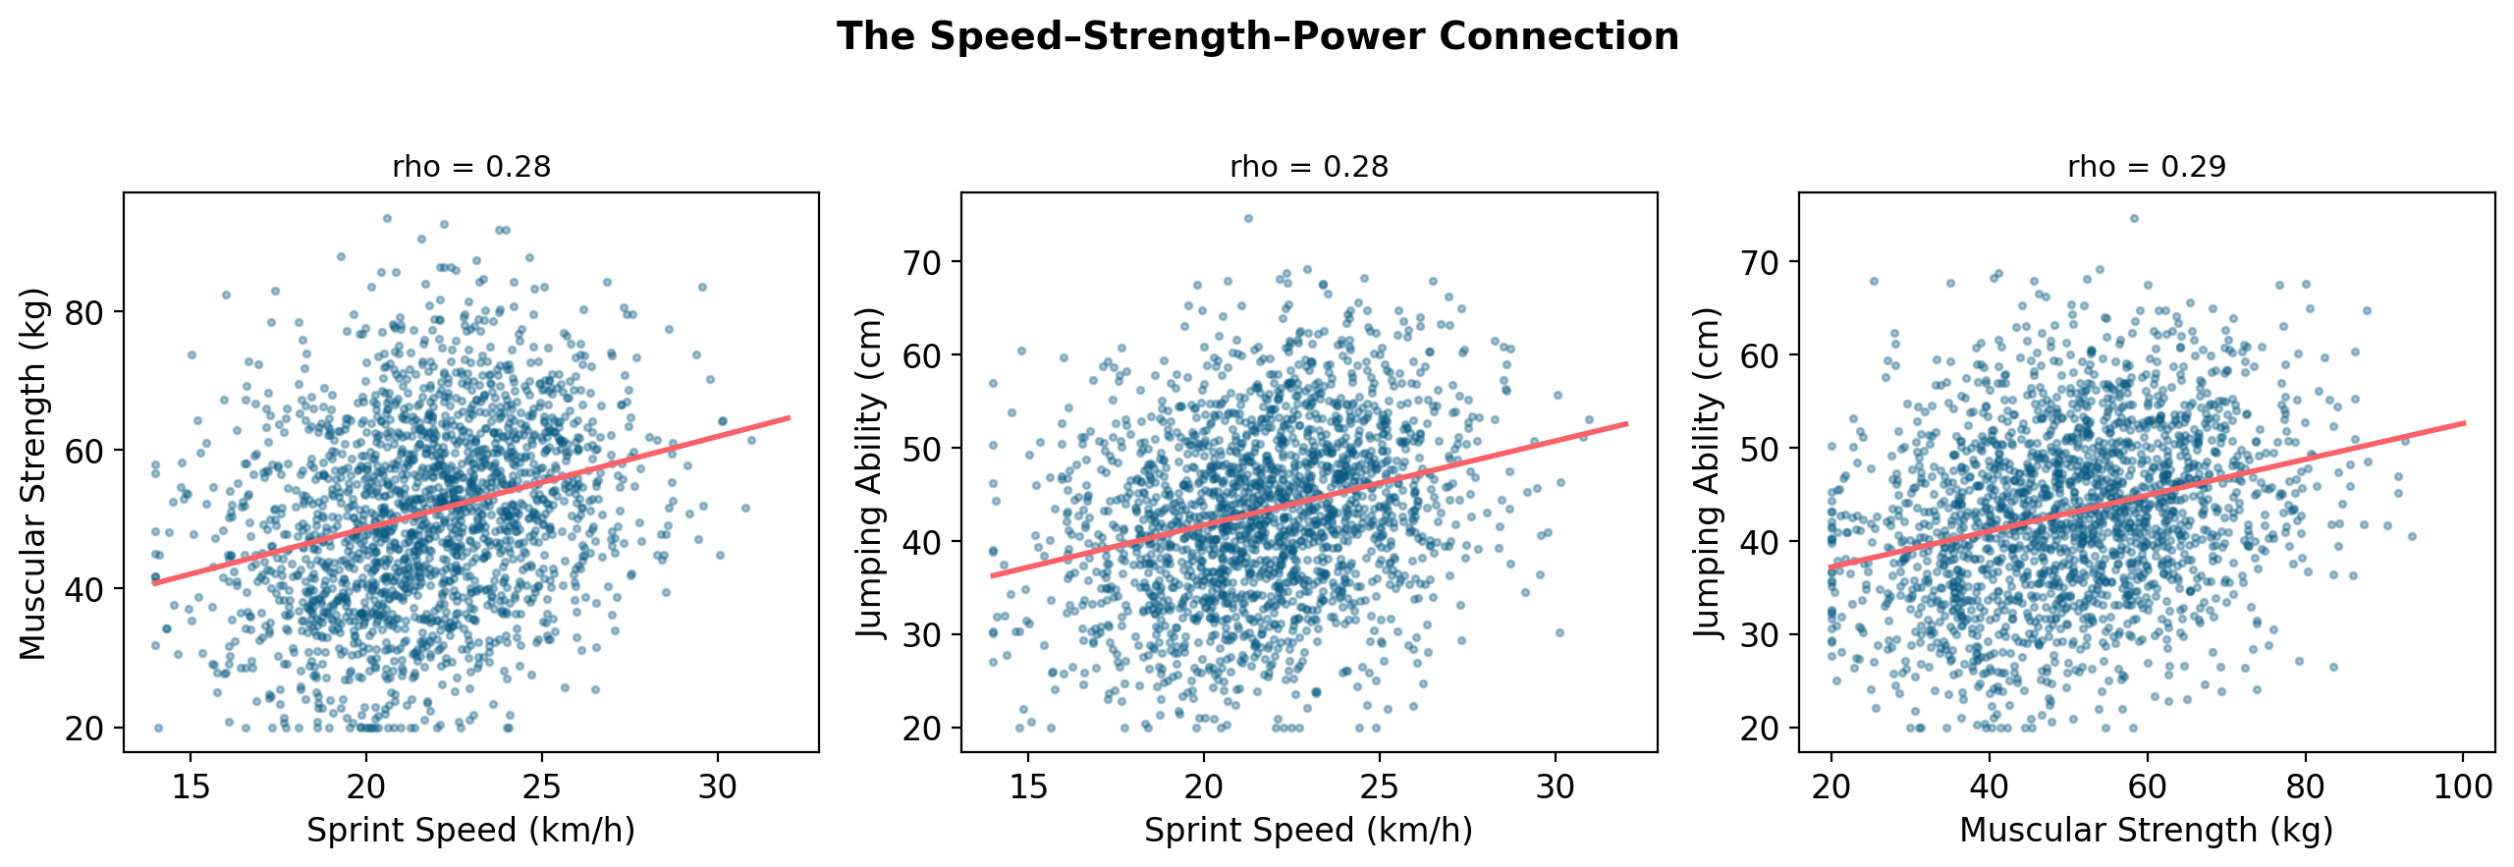
Figure 3. Pairwise relationships among sprint speed, muscular strength, and jumping ability (n = 2,000 random sample shown; red line = linear fit).

3.4 Heart Rate and Cardiovascular Measures
Resting heart rate showed only a weak negative association with performance rank (ρ = −0.11, p < .001) and was essentially uncorrelated with endurance, running time, or sprint speed (all |ρ| < 0.02). This suggests that, in this dataset, resting heart rate carries little independent information about cardiovascular fitness beyond what is already captured by the direct performance tests.

3.5 Training Dose and Performance
Training duration, activity intensity, and exercise frequency were each positively associated with performance rank, but the associations were modest in size (ρ = 0.14, 0.10, and 0.11, respectively; all p < .001). Figure 4 shows group means with standard-error bars: athletes in the Excellent category trained, on average, about 16 minutes longer per session and about 0.5 more days per week than athletes in the Low category, but the overlap between adjacent groups is substantial. This provides partial support for H4: the direction of the association is as predicted, but the effect size is small relative to the physical attributes.
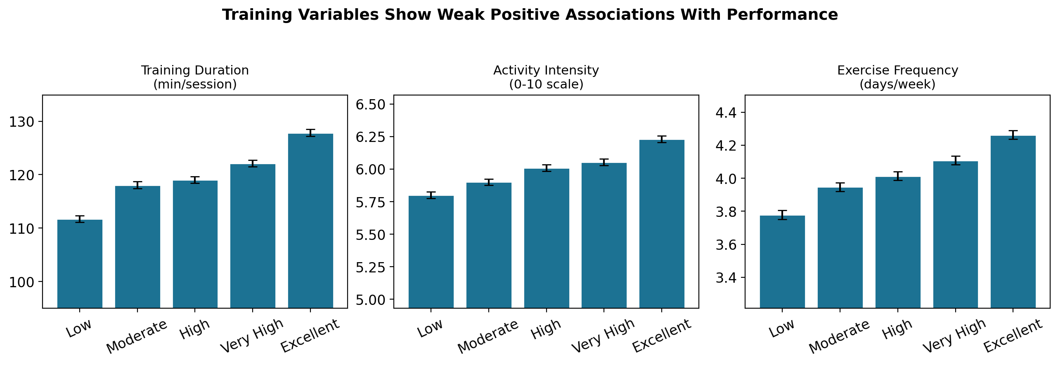
Figure 4. Mean training duration, activity intensity, and exercise frequency by performance category (error bars = ±1 SEM).

3.6 Sport-Specific Patterns
To test H5, we examined whether the predictors of performance differed across the eight sports. Contrary to our hypothesis, the same three variables — sprint speed, muscular strength, and jumping ability — were the top three predictors of performance in every single sport, with strikingly similar correlation magnitudes (Figure 5). A one-way ANOVA further showed no meaningful difference in mean performance rank across sports (F = 0.30, p = .95), indicating that performance categories are distributed identically across sports rather than varying with sport-specific physical demands.
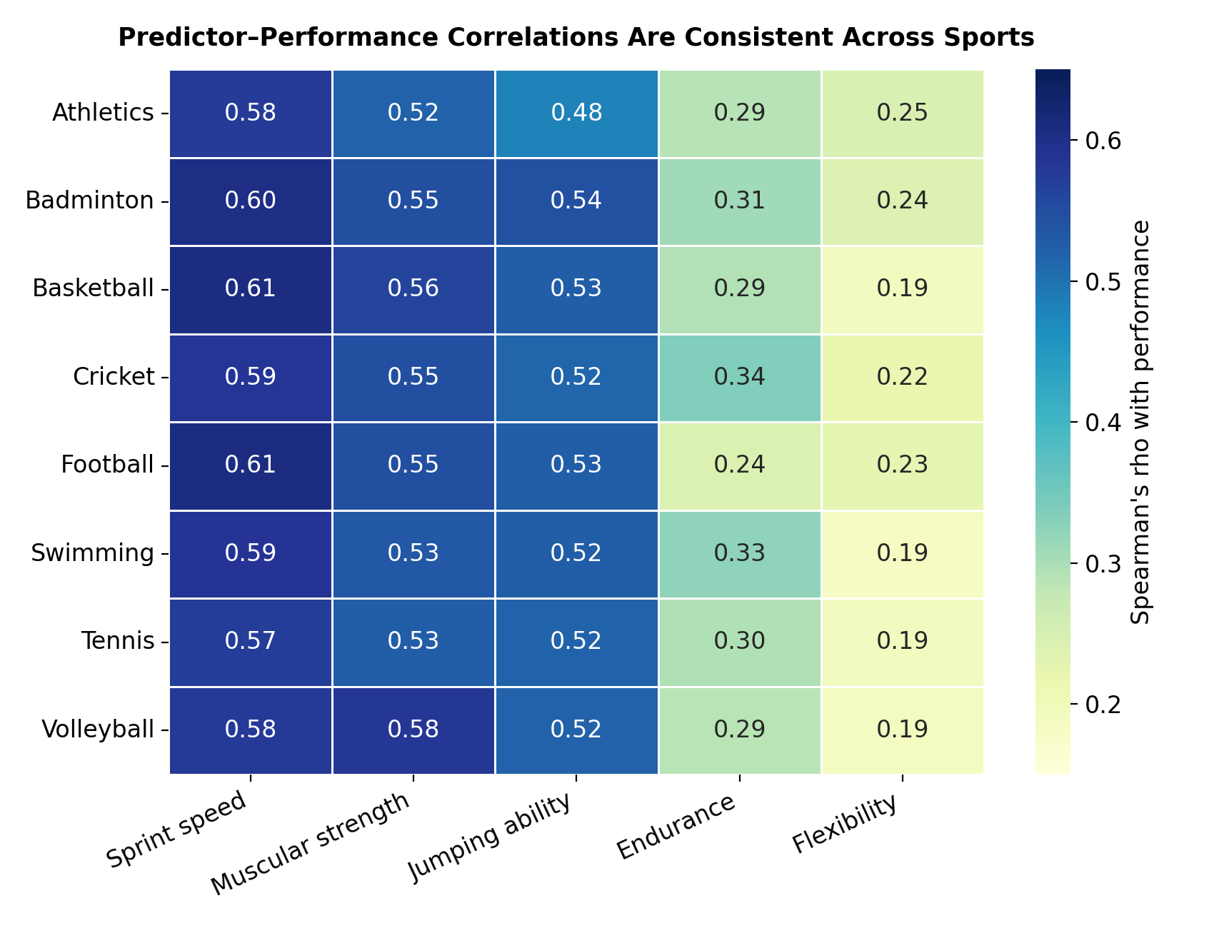
Figure 5. Correlation between each of the five strongest predictors and performance rank, computed separately within each sport.
H5 was not supported: rather than sport-specific performance profiles, the data show a single, generalized athleticism factor that predicts performance similarly regardless of sport.

3.7 Predicting Performance Category
A random forest classifier trained on all fourteen physical and training variables achieved 54.8% accuracy on a held-out test set (54.5% mean 5-fold cross-validated accuracy, SD = 0.9%) — well above the 20% baseline expected from chance across five balanced categories. Feature importances (Figure 6) closely mirrored the correlation results: sprint speed, muscular strength, jumping ability, and endurance together accounted for roughly two-thirds of total predictive weight, while training variables, heart rate, and demographic variables contributed comparatively little. A standardized multinomial logistic regression produced a consistent ranking of predictor importance.
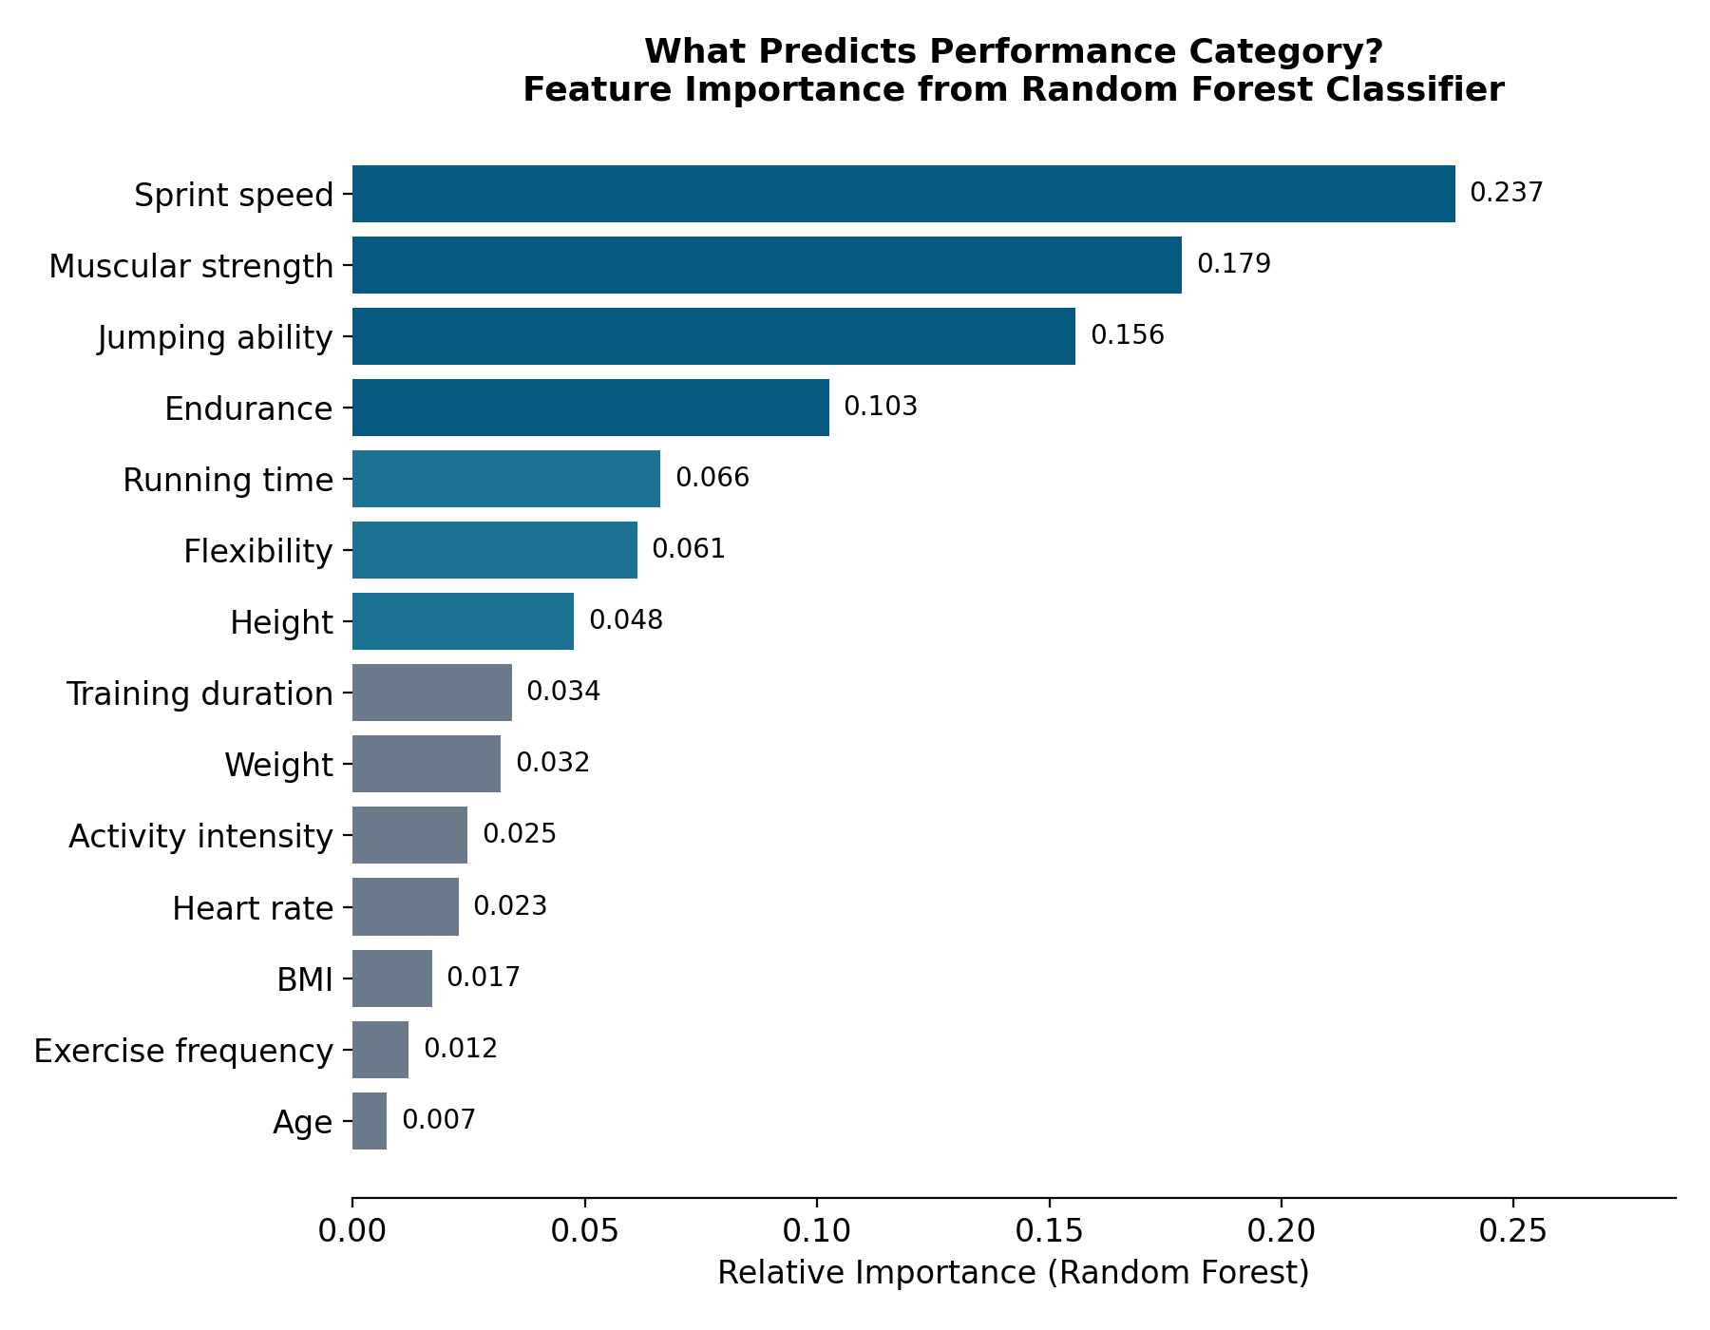
Figure 6. Random forest feature importances for predicting performance category.
The confusion matrix (Figure 7) reveals a meaningful pattern: the two extreme categories, Low and Excellent, were classified correctly 84% and 81% of the time, respectively, while the three middle categories (Moderate, High, Very High) were more frequently confused with their immediate neighbors. This is consistent with performance existing on a continuous underlying scale that has been discretized into five categories — misclassifications occur mainly at the boundaries between adjacent categories rather than at random.
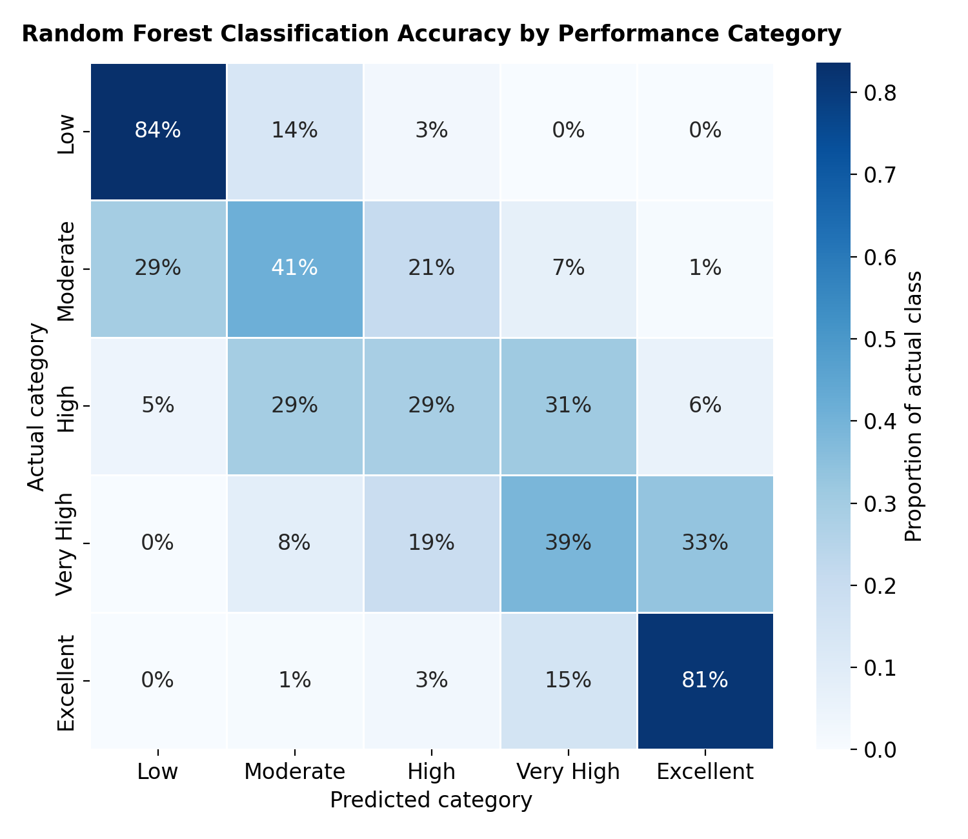
Figure 7. Confusion matrix showing the percentage of each actual performance category predicted into each category.

4. Discussion
This study set out to identify which physical and training characteristics are most strongly associated with athletic performance among college athletes. Three findings stand out. First, explosive/power-related attributes — sprint speed, muscular strength, and jumping ability — were, by a wide margin, the strongest correlates of performance, together with a meaningful contribution from endurance. This is broadly consistent with performance-science literature emphasizing power and speed qualities as central to athletic success across many sports. Second, training behaviors (how long, how hard, and how often athletes train) were positively but only weakly associated with performance in this sample. This does not mean training is unimportant; rather, it suggests that, among athletes who are already training regularly (as this sample appears to be, given a mean of about 4 sessions per week), further variation in dose has a comparatively small marginal association with the performance categories captured here — or that unmeasured aspects of training quality, technique, and periodization matter more than simple volume and frequency. Third, and most surprisingly, the physical predictors of performance were nearly identical across all eight sports. We had hypothesized that different sports would reward different physical profiles (e.g., endurance for swimming versus power for basketball), but the data instead point to a single, generalized athleticism factor that predicts performance similarly regardless of sport.
The predictive modeling results reinforce this picture. A little over half of athletes were placed in exactly the right performance category using only physical and training measures, and most of the remaining errors were between adjacent categories rather than distant ones — the model rarely confused a Low performer with an Excellent one. This pattern is what would be expected if performance is fundamentally continuous and the five labels are convenient but somewhat arbitrary cut points along that continuum.

5. Limitations
- Cross-sectional and observational design: All variables were measured at a single point in time, so results should be interpreted as associations, not causal effects. We cannot determine, for example, whether more training causes higher performance or whether higher-performing athletes simply choose to train more.
- Single, narrow population: The dataset describes college-aged athletes from a single country and age range (17–25). Findings may not generalize to professional or elite athletes, younger athletes, or other cultural and training contexts.
- Uniform sport-level relationships: The near-identical predictor patterns across sports, and the null relationship between sport and overall performance rank, are somewhat unusual for real-world sport-science data, where sport-specific demands typically produce distinct physical profiles. This raises the possibility that the performance-category label reflects a generalized fitness composite rather than sport-specific competitive success, and that finding should temper strong claims about sport-specific talent identification.

6. Conclusion
Among the physical and training characteristics available in this dataset, explosive power qualities — sprint speed, muscular strength, and jumping ability — are the strongest and most consistent correlates of athletic performance in college athletes, followed by a smaller but reliable contribution from endurance. Training dose variables matter, but their marginal association with performance is modest once physical capacity is accounted for. Contrary to expectation, these relationships hold almost identically across eight different sports, suggesting that, at least in this dataset, a generalized athleticism factor better explains performance than sport-specific physical demands. Future work with sport-specific performance metrics, longitudinal training records, and technique-level data would help clarify whether this reflects a genuine general-athleticism phenomenon or an artifact of how performance was originally categorized in the dataset.

References
Pedregosa, F., Varoquaux, G., Gramfort, A., Michel, V., Thirion, B., Grisel, O., ... & Duchesnay, É. (2011). Scikit-learn: Machine learning in Python. Journal of Machine Learning Research, 12, 2825–2830.
Virtanen, P., Gommers, R., Oliphant, T. E., Haberland, M., Reddy, T., Cournapeau, D., ... & SciPy 1.0 Contributors. (2020). SciPy 1.0: Fundamental algorithms for scientific computing in Python. Nature Methods, 17, 261–272.
Breiman, L. (2001). Random forests. Machine Learning, 45(1), 5–32.
Spearman, C. (1904). The proof and measurement of association between two things. American Journal of Psychology, 15(1), 72–101.

