Database creation:-

>>Show databases;

>>create database employeedb;

>> use employeedb;

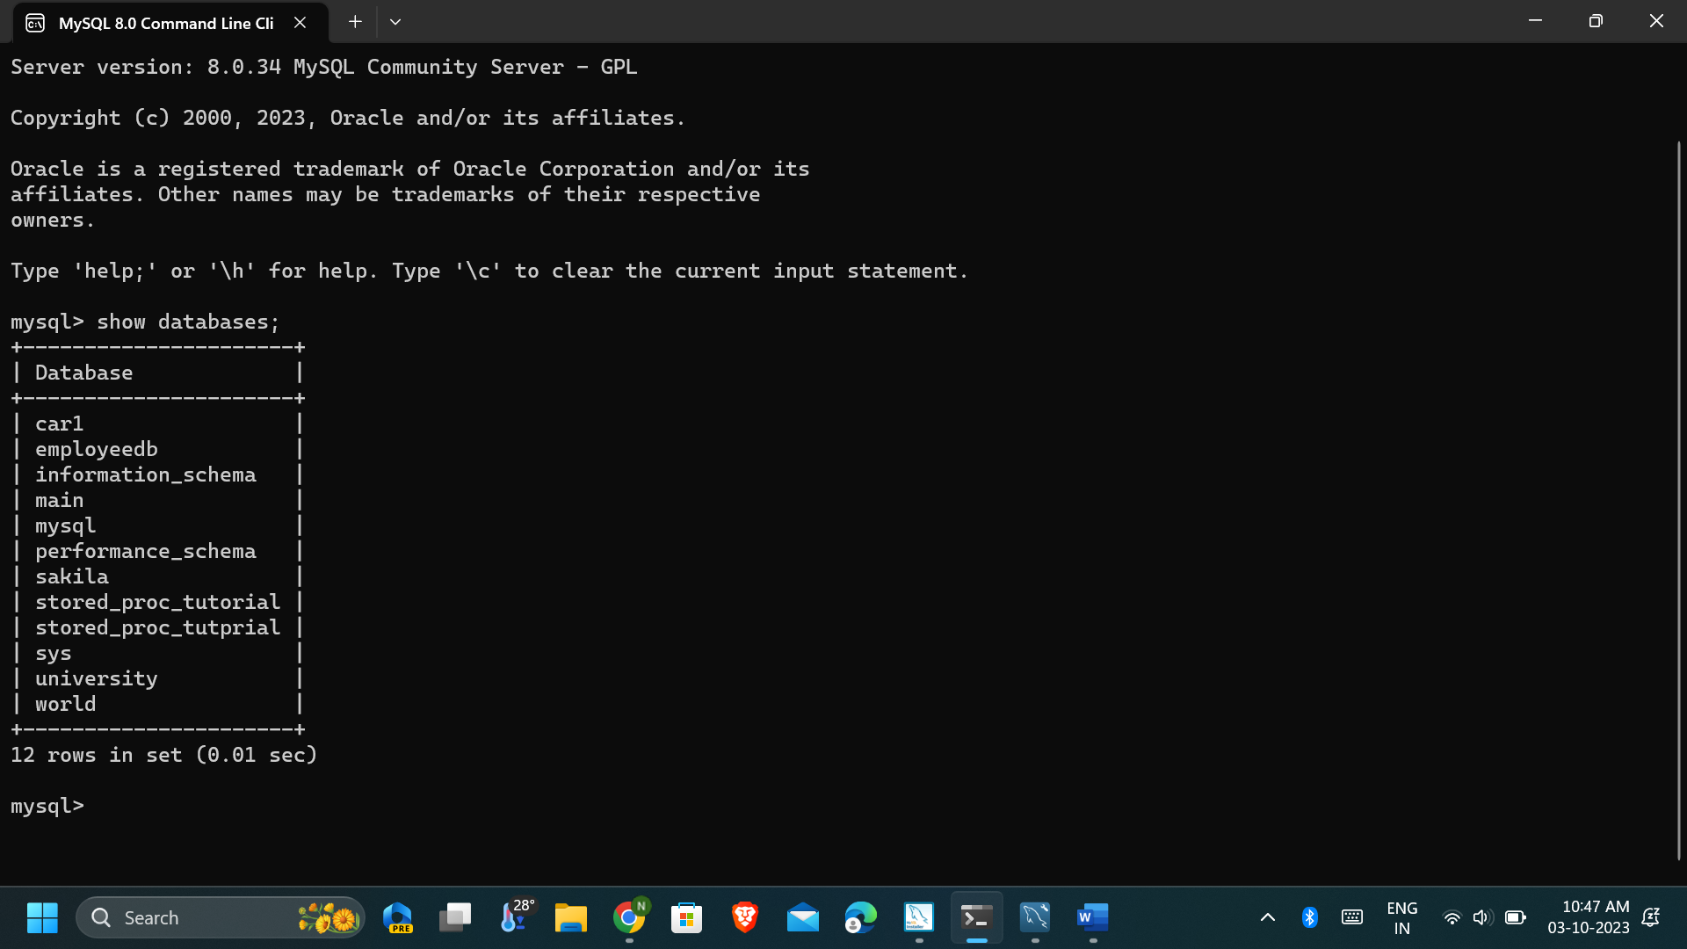

DESC the assignment_timecard Table

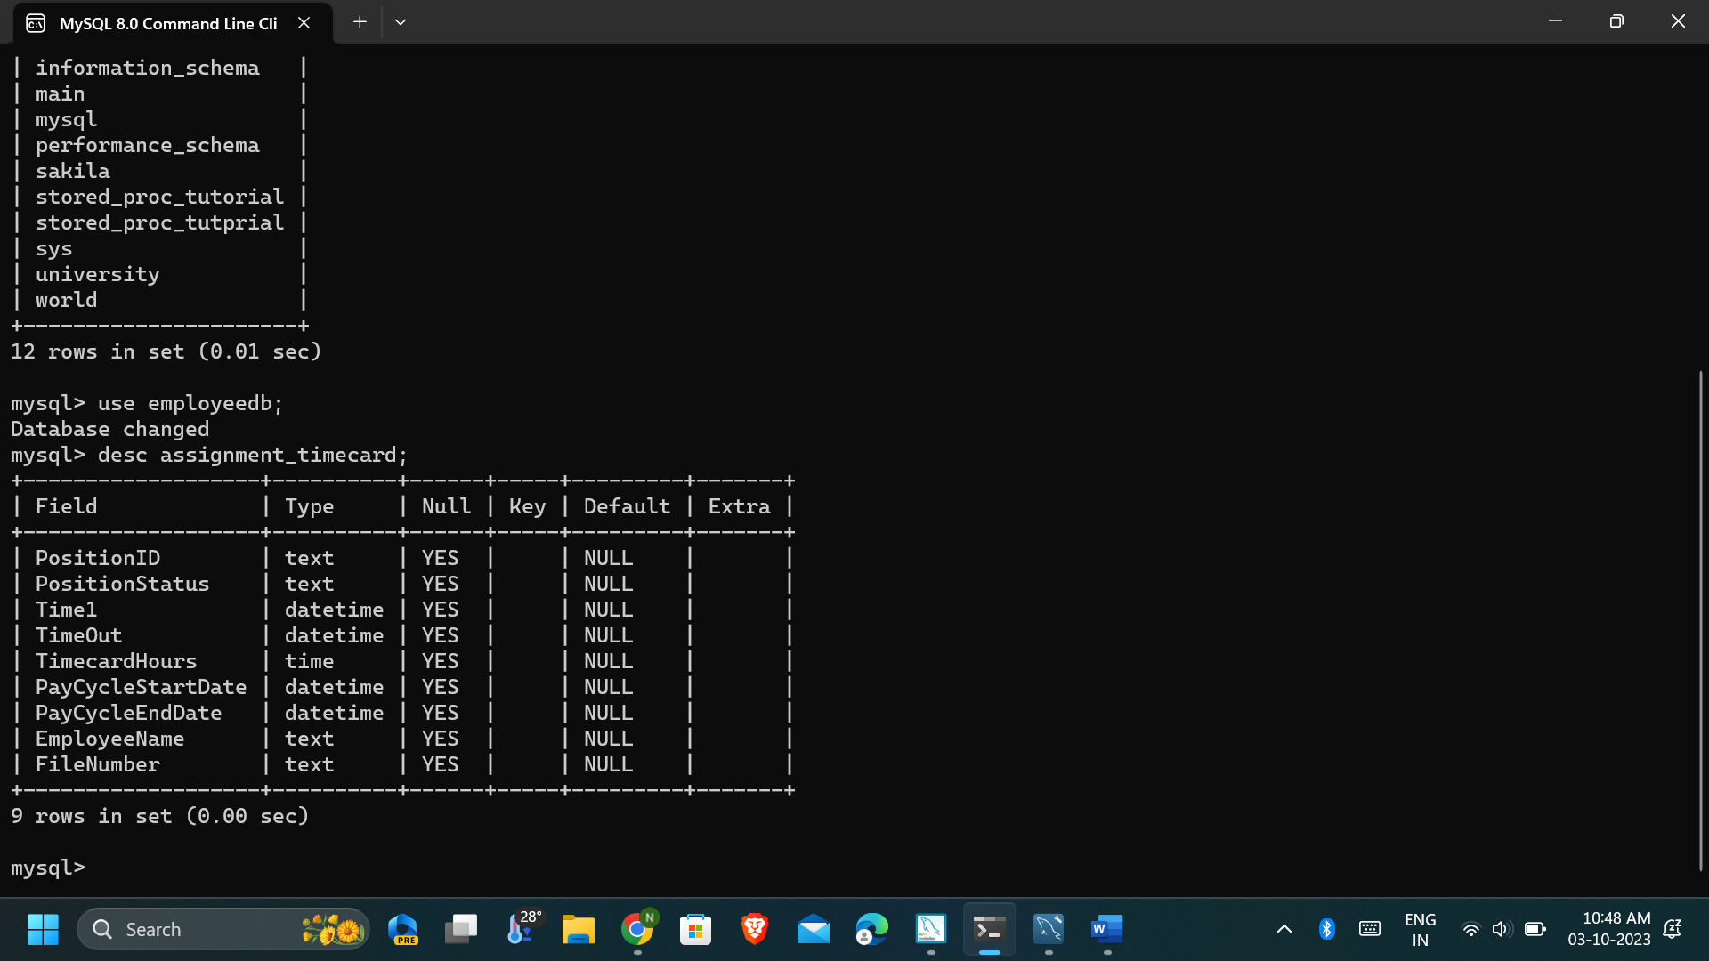

SELECT all rows from assignment_timecard

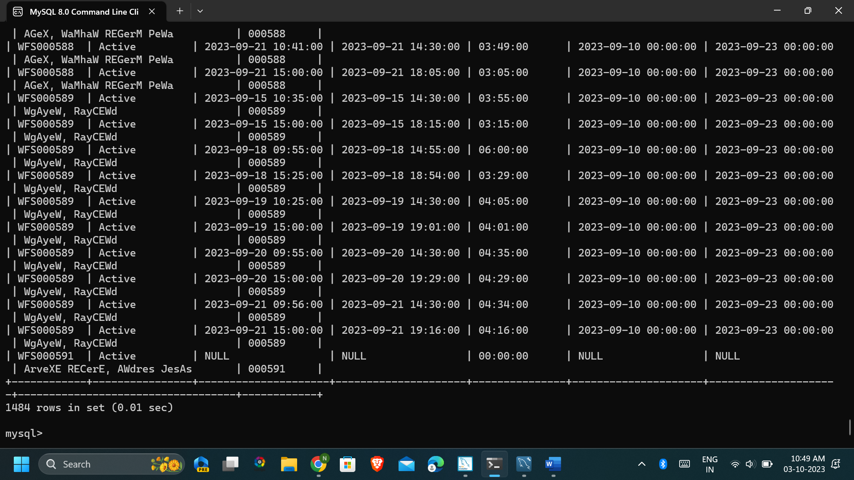

who has worked for 7 consecutive days

>>-- use employeedb;

-- select * from assignment_timecard;

SELECT

EmployeeName,

FileNumber,

COUNT(*) AS ConsecutiveDaysWorked

FROM (

SELECT

EmployeeName,

FileNumber,

DATE(Time1) AS WorkDate,

LAG(DATE(Time1), 1) OVER (PARTITION BY FileNumber ORDER BY Time1) AS PreviousWorkDate

FROM assignment_timecard

) AS subquery

WHERE DATEDIFF(WorkDate, PreviousWorkDate) = 1 OR PreviousWorkDate IS NULL

GROUP BY EmployeeName, FileNumber

HAVING ConsecutiveDaysWorked >= 7;

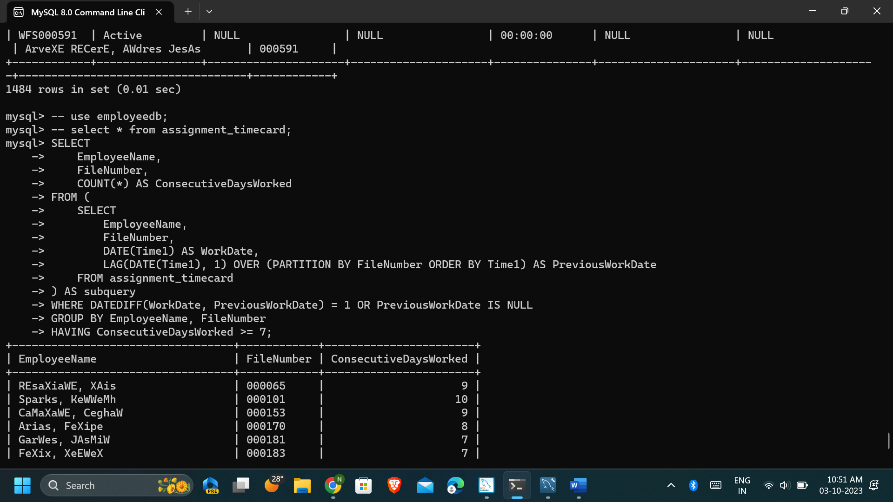

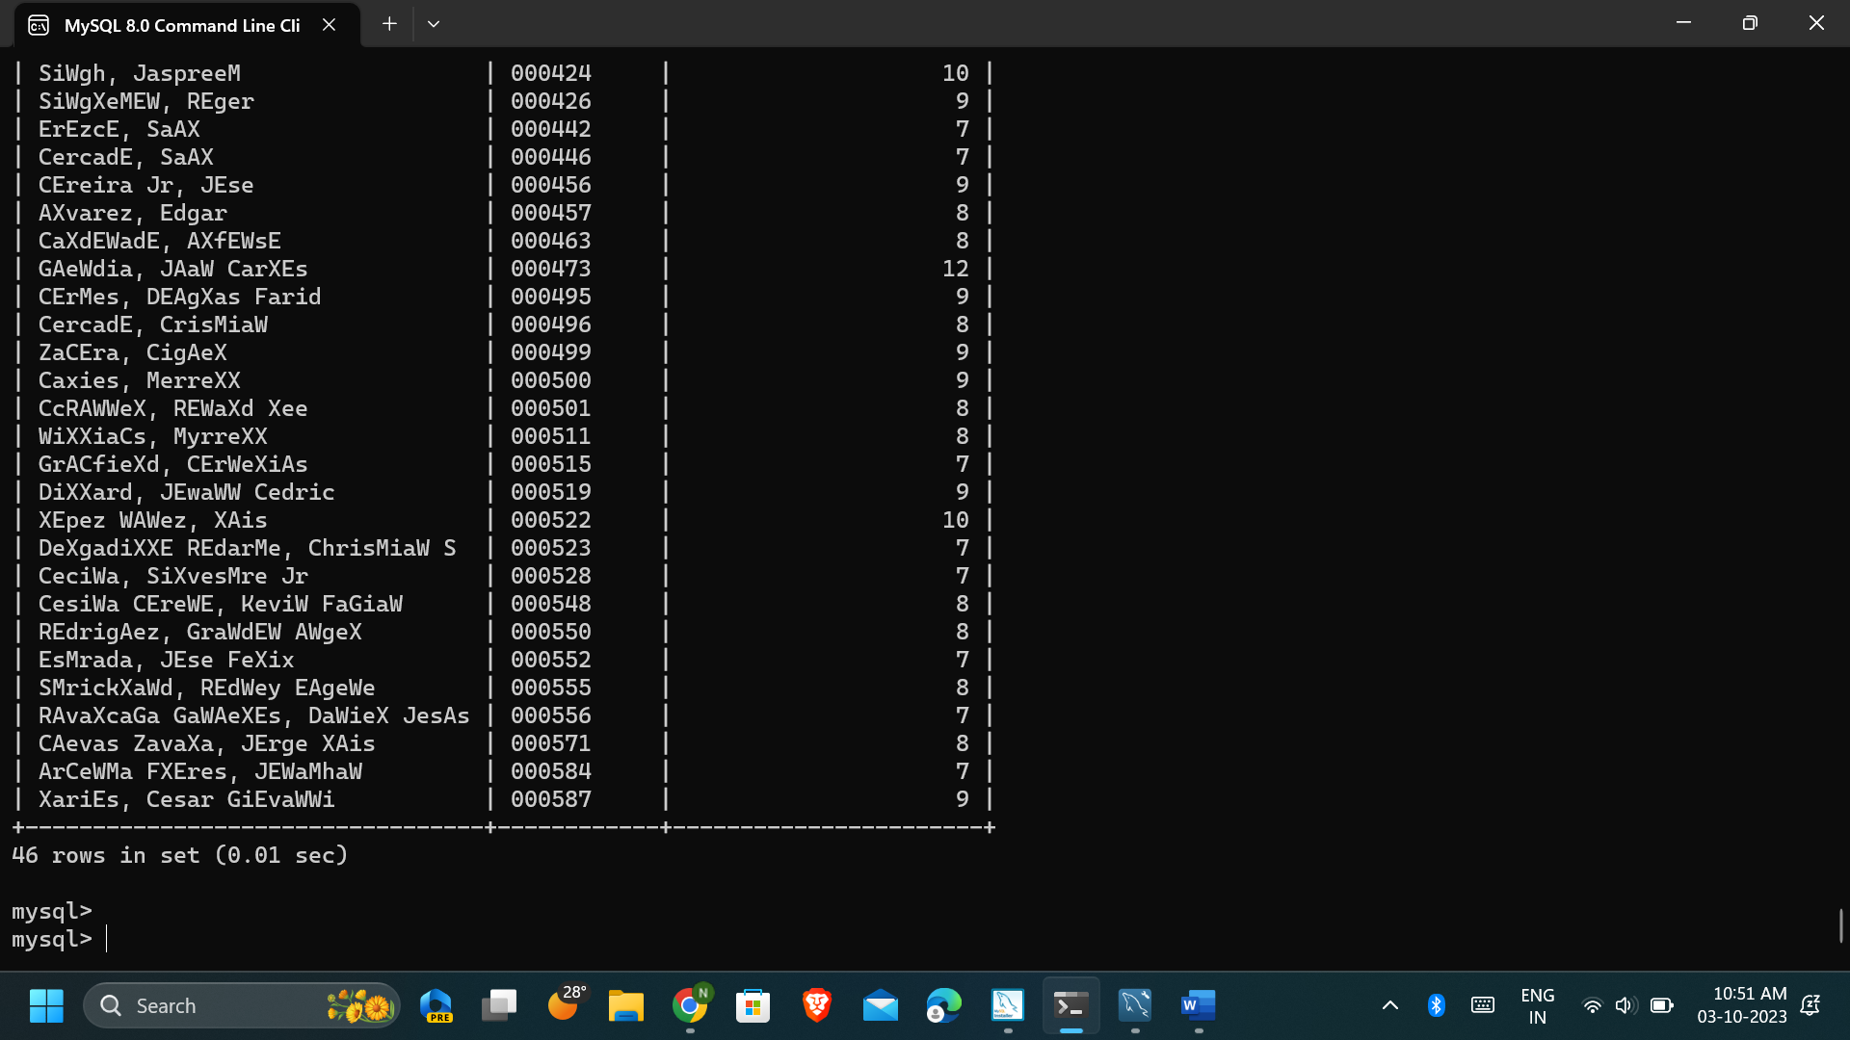

who have less than 10 hours of time between shifts but greater than 1 hour

>>SELECT

a.`PositionID`,

a.`TimeOut` AS 'FirstShiftEndTime',

b.`Time1` AS 'SecondShiftStartTime',

TIMEDIFF(b.`Time1`, a.`TimeOut`) AS 'TimeBetweenShifts'

FROM

(SELECT

`PositionID`,

`TimeOut`,

LAG(`TimeOut`) OVER (PARTITION BY `PositionID` ORDER BY `TimeOut`) AS prev_time_out

FROM

assignment_timecard) a

JOIN

(SELECT

`PositionID`,

`Time1`,

LEAD(`Time1`) OVER (PARTITION BY `PositionID` ORDER BY `Time1`) AS next_time

FROM

assignment_timecard) b

ON

a.`PositionID` = b.`PositionID`

WHERE

a.prev_time_out IS NOT NULL

AND b.next_time IS NOT NULL

AND TIMEDIFF(b.`Time1`, a.`TimeOut`) > '01:00:00'

AND TIMEDIFF(b.`Time1`, a.`TimeOut`) < '10:00:00';

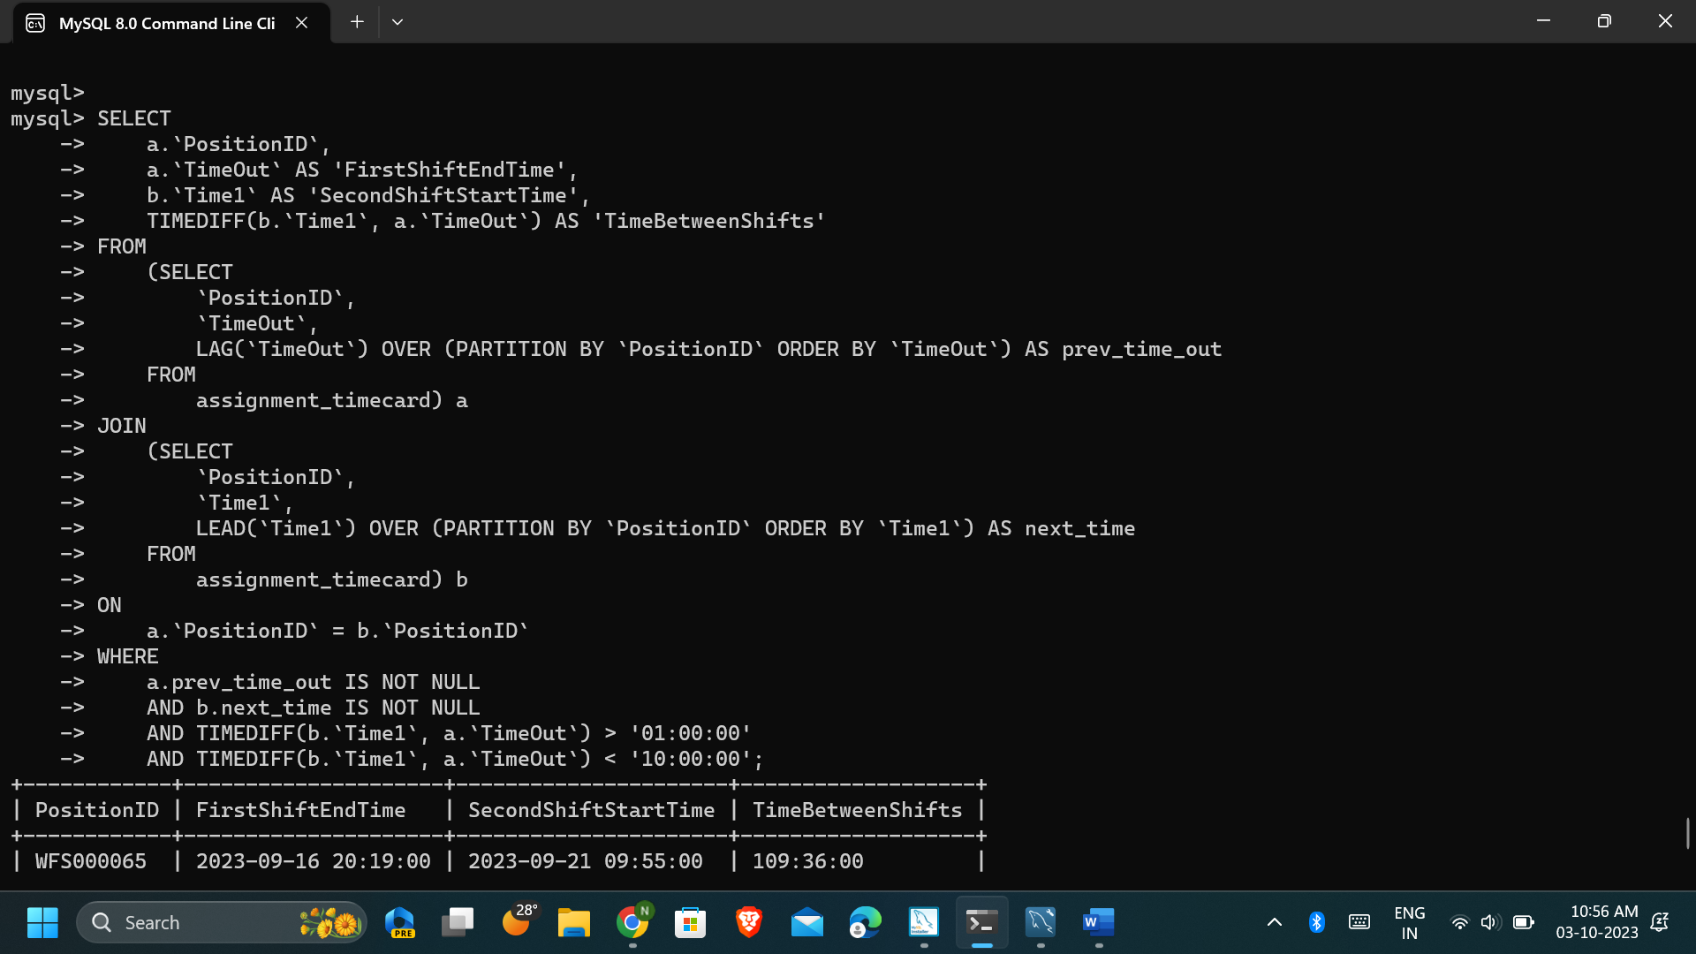

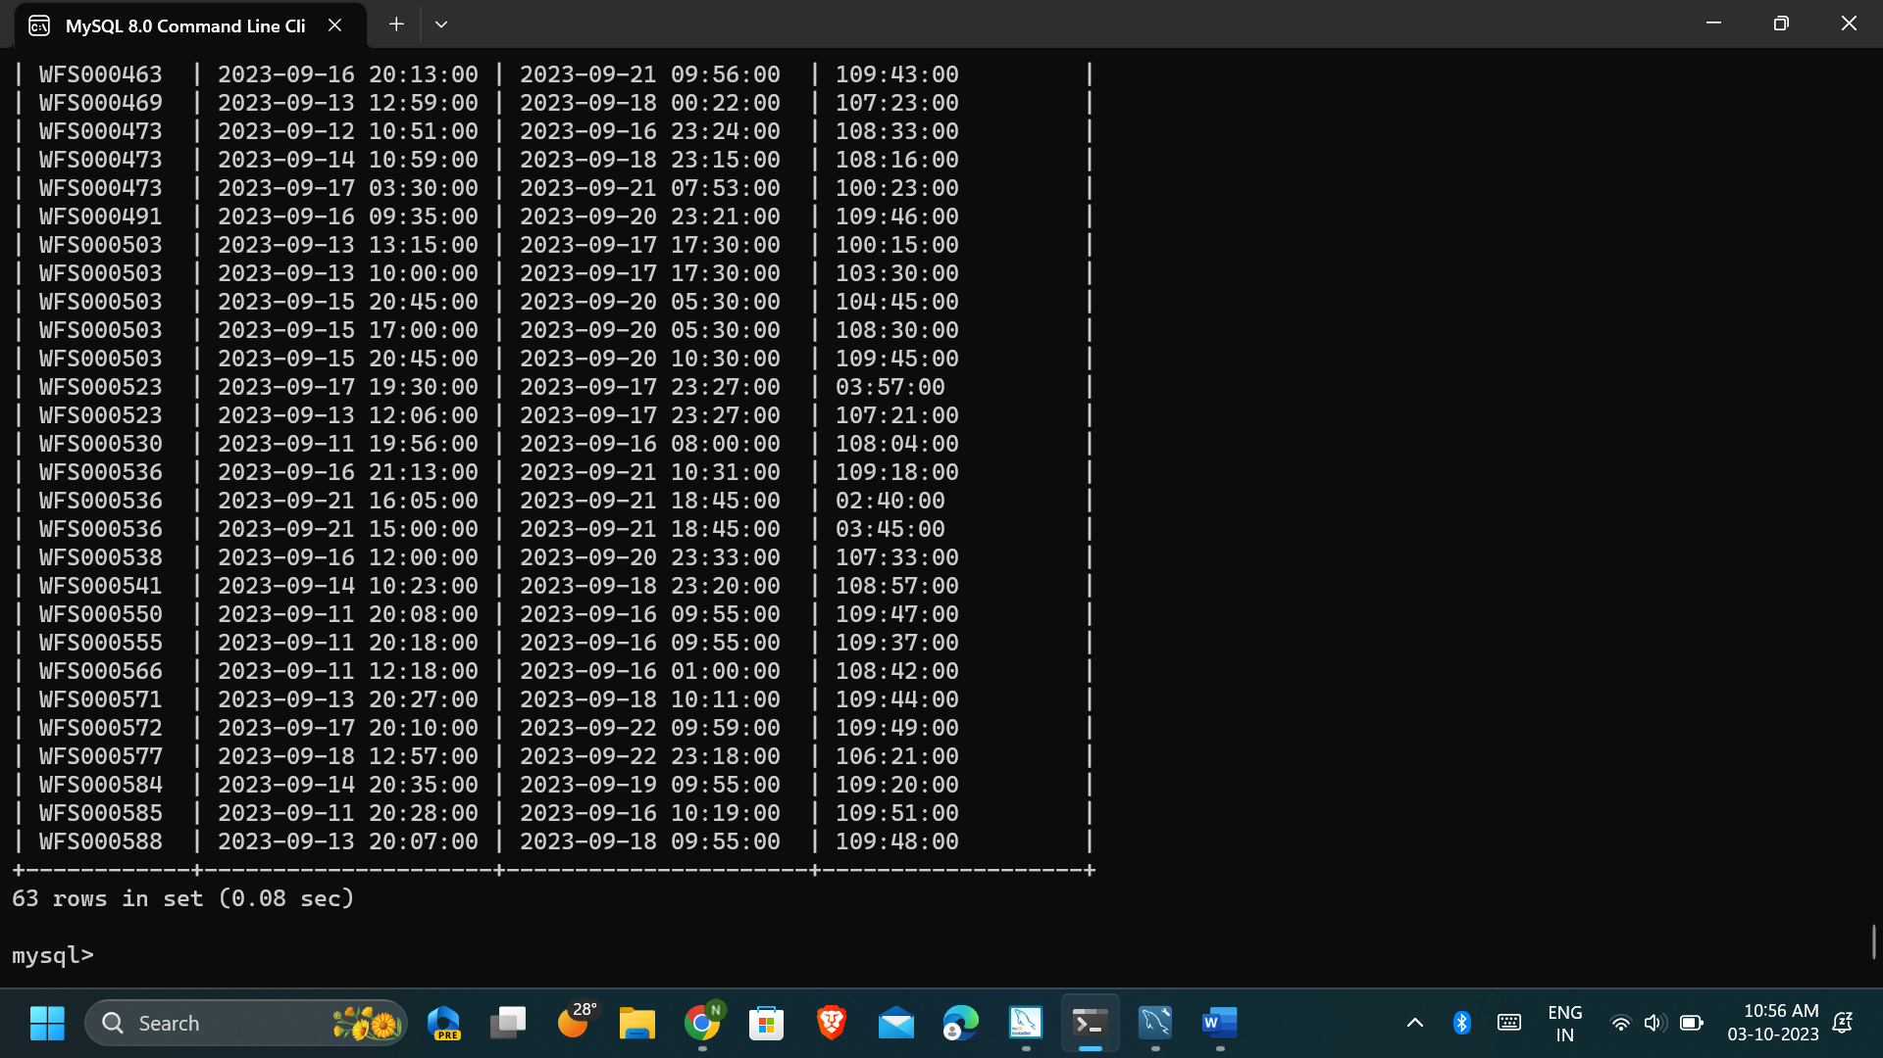

Who has worked for more than 14 hours in a single shift

>>SELECT EmployeeName,

FileNumber,

Time1,

TimeOut,

TIMEDIFF(TimeOut, Time1) AS WorkedHours

FROM assignment_timecard

HAVING WorkedHours > '14:00:00';

