**GROUP-12**

**LAKSHMI MANJUSHA YARREDDU - 11637264  
LOKESH HARINATH GONTHINA - 11702591   
RAVI TEJA JASTI - 11611550**

**JEEVAN KUMAR CHILAMKURI - 11648175**

**NYALAM NIKHIL KUMAR - 11636071**

**Phase 3: Develop a user interface**

**Use Case 1: Dog Breed Prediction:**

The provided communication diagram depicts the sequence of interactions among components within the Dog Breed Prediction application from the user's perspective to the completion of a breed prediction task.

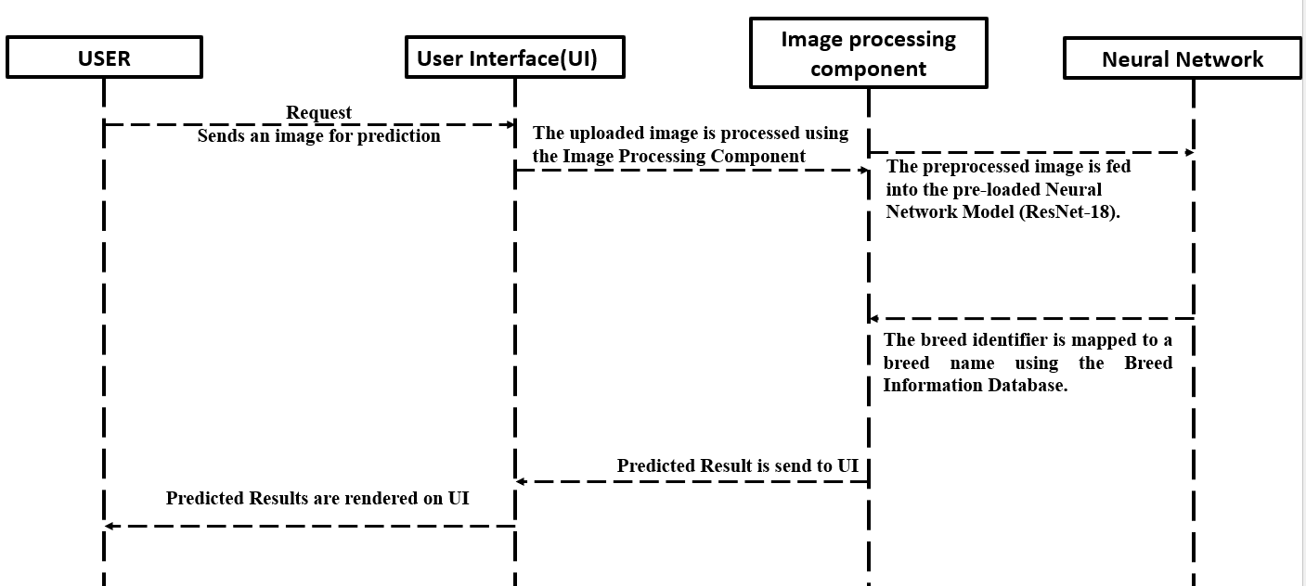

In the first interaction, a user initiates the process by sending an image through the User Interface (UI) component of the web application, which acts as the entry point for the breed prediction service. The UI is designed to be intuitive, allowing users to easily upload an image for analysis. Upon receiving the image, the UI forwards it to the Image Processing Component. This component is responsible for preparing the image for analysis by executing a series of predefined transformations. These transformations typically include resizing the image to meet the input requirements of the model, normalizing pixel values, and potentially augmenting the data to improve model performance and robustness.

Once the image has been adequately processed, it is passed to the Neural Network component, which contains the pre-loaded ResNet-18 model trained for dog breed classification. The Neural Network performs inference on the processed image, outputting a breed identifier that corresponds to its prediction. This identifier is then cross-referenced with the Breed Information Database, which contains the mappings of breed identifiers to human-readable breed names. The resulting breed name represents the model's prediction and is relayed back to the UI. Finally, the UI updates to display the predicted result, completing the flow of operations and providing the user with the information they sought. This end-to-end communication ensures a seamless experience for the user, from image upload to receiving the breed prediction.

**Use Case 2: Breed Education:**

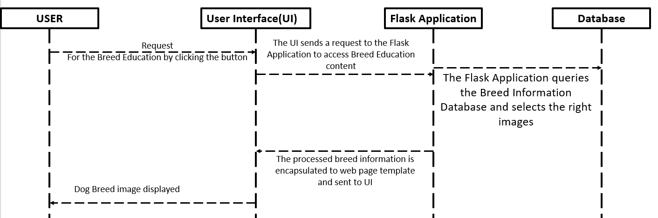

In the development of the Breed Education feature for our dog breed classification application, we have meticulously crafted a communication diagram that encapsulates the logical flow of user interactions and data processing. This diagram serves as a blueprint for the seamless exchange of information between the user interface and the underlying Flask application, culminating in the delivery of comprehensive breed-related content.

When a user expresses the desire to explore the Breed Education section, they initiate the journey by interacting with a clearly marked button on our user interface. This action triggers a request that is adeptly handled by our Flask Application, the core facilitator of our application's logic and data retrieval operations. The Flask Application, upon receiving the user's request, diligently queries our extensive Breed Information Database. This database is a curated repository of detailed breed profiles, encompassing a rich array of images and descriptive content. By selecting the most pertinent images and collating relevant information, the Flask Application ensures that each breed's unique attributes are highlighted and accessible.

The next phase involves the Flask Application weaving the retrieved information into a web page template, which is meticulously designed to optimize user engagement and knowledge acquisition. This template not only structures the content for clarity and impact but also enriches it with visual aids that foster an immersive learning experience. Once the Flask Application has interlaced the breed information within the web page, it dispatches this composite to the user interface, which dynamically renders it for the user. As a result, the user is presented with a visually enriched and informative display of dog breeds, complete with images and educational narratives that bring to light the fascinating world of canine diversity. Through this harmonized flow of interactions and data, our Breed Education feature stands as a testament to our commitment to providing an enriching and informative platform for dog lovers and enthusiasts alike.