

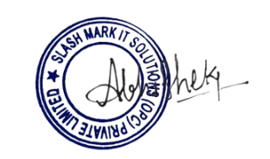

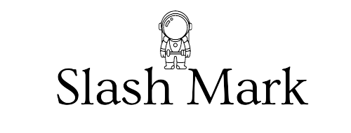
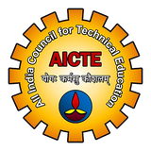


INTERNSHIP COMPLETION CERTIFICATE
This is to certify that
Nikhil Dandolu
has successfully completed the Full Stack Web Development Internship
at Slash Mark IT Solutions (OPC) Pvt. Ltd., an ISO 9001:2015 Certified and DPIIT-recognized Organization based in Karimnagar, Telangana, India,
during the period of December 23, 2025 to April 23, 2026.
This certificate is issued in recognition of the successful completion of the internship.

P. Abhishek Intern ID : SMI82853
Human Resources (HR) Credits Awarded: 3
Slash Mark IT Solutions (OPC) Pvt. Ltd. Internship Mode : Virtual hr@slashmark.in

