SOFTWARE REQUIREMENTS SPECIFICATION

1.0 Introduction

Description of the system
The project entitled "Pharmacy Management System" is implemented at hospital . The main aim of the project is the management of the database of pharmacy in the hospital. This is done by creating a database of the available medicine in the pharmacy. The patients can register their details and they can book for consultation in advance. This web application can generate reports, as per the user's requirement, as well as printing bills, receipts etc. It gives the price of medicine and warns when the medicine has reached its expiry date. It keeps the total records of medicines present in the store and we can also print the bills of medicine sold and keeps the updated record for the medicine sold so that we can check the deficiency of the medicine. By using this management system the time get saved and their will be negligible chance for the errors to occur. We can check the records instantly which is not possible by manual methods.
The pharmacy management system is very useful in carrying out the operations in hospital. Since almost all the pharmacy follow a similar pattern, this software can be used for any hospital. All the details the pharmacy cannot cover under this project, since pharmacy management system is a vast and wide area.
Advantages of developing of such package is to reduce the manpower, in this software, the data is stored in the database whenever a reference for a particular item is need ,user has to given the code of that and retrieve the data. This can avoid bundles of records for the storing of data.

Actors of the system.
- Admin
- Staff
- Doctor
- Patient
- Pharmacist

Modules of the System.
- Login
- Registration
- Staff Registration
- Doctor Registration
- Patient Registration
- Update / Remove Staff
- Stock Management
- Add Medicine
- Update Medicine
- Block/Remove Medicine
- Review Status
- Sales Review
- Stock Review
- Booking Consultation
- Billing
- Prescription Generation

1.1 Goals and objectives
- Concurrent Stock Management
- Convenient patient Support
- Security in drug handling
1.2 Statement of scope
This web application is developed for computerization of a pharmacy in a hospital. The admin of the system is the one who register staff and doctor to the system. He also can review the status of stocks, accounts. He can generate reports of the same as daily, monthly , or annual based reports.
As a patient is consulted with the doctor, the prescription of medicine and dosage of use are described in a prescription document and is submitted online.
A new patient to the hospital can register him/herself or registered patient can login to the system. A registered patient is provided with a patient id card with a description of patient details and unique ID. This id is used in all areas of operation. As per his convenience, he can choose a doctor for consultation in a favorable manner. There is also facility to book consultation in advance. After consultation the patient goes to the billing counter and pay. Now his prescribed medicines will be ready at pharmacy. He can go and collect it. He also receives a printed medicine details with usage description.
The staff at the billing counter enters a patient id and he can generate bill accordingly. Now the pharmacist gets the patient information with the medicine details. And the medicine is delivered to the patient with a print out of medicine description and usage.
1.3 Software context
System provides an experience to the patient to book their consultation online. There is a separate admin section is available for secure use. Admin can register staff, doctor, generate report and view the stock and sales details.
1.4 Major constraints
Online Delivery of Medicine is not possible

2.0 Usage scenario
2.1 User profiles
Patient:
Patient can register, consult particular doctor in a preferable time or day.
Admin:
The admin of the system is the one who register staff and doctor to the system. He also can review the status of stocks, accounts. He can generate reports of the same as daily, monthly , or annual based reports.
Staff:
The staff at the billing counter enters a patient id and he can generate bill accordingly. Now the pharmacist gets the patient information with the medicine details. And the medicine is delivered to the patient with a print out of medicine description and usage.
Doctor: As a patient is consulted with the doctor, the prescription of medicine and dosage of use are described in a prescription document and is submitted online.
Pharmacist:
Pharmacist gets the patient information with the medicine details. And the medicine is delivered to the patient with a print out of medicine description and usage.

2.2 Use-cases
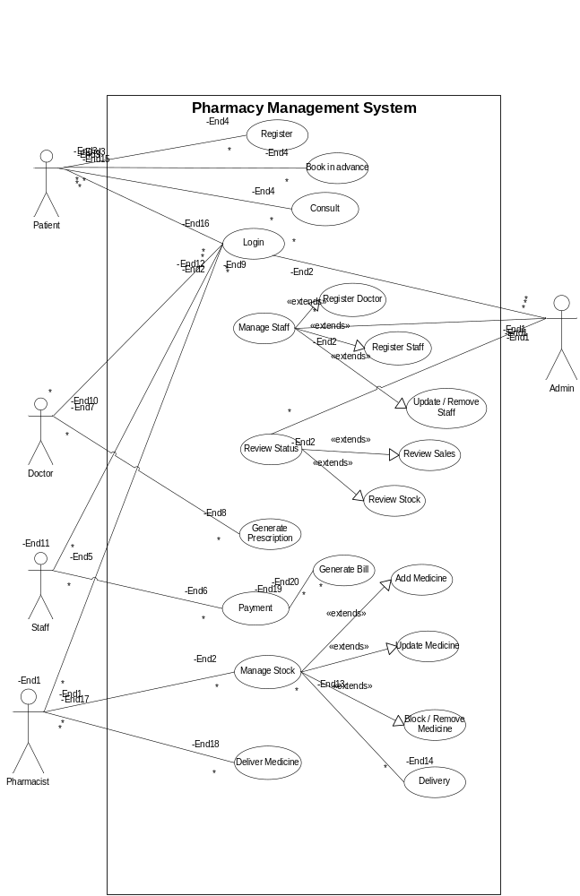

3.0 Data Model and Description
3.1 Data Object
Patient: Stores the patient profile.
Doctor: Stores the doctor profile.
Staff: Stores the staff profile.
Medicine: Keeps the medicine stock details.
Consultation: Stores the consultation schedule.
Prescription: Prescriptions of medicines are stored for a consulted patient.
3.1.1 Data Description
Patient: patient id, Pname, age, address, phone
Doctor: Doctor id name, address, specialization.
Staff: staff id, name, address.
Medicine: Medicine id, name, price, manufacturing date, expiry date.
Consultation: consult id, date, doctor id, time, patient id.
Prescription: prescription id, patient id, consult id, medicine id.

3.1.2 Relationships

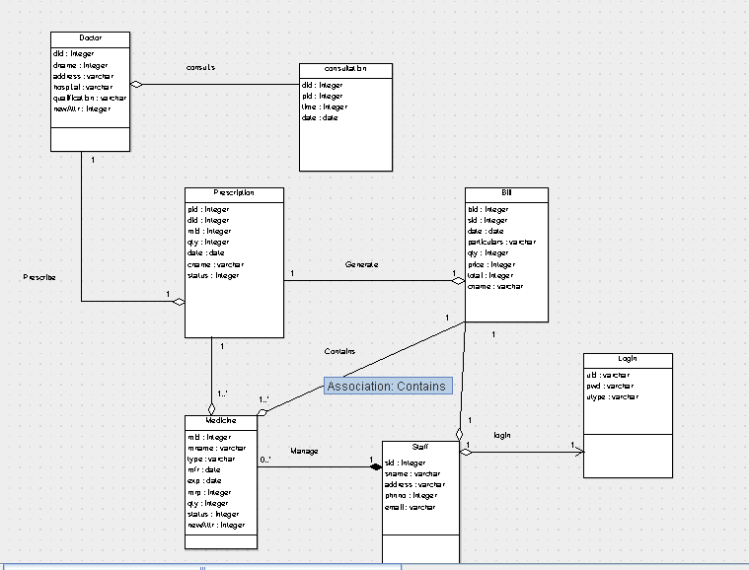
3.1.3 Complete Data Model

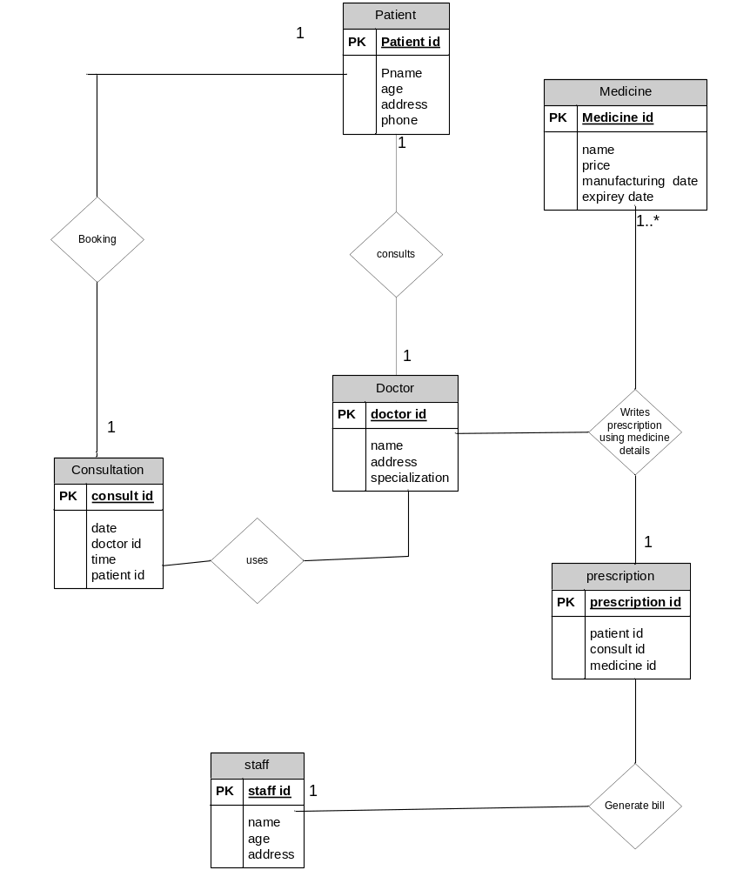

3.1.4 Data dictionary
Table: Patient details
Field Name | Data type | Constraints
patient id | INT | PRIMARY KEY
Pname | VARCHAR(45) | NOT NULL
age | INT | NOT NULL
address | VARCHAR(45) | NOT NULL
phone | INT | NOT NULL
Table: Staff details
Field Name | Data type | Constraints
Staff id | INT | PRIMARY KEY
name | VARCHAR(45) | NOT NULL
age | INT | NOT NULL
address | VARCHAR(45) | NOT NULL
Table: Doctor details
Field Name | Data type | Constraints
Doctor id | INT | PRIMARY KEY
name | VARCHAR(45) | NOT NULL
address | VARCHAR(45) | NOT NULL
specialization | VARCHAR(45) | NOT NULL

Table: Medicine details
Field Name | Data type | Constraints
Medicine id | INT | PRIMARY KEY
name | VARCHAR(45) | NOT NULL
price | INT | NOT NULL
manufacturing date | Date | NOT NULL
expiry date | Date | NOT NULL
Table: Consultation details
Field Name | Data type | Constraints
consult id | INT | PRIMARY KEY
Date | DATE | FOREIGN KEY
doctor id | INT | FOREIGN KEY
time | Date | NOT NULL
patient id | Date | FOREIGN KEY
Table: Prescription details
Field Name | Data type | Constraints
prescription id | INT | PRIMARY KEY
patient id | INT | FOREIGN KEY
consult id | INT | FOREIGN KEY
medicine id. | INT | FOREIGN KEY
4.0 Functional Model and Description
4.1 Description for Function
Patient:
Patient can register, consult particular doctor in a preferable time or day.
Admin:
The admin of the system is the one who register staff and doctor to the system. He also can review the status of stocks, accounts. He can generate reports of the same as daily, monthly , or annual based reports.
Staff:
The staff at the billing counter enters a patient id and he can generate bill accordingly. Now the pharmacist gets the patient information with the medicine details. And the medicine is delivered to the patient with a print out of medicine description and usage.
Doctor: As a patient is consulted with the doctor, the prescription of medicine and dosage of use are described in a prescription document and is submitted online.
Pharmacist:
Pharmacist gets the patient information with the medicine details. And the medicine is delivered to the patient with a print out of medicine description and usage

4.1.1Function flow diagram
Level 0 (Context diagram)
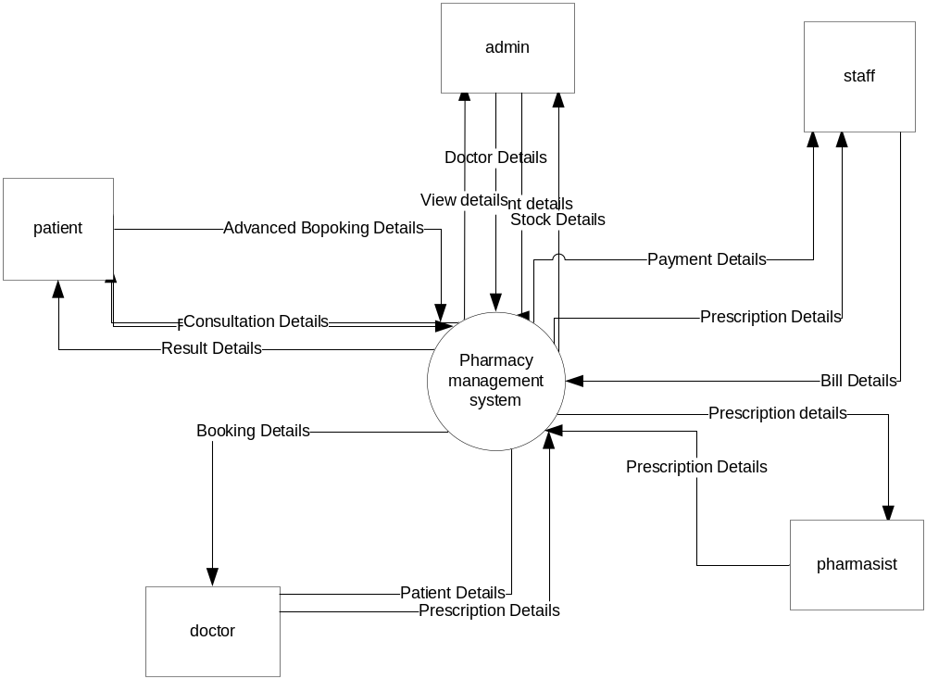

Level 1
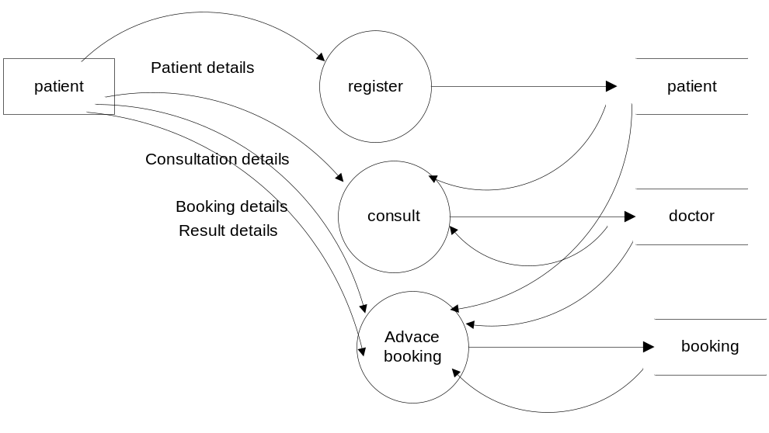

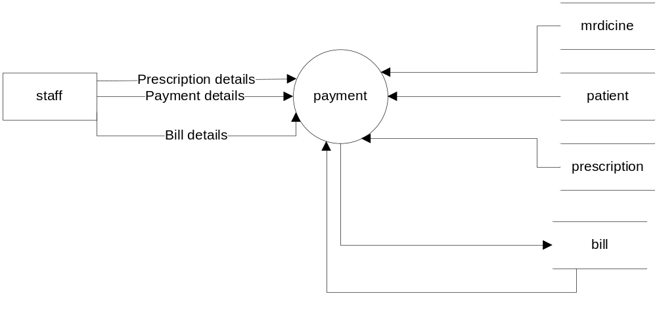

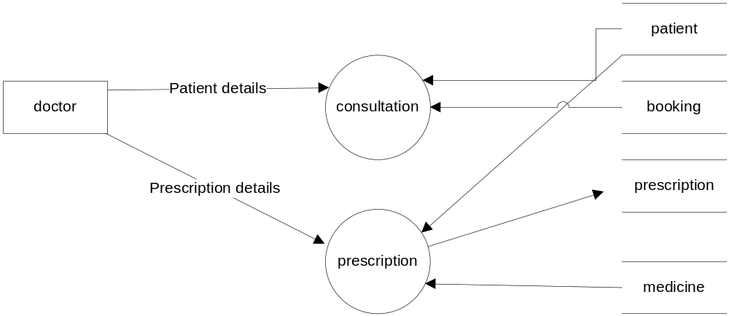

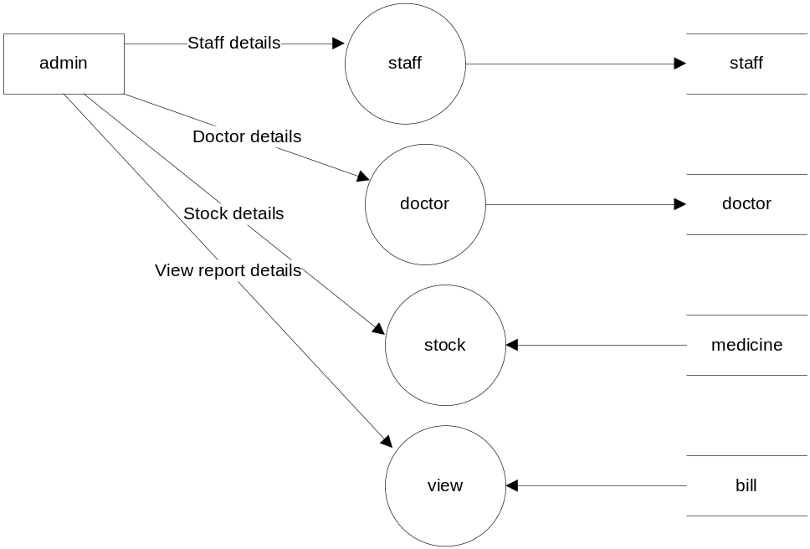

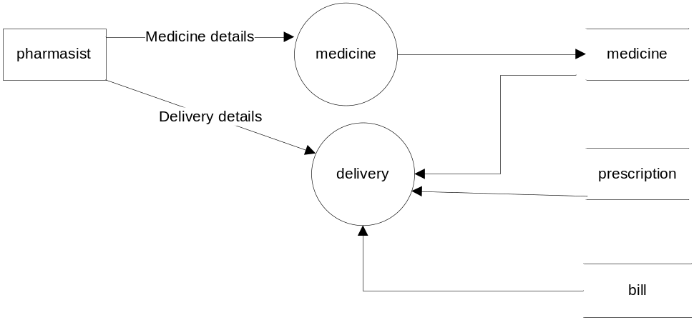

Level 2
