Phase 1 — Prepare the Azure VM

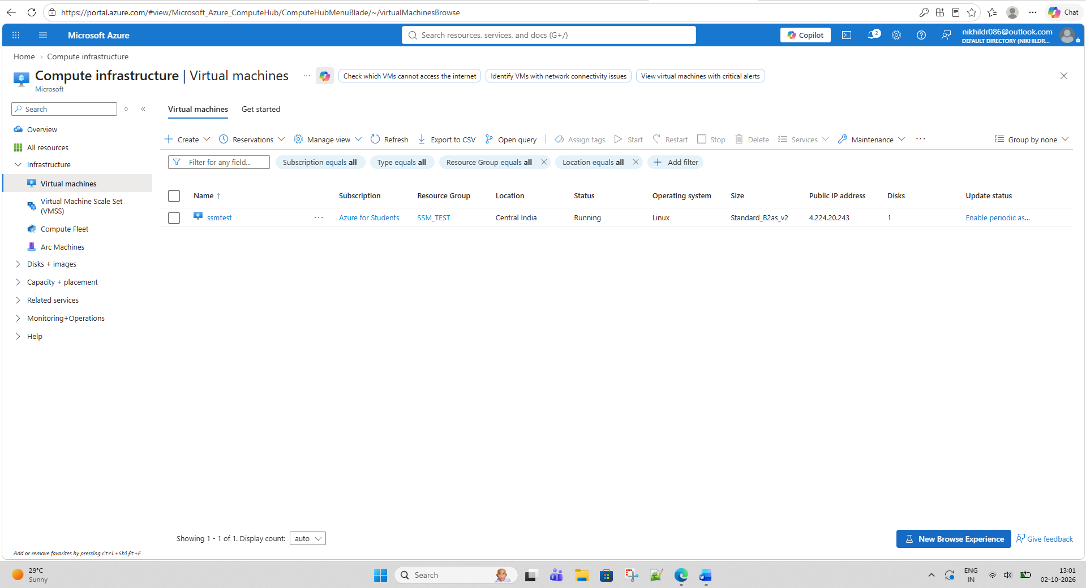

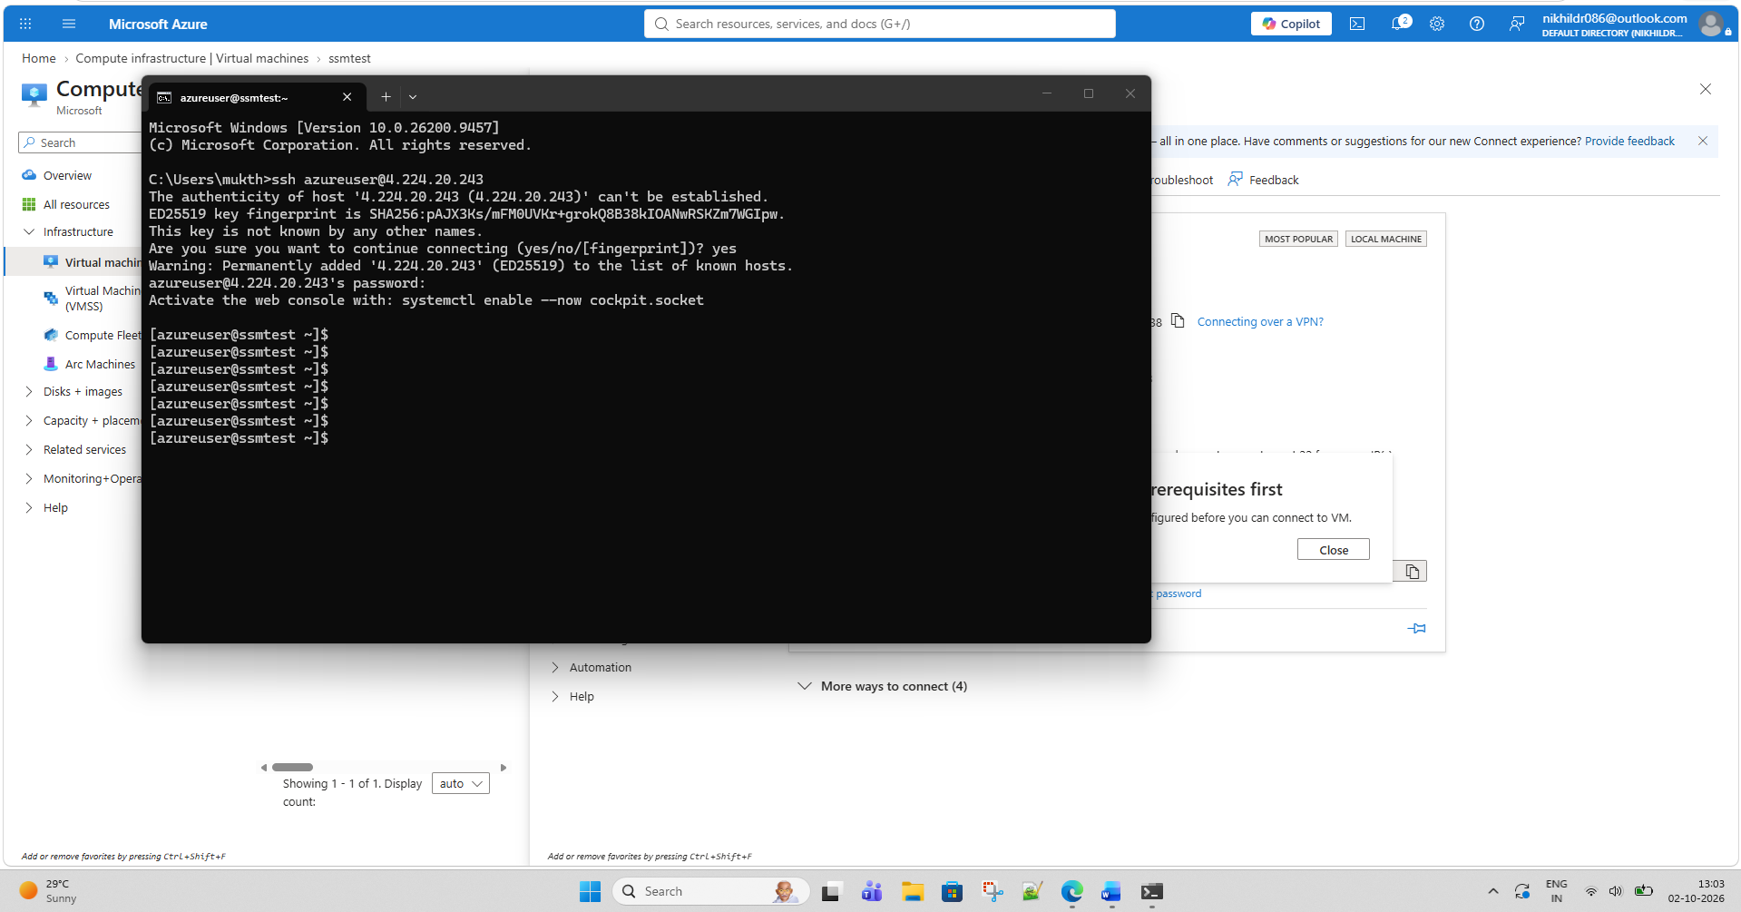

Phase 2 — Create AWS Hybrid Activation

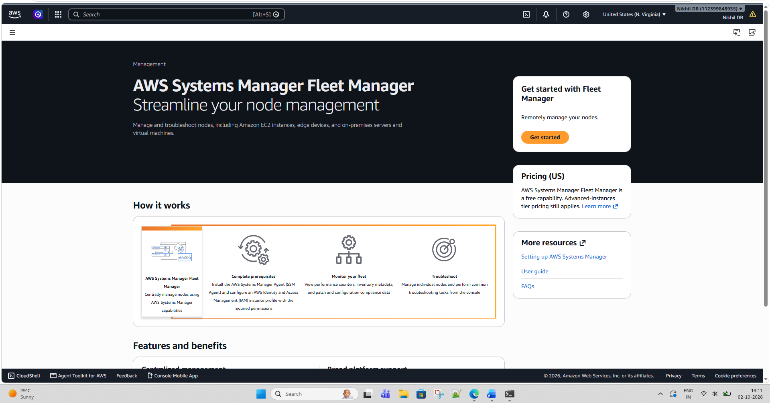

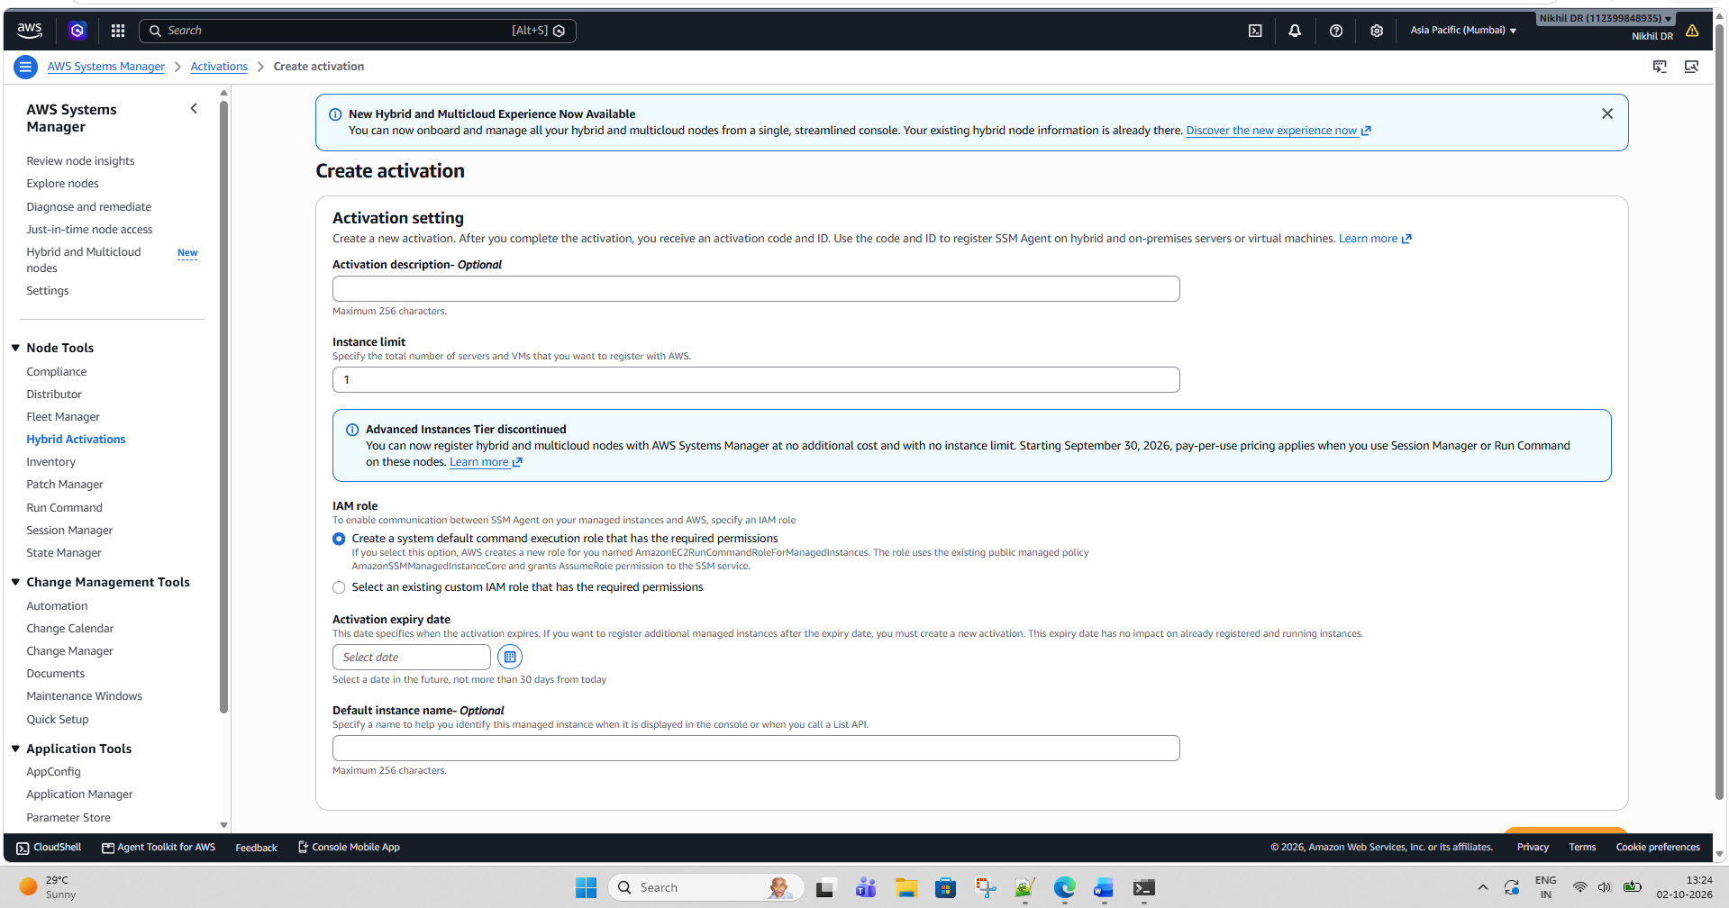

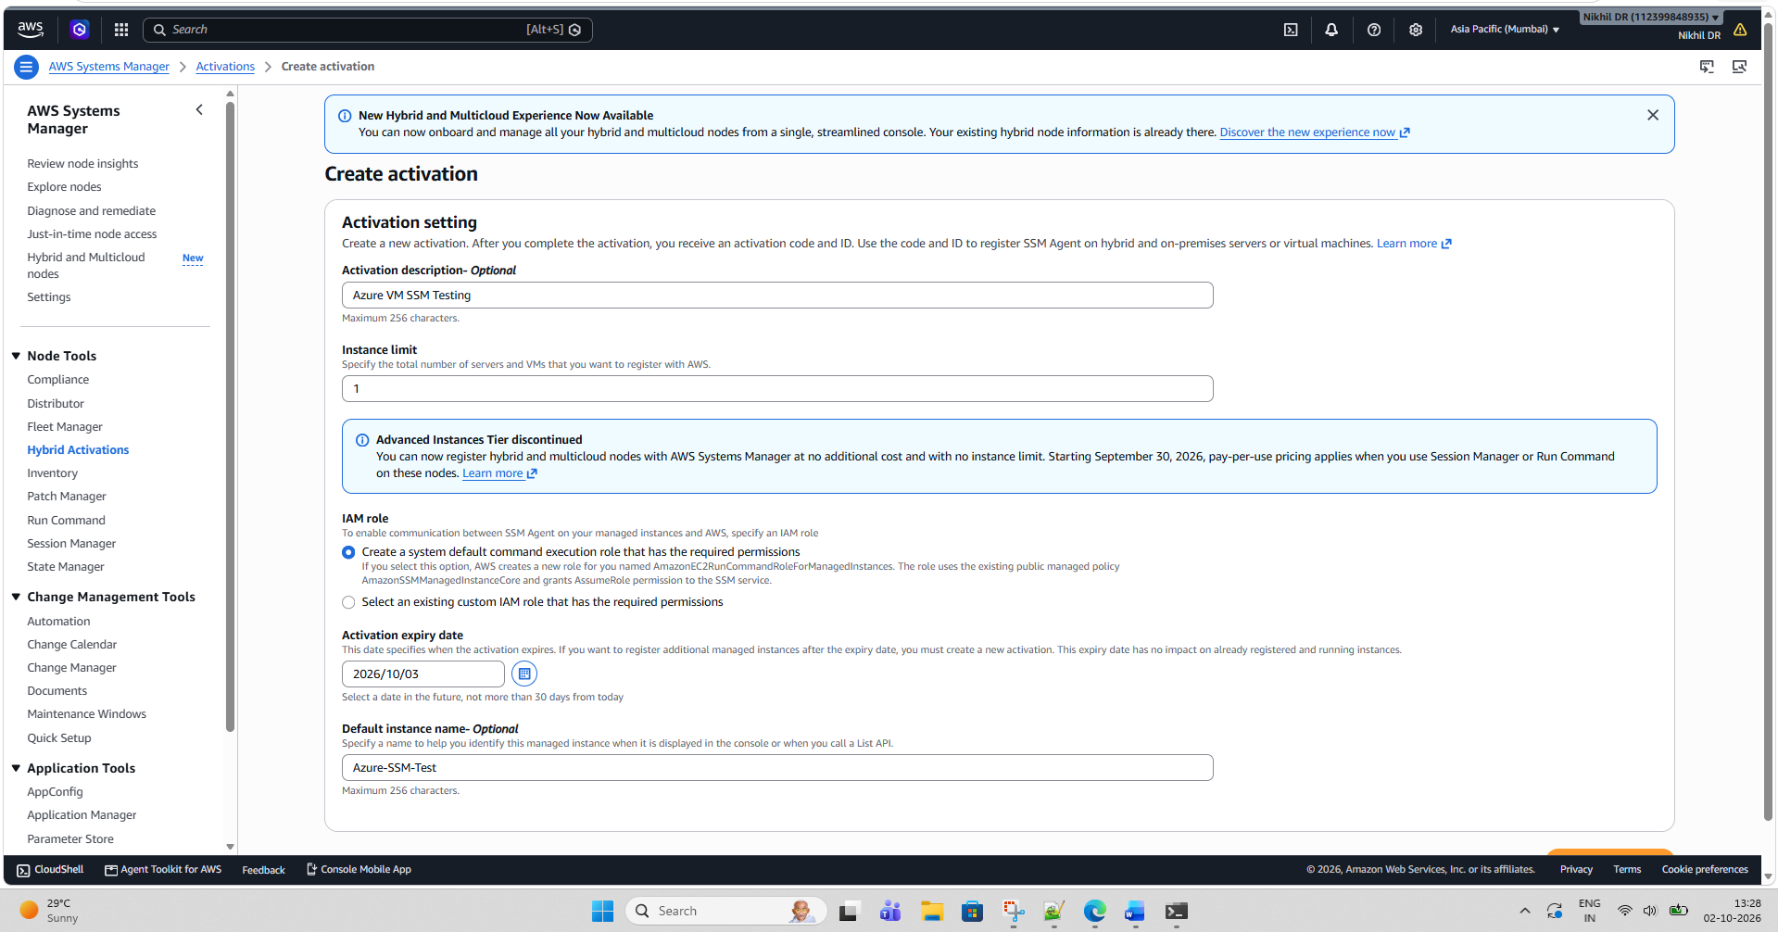

You have successfully created a new activation. Your activation code is listed below. Copy this code and keep it in a safe place as you will not be able to access it again.
Activation Code NG4O8Glo5UkyxHtIiCEW

Activation ID 9bc9127e-9d95-45de-97aa-6bdc103b2653

You can now install amazon-ssm-agent and manage your instance using Run Command. Learn more

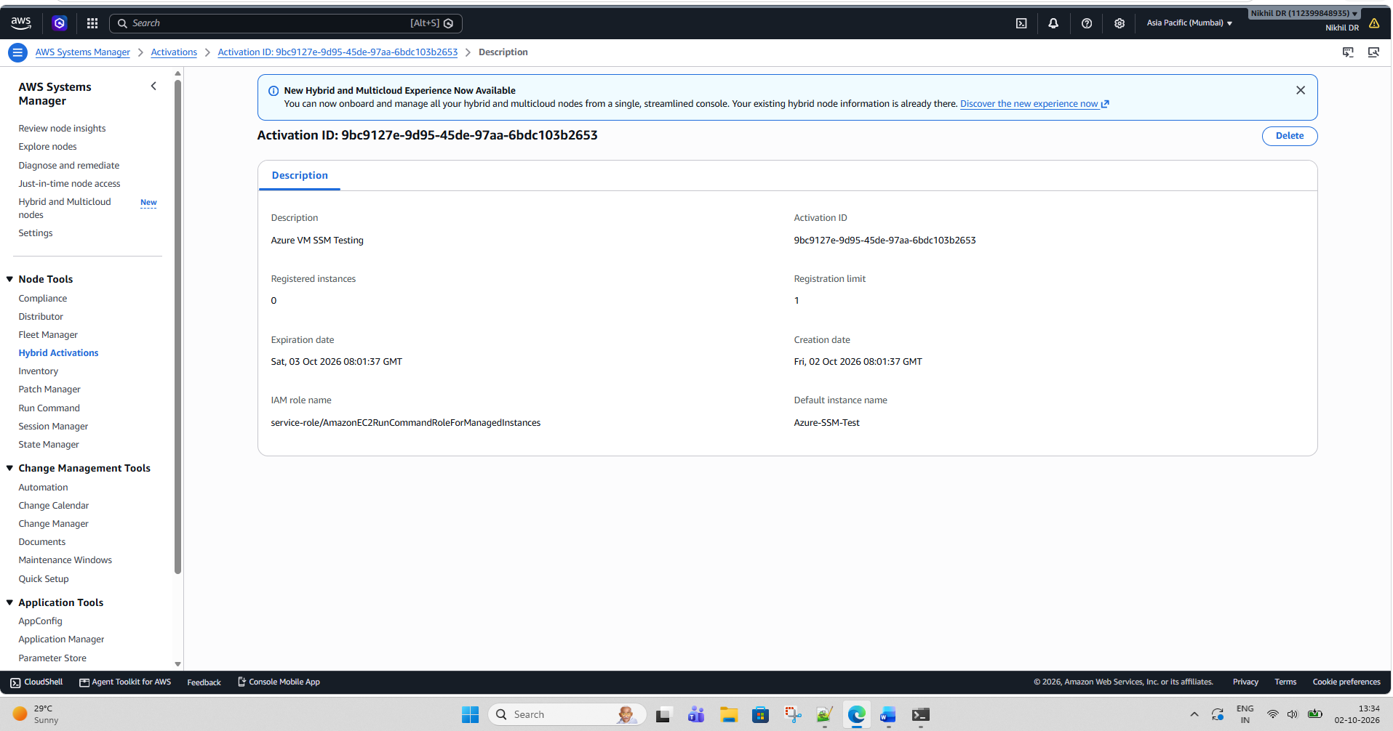

Phase 3 — Install SSM Agent on Azure Oracle Linux VM

sudo dnf install -y https://s3.ap-south-1.amazonaws.com/amazon-ssm-ap-south-1/latest/linux_amd64/amazon-ssm-agent.rpm

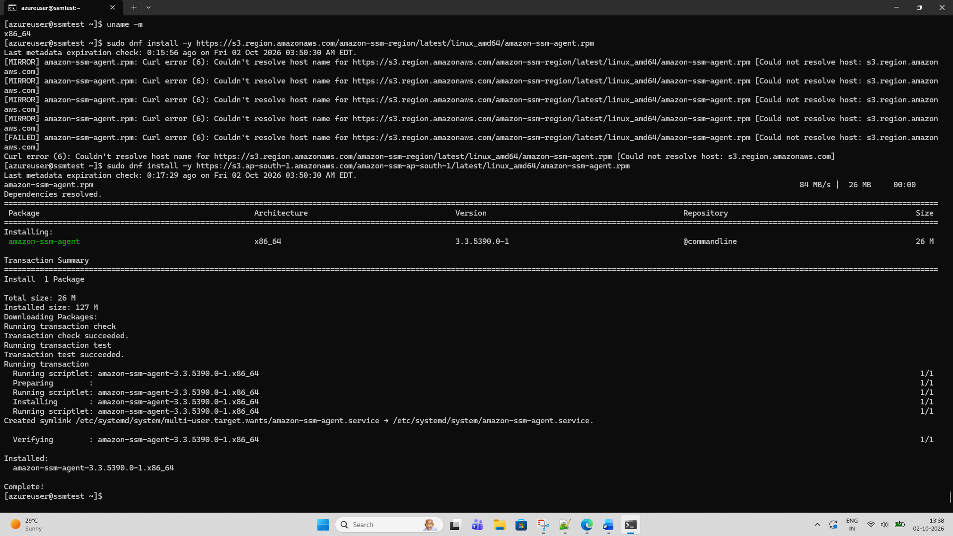

sudo /tmp/ssm/ssm-setup-cli -register \
-activation-code "NG4O8Glo5UkyxHtIiCEW" \
-activation-id "9bc9127e-9d95-45de-97aa-6bdc103b2653" \
-region "ap-south-1" \
-provider "Azure"

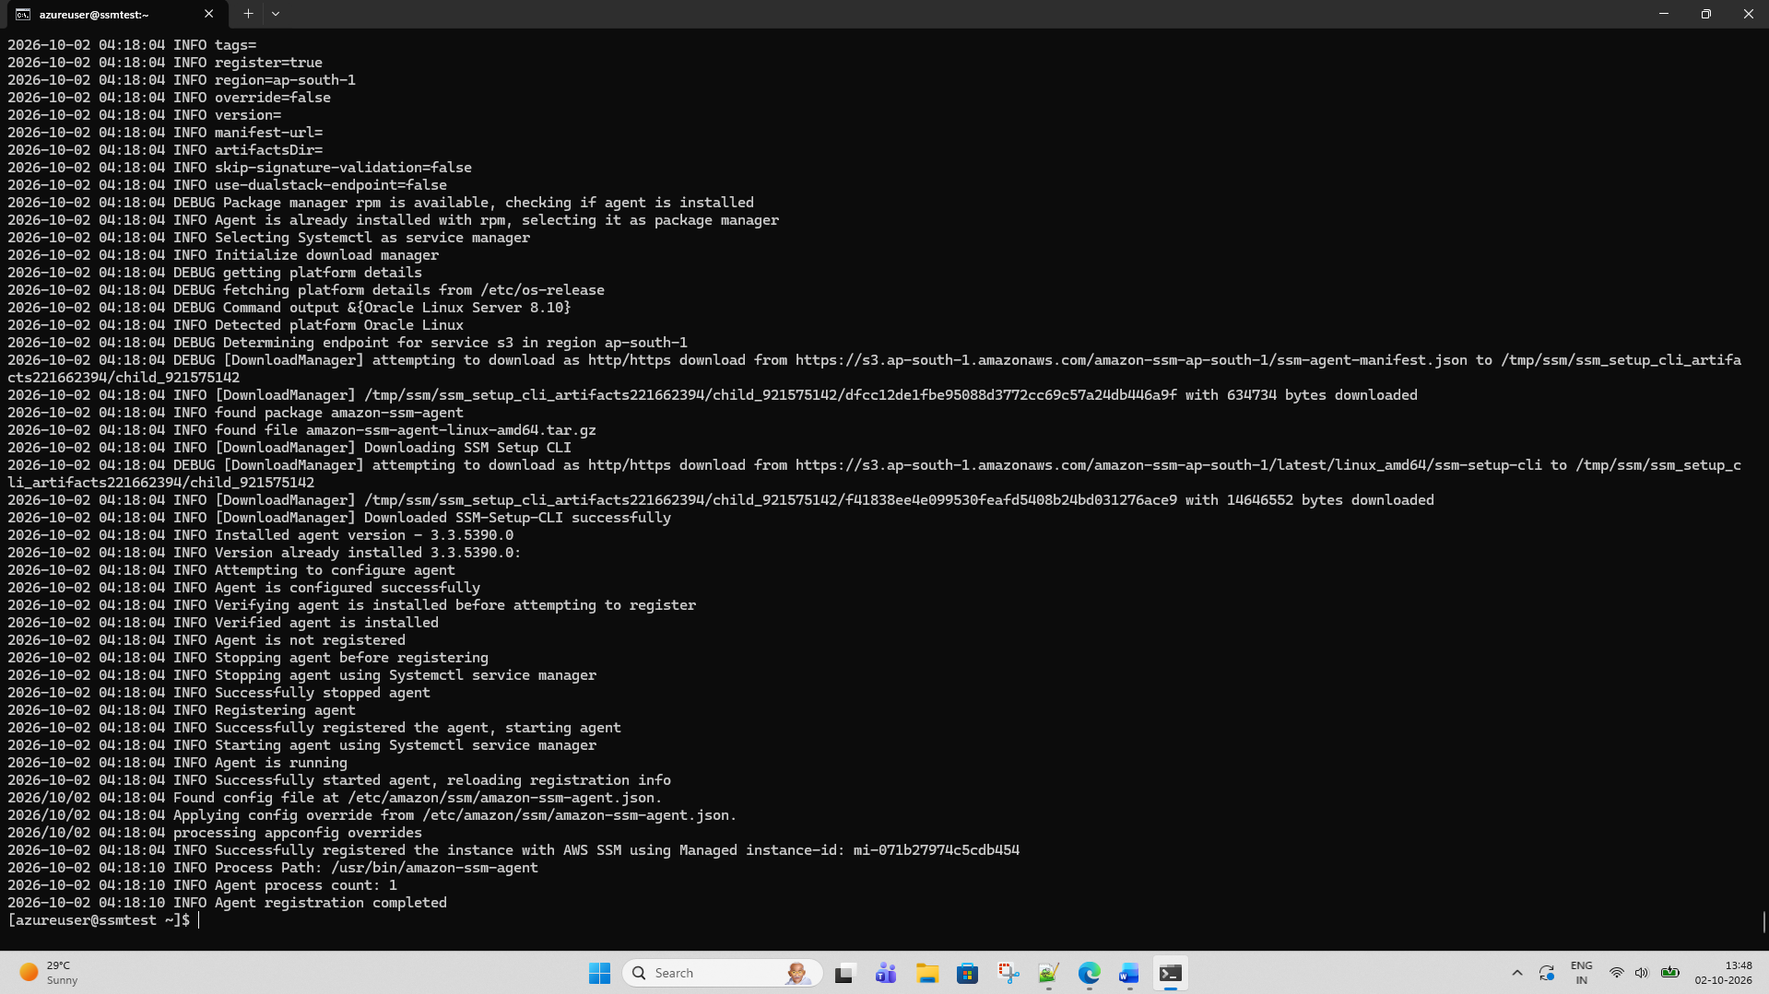

[azureuser@ssmtest ~]$ sudo systemctl status amazon-ssm-agent
● amazon-ssm-agent.service - amazon-ssm-agent
Loaded: loaded (/etc/systemd/system/amazon-ssm-agent.service; enabled; vendor preset: disabled)
Active: active (running) since Fri 2026-10-02 04:18:04 EDT; 50s ago
Main PID: 7298 (amazon-ssm-agen)
Tasks: 22 (limit: 48114)
Memory: 63.4M
CGroup: /system.slice/amazon-ssm-agent.service
├─7298 /usr/bin/amazon-ssm-agent
└─7314 /usr/bin/ssm-agent-worker

Oct 02 04:18:05 ssmtest amazon-ssm-agent[7298]: 2026-10-02 04:18:05.0025 INFO [amazon-ssm-agent] amazon-ssm-agent - v3.3.5390.0
Oct 02 04:18:05 ssmtest amazon-ssm-agent[7298]: 2026-10-02 04:18:05.0026 INFO [amazon-ssm-agent] OS: linux, Arch: amd64
Oct 02 04:18:05 ssmtest amazon-ssm-agent[7298]: 2026-10-02 04:18:05.0026 INFO [amazon-ssm-agent] Starting Core Agent
Oct 02 04:18:05 ssmtest amazon-ssm-agent[7298]: 2026-10-02 04:18:05.0026 INFO [CredentialRefresher] credentialRefresher has started
Oct 02 04:18:05 ssmtest amazon-ssm-agent[7298]: 2026-10-02 04:18:05.0027 INFO [CredentialRefresher] Starting credentials refresher loop
Oct 02 04:18:05 ssmtest amazon-ssm-agent[7298]: 2026-10-02 04:18:05.1058 INFO [CredentialRefresher] Credentials ready
Oct 02 04:18:05 ssmtest amazon-ssm-agent[7298]: 2026-10-02 04:18:05.1060 INFO [CredentialRefresher] Next credential rotation will be in 29.99910002265 minutes
Oct 02 04:18:06 ssmtest amazon-ssm-agent[7298]: 2026-10-02 04:18:06.1153 INFO [amazon-ssm-agent] [LongRunningWorkerContainer] [WorkerProvider] Worker ssm-agent-worker is not running, starting worker process
Oct 02 04:18:06 ssmtest amazon-ssm-agent[7298]: 2026-10-02 04:18:06.1188 INFO [amazon-ssm-agent] [LongRunningWorkerContainer] [WorkerProvider] Worker ssm-agent-worker (pid:7314) started
Oct 02 04:18:06 ssmtest amazon-ssm-agent[7298]: 2026-10-02 04:18:06.1188 INFO [amazon-ssm-agent] [LongRunningWorkerContainer] Monitor long running worker health every 60 seconds
[azureuser@ssmtest ~]$

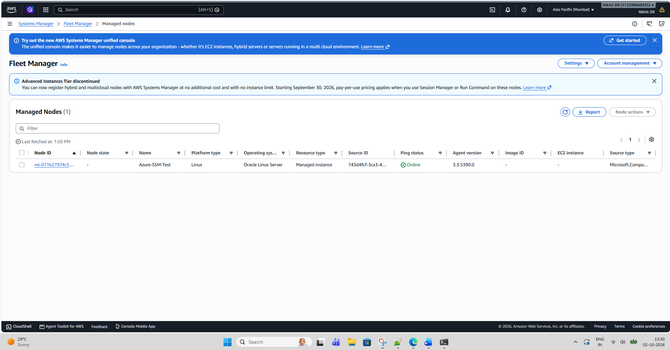

Phase 6 — Install CloudWatch Agent
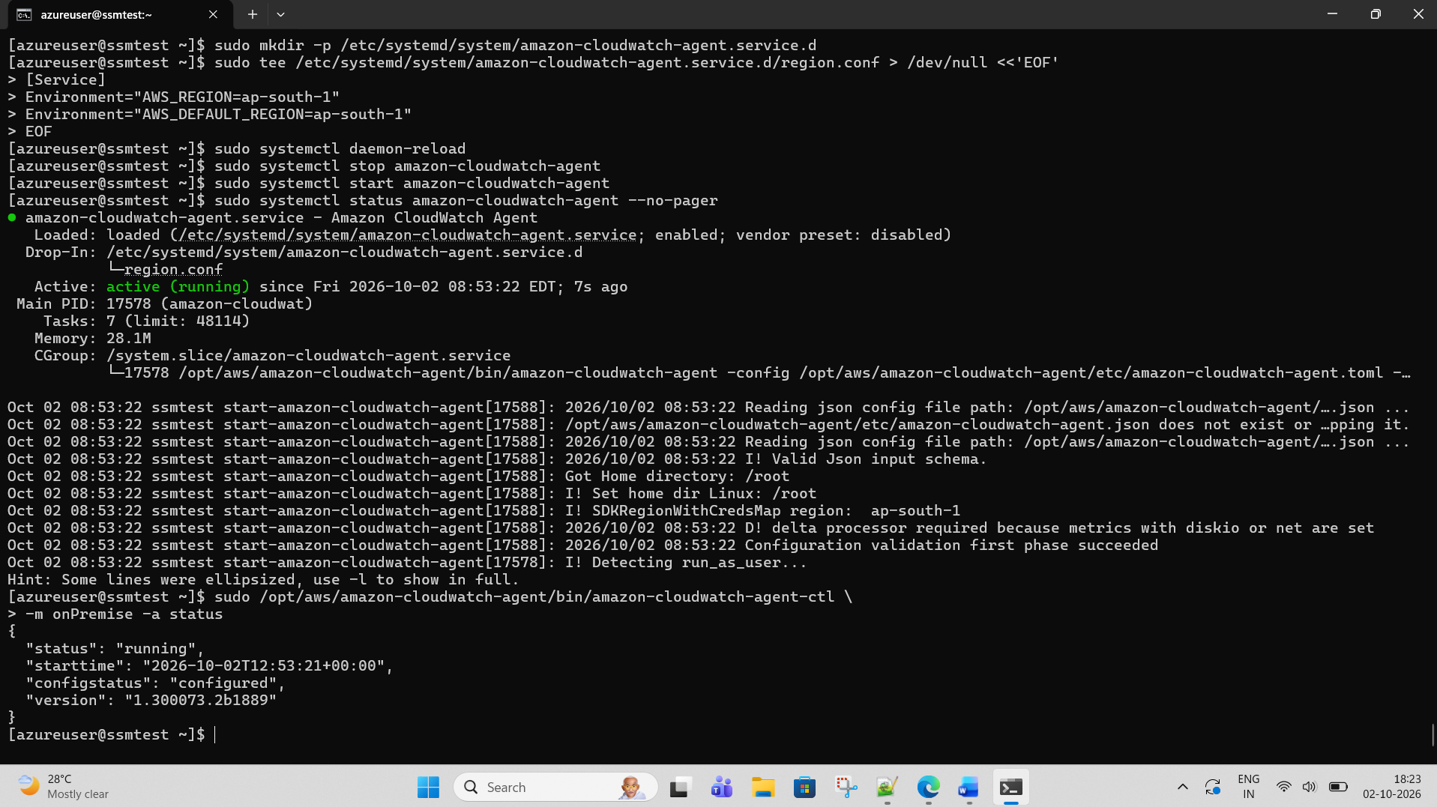

Step 9: Test Run Command

