YUVA INTERN – WEEK 1 TASK
Data Collection and Cleaning for Social Media Campaigns
Junior Data Analyst – Digital Marketing & Advertising

Candidate: Nikhil Ednuri
Project: Social Media Campaign Data Collection & Cleaning
Submission: Week 1
Date: 04 October 2026

Prepared as an independent analytical exercise using publicly documented social-media advertising data concepts and a separate practice working extract.

1. Executive Summary
This report documents a complete data-collection and cleaning workflow for a social media advertising analysis. The objective is to transform campaign-level marketing information into a structured, analysis-ready dataset while demonstrating practical data-quality checks such as duplicate detection, missing-value treatment, text standardization, date normalization, numeric validation, and logical consistency checks.
The public reference dataset selected for this exercise is Kaggle’s “Sales Conversion Optimization” dataset, which contains 1,143 observations and 11 variables describing an anonymous organization’s social media advertising activity. The dataset includes identifiers, audience attributes, impressions, clicks, spend, total conversions, and approved conversions. A public project using the same dataset documents a specific logical-quality issue: records with zero clicks but positive total conversions. The independent cleaning workflow therefore treats business-rule validation as an important complement to simple null and duplicate checks.
For hands-on practice, the accompanying Excel workbook contains a clearly labelled 100-record working extract constructed with the same type of campaign-performance fields. It intentionally contains a small number of data-quality issues so the cleaning process can be demonstrated transparently. This practice extract is not represented as a raw export from the Kaggle source.

2. Data Source and Rationale
The source was selected because it is publicly accessible, directly related to social media advertising, and contains core campaign-performance measures required for digital marketing analysis. It is also large enough to demonstrate real data-quality considerations without using proprietary company information.
Public source: Kaggle – Sales Conversion Optimization
Reference documentation: Public GitHub analysis describing the dataset and cleaning logic
The public source describes 11 variables: ad ID, campaign IDs, age, gender, interest, impressions, clicks, spend, total conversion, and approved conversion. These fields are sufficient to study advertising reach, traffic generation, cost efficiency and conversion.

3. Data Collection Process
1. Define the analytical objective: prepare social-media campaign data for reliable downstream analysis.
2. Identify a public dataset containing campaign delivery, cost and conversion metrics.
3. Review the dataset documentation and understand the meaning and expected type of each field.
4. Create a working copy rather than modifying the original source.
5. Inspect column names, data types, record counts and missing-value patterns.
6. Check for duplicate records and inconsistent categorical values.
7. Normalize date and numeric fields so calculations can be performed consistently.
8. Apply business-rule checks, especially where one metric logically constrains another.
9. Document every cleaning decision so the process is reproducible.
10. Save the cleaned data separately from the raw data and prepare it for analysis.

4. Data Dictionary
Field | Description | Role
ad_id | Unique advertisement identifier | Identifier
xyz_campaign_id | Campaign identifier | Campaign
fb_campaign_id | Platform tracking campaign identifier | Campaign
age | Age group of targeted audience | Audience
gender | Gender category of targeted audience | Audience
interest | Interest/category code | Audience
Impressions | Number of ad impressions | Delivery
Clicks | Number of clicks generated | Delivery
Spent | Amount spent on advertising | Cost
Total_Conversion | People who enquired/converted after seeing the ad | Conversion
Approved_Conversion | People who completed the approved/purchase conversion | Conversion

5. Data Quality Assessment
The public reference analysis reports 1,143 original observations. It identified 204 records in which Clicks was zero while Total_Conversion was greater than zero. Because the business process represented by the dataset expects a conversion to be associated with user action, these records were treated as logically inconsistent and removed, leaving 939 records for the cleaned analytical dataset.
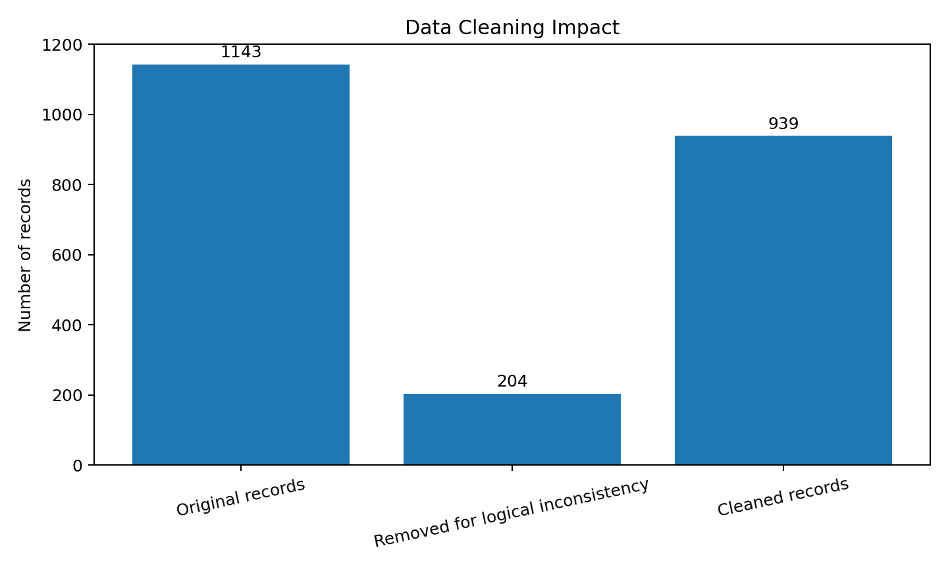
Figure 1. Cleaning impact reported in the public reference analysis.

6. Cleaning Methodology
Check | Approach | Decision
Duplicate check | Compare full rows and unique identifiers | Remove exact duplicates; preserve the most complete record when applicable.
Missing values | Count null/blank cells by field | Use median for appropriate numeric practice fields; document each imputation.
Text consistency | Trim whitespace and standardize case | Convert category labels to a consistent representation.
Date consistency | Parse different date formats | Convert to a single YYYY-MM-DD representation.
Numeric validation | Check numeric fields and impossible negatives | Coerce invalid entries to missing and review before imputation.
Business rules | Check relationships between metrics | Flag logically inconsistent records instead of silently accepting them.

7. Practice Working Dataset – Cleaning Log
The accompanying workbook contains a 100-record practice dataset built to demonstrate the above workflow. It intentionally includes missing numeric values, inconsistent capitalization/spacing, mixed date formats and one exact duplicate. The cleaned workbook preserves the raw data in a separate file and records each cleaning action.
Field | Issue | Rows Affected | Action Taken
Clicks | Missing values | 1 | Filled with median (3206.00)
Likes | Missing values | 1 | Filled with median (1258.00)
Ad Spend (INR) | Missing values | 1 | Filled with median (6909.59)
Conversions | Missing values | 1 | Filled with median (248.00)
All columns | Duplicate rows | 1 | Removed exact duplicate rows
Date | Inconsistent formats | 2 | Parsed to YYYY-MM-DD using pandas

8. Before-and-After Example
Field | Raw value | Cleaned value
Platform | instagram | Instagram
Platform | Instagram | Instagram
Campaign Name | Festive Offer | Festive Offer
Date | 2026/08/15 | 2026-08-15
Date | 15-08-2026 | 2026-08-15
Clicks | Missing | Median-imputed value

9. Data Validation and Derived Metrics
After cleaning, the practice workbook adds calculated fields that can be used in later campaign-performance analysis. These metrics are not replacements for the source measures; they are derived KPIs used to make comparisons easier.
Metric | Formula | Purpose
CTR (%) | Clicks / Impressions × 100 | Measures how effectively impressions generate clicks.
Engagement Rate (%) | (Likes + Shares + Comments) / Impressions × 100 | Measures visible social engagement relative to exposure.
Conversion Rate (%) | Conversions / Clicks × 100 | Measures the percentage of clicks that produce conversions.
CPC (INR) | Ad Spend / Clicks | Measures average cost per click.
CPA (INR) | Ad Spend / Conversions | Measures average cost per conversion.

10. Visual Examples
Visual documentation is included because the internship instructions request examples such as cleaned-data snapshots or charts. The following chart groups the public dataset's 11 fields by their analytical role and demonstrates how the raw schema can be organized before analysis.
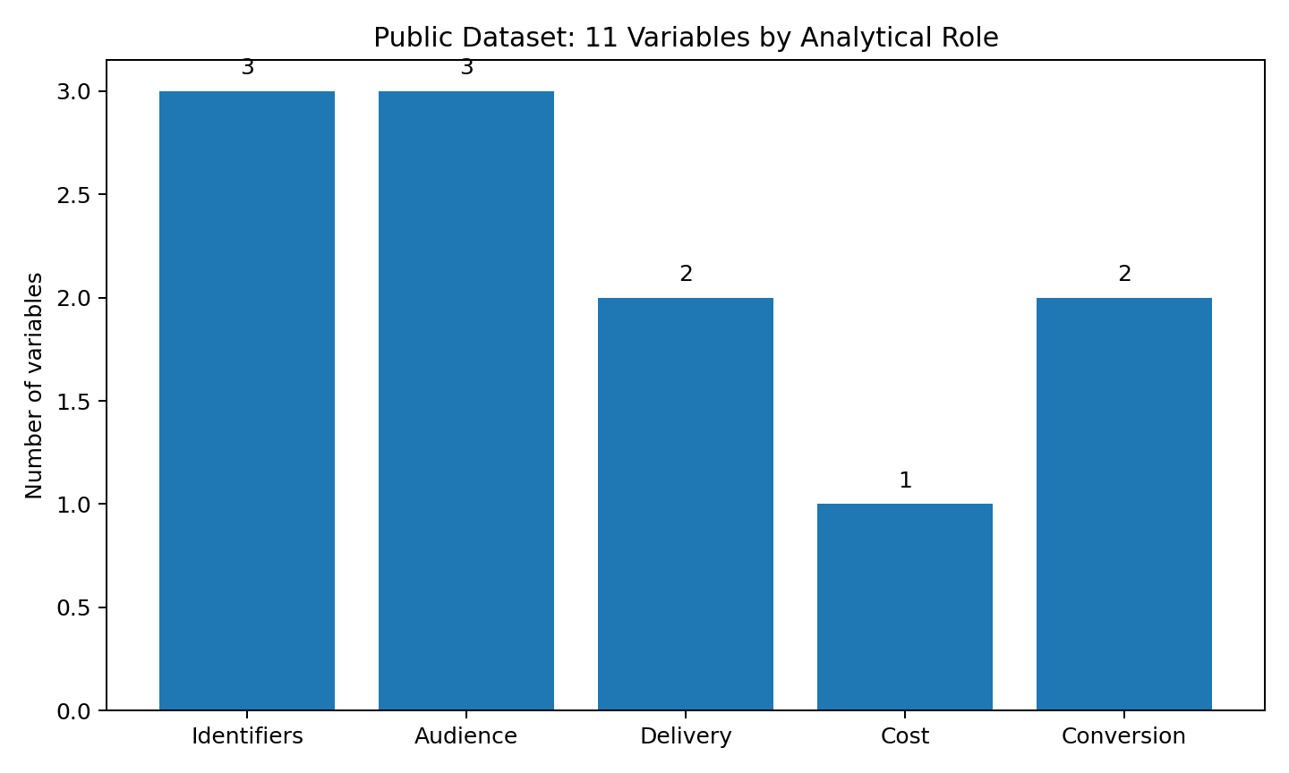
Figure 2. Analytical grouping of the public dataset fields.

11. Challenges and Decisions
Challenge | Risk | Decision
Different data types | Dates and numeric values can appear in inconsistent formats. | Standardize types before calculating KPIs.
Missing values | Deleting every row with a missing value can unnecessarily reduce the dataset. | Use field-specific imputation where the value can be reasonably estimated; document the decision.
Duplicates | Repeated records can inflate campaign totals. | Check full-row duplicates and identifiers before aggregation.
Logical inconsistencies | A record may be technically valid but contradict the business process. | Apply business-rule validation in addition to schema checks.
Reproducibility | Undocumented edits are difficult to audit. | Maintain a cleaning log and preserve raw and cleaned copies separately.

12. Key Findings from the Cleaning Exercise
• Data cleaning is not limited to removing blank cells; business logic is equally important.
• The public reference analysis found 204 logically inconsistent records and retained 939 records after that validation step.
• Standardized field names, dates, categories and numeric types make later aggregation and visualization more reliable.
• Keeping a raw copy and a cleaned copy improves traceability and makes the analysis easier to reproduce.
• Derived KPIs such as CTR, CPC, conversion rate and CPA provide a bridge from data preparation to campaign-performance analysis.

13. Conclusion
This Week 1 project demonstrates a structured approach to collecting, understanding and cleaning social-media advertising data. The workflow begins with a public and relevant data source, establishes a clear data dictionary, inspects quality, applies both technical and business-rule validation, documents decisions and produces an analysis-ready working file. The resulting dataset can be used in later tasks for campaign comparison, KPI calculation and visualization.
The exercise also emphasizes an important data-analyst principle: a dataset should not be considered clean merely because it has no blank cells. A reliable analyst must understand what each field means, identify inconsistent relationships between fields, and document why a record was retained, corrected or removed.

14. Submission Checklist
☐ Word report (.docx) – required by Yuva Intern.
☐ 200+ word submission description – provided separately below.
☐ GitHub project URL – recommended/required if Yuva treats this data-analyst task as technical.
☐ Cleaned Excel workbook – supporting project artifact.
☐ Raw practice dataset – supporting artifact and audit trail.

Appendix A – 200+ Word Submission Description
This report presents my Week 1 work for the Junior Data Analyst – Digital Marketing & Advertising internship. I focused on data collection and cleaning for social media campaign analysis. I selected a publicly available social media advertising dataset from Kaggle, Sales Conversion Optimization, because it contains campaign identifiers, audience attributes, impressions, clicks, advertising spend and conversion measures that are directly relevant to digital marketing analytics. I first reviewed the dataset documentation and created a data dictionary to understand the purpose and expected type of each field. I then defined a repeatable collection and cleaning workflow covering duplicate detection, missing-value checks, text standardization, date normalization, numeric validation and business-rule checks. A key quality issue identified in the public reference analysis was the presence of records with zero clicks but positive total conversions. These records were treated as logically inconsistent because the relationship between clicks and conversions should be meaningful for campaign analysis. For hands-on practice, I also prepared a separate 100-record working extract with campaign-performance fields and intentionally introduced a small number of missing, inconsistent and duplicate values. I cleaned this working dataset by trimming text, standardizing platform labels, converting dates to a consistent format, imputing appropriate numeric missing values using medians, and removing the exact duplicate. I also calculated derived metrics such as CTR, engagement rate, conversion rate, CPC and CPA so that the cleaned dataset is ready for further analysis. The report documents the methodology, cleaning decisions, challenges and visual examples. The raw and cleaned files are kept separately to maintain traceability and reproducibility. This project strengthened my practical understanding of data quality and prepared the dataset for the next stage of campaign performance analysis and visualization.

Important note: The accompanying 100-record working extract is a practice dataset created to demonstrate the cleaning workflow; it is not claimed to be the raw Kaggle file.

