YUVA INTERN – WEEK 5 TASK
Predictive Modeling and Forecasting for Ad Campaigns
Junior Data Analyst – Digital Marketing & Advertising
Candidate: Nikhil Ednuri
Model: Multiple Linear Regression
Forecast horizon: 6 months
Submission: Week 5
Date: 04 October 2026

1. Executive Summary
This Week 5 report demonstrates a simple predictive-modeling workflow for digital advertising campaigns. The objective is to show how historical campaign variables can be used to estimate future conversion performance and support planning decisions. Because the internship task permits hypothetical or publicly available trend data, this project uses a clearly labeled simulated campaign dataset rather than presenting invented observations as real company data.
A multiple linear regression model was trained to predict conversions from ad spend, click-through rate (CTR) and conversion rate. The historical dataset contains 36 monthly observations. The model was evaluated on a held-out test set. The test-set R² was 0.923, mean absolute error was 349.72 conversions and RMSE was 459.13 conversions. A six-month forward scenario was then generated by assuming a gradual increase in advertising spend and modest improvements in CTR and conversion rate. The resulting forecasts are scenario estimates, not guarantees.
The analysis also visualizes historical rates, observed versus forecast conversions, the relationship between ad spend and conversions, and forecast ROAS. The methodology, assumptions, validation process, limitations and business recommendations are documented so that the model can be reproduced and critically evaluated.

2. Objectives
• Define campaign variables suitable for forecasting.
• Build and explain a simple predictive model.
• Validate the model using a hold-out test set and standard regression metrics.
• Generate a six-month scenario forecast for conversions and ROAS.
• Translate model results into practical digital-marketing recommendations.

3. Dataset and Variables
The dataset contains 36 monthly observations created specifically for this analytical exercise. Values are simulated to resemble a plausible paid-digital-campaign environment. The simulation includes seasonally neutral, gradually changing campaign behavior plus random variation.
Variable | Role | Description
Ad Spend | Feature | Monthly paid-media spend.
Impressions | Context variable | Estimated number of ad impressions.
CTR | Feature | Clicks divided by impressions.
Clicks | Derived metric | Impressions multiplied by CTR.
Conversion Rate | Feature | Conversions divided by clicks.
Conversions | Target | Desired campaign outcome predicted by the model.
Revenue | Outcome proxy | Estimated revenue based on conversions and average value.
ROAS | Business metric | Revenue divided by ad spend.

4. Predictive Modeling Method
Multiple linear regression was selected because it is simple, interpretable and appropriate for demonstrating the relationship between a continuous campaign outcome and several numeric predictors. The model estimates conversions as a linear function of ad spend, CTR and conversion rate.
Model form: Conversions = intercept + β1(Ad Spend) + β2(CTR) + β3(Conversion Rate) + error.
The data was split into an 80% training set and a 20% test set using a fixed random seed for reproducibility. The model was fit only on the training data and evaluated on the unseen test observations.

5. Model Validation
Metric | Result | Purpose
R² | 0.923 | Explains the proportion of test-set variation captured by the model.
MAE | 349.72 | Average absolute prediction error.
RMSE | 459.13 | Penalizes larger prediction errors more strongly.

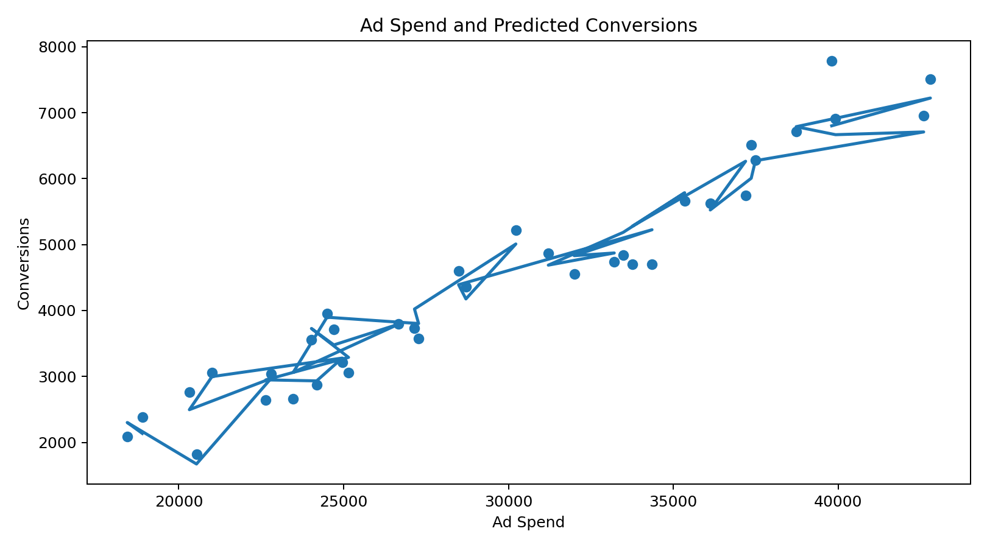
Figure 1. Relationship between ad spend and model-predicted conversions.
Validation is important because a model can fit historical observations but perform poorly on new data. The held-out test set provides a basic check against this problem. A production model would require time-based validation, larger datasets and monitoring for model drift.

6. Forecasting Approach
For the six-month scenario forecast, future ad spend was assumed to increase gradually from approximately 103% to 115% of the final historical monthly spend. CTR was assumed to improve gradually by up to 8% from its latest historical value, while conversion rate was assumed to improve by up to 6%. These assumptions are scenario inputs, not predictions independently learned from external market data.
Forecast month | Ad spend | CTR | Conversion rate | Forecast conversions | Forecast ROAS
Jan-2026 | ₹40,997 | 2.47% | 6.76% | 6,995 | 20.04x
Feb-2026 | ₹41,952 | 2.51% | 6.84% | 7,263 | 20.33x
Mar-2026 | ₹42,907 | 2.55% | 6.92% | 7,530 | 20.61x
Apr-2026 | ₹43,862 | 2.59% | 7.00% | 7,797 | 20.88x
May-2026 | ₹44,818 | 2.63% | 7.08% | 8,065 | 21.13x
Jun-2026 | ₹45,773 | 2.66% | 7.16% | 8,332 | 21.38x

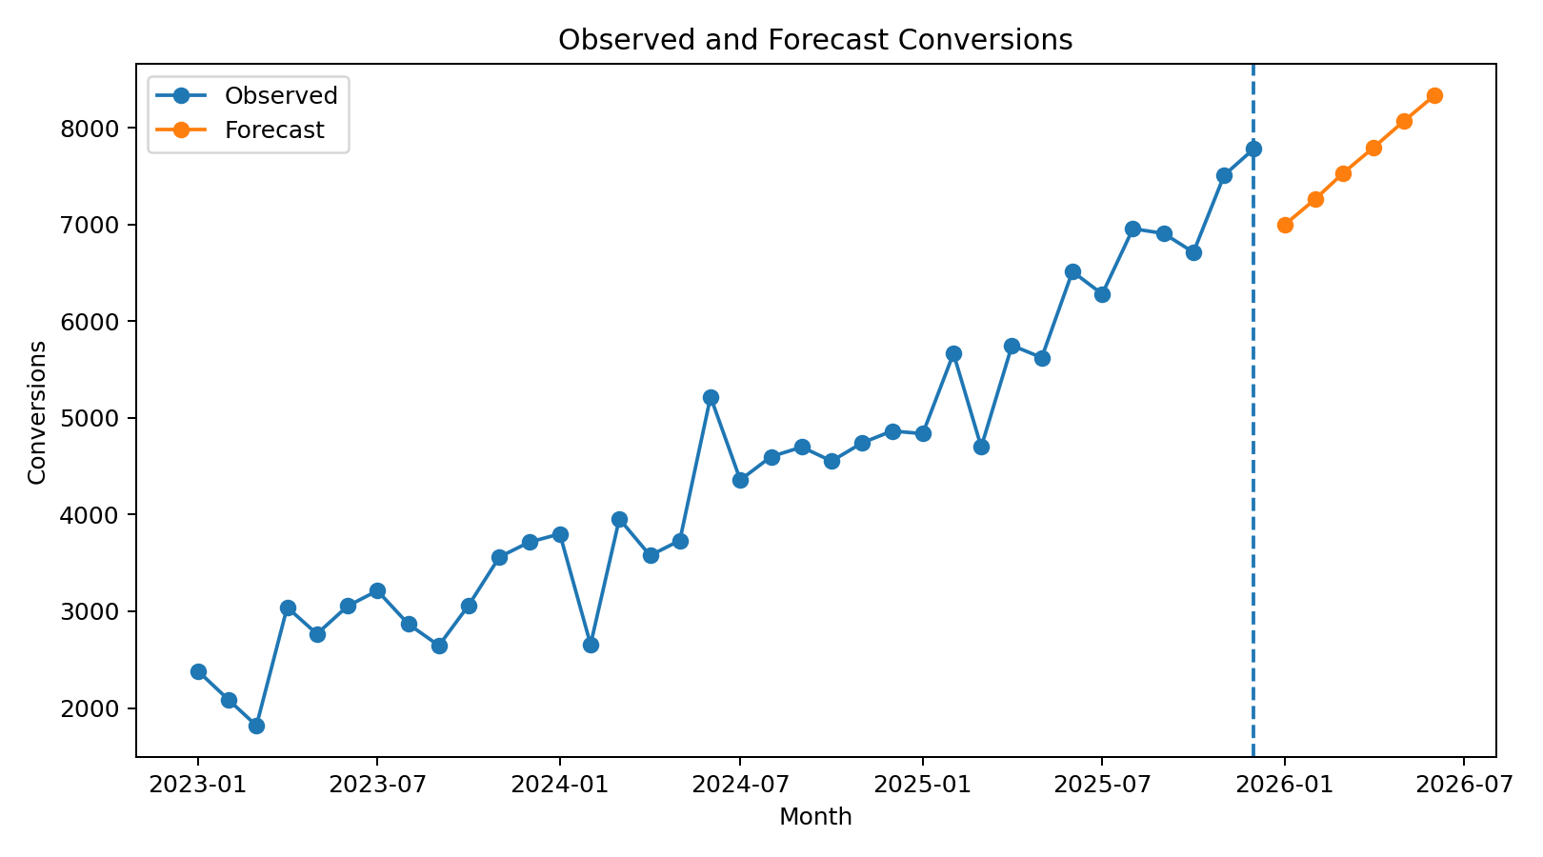
Figure 2. Observed conversions and six-month scenario forecast.

7. Additional Visual Analysis
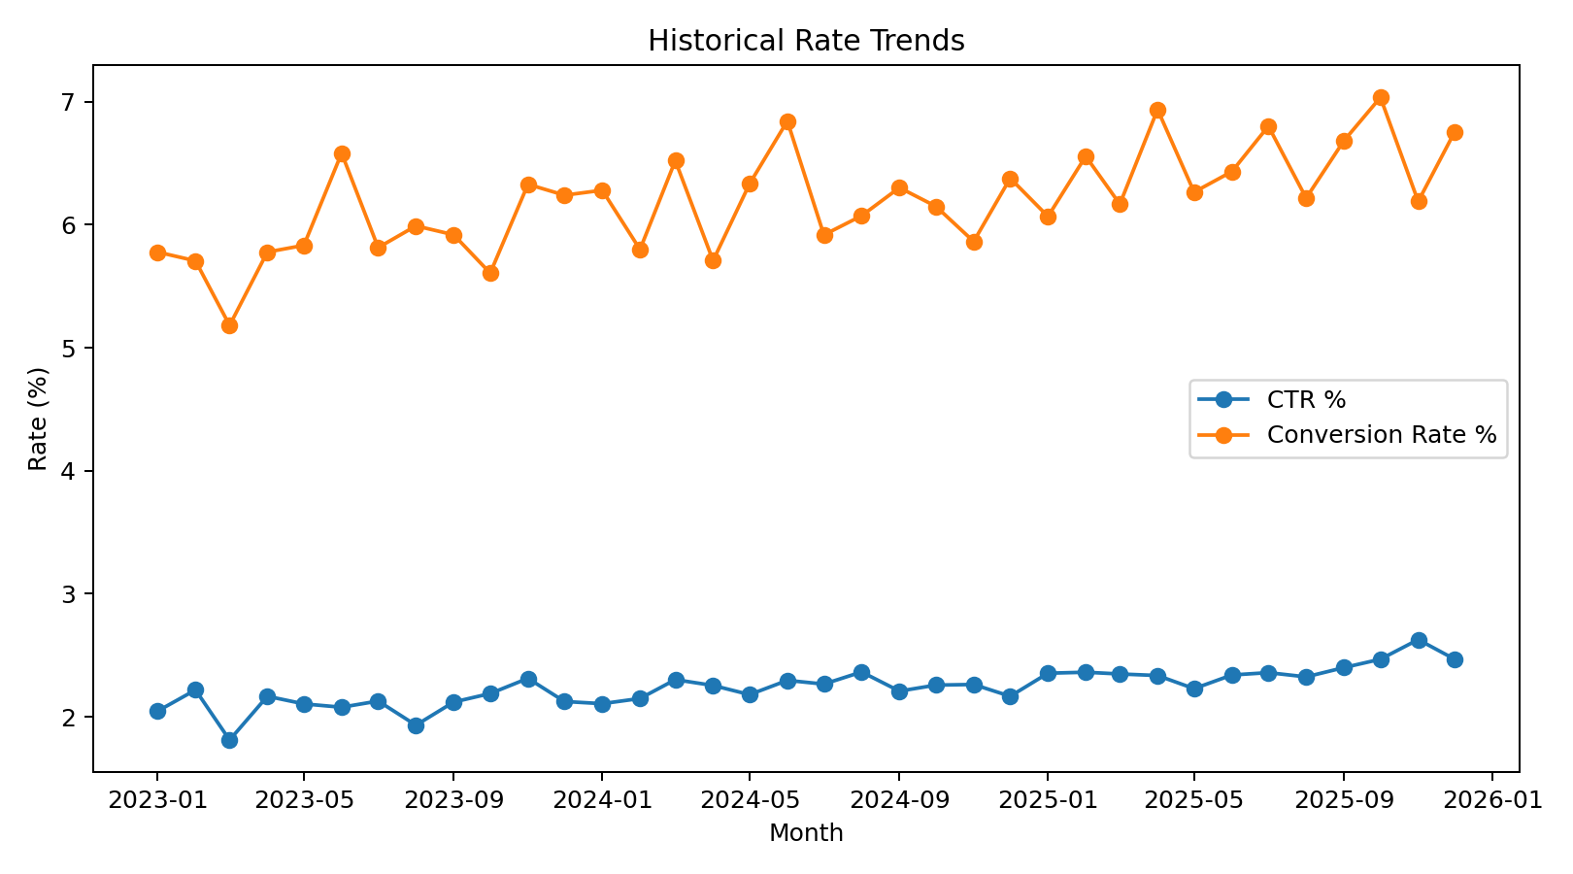
Figure 3. Historical CTR and conversion-rate trends.
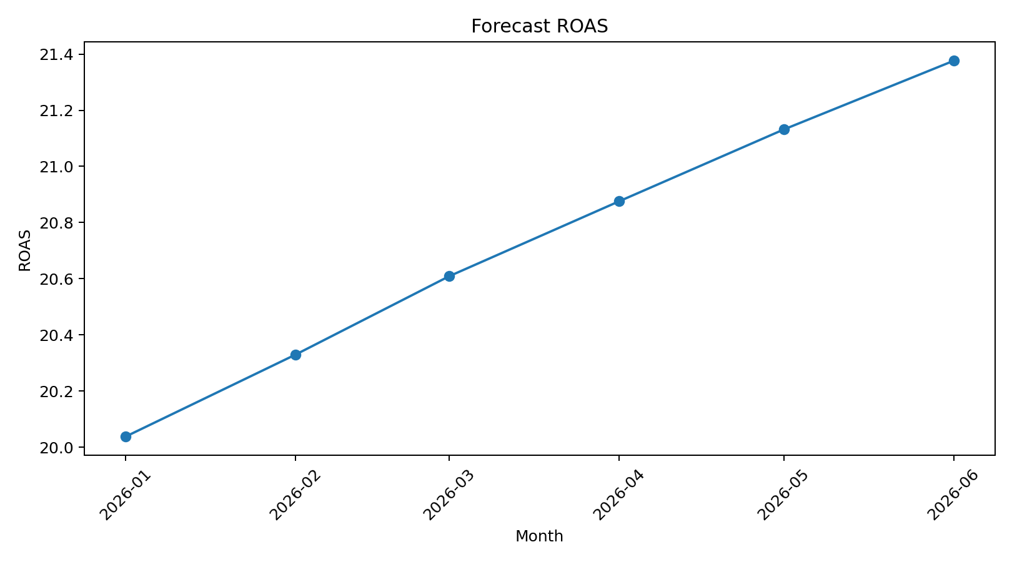
Figure 4. Scenario forecast for ROAS.
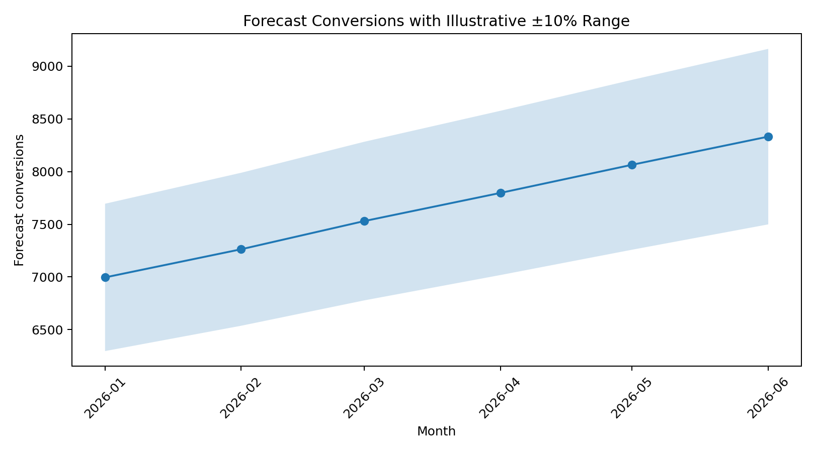
Figure 5. Forecast conversion range using an illustrative ±10% uncertainty band.

8. Key Findings
• Ad spend is positively associated with conversions in the simulated campaign environment, but spend alone is not sufficient to explain performance.
• CTR and conversion rate are important levers because improvements at either stage of the funnel can increase the number of conversions generated from the same traffic volume.
• The forecast scenario indicates that gradually increasing spend while improving funnel efficiency can produce higher conversion volume; however, the result depends strongly on the assumptions supplied to the model.
• ROAS should be monitored alongside conversions because additional conversions are not automatically profitable if acquisition costs rise faster than revenue.
• Forecasts should be refreshed as new campaign data arrives rather than treated as fixed commitments.

9. Challenges and Validation Considerations
• The dataset is simulated, so it cannot prove real-world campaign effectiveness.
• Random train/test splitting is suitable for demonstration but is not ideal for a genuine time-series forecasting problem; production work should use chronological validation.
• Linear regression assumes a linear relationship and may miss saturation, interaction and nonlinear effects.
• Future CTR and conversion-rate assumptions materially influence the forecast.
• Revenue is modeled using an average-value proxy; actual revenue should be linked to transaction-level or campaign-level financial data.

10. Business Recommendations
• Use the model as a planning aid for scenario analysis rather than as an automatic budget-setting system.
• Track spend, impressions, clicks, CTR, conversions, conversion rate, revenue and ROAS consistently at campaign and channel level.
• Test creative and landing-page changes to improve CTR and conversion rate before increasing spend aggressively.
• Use time-based backtesting and compare regression with tree-based models or time-series methods when enough historical data becomes available.
• Create forecast intervals and alert thresholds so campaign managers can react when actual conversions fall materially below the expected range.
• Retrain the model regularly and document major changes in audience, platform mix, tracking definitions or campaign objectives.

11. Limitations
• All campaign observations in this internship exercise are simulated.
• The model uses only three predictive features and therefore omits many real advertising drivers.
• The forecast does not account for seasonality, competitor actions, platform algorithm changes or budget saturation.
• Model performance metrics are specific to this simulated dataset and should not be generalized to a real advertiser.
• The forecast is a scenario analysis and not a guaranteed outcome.

12. Conclusion
This project demonstrates an end-to-end predictive analytics workflow: defining variables, preparing data, selecting an interpretable model, validating it on unseen data, generating a forward scenario and translating the results into business recommendations. The main lesson is that predictive modeling is most useful when its assumptions and limitations are made explicit. In a real digital-marketing environment, the same workflow could be extended with richer campaign, audience, channel and revenue data and validated using chronological backtesting.

13. Submission Description (200+ words)
This Week 5 report focuses on predictive modeling and forecasting for digital advertising campaigns. The objective was to demonstrate how historical campaign variables can be transformed into a simple predictive model and then used to estimate future campaign outcomes. Because the internship task permits hypothetical or publicly available trend data, I created a clearly labeled simulated monthly campaign dataset rather than presenting invented values as real company data. The dataset contains variables such as ad spend, impressions, clicks, click-through rate, conversion rate, conversions, estimated revenue and return on advertising spend. I selected multiple linear regression because it is an interpretable statistical method that can show how several numeric campaign variables are associated with conversions. The model used ad spend, CTR and conversion rate as predictors and conversions as the target variable. I divided the data into training and test sets and evaluated the model using R-squared, mean absolute error and root mean squared error. I then created a six-month scenario forecast by gradually increasing ad spend and making modest assumptions about improvements in CTR and conversion rate. The report includes visualizations comparing observed and forecast conversions, the relationship between ad spend and conversions, historical rate trends, forecast ROAS and an illustrative forecast uncertainty range. I also documented challenges, validation considerations and limitations, including the simulated nature of the data and the limitations of linear regression for complex time-series behavior. Finally, I translated the model results into practical recommendations around budget planning, funnel optimization, monitoring and future model improvement. This task strengthened my understanding of predictive analytics, model validation, forecasting assumptions and the use of data-driven insights for digital marketing decisions.

