YUVA INTERN – WEEK 3 TASK
Customer Segmentation and Targeting Analysis
Junior Data Analyst – Digital Marketing & Advertising
Candidate: Nikhil Ednuri
Project: Customer Segmentation & Targeting
Submission: Week 3
Date: 04 October 2026

1. Executive Summary
This report demonstrates a customer-segmentation workflow for digital marketing. The objective is to identify meaningful customer groups using demographic and behavioral characteristics and then recommend marketing strategies tailored to each group. Because the Week 1 campaign dataset contains campaign-level rather than customer-level demographic records, a clearly labeled synthetic customer-level working dataset was created for this exercise. The synthetic data is designed to reflect realistic marketing behaviors while avoiding any claim that it represents real customers.
Seven behavioral and demographic variables were considered: age, annual income, engagement score, monthly spend, monthly visits, monthly conversions and days since last interaction. These variables capture customer value, activity, engagement and recency. The variables were standardized and K-Means clustering with three clusters was used to identify distinct groups. The resulting clusters were interpreted as High-Value Engaged, Active Deal Seekers and Low-Engagement Explorers. Each segment has a different business opportunity and therefore requires a different communication and targeting strategy.

2. Background and Segmentation Rationale
Customer segmentation groups customers with similar characteristics so that marketing messages, offers and channels can be tailored rather than treating the entire market as one audience. Demographic variables help describe who customers are, while behavioral variables help explain how they interact with a brand. In this exercise, behavioral indicators were emphasized because they are directly useful for digital targeting.
Public reference for the campaign-data structure: Kaggle – Sales Conversion Optimization

3. Data and Methodology
The working customer table contains 180 simulated customer profiles. The dataset was generated specifically for this internship exercise using deterministic random generation and three realistic behavioral profiles. The purpose is methodological demonstration, not representation of actual individuals.
Variable | Role in segmentation
Age | Basic demographic profile
Annual Income | Purchasing-power proxy
Engagement Score | Level of interaction with marketing content
Monthly Spend | Customer-value indicator
Monthly Visits | Activity/frequency indicator
Monthly Conversions | Outcome/response indicator
Days Since Last Interaction | Recency indicator

Before clustering, numeric features were standardized so that variables measured on different scales would contribute more comparably. K-Means clustering was then applied with three clusters because the task explicitly requires at least three distinct customer segments. Cluster centroids were reviewed and translated into business-friendly segment names.

4. Segment Overview
Segment | Customers | Share | Avg Age | Avg Income | Engagement | Monthly Spend | Visits | Conversions | Recency
Active Deal Seekers | 62 | 34.4% | 27.4 | ₹52,529 | 63.8 | ₹2,518 | 7.3 | 2.7 | 13.6
High-Value Engaged | 58 | 32.2% | 33.5 | ₹94,928 | 78.0 | ₹5,186 | 9.1 | 4.1 | 7.9
Low-Engagement Explorers | 60 | 33.3% | 39.5 | ₹46,007 | 26.9 | ₹657 | 2.4 | 0.7 | 36.0

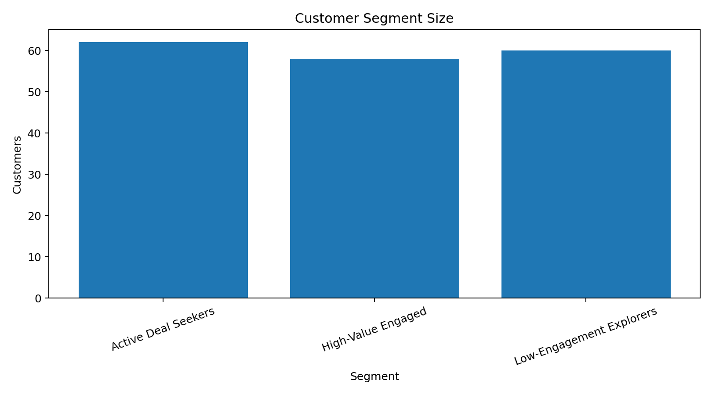
Figure 1. Relative size of the three customer segments.

5. Segment 1 – High-Value Engaged
This segment contains 58 customers (32.2% of the working sample). It has the highest average monthly spend at approximately ₹5,186, strong engagement (78.0/100), frequent visits and the shortest average recency (7.9 days). These customers are the strongest candidates for retention and premium-value campaigns.
Recommended targeting strategies:
• VIP or loyalty programs with tiered benefits.
• Personalized cross-sell and upsell recommendations.
• Early access to new products, premium features or limited offers.
• Retention messaging focused on value rather than deep discounts.
• High-value customer journeys through email, remarketing and personalized landing pages.

6. Segment 2 – Active Deal Seekers
This segment contains 62 customers (34.4%). Engagement is healthy and visit frequency is relatively high, but average monthly spend is lower than the High-Value Engaged segment. This pattern suggests customers who respond to active promotions and may increase value when the offer is relevant.
• Limited-time discounts and promotional bundles.
• Cart or browse-abandonment reminders.
• Coupon codes tied to a minimum purchase value.
• Retargeting based on recent browsing or engagement.
• A/B test promotional messaging to identify the most efficient incentive level.

7. Segment 3 – Low-Engagement Explorers
This segment contains 60 customers (33.3%). Its average engagement is the lowest at 26.9/100, monthly spend is approximately ₹657, and average recency is 36.0 days. These customers should not receive expensive high-frequency campaigns until engagement improves.
• Low-cost re-engagement campaigns with simple value propositions.
• Educational or awareness content before aggressive conversion messaging.
• Light retargeting and frequency-capped paid media.
• Win-back sequences triggered after defined inactivity periods.
• Test different creatives and channels before increasing acquisition spend.

8. Behavioral Visualizations
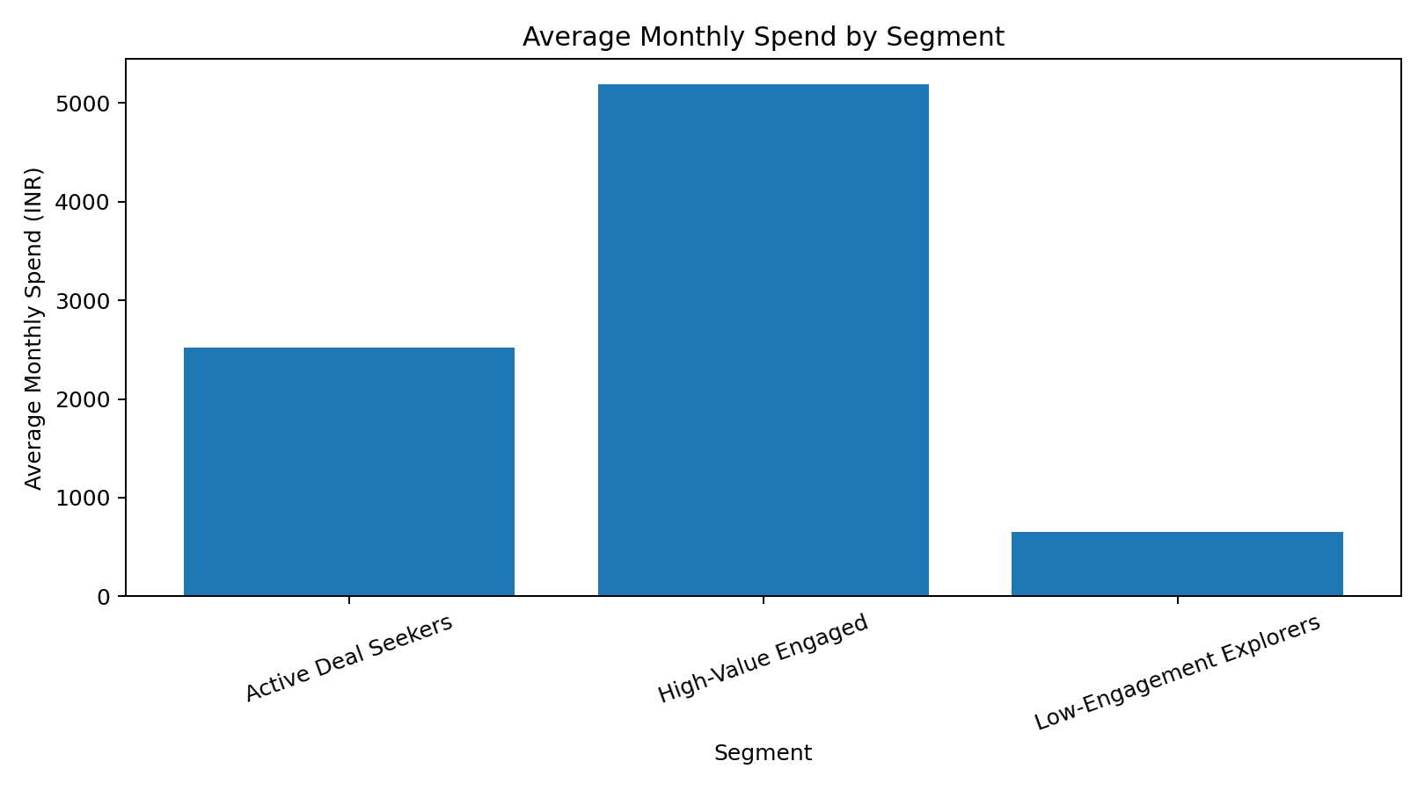
Figure 2. Average monthly spend by segment.
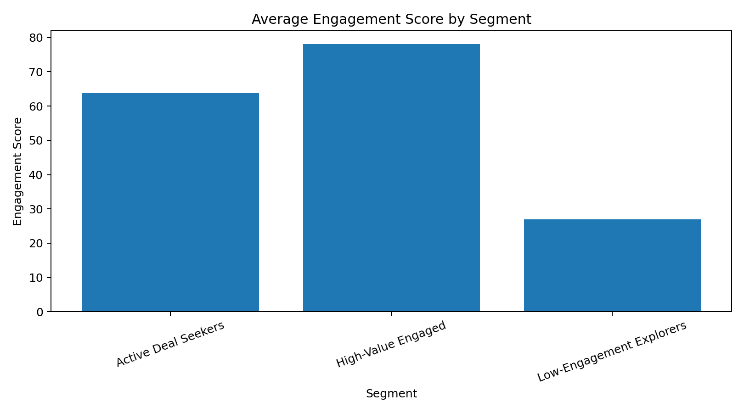
Figure 3. Average engagement score by segment.
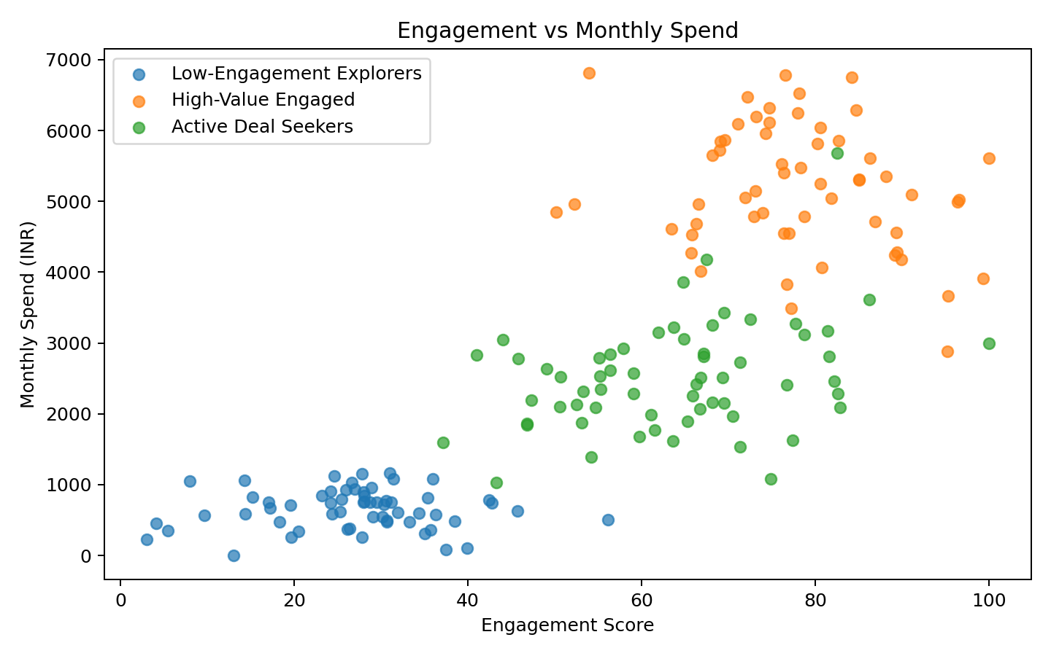
Figure 4. Relationship between engagement and monthly spend.
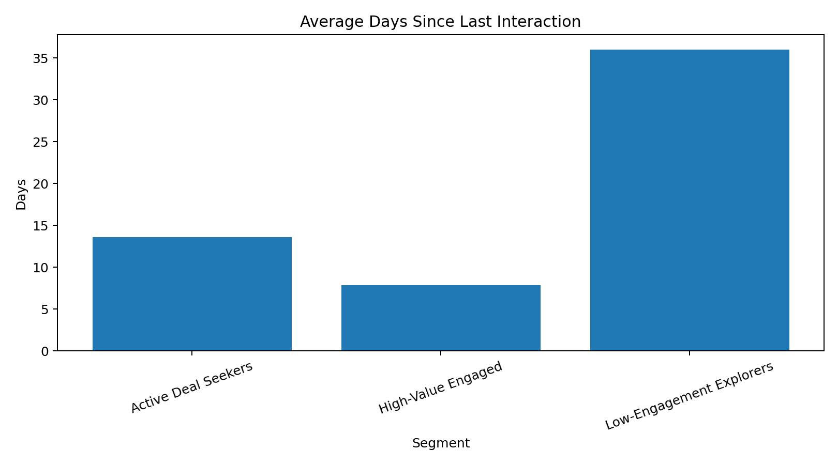
Figure 5. Average recency by segment.

9. Segment Comparison and Targeting Matrix
Segment | Primary Need | Best Message | Recommended Channel | Main KPI
High-Value Engaged | Retention & expansion | Premium value / exclusivity | Email, CRM, personalized ads | Spend, retention, repeat conversion
Active Deal Seekers | Increase basket/value | Relevant offers & bundles | Paid social, email, remarketing | Conversion rate, CPA, average order value
Low-Engagement Explorers | Re-engagement | Simple value + education | Low-cost social, email, retargeting | Reactivation rate, CTR, CPA

The targeting approach should balance relevance and cost. High-value customers can justify more personalized communication because their expected value is higher. Deal seekers should receive measurable promotional tests so discounting does not unnecessarily reduce margin. Low-engagement customers should be approached with lower-cost experiments until there is evidence of renewed interest.

10. Evaluation and Business Recommendations
• Refresh the segmentation periodically because customer behavior changes over time.
• Use engagement, recency and spend together rather than relying on age or income alone.
• Track segment-level CTR, conversion rate, CPA and retention to evaluate campaign effectiveness.
• Create separate audience lists for each segment and test tailored creative rather than one generic message.
• Use A/B testing to determine whether segment-specific messaging improves conversion and reduces acquisition cost.
• Protect high-value customers from excessive discounting; use loyalty and exclusivity instead.
• Use frequency caps for low-engagement customers to reduce wasted impressions and ad fatigue.

11. Limitations
• The customer-level data is synthetic and created solely to demonstrate the requested segmentation methodology.
• The analysis cannot be interpreted as actual customer behavior or used for real budget allocation.
• Three clusters were selected to satisfy the task requirement and to create interpretable business segments; real projects should evaluate the appropriate number of clusters using methods such as silhouette analysis and business validation.
• No customer lifetime value, revenue, product category or channel attribution data was available.
• Demographic variables such as gender, location and occupation were not used because the exercise focuses on a minimal, privacy-conscious feature set.

12. Conclusion
The segmentation exercise shows how demographic and behavioral indicators can be transformed into actionable marketing audiences. The three resulting segments have clearly different value, engagement and recency profiles. High-Value Engaged customers should receive retention and expansion campaigns, Active Deal Seekers should receive relevant promotional offers and Low-Engagement Explorers should receive low-cost re-engagement and awareness campaigns. The most important analytical principle is that segmentation should lead to different actions; simply naming clusters is not enough. In a real marketing environment, the next step would be to connect these segments to campaign performance, revenue, customer lifetime value and controlled experiments.

13. Tools Used
Python, Pandas, NumPy, Scikit-learn, Matplotlib, Microsoft Excel and Microsoft Word.

Appendix – 200+ Word Submission Description
This Week 3 report focuses on customer segmentation and targeting analysis for digital marketing. The objective was to simulate a practical segmentation workflow using demographic and behavioral characteristics and then convert the resulting customer groups into actionable marketing strategies. Because the campaign dataset used during the earlier internship tasks is campaign-level data rather than a customer-level demographic dataset, I created a clearly labeled synthetic customer-level working dataset for this exercise. The dataset contains age, annual income, engagement score, monthly spend, monthly visits, monthly conversions and days since last interaction. These variables were selected because they provide a combination of demographic, behavioral, value and recency information that can support digital marketing segmentation. The numeric variables were standardized before applying K-Means clustering. Three clusters were created and interpreted as High-Value Engaged, Active Deal Seekers and Low-Engagement Explorers. Each segment was analyzed using average spend, engagement, visit frequency, conversion behavior and recency. I created visualizations showing segment size, average monthly spend, engagement score, the relationship between engagement and spend, and average days since the last interaction. Based on these profiles, I proposed different strategies for each segment. High-Value Engaged customers are suitable for loyalty, premium and cross-sell campaigns. Active Deal Seekers can be targeted with relevant offers, bundles and remarketing. Low-Engagement Explorers should receive low-cost awareness and re-engagement campaigns before higher advertising investment is considered. The report also documents the methodology, assumptions, limitations and recommendations. This task helped me understand how data analysis can move beyond descriptive statistics and support audience selection, campaign personalization and marketing decision-making.

