YUVA INTERN – WEEK 6 TASK
KPI Reporting and Strategic Recommendations
Junior Data Analyst – Digital Marketing & Advertising
Candidate: Nikhil Ednuri
Reporting period: January–December 2025
Data type: Simulated campaign data
Submission: Week 6

1. Executive Summary
This Week 6 report integrates digital-marketing measurement, KPI analysis and strategic planning into a decision-oriented performance report. The analysis uses a simulated 12-month advertising dataset to demonstrate how a marketing analyst could collect, calculate, interpret and communicate campaign KPIs. The selected KPIs cover the full funnel: impressions and CPM for reach, CTR and CPC for engagement and traffic efficiency, conversion rate and conversions for outcome performance, and CPA, revenue and ROAS for commercial efficiency.
Across the simulated period, the campaign generated 34.21 million impressions, 821,410 clicks and 44,574 conversions. Blended CTR was 2.40%, conversion rate was 5.43%, CPA was 7.55, and ROAS was 15.00x. These figures are illustrative and are intended to demonstrate the KPI-reporting process rather than represent the performance of a real advertiser.

2. KPI Framework and Relevance
KPI | Definition | Why it matters
Impressions | Number of ad exposures | Measures reach and scale.
CPM | Spend ÷ impressions × 1,000 | Shows cost of reaching audiences.
CTR | Clicks ÷ impressions | Indicates creative/message engagement.
Clicks | Impressions × CTR | Measures traffic generated by ads.
CPC | Spend ÷ clicks | Measures cost efficiency of traffic.
Conversion Rate | Conversions ÷ clicks | Measures landing-page/funnel effectiveness.
Conversions | Completed desired actions | Primary campaign outcome.
CPA | Spend ÷ conversions | Shows cost of acquiring a conversion.
Revenue | Conversions × average order value | Connects campaign activity to commercial value.
ROAS | Revenue ÷ spend | Measures revenue efficiency of advertising investment.

3. Data Collection and Measurement Approach
In a real campaign, KPI data would be collected from advertising platforms, analytics tools, CRM/order systems and finance records. For this internship simulation, the same measurement logic was reproduced in a monthly dataset. Impressions, ad spend, CTR, conversion rate and average order value were used to derive clicks, conversions, CPC, CPA, revenue, ROAS and CPM. Definitions were kept consistent across months so that trends could be compared without changing the denominator or business meaning of a KPI.
The simulated dataset intentionally demonstrates a gradual improvement in funnel efficiency. This makes it possible to evaluate whether improving engagement and conversion performance is reflected in acquisition cost and return metrics.

4. Overall KPI Dashboard
KPI | Overall result | Illustrative status
Impressions | 34.21M | Informational
CTR | 2.40% | On track
Clicks | 821,410 | Informational
CPC | 0.41 | On track
Conversion Rate | 5.43% | On track
Conversions | 44,574 | Informational
CPA | 7.55 | On track
Revenue | 5,048,271 | Informational
ROAS | 15.00x | On track
CPM | 9.84 | Informational

5. KPI Trend Analysis
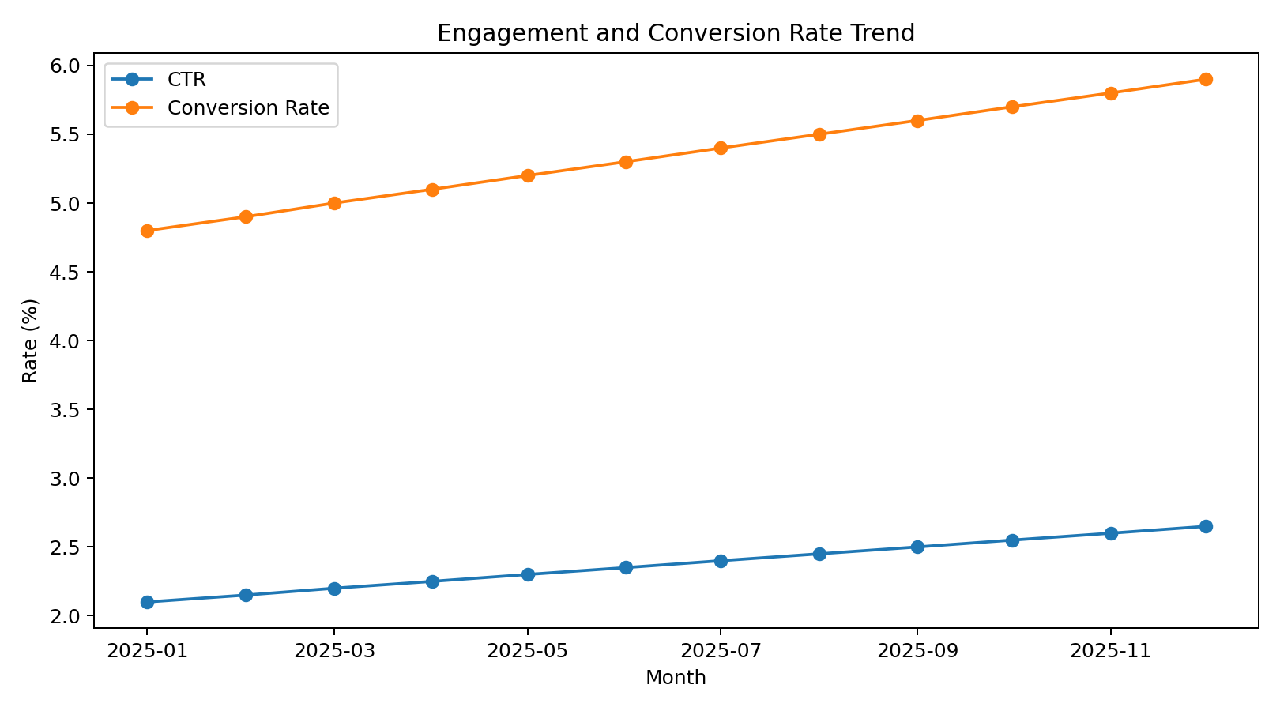
Figure 1. CTR and conversion-rate trends across the simulated reporting period.
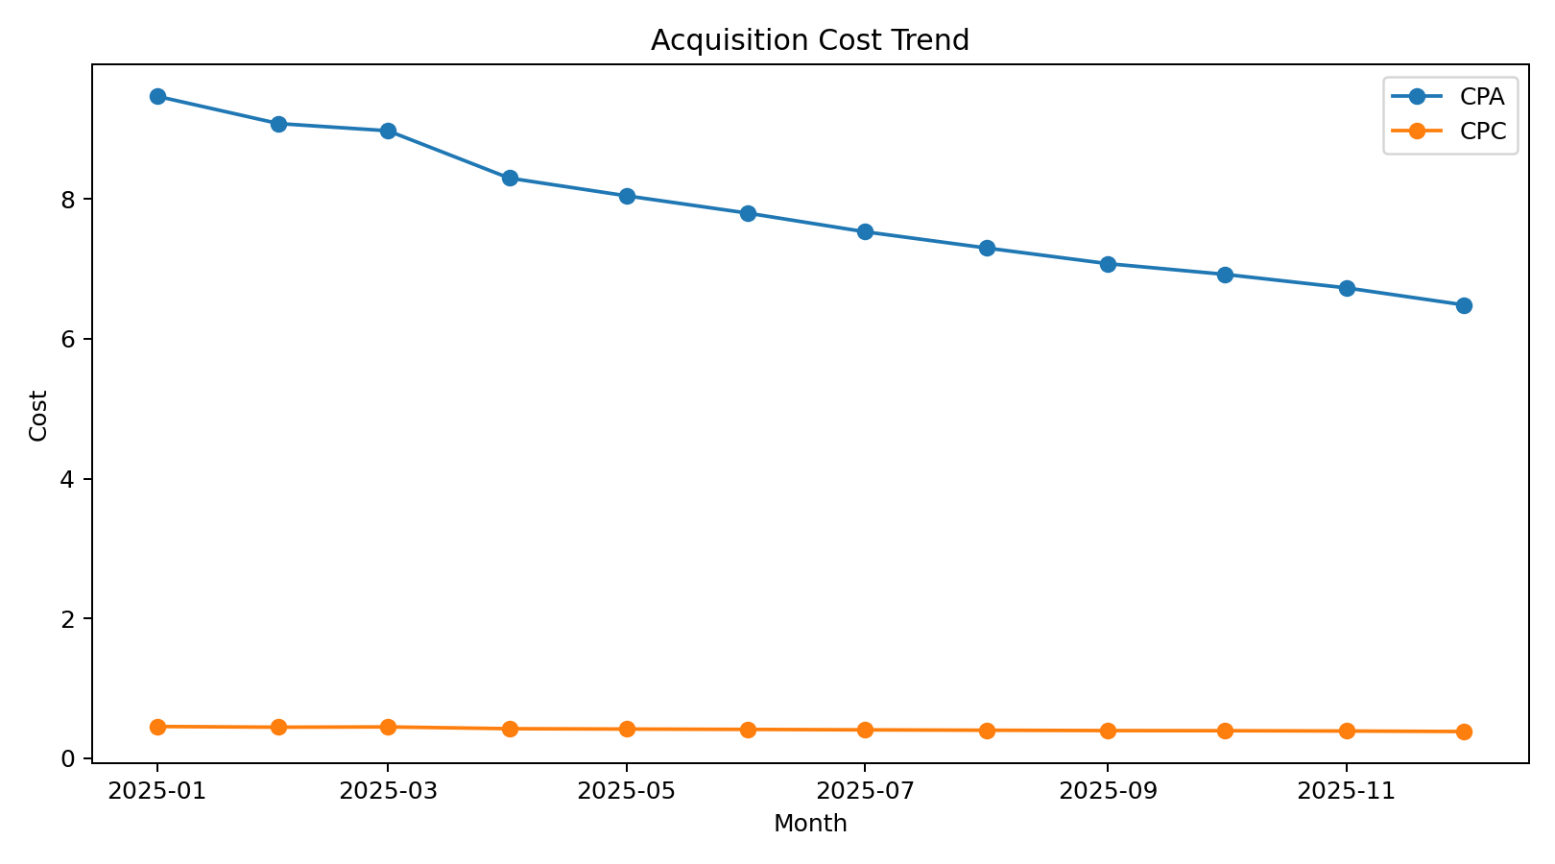
Figure 2. CPC and CPA trends. Lower acquisition cost indicates improving efficiency when conversion quality remains stable.
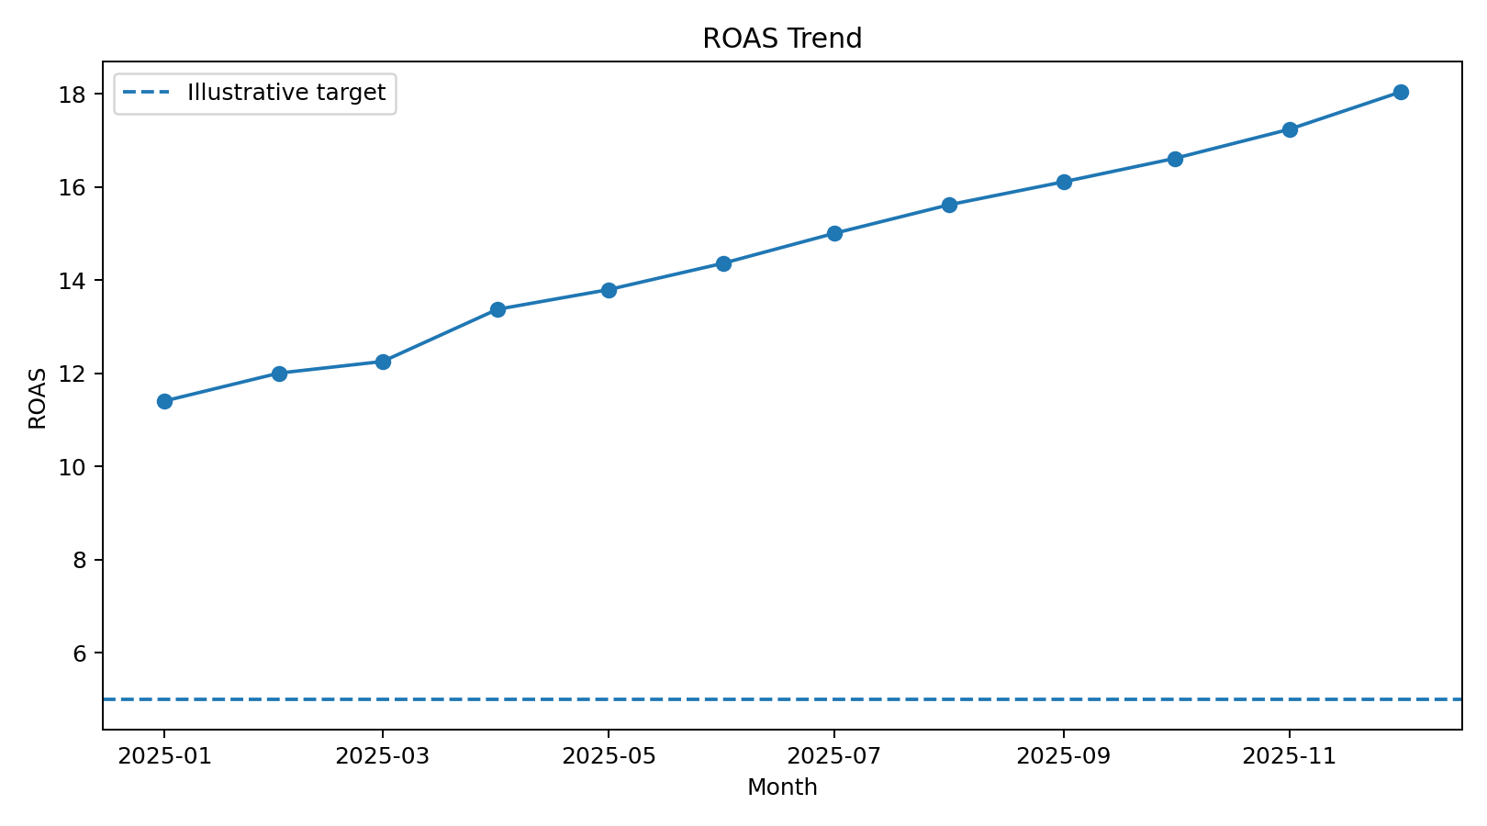
Figure 3. ROAS trend compared with an illustrative 5.0x management target.
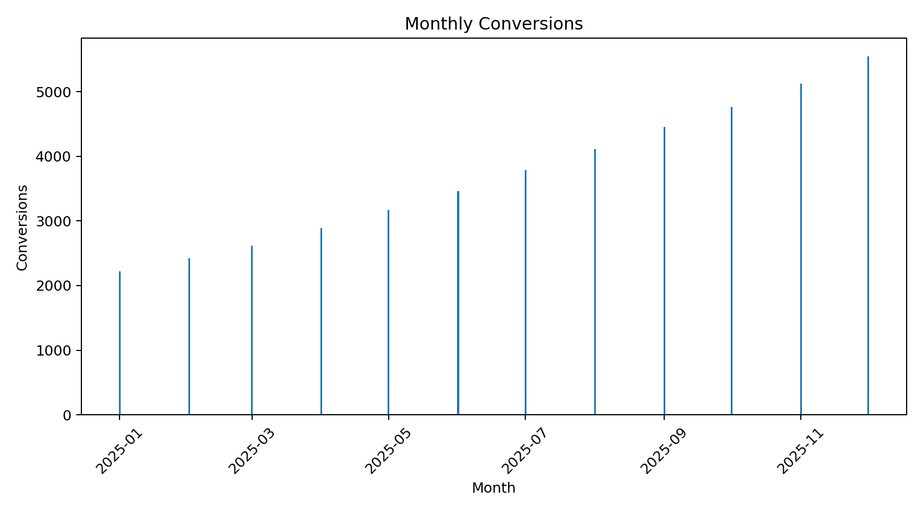
Figure 4. Monthly conversion volume.
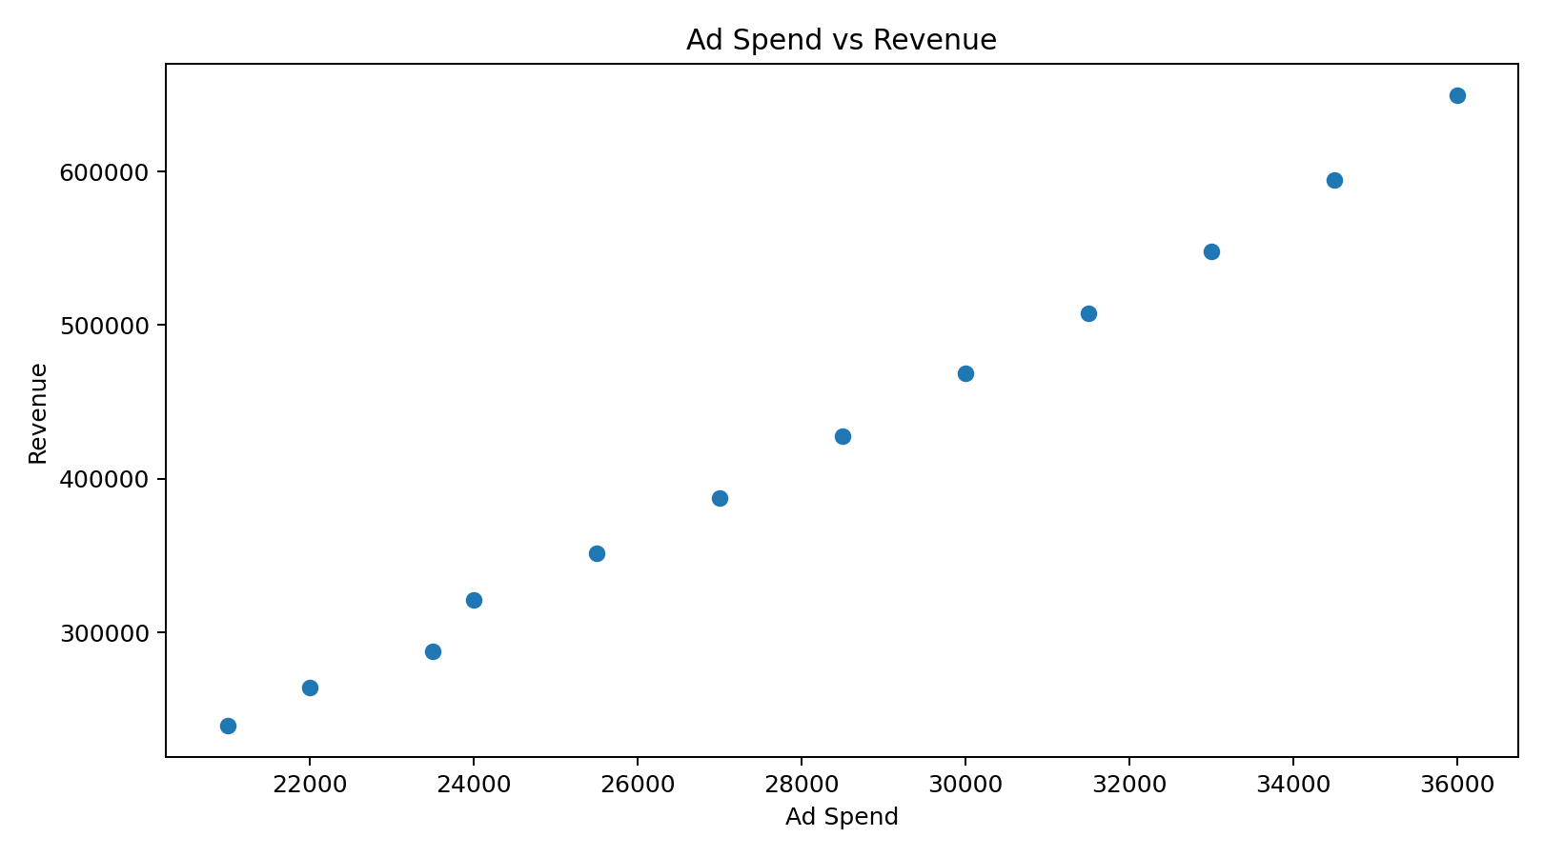
Figure 5. Relationship between ad spend and revenue in the simulated dataset.

6. Key Insights for Decision-Makers
• Reach and traffic scale increased throughout the period, giving the campaign a larger opportunity to generate conversions.
• CTR improved gradually, suggesting that the simulated creative and audience strategy became more effective at generating clicks.
• Conversion rate also improved, which is important because traffic growth without funnel efficiency can increase spend without producing proportional business outcomes.
• CPA should be interpreted together with conversion quality and revenue; a lower CPA is not automatically better if the acquired customers have lower value.
• ROAS provides a direct connection between marketing investment and modeled revenue, making it useful for budget allocation and executive reporting.
• KPI dashboards should combine leading indicators such as CTR with lagging business outcomes such as revenue and ROAS rather than relying on a single metric.

7. Strategic Recommendations
1. Improve creative testing: Run structured A/B tests for headlines, formats, hooks and calls-to-action. Prioritize variants that improve CTR without reducing downstream conversion quality.
2. Optimize the conversion funnel: Review landing-page relevance, page speed, mobile usability, forms and checkout friction. Use conversion rate alongside CTR to identify whether problems occur before or after the click.
3. Allocate budget by marginal efficiency: Increase spend gradually in campaigns where incremental conversions and ROAS remain healthy. Avoid scaling solely because impressions or clicks are increasing.
4. Establish KPI guardrails: Set management thresholds for CTR, CPC, conversion rate, CPA and ROAS. Trigger investigation when a KPI moves materially outside its expected range.
5. Build first-party measurement: Connect advertising data with analytics and CRM/order data so revenue and customer quality can be measured rather than inferred from clicks alone.
6. Segment performance: Break KPIs down by platform, audience, creative, geography and device. Aggregate reporting can hide weak segments that consume budget.
7. Review performance regularly: Use weekly operational monitoring and a monthly executive review. Document major campaign changes so KPI movements can be interpreted correctly.

8. Suggested Decision-Making Framework
Signal | Possible interpretation | Recommended action
CTR down + CPC up | Creative/audience engagement weakening | Refresh creatives and review targeting.
CTR stable + conversion rate down | Post-click experience weakening | Audit landing page, offer and tracking.
Conversions up + CPA up sharply | Scale may be inefficient | Check marginal CPA and reduce weak segments.
ROAS below target | Revenue efficiency insufficient | Reallocate budget and test offer/funnel.
ROAS healthy + conversion volume growing | Potential scalable segment | Increase spend gradually while monitoring marginal return.

9. Challenges and Measurement Risks
• KPI definitions can differ between platforms, especially attribution windows and conversion counting rules.
• Last-click reporting can undervalue awareness and assist interactions.
• Simulated data cannot reproduce all real-world effects such as seasonality, auction dynamics, competitor behavior or tracking loss.
• Revenue-based KPIs require accurate transaction values and cancellation/refund handling.
• Correlation between spend and revenue does not prove that additional spend caused all incremental revenue.

10. Conclusion
A strong digital-marketing KPI report should move beyond listing numbers. It should define each metric, explain why it matters, show how it changes over time, identify relationships between funnel stages and translate the evidence into decisions. This Week 6 analysis demonstrates that approach using a simulated campaign dataset. The recommended strategy is to monitor a balanced KPI set, diagnose the stage of the funnel where performance changes, and allocate budget according to incremental efficiency and business value. In a real organization, the framework can be extended with channel-level data, customer lifetime value, attribution analysis and statistical experimentation.

11. Submission Description (200+ words)
This Week 6 project focuses on KPI reporting and strategic recommendations for digital marketing and advertising campaigns. The purpose was to integrate data collection, KPI calculation, visualization and business interpretation into a report that could support decision-makers. I selected a balanced set of KPIs covering the advertising funnel, including impressions, CPM, CTR, clicks, CPC, conversion rate, conversions, CPA, revenue and ROAS. Each KPI was defined and its relevance to campaign management was explained. To demonstrate the measurement process, I created a simulated 12-month campaign dataset containing ad spend, impressions, engagement, conversion and revenue-related variables. The derived metrics were calculated using consistent formulas so that monthly performance could be compared. I developed visualizations for engagement and conversion rates, acquisition costs, ROAS, conversion volume and the relationship between ad spend and revenue. The analysis shows why decision-makers should not rely on a single KPI. For example, higher click volume may be positive, but it must be considered alongside conversion rate and CPA. Similarly, revenue and ROAS provide a stronger view of commercial efficiency than impressions or clicks alone. I also developed a practical strategic recommendation section covering creative testing, conversion-funnel optimization, budget allocation, KPI guardrails, first-party measurement, segmentation and regular performance reviews. Important measurement risks were documented, including attribution differences, simulated data limitations, tracking quality and the difference between correlation and causation. The final report therefore demonstrates an end-to-end KPI reporting workflow: define the metrics, collect or simulate consistent data, calculate KPIs, visualize trends, identify performance signals and translate those signals into actionable decisions. This task strengthened my ability to communicate quantitative marketing performance in a structured, business-focused manner.

