YUVA INTERN – WEEK 4 TASK
Trend Analysis and Competitor Evaluation
Junior Data Analyst – Digital Marketing & Advertising
Candidate: Nikhil Ednuri
Market focus: Digital marketing in India
Competitors: Nike and adidas
Submission: Week 4
Date: 04 October 2026

1. Executive Summary
This Week 4 report combines digital-market trend analysis with a competitor evaluation. The analysis uses publicly accessible digital-market information for India and publicly reported company information from Nike and adidas. The purpose is to identify important changes in digital consumer behavior, evaluate how major competitors respond to those changes, and translate the findings into actionable marketing recommendations.
India provides a large and increasingly connected digital market. DataReportal reported 806 million internet users and 491 million social-media user identities in India at the beginning of 2025. Instagram had an estimated 414 million users in India, while Facebook had 384 million and Snapchat 208 million in the same period. These figures show why mobile-first social media, creator-led content and measurable digital experiences are strategically important for marketers.
The competitor review shows two mature brands using a combination of digital commerce, social storytelling, partnerships, apps and physical retail. Nike reported fiscal 2025 revenue of $46.3 billion and NIKE Direct revenue of $18.8 billion, while adidas reported that direct-to-consumer sales represented 40% of its 2025 net sales and that e-commerce sales increased 16%. These company-reported figures are kept separate because their definitions and reporting periods differ.

2. Objectives
• Identify important digital-marketing trends relevant to the Indian market.
• Compare at least two major competitors using publicly reported metrics and strategic evidence.
• Evaluate competitor positioning across digital commerce, social storytelling, personalization, partnerships and omnichannel execution.
• Develop actionable recommendations for a digital-marketing team based on the observed trends.

3. Public Data Sources and Method
The analysis uses publicly available secondary information. India digital-market figures were taken from DataReportal's Digital 2025: India report. Nike company strategy and financial information was taken from its SEC-filed Form 10-K. adidas strategy, channel mix and e-commerce information was taken from its 2025 Annual Report. The report also contains an illustrative trend index and capability scorecard created for this internship exercise. These illustrative values are explicitly labeled and are not presented as company-reported facts.
DataReportal – Digital 2025: India: https://datareportal.com/reports/digital-2025-india
NIKE – 2026 Form 10-K / SEC: https://www.sec.gov/Archives/edgar/data/320187/000032018726000088/nke-20260531.htm
adidas Annual Report 2025: https://report.adidas-group.com/2025/en/group-management-report-our-company/description-of-business-model/markets-and-sales-channels.html
adidas Product and Marketing: https://www.report.adidas-group.com/2025/en/group-management-report-our-company/product-and-marketing.html

4. Digital Market Trend: India
Indicator | Reported value | Period
Internet users in India | 806 million | January 2025
Social-media user identities | 491 million | January 2025
Instagram users | 414 million | Early 2025
Facebook users | 384 million | Early 2025
Snapchat users | 208 million | Early 2025

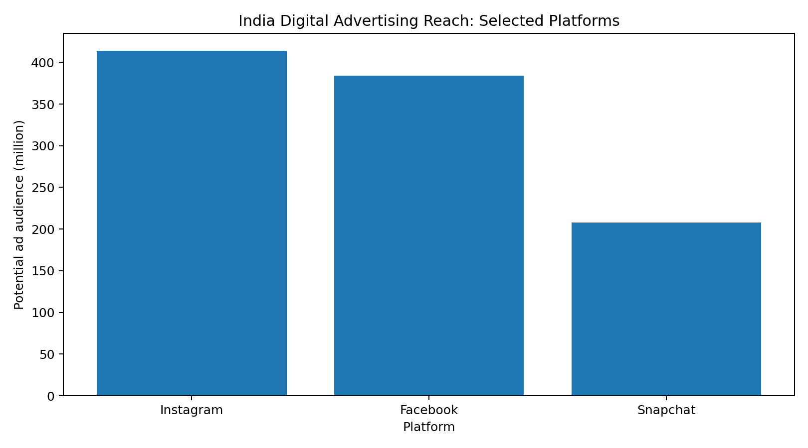
Figure 1. Selected platform audience figures for India.
The platform data indicates that social media is not a niche channel in India. The size of the reachable audience supports a mobile-first strategy where brands use platform-native creative, short-form video, creator partnerships and social proof. Marketers should distinguish between advertising reach and unique active users because platform ad-planning figures are not equivalent to audited monthly active-user counts.

5. Emerging Trend Assessment
Several trends are especially relevant to digital marketing: short-form video and creator-led discovery; personalization and recommendation; social-to-commerce journeys; first-party data and loyalty ecosystems; and the growing use of AI-enabled search and shopping experiences.
Trend | Strategic importance | Marketing implication
Short-form video & creators | High | Build awareness and consideration through native, creator-led storytelling.
Personalization | High | Use behavior and first-party data to tailor offers, recommendations and messages.
Social commerce | High | Reduce friction between discovery, product information and purchase.
Loyalty / membership | High | Connect purchases, content, apps, events and rewards into one customer relationship.
AI-enabled discovery | Emerging/High | Optimize product information and digital experiences for AI-assisted search and recommendations.

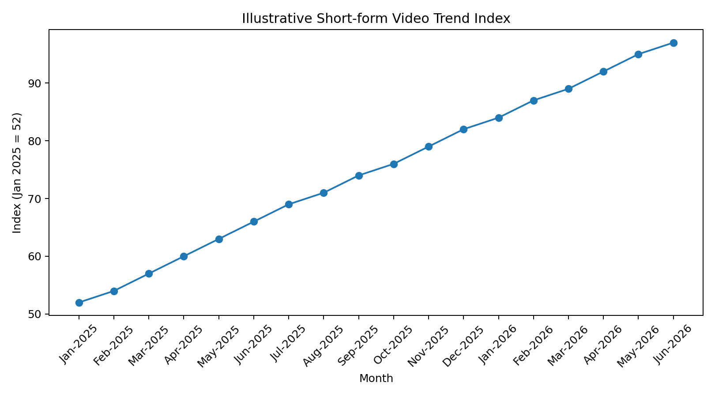
Figure 2. Illustrative short-form-video trend index (not a reported market statistic).
The illustrative index demonstrates the trend-analysis method requested by the internship task. It starts at 52 in January 2025 and rises to 97 by June 2026, representing a hypothetical increase in strategic importance. It must not be interpreted as a measured industry index.

6. Competitor Evaluation – Nike
Nike's filings describe a strategy centered on sport, innovation, consumer connection and digital experiences. Nike operates NIKE Direct through owned retail and digital platforms as well as wholesale channels. Its fiscal 2025 revenue was $46.3 billion and NIKE Direct revenue was $18.8 billion, representing approximately 42% of total NIKE Brand revenue. Nike also identifies digital commerce, social media, mobile experiences and AI-enabled search, discovery, personalization and recommendation as competitive areas.
Nike metric / initiative | Publicly reported observation
FY2025 total revenue | $46.3 billion
FY2025 NIKE Direct revenue | $18.8 billion
NIKE Direct share of NIKE Brand revenue | Approximately 42%
Digital strategy | Digital commerce, apps, consumer experiences and personalization
Competitive focus | Product innovation, consumer connection, social media, digital experiences

Source: Nike FY2026 Form 10-K and FY2025 disclosures.

7. Competitor Evaluation – adidas
adidas reports a balanced channel strategy combining wholesale, own retail and e-commerce. In 2025, wholesale represented 60% of total net sales and direct-to-consumer business represented 40%. adidas also reported a 16% increase in e-commerce sales. Its digital ecosystem includes adiClub, the adidas Running app and the Confirmed app, while its marketing approach connects brand campaigns, product franchises, category activation, brand stories and commercial conversion.
adidas metric / initiative | Publicly reported observation
Wholesale share of 2025 net sales | 60%
Direct-to-consumer share of 2025 net sales | 40%
2025 e-commerce sales growth | 16%
Digital ecosystem | adiClub, adidas Running and Confirmed
Marketing approach | Connected funnel from awareness to consideration to conversion

Source: adidas Annual Report 2025.
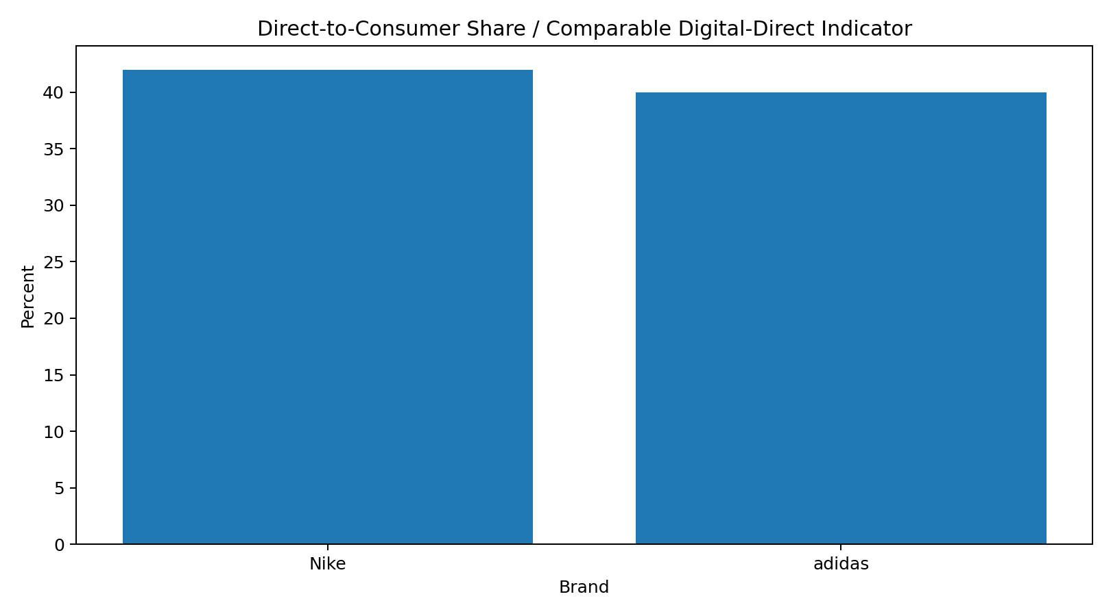
Figure 3. Reported DTC shares for Nike and adidas. Definitions differ, so this is a directional comparison only.

8. Competitive Positioning Matrix
Capability | Nike | adidas | Analyst interpretation
Digital commerce | 5 | 5 | Both have mature DTC/e-commerce ecosystems
Social storytelling | 5 | 5 | Both use campaigns, athletes, creators and cultural moments
Personalization / apps | 5 | 5 | Both use digital experiences; Nike highlights AI-enabled capabilities, adidas uses apps/membership
Community & partnerships | 5 | 5 | Both use athletes, creators, collaborations and events
Omnichannel integration | 5 | 5 | Both combine digital experiences with physical retail and wholesale

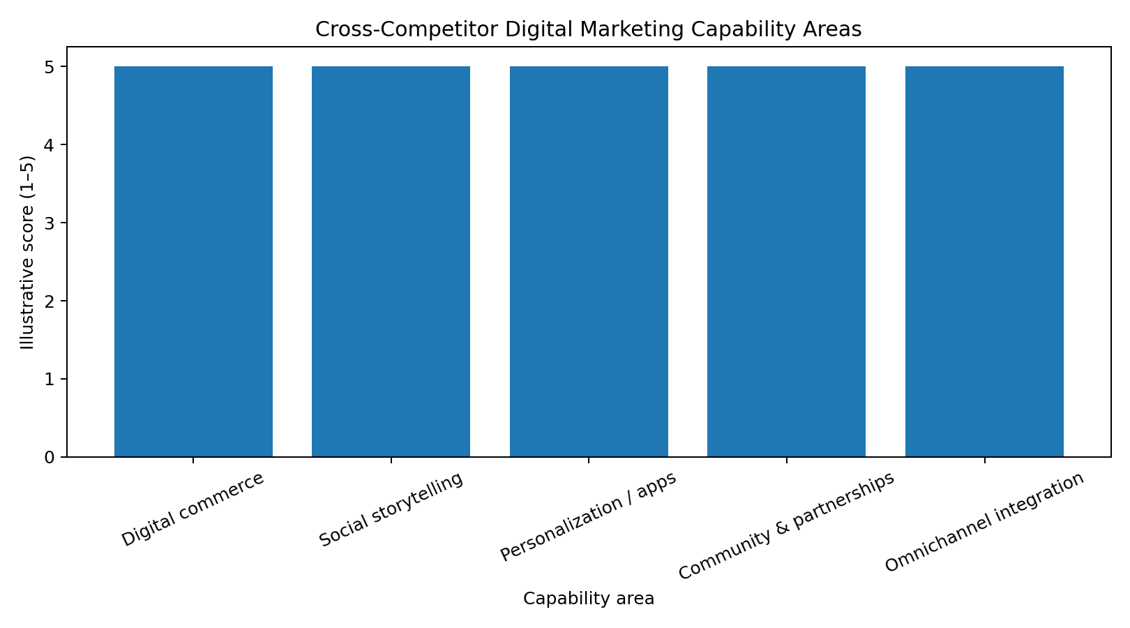
Figure 4. Illustrative capability assessment (1–5); not company-reported scores.
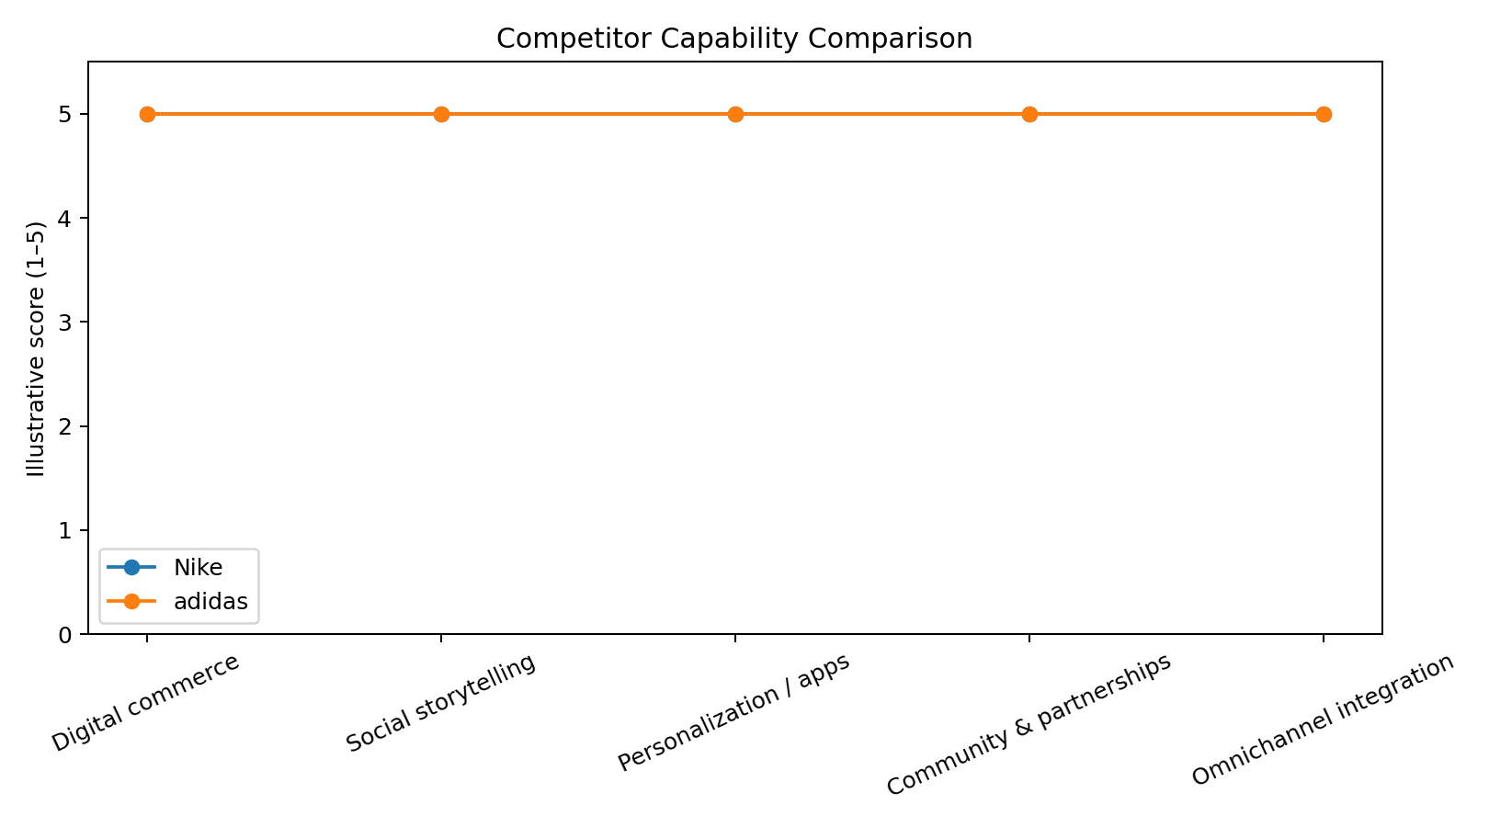
Figure 5. Competitor capability comparison.
The matrix intentionally avoids claiming that one competitor is objectively superior across all capabilities. Both brands demonstrate mature digital ecosystems, strong storytelling and significant partnership capabilities. The strategic difference is more visible in execution details: Nike's disclosures emphasize direct consumer connection, digital commerce and the need to adapt to AI-enabled shopping, while adidas emphasizes a connected marketing funnel, membership, apps, collaborations and a 40% DTC channel share.

9. Key Insights
• India's large social-media audience makes platform-native content and creator-led discovery important components of digital strategy.
• Digital commerce is no longer separate from brand marketing; both competitors connect awareness, engagement, product discovery and conversion.
• Membership and first-party data ecosystems can increase the frequency and relevance of customer interactions beyond individual campaigns.
• AI-enabled search, recommendation and shopping experiences are becoming a competitive consideration, not only an experimental technology.
• Competitor comparison should use consistent definitions. Nike's DTC metric and adidas's DTC metric are reported under different business definitions and should not be treated as directly equivalent.

10. Actionable Recommendations
• Build a short-form content engine with creator partnerships, multiple creative hooks and rapid testing of formats.
• Connect social campaigns to measurable landing-page, product-view and conversion events instead of optimizing only for impressions or likes.
• Develop a first-party customer-data strategy through loyalty, consented preferences, purchase history and engagement signals.
• Use AI-assisted search and recommendation carefully to improve product discovery while maintaining accurate product information and transparent customer experiences.
• Create a competitor dashboard that tracks channel mix, campaign themes, product launches, engagement signals, digital features and public financial indicators each quarter.
• For the Indian market, localize creative, partnerships and cultural moments rather than simply adapting global campaigns word-for-word.

11. Limitations
• Publicly reported company metrics use different definitions and reporting periods.
• Social-platform advertising reach is not the same as unique active users.
• The short-form-video trend index and 1–5 capability scores are illustrative analytical constructs created for this internship task.
• Public information does not provide a complete picture of competitor campaign-level ROI, conversion rates or customer acquisition costs.
• The report should be treated as a strategic analysis exercise rather than an investment recommendation or audited market study.

12. Conclusion
The digital marketing environment is moving toward faster content cycles, creator-led discovery, personalized experiences, connected commerce and AI-assisted product discovery. India offers a particularly large addressable digital audience, while Nike and adidas demonstrate how major brands combine digital platforms with physical retail, partnerships and marketing campaigns. A strong digital-marketing team should therefore monitor both consumer trends and competitor execution, translate observations into measurable KPIs, and continuously test creative and targeting strategies.

13. Submission Description (200+ words)
This Week 4 report focuses on trend analysis and competitor evaluation within the digital marketing landscape. The objective was to identify important digital-market trends, compare the strategies of at least two major competitors, and convert the findings into actionable marketing recommendations. I used publicly accessible secondary information relating to digital usage in India and company-reported information from Nike and adidas. The analysis examined trends including social-media growth, short-form video, creator-led marketing, personalization, social commerce, loyalty ecosystems and AI-enabled product discovery. DataReportal information was used to provide context on India's digital environment, including internet users and selected social-platform audience figures. Nike and adidas were selected as competitors because both operate large global sports and lifestyle brands with significant digital commerce and marketing ecosystems. For Nike, I reviewed reported revenue, NIKE Direct performance and the company's discussion of digital commerce, consumer connection and AI-enabled search and personalization. For adidas, I reviewed its reported channel mix, e-commerce growth, membership programs, apps and connected marketing-funnel approach. I created visualizations to communicate platform reach, an illustrative trend index, reported direct-to-consumer shares and a competitor capability matrix. The report distinguishes clearly between company-reported facts and illustrative analytical scores so that simulated values are not presented as real market statistics. Based on the findings, I recommended stronger short-form content, creator partnerships, first-party data collection, connected social-to-commerce journeys, AI-assisted discovery and regular competitor monitoring. This task strengthened my ability to collect secondary data, evaluate competitors, compare business metrics carefully, visualize trends and translate market observations into practical digital-marketing strategies.

