YUVA INTERN – WEEK 2 TASK
Data Analysis and Visualization for Campaign Performance
Junior Data Analyst – Digital Marketing & Advertising
Candidate: Nikhil Ednuri
Project: Social Media Campaign Performance Analysis
Submission: Week 2
Date: 04 October 2026

1. Executive Summary
This report analyzes a cleaned social-media campaign working dataset to identify performance patterns across platforms, campaigns and time. The analysis focuses on impressions, clicks, engagement, advertising spend and conversions. Five visualizations are used to compare platform performance, evaluate click-through rate, examine conversion trends and explore the relationship between advertising spend and conversions.
The analysis is designed as a simulated digital-marketing exercise using the Week 1 practice dataset. It demonstrates the analytical workflow required for a Junior Data Analyst: define KPIs, aggregate data at useful levels, visualize patterns, identify anomalies or opportunities, and translate numerical results into actionable recommendations.

2. Dataset and Analytical Objective
The working dataset contains campaign-level records with platform, campaign name, date, impressions, clicks, likes, shares, comments, advertising spend and conversions. The objective is to determine which platforms and campaigns generate stronger traffic and conversion outcomes, how efficiently spend is converted into clicks and conversions, and whether performance changes over time.
Public reference dataset: Kaggle – Sales Conversion Optimization

3. Metrics and Methods
Metric | Formula | Interpretation
Impressions | Source field | Total ad exposure
CTR (%) | Clicks / Impressions × 100 | Ability to turn exposure into clicks
Engagement Rate (%) | (Likes + Shares + Comments) / Impressions × 100 | Social interaction relative to exposure
Conversion Rate (%) | Conversions / Clicks × 100 | Ability to turn clicks into conversions
CPC (INR) | Spend / Clicks | Average cost of a click
CPA (INR) | Spend / Conversions | Average cost of a conversion

Platform and campaign-level aggregations were used to compare groups. Monthly aggregation was used to identify trends. A scatter plot was used to examine whether higher advertising spend is associated with higher conversions.

4. Overall Performance Snapshot
KPI | Result
Total impressions | 5,277,608
Total clicks | 372,261
Total conversions | 33,865
Total ad spend | ₹739,410.62
Overall CTR | 7.05%
Overall conversion rate | 9.10%
Overall CPC | ₹1.99
Overall CPA | ₹21.83

5. Platform Performance Analysis
Platform | Clicks | Conversions | CTR | Conv. Rate | CPC | CPA
Facebook | 76,803 | 6,782 | 6.82% | 8.83% | ₹2.24 | ₹25.37
Instagram | 54,320 | 4,813 | 6.94% | 8.86% | ₹2.25 | ₹25.35
Linkedin | 70,376 | 6,189 | 6.77% | 8.79% | ₹2.04 | ₹23.15
X | 99,903 | 8,901 | 6.92% | 8.91% | ₹1.61 | ₹18.02
Youtube | 70,859 | 7,180 | 8.00% | 10.13% | ₹2.00 | ₹19.73

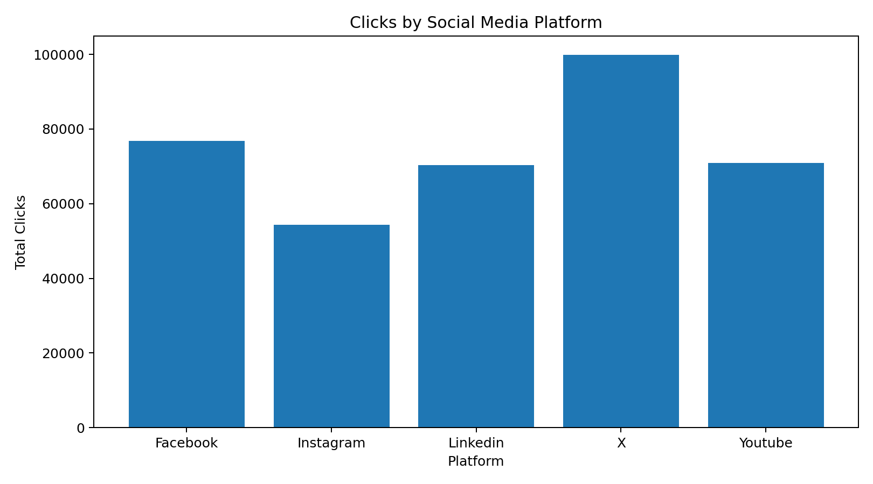
Figure 1. Total clicks by platform.
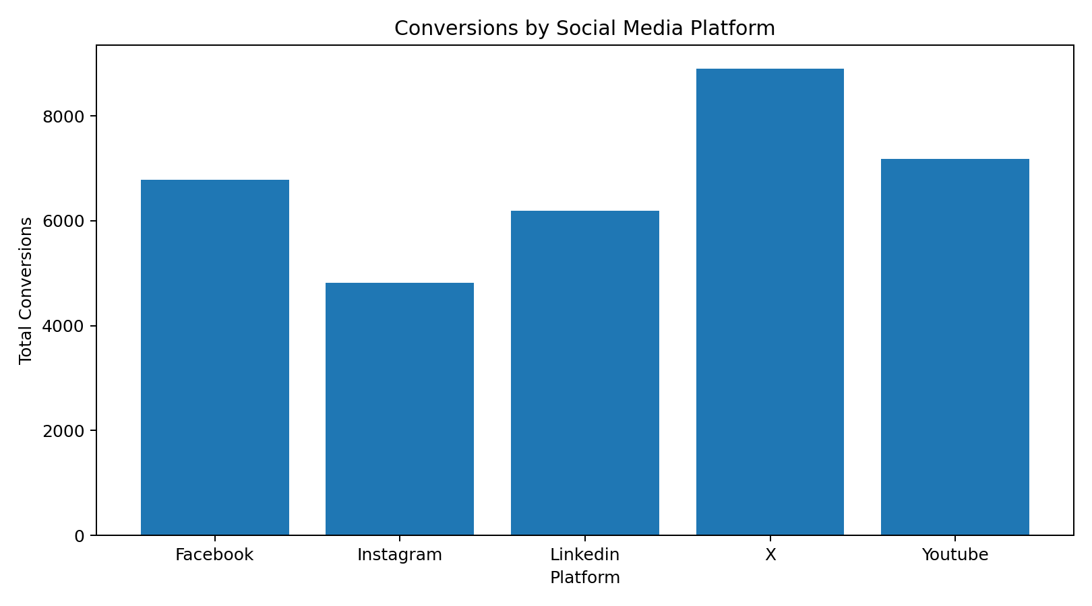
Figure 2. Total conversions by platform.
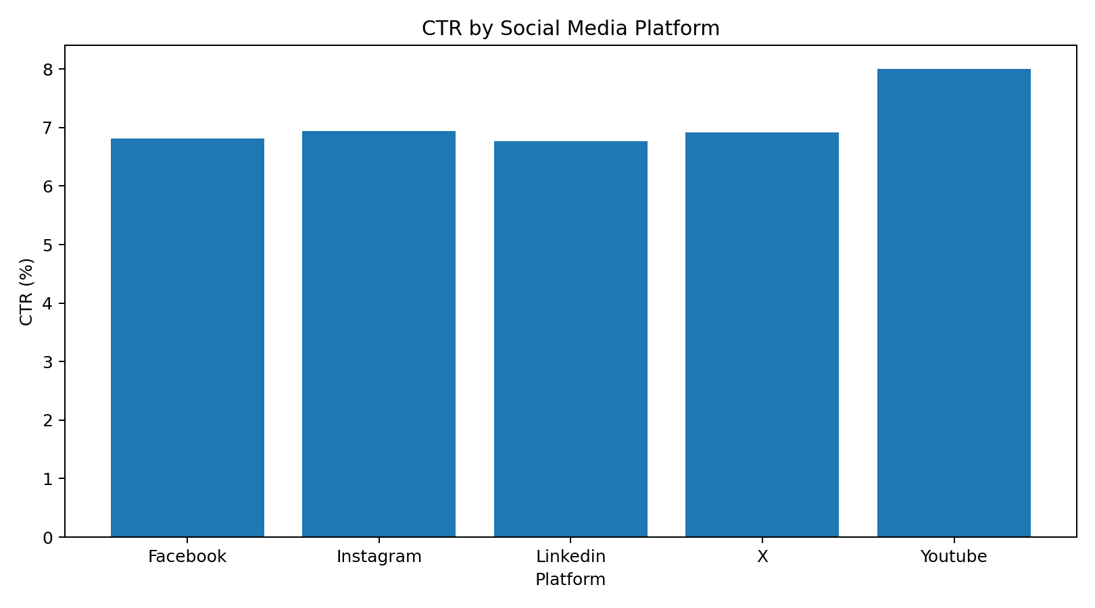
Figure 3. Click-through rate by platform.

6. Campaign Performance Analysis
Campaign | Impressions | Clicks | CTR | Conversions | Conv. Rate | CPA
Weekend Discount | 1,034,168 | 68,112 | 6.59% | 6,865 | 10.08% | ₹16.55
Winter Sale | 749,290 | 63,168 | 8.43% | 6,012 | 9.52% | ₹12.08
Summer Sale | 742,264 | 51,654 | 6.96% | 5,602 | 10.85% | ₹24.74
Brand Awareness | 894,923 | 56,598 | 6.32% | 4,398 | 7.77% | ₹36.06
Festive Offer | 766,478 | 57,964 | 7.56% | 4,120 | 7.11% | ₹19.05
Student Offer | 341,348 | 22,766 | 6.67% | 2,798 | 12.29% | ₹18.95
Lead Generation | 490,749 | 34,043 | 6.94% | 2,626 | 7.71% | ₹31.36
New Product Launch | 258,388 | 17,956 | 6.95% | 1,444 | 8.04% | ₹29.12

The campaign with the highest CTR in this working dataset is Winter Sale (8.43%). The campaign with the highest number of conversions is Weekend Discount (6865 conversions). These measures answer different business questions: CTR indicates traffic-generation efficiency, while conversions indicate outcome volume.

7. Time Trend Analysis
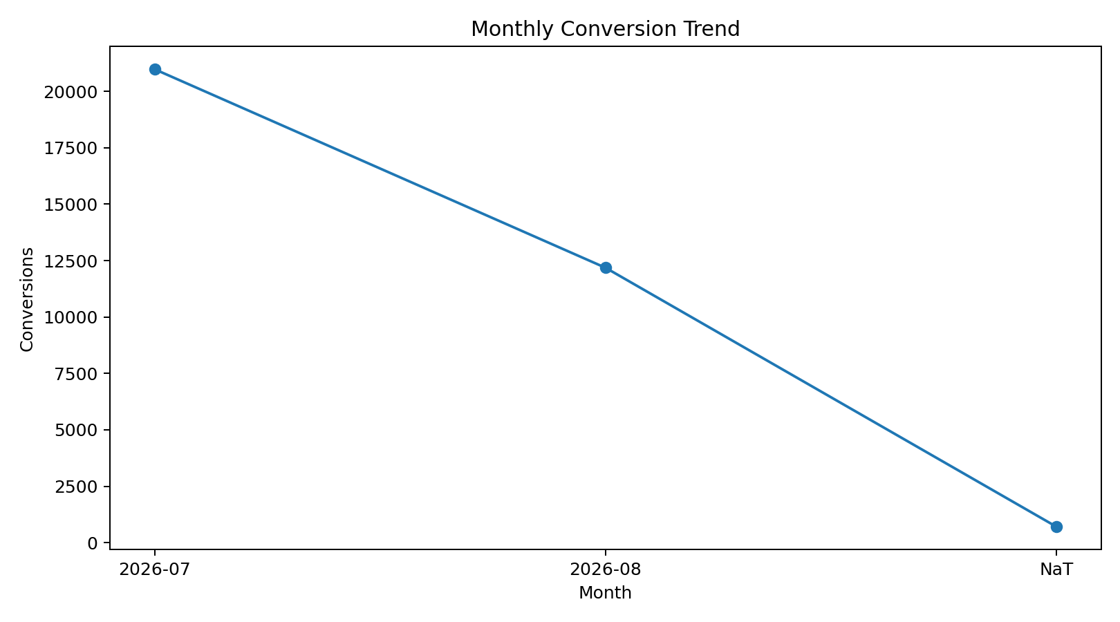
Figure 4. Monthly conversion trend.
Monthly aggregation reduces record-level noise and makes it easier to identify whether conversion volume is increasing or decreasing. The trend should be interpreted alongside spend and traffic because a change in conversions can result from a change in campaign intensity, audience mix or traffic volume rather than a change in efficiency alone.

8. Spend vs. Conversion Analysis
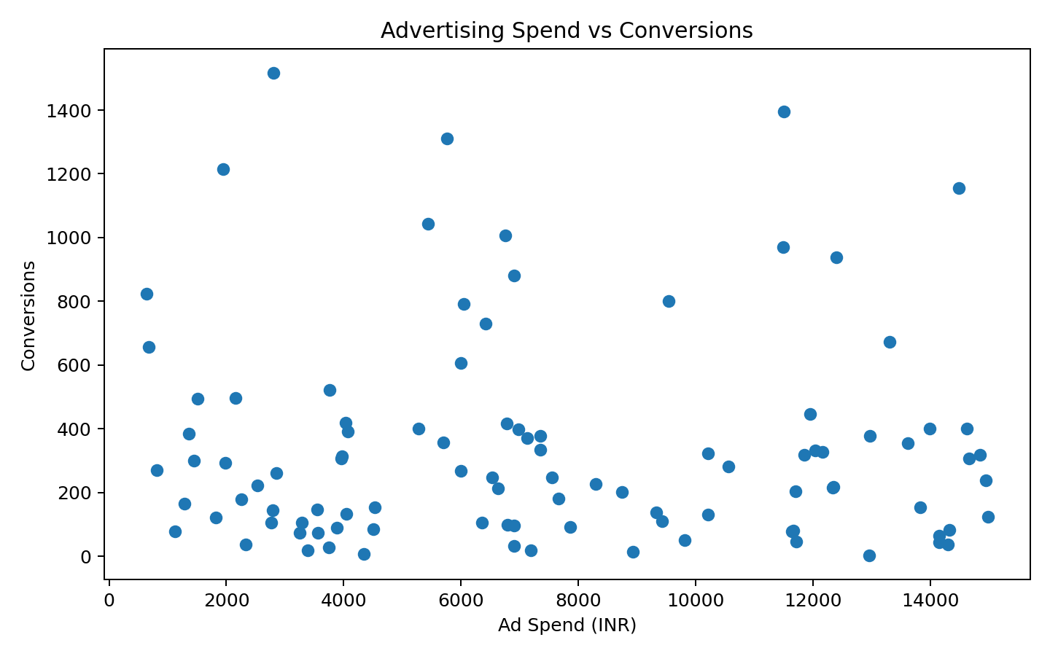
Figure 5. Relationship between advertising spend and conversions.
The Pearson correlation between advertising spend and conversions in the working dataset is -0.03. A positive association would indicate that higher spending tends to coincide with more conversions, but correlation alone does not establish causation. Campaign targeting, creative quality, platform mix and audience size may also influence results.

9. Key Insights and Interpretation
• Youtube has the highest platform-level CTR at 8.00%, indicating strong click generation relative to impressions.
• X produces the largest number of conversions (8901) in the working dataset, making it important for conversion-volume objectives.
• X has the lowest CPA at approximately ₹18.02, making it the strongest platform on conversion-cost efficiency.
• The overall CTR is 7.05% and the overall conversion rate is 9.10%; these provide baseline values for comparing individual platforms and campaigns.
• Spend should not be evaluated using conversions alone. A platform can generate many conversions while still having a high CPA, so both volume and efficiency should be monitored.

10. Recommendations
• Use platform-level CTR to identify channels that are effective at generating traffic, then validate whether those clicks also convert efficiently.
• Prioritize platforms with a favorable CPA when the business objective is acquisition efficiency, while maintaining sufficient spend on high-volume channels.
• Investigate campaigns with unusually high or low CTR, conversion rate or CPA for creative, audience or landing-page differences.
• Review monthly performance alongside spend so increases in conversion volume are not mistaken for improvements in efficiency.
• For future analysis, add campaign objective, creative type, audience segment, placement, geography and conversion value to support deeper optimization.

11. Limitations
• This is a simulated practice analysis and should not be used as a real company's financial or marketing decision.
• The working dataset is a constructed practice extract based on the structure of public social-media campaign data; it is not presented as the raw source dataset.
• The analysis does not contain revenue or profit, so CPA cannot be translated directly into return on ad spend.
• No A/B testing information is available, so causal conclusions about campaign changes cannot be made.
• The sample is relatively small for strategic generalization and should be supplemented with larger, real campaign exports.

12. Tools Used
Microsoft Excel was used for structured data storage and review. Python/Pandas was used for aggregation and KPI calculations, while Matplotlib was used to create the visualizations. Microsoft Word was used for documentation.

13. Conclusion
The analysis converts cleaned campaign records into actionable digital-marketing metrics. By comparing platforms, campaigns and time periods, the exercise demonstrates how a data analyst can move from raw records to measurable performance insights. The five visualizations make it easier to communicate differences in traffic, conversions, CTR, trends and the relationship between spend and outcomes. The next stage would be to combine these findings with campaign objectives, audience segments and conversion value to support a more complete optimization strategy.

Appendix A – 200+ Word Submission Description
This Week 2 report focuses on data analysis and visualization for digital marketing campaign performance. I used the cleaned social media campaign working dataset prepared during Week 1 and analyzed key performance indicators including impressions, clicks, engagement, advertising spend and conversions. The main objective was to understand which platforms and campaigns generated stronger traffic and conversion outcomes and to identify patterns that could support future marketing decisions. I calculated Click-Through Rate (CTR), Engagement Rate, Conversion Rate, Cost per Click (CPC) and Cost per Acquisition (CPA). I then aggregated the data at platform, campaign and monthly levels so that performance could be compared from different business perspectives. Five visualizations were created: clicks by platform, conversions by platform, CTR by platform, monthly conversion trend, and advertising spend versus conversions. These visualizations helped identify differences between channels, campaign performance patterns and the relationship between spending and outcomes. I also interpreted the results instead of relying only on numerical totals. For example, conversion volume and conversion efficiency were considered separately because a platform can produce many conversions while still having a high cost per acquisition. Based on the analysis, I provided recommendations around platform allocation, campaign investigation, KPI monitoring and future data collection. I also documented limitations, including the absence of revenue data and the fact that the dataset is a simulated practice working extract. The analysis was completed using Python, Pandas, Matplotlib and Excel, and the findings were compiled into a structured report. This task improved my ability to transform cleaned data into business-oriented insights and communicate analytical findings through clear visualizations.

