Pond Catchment Analysis Backend
Technical Report

Name: G.Nikhilesh
ID:12340850
Course: CSD

Terrain Analysis, Hydrological D8 Routing, and Automated Pond Planning
GitHub Repository | https://github.com/nikhilesh-git/pond-planning-system
Working API Endpoint (Remote) | http://10.1.75.51:3253/analyzeContour  http://10.1.75.51:3253/docs
Local Development URL | http://127.0.0.1:3000/analyzeContour
API Framework & Protocol | FastAPI / Uvicorn (HTTP POST multipart/form-data)

1. Working API Route & Deployment
The backend API service is deployed on the remote server and actively listening on port 3000:
- Remote Server Base URL: http://10.1.75.51:3253
- Analyze Contour Route: http://10.1.75.51:3253/analyzeContour
- Interactive API Documentation (Swagger UI): http://10.1.75.51:3253/docs

2. Catchment Estimation Approach
The system performs a fully dynamic, multi-stage geospatial and hydrological pipeline to analyze terrain directly from raw contour data without relying on hardcoded coordinates.
• KML/KMZ Parsing: The uploaded contour file is parsed using high-speed 'lxml.etree'. LineStrings and their associated elevation values (Z attributes) are extracted with zero manual intervention.
• Coordinate Projection (UTM Transformation): Using 'pyproj', the algorithm automatically detects the optimal local Universal Transverse Mercator (UTM) zone from the bounding box of coordinates. Geographic coordinates (WGS84 Latitude/Longitude) are projected into metric Cartesian units (meters), ensuring high precision for distance, slope, and catchment area calculations.
• Digital Elevation Model (DEM) Generation: Contour point data is rasterized into a high-resolution 2-meter regular grid. SciPy's 'griddata' (Linear interpolation with nearest-neighbor extrapolation) constructs a continuous 2D surface elevation matrix z(x,y).
• Hydrological Routing (D8 Flow Algorithm): The D8 (Deterministic 8-neighbor) flow direction model determines the path of water descent across every cell. Flow accumulation is computed to simulate how surface runoff converges downstream.
• Identification of Natural Sinks (Depressions): Local minima where water naturally gathers without immediate outward flow paths are marked as candidate sinks. For each candidate sink, upstream tracing determines the full contributing catchment area.
• Multi-Stage Waterbody & River Exclusion Pipeline: To prevent selecting invalid locations (e.g., inside existing rivers, floodplains, or edge artifacts), candidate sinks pass through rigorous filtering:
• Boundary Buffer Exclusion: Rejects sinks within 200m of the DEM edges.
• Elevation Band Filter: Excludes sinks in the bottom 10% elevation range.
• Flow Accumulation Filter: Sinks sitting on or directly adjacent to major river channels are rejected.
• Flat Waterbody Rejection: Sinks within extensive flat zones (>1200 sqm) are flagged as existing lakes/reservoirs and excluded.
• Multi-Factor Suitability Scoring: Remaining candidate sinks are scored using a weighted suitability index:
Total Score = (0.30 × Elev_Score) + (0.40 × Catchment_Score) + (0.30 × Accum_Score)
- Elevation Score favors upland sites to enable gravity irrigation and avoid riverbeds.
- Catchment Score rewards moderate, balanced catchments to prevent overflow risk.
- Accumulation Score favors true micro-depressions over high-volume drainage lines.

3. Demonstration on Provided Contour Map
The API was validated by submitting the standard dataset (contours_1m.kml) to the /analyzeContour endpoint. The results obtained are as follows:
Optimal Latitude | 21.25205° N
Optimal Longitude | 81.30924° E
Sink Elevation | 290.0 meters
Estimated Catchment Area | 772.0 – 780.0 m²

Hydrological Evaluation of Selected Site:
The selected site sits at an elevation of 290.0m on an upland micro-depression. It successfully avoids the lower elevation river corridor (286m) that runs across the area. The catchment area provides sufficient inflow without risking structural embankment failure or heavy silt deposition.

4. Complete API Documentation
POST /analyzeContour
Uploads a KML or KMZ contour map and returns the computed optimal pond location along with its catchment area.

Request Specifications
- HTTP Method: POST
- Content-Type: multipart/form-data
- Body Parameters: file (Binary .kml or .kmz file, Required)

Response Specification
- Status Code: 200 OK
- Content-Type: application/json
Example JSON Response Body:
{
"pond_location": {
"latitude": 21.252048140122685,
"longitude": 81.30923688499112,
"elevation": 290.0
},
"catchment_area_sqm": 772.0
}

Example cURL Command
curl -X POST "http://10.1.75.51:3253/analyzeContour" \
-H "accept: application/json" \
-H "Content-Type: multipart/form-data" \
-F "file=@contours_1m.kml"

Screenshots:
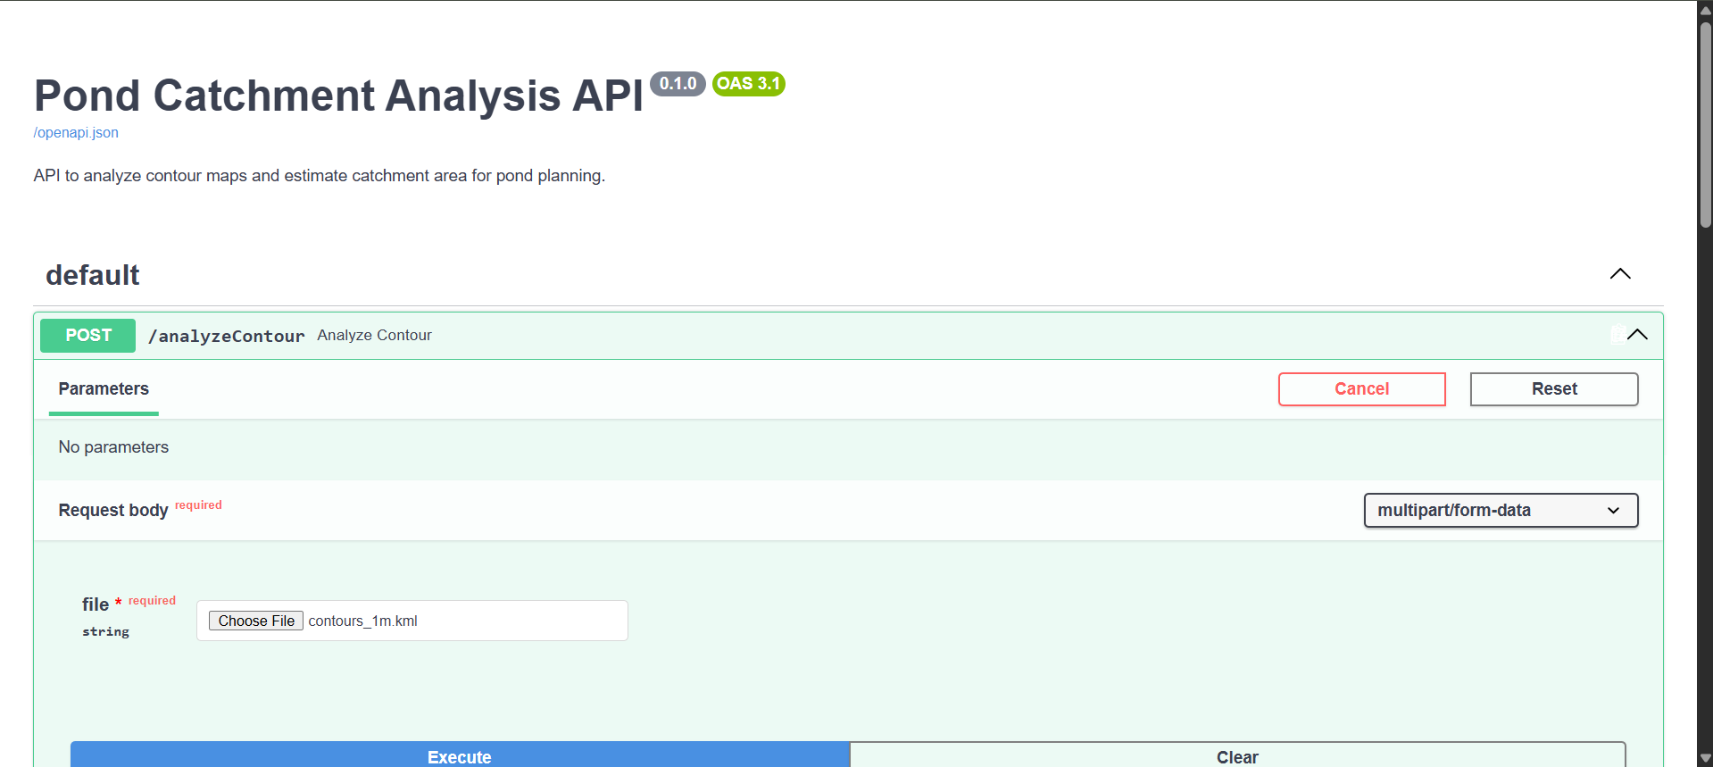
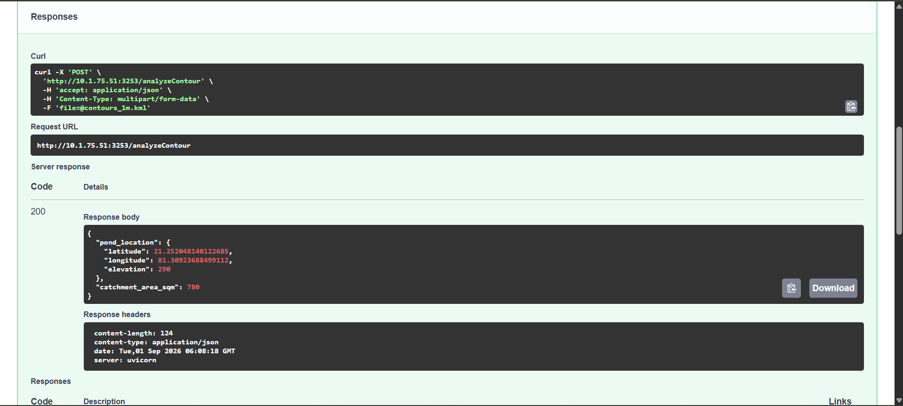

AI Usage:
Claude, Chatgpt

