

**CAPSTONE 2019-2020**

(Project Semester August-December 2019)

***(Verto Guide)***

Submitted by

**SAZID ALI: 11613989**

**DENA VERMA: 11605864**

**NIKHILESH DUBEY: 11609446**

Programme: **B-Tech (CSE)**

Course Code: **CSE439**

Under the Guidance of

**(Mr. Puneet Kumar)**

**Discipline of CSE/IT**

**LOVELY SCHOOL OF COMPUTER SCIENCE LOVELY PROFESSIONAL**

**UNIVERSITY, PHAGWARA**

**DECLARATION**

We hereby declare that the project work entitled “**Verto Guide**” is an authentic record of our own work carried out as requirements of Capstone Project for the award of B. Tech degree in Computer Science and Engineering from Lovely Professional University, Phagwara under the guidance of Mr. Rahul Malik during January to December 2019. All the information furnished in this capstone project report is based on our own intensive work and is genuine.

Project Group Number: CSE440

Name of Student 1: Nikhilesh Dubey

Registration Number: 11609446

Name of Student 2: Sazid Ali

Registration Number: 11613989

Name of Student 3: Dena Verma

Registration Number: 11605864

Signature of student 1:

Date:

Signature of student 2:

Date:

Signature of student 3:

Date:

**CERTIFICATE**

This is to certify that the declaration statement made by this group of students is correct to the best of my knowledge and belief. They have completed this Capstone Project under my guidance and supervision. The present work is the result of their original investigation, effort and study. No part of the work has ever been submitted for any other degree at any University. The Capstone Project is fit for the submission and partial fulfillment of the conditions for the award of B. Tech degree in Computer Science Engineering from Lovely Professional University, Phagwara.

## Signature and Name of the Mentor:

## Mr. Rahul Malik

## Designation: Assistant Professor

**School of Computer Science and Engineering,**

Lovely Professional University, Phagwara, Punjab.

Date :

**ACKNOWLEDGEMENT**

We humbly take this opportunity to present our votes of thanks to all that guidepost who really acted as lightening pillars to enlighten our way throughout this project that has led to successful and satisfactory completion of this study.

We are really grateful to our HOS Mr. Amandeep Nagpal and our mentor Mr. Rahul Malik for providing us with an opportunity to undertake this project in this university and providing us with all the bright and innovative ideas for making our project a really worthwhile of running in an organization. We are highly thankful for his active support, valuable time and advice, whole-hearted guidance, sincere cooperation and pains-taking involvement during the study and in completing the capstone project within the time stipulated.

We are thankful to all those, particularly our friends, who have been instrumental in creating proper, healthy and conductive environment and including new and fresh innovative ideas for us during the project, without their help, it would have been extremely difficult for us to prepare the project in a time bound framework.

Nikhilesh Dubey Sazid Ali

Dena Verma

**TABLE OF CONTENT**

**S.no. Title Page no.**

1. Introduction...................................................................................................................08
2. Profile of the problem. Rationale/scope of the study (problem Statement) .................09
3. Existing System.............................................................................................................12
   1. Introduction............................................................................................................12
   2. Existing Software...................................................................................................12
   3. DFD for present system.......................................................................................12
4. Problem Analysis..........................................................................................................13
   1. Product definition..................................................................................................13
   2. Feasibility analysis.................................................................................................14
5. Software Requirement Analysis....................................................................................15
   1. Introduction............................................................................................................15
   2. General Description................................................................................................16
   3. Specific Requirement..............................................................................................18
6. Design............................................................................................................................19
   1. System Design........................................................................................................20
   2. Design Notation......................................................................................................20
   3. Detailed Design......................................................................................................21
7. Testing...........................................................................................................................22
   1. Functional Testing..................................................................................................23
   2. Structural Testing...................................................................................................23
   3. Levels of testing.....................................................................................................24
   4. Testing the project .............................................................................................24
8. Implementation.............................................................................................................25
   1. Implementation of project......................................................................................25
   2. Post implementation and Software Maintained.....................................................25
9. Project Legacy..............................................................................................................27
   1. Current status of the project..................................................................................27
   2. Remaining Area of concern..................................................................................27
   3. Technical and Management lessons learnt...........................................................27
10. User Manual: A complete (Help Guide) of the software developed............................28
11. Source code (wherever applicable) or system snapshots.............................................33
12. Bibliography.................................................................................................................54

# INTRODUCTION

Verto Guide is a site or gadget framework that advances and helps computerized creation and alteration. A common client experience is generally utilized, bringing about a truly helpful environment in which numerous clients work around one another. The interface utilized is essential to the point that even individuals with almost no consciousness of their vocations or any examination related issues can be recognized on the site.

Verto Guide that we are going to work upon will be a fundamental utility to serve the understudies of Lovely Professional University. Our proposed task will furnish you with an accommodating manual for an unpredictably structured guide of Lovely Professional University so the freshers or our pariah's won't need to burn through their time requesting headings, provisioning of online coaches to understudies who will be fundamentally understudies who don't have a clue what to do next for their better bearer plan.

Through our site understudies will have the option to get appropriate direction in their scholastics also.

The site will give every one of the modules online to each course code in a composed way so the understudies need not to go somewhere else looking for sources to gain from. We expect to accumulate the significant information into one spot. We mean to help understudies far and wide to investigate courses, illuminate their inquiries and even contact understudies of Lovely Professional University.

Our site will likewise help the understudies having issue identified with their minor that what to decide for showing signs of improvement openings into future that will assist's them with fulfilling their fantasy subsequent to breaking down the we will tell the understudy that what will be the better choice for him/her to pick. We are additionally helping the understudies to develop in an expert way.

# PROFILE OF THE PROBLEM

# The following are our project's planned characteristics / objectives: -

To give a unique plan map featuring the significant squares of Lovely Professional University. Online coach: allotment of online tutors to every single understudy for directing them through their issues, be it scholastic individual or private. VERTO Guide is there to take into account the necessities of all the VERTOs. These online coaches would be none other than understudies of Lovely Professional University who are year leader of the mentees. The guide will be appraised by their presentation and their exhibition will be examination for giving them scholastic advantages. Provisioning of video instructional exercises (or connections) for each course code: the VERTO guide will likewise go about as a scholastic field for all the VERTOs by giving connects to video instructional exercises, settled inquiry papers etc.to help them with their scholastics.

**2.1 Description of Project:**

The website Verto Guide will be created using web technologies like Hypertext markup language (HTML), cascading stylesheet (CSS), java script (JS), hypertext preprocessor (PHP).

**Module 1: Map to Lovely Professional University**

Verto Map is a client-friendly mapping technology and a data hub for small business. Verto Map is made up of heavy-resolution images in its complete form. This contains all of Lovely Professional University.

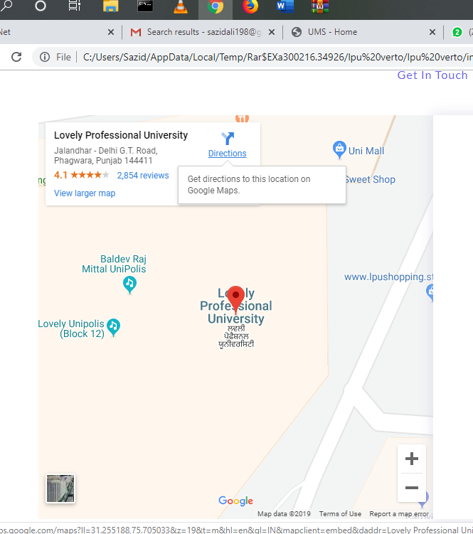l

Figure 2.1: LPU Map

**Module 2: Academic Hub**

The video tutorials (or links) for each course code: The VERTO guide will also act as an academic arena for all the VERTOs by providing links to video tutorials, solved question papers etc. to help them with their academics.

This module originated from the idea that there exists a class of readers who respond better to online content and prefer to learn new skills at their own pace from the comforts of their drawing rooms.

Our content and resources are freely available, and we prefer to keep it that way to encourage our VERTOs acquire as many skills as they would like to.

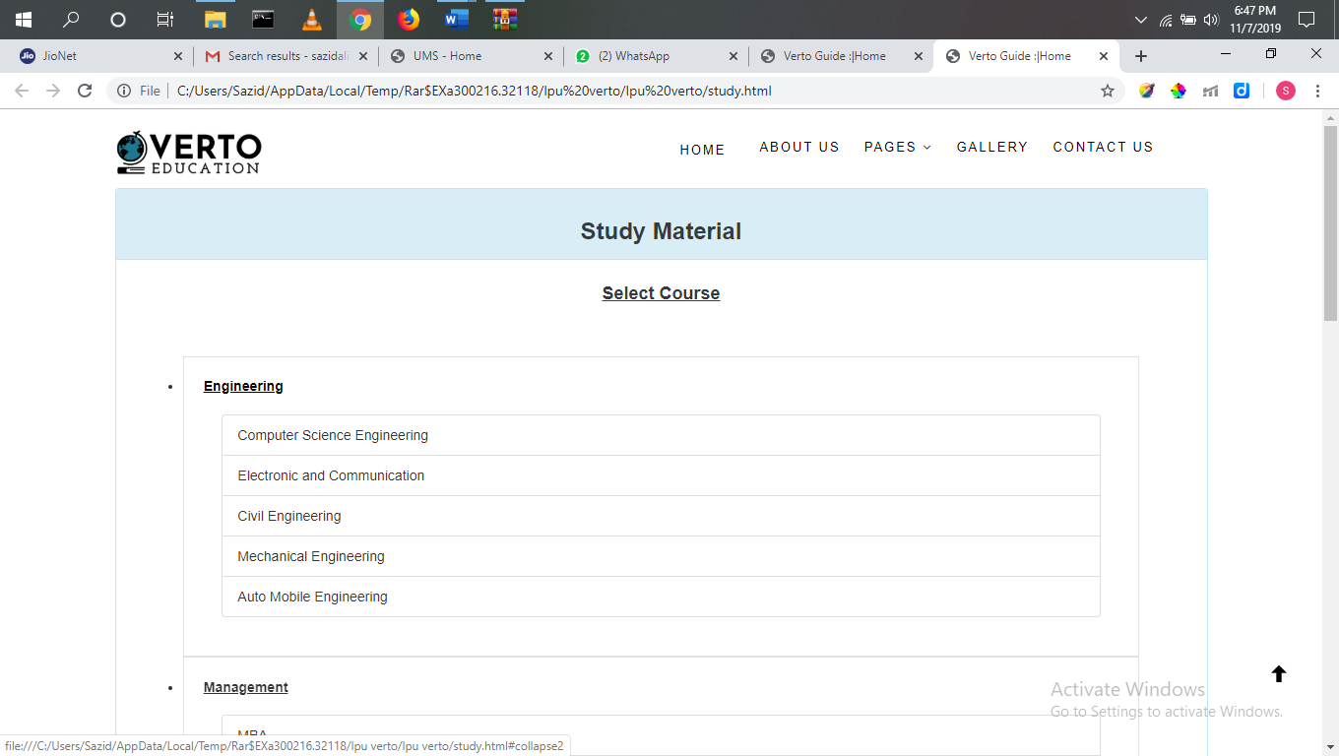

**Module 3: Online Tutoring**

Online tutoring is the process of tutoring in an online, virtual environment or networked environment in which teachers and learners are separated by time and space. Online tutoring, as a reflection of the diversity of the wider Internet, is practiced using many different approaches and is addressed to distinct sets of users. The distinctions are in online content and interface, as well as in tutoring and tutor-training methodologies. Definitions associated with online tutoring vary widely, reflecting the ongoing evolution of the technology, the refinement and variation in online learning methodology, and the interactions of the organizations that deliver online tutoring services with the institutions, individuals, and learners that employ the services. This form of Internet service is a classical micropublishing situation.

VERTO Guide is additionally proposed to go about as a scholastic guide subsequently it will be intended to take into account the necessities of all the VERTO'S. Online coaches would be designated to every single understudy for controlling them through their issues, be it scholarly close to home or private. These online tutors would be none other than understudies of Lovely Professional University who are year leader of the mentees. The guide will be evaluated by their exhibition and their presentation will be investigation for furnishing them with scholastic advantages.

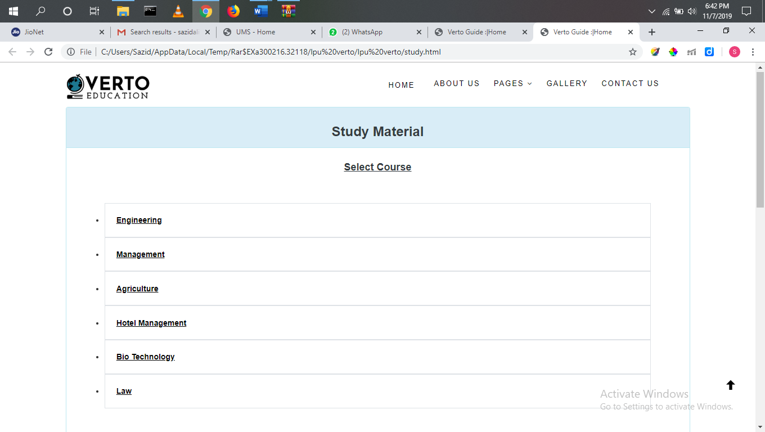

Figure 2.3: Online Tutorial

1. **EXISTING SYSTEM**

## Introduction

Well, till now no website is using this concept but many websites are there which are

Providing these types of opportunities but there is some restriction like one-month free

Trail after the trail we have to pay them.

## Existing Software

There isn't any correct framework existing yet a segment of sites are accessible however we join every one of the highlights in a site and make a typical way for the understudies.

## DFD for present system

Student

admin

user

Mentor

## Figure: 3

## 

# PROBLEM ANALYSIS

## Product Definition

## Verto guide.com is fundamentally a viral site that discharges a wide range of research-related substance and contentions. Any understudy can compose an inquiry on this site or make an exchange for which they will be perplexed.

## Feature of Verto guide

## 1. LPU Map: Our billing system is in its entirety working on google api mean if a student goes to any block, he/she didn’t ask the direction to anyone directly he/she will go through our website.

## 2. Academic Hub: We give registered clients any point for their on-site behavior, as if users want any kind of study material. then he can download is very easily.

## 3. Discussion system: Together with viral content users can create a conversation about any subject of general interest. These activities include posting a question, study related issue, minor related issue These points are known as points of reputation. And we rank the profile of users accordingly based on these points.

## Feasibility Study

It is the phase of the project we must aware about the project description like what are requirements what is the raw material for our project.

* + 1. **Technical Feasibility**

Verto Guide's technical feasibility must follow these aspects:

• Next, we need to ensure that the adapting procedure we use is either beneficial or not. How we get the data for it. We've checked the Google Test API to ensure it works

• User the executives might be a troublesome errand to deal with all reports, so we have to ensure that the framework handles the procedures genuinely well.

• While the client attempts to get to any site from the server, the server must answer at the earliest opportunity to the client.

• Our server needs a decent number of guests to deal with.

## Economic feasibility

## As far as financial suitability, we see that in the event that we have to live our undertaking and what the cost will be and when we get RIO. While we make an online application, we have to deal with our database expenses and advertising costs toward the end..

## Verto Guide is very savvy since we need a google database that will cost less to take the undertaking live. Toward the end, we can utilize low asset server to diminish costs. We will refresh it in like manner as the quantity of guests increments later.

## Operational Feasibility

* + - * and content. We must focus on making the site more user-friendly.
      * Implementing a new marketing strategy to gather more freelance writers

# SOFTWARE REQUIREMENT ANALYSIS

## Introduction

These are the technologies that we need:

We have to have a few exercises after the consummation of the venture that should be finished every once in a while. We have to concentrate on these authoritative assignments in the Verto control.

• Queries of clients: It is a routine regulatory manual movement to answer customer demands inside one day.

• Website reinforcement: This is significant for the site to be supported up in light of the fact that

could be a change to lose the information because of any equipment and

**PHP**: PHP (Hyper Text Pre-processor) is widely used open source scripting language that is especially suited for Web development and can be embedded into html. PHP is a widely used, free, and efficient alternative to competitors such as Microsoft's ASP. PHP is saved with filename.php extension.

**MYSQL**: A database management, or DBMS, gives the user access to their data and helps them transform the data into information.

**HTML**: HTML or Hyper Text Mark-up Language is the standard mark-up language used to create web pages. A web browser can read HTML files and comprise them into visible or audible web pages.

**CSS**: Cascading Style Sheets (CSS) is a style sheet language used for describing the look and formatting of a document written in a markup language.

**Android:** Android is a mobile operating system now developed by google, based on the Linux kernel and designed mainly for touchscreen mobile devices such as smartphones and tablets.

**Google Analytics:** It is a free web analytics service provided by google that tracks and reports website traffic. Google analytics is now the most widely used web analytics service on internet. This also have two additional versions.

**Google AdSense:** This is a program run by Google that allows publishers in the Google Network of content sites to serve automatic test, image, video, that are targeted to site content and audience. AdSense is a participant in the ad choices program, so AdSense ads normally comprise the triangle-shaped Ad Choices icon. This program also operates on HTTP cookies.

**Google Analytics:** This is a lot of use programming interfaces created by Google It makes it conceivable to associate with and coordinate Google Services with different administrations. The APIs give highlights, for example, examination, learning as an assistance, and client information get to.

**General Description**

**General Description of PHP**

Rasmus Leadoff in 1994. he named it as close to home landing page. Later it was named as pre-processor hypertext. PHP (Hyper Text Pre-processor) is broadly utilized open source scripting language that is particularly appropriate for Web improvement and can be implanted into html. PHP is a generally utilized, free, and productive option in contrast to contenders, for example, Microsoft's ASP. PHP is spared with filename augmentation.

## General Description of WordPress

WordPress is a free and open-source content management system (CMS) based on PHP and MySQL. Features include plugin architecture and a template system. WordPress was used by more than 23.3% of the top 10 million websites as of January 2015. WordPress is the most popular blogging system in use on the Web, at more than 60 million websites.

Themes: WordPress users may install and switch between themes. Themes allow users to change the appearance and functionality of a WordPress website and they can be installed without altering the content or health of the site. Every WordPress website requires at least one theme to be present and every theme should be designed using WordPress standards with structured PHP, valid HTML and Cascading Style Sheets (CSS). If WordPress users do not have themes development knowledge, then they may download and use free WordPress themes from wordpress.org.

Plugins: WordPress plugins architecture allows user to extend the features and functionality of a website or blog. WordPress has over 40,501 plugins available, each of which offers custom functions and features enabling users to alter their sites to their needs.

## General Description of Google Analytics

Google investigation is free web examination that offers measurements and fundamental investigation devices for website streamlining and promoting reason. This administration is for any individual who have google account. Google examination is intended for little and medium-sized retail sites.

## Features:

* + 1. E-mail based communication.
    2. Data visualization tool with dashboard, scorecards and motion charts, which shows modification in data over time.
    3. Custom support.

**General Description of Google AdSense:** Google AdSense is a program in which enterprises can display Google advertisements on web sites and make revenue from hits that generate traffics for the Google search engine. This shows businesses of all sizes worldwide in different languages. AdSense is a improvement and expansion of the concept behind banner –ad sharing arrangement that have been used for years. There are different kinds of AdSense- AdSense for content, AdSense for video, AdSense for search.

## Specific Requirements:

* + 1. **S/w and H/w requirement:**
       - **Environment:** PhpStorm, wampp
         * **Operating System:** - Microsoft Windows 7 or Higher
         * **Data Base Server:** MySQL
         * **Clients:** Microsoft Internet Explorer, Google chrome
         * **Tools**: Notepad ++, WordPress, Microsoft office
         * **User Interface:** PHP with html, CSS, JavaScript

## Hardware requirements:

**Table 5.3.**1

|  |  |
| --- | --- |
| **Number** | **Description** |
| 1 | PC with 2 GB hard disk |
| and 256 MB RAM |

**Software requirements:**

**Table 5.3.2**

|  |  |
| --- | --- |
| **Number** | **Description** |
| 1 | Windows XP or Higher |
| 2 | MySQL |
| 3 | Notepad++ |
| 4 | WordPress |
| 5 | Magic Draw |

# DESIGN

## System design

It is the strategy of depicting the development, segments, modules, interfaces, and information for a framework to fulfill indicated prerequisites. One could comprehend it as the sales of frameworks hypothesis to item improvement. There is almost get together with the controls of frameworks investigation, frameworks design and frameworks building.

## Use Case Diagram

It is an approach to depict all the arrangement of our model like what are the essential necessities what are the means to perform before to go to subsequent stage what are client prerequisites and how to finish them and deal with the client inquiries and prerequisites.

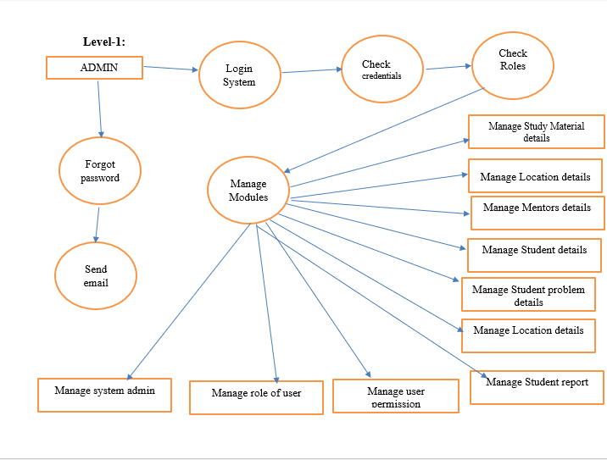

**Level-2:-**

user

Select Mentor

Student

Download Study Material

Mentor

Student

Check out

Add Query

**- 6.1 ER Diagrams**

Name

Details

Address

Id

Image

Email

Name

Detail

Address

Email

Image

Id

Payment

Mentor

Material List

Quantity

Query

Password

Mobile

Name

Has

Has

Mentor

Study material

Student

Has

Web portal

User

details

Subject

Branch

Student

Material

Topic

1. **TESTING**

## Introduction

The period of programming designing can be viewed as a winding. Right off the bat, framework building characterizes the situation of programming and prompts PC determination investigation where programming depends on the information space, capacities, activities, execution, limitations and approval criteria. We're moving in the winding, structuring lastly coding. We legitimize the structure of program, which lessens the degree of deliberation at each progression.

Out of sight of the winding, a technique for programming testing can likewise be seen. Unit testing starts at the winding vertex and centers as actualized in source code on every unit of the program. Testing improvement by going on the winding to coordination testing where the attention is on PC engineering plan and development. Talking another turn on the winding we run over approval testing where prerequisites set up as a component of the investigation of programming necessities are approved against the fabricated programming. At last, we go to a framework test, where the product and different components of the framework all in all are tried.

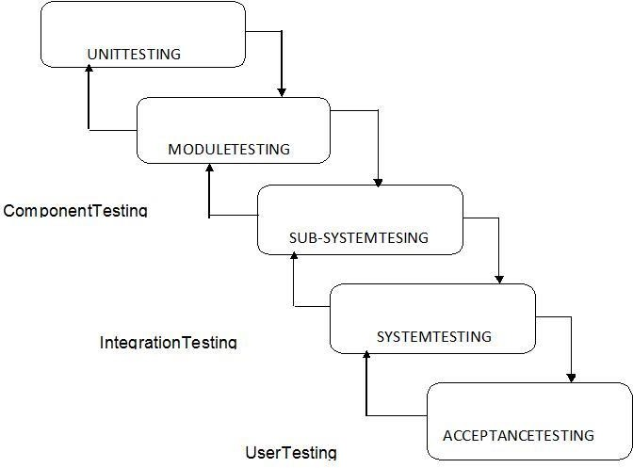

Figure 7.1 types of testing

## Functional Testing:

Useful testing is a QA procedure and a type of discovery testing that puts together its experiments with respect to the application item prerequisites being tried. Capacities are tried by serving them information and testing yield, and the inner program structure is only occasionally (dislike in white box testing). Ordinarily, useful testing clarifies what the framework is doing.

Practical testing normally includes five stages:

i. Identifying the assignments to be finished by the program.

ii. Create input information dependent on the particulars of the capacity.

iii. Determining the presentation dependent on the parameters of the component.

iv. The execution of the experiment.

v. Comparison of real and foreseen yields.

Discovery testing is a product testing approach that tests an application's highlights (for example what the program manages) without investigating its inner structures or activities (see white-box testing). This testing strategy can be reached out to pretty much every product testing level: module, execution, procedure and acknowledgment. This normally incorporates a lot, if not all, investigation at the more elevated level. Discovery testing will in general discover various types of mistakes than white box testing:

* Missing functions
* Usability problems
* Performance problems
* Errors in competition and timing
* Errors of initialization and termination.

## Structural_Testing:

White box testing (otherwise called clear box testing, glass box testing, straightforward box testing, and basic testing) is a product testing strategy that tests center structures or usefulness of an application instead of its usefulness (for example discovery testing). All through white-box examination, all interior framework perception and programming capacities are utilized to display experiments. The analyzer chooses contributions through the program to practice ways and decide the suitable yields. This is practically equivalent to assessing hubs in a circle, e.g.in – testing of circuits (ICT).

Albeit white-box testing can be led at the product testing process layer, execution or application level, it is normally performed at the unit level. In spite of the fact that this test structure technique may uncover numerous mistakes or issues, unimplemented parts of the particular or missing prerequisites may not be taken note.

White-box test design techniques include:

* Control flow testing
* Data flow testing
* Branch testing
* Path testing
* Statement coverage
* Decision coverage

## Levels

* 1. **Unit Testing**

## White-box testing is led during unit testing to guarantee the product functions as expected before any combination with recently tried code happens. White box testing during unit testing gets any flaws at an opportune time and assists with any issues that happen later after the code is coordinated with the remainder of the application and in this way forestalls any sort of deficiencies later.

## Integration Testing

## Now, white box testing is composed to check the communications between every interface. The testing of the unit level guarantees that each code was checked and performed accurately in a disengaged situation and usage tests the exactness of the conduct in an open domain by utilizing white box testing for any connections with interfaces known to the developer.

## Project Testing

7.3.1 After the task advancement and coding has been finished, we move to the undertaking testing stage. The following stages are taken in the test stage:

7.3.2 We test the validation/enlistment page of the understudy whether the login username and secret word offer a genuine response. We utilized different usernames and passwords for login in this. In the event that in the server username and secret phrase are open, login bombs generally.

7.3.3 Next, understudy records are put away or not in the server. At that point we manufacture three creators to check whether data is appropriately put away. Next phase of getting to a similar database data.

7.3.4 Then we attempted to compose an article on our site and examine it. At that point we checked whether we could add things and dialog presents on every class. The site has been checked to include depiction and media capacities.

# IMPLEMENTATION

## Implementation of the project

## We utilized WordPress, Google Analytics API and great advertisement sense to actualize our framework.

## WordPress made it simple to deal with the back finish of the framework, anyway our backend additionally comprises of google logical API which is incorporated in PHP and afterward added to the WordPress backend.

## Implementing Front End

The Front finish of our site incorporates, the posts, talks, menus, and so forth. This is executed by making a custom topic in WordPress. The custom topic was utilized to change the manner in which our site look and carry on. WordPress likewise empower us to add a few gadgets to make it look shockingly better, anyway we didn't utilize quite a bit of gadgets and just centered around our custom topic more. The custom topic comprises of many .php documents and

.CSS templates. Additionally, WordPress capacities are being utilized alongside php in custom subject.

If there should arise an occurrence of Android application, the front end was actualized utilizing shroud, to include and oversee various designs, giving better UI.

## Implementing Back End

WordPress gives its own back end, which is very simple to utilize and offers fast answers for the back-end issues. Nonetheless, for our situation we not just required WordPress backend or dashboard for administrator , yet required google investigation API to be coordinated in PHP with the goal that it very well may be utilized to see the income to every single creator , this was finished by associating google examination to google advertisement sense.

## POST IMPLEMENTATION AND SOFTWARE MAINTENANCE

Following execution, the principle center is to expand the client base and include an ever increasing number of individuals in our task, as our undertaking depends on a the issue it turns out to be truly critical to have the privilege and important content on the site to run it well.

Search engine optimization and adventure showcasing are the primary issues of post-execution. For our task, making site and celebrated is significant, the more clients are no, the more we will get.

So as to keep up the site and the application, one of our colleagues checks the site every day, our colleagues are additionally creators, so any issues or issues emerging from the site or programming will be analyzed and redressed and afterward. Turning out to be purchasers and journalists has enabled us to see our innovation from the client's point of view, which even encourages us improve programming changes.

# PROJECT LEGACY

## Current Status of the project

In the wake of performing testing stage, we discovered heaps of bugs in application. We fixed every one of the bugs after the testing stage. Application performs well, the mistakes in posting the accounts and remarking have been amended.

We are as of now concentrating on making the site more easy to use, and on improving the android application interface, since we don't have numerous clients who need android application, this is some place our second need additionally we are chipping away at website improvement.

## Remaining Areas of Concern

* A better solution for posting through android application.
* Database support (SQL)
* PHP environment

## Technical and Managerial Lessons learnt

• Better comprehension of PHP language and WordPress highlights.

• Everything we did, we became more acquainted with a ton of focuses.

• How to test the material in assembling. Also, the rectification of mistakes after the test.

• Product support is the last yet not the last point. How might we make it manageable later on?

• Vast Database Support (MySQL)

We figured out how to function in a group. The most effective method to make various modules and afterward incorporate them.

# USER MANUAL

This segment will acquaint you with the general interface of the site including the fundamental menu and different alternatives. The main action a peruser sees when the person in question uses the site in the gateway is Verto Guide Home Page. The Home page on the top comprise of connections to proceed onward to the login and register page, at that point it has various classes present, about which the articles are accessible on the site. The landing page partitions the articles or post based on

* Request
* Study Material
* Change Password
* Logout

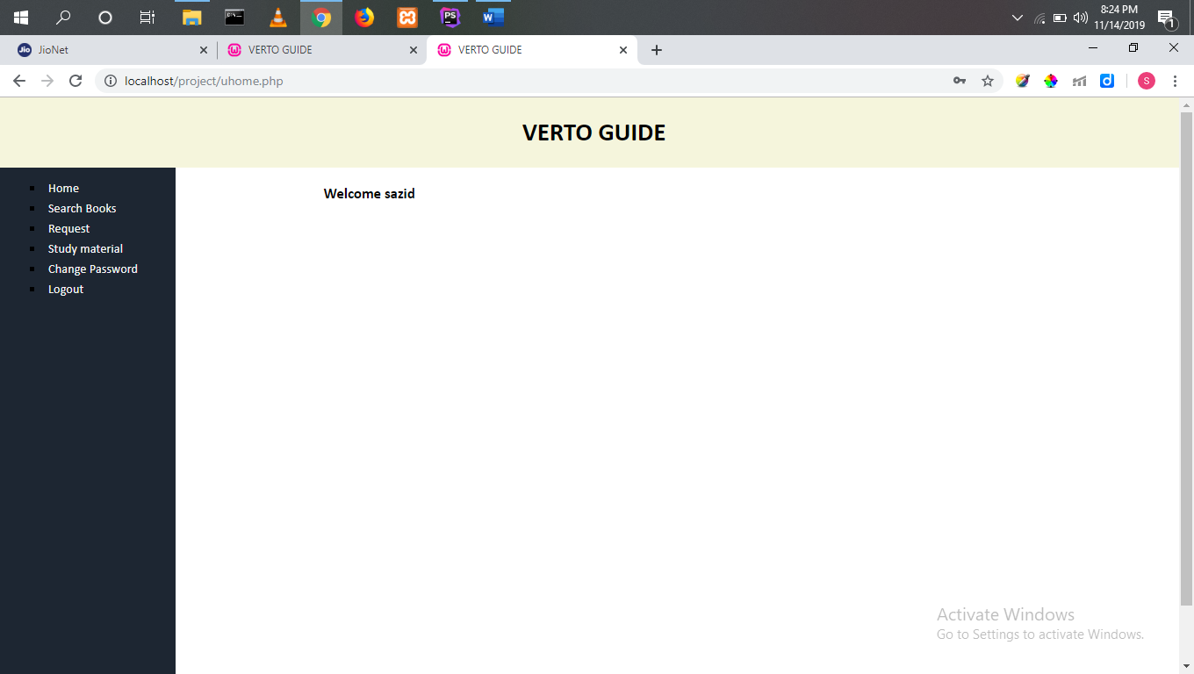

Figure 10.1: homepage

## View Module

## The post will open in the program in the wake of tapping on an application for a view. As should be obvious, the insights regarding the understudy who composed the post is on the left half of the page and in the center, we have the post name, what is the date of issue on which it was composed

.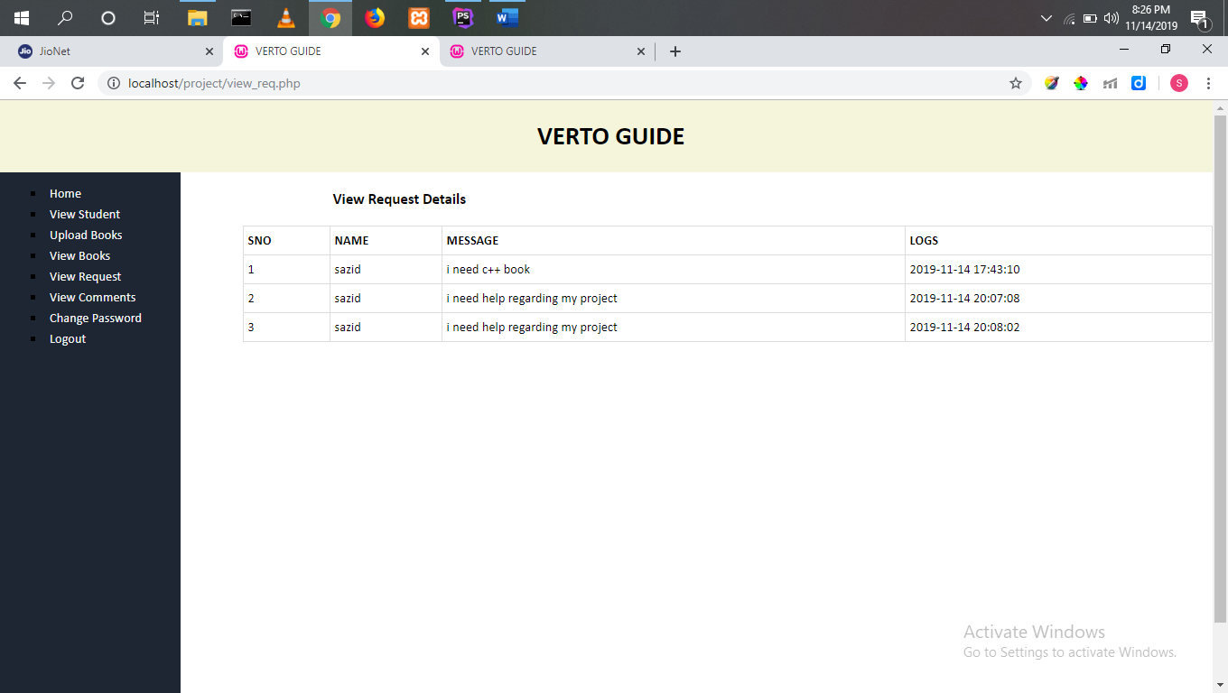

Figure 10.2 : view module

## Registration Page

Whenever the user wishes to register as an author, he clicks on the register button and the window below will appear:

Name

Username Email

Password

Branch

After completing these and clicking on submit, the user is registered with the portal.

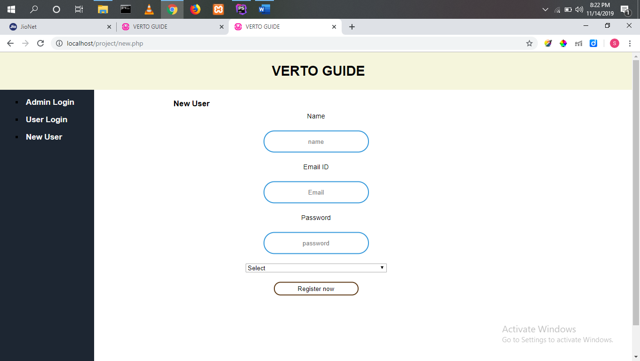

Figure 10.3: registration page

## Login Page

Login Page GUI consists of two Columns which helps in attaining the information of all the users.

* Username
* Password

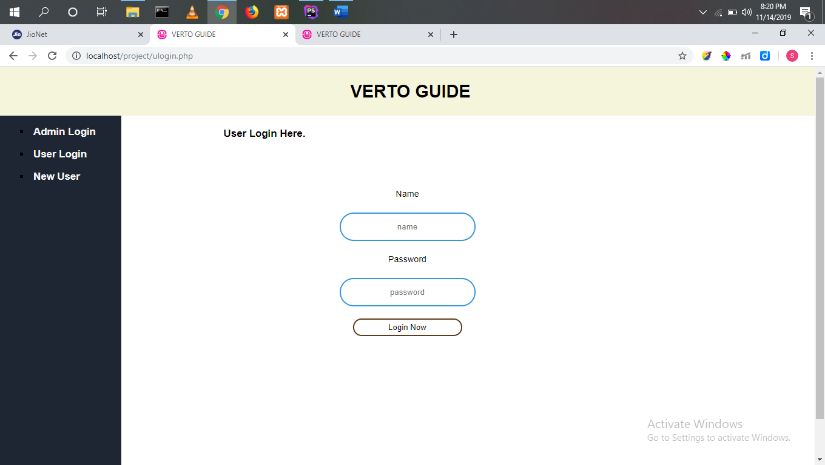

Figure10.4 : Login Module

## In the wake of signing in you can utilize the each module of site like examination material , raise question, minor related issue, LPU map and numerous others benefits in light of the fact that in this period of world consistently individual has stressed that what should I do on the grounds that everybody need accomplishment and need to do best from his/her side.

## Homepage for Administrator

The contrast between the landing page for clients and overseer is that, executive have a choice of add some component or answer to anybody issue, posing the inquiries and furthermore have the choice to see their profiles and check their notices.

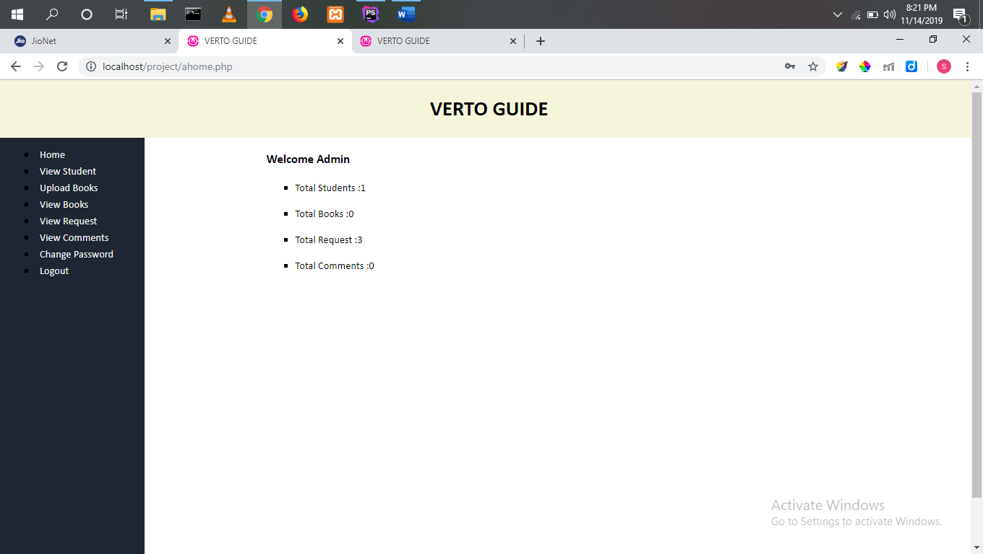

Figure 10.4: Administrator’s Home Page

We have made two pages one for student and one for administrator via student page a student ca raises any query regarding related to its academic or non-academic. Wherever from the administrator side he can see the requests of students and how many students are registered that all the data stored in SQL database.

Manage links to the Service Management section. Use this site to handle service requests (including configuration requests, requests for processing, and termination of service) and configure workspace preferences, edit ads, display usage reports and log files, and monitor session status and application models.

## Raise Query Module

After clicking on the link to add the story, the window below shows the required fields to fill in:

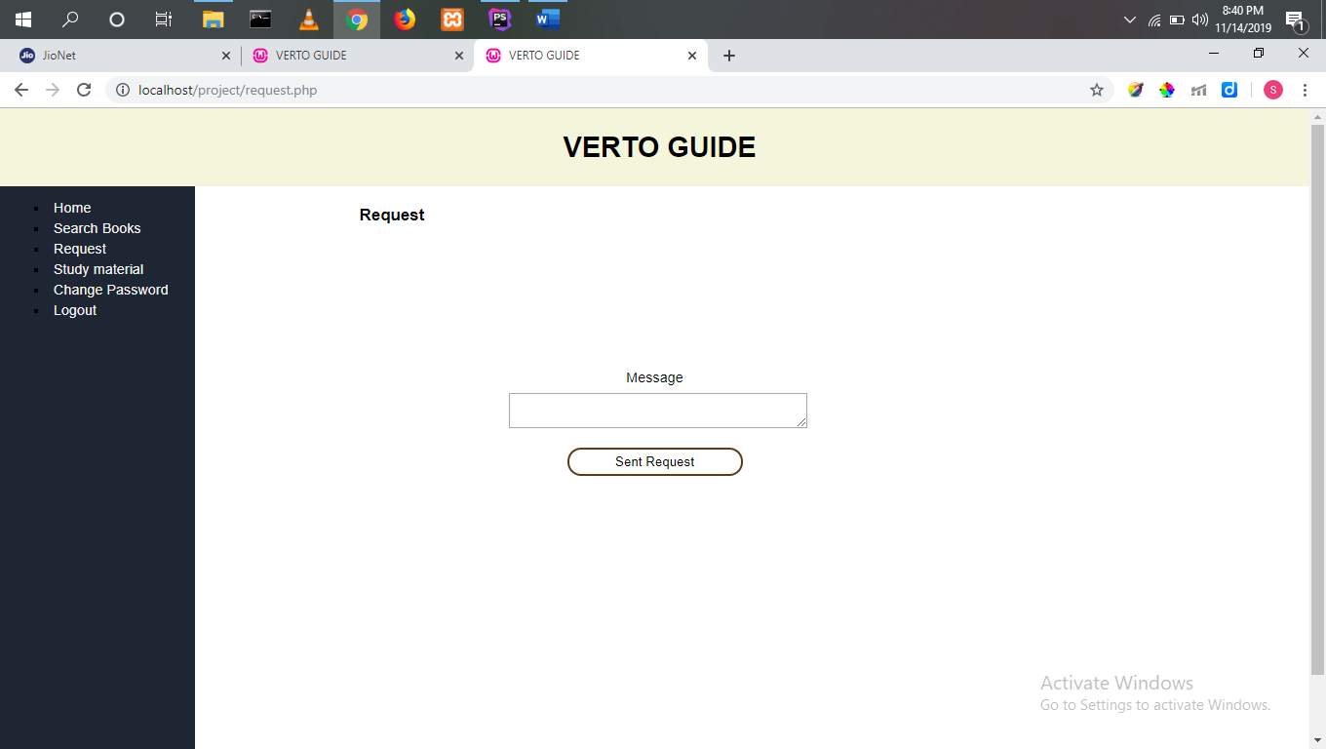

Figure 10.5: Raise Query page

## Ask Module

Ask Module is similar to the add story module, but it Has some less fields to be filled

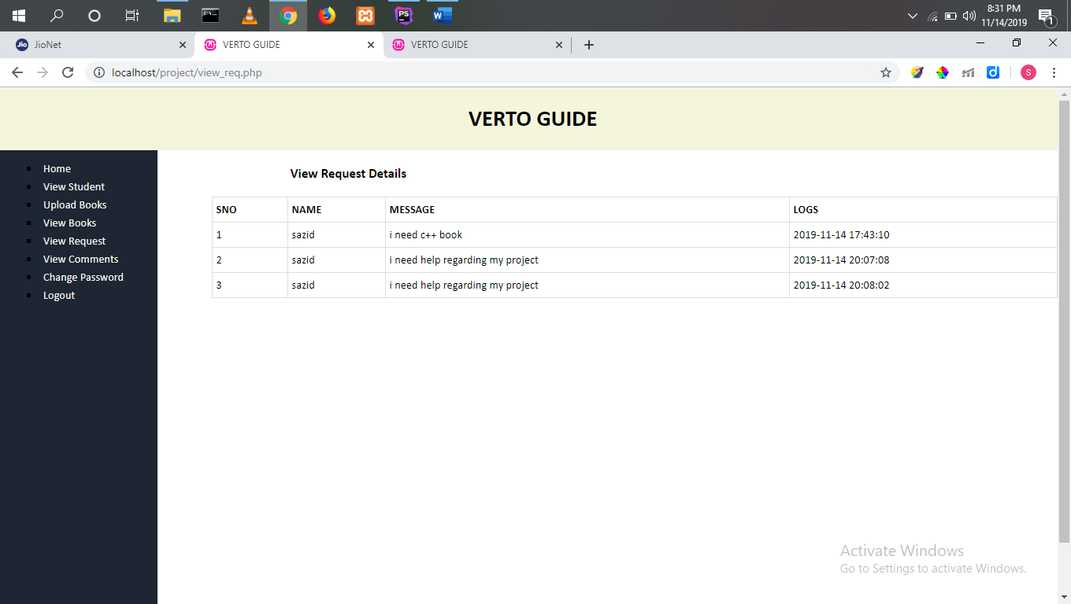

Figure 10.6 Ask Module

# SOURCE CODE

<?php  
session_start();  
include "database.php";  
  
  
  
if(!isset($_SESSION["AID"]))  
{  
 header("location:alogin.php");  
}  
?>  
  
  
<!DOCTYPE html>  
<html>  
<head>  
 <title>VERTO GUIDE</title>  
 <link rel="stylesheet" type="text/css" href="css/style.css">  
 <link rel="stylesheet" type="text/css" href="css/style1.css">  
</head>  
<body>  
<div id="container">  
 <div id="header">  
 <<h1><a href="index.php">VERTO GUIDE</a></h1>  
 </div>  
 <div id="wrapper">  
 <h3 id="heading">Change Password</h3>  
<div id="center">  
  
 <?php  
 if(isset($_POST["submit"]))  
 {  
 $sql="SELECT * from admin WHERE APASS='{$_POST["opass"]}' and AID='{$_SESSION["AID"]}'";  
 $res=$db->query($sql);  
 if($res->num_rows>0)  
 {  
 $s="Update admin set APASS='{$_POST["npass"]}' WHERE AID=".$_SESSION["AID"];  
 $db->query($s);  
 echo"<p class='success'>Password Changed succesfully</p>";  
 }  
 else  
 {  
 echo"<p class='error'>Invalid Password</p>";  
 }  
 }  
 ?>  
  
 <form class="box" action="<?php echo $_SERVER["PHP_SELF"]; ?>" method="post">  
 <label>Old Password</label>  
 <input type="password" name="opass" placeholder="Old Password" required>  
 <label>New Password</label>  
 <input type="password" name="npass" placeholder="New Password" required>  
 <input type="submit" name="submit" value="Update Password">  
 </form>  
</div>  
  
  
 </div>  
 <div id="navi">  
 <?php  
 include "adminsideBar.php";  
 ?>  
 </div>  
 <div id="footer">  
 <p>Copyright &copy;Created by Sazid Ali 2019</p>  
 </div>  
</div>  
  
</body>  
</html>

<ul id="bar">  
 <li><a href="ahome.php">Home</a></li>  
 <li><a href="view_student.php">View Student</a></li>  
 <li><a href="upload_books.php">Upload Books</a></li>  
 <li><a href="view_book.php">View Books</a></li>  
 <li><a href="view_req.php">View Request</a></li>  
 <li><a href="view_comm.php">View Comments</a></li>  
 <li><a href="achangePass.php">Change Password</a></li>  
 <li><a href="logout.php">Logout</a></li>  
</ul>

<?php  
session_start();  
include "database.php";  
function countRecord($sql,$db)  
{  
 $res=$db->query($sql);  
 return $res->num_rows;  
}  
  
  
if(!isset($_SESSION["AID"]))  
{  
 header("location:alogin.php");  
}  
?>  
  
  
<!DOCTYPE html>  
<html>  
<head>  
 <title>VERTO GUIDE</title>  
 <link rel="stylesheet" type="text/css" href="css/style.css">  
</head>  
<body>  
<div id="container">  
 <div id="header">  
 <h1><a href="index.php">VERTO GUIDE</a></h1>  
 </div>  
 <div id="wrapper">  
 <h3 id="heading">Welcome Admin</h3>  
 <div id="center">  
 <ul class="record">  
 <li>Total Students :<?php echo countRecord("select * from student",$db); ?></li>  
 <li>Total Books :<?php echo countRecord("select * from book",$db); ?></li>  
 <li>Total Request :<?php echo countRecord("select * from request",$db); ?></li>  
 <li>Total Comments :<?php echo countRecord("select * from comment",$db); ?></li>  
 </ul>  
 </div>  
 </div>  
 <div id="navi">  
 <?php  
 include "adminsideBar.php";  
 ?>  
 </div>  
 <div id="footer">  
 <p>Copyright &copy;Created by Sazid Ali 2019</p>  
 </div>  
</div>  
  
</body>  
</html>

<?php  
session_start();  
include "database.php";  
?>  
  
<!DOCTYPE html>  
<html>  
<head>  
 <title>VERTO GUIDE</title>  
 <link rel="stylesheet" type="text/css" href="css/style.css">  
 <link rel="stylesheet" type="text/css" href="css/style1.css">  
</head>  
<body>  
<div id="container">  
 <div id="header">  
 <h1><a href="index.php">VERTO GUIDE</a></h1>  
 </div>  
 <div id="wrapper">  
 <h3 id="heading">Admin Login Here.</h3>  
 <div id="center">  
 <?php  
 if(isset($_POST["submit"]))  
 {  
 $sql="SELECT * FROM admin where ANAME='{$_POST["aname"]}' and APASS='{$_POST["apass"]}'";  
 $res=$db->query($sql);  
 if($res->num_rows>0)  
 {  
 $row=$res->fetch_assoc();  
 $_SESSION["AID"]=$row["AID"];  
 $_SESSION["ANAME"]=$row["ANAME"];  
 header("location:ahome.php");  
 }  
 else  
 {  
 echo"<p class='error'> Invalid User Details</p>";  
 }  
 }  
 ?>  
 <form class="box" action="alogin.php" method="post">  
 <label>Name</label>  
 <input type="text" name="aname" placeholder="Username" required>  
 <label>Password</label>  
 <input type="password" name="apass" placeholder="Password" required>  
 <input type="submit" name="submit" value="Login">  
 </form>  
 </div>  
 </div>  
 <div id="navi">  
 <?php  
 include "sideBar.php";  
 ?>  
 </div>  
 <div id="footer">  
 <p>Copyright &copy;Created by Sazid Ali 2019</p>  
 </div>  
</div>  
  
</body>  
</html>

<?php  
session_start();  
include "database.php";  
  
  
  
if(!isset($_SESSION["ID"]))  
{  
 header("location:ulogin.php");  
}  
?>  
  
  
<!DOCTYPE html>  
<html>  
<head>  
 <title>VERTO GUIDE</title>  
 <link rel="stylesheet" type="text/css" href="css/style.css">  
</head>  
<body>  
<div id="container">  
 <div id="header">  
 <h1><a href="index.php">VERTO GUIDE</a></h1>  
 </div>  
 <div id="wrapper">  
 <h3 id="heading">Send Your Comment.</h3>  
  
 <?php  
  
  
 if(isset($_POST["submit"])) {  
 $sql = "INSERT INTO comment(BID, SID, COMM, LOGS) VALUES ({$_GET["id"]}, {$_SESSION["ID"]}, '{$_POST["mes"]}',now())";  
 $db->query($sql);  
 echo "<p class='success'>Comment Posted Successfully</p>";  
 }  
  
  
  
 $sql="SELECT * from BOOK where BID=".$_GET["id"];  
 $res=$db->query($sql);  
 if($res->num_rows>0)  
 {  
 echo"<table>";  
 $row=$res->fetch_assoc();  
 echo "  
 <tr>  
 <th>Book Name</th>  
 <td>{$row["BTITLE"]}</td>  
 </tr>  
 <tr>  
 <th>Keywords</th>  
 <td>{$row["KEYWORDS"]}</td>  
 </tr>  
 ";  
 echo "</table>";  
 }  
 else  
 {  
 echo "<p class='error'>No Books Found</p>";  
 }  
 ?>  
  
  
 <div id="center">  
  
 <form action="<?php echo $_SERVER["REQUEST_URI"]; ?>" method="post">  
 <label>Your Comments</label>  
 <textarea name="mes" required></textarea>  
 <button type="submit" name="submit">Post Now</button>  
 </form>  
  
 </div>  
  
  
 <?php  
  
 $sql="SELECT student.NAME ,comment.COMM,comment.LOGS from comment inner join student on comment.SID=student.ID  
 where comment.BID={$_GET["id"]} order by comment.CID DESC";  
 $res=$db->query($sql);  
 if($res->num_rows>0)  
 {  
 while($row=$res->fetch_assoc())  
 {  
 echo"<p>  
 <strong>{$row["NAME"]}</strong>  
 {$row["COMM"]}  
 <i>{$row["LOGS"]}</i>  
</p>";  
 }  
 }  
 else  
 {  
 echo "<p class='error'>No Comments Yet...</p>";  
 }  
 ?>  
  
  
  
 </div>  
 <div id="navi">  
 <?php  
 include "usersideBar.php";  
 ?>  
 </div>  
 <div id="footer">  
 <p>Copyright &copy;Created by Sazid Ali 2019</p>  
 </div>  
</div>  
  
</body>  
</html>

<!DOCTYPE html>  
 <head>  
 <title>VERTO GUIDE</title>  
 <link rel="stylesheet" type="text/css" href="css/style.css">  
 </head>  
 <body>  
  
 <div id="container">  
 <div id="header">  
 <h1><a href="index.php">VERTO GUIDE</a></h1>  
 </div>  
 <div id="wrapper">  
  
 </div>  
 <div id="navi">  
 <?php  
 include "sideBar.php";  
 ?>  
 </div>  
 <div id="footer">  
 <p>Copyright &copy;Created by Sazid Ali 2019</p>  
 </div>  
</div>  
  
 </body>  
</html>

<?php  
  
include "database.php";  
  
?>  
  
  
<!DOCTYPE html>  
<html>  
<head>  
 <title>VERTO GUIDE</title>  
 <link rel="stylesheet" type="text/css" href="css/style.css">  
 <link rel="stylesheet" type="text/css" href="css/style1.css">  
</head>  
<body>  
<div id="container">  
 <div id="header">  
 <h1><a href="index.php">VERTO GUIDE</a></h1>  
 </div>  
 <div id="wrapper">  
 <h3 id="heading">New User</h3>  
 <div id="center">  
  
 <?php  
 if(isset($_POST["submit"])) {  
 $sql = "insert into student(NAME,PASS,MAIL,DEP) values('{$_POST["name"]}','{$_POST["pass"]}','{$_POST["mail"]}','{$_POST["dep"]}')";  
 $db->query($sql);  
 echo "<p class='success'>User Registration Successfully</p>";  
 }  
  
 ?>  
  
 <form class="box" action="<?php echo $_SERVER["PHP_SELF"]; ?>" method="post" >  
 <label>Name</label>  
 <input type="text" name="name" placeholder="name" required>  
 <label>Email ID</label>  
 <input type="email" name="mail" placeholder="Email" required>  
 <label>Password</label>  
 <input type="password" name="pass" placeholder="password" required>  
  
 <select type="text" name="dep" required>  
 <option value="">Select</option>  
 <option value="BCA">BCA</option>  
 <option value="B.Sc CS">B.Sc CS</option>  
 <option value="MCA">MCA</option>  
 <option value="B.Tech CSE">B.Tech CSE</option>  
 <option value="OTHERS">OTHERS</option>  
 </select>  
 <input type="submit" name="submit" value="Register now">  
 </form>  
 </div>  
  
  
 </div>  
 <div id="navi">  
 <?php  
 include "sideBar.php";  
 ?>  
 </div>  
 <div id="footer">  
 <p>Copyright &copy;Created by Sazid Ali 2019</p>  
 </div>  
</div>  
  
</body>  
</html>

<?php  
session_start();  
include "database.php";  
  
  
  
if(!isset($_SESSION["ID"]))  
{  
 header("location:ulogin.php");  
}  
?>  
  
  
<!DOCTYPE html>  
<html>  
<head>  
 <title>VERTO GUIDE</title>  
 <link rel="stylesheet" type="text/css" href="css/style.css">  
 <link rel="stylesheet" type="text/css" href="css/style1.css">  
</head>  
<body>  
<div id="container">  
 <div id="header">  
 <h1><a href="index.php">VERTO GUIDE</a></h1>  
 </div>  
 <div id="wrapper">  
 <h3 id="heading">New Book Request</h3>  
 <div id="center">  
  
 <?php  
 if(isset($_POST["submit"]))  
 {  
 $sql="insert into request (ID,MES,LOGS) values ({$_SESSION["ID"]},'{$_POST["mess"]}',now())";  
 $res=$db->query($sql);  
  
  
 echo"<p class='success'>Request Sent To Admin</p>";  
  
 }  
 ?>  
  
 <form class="box" action="<?php echo $_SERVER["PHP_SELF"]; ?>" method="post">  
 <label>Message</label>  
 <textarea required name="mess"></textarea>  
 <input type="submit" name="submit" value="Sent Request">  
 </form>  
 </div>  
  
  
 </div>  
 <div id="navi">  
 <?php  
 include "usersideBar.php";  
 ?>  
 </div>  
 <div id="footer">  
 <p>Copyright &copy;Created by Sazid Ali 2019</p>  
 </div>  
</div>  
  
</body>  
</html>

<?php  
session_start();  
include "database.php";  
  
  
  
if(!isset($_SESSION["ID"]))  
{  
 header("location:ulogin.php");  
}  
?>  
  
  
<!DOCTYPE html>  
<html>  
<head>  
 <title>VERTO GUIDE</title>  
 <link rel="stylesheet" type="text/css" href="css/style.css">  
 <link rel="stylesheet" type="text/css" href="css/style1.css">  
</head>  
<body>  
<div id="container">  
 <div id="header">  
 <h1><a href="index.php">VERTO GUIDE</a></h1>  
 </div>  
 <div id="wrapper">  
 <h3 id="heading">Search Book</h3>  
 <div id="center">  
  
  
 <form class="box" action="<?php echo $_SERVER["PHP_SELF"]; ?>" method="post">  
 <label>Enter Book Name or Keywords</label>  
 <input type="text" required name="name">  
 <input type="submit" name="submit" value="Search Now">  
 </form>  
 </div>  
  
  
  
  
 <?php  
 if(isset($_POST["submit"])) {  
 $sql = "SELECT * FROM book where BTITLE like '%{$_POST["name"]}%' or keywords like '%{$_POST["name"]}%'";  
 $res = $db->query($sql);  
 if ($res->num_rows > 0) {  
 echo "<table>  
 <tr>  
 <th>SNO</th>  
 <th>BOOK NAME</th>  
 <th>KEYWORDS</th>  
 <th>VIEW</th>  
 <th>COMMENT</th>  
 </tr>  
 ";  
 $i = 0;  
 while ($row = $res->fetch_assoc()) {  
 $i++;  
 echo "<tr>";  
 echo "<td>{$i}</td>";  
 echo "<td>{$row["BTITLE"]}</td>";  
 echo "<td>{$row["KEYWORDS"]}</td>";  
 echo "<td><a href=' {$row["FILE"]}' target='_blank'>View</a></td>";  
 echo "<td><a href='comment.php?id={$row["BID"]}'>Go</a></td>";  
 echo "</tr>";  
 }  
  
 echo "</table>";  
 } else {  
 echo "<P class='error'> No Book Record Found</P>";  
 }  
 }  
 ?>  
  
  
  
  
  
 </div>  
 <div id="navi">  
 <?php  
 include "usersideBar.php";  
 ?>  
 </div>  
 <div id="footer">  
 <p>Copyright &copy;Created by Sazid Ali 2019</p>  
 </div>  
</div>  
  
</body>  
</html>

<ul>  
 <h3 id="zoom"> <li><a href="alogin.php">Admin Login</a></li></h3>  
 <h3 id="zoom"><li><a href="ulogin.php">User Login</a></li></h3>  
 <h3 id="zoom"><li><a href="new.php">New User</a></li></h3>  
</ul>

<?php  
session_start();  
include "database.php";  
  
  
  
if(!isset($_SESSION["ID"]))  
{  
 header("location:ulogin.php");  
}  
?>  
  
  
<!DOCTYPE html>  
<html>  
<head>  
 <title>VERTO GUIDE</title>  
 <link rel="stylesheet" type="text/css" href="css/style.css">  
 <link rel="stylesheet" type="text/css" href="css/style1.css">  
</head>  
<body>  
<div id="container">  
 <div id="header">  
 <h1><a href="index.php">VERTO GUIDE</a></h1>  
 </div>  
 <div id="wrapper">  
 <h3 id="heading">Change Password</h3>  
 <div id="center">  
  
 <?php  
 if(isset($_POST["submit"]))  
 {  
 $sql="SELECT * from student WHERE PASS='{$_POST["opass"]}' and ID='{$_SESSION["ID"]}'";  
 $res=$db->query($sql);  
 if($res->num_rows>0)  
 {  
 $s="Update student set PASS='{$_POST["npass"]}' WHERE ID=".$_SESSION["ID"];  
 $db->query($s);  
 echo"<p class='success'>Password Changed succesfully</p>";  
 }  
 else  
 {  
 echo"<p class='error'>Invalid Password</p>";  
 }  
 }  
 ?>  
  
 <form class="box" action="<?php echo $_SERVER["PHP_SELF"]; ?>" method="post">  
 <label>Old Password</label>  
 <input type="password" name="opass" required>  
 <label>New Password</label>  
 <input type="password" name="npass" required>  
 <input type="submit" name="submit" value="Update Password">  
 </form>  
 </div>  
  
  
 </div>  
 <div id="navi">  
 <?php  
 include "usersideBar.php";  
 ?>  
 </div>  
 <div id="footer">  
 <p>Copyright &copy;Created by Sazid Ali 2019</p>  
 </div>  
</div>  
  
</body>  
</html>

<?php  
session_start();  
include "database.php";  
  
if(!isset($_SESSION["ID"]))  
{  
 header("location:ulogin.php");  
}  
?>  
  
  
<!DOCTYPE html>  
<html>  
<head>  
 <title>VERTO GUIDE</title>  
 <link rel="stylesheet" type="text/css" href="css/style.css">  
</head>  
<body>  
<div id="container">  
 <div id="header">  
 <h1><a href="index.php">VERTO GUIDE</a></h1>  
 </div>  
 <div id="wrapper">  
 <h3 id="heading">Welcome <?php echo $_SESSION["NAME"]; ?></h3>  
  
 </div>  
 <div id="navi">  
 <?php  
 include "usersideBar.php";  
 ?>  
 </div>  
 <div id="footer">  
 <p>Copyright &copy;Created by Sazid Ali 2019</p>  
 </div>  
</div>  
  
</body>  
</html>

<?php  
session_start();  
include "database.php";  
?>  
  
<!DOCTYPE html>  
<html>  
<head>  
 <title>VERTO GUIDE</title>  
 <link rel="stylesheet" type="text/css" href="css/style.css">  
 <link rel="stylesheet" type="text/css" href="css/style1.css">  
</head>  
<body>  
<div id="container">  
 <div id="header">  
 <h1><a href="index.php">VERTO GUIDE</a></h1>  
 </div>  
 <div id="wrapper">  
 <h3 id="heading">User Login Here.</h3>  
 <div id="center">  
 <?php  
 if(isset($_POST["submit"]))  
 {  
 $sql="SELECT * FROM student where NAME='{$_POST["name"]}' and PASS='{$_POST["pass"]}'";  
 $res=$db->query($sql);  
 if($res->num_rows>0)  
 {  
 $row=$res->fetch_assoc();  
 $_SESSION["ID"]=$row["ID"];  
 $_SESSION["NAME"]=$row["NAME"];  
 header("location:uhome.php");  
 }  
 else  
 {  
 echo"<p class='error'> Invalid User Details</p>";  
 }  
 }  
 ?>  
 <form class="box" action="ulogin.php" method="post">  
 <label>Name</label>  
 <input type="text" name="name" placeholder="name" required>  
 <label>Password</label>  
 <input type="password" name="pass" placeholder="password" required>  
 <input type="submit" name="submit" value="Login Now">  
 </form>  
 </div>  
 </div>  
 <div id="navi">  
 <?php  
 include "sideBar.php";  
 ?>  
 </div>  
 <div id="footer">  
 <p>Copyright &copy;Created by Sazid Ali 2019</p>  
 </div>  
</div>  
  
</body>  
</html>

<?php  
session_start();  
include "database.php";  
  
  
  
if(!isset($_SESSION["AID"]))  
{  
 header("location:alogin.php");  
}  
?>  
  
  
<!DOCTYPE html>  
<html>  
<head>  
 <title>VERTO GUIDE</title>  
 <link rel="stylesheet" type="text/css" href="css/style.css">  
 <link rel="stylesheet" type="text/css" href="css/style1.css">  
</head>  
<body>  
<div id="container">  
 <div id="header">  
 <h1><a href="index.php">VERTO GUIDE</a></h1>  
 </div>  
 <div id="wrapper">  
 <h3 id="heading">Upload Books</h3>  
 <div id="center">  
  
 <?php  
 if(isset($_POST["submit"])) {  
 $target_dir = 'upload/';  
 $target_file = $target_dir . basename($_FILES['filename']['name']);  
  
 if (move_uploaded_file($_FILES['filename']['tmp_name'], $target_file))  
 {  
 $sql = "insert into book(BTITLE,KEYWORDS,FILE) values('{$_POST["bname"]}','{$_POST["keys"]}','{$target_file}')";  
 $db->query($sql);  
 echo "<p class='success'>Book Uploaded Successfully</p>";  
 }  
 else  
 {  
 echo "<p class='error'>Error in Upload</p>";  
 }  
 }  
 ?>  
  
 <form class="box" action="<?php echo $_SERVER["PHP_SELF"]; ?>" method="post" enctype="multipart/form-data" >  
 <label>Book Title</label>  
 <input type="text" name="bname" placeholder="Book Name" required>  
 <label>Keyword</label>  
 <input type="text" name="keys" placeholder="Keyword" required>  
 <label>Upload File</label>  
 <input type="file" name="filename" required>  
 <input type="submit" name="submit" value="Upload Book">  
 </form>  
 </div>  
  
  
 </div>  
 <div id="navi">  
 <?php  
 include "adminsideBar.php";5  
 ?>  
 </div>  
 <div id="footer">  
 <p>Copyright &copy;Created by Sazid Ali 2019</p>  
 </div>  
</div>  
  
</body>  
</html>

<ul id="bar">  
 <li><a href="uhome.php">Home</a></li>  
 <li><a href="search_books.php">Search Books</a></li>  
 <li><a href="request.php">Request</a></li>  
 <li><a href="lpu verto/study.html">Study material</a></li>  
 <li><a href="uchangePass.php">Change Password</a></li>  
 <li><a href="logout.php">Logout</a></li>  
  
</ul>

<?php  
session_start();  
include "database.php";  
  
  
  
if(!isset($_SESSION["AID"]))  
{  
 header("location:alogin.php");  
}  
?>  
  
  
<!DOCTYPE html>  
<html>  
<head>  
 <title>VERTO GUIDE</title>  
 <link rel="stylesheet" type="text/css" href="css/style.css">  
</head>  
<body>  
<div id="container">  
 <div id="header">  
 <h1><a href="index.php">VERTO GUIDE</a></h1>  
 </div>  
 <div id="wrapper">  
 <h3 id="heading">View Book Details</h3>  
  
 <?php  
 $sql="SELECT * FROM book";  
 $res=$db->query($sql);  
 if($res->num_rows>0)  
 {  
 echo "<table>  
 <tr>  
 <th>SNO</th>  
 <th>BOOK NAME</th>  
 <th>KEYWORDS</th>  
 <th>VIEW</th>  
 </tr>  
 ";  
 $i=0;  
 while($row=$res->fetch_assoc())  
 {  
 $i++;  
 echo"<tr>";  
 echo"<td>{$i}</td>";  
 echo"<td>{$row["BTITLE"]}</td>";  
 echo"<td>{$row["KEYWORDS"]}</td>";  
 echo"<td><a href=' {$row["FILE"]}' target='_blank'>View</a></td>";  
 echo"</tr>";  
 }  
  
 echo"</table>";  
 }  
 else  
 {  
 echo "<P class='error'> No Book Record Found</P>";  
 }  
 ?>  
  
  
 </div>  
 <div id="navi">  
 <?php  
 include "adminsideBar.php";  
 ?>  
 </div>  
 <div id="footer">  
 <p>Copyright &copy;Created by Sazid Ali 2019</p>  
 </div>  
</div>  
  
</body>  
</html>

<?php  
session_start();  
include "database.php";  
  
  
  
if(!isset($_SESSION["AID"]))  
{  
 header("location:alogin.php");  
}  
?>  
  
  
<!DOCTYPE html>  
<html>  
<head>  
 <title>VERTO GUIDE</title>  
 <link rel="stylesheet" type="text/css" href="css/style.css">  
</head>  
<body>  
<div id="container">  
 <div id="header">  
 <h1><a href="index.php">VERTO GUIDE</a></h1>  
 </div>  
 <div id="wrapper">  
 <h3 id="heading">View Comments Details</h3>  
  
 <?php  
 $sql="SELECT book.BTITLE,student.NAME,comment.COMM,comment.LOGS from comment INNER join book on book.BID=comment.BID INNER join student on comment.SID=student.ID";  
 $res=$db->query($sql);  
 if($res->num_rows>0)  
 {  
 echo "<table>  
 <tr>  
 <th>SNO</th>  
 <th>BOOK</th>  
 <th>NAME</th>  
 <th>COMMENT</th>  
 <th>LOGS</th>  
 </tr>  
 ";  
 $i=0;  
 while($row=$res->fetch_assoc())  
 {  
 $i++;  
 echo"<tr>";  
 echo"<td>{$i}</td>";  
 echo"<td>{$row["BTITLE"]}</td>";  
 echo"<td>{$row["NAME"]}</td>";  
 echo"<td>{$row["COMM"]}</td>";  
 echo"<td>{$row["LOGS"]}</td>";  
 echo"</tr>";  
 }  
  
 echo"</table>";  
 }  
 else  
 {  
 echo "<P class='error'> No Comment Found</P>";  
 }  
 ?>  
  
  
 </div>  
 <div id="navi">  
 <?php  
 include "adminsideBar.php";  
 ?>  
 </div>  
 <div id="footer">  
 <p>Copyright &copy;Created by Sazid Ali 2019</p>  
 </div>  
</div>  
  
</body>  
</html>

<?php  
session_start();  
include "database.php";  
  
  
  
if(!isset($_SESSION["AID"]))  
{  
 header("location:alogin.php");  
}  
?>  
  
  
<!DOCTYPE html>  
<html>  
<head>  
 <title>VERTO GUIDE</title>  
 <link rel="stylesheet" type="text/css" href="css/style.css">  
</head>  
<body>  
<div id="container">  
 <div id="header">  
 <h1><a href="index.php">VERTO GUIDE</a></h1>  
 </div>  
 <div id="wrapper">  
 <h3 id="heading">View Request Details</h3>  
  
 <?php  
 $sql="SELECT STUDENT.NAME,request.MES,request.LOGS from STUDENT inner join request on STUDENT.ID=request.ID";  
 $res=$db->query($sql);  
 if($res->num_rows>0)  
 {  
 echo "<table>  
 <tr>  
 <th>SNO</th>  
 <th>NAME</th>  
 <th>MESSAGE</th>  
 <th>LOGS</th>  
 </tr>  
 ";  
 $i=0;  
 while($row=$res->fetch_assoc())  
 {  
 $i++;  
 echo"<tr>";  
 echo"<td>{$i}</td>";  
 echo"<td>{$row["NAME"]}</td>";  
 echo"<td>{$row["MES"]}</td>";  
 echo"<td>{$row["LOGS"]}</td>";  
 echo"</tr>";  
 }  
  
 echo"</table>";  
 }  
 else  
 {  
 echo "<P class='error'> No Request Record Found</P>";  
 }  
 ?>  
  
  
 </div>  
 <div id="navi">  
 <?php  
 include "adminsideBar.php";  
 ?>  
 </div>  
 <div id="footer">  
 <p>Copyright &copy;Created by Sazid Ali 2019</p>  
 </div>  
</div>  
  
</body>  
</html>

<?php  
session_start();  
include "database.php";  
  
  
  
if(!isset($_SESSION["AID"]))  
{  
 header("location:alogin.php");  
}  
?>  
  
  
<!DOCTYPE html>  
<html>  
<head>  
 <title>VERTO GUIDE</title>  
 <link rel="stylesheet" type="text/css" href="css/style.css">  
</head>  
<body>  
<div id="container">  
 <div id="header">  
 <h1><a href="index.php">VERTO GUIDE</a></h1>  
 </div>  
 <div id="wrapper">  
 <h3 id="heading">View Student Details</h3>  
  
 <?php  
 $sql="SELECT * FROM student";  
 $res=$db->query($sql);  
 if($res->num_rows>0)  
 {  
 echo "<table>  
 <tr>  
 <th>SNO</th>  
 <th>Name</th>  
 <th>Email</th>  
 <th>Department</th>  
 </tr>  
 ";  
 $i=0;  
 while($row=$res->fetch_assoc())  
 {  
 $i++;  
 echo"<tr>";  
 echo"<td>{$i}</td>";  
 echo"<td>{$row["NAME"]}</td>";  
 echo"<td>{$row["MAIL"]}</td>";  
 echo"<td>{$row["DEP"]}</td>";  
 echo"</tr>";  
 }  
  
 echo"</table>";  
 }  
 else  
 {  
 echo "<P class='error'> No Student Record Found</P>";  
 }  
 ?>  
  
  
 </div>  
 <div id="navi">  
 <?php  
 include "adminsideBar.php";  
 ?>  
 </div>  
 <div id="footer">  
 <p>Copyright &copy;Created by Sazid Ali 2019</p>  
 </div>  
</div>  
  
</body>  
</html>

# BIBLIOGRAPHY

## Textbook

1. HTML Black Book (English) 1st Edition
2. Running website with WordPress by Alastair McDermott
3. Professional WordPress Plugin Development By Brad Williams, Ozh Richard
4. The Complete Reference to PHP by Sieven holsner

## Website:

1. <http://www.w3schools.com/php/>
2. <http://www.w3schools.com/css/default.asp>
3. [http://www.wpbeginner.com/wp-tutorials/how-to-create-custom-post-types-in- WordPress/](http://www.wpbeginner.com/wp-tutorials/how-to-create-custom-post-types-in-wordpress/)
4. <https://wordpress.org/support/topic/featured-image-size-pages-in-header>