WEB TECHNOLOGY

Nikhilesh Raj Singh

22it3026

T1.

<!DOCTYPE html>

<html lang="en">

<head>

    <meta charset="UTF-8">

    <meta name="viewport" content="width=device-width, initial-scale=1.0">

    <title>Simple Web Page</title>

    <style>

        body {

            display: flex;

            align-items: center;

            justify-content: center;

            height: 100vh;

            margin: 0;

            font-family: Arial, sans-serif;

        }

        h2 {

            transition: transform 0.5s ease-in-out;

        }

        input {

            padding: 5px;

            margin-right: 10px;

        }

        button {

            padding: 5px;

            cursor: pointer;

        }

        @keyframes spin {

    from {

        transform: rotate(0deg);

    }

    to {

        transform: rotate(360deg);

    }

}

.spin-animation {

    animation: spin 2s linear infinite;

}

    </style>

</head>

<body>

    <h2 id="helloHeader">Hello</h2>

    <input type="text" id="textInput" placeholder="Type a word or phrase">

    <button onclick="changeText()">Change Text</button>

    <script>

        function changeText() {

            var inputText = document.getElementById("textInput").value;

            var helloHeader = document.getElementById("helloHeader");

            // Replace the old h2 with the entered word

            helloHeader.innerText = inputText;

            // Add animation class to make the word spin

            helloHeader.classList.add("spin-animation");

            // Remove the animation class after the animation completes

            setTimeout(function() {

                helloHeader.classList.remove("spin-animation");

            }, 500);

        }

    </script>

</body>

</html>

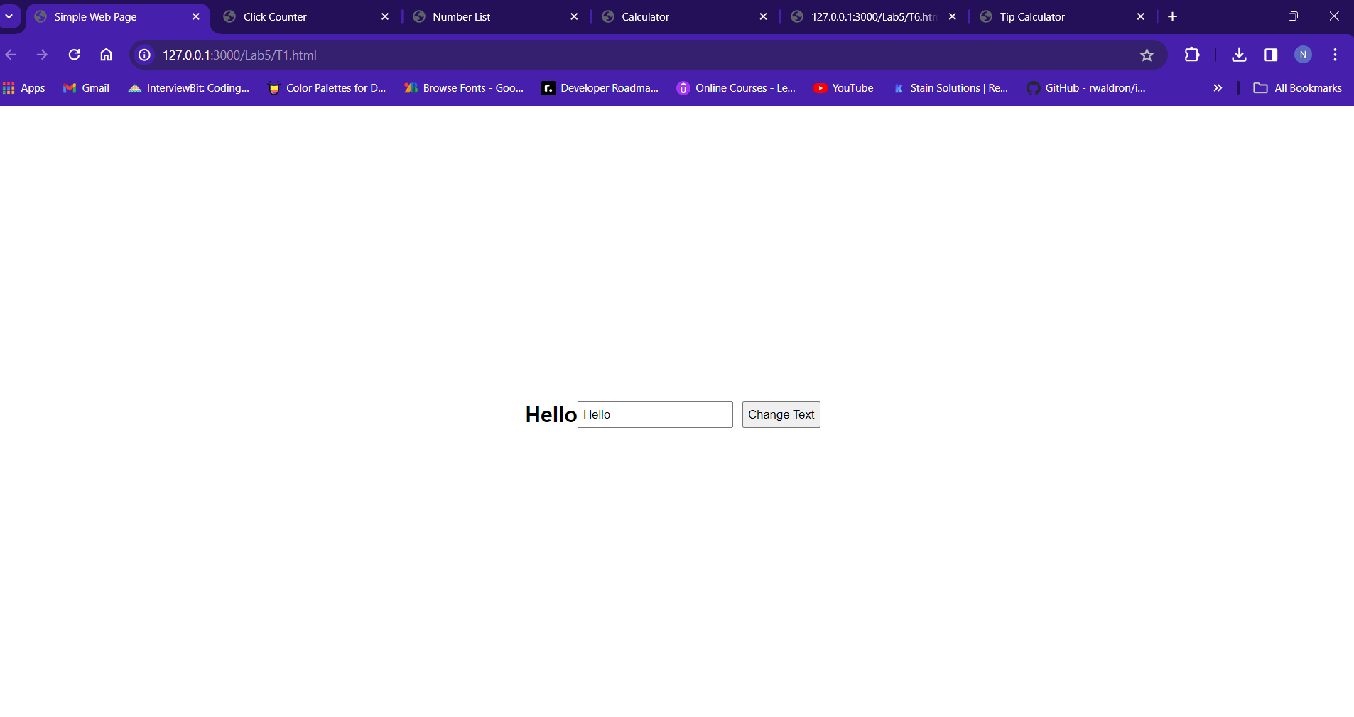

T2.

<!DOCTYPE html>

<html lang="en">

<head>

    <meta charset="UTF-8">

    <meta name="viewport" content="width=device-width, initial-scale=1.0">

    <title>Click Counter</title>

    <style>

        #count {

            font-size: 24px;

            margin-bottom: 10px;

        }

    </style>

</head>

<body>

    <p id="count">0</p>

    <button onclick="incrementCount()">Click Me!</button>

    <script>

        let count = 0;

        function incrementCount() {

            count++;

            document.getElementById("count").innerHTML = count;

            document.getElementById("count").style.fontSize = (count \* 2) + "px";

        }

    </script>

</body>

</html>

Output:

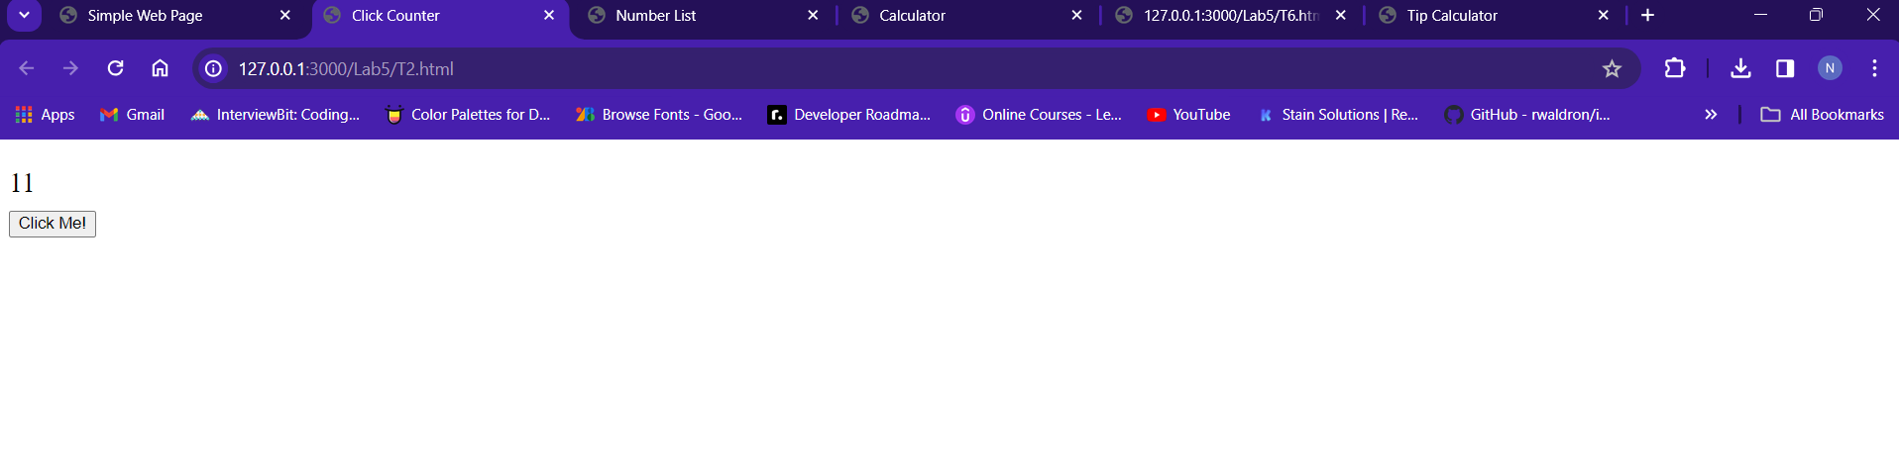

T3.

<!DOCTYPE html>

<html lang="en">

<head>

    <meta charset="UTF-8">

    <meta name="viewport" content="width=device-width, initial-scale=1.0">

    <title>Number List</title>

    <style>

        #numberList {

            list-style: none;

            padding: 0;

            margin: 0;

        }

        #numberList li {

            font-size: 24px;

            margin-bottom: 10px;

        }

    </style>

</head>

<body>

    <ul id="numberList"></ul>

    <button onclick="addNumber()">Add Number</button>

    <script>

        let numbers = [];

        function addNumber() {

            const number = numbers.length + 1;

            numbers.push(number);

            const li = document.createElement("li");

            li.textContent = number;

            li.style.fontSize = (number \* 2) + "px";

            const numberList = document.getElementById("numberList");

            numberList.appendChild(li);

        }

    </script>

</body>

</html>

OUTPUT:

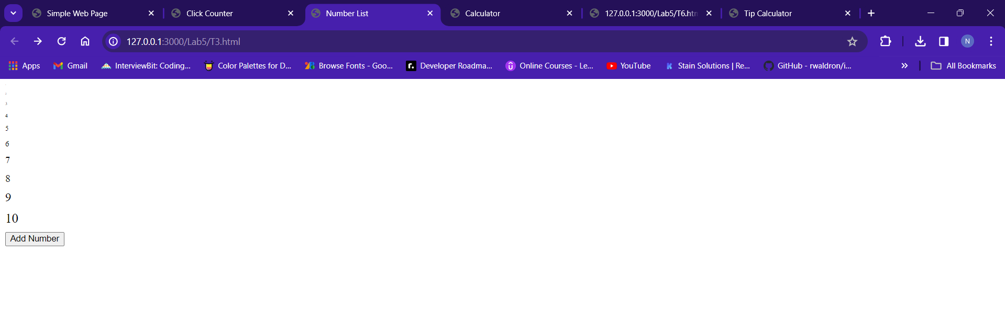

T5.

<!DOCTYPE html>

<html lang="en">

<head>

    <meta charset="UTF-8">

    <meta name="viewport" content="width=device-width, initial-scale=1.0">

    <title>Calculator</title>

</head>

<body>

    <input type="text" id="number1" placeholder="Enter first number">

    <input type="text" id="number2" placeholder="Enter second number">

    <br>

    <button onclick="calculate('+')">+</button>

    <button onclick="calculate('-')">-</button>

    <button onclick="calculate('\*')">\*</button>

    <button onclick="calculate('/')">/</button>

    <br>

    <p id="result"></p>

    <script>

        function calculate(operator) {

            const number1 = Number.parseFloat(document.getElementById("number1").value);

            const number2 = Number.parseFloat(document.getElementById("number2").value);

            let result;

            switch (operator) {

                case '+':

                    result = number1 + number2;

                    break;

                case '-':

                    result = number1 - number2;

                    break;

                case '\*':

                    result = number1 \* number2;

                    break;

                case '/':

                    // Check for division by zero

                    if (number2 === 0) {

                        result = "Error: Division by zero";

                    } else {

                        result = number1 / number2;

                    }

                    break;

                default:

                    result = "Invalid operator";

            }

            document.getElementById("result").textContent = result;

        }

    </script>

</body>

</html>

OUTPUT:

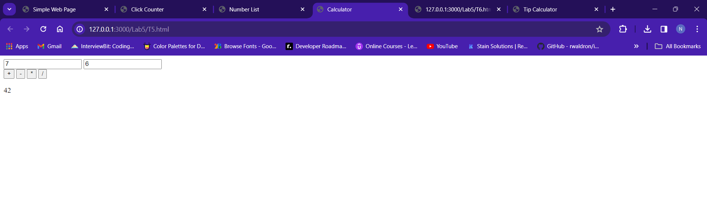

T6.

<html>

<body>

<button onclick="makePage();">Click Here</button>

</body>

<script>function makePage() {

    // Create the main container element

    const container = document.createElement('div');

    container.classList.add('container'); // Add a CSS class for styling

    // Create the heading element

    const heading = document.createElement('h1');

    heading.textContent = 'I am an H1';

    // Create the paragraph element

    const paragraph = document.createElement('p');

    paragraph.textContent = 'This is a paragraph followed by a list';

    // Create the ordered list element

    const list = document.createElement('ol');

    // Create and add list items

    const listItem1 = document.createElement('li');

    listItem1.textContent = 'I. This is first';

    list.appendChild(listItem1);

    const listItem2 = document.createElement('li');

    listItem2.textContent = 'II. This is second';

    list.appendChild(listItem2);

    // Append elements to the container

    container.appendChild(heading);

    container.appendChild(paragraph);

    container.appendChild(list);

    // Add the container to the body

    document.body.appendChild(container);

  }

  // Call the function to create the page

  makePage();

  </script>

</html>

OUTPUT:

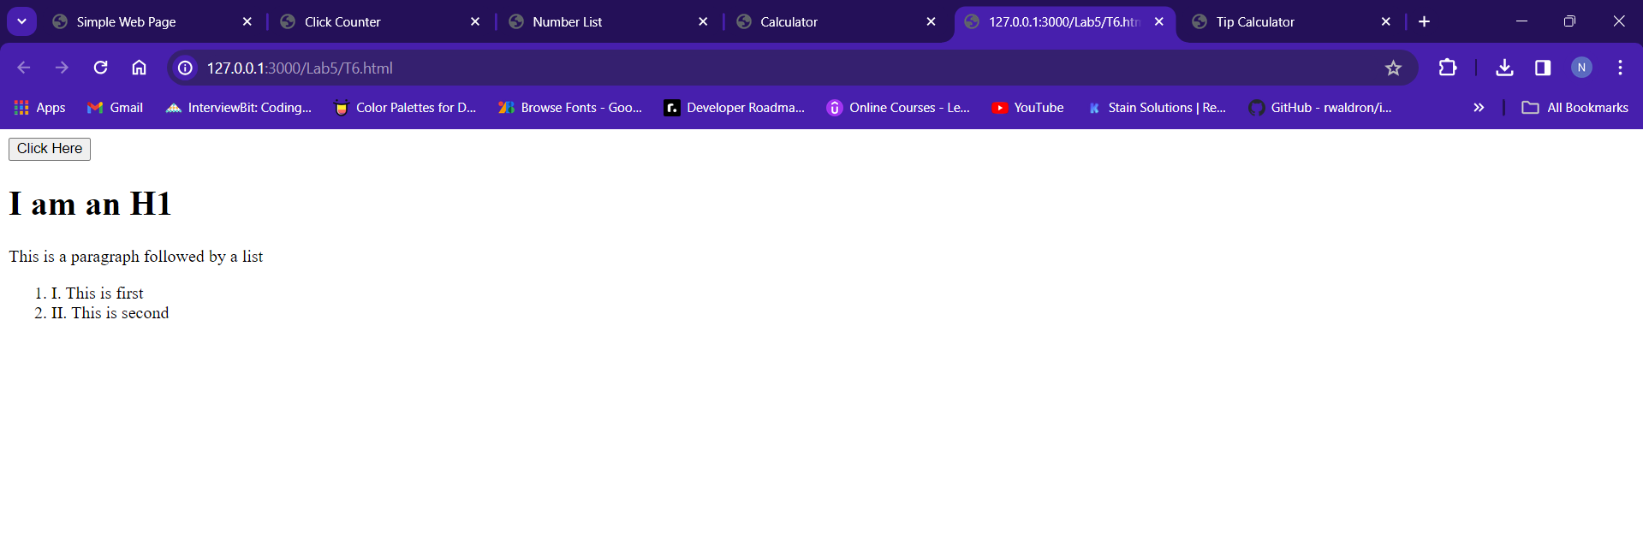

T7.

HTML:

<!DOCTYPE html>

<html lang="en">

<head>

  <meta charset="UTF-8">

  <meta name="viewport" content="width=device-width, initial-scale=1.0">

  <title>Tip Calculator</title>

  <link rel="stylesheet" href="./T7.css">

</head>

<body>

  <h1>Tip Calculator</h1>

  <div class="calculator">

    <div class="inputs">

      <label for="amount">Bill Amount:</label>

      <input type="number" id="amount" placeholder="Enter amount">

      <div class="tip-options">

        <label for="tip-percentage">Tip Percentage:</label>

        <input type="range" id="tip-percentage" min="0" max="100" value="15">

        <span id="tip-percentage-value">15%</span>

      </div>

      <label for="people">Number of People:</label>

      <input type="number" id="people" min="1" value="1">

    </div>

    <button onclick="calculateTip()">Calculate Tip</button>

    <div id="results">

      <p>Tip Amount: <span id="tip-amount"></span></p>

      <p>Total per Person: <span id="total-per-person"></span></p>

    </div>

  </div>

  <script src="./T7.js"></script>

</body>

</html>

CSS:

.calculator {

    display: flex;

    flex-direction: column;

    width: 300px;

    margin: 0 auto;

    padding: 20px;

    border: 1px solid #ddd;

    border-radius: 5px;

  }

  .inputs {

    display: flex;

    flex-direction: column;

    margin-bottom: 10px;

  }

  .inputs label {

    margin-bottom: 5px;

  }

  .tip-options {

    display: flex;

    align-items: center;

  }

  .tip-options input[type="range"] {

    width: 100px;

    margin-right: 10px;

  }

  #results {

    margin-top: 20px;

  }

  #results p {

    margin-bottom: 5px;

  }

JS:

const amountInput = document.getElementById('amount');

const tipPercentageInput = document.getElementById('tip-percentage');

const peopleInput = document.getElementById('people');

const tipAmountSpan = document.getElementById('tip-amount');

const totalPerPersonSpan = document.getElementById('total-per-person');

let displayedTipPercentage = parseFloat(tipPercentageSpan.textContent.slice(0, -1)) / 100;

function calculateTip() {

  const amount = parseFloat(amountInput.value);

  const tipPercentage = parseFloat(document.getElementById('tip-percentage').value) / 100;

  const people = parseInt(peopleInput.value);

  const tipAmount = amount \* tipPercentage;

  const totalPerPerson = tipAmount / people;

  tipAmountSpan.textContent = tipAmount.toFixed(2);

  totalPerPersonSpan.textContent = totalPerPerson.toFixed(2);

}

tipPercentageInput.addEventListener('input', () => {

  const value = tipPercentageInput.value;

  tipPercentageSpan.textContent = `${value}%`;

});

OUTPUT:

