TASK 2
The Creative Visionary
Generative AI Internship — Industrial Training Mission Kit
DecodeLabs | Batch 2026

1. Task Overview
A tech startup is rebranding and needs high-quality visual assets for its website and social media. Stock photos are too generic. The goal is to establish a unique "Cyberpunk-Corporate" aesthetic that is visually consistent across all brand materials.

Objectives
- Generate 5 high-fidelity, brand-consistent visual assets using image generation AI
- Apply advanced prompting techniques: negative prompts, aspect ratios, and lighting styles
- Demonstrate image-to-image style consistency across multiple scenes
- Deliver a complete brand asset set: logo, hero image, icon sets, and social banner

Tool Used:
DALL-E 3 — Free tier

Aesthetic:
Cyberpunk-Corporate — deep navy black + electric teal + vivid purple

2. Generated Brand Assets

Image 1 — Brand Character / Hero Portrait
A brand ambassador portrait establishing the human face of NexCore Tech. The character wears a circuit-board blazer in a rain-soaked neon cityscape, projecting authority and technological sophistication.

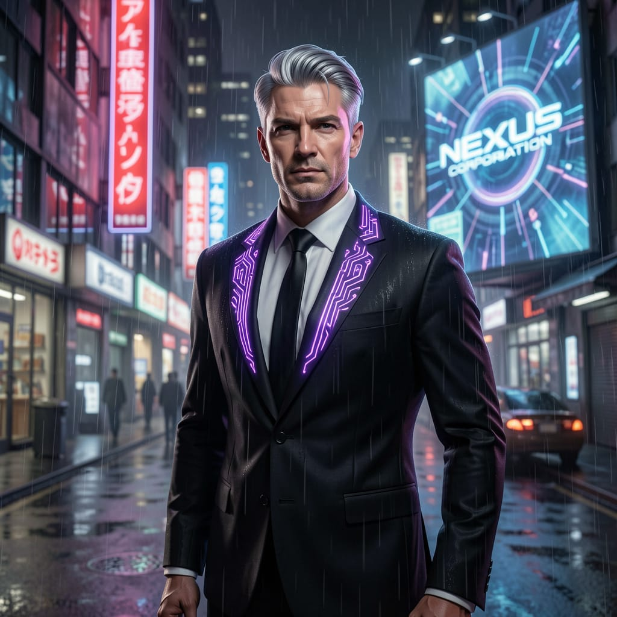

Prompt Used:
Cyberpunk corporate brand ambassador, silver-haired executive man in a black suit with glowing purple circuit-board lapels, rainy neon-lit city street at night, NEXUS CORPORATION holographic billboard in background, dramatic rim lighting, cinematic realism, photorealistic, 1:1 aspect ratio
Negative Prompt:
no warm colors, no casual clothing, no daytime, no cartoon style
Techniques Applied:
- Persona anchoring — detailed character description for consistent identity
- Lighting direction — dramatic rim lighting for cinematic effect
- Negative prompting — excluded unwanted styles and tones
- Aspect ratio control — 1:1 for square social media format

Image 2 — Hero Scene / Office Interior
A cinematic wide-angle interior scene showing a lone executive surveying holographic data across a futuristic corporate atrium. Designed for use as a website hero banner or LinkedIn cover.

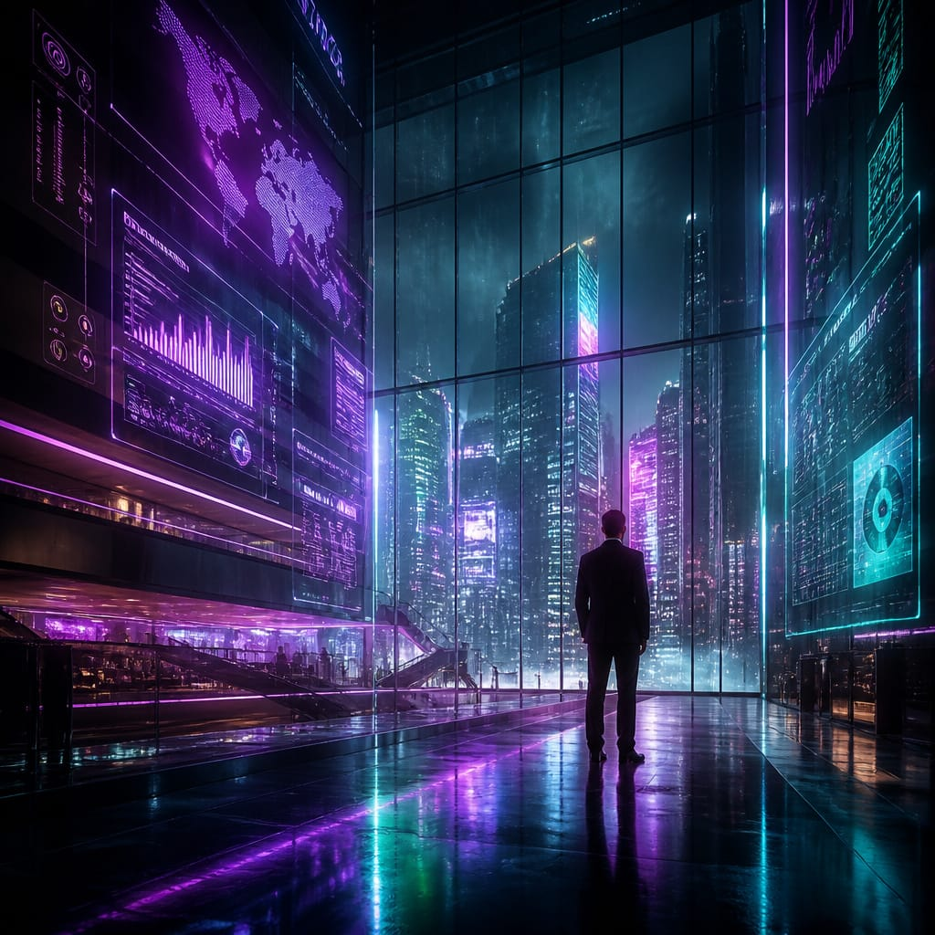

Prompt Used:
Futuristic corporate office interior, floor-to-ceiling holographic data displays showing world maps and analytics, silhouette of executive in black suit, electric teal and purple neon color palette, cyberpunk-corporate aesthetic, cinematic wide-angle shot, dramatic rim lighting, ultra-detailed, 16:9 aspect ratio
Negative Prompt:
no warm colors, no orange tones, no daylight, no casual clothing
Techniques Applied:
- Aspect ratio (16:9) — matched to website hero banner format
- Lighting style — cinematic, high-contrast rim lighting
- Compositional direction — silhouette subject framing for mood
- Negative prompting — enforced dark, cool color palette

Image 3 — Logo Concept
A clean vector-style logo built from a hexagon with circuit board traces extending outward. The teal-to-purple gradient gives it a tech-forward identity while remaining clean enough for use at any scale.

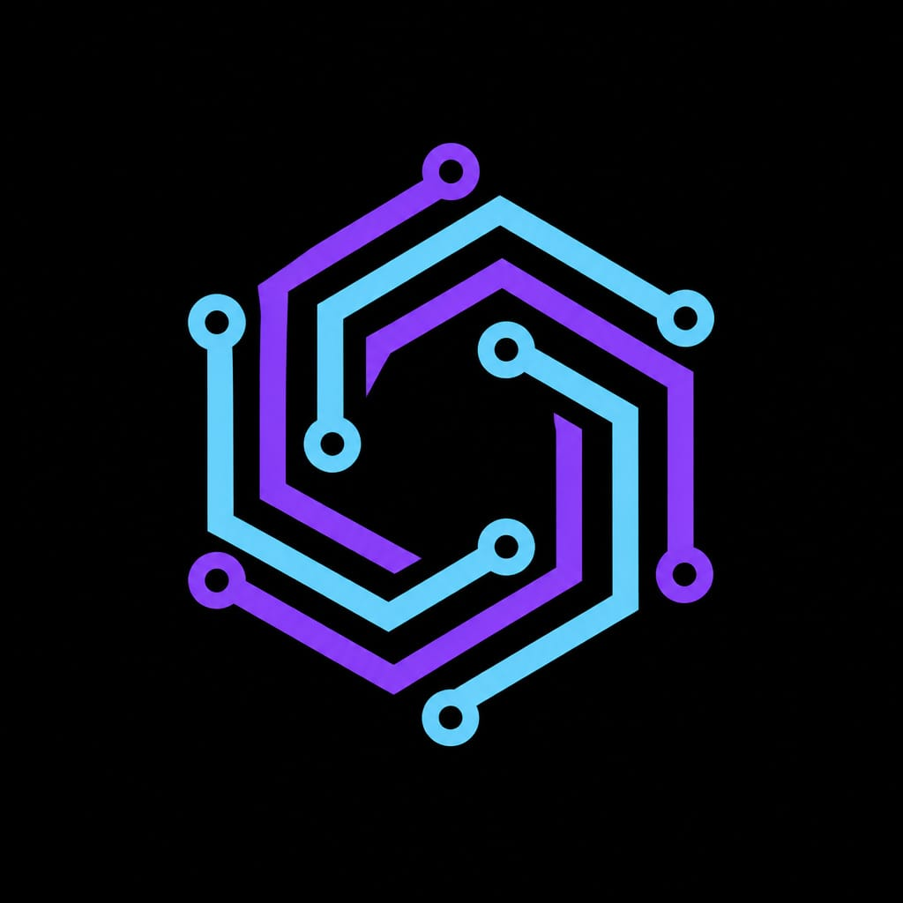

Prompt Used:
Minimalist tech company logo, geometric hexagon shape with circuit board lines inside, electric teal and purple neon gradient, dark black background, corporate clean style, cyberpunk aesthetic, vector art, flat design, no text, centered composition, 1:1 aspect ratio
Negative Prompt:
no humans, no gradients on background, no realistic textures, no serif fonts, no text
Techniques Applied:
- Style specification — vector art, flat design for scalable output
- Color palette locking — teal-to-purple gradient for brand consistency
- Aspect ratio (1:1) — ideal for logo/icon use
- Negative prompting — prevented cluttered or realistic output

Image 4 — Icon Set
A complete set of 9 UI icons sharing consistent visual language: uniform line weight, teal-to-purple outlines, and a dark navy grid layout. Covers AI, security, analytics, and connectivity themes.

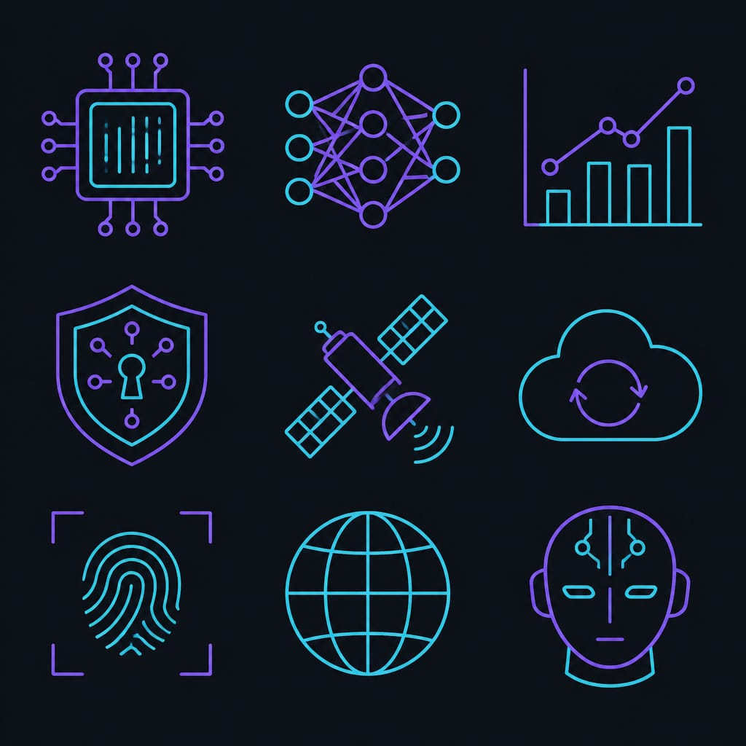

Prompt Used:
Set of 9 flat UI icons on dark navy background: AI chip, neural network, analytics chart, security shield, satellite, cloud sync, fingerprint scanner, global network, robot head — all outlined in teal-to-purple gradient, cyberpunk corporate icon set, consistent line weight, minimalist, 3x3 grid layout, 1:1 aspect ratio
Negative Prompt:
no color fill inside icons, no drop shadows, no realistic style, no text labels
Techniques Applied:
- Style-seed phrase — same color/style description as all other assets for consistency
- Layout instruction — 3x3 grid enforces orderly composition
- Line weight consistency — specified to match across all icons
- Negative prompting — kept icons outline-only and clean

Image 5 — Social Media Banner / Background
An aerial cinematic shot of a futuristic city built from circuit board geometry, with glowing teal data-grid lines cutting across deep purple skies. Designed for use as a LinkedIn banner, Twitter header, or website background.

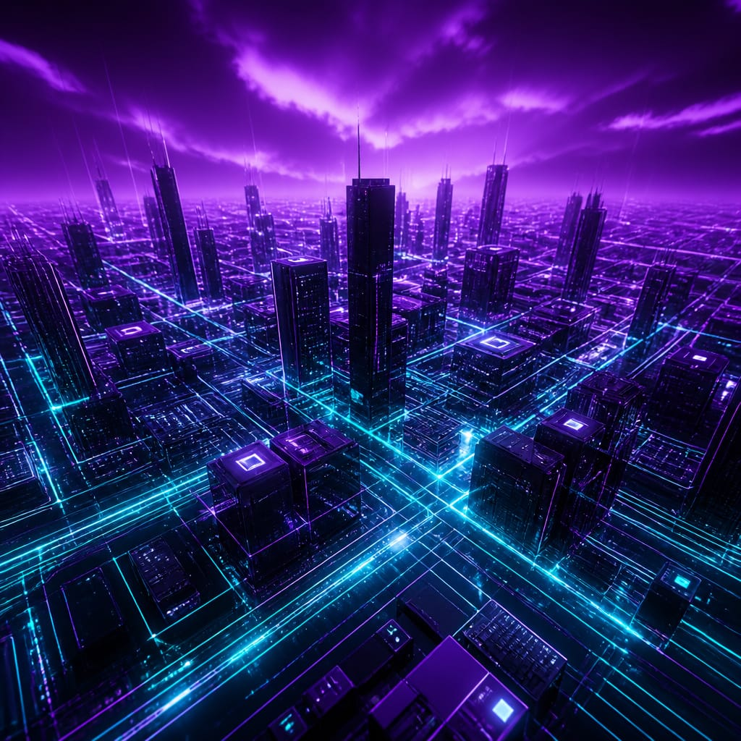

Prompt Used:
Aerial view of a futuristic city built like a circuit board, skyscrapers connected by glowing teal data streams and neon grid lines, deep purple stormy sky, cyberpunk-corporate aesthetic, cinematic drone shot perspective, ultra-detailed, electric teal and violet color palette, 16:9 aspect ratio
Negative Prompt:
no faces, no cars, no organic nature elements, no warm tones, no text
Techniques Applied:
- Perspective direction — aerial/drone shot for epic scale
- Aspect ratio (16:9) — matched to banner/header format
- Thematic metaphor — city-as-circuit-board reinforces brand concept
- Negative prompting — kept the scene abstract and brand-safe

3. Prompting Techniques Summary

Technique | Where Used | Purpose
Negative prompting | All 5 images | Eliminated unwanted colors, styles, elements
Aspect ratio control | Images 2 & 5 (16:9), 1,3,4 (1:1) | Matched each asset to its intended use
Lighting style direction | Images 1 & 2 | Cinematic rim lighting for dramatic effect
Style seed phrase | All 5 images | Kept Cyberpunk-Corporate aesthetic unified
Compositional instruction | Images 2 & 5 | Guided camera angle and subject placement
Persona anchoring | Image 1 | Defined visual brand character identity

4. Image-to-Image Consistency Strategy
Since Bing Image Creator (DALL-E 3) does not natively support image uploads as style references, visual consistency across all 5 assets was achieved through a repeating style seed phrase embedded in every prompt:

"electric teal and purple neon, dark navy/black background, cyberpunk-corporate aesthetic, consistent line weight"

This phrase appears in all 5 prompts as an anchor that guides the model to maintain the same visual identity across different subject matter — from the logo to the cityscape.

True Image-to-Image Workflow
For tools that support image input (DALL-E via ChatGPT Plus, Stable Diffusion, Midjourney --cref), the process is:
- Generate the base asset (e.g., brand character in Image 1)
- Upload the generated image as a style/character reference
- Prompt: "Same character, now seated at a glowing terminal in a dark server room"
- The model preserves subject identity while placing them in a new scene

5. Brand Consistency Audit
All 5 generated images were reviewed against the brand brief. Results:

Criteria | Met? | Images
Dark navy / black backgrounds | ✅ Yes | All 5
Electric teal + purple neon palette | ✅ Yes | All 5
Cyberpunk-Corporate visual tone | ✅ Yes | All 5
High-contrast cinematic lighting | ✅ Yes | 1, 2, 5
No warm colors (excluded via negative prompts) | ✅ Yes | All 5
Professional, corporate subject matter | ✅ Yes | All 5

6. Conclusion
This task demonstrated the full creative workflow of an AI Visual Designer — from brand brief to a complete set of deployable assets. By applying advanced prompting techniques (negative prompts, aspect ratio control, lighting direction, and style seed phrases), a coherent visual brand identity was established across 5 distinct image types without any manual design tools.

The Cyberpunk-Corporate aesthetic is visually compelling, professionally consistent, and ready for use across web, social media, and marketing materials.

Submitted as part of the DecodeLabs Generative AI Industrial Training — Batch 2026

