What is Software?

It is a set of instructions or programs used to execute a specific task.

What is Software Testing?

Software Testing can be defined as a **process** of verification (static testing) and validation (dynamic testing) to ensure that software meets business as well as technical requirements and desired quality.

Quality of Software should,

  1) Meet Customer Requirement (Needs)

  2) Meet Customer Expectations (Feeling, user experience, Performance etc.)

  3) Cost of Software (affordable)

  4) Timely Delivery (Time-to-Market)

  5) Risk Management (Maintenance period)

Software Development Life Cycle (SDLC):

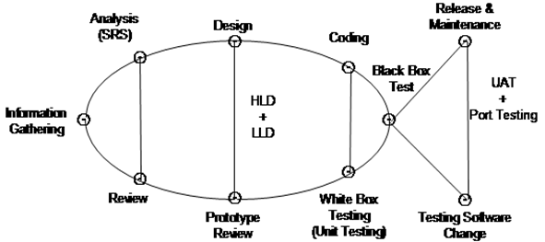

SDLC is a process which defines various stages involved in development of software for delivering high quality products.

The purpose of SDLC is to deliver high quality software as per customer requirement.

SDLC has defined phases like Requirement Gathering, Analysis, Design, Coding, Testing, Release & Maintenance.

1)     Requirement Gathering

In this phase, Business Analyst is involved to gather relevant information from customers as per business needs. Following questions are asked by BA during this phase,

1. What is the business problem (problem statement)?
2. Why is this software required? How will it solve the problem?
3. Who are the targeted users? How will this impact them?

Business Analyst (BA) documents the requirement in BRS (Business Requirement Specification) format.

Business Analyst gets BRS reviewed & approved by the customer before passing to the next phase i.e. the analysis phase.

2)     Analysis Phase

In this phase the Project Manager is involved. Project Manager receives BRS document as input from BA.

After receiving BRS document project manager does following activity-

i)                    Analyzing Requirements (Study)

ii)                  Feasibility Study (Check possibility)

iii)                Decide Technology

iv)                Effort estimation and planning

Project manager defines & documents the software requirements in the form of SRS (Software Requirement Specification)

SRS consists of all the software requirements to be designed and developed during the project life Cycle.

SRS can be defined as functional requirements to be developed as per customer needs and system requirements to be used.

The key people involved in the review of SRS are Project Manager, Business Analyst & Senior team members (Software Architect, Project lead, Test lead, etc).

The outcome of this phase is an SRS document which is reviewed by internal stakeholders as well as the client before moving to the next phase.

3)     Design Phase

It has two steps High Level Design (HLD) & Low-Level Design (LLD).

High Level Design (HLD) - It defines architecture of software products to be developed & done by Software Architect.

Low Level Design (LLD) - It defines how each and every feature of software should work and how every component should work that is internal structure. After HLD & LLD, the prototype model is developed for client review before moving to the coding phase. Prototype is a blueprint of how the actual software will look like.

4)     Coding Phase

In this phase software developers are involved.

This is a phase where we start coding for software.

Outcome of this phase is source code document & developed (working) software.

Developers also perform unit testing (using White box testing techniques) in this phase to verify internal working of the code.

5)     Testing Phase

In this phase, a Software Tester is involved.

When the software is ready, it is sent to the testing team for complete testing.

The testing is done manually or using automated testing tools depending on the process defined in SDLC & ensure each and every feature of software is working fine as per customer requirements.

After completion of testing software is made ready for delivery or deployment for the customer.

6)     Release and Maintenance

After Successful testing, software is delivered or deployed to customers for their reviews.

Deployment is done by the release team.

Once the customer starts using software then actual problems will come up & will need to be resolved from time to time as part of the maintenance phase.

Difference between Verification & Validation.

|  |  |
| --- | --- |
| **VERIFICATION** | **VALIDATION** |
| Verification is a static practice of verifying documents, design, code and program. | Validation is a dynamic mechanism of validating and testing the actual product. |
| It does not involve executing the code. | It always involves executing the software. |
| It is human based checking of documents and files. | It is computer based execution of a program. |
| Verification uses methods like inspections, reviews, walkthroughs, and etc. | Validation uses methods like black box (functional) testing, grey box testing, and white box (structural) testing etc. |
| Verification is to check whether the software conforms to specifications. | Validation is to check whether software meets the customer expectations and requirements. |
| It can catch errors that validation cannot catch. It is low level exercise. | It can catch errors that verification cannot catch. It is High Level Exercise. |
| Verification is done by the development team to provide that the software is as per the specifications in the SRS document. | Validation is carried out with the involvement of the customer and testing team. |
| It, generally, comes first before validation. | It is generally done after verification. |
| Question  Are we building the product right? | Question  Are we building the right product? |
| Evaluation Items  Plans, Requirement Specs, Design Specs, Code, Test Cases | Evaluation Items  The actual product/software. |

Interview questions:

1. What is SDLC?
2. Explain SDLC in detail.
3. What is the difference between verification and validation?
4. What is the difference between HLD and LLD?
5. What happens in the Information or Requirement Gathering phase?
6. What happens in the Analysis phase?
7. What happens in the Design phase?
8. What happens in the coding and testing phase?
9. What happens in the release and maintenance phase?