Waterfall Model

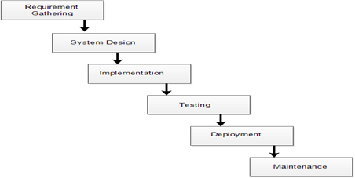

The Waterfall Model was the first process Model to be introduced. It is also referred to as a linear-sequential life cycle model.  It is very simple to understand and easy to use. In a waterfall model, each phase must be completed fully before the next phase can begin.

This type of software model is used for projects which are small & there are no uncertain requirements (i.e. requirements should be fixed).

At the end of each phase, a review takes place to determine if the project is on the right path and whether or not to continue or discard the project.

In this model software testing starts only after development is completed i.e. phases do not overlap.

Advantages of waterfall model:

1.      Simple and easy to understand and use.

2.      Easy to manage due to the rigidity of the model.

3.      Phases are processed and completed one at a time & they don’t overlap.

4.      This model works well for smaller projects where requirements are clearly defined & well understood.

 Disadvantages of waterfall model:

1. Release takes longer and longer: Each release is taking more time, effort, and cost to get delivered to its customer.
2. Release schedule slip: Commitment to the customer is not met. If releases are not delivered on the promised time the plans are thrown in disarray and money and credibility is lost.
3. Stabilization at the end takes longer and longer
4. Planning takes too long and doesn't get right: Releases can take too long and because we didn’t plan well enough at the start of the work. We didn't get our requirements firmed up and fully developed. To rectify it all more ideas are included and these are reworked. As a result a lot more time is spent in planning and release date is delayed.
5. Changes are hard to introduce mid release: The current process cannot accommodate change easily. Often something critical has to be included or a new feature is to be  added. To incorporate this change we have to adjust all the work that we have already done to accommodate it. This is difficult because it's hard to understand the ripple effect in the software.
6. Quality is deteriorating: Every time we might rush the development of the project, there is a possibility of compromising on the quality by missing defects and resulting in failure.

When to use the waterfall model:

1.      Requirements are very well known, clear and fixed.

2.      Product definition is stable.

3.      Technology is understood.

4.      There are no ambiguous requirements

5.      Sufficient teams with required expertise are available.

6.      The project is of short duration.

Interview questions:

1. What is a waterfall model?
2. Explain how the waterfall model works?
3. Advantages and disadvantages of the waterfall model?
4. When to use a waterfall model?