**Unit Testing –**

A Unit is a smallest part of software like function, class, procedure or interface.

Unit testing is a method by which developer verifies working of the code as per design & requirement specifications to check whether the code is behaving as expected or not.

The objective of unit testing is to divide or isolate each part of the program and test individual part of the program. Developers will check a particular function by providing a set of input & by verifying corresponding output.

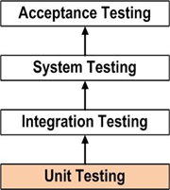

From above diagram unit testing is done before integration testing.

During Unit Testing developers use white box testing techniques to verify internal structure of code.

Following aspects are considered for unit testing;

1.      Module Interface is tested  to ensure data flows into & out of the program unit.

2.      Local Data structure is tested to ensure data stored temporarily maintains its integrity.

3.      Boundary Conditions are tested to ensure the module operates within established boundary limits.

4.      All Independent paths are tested to ensure every program statement executes at least once.

5.      All the error handling paths are tested.

**Interview Questions:**

1.      What is unit testing?

2.      Who performs unit testing? - Developer

3.      When it is performed? – Before integration testing

4.      What is tested during unit testing?- Developer verifies the internal structure of the program/code.

5.   What is the scope of unit testing? What areas are covered?

6. How Unit Testing is performed? - Using White box testing techniques unit testing is performed.