|  |  |  |  |  |  |  |  |
| --- | --- | --- | --- | --- | --- | --- | --- |
| **Account No : 9039559277 Invoice No: SDCAP0017641074**  **Invoice Date : 03/08/2021 Billing Period** | | | | | | | |
|  | **01/07/2021 to 31/07/2021** | | | | | | |
| **Tariff plan: 400GB Plan CS95 - Bharat Fiber** | | | | | | | |
| **AMOUNT PAYABLE**  **16** **50.00**  [**PAY NO** **W**](http://portal2.bsnl.in/myportal/QRService/initiaterequest.do?msg=08579295669|9039559277|SDCAP0017641074|CDR|873|AP|NA|NA) | | | |  | **DUE DATE**  **20/08/2021** | | |
| **CURRENT CHARGES**  {ç³çÜ$¢™è ¼Ë$Ï | | **(=)** | **TOTAL**   **DUE** ¼Ë$Ï  Ððþ$$™è ¢… | | | **(=)** | **AMOUNT PAYABLE**  ¼Ë$Ï Ððþ$$™è ¢… |
| R **1650.00** | | R **1650.00** | | | R **1650.00** |

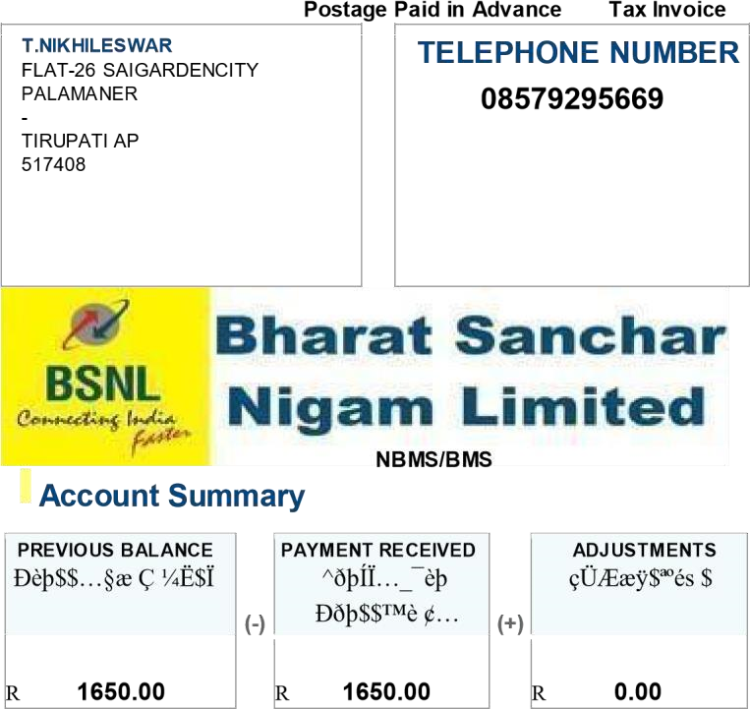

**(+)**

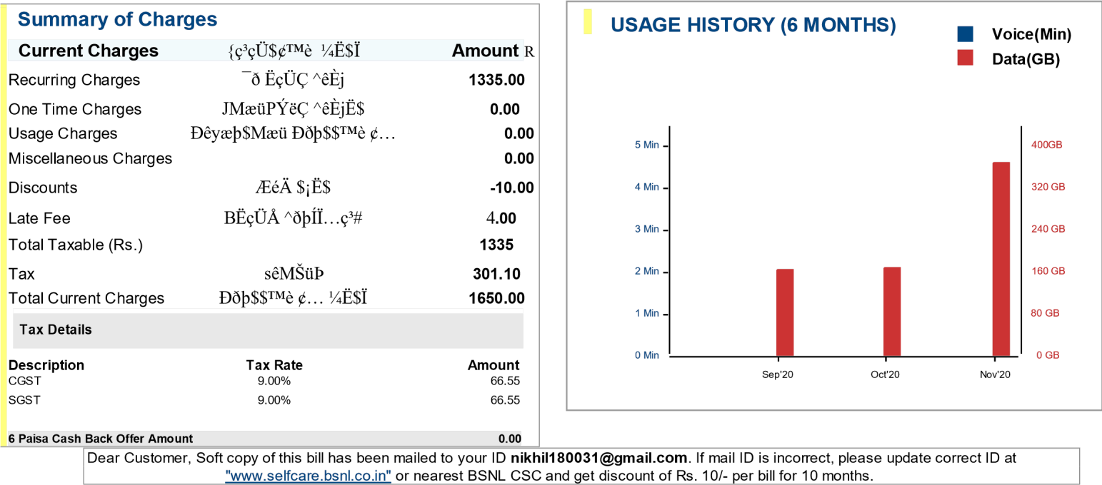

Please make crossed Cheque/DD/Pay order for Amount Payable (Rounded Up) in favour of AO (Cash), BSNL,

Tirupati.

This is a Computer generated Bill and does not require any Signature. Page 1 of 2

Account No: 9039559277

| Invoice No: SDCAP0017641074 | Invoice date: 03/01/2021

|  |  |  |  |
| --- | --- | --- | --- |
| **WAYS TO PAY BILL**   * Dial Toll Free Number **1500** for (Landline/Broadband) from BSNL Numbers and **1800-345-1500** from all other Service Provider Numbers. * Dial Toll Free Number **1503** for (Mobile) from BSNL Numbers and **1800-180-1503** from all other Service Provider Numbers. * Dial **198** from BSNL numbers for Automatic Fault Booking.  Log on to web selfcare portal **www.selfcare.bsnl.co.in** * Download My BSNL App to avail BSNL services & making bill payments.  Reverse Charges Not Applicable  |  | | --- | | **Account Officer address**:O/o General Manager, Sanchar Bhavan, Near HPO Compound, Tirupathi, Andhra Pradesh - 517501 | | **BSNL GO-GREEN INITIATIVE**  Say no to Paper Bill, opt for " Bill on Email Only " option & get discount of Rs.10/- per bill for 10 months. Register for E-bill at **www.selfcare.bsnl.co.in** or visit nearest BSNL CSC |   **CUSTOMER INFORMATION**   * Get the last bill details on your mobile, SMS '**BILL<Space><STDCODE-TEL.NO><Space><BILLING ACCOUNT NO>** on 53334 from BSNL Mobile and for Non BSNL Mobile on 9478053334 * Logon to **www.bsnl.co.in** for information on the tariff plans and prices  For change of billing address, please contact your nearest customer care or AO (TR) / Commercial Officer of your exchange area.  If your mobile/landline is used for sending unsolicited commercial communication (UCC) through SMS or Voice, it leads to disconnection of your telecom resources and blacklisting for two years * For contact details of Nodal Officer / Appellate Authority, tariffs and other information, visit our website **www.bsnl.co.in**  Disputes if any, should be brought to the notice of the concerned AO(TR) within 60 days. | |
| **Installation Address:**  T.NIKHILESWAR, FLAT-26,  SAI GARDEN CITY ,PALAMANER,TIRUPATI, Andhra Pradesh -517408 | ★ **GST Registration Number:** 37AABCB5576G3ZI  **PAN Number:** AABCB5576G   **HSN/SAC Code:** 998412  **CIN:**U74899DL2000GOI107739   |



