Name:Nikhilesh Yadav

ID: 11904442

CA -3

INTRODUCTION :

# OBJECTIVE :

Any open source software used to transfer files between two computers on a network should have the goal of enabling quick and secure file transfers between two machines. In addition to being user-friendly, the software should perform consistently and reliably and be compatible with a variety of operating systems.

Finding additional features and functionalities that can improve this open source software's usability and effectiveness can be accomplished by investigating its other options. This can involve looking into the software's configuration options, security features, support for various protocols, and integration with other tools and applications. The software's community and support resources, as well as any user-accessible documentation or tutorials, are additional potential research areas. In the end, the objective is to determine the best options and procedures for utilizing open source software to achieve effective and secure file transfer in a specific network environment.

# DESCRIPTION :

Using open source software to move files from a server to a client involves using a network file transfer program. Both the server and client computers can have the software installed, and it can transfer files using a variety of protocols like FTP, SFTP, or SCP.

FileZilla is a well-known open source program for file transfers and is accessible on Windows, macOS, and Linux. FileZilla offers a user-friendly graphical interface for simple configuration and file transfer. It supports a variety of protocols, including FTP, SFTP, and FTPS.

Examining extra features and functionalities that can improve its performance and usability can be done when looking into alternative FileZilla or other open source file transfer options. For instance, FileZilla offers options for adjusting file transfer rates, creating bookmarks for frequently used servers, and personalizing the interface to suit preferences. Other open source file transfer programs might provide different features and options.

To make sure that the file transfer is secure and private, it is also essential to investigate the software's security features. For instance, FileZilla offers options for SSL/TLS encryption during file transfers and supports both password and public key authentication. Other file transfer open source software might provide various security features and settings.

All things considered, using open source software for file transfer offers a flexible, affordable solution for quick and secure file transfer between computers in a network. You can find the best practices for using the software and optimize its performance for your particular use case by looking over all of its available options and features.

Software Used : PROJECTSEND

### ABOUT :

ProjectSend is a self-hosted application (you can install it easily on your own VPS or shared web hosting account) that lets you upload files and assign them to specific clients that you create yourself! Secure, private and easy. No more depending on external services or e-mail to send those files.

A web-based file sharing and collaboration tool called ProjectSend is open source. It is intended to support companies and organizations in securely transferring files to customers, partners, and staff. Users can upload, manage, and share files from a single location with ease using ProjectSend's user interface, which is clear and simple to use.

It is simple to manage who has access to and can manage files with ProjectSend because users can create various user accounts with various permission levels. Additionally, it provides tools that facilitate user collaboration and teamwork on documents, including file versioning, file locking, and file commenting.

The fact that ProjectSend is self-hosted, allowing users to install it on their own server and have total control over their data, is one of its main advantages. Businesses that must adhere to data protection laws or have particular security requirements may find this to be especially helpful.

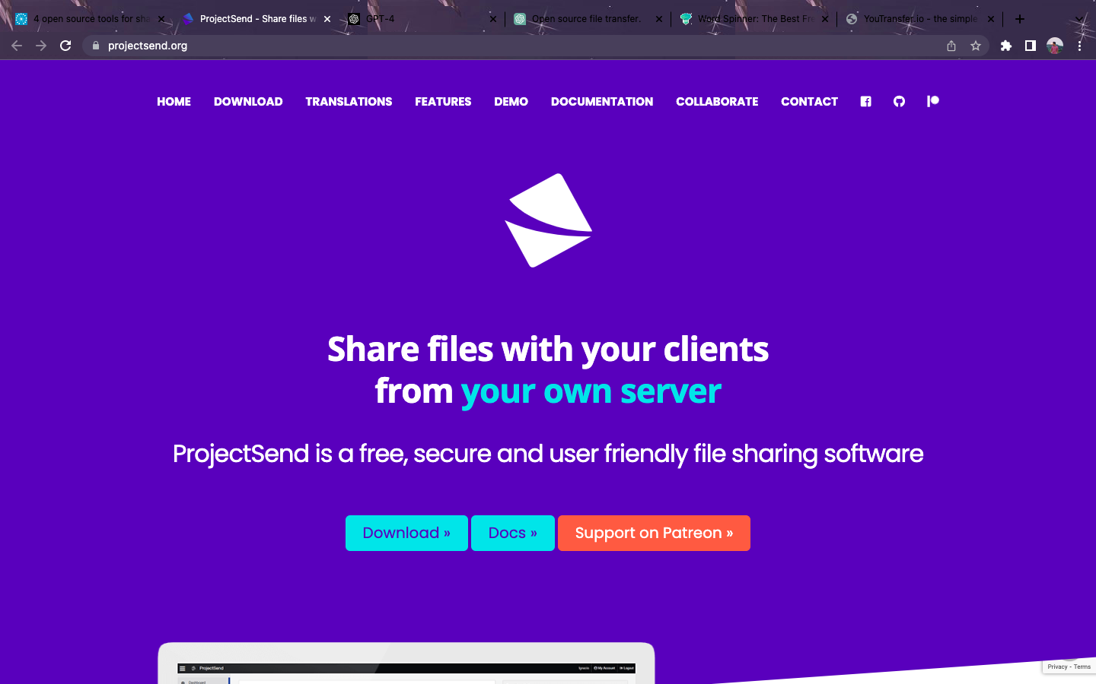

The majority of contemporary web servers are compatible with ProjectSend because it is written in PHP and uses a MySQL database. It is distributed under the GNU General Public License (GPL), making it free and open source software that may be freely altered and distributed.

Overall, ProjectSend is a strong and adaptable file sharing and collaboration tool that can assist companies and organizations in securely managing and sharing files with their clients, partners, and team members. It is a well-liked option for companies of all sizes due to its self-hosted nature, user management features, and collaboration tools.

## Who can Use PROJECTSEND :

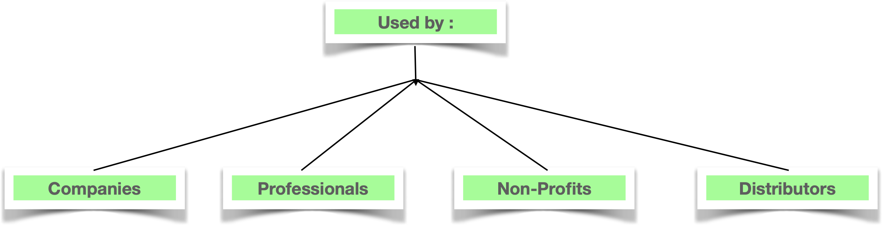

# Features :

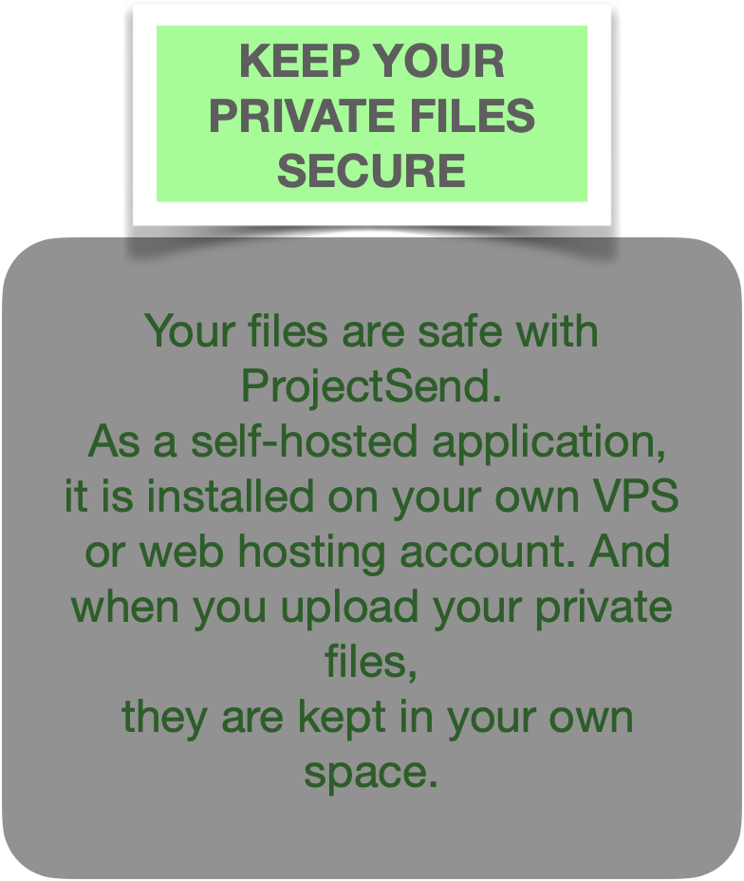 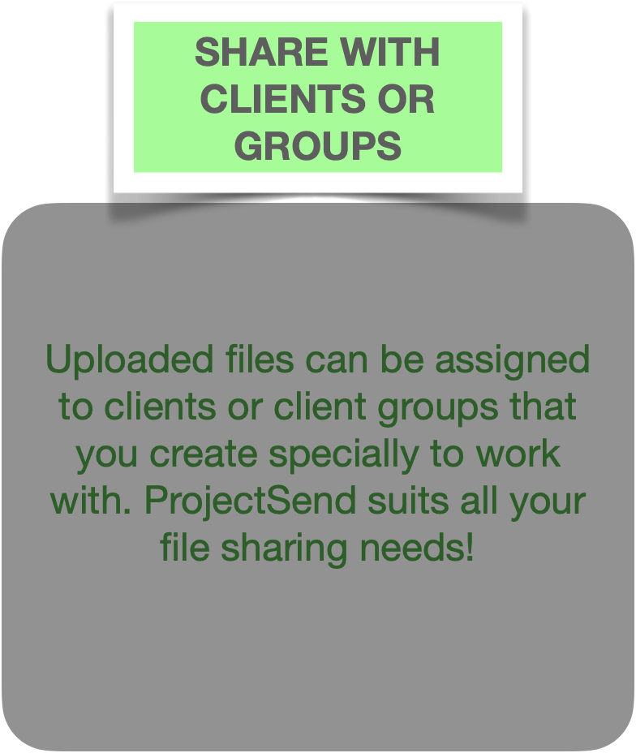

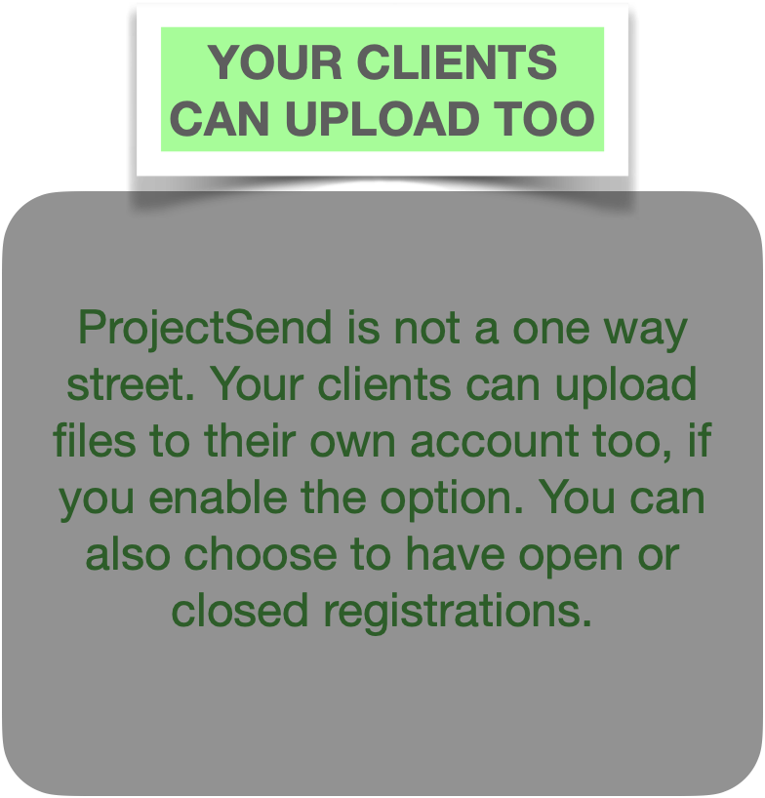 

# Interface :

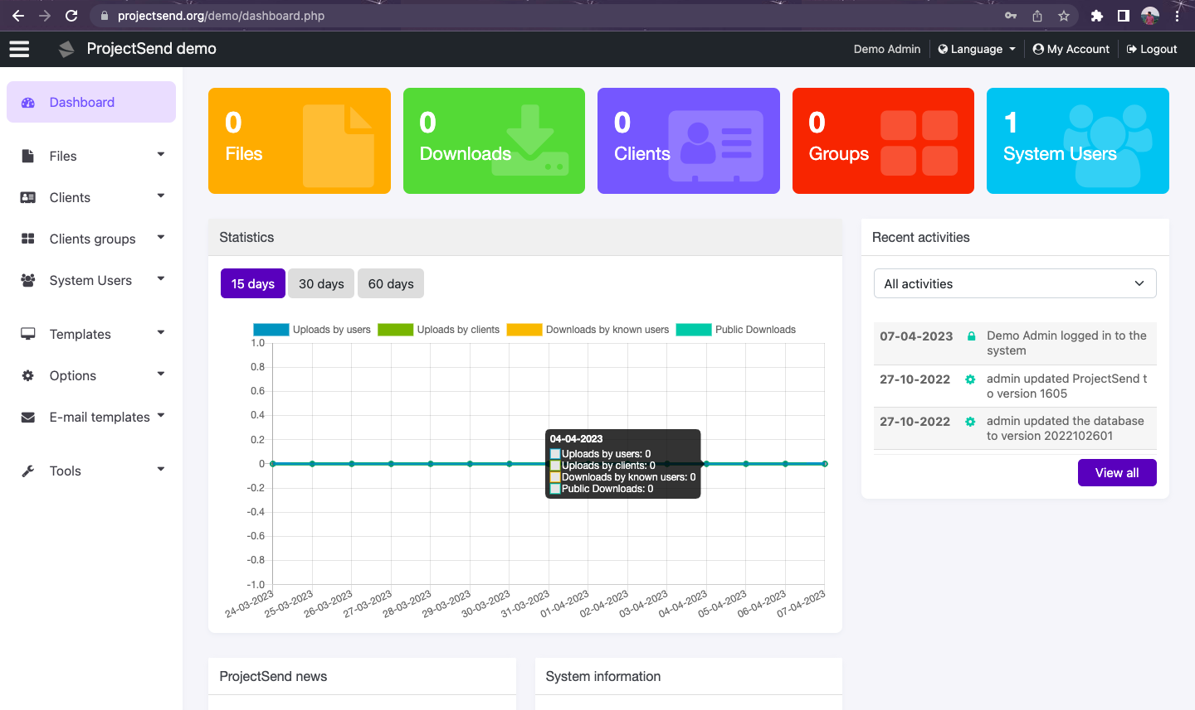

This is the Dashboard.



This pane consists of Files with options regarding upload and catogories.

We can new clients and manage clients who can access the files.

It is simple tool to manage who has access to and can manage files with ProjectSend because users can create multiple user accounts with various permission levels. Additionally, it provides tools that facilitate user collaboration and teamwork on documents, including file versioning, file locking, and file commenting.

One of ProjectSend's main benefits is that it is self-hosted, allowing users to install it on their own server and have total control over their data. Businesses that must adhere to data protection laws or that have particular security requirements may find this to be of particular use.

ProjectSend is compatible with the majority of current web servers because it is written in PHP and uses a MySQL database. It is free and open source software that may be altered and distributed without restriction because it is distributed under the terms of the GNU General Public License (GPL).

ProjectSend features consist of:.

Management of user accounts with various levels of permission.

Versioning, locking, and commenting of files.

Email alerts sent automatically for comments and file uploads.

Easy file sharing and management with a clear and simple interface.

Logs of user activity to monitor changes and access to files.

A progress bar for file uploads and pause/resume options.

In conclusion, ProjectSend is a potent and adaptable file sharing and collaboration tool that can assist companies and organizations in securely managing and sharing files with their clients, partners, and team members. It is a popular option for companies of all sizes because of its self-hosted structure, user management capabilities, and collaboration tools.

# References :

1. <https://www.projectsend.org/>.

2. <https://www.youtube.com/watch?v=ohkpCf9DrCI&ab_channel=DBTech>

3. <https://www.projectsend.org/demo/dashboard.php>

4.https://www.youtube.com/watch?v=RRdFR9n_Cw0&ab_channel=LinuxIntellect

# Git Hub Link : https://github.com/nikhileshyadav9/Opensourcetech