## Lab 16

## Install and configure wordpress application and create port on php programming.

Step 1 : Download and unzip the WordPress package from [wordpress.org/download/](https://wordpress.org/download/).

Step 2: set file location to htdocx folder in PHP folder where you have installed PHP.

Step 3: start xmapp server and create a database in phpmyadmin to use it in our project and then go to localhost/yourfolder to start wordpress then enter details as per screenshot.

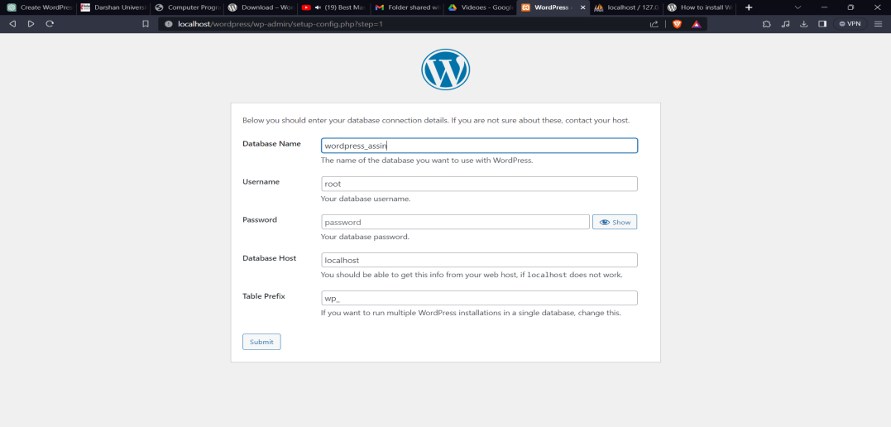

Step 4: then click on run the installation.

Step 5: then enter details as per screenshot

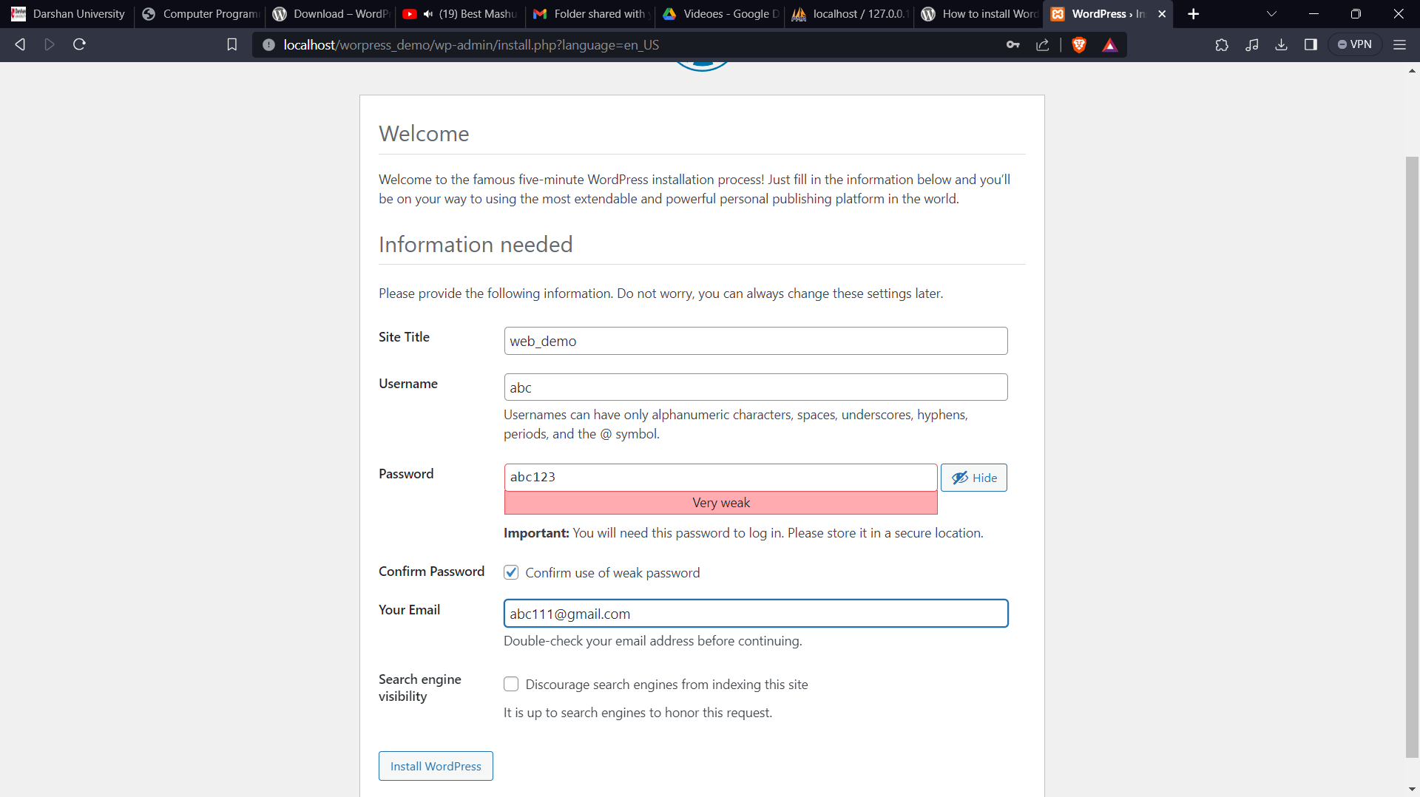

Step 6: then done log in with username and password which you have entered. And you have crated wordpress site.

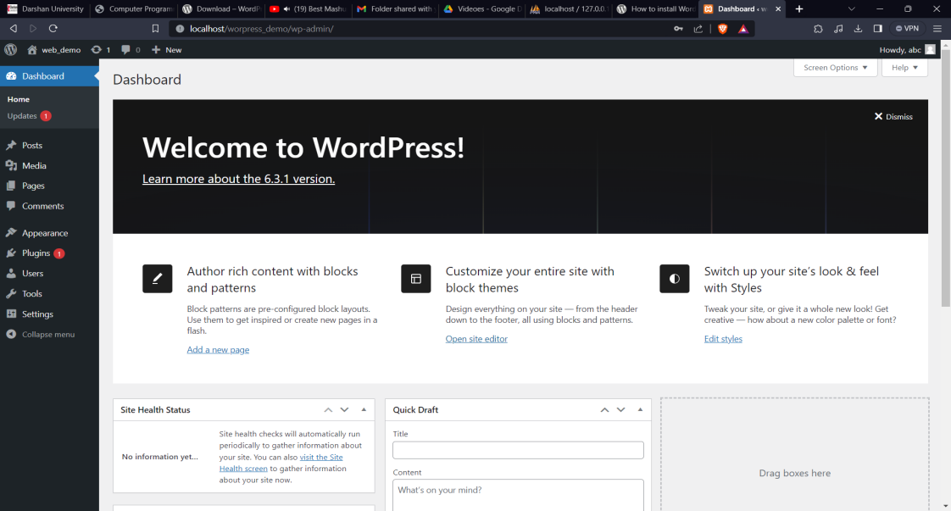

Step 7: for create new post Visit your [dashboard](https://wordpress.com/home). Click on Posts on the left side. Click on the **Add new post** button. Give your post a title by typing it in the box at the top that says Add title.

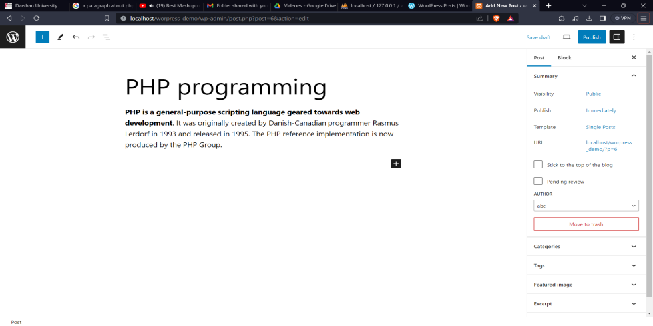

Step 8: click on publish to publish your post on website. To see output copy link and open it.

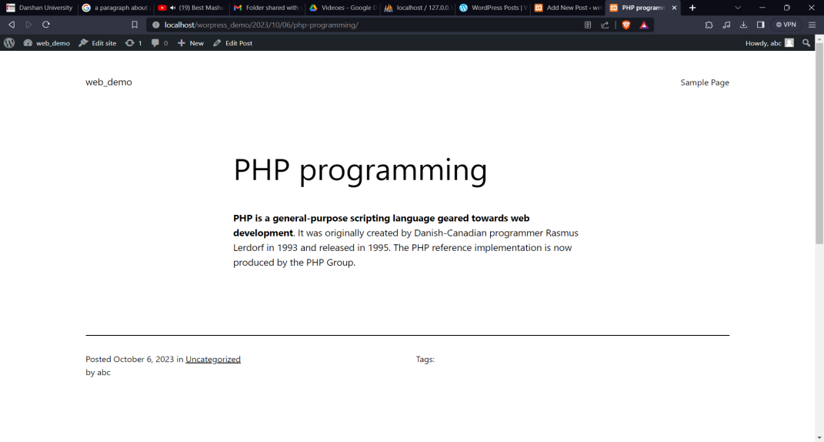

## Create wordpress posts on various topics of php and categories it also use tags for better seo.

Step 1: first create a new post as per previous lab and right side bar we can see categories and tags just add there like this.

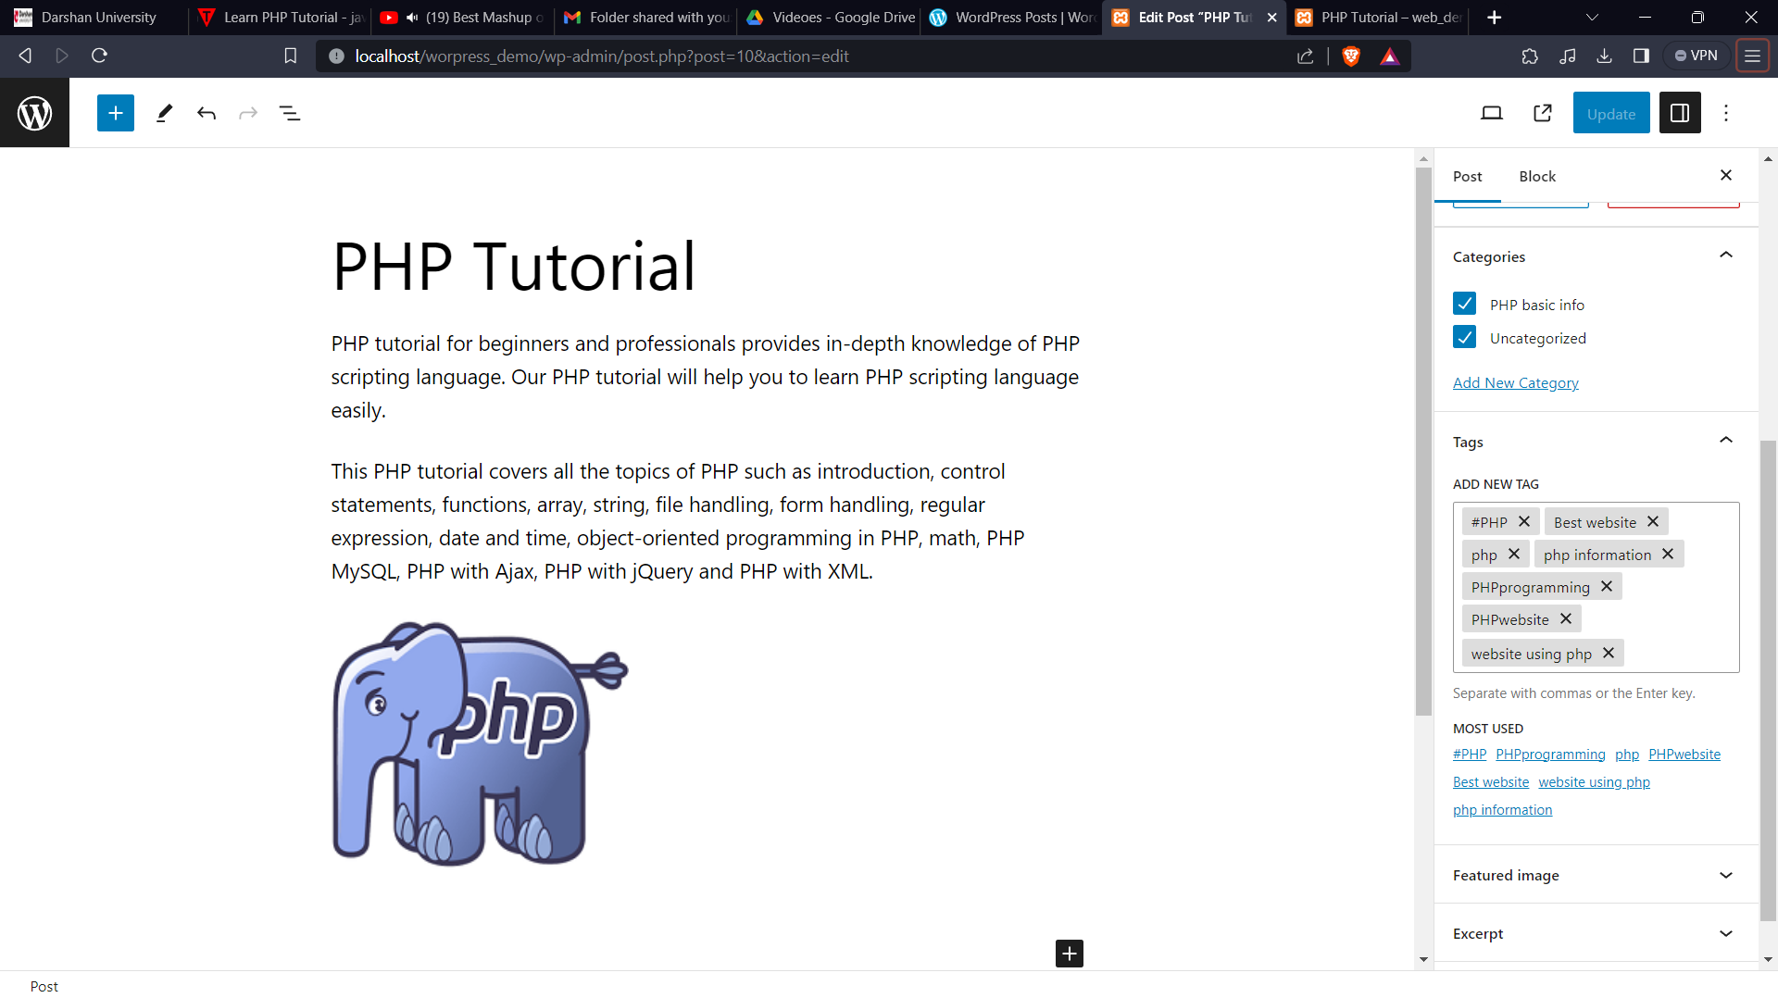

Step 2: hare you can see I have created three post on php basic and categories name is php basic info. For more I have apply filter so we can see it clearly.

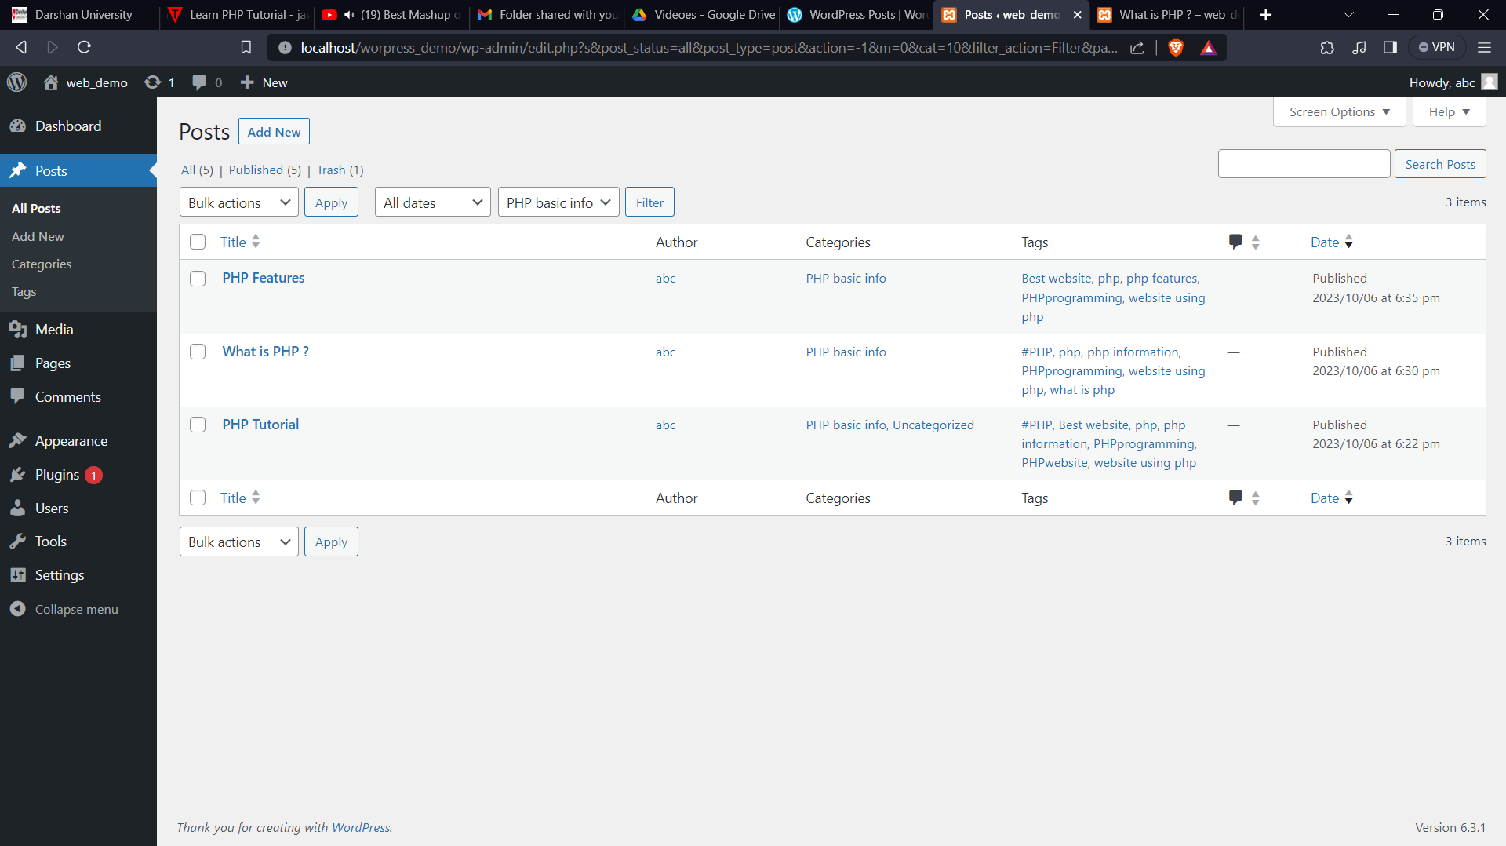

## Lab 17

## Create wordpress application which contains home page ,about page contact page and product page also create menu on top.[A]

Step1 : click on pages in left side menu bar on dashboard of wordpress. Then click on addnew button to add new page in website.

Step2 : add title of your page and add details of it. Here I have created home page as per screenshot.

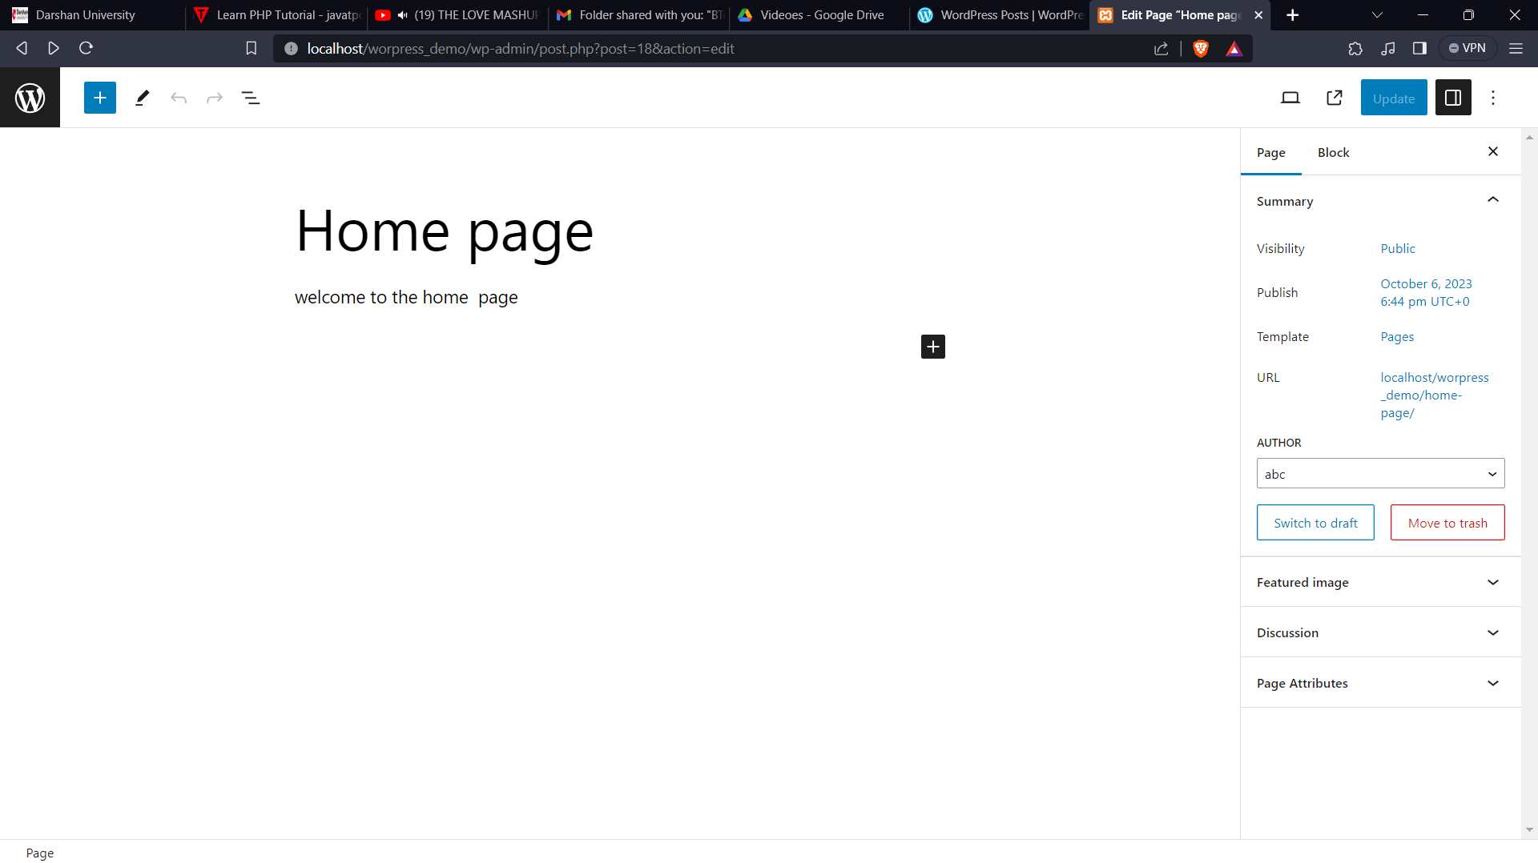

Step3 : as per this make all those pages

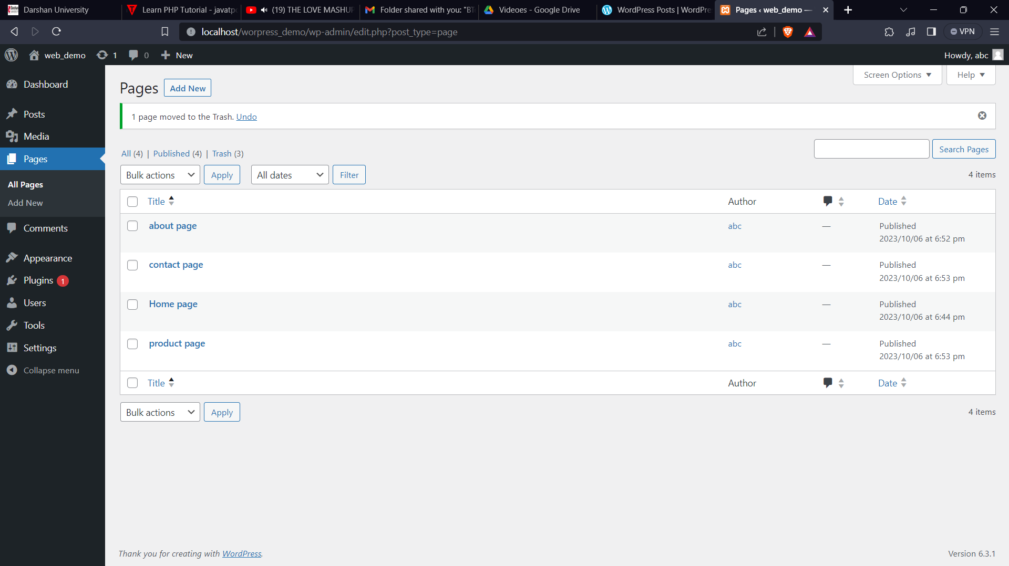

Step 4: let’s create a menu pages on top,for that click on + button in left top corner and then search navigation and add it like this

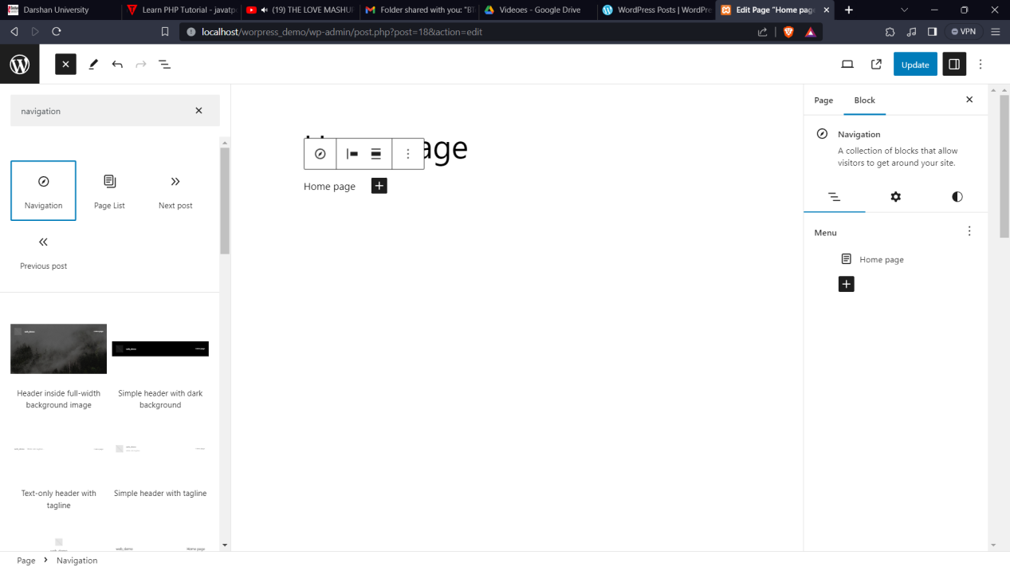

Step 5: to add new pages link in menu click on plus button in menu than select pages as you want after that click on update to apply changes. And also add this menu to all pages.

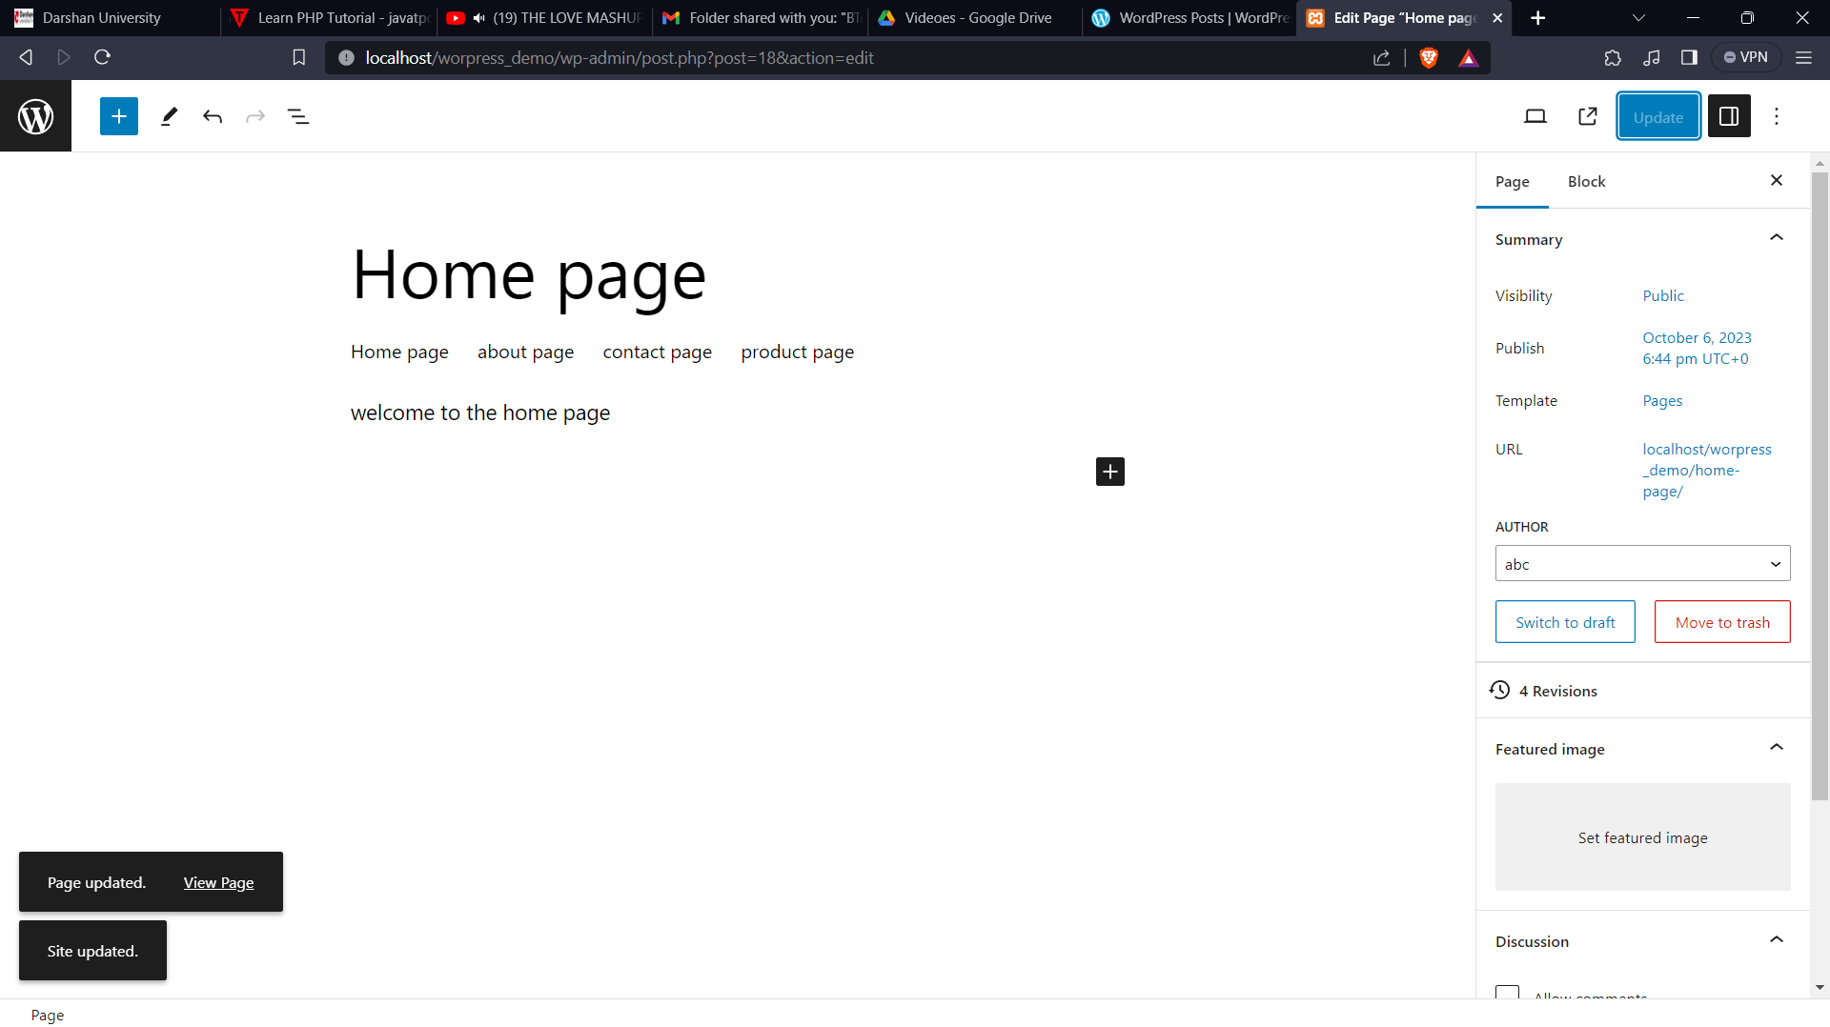

## Lab 18

## Practice various settings available in wordpress.[A]

Step 1: go to dashboard and in left side we can see settings button. Click it and there many settings availabes.

1. general settings:

* Here I have changed date format and from start there are site title, tagline, wordpress url, site url, membership new user default role , language, timezone date format and time format all this are settings which you can customize as per you want.
* In last click on save changes.

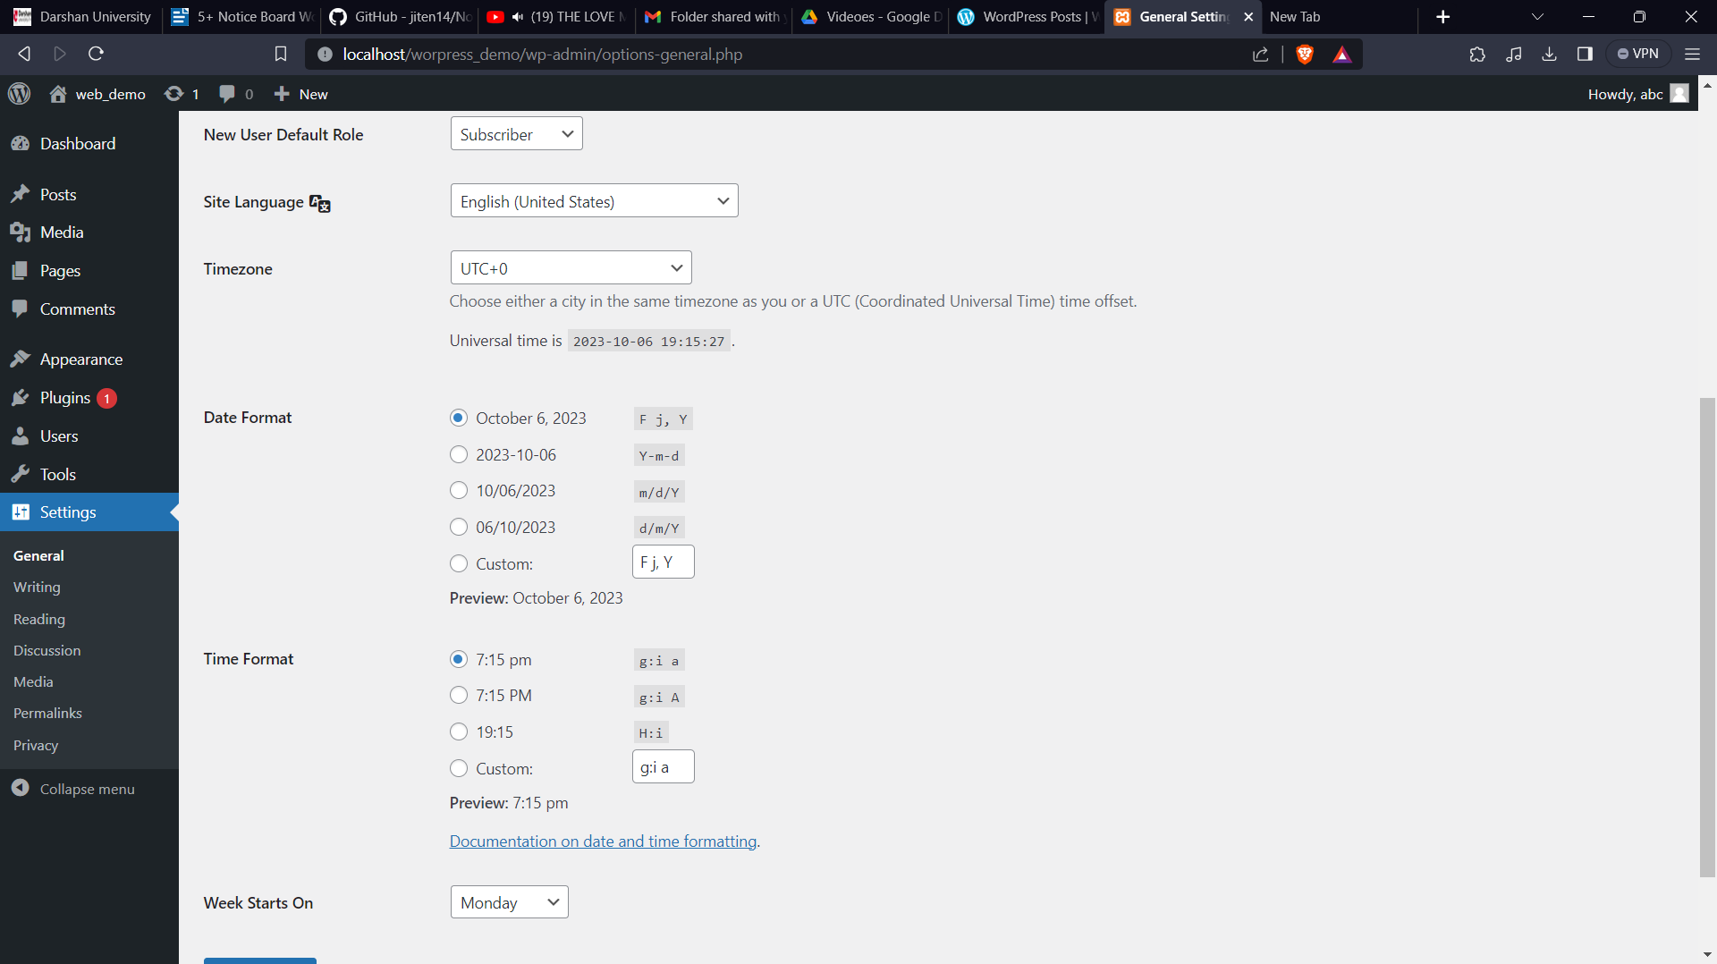

1. Writing settings:

* In second option we have writing settings. There are many settings as per screenshot.
* We can also set up a email account to post on wordpress throw email account for that enter details in that.

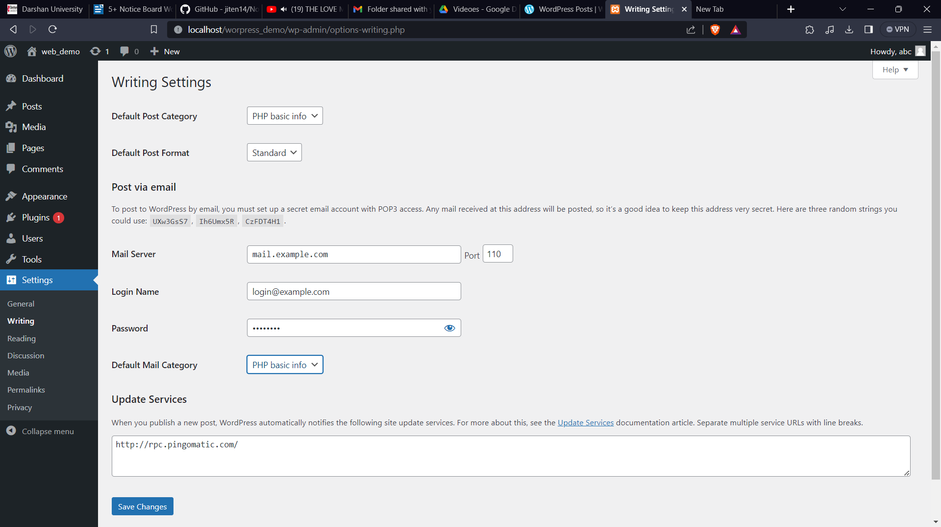

1. Reading settings:

* As per screenshot you can change settings. In last to save changes click on save changes.

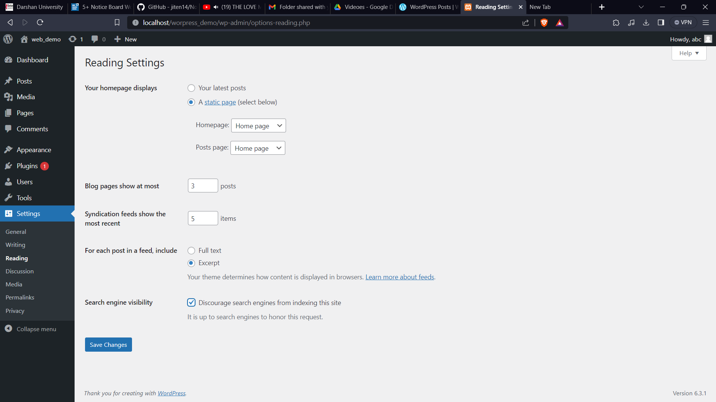

1. Media settings:

* As per screenshot you can save changes for image sizes and uploading files.

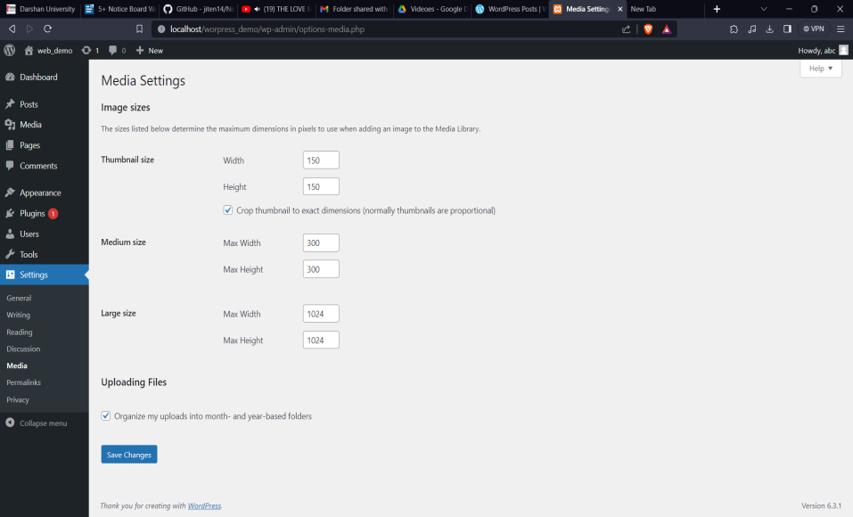

1. Permalinks settings :

* As per screenshot we can change permalink structure and customized your url also.

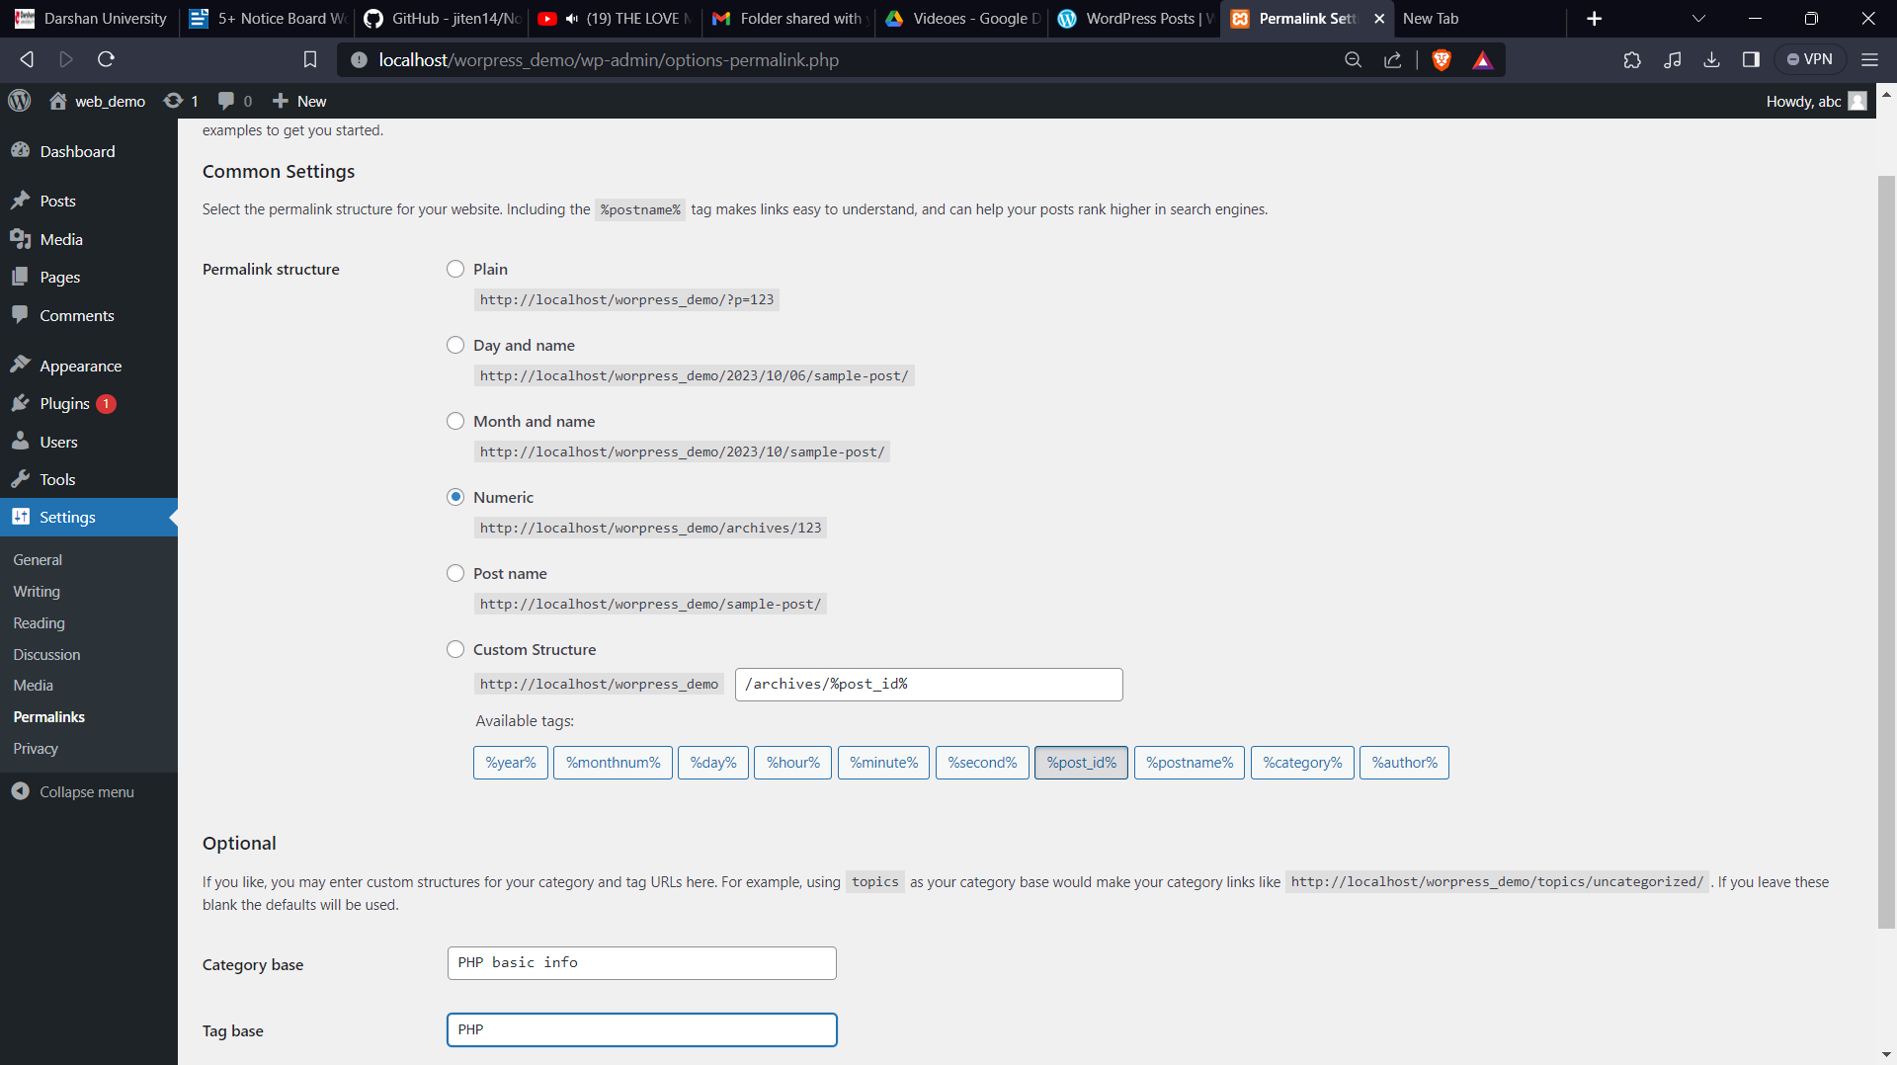

6 privacy settings:

* You can create privacy page or change to another page from here.

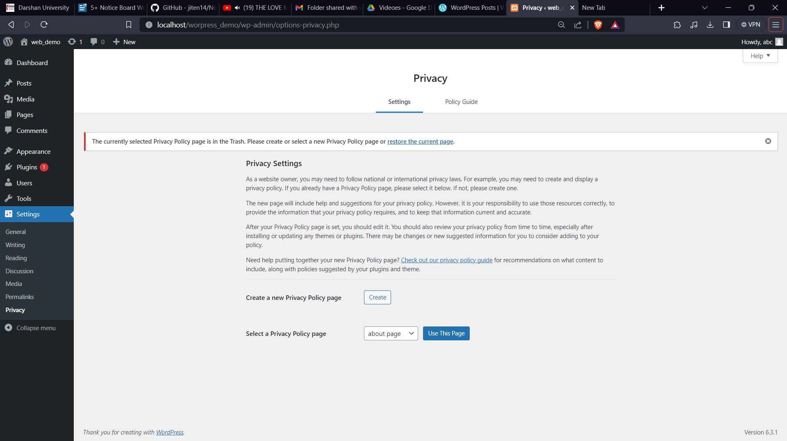

7 Discussion settings:

* As per screenshot you can adjust you comments and avtars of user

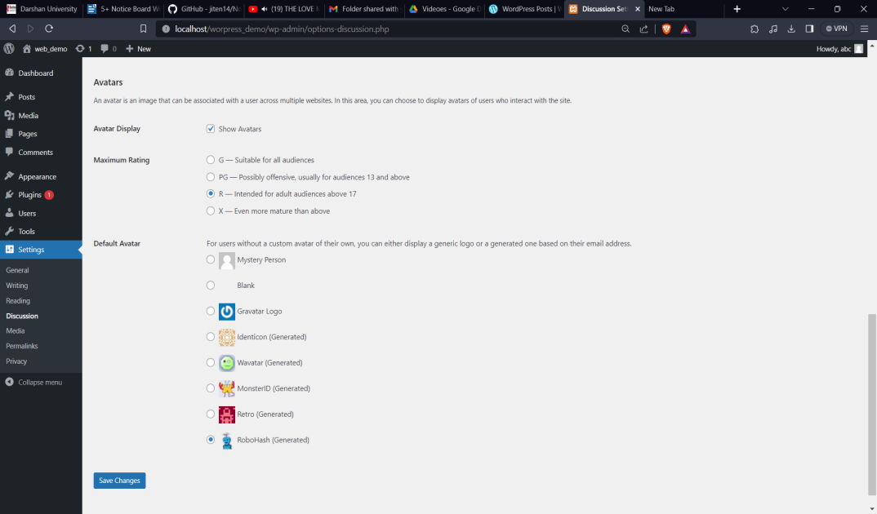

## Practice how to use various themes on wordpress.[A]

Step 1: in left side menu we can see appearance and in that we can see themes click on it, then click on add new , here we get many themes let’s use one.

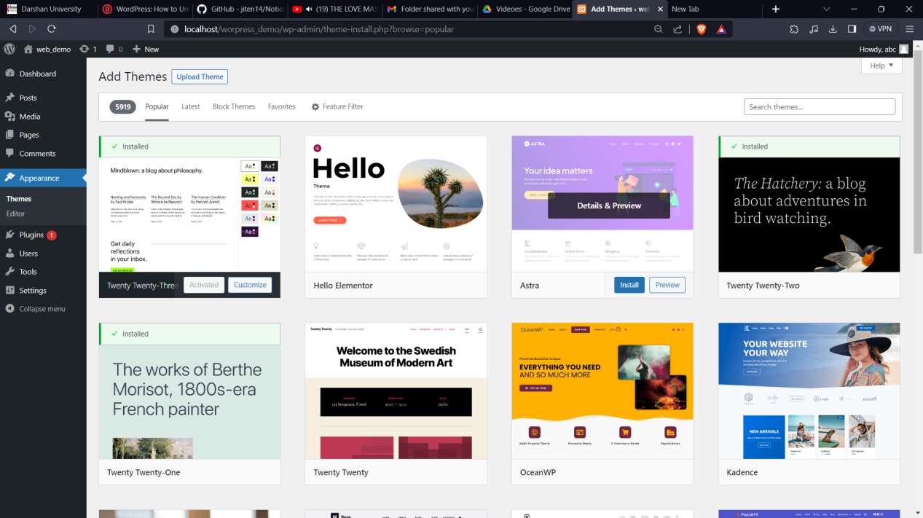

Step 2: to use theme click on install then click on activate then customize. Then you can customize as per your need.

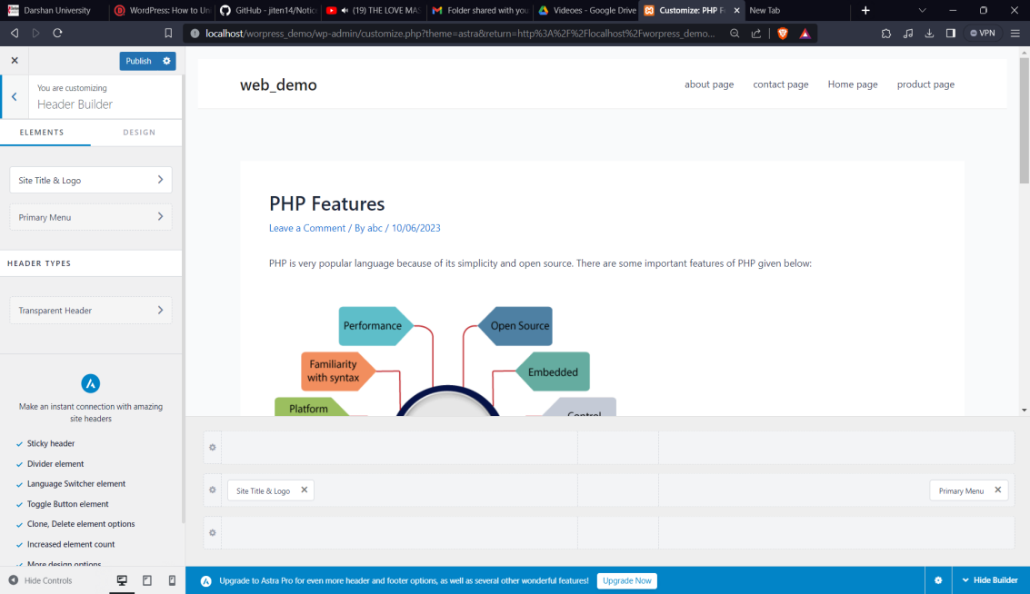

## Lab 19

## Use various plugins available in wodpress.

Step 1 : click on plugins in left side menu.then add new then we can see many plugins.

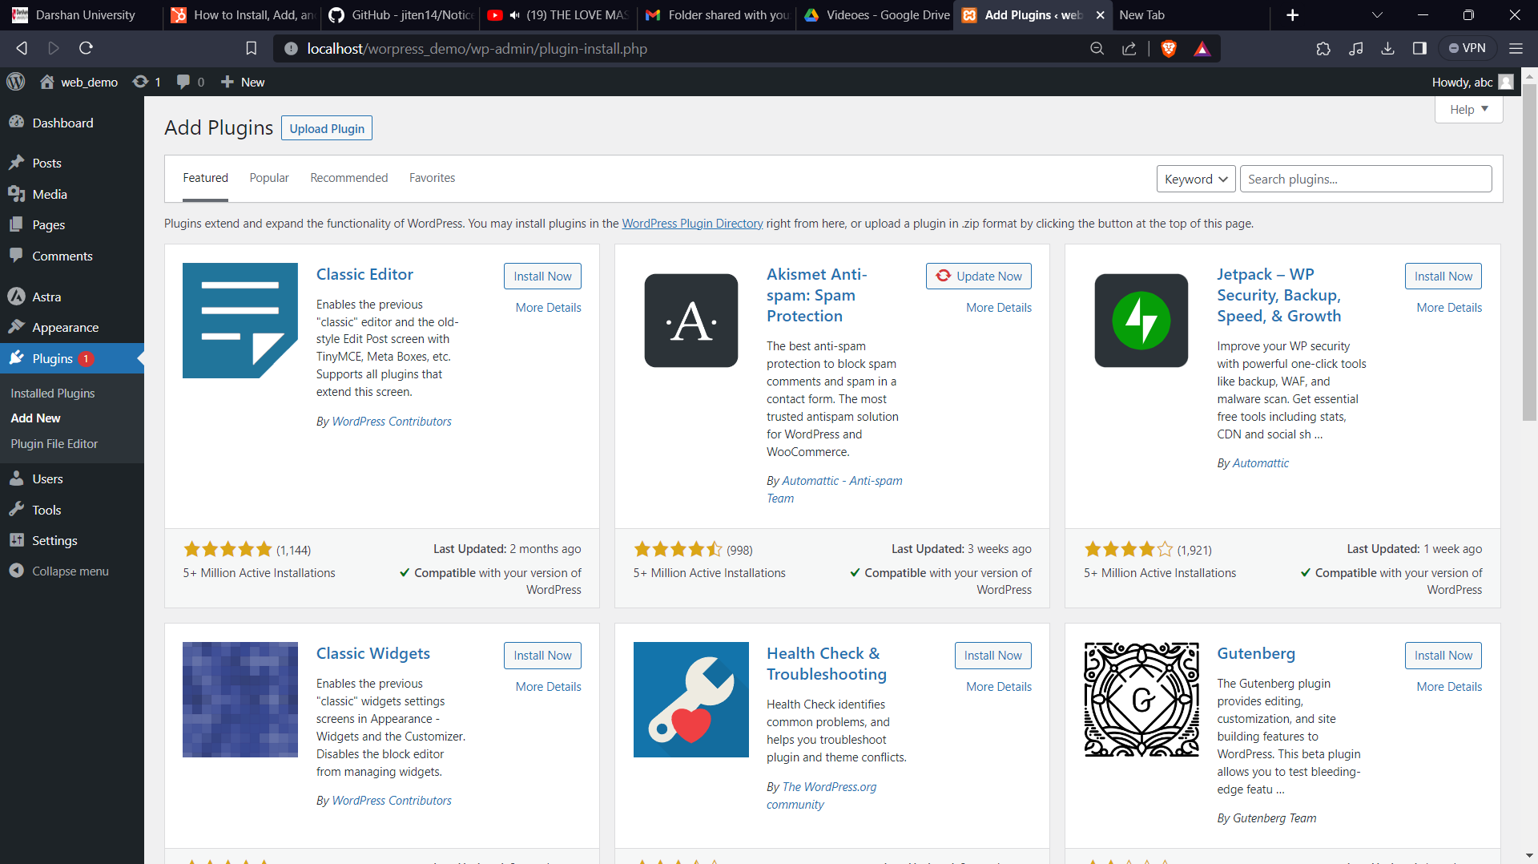

Step 2: click on install to install plugin and after that click on active to active it.from here you can is it as per your need.

