**Calculator:**

1. **Task Description**

This project is a React.js-based Simple Calculator, designed to perform basic arithmetic operations and keep a record of calculations in a user-friendly interface. The application ensures smooth functionality and provides a seamless experience for users who wish to perform operations and view their calculation history.

1. 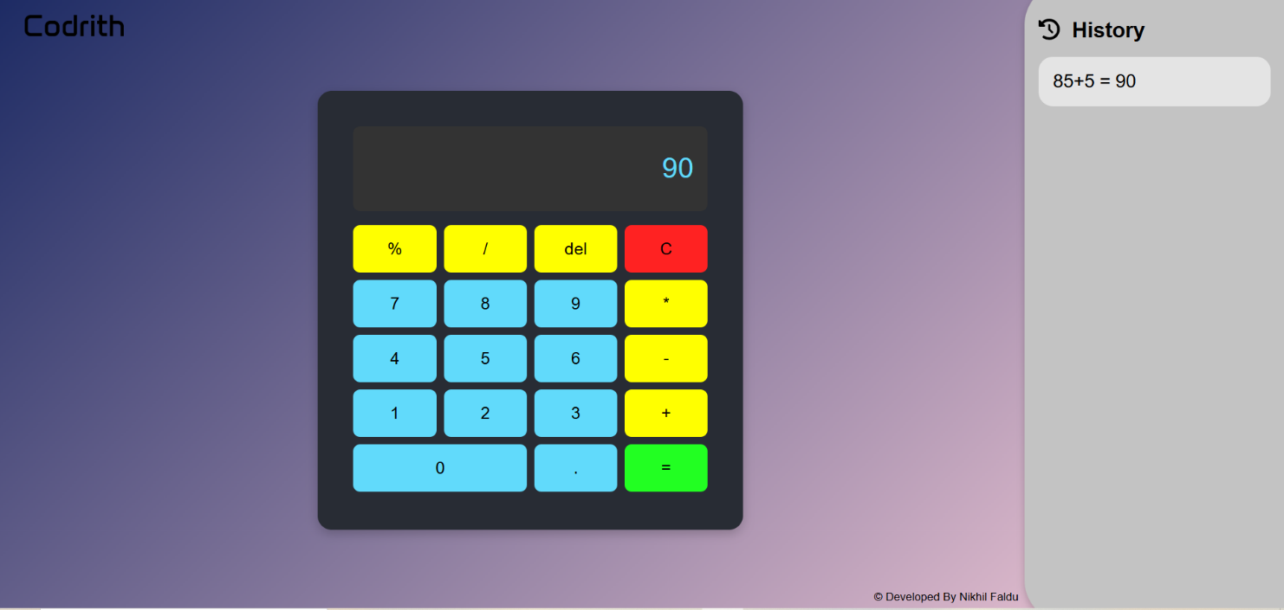**Task Output Screenshot**
2. **Widget/Algorithm Used In Task**

**Reusable Button Component (Button.js)**:

* + Encapsulates button design and functionality.
  + Props: value (text/number displayed), onClick (click handler).

**Dynamic Display (App.js)**:

* + Shows user input and calculation results.
  + Maintains state using React's useState.

**Button Grid Layout**:

* + Buttons are organized in a grid for a calculator-like UI.
* **Algorithm:**

**Input Handling**: Update input string upon button clicks.

**Result Calculation**:

* + - Evaluate input string using eval for arithmetic calculations.
    - Clear input and result on "C".
    - Handle errors (e.g., invalid input).
    - **Reusable Buttons**: Button labels and functionality are dynamically mapped.