**Chess board:**

1. **Task Description**

This project demonstrates an Interactive Chessboard built using React.js and Redux. The application highlights user interactions with the chessboard by dynamically changing square colors based on simple conditions.

1. 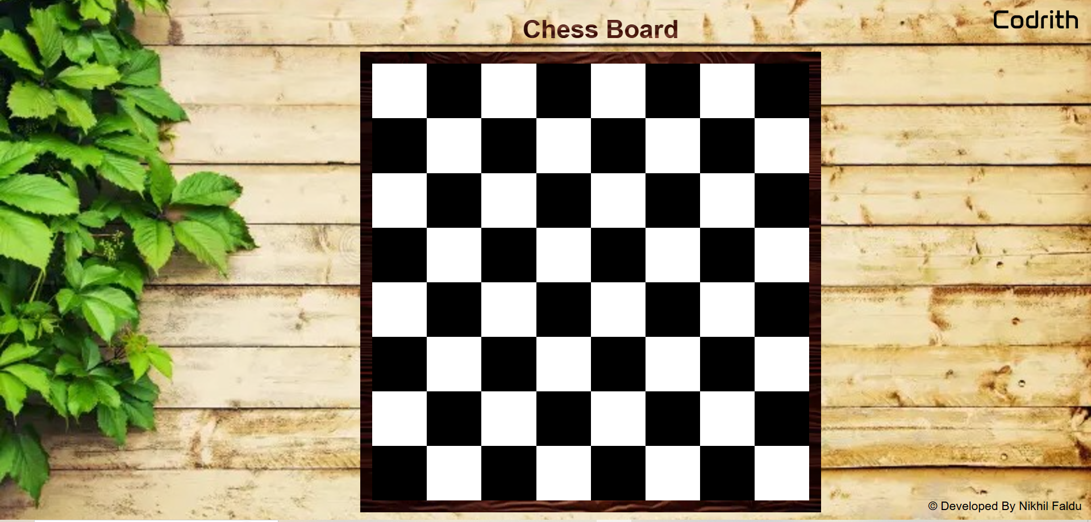**Task Output Screenshot**
2. **Widget/Algorithm Used in Task:**

**Algorithm:**

1. **State Initialization:** Initialize an 8x8 grid with alternating white and black squares.
2. **Action:** On square click, dispatch an action to change the square's color:
   * White → Yellow
   * Black → Red
3. **Reducer:** Update the color of the clicked square in the Redux store.
4. **UI Rendering:** React components (ChessBoard and ChessSquare) use useSelector to display the updated state and useDispatch to trigger color changes.

**Widgets:**

1. **ChessBoard:** Renders the 8x8 grid, mapping state to display squares.
2. **ChessSquare:** Renders individual squares and handles click events to update the color.
3. **Redux Store:** Manages and updates the board state (color of each square).