Currencies convertor:
- Task Description
This project is a Currency Converter Application built with React.js, designed to provide real-time currency conversions using up-to-date exchange rates. The app is intuitive and user-friendly, catering to anyone needing quick and accurate currency conversions.

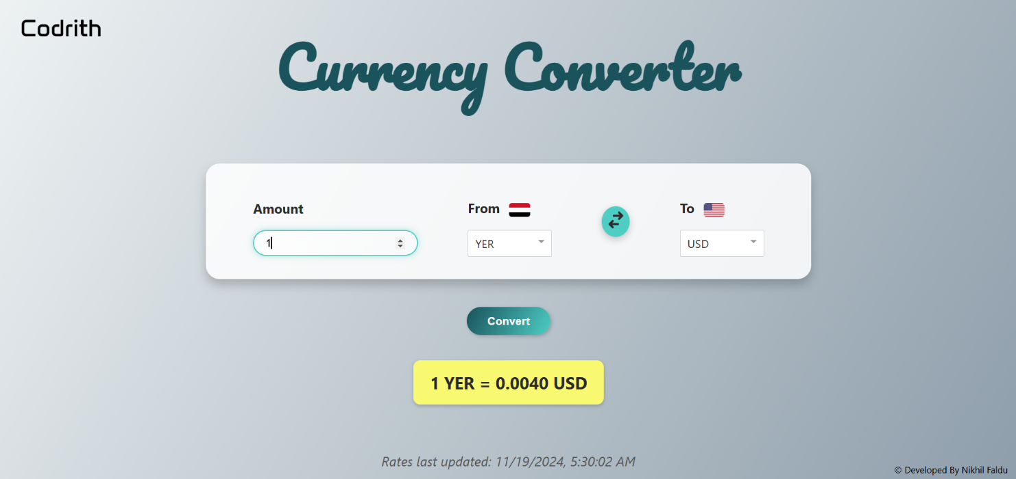
- Task Output Screenshot

- API Details

- API URL: https://api.exchangerate-api.com/v4/latest/USD
- Replace USD with the selected base currency.
- Add your API key if the service requires authentication.

Features
- Dynamic Dropdowns: The app populates currency dropdowns dynamically from the fetched API data.
- Real-Time Conversion: Converts the input amount based on the latest exchange rates.
- Responsive Design: A clean and simple design that adapts to different screen sizes.

