**OS Assignment**

Submitted by:

Nikhil Garg(18CSU141)

1. **Gross Salary**

**File Name**

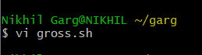

**Code-**

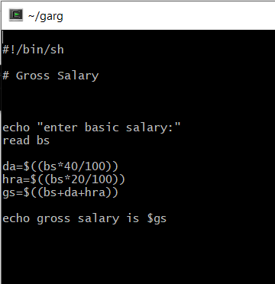

**Output-**

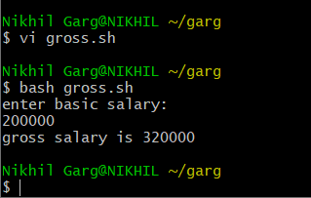

1. **Fibonacci Series**

**File Name**

C:\Users\Nikhil Garg\Desktop\cygwin\fibonacci\1.PNG

**Code-**

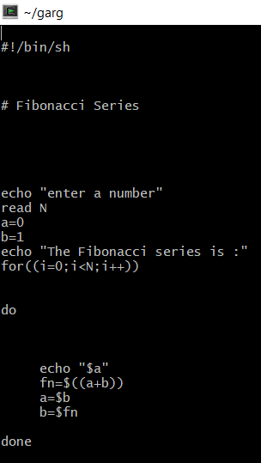

**Output-**

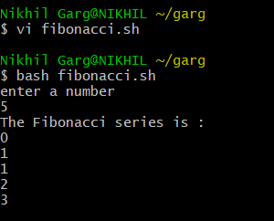

1. **Largest of 3 numbers**

**File Name**

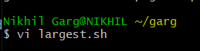

**Code-**

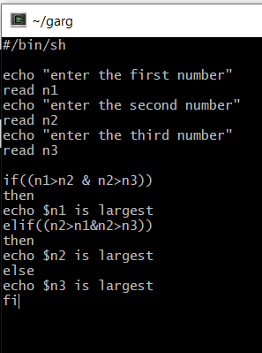

**Output-**

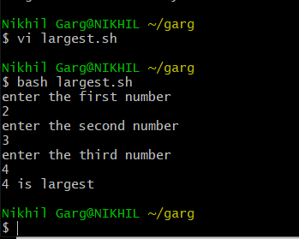

1. **Factorial Of A Number**

**File Name**

**C:\Users\Nikhil Garg\Desktop\cygwin\factorial\1.PNG**

**Code-**

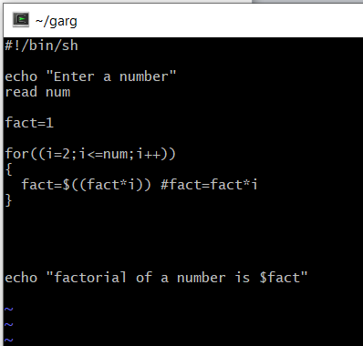

**Output-**

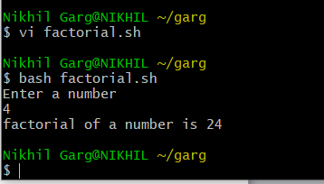

1. **Print “Hello World”**

**File Name**

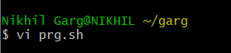

**Code-**

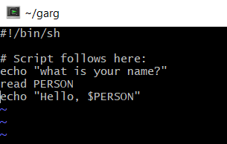

**Output-**

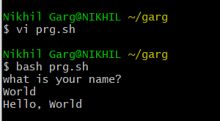

1. **Average Of Numbers**

**File Name**

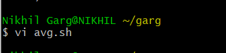

**Code-**

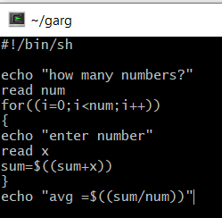

**Output-**

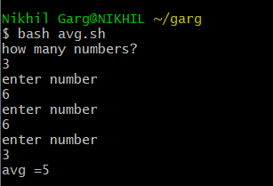

**7. Perform actions according to given menu**

Code:

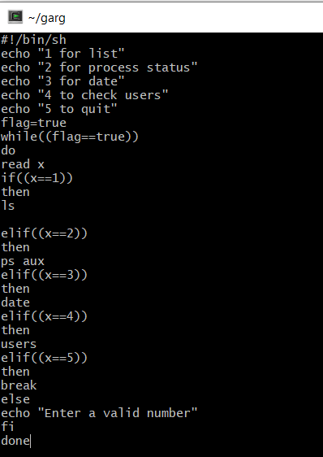

**Output –**

