Online Question Paper Generation Application
Url: https://onlinequestionpaper.gitam.edu/

Roles:
- DOE
- HOD
- FACULTY
- MODERATOR
- CONTROLLER OF EXAMINATION (COE)
- VETTING MODERATOR
- ACE

Application Flow:
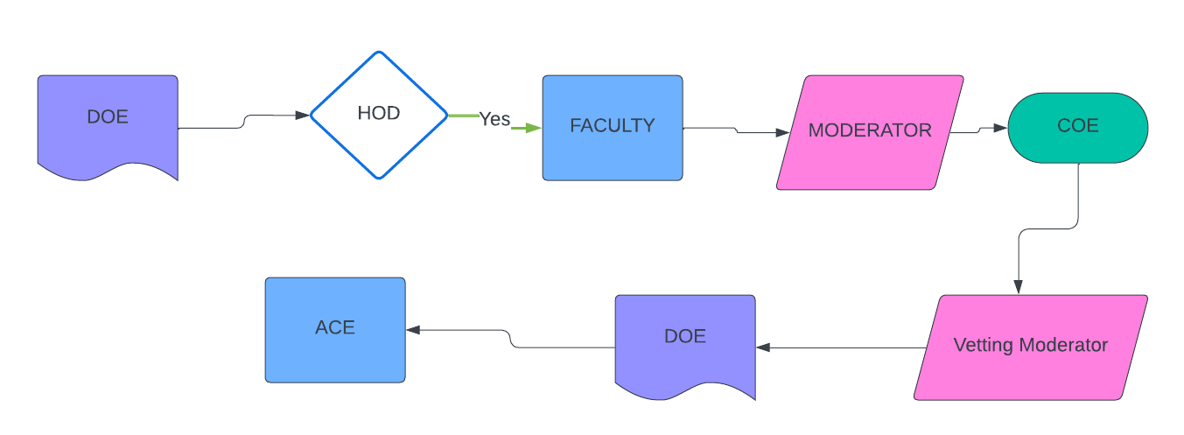

DOE
- DOE has an access to create question paper pattern as shown below:
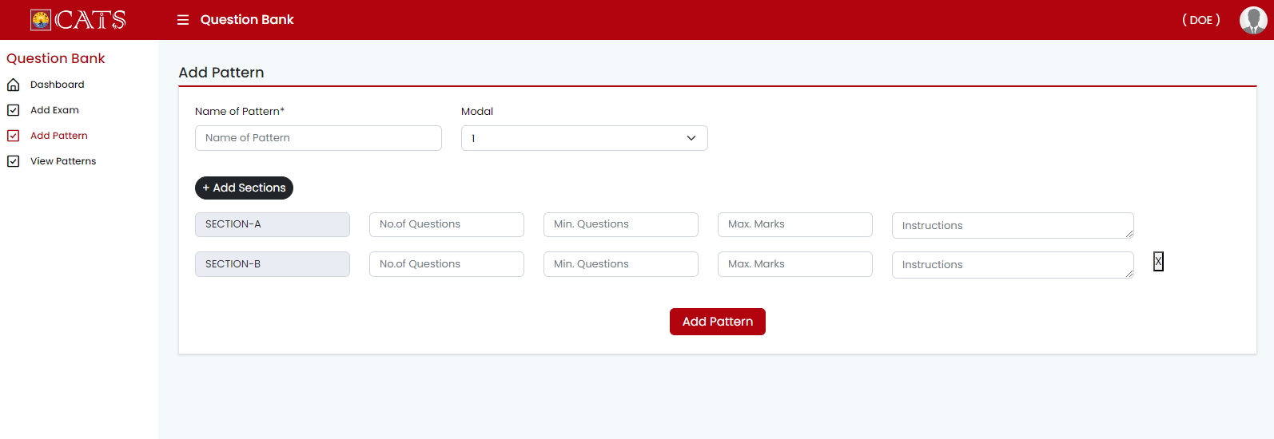
- Exam will created by selecting the pattern and forwarded to the hod as shown below:
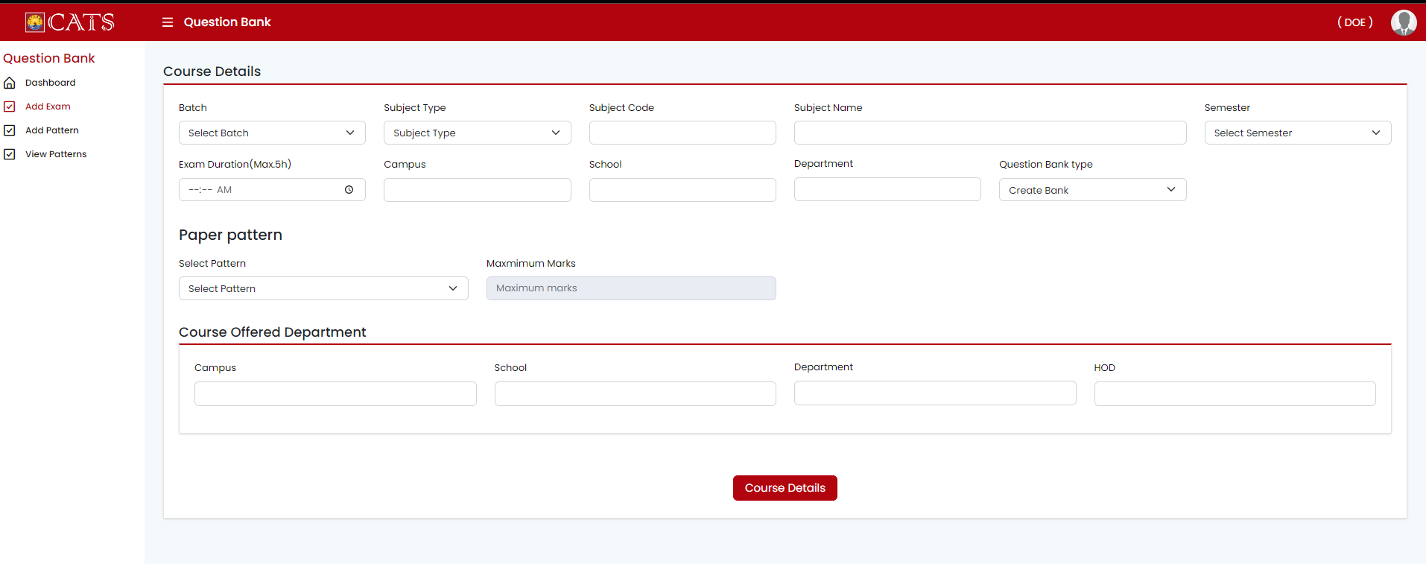
HOD:
- HOD has access to assign faculty, Moderator and Vetting Moderator based on the Exam (Subject)
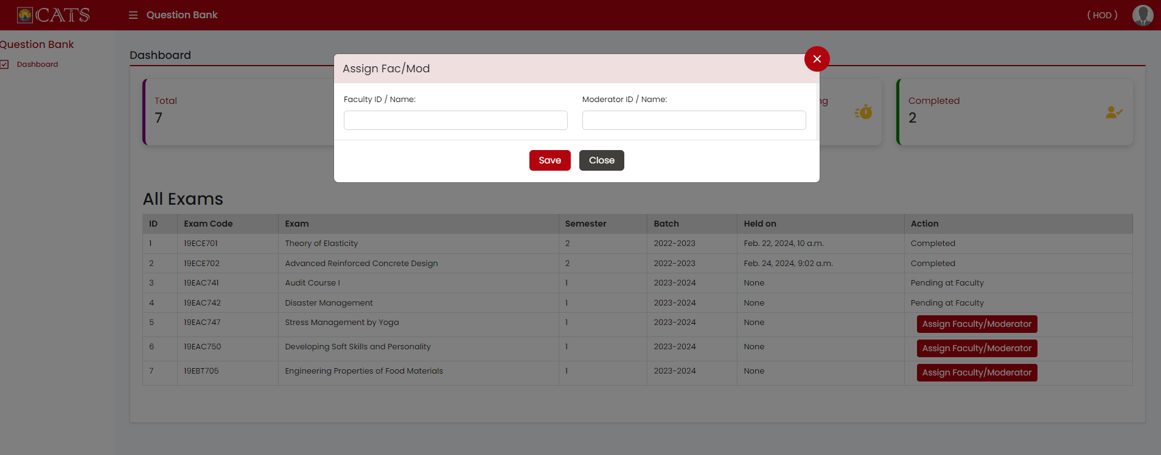

Faculty:
- Selected Faculty has an access to set question bank by adding questions as per pattern.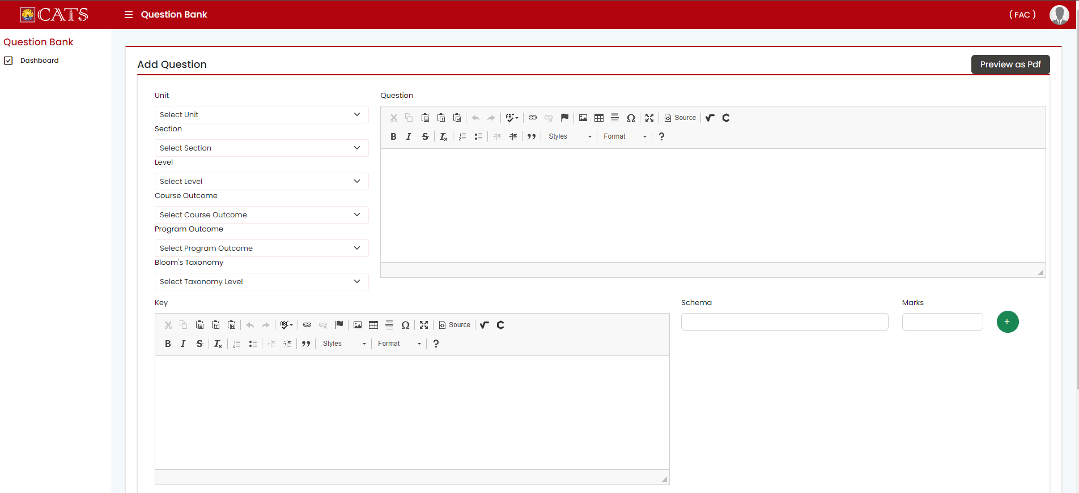
MODERATOR:
1.Moderator has an access to make changes in the question bank which was created by faculty.
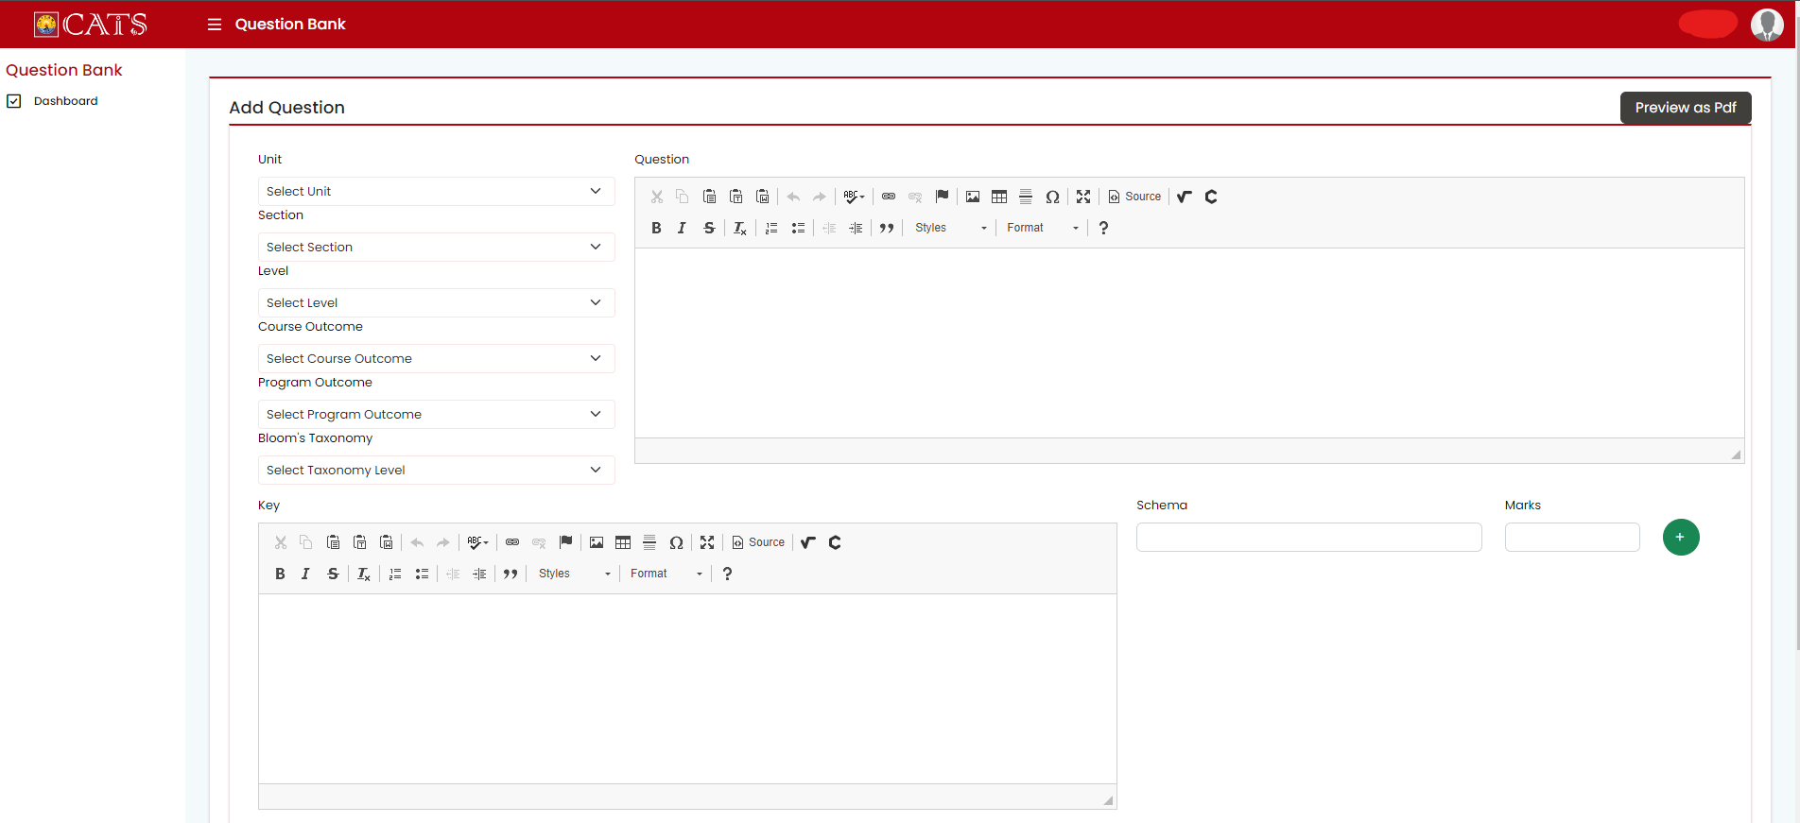

COE:
- COE will generate number of sets, paper Hardness of Exam from the question bank
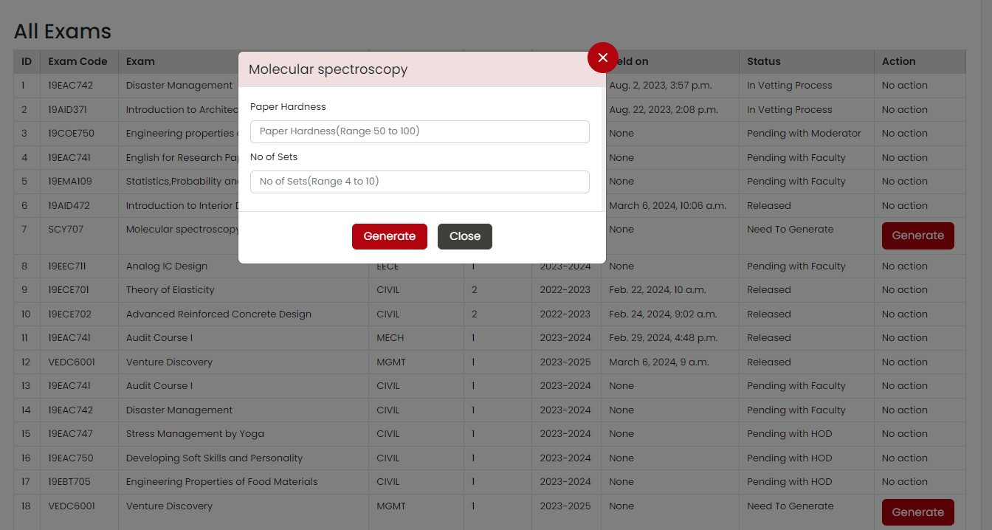

Vetting Moderator:
- Vetting Moderator has an access to edit the generated set of question papers
- The next step will be forwarded to DOE as shown in flow chart above and DOE will confirm the Exam Date.

ACE:
ACE will download the question papers one hour or two hours before the Exam.

