**CHANDIGARH COLLEGE OF ENGINEERING AND TECHNOLOGY (DEGREE WING)**

Government Institute under Chandigarh (UT) Administration | Affiliated to Panjab University , Chandigarh

Sector-26, Chandigarh. PIN-160019 | Tel. No. 0172-2750947, 2750943 Website: [www.ccet.ac.in](http://www.ccet.ac.in/) | Email: [principal@ccet.ac.in](mailto:principal@ccet.ac.in) | Fax. No**. :**0172-2750872

**Department of Computer Sc. & Engineering**

**CANDIDATE’S DECLARATION**

I hereby declare that the work presented in this report entitled “Industrial Training in Machine Learning”, in fulfillment of the requirement for the award of the degree Bachelor of Engineering in Computer Science & Engineering, submitted in CSE Department, Chandigarh College of Engineering & Technology(Degree wing) affiliated to Punjab University, Chandigarh, is an authentic record of my/our own work carried out during my degree under the guidance of < Dr. Ankit Gupta >. The work reported in this has not been submitted by me for award of any other degree or diploma.

Date:30/07/20 <Nikhil Anand>

Place: Chandigarh <Roll no. C017342>

**CHANDIGARH COLLEGE OF ENGINEERING AND TECHNOLOGY (DEGREE WING)**

Government Institute under Chandigarh (UT) Administration | Affiliated to Panjab University , Chandigarh

Sector-26, Chandigarh. PIN-160019 | Tel. No. 0172-2750947, 2750943 Website: [www.ccet.ac.in](http://www.ccet.ac.in/) | Email: [principal@ccet.ac.in](mailto:principal@ccet.ac.in) | Fax. No**. :**0172-2750872

**Department of Computer Sc. & Engineering**

**CERTIFICATE**

This is to certify that the Project work entitled “Calculator app.” submitted by <Nikhil Anand and roll no. C017342 > fulfillment for the requirements of the award of Bachelor of Engineering Degree in Computer Science & Engineering at Chandigarh College of Engineering and Technology (Degree Wing), Chandigarh is an authentic work carried out by him/her under my supervision and guidance.

To the best of my knowledge, the matter embodied in the project has not been submitted to any other University / Institute for the award of any Degree .

Date :30/07/20 <AP- Dr. Ankit Gupta> Place :Chandigarh <Deptt. of CSE>

<CCET(Degree Wing)>

< Chandigarh>

**CHANDIGARH COLLEGE OF ENGINEERING AND TECHNOLOGY (DEGREE WING)**

Government Institute under Chandigarh (UT) Administration | Affiliated to Panjab University , Chandigarh

Sector-26, Chandigarh. PIN-160019 | Tel. No. 0172-2750947, 2750943 Website: [www.ccet.ac.in](http://www.ccet.ac.in/) | Email: [principal@ccet.ac.in](mailto:principal@ccet.ac.in) | Fax. No**. :**0172-2750872

**Department of Computer Sc. & Engineering**

**ACKNOWLEDGEMENT**

The completion of this project could have been possible with continued and dedicated efforts and guidance of faculty and staff members of our institute . I acknowledge my gratitude to all of them . The acknowledgement would however be incomplete without specific mention as follows.

I wish my deep gratitude to Dr. Ankit Gupta , faculty member of our institute for his cooperation and guidance and providing me with necessary advices throughout the training period without which completion of this training could not have been possible.I choose this moment to acknowledge his contribution gratefully. Furthermore , I would also like to acknowledge with much appreciation the crucial role of our HOD. Prof. Dr. Sunil K Singh for this encouragement and providing all these facilities in the department .

This report has been prepared for the internship that has been done on Coursera , an online portal for industrial training in order to study pratical aspect of the course and implement the theory in real life . The aim of this internship is to be familiar to pratical aspect and uses of theoretical knowledge and clarifying the career goals, so I have successfully completed the internship and compiled this report as the summary and the conclusion that have been drawn from the internship experience.

Finally, I would like to say that I am indebted to my parents and teachers for everything they have done for me and without their guidance and their support I have been able to complete the training . And also I would like to thank God for being kind to me and driving me through this journey.

Nikhil Anand

**CHANDIGARH COLLEGE OF ENGINEERING AND TECHNOLOGY (DEGREE WING)**

Government Institute under Chandigarh (UT) Administration | Affiliated to Panjab University , Chandigarh

Sector-26, Chandigarh. PIN-160019 | Tel.

No. 0172-2750947, 2750943 Website:

[www.ccet.ac.in |](http://www.ccet.ac.in/) Email: [principal@ccet.ac.in |](mailto:principal@ccet.ac.in) Fax. No**. :**0172-2750872

**Department of Computer Sc. & Engineering**

**ABSTRACT**

Industrial training is an important phase of a student life. A well planned, properly executed and evaluated industrial training helps a lot in developing a professional attitude. It develop an awareness of industrial approach to problem solving, based on a broad understanding of process and mode of operation of organization. The aim and motivation of this industrial training is to receive discipline, skills, teamwork and technical knowledge through a proper training environment, which will help me, as a student in the field of Computer Science, to develop a responsiveness of the self-disciplinary nature of problems in information and communication technology. During a period of three months training at coursera , I was assigned to creating an efficient Calculator app in java which can help us to perform basic arithmetic operation such as addition ,multiplication, subtraction and division even in decimal numbers that can save our calculation error and provide us with precise answers and also save our time. As a result I vital to achieve the minimum requirement of the company, it will help me to boost my career as developer in java programming language.This report also contains basic theory of Machine Learning and also its history and some basic knowledge about the software which was used to design the project i.e Jupyter . and futher all this information is provided in form of chapters .

Throughout this industrial training, I have been learned new programming language that required for the creation of web application,embedded system, desktop GUI(graphical user interface), the process of the production lines and able to implement what I have learnt for the four weeks that can to put my contribution towards our technological growth of our society.

**CERTIFICATE OF COMPLETION**

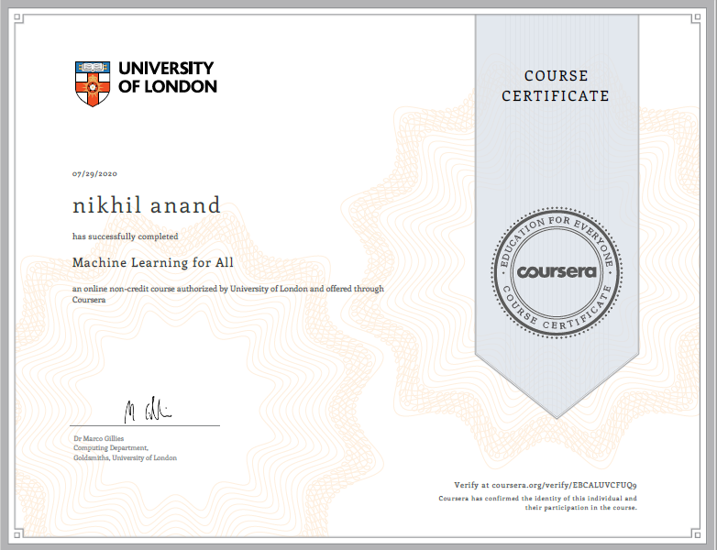

**LIST OF FIGURES:**

FIGURE 1………………………04

FIGURE 2……………………....06

FIGURE 3……………………….07

FIGURE 4……………………….09

FIGURE 5… 10

FIGURE 6………………………11

FIGURE 7……………………….11

FIGURE 8………………………..13