**ABORTING MESSAGE IN HIE**

* NOTE: before Aborting make sure that it is a message issue.

Here is an example of PatientSummaryGetNsmgCcdFromUnity **Interface** which is down in HMT.



Copy the interface name and click on ACCESS01 Namespace.

As you can see in above screenshot press CRTL F and CRTL V so the copied interface name get pasted in search field and we can se PatientSummaryGetNsmgCcdFromUnity click on Interface.

After clicking on Interface, you can see side bar showing Settings, Queue, Log, Messages, Jobs and Actions.

Click on Queue and then click on Go To Queues.



As you can see in above screenshot the messages appear on right side Queue Contents table.

Click on the first message as you can see the blue highlight in above screenshot.



After clicking on the first message the task bar appears on right side which consists of Header, Body, Contents, Trace.

Click on Trace.



Click on View Full Trace.



Now copy the URL of Visual Trace page (Use CRTL A for copying the URL because we must make sure that overall URL get copied)



The copied URL of Visual Trace Page is Session ID.

<https://hsagprod01.nshs.edu/csp/healthshare/access01/EnsPortal.VisualTrace.zen?SESSIONID=26612296424>

Now attach the copied Session ID in Mail to HIE team Aman Rana or Vignesh

NOTE : Email needs to be sent before end of the shift

Now you can Abort the message by going back to Queue Contents table and click on the message and then click on Abort.

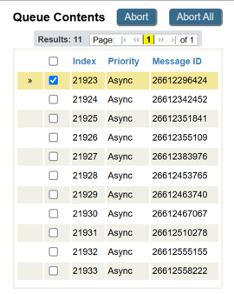

Beta testing SOP will be updated regularly.