**Check points after IBE server reboot**

1. When logging into https://cgeopibepmon01v:8444/rhapsody/login/ViewLogin.action, make sure to check the server name, below mentioned server should be the primary one.



If this is not showing up as the primary, stop the HealthCheck Http communication point on other two servers which is SYKPIBEINTDB02V (backup) and SWBZIBEINTDB01V (DR), keep this enabled on SYKPIBEINTDB01V until the data is live on primary.

Once the data is live on primary, enable HealthCheck HTTP Server communication point on the backup and DR node as well.



If the data is not live for ECM or messages are getting queued up, reach out to Telehealth Delivery Services to restart the connections at Orion.

After this, login to SYKPIBEHIF01V and SYKPIBEHIF02V, check for services Philips HIF service and Rhapsody service, check if those are running on DR node.

If they are running on DR node (SWBZIBEHIF01V, SWBZIBEHIF02V), contact DBA Team and have them do the failover to the primary HIF servers which are SYKPIBEHIF01V and SYKPIBEHIF02V

Also verify below HIF connections should be running on primary server.

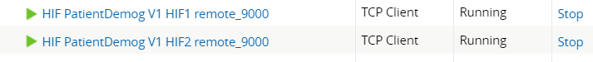

**For IBE server reboots:**

**For Non-PROD Servers:**

1. **Create a RITM Request:**
   * Assign it to Database Services.
2. **Send an Email:**
   * Contact the DBA team to inquire about resource availability.

**For PROD Servers:**

1. **Create a CHG Ticket:**
   * Complete the schedule and Risk Assessment sections.
   * Request the necessary approvals.
2. **Send an Email:**
   * Contact the DBA team.
   * CC the following teams:
     + Telehealth Delivery Services
     + SCM Tech
     + SCM Capsule Team