Capsule: provides the status of DDIS (Monitors) in hospital.

Elink; Provides patient records

Log in to Capsule server:

RDP to server and log in with Northwell Creds à Click on Smart Linx Control Center

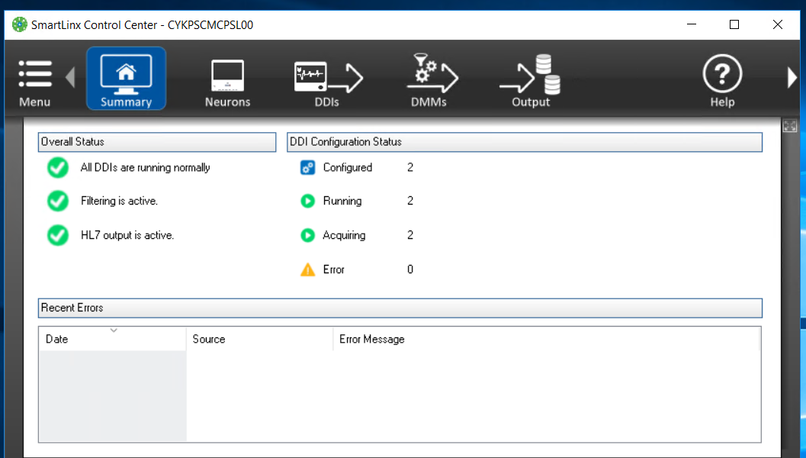

Summary tells us the current status of system in short.

Click on DDIS

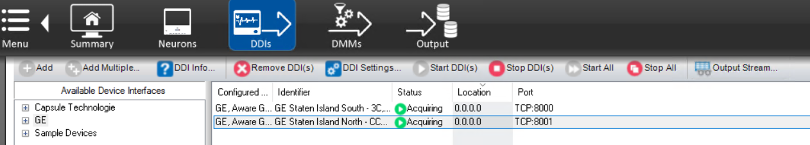

Click on any DDI to select

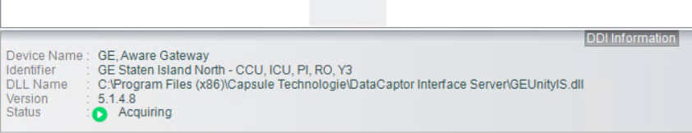

It will show the full name and current status of DDIs

If the status is stopped à Click on Start DDIS  for single DDI

and for multiple -- 

and for restart à for single  and for multiple  and then start ..

Elink : (always log in to load balancer)

MonDev Elink (Load Balancer: SCMLBELNKP04): sends capsule messages

1. SYKPSCMELNK4n5v

2. SYKPSCMELNK4n6v

3. SWBPSCMELNK4n5v

4. SWBPSCMELNK4n6v

Non- MonDev (Load Balancer: SCMLBELNKP44): pharmacy charges, immunisation messages, sindrome messages >> we handle only this as per satyam in elink overview vdo

(satyam is not with us now.. linu thomas is the point of conatct)

1. SYKPSCMELNK4n7v

2. SYKPSCMELNK4n8v

3. SWBSSCMELNK4n7v

4. SWBSSCMELNK4n8v

Log in to server – Mondev

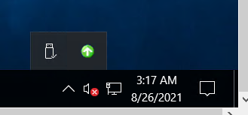

Click on green ball where arrow is on upward side

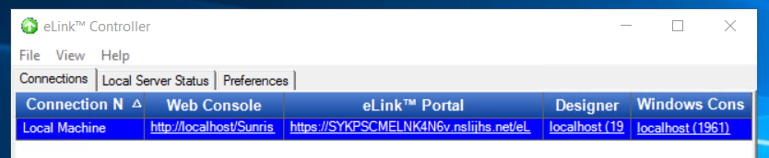

Click on Local host in windows console.

Log in to server with northwell creds.

Check for both translators are in running state.

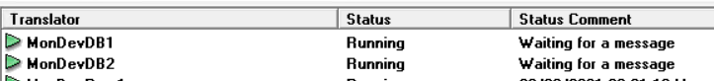

Click on any queue either DBQ1 or DBQ2

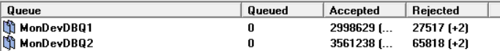

Search for the bed unit

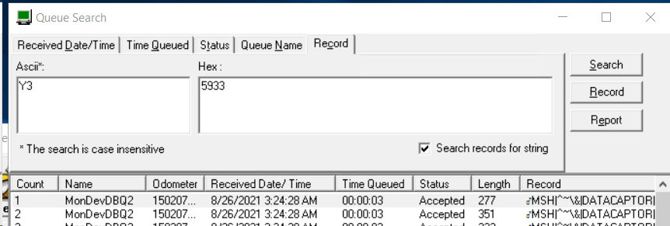

Log in to server – Non - Mondev

Check for the translator are in running state.

And if not then send an mail to Linu Thomas.

Alerts:

Capsule – Elink

Alert name: SCM - PROD - Capsule Bedside Nursing Unit/Bed Is Not Transmitting

Step 1:

Confirm the server to log in by locating SITE and bed unit. Use below link.

<https://confluence.northwell.edu/pages/viewpage.action?spaceKey=IS&title=45+-+Server+Repository>

Step 2: Log in to Server:

Check if the DDIs are in acquiring state. And take their screenshot.

If DDIs in not in acquiring then stop and start it, if it gets up gets up then no issue and If not then create P2 to SCM change operation and mention the DDIs and name of server.

Step 3: Log in to Mondev - SCMLBELNKP04

Search patient record for the bed unit and confirm the bed unit and site in OBR segment of message as per the alert.

**OBR|||||||**20210826032300**|||**SICU**^**11A**|||**GE Staten Island North - CCU, ICU, PI, RO, Y3

Step 4. Send mail with the screenshot of DDIs and patient record

Non mondev alerts –

1. Translator ClnMgrIMMSend's status has changed to "Failure". Or .Translator NYCVXUPrep's status has changed to "Stopped".

If translator is in running state then reply on mail with screenshot,

And if the translator is not in running state, then try to do start and stop. If the translator gets up then

2. The threshold for eLink messages older than 24 hours is exceeded.

log in to SCMLBELNKP44

check

ImmTransportACKQ

ImmTransportErrQ

ImmTransportQ

queues should be zero

send mail mentioning all queues are drained and nothing pending.