1 Intro

Intersystem à Ensemble – HL7 and file and Sftp interface

Hie – health share information Exchange – XML, json

Architecture

3 parts

Services – sources --- starts with From

Processes – data processing and data route destination -- ends with rtr

Operation – destination – starts with To

------------------------------------------------------------------------------------------------------------------------------------------

2.

Environment –

Prod- production

stage replica of prod

Non-prod – Dev and QA

Namespace and sites

ENS – 3 PROD SERVERS

SERVER à NAMESPACE-> INTERFACE

HOW TO ACCESS INTERFACE

SERVER – ENSEMBLE – NAMESPACE- ENSEMBLE – CONFIGURE – PRODCUTION

\*How to classify the server ensemble or health share – hie

Ensemble server starts with ENS ENSPROD01, ENSPROD02, ENSPROD03

Healthshare server starts with HS HSAGPRO01, HSAGPRO02,

SITE DISTRIBUTION

Number of sites combined in one namespace

Number of namespaces into one server

-----------------------------------------------------------------------------------------------------------------------------------------

Interface syntax

Source ya destination à Site à Application à message typeà connection type

FromNsuhInvitionAdtTcp

Source – From site – Nsuh Application – Invision msg – Adt conn - Tcp

ToScmNsuhInvisionAdtTcp

Destination – ToScm site – Nsuh Application – Invision msg – Adt conn - Top

Restart interface – double click

Either click on enable or restart

Connection details

Click on connection à settings à Basic settings – IP address and port number

1. GREEN -- Interface is in running state
2. GREY -- Interface is down
3. RED - Interface is in error state

Reasons of disconnection –

Connection issue:

1. Connection timeout
2. Lost TCP connection
3. ErrOutConnectionLost: Lost HL7 Read connection to
4. ErrOutConnectExpired TCP Connect timeout period (5) expired
5. Request to server on port number denied

Message issue:

1. Message Error – Negative Ack – AE
2. Invalid Segment in msg

Logs -- Shows the reason for disconnection

QUEUE – shows pending and not processing data

Message- shows delivered or skipped message

Troubleshooting in Ensemble:

1. troubleshooting the interfaces from IOS report
2. User requested interface troubleshooting.

Troubleshooting the interfaces from IOS report:

Connection issue -

1. Copy the server's name from Ip address Either go to bookmarks or go to SMP (cross verify J2ops name in SMP and Server name in IOS)

2. Locate the interface in namespace

3. try to restart. If interface turns green and queues drain, then all good or else

4. check logs – find out if it is a message issue or connectivity issue.

Connection issue:

1. Connection timeout
2. Lost TCP connection
3. ErrOutConnectionLost: Lost HL7 Read connection to
4. ErrOutConnectExpired TCP Connect timeout period (5) expired
5. Request to server on port number denied

Connectivity issue – check the interface details in IACL

Create a ticket asking destination to restart the connection from their end.

Mention interface details like interface name: port number: IP address;

Message issue -

1. Copy the server's name from Ip address Either go to bookmarks or go to SMP (cross verify J2ops name in SMP and Server name in IOS)

2. Locate the interface in namespace

3. try to restart. If interface turns green and queues drain, then all good or else

4. check logs – find out if it is a message issue or connectivity issue.

Message issue:

1. Invalid or unrecognized Segment in msg
2. Message Error – Negative Ack – AE

Invalid or unrecognized Segment in msg:

* + - 1. Select the interface and check the logs.
      2. Confirm the error with Invalid or unrecognized Segment in Message.
      3. Go to queues à select the message on top and confirm the error in content as well.
      4. Skip the message

Message issue: Click on interface --> go to queues --> select the message and click on abort on the top.

1. Message in Service (From)-- create ticket and contact to source.

2. Message in Process (Rtr)-- create ticket and contact to source.

3. Message in Operation (To)-- create ticket and contact to destination.

Acknowledgment Error – AE

1. Check error in logs and confirm if the interface is down because of ‘AE’

2. Go to message viewer.

3. select the message and click on Trace as shown below and click on view full trace.

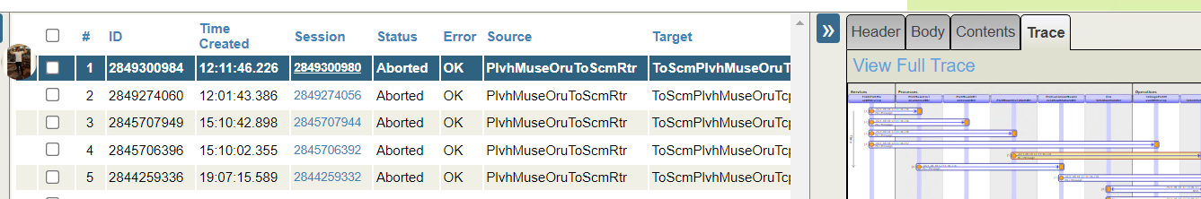

4. select reapply filter to corresponding.

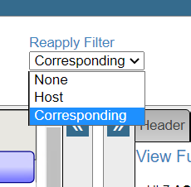

5.Click on numbers in Operation IO as shown below.

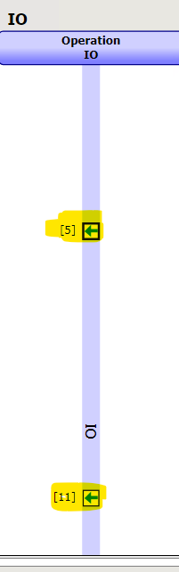

6. confirm the port number by clicking on Header and then in source as shown below. Port is highlighted

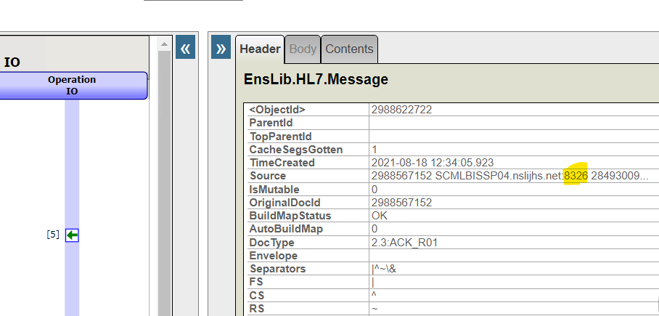

7. Check the content of Ack

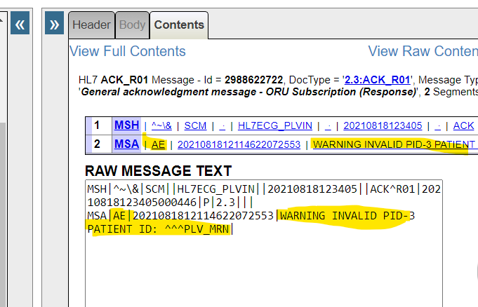

* \*User requested interface troubleshooting.

Ask for this thing --

Source or destination à Site à Application à message type --> connection type

Or port number

Handshake

step 1. find the interface

check the port number and find connecting interface by port number or by interface in IACL

step 2. Disabling the interface

disable the connecting interface first and then the previous one

step 3. Enable the interfaces

Enable the previous one first then the connecting one.

Troubleshooting in HIE:

1. Copy the server's name from Ip address Either go to bookmarks or go to SMP (cross verify J2ops name in SMP and Server name in IOS)

2. Locate the interface in namespace

3. try to restart. If interface turns green and queues drain, then all good or else

4. check logs.

5. Abort one message and restart the interface. - If the interface gets up then create P3 ticket and assign to Glenn and send mail as well.

6. if the interface didn’t get up even after aborting one message, then call the on-call person, create a P2 and assign to on call, send mail.

Monmgr Alerts. :

Follow the SOP given in Link - https://confluence.northwell.edu/display/IS/Monmgr+Alerts