**Ensemble SOP and FAQ’s**

**Introduction**:

Ensemble is designed to integrate and manage data from multiple sources to streamline healthcare operations. It is an environment where interfaces are deployed and process as they are programmed in different ensemble servers.

**Architecture:**

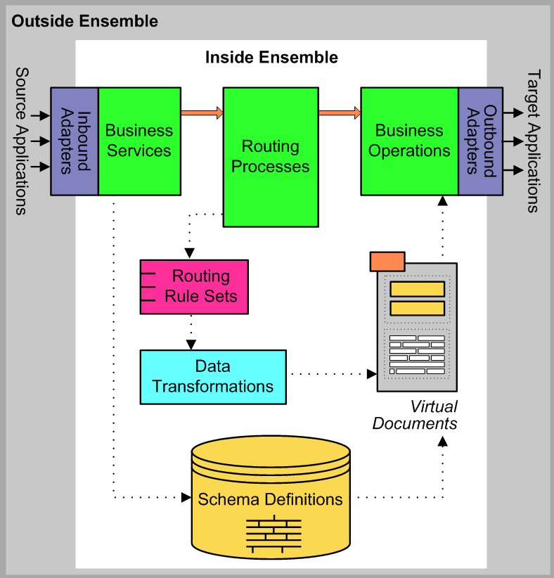

**Overview of architecture:**

Ensemble production system consists of business services, processes, and operations. The interfaces are deployed in this environment, the data

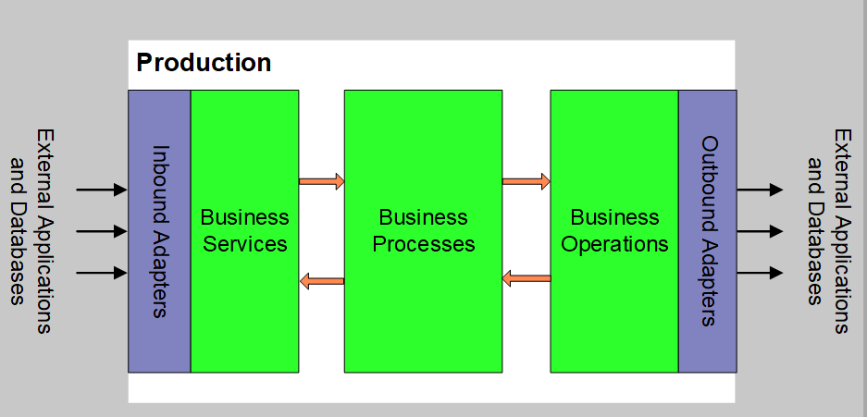

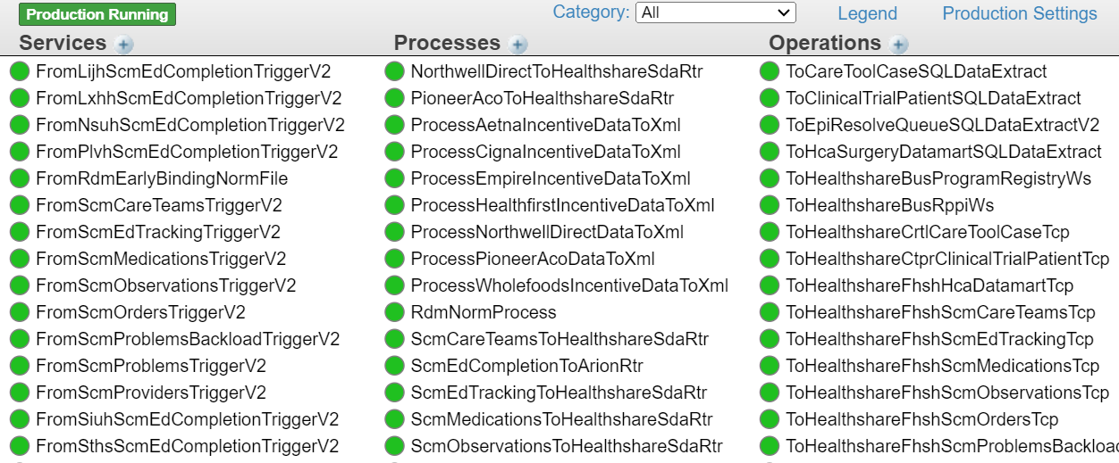

**Services** –> Source -- starts with **From** (We receive data from source application)

**Process** –> Router -- Data processes and routes to the destination -- ends with **rtr** (Processes are the routers that routes the messages to the destination, they are basically programmed interfaces that has key values that helps records reach different destinations)

**Operation** –> Destination – starts with **To** (Operation is connection where router sends data, which has destination IP address and port assigned. They are deployed to transfer data to the external applications)

**Ensemble Environments**:

We work on 4 different environments:

* Production (Live)
* Stage
* Development
* QA

**Ensemble servers and associated namespaces**:

There are 4 main ensemble production servers and 5 Main IRIS Servers:

ENS/INT-> Environment -> Server No. --- Namespace

ENS – Ensemble, INT - IRIS

* [ENSPROD01](https://ensprod01.nshs.edu/csp/sys/UtilHome.csp)- Pegasus, Sirens
* [ENSPROD02](https://ensprod02.nshs.edu/csp/sys/UtilHome.csp)- Apollo, Minotaur, Nessus, Odysseus
* [ENSPROD03](https://ensprod03.nshs.edu/csp/sys/UtilHome.csp)- Arion, Poseidon, Orthrus, Xanthus
* [ENSPRODATOM01](http://ensatomprod01.nshs.edu:80/csp/sys/UtilHome.csp)- Atom
* [INTATOMPROD01](https://intatomprod01.mid.northwell.edu/csp/sys/UtilHome.csp) – Atom
* [INTPROD01](https://intprod01.mid.northwell.edu/csp/sys/UtilHome.csp) - Pegasus, Sirens, Postrouter
* [INTPROD02](https://intprod02.mid.northwell.edu/csp/sys/UtilHome.csp) - Apollo, Minotaur, Nessus, Odysseus
* [INTPROD03](https://intprod03.mid.northwell.edu/csp/sys/UtilHome.csp) - Xanthus, Poseidon, Orthrus
* [INTPROD04](https://intprod04.mid.northwell.edu/csp/sys/UtilHome.csp) - Arion

**Interface syntax:**

**Inbound Interface syntax:**

From Site à Source Application à Message typeà Connection type

* Example: Source Interface – **FromFrkhOptimumAdtTcp**

From site–->**FRKH**- Source application ->**Optimum**---–>message type–> **ADT**-connection type-**>Tcp**

**Outbound Interface Syntax:**

To Destination application à Site à Source application àMessage type àConnection type

* Example: Destination Interface: **ToScmFrkhOptimumAdtTcp**

Destination Application ->**SCM**-Site->**FRKH**->Source Application->**Optimum**-message type->**ADT**-connection type->**Tcp**

**Interface Status:** Below are the indicators to identify the status of the interface.

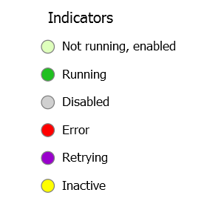

1. If the interface is in the **retry** state check the logs of the interface if its connection error, troubleshoot the connection at our end, recycle the interface once and if the issue persists create the incident to destination application support team according to priority and mention IP/Port of the interface in it.
2. If the service is in **error/listening** state and if there is no data received from source system, then recycle that connection and check if the interface is receiving data. If there’s no activity, create an incident and assign it to the source team to check and validate.
3. If the interface is in **disabled** state, try to restart it. If no progress is found check the logs. If it is a message issue, then skip that record and restart the connection. After skipping the record, create an incident to source system with respect to priority of source interface and attach that skipped record in it.
4. Sometimes the connection is in **error/down** due to no port/IP address assigned to it. In such cases create a ticket and reach out to the developer to check and make the necessary changes.
5. If the interface is **inactive** state, recycle it and the interface will be back to running state. If there is no data received, then follow the same process as point **(2)**

**Interface interaction:**

**IACL and its uses:**

IACL is used to determine all the information regarding the interfaces deployed in different servers. Below are the details that we can find in IACL.

* **Priority**
* **Owner**
* **CA group**
* **Email address**
* **Port Number**
* **IP Address**

Referring to the above details in IACL we create the incident with the mentioned priority, assign it to the correct CA group in service now and send the email to the owner group of the interface.

Link to access IACL - <http://ensdev02:57772/csp/sds/CUSTOM.ZenIACL.EnsembleIACLEdit.cls>

**IP Address/Port of interfaces:**

The Tcp interfaces are assigned with IP Address and Port. The WS, File, SFTP interfaces are connected using file path or web service standards.

* **Steps to check source interface IP and Port:**

Click on the source interface (service), on the left-hand side click on the log tab. You will see the Port and IP address of the interface (refer below image). In case you do not see the details in logs, recycle the interface once and check the logs again you’ll find the Port number and IP address.

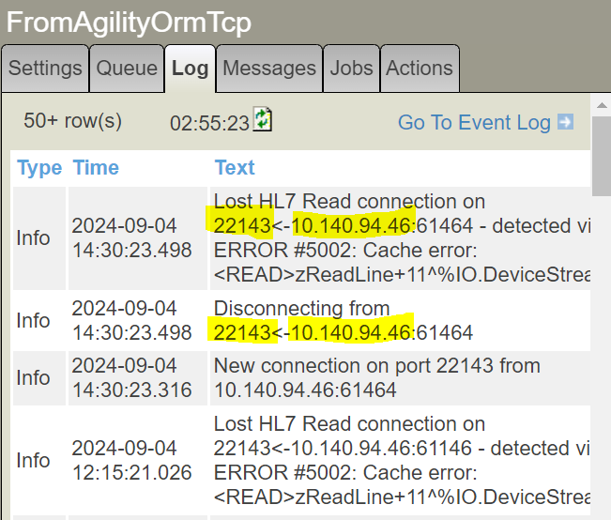

* **IP/Port of destination interface**

It is easy to find the IP and Port of destination interface. Click on destination interface (Operation) and in Settings you can see the IP address and Port of that respective interface.

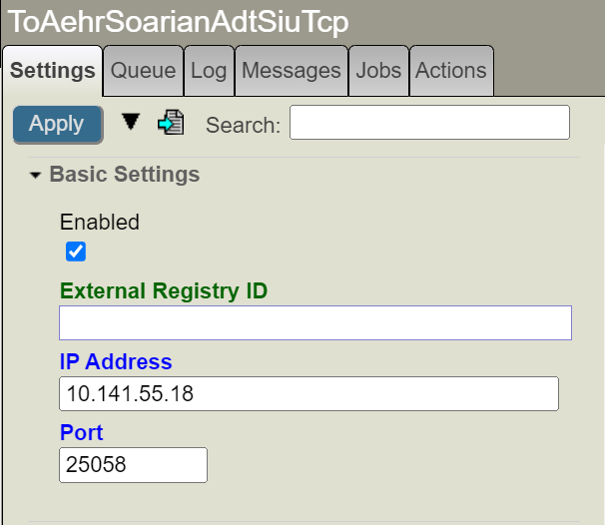

**How to check DNS (Domain Name System) using nslookup**

The domain name system (DNS) is a naming database in which internet domain names are located and translated into Internet Protocol (IP) addresses.

We use ‘nslookup’ to check DNS address of any IP address. Refer below snap to understand the difference between DNS address and IP address.

1. Open command prompt.
2. Type nslookup <IP Address>
3. Hit Enter

In the snapshot below, 10.141.53.26 is an IP address and SYKPSCMCONS1N1v.nslijhs.net is a DNS address of that IP.

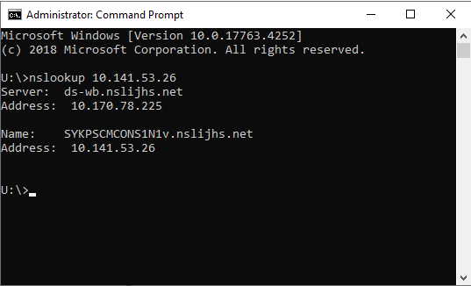

**How to find the interface and get the acknowledgement for Prod/Non-Prod issues:**

We received emails, where the message acknowledgement and the interface status are requested. Below are the parameters needed to find the right interface and message acknowledgement.

* Source, Destination, Message type and Site/facility
* Date and Time
* MRN number/Encounter number/Name of Patient

If you do not have any details mentioned in email, revert to the vendor requesting for more information. Also, for Dev/QA issues, kindly ask for the project number, as there is a developer assigned for it and that helps in taking assistance when required.

**Steps to Filter the messages with Extended Criteria**:

Once you find the source and destination interface, the vendor requires the HL7 message acknowledgement to confirm if it has successfully crossed to the downstream application or to the directed destination.

* Click on the destination interface, then go to the **Messages** Tab as shown below, click on **Go To Message Viewer**

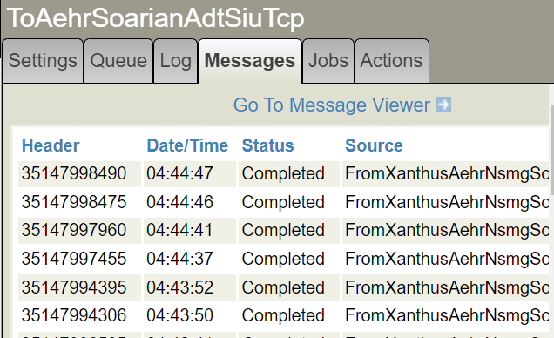

* New window will open (refer below image), now go to the left-hand side enter the approximate **Date and Time** of the HL7 message and click on **Add criterion** below extended criterion section**.**   
  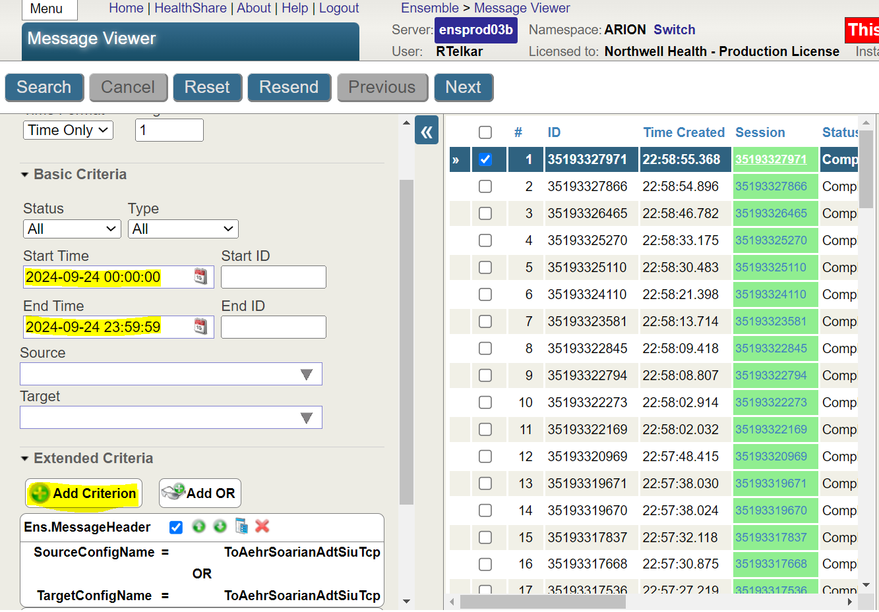
* Below window opens, select the Criterion Type – **Body Property**, Class - **EnsLib.HL7.Message**. In Conditions IF – **RawContent** and **Contains** (from drop down)and then enter the **MRN number/Name of Patient/Encounter Number,** Click on **OK.**

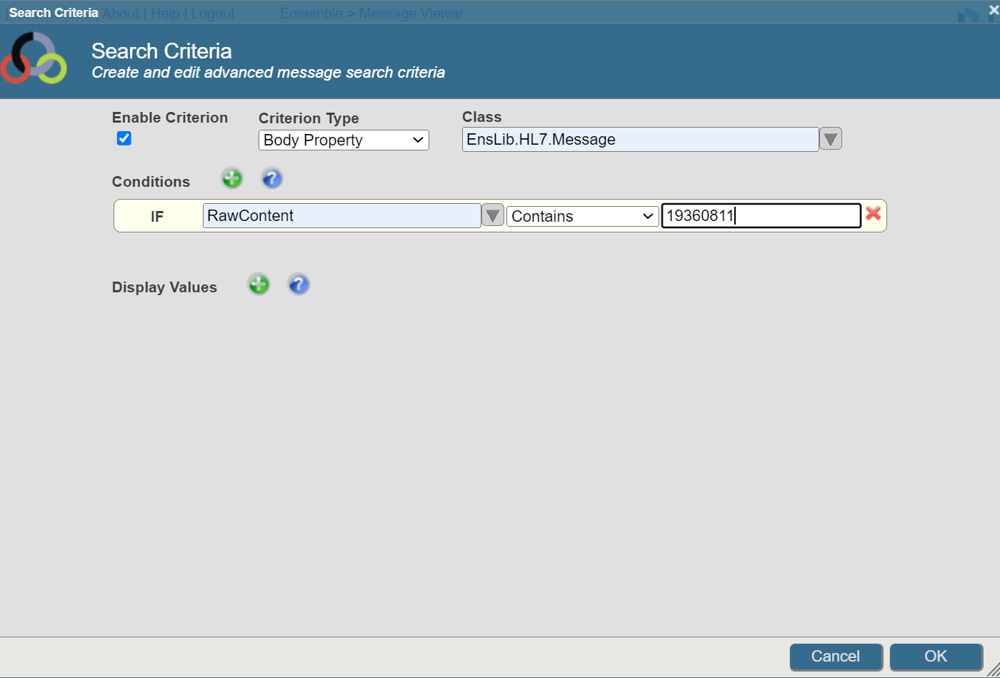

* The message will then filtered and displayed as shown below. By clicking on the Contents Tab – **View Full Contents** and **View Raw Contents** the complete HL7 message can be seen.

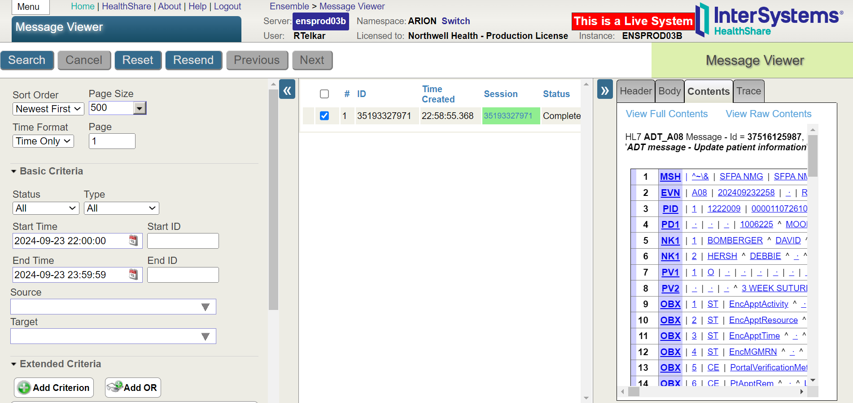

To view the full Trace of the message and get the acknowledgement status, Click on **Trace** tab and **View Full Trace,** the below window will then open in new tab of your browser. In Reapply Filter select **Corresponding** and Click on the **Contents** Tab as shown below, the Message Acknowledgement is then displayed. **AA** is the **Application Accept**. Copy the acknowledgement and share it to the vendor over email stating that message has successfully crossed the downstream application.

Below is the meaning of the code in Visual Trace that are used to derive the status of the message.

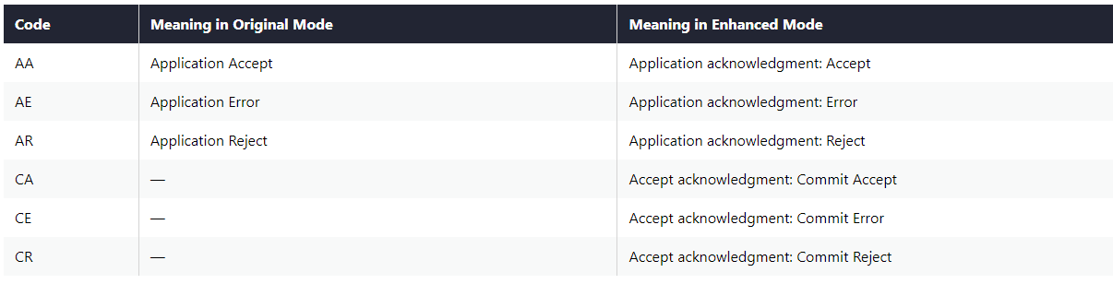

**Monitoring Interfaces:**

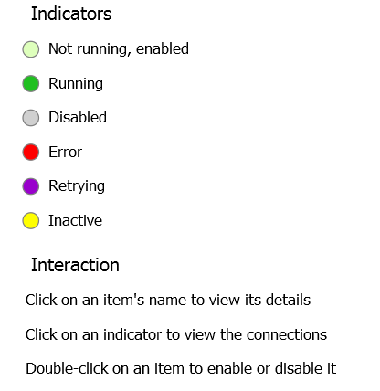

To view a production, the **Interoperability > Configure > Production page**.

This page displays the business hosts in the production, with useful color coding as in the following example:

to view a production, the **Interoperability** > **Configure** > **Production** page.

This page displays the business hosts in the production, with useful color coding as in the following example:

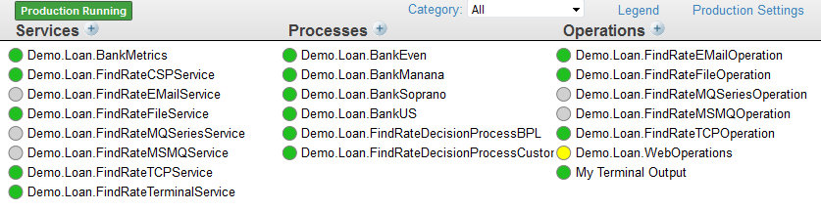

**Queues**

The **Queues** table lists the status of Ensemble internal message queues and how many messages are currently waiting in each queue.

This table uses the same icons and color-coding as below. If you click an item in this table, the right area is updated with details and the **Queue Contents** link.

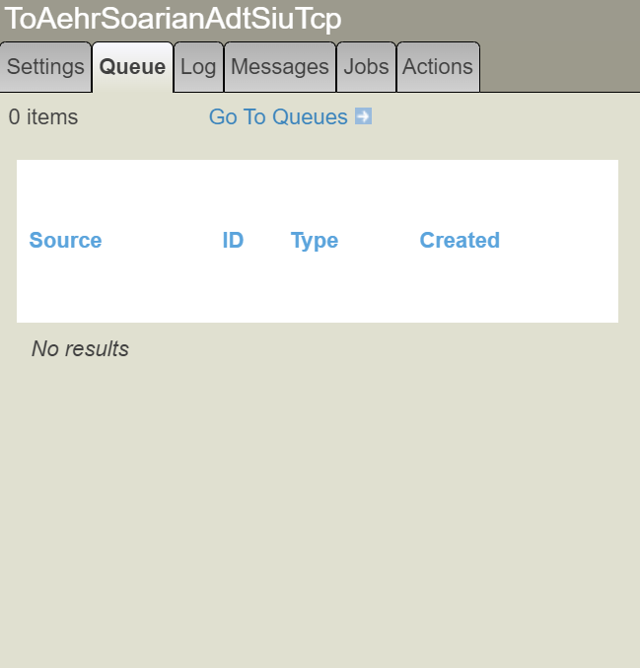 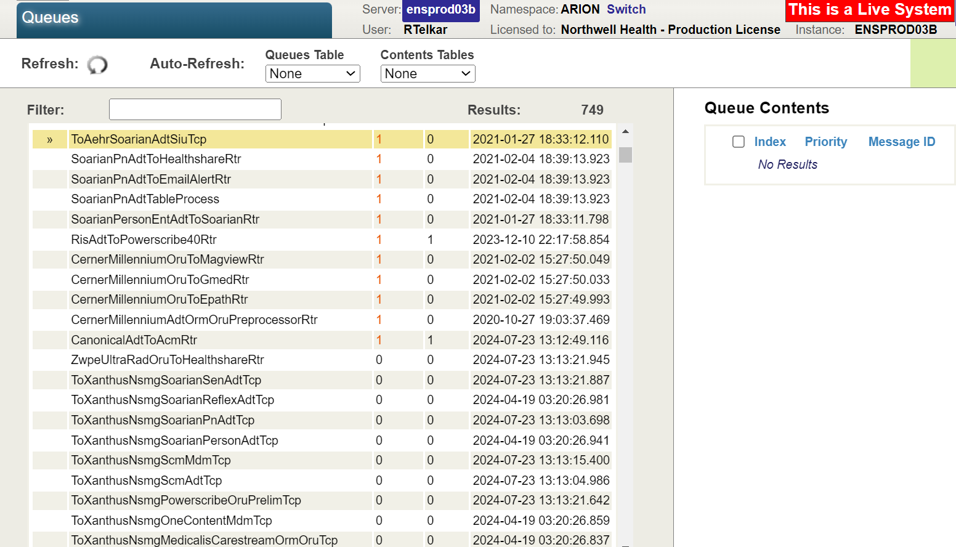

**Event Log**

The **Event Log** summarizes recent entries in the Event Log.

Each entry provides an icon and color to indicate the item’s status, as follows:

* Red !—Error.
* Orange W—Warning.
* Yellow A—Alert.

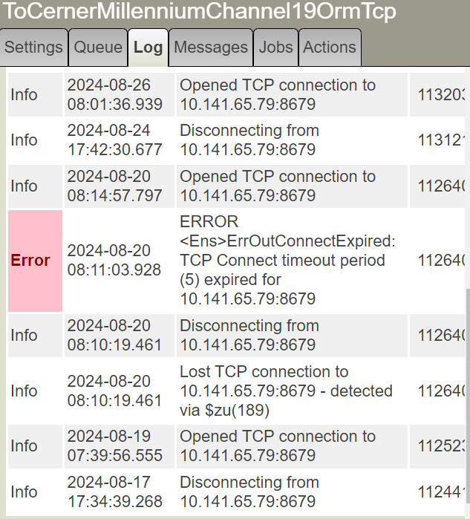

**Aborting messages:**

**Steps:**

* When the interface is down, locate it and check the error logs.
* If it is a message error, open Queues Tab and click on Go to Queues, below window is displayed.

* Select the interface that is queued up and in the Queue Contents section select the 1st queued message.
* Now click on the Abort button and a pop up will appear, click OK

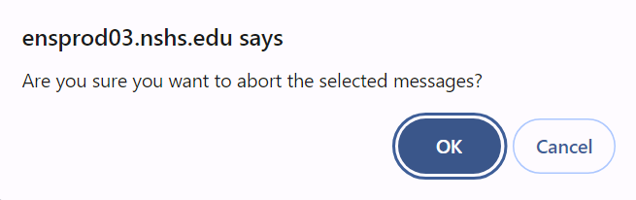

**How to find the aborted record:**

The selected message is than aborted. You can get the aborted message by following below steps:

Go to Message viewer >> Enter the date and time >> In Basic criteria status drop down select Aborted>> The aborted message will be displayed.

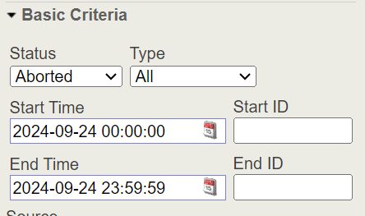

You can then copy the HL7 message and paste it in the notepad and create a ticket to vendor/Oncall developer and attach the aborted record to review and resend.