FHIR – Fast healthcare Inter-operability Resources

MPI – Master Patient Index

Why do we have MPI?

There was no “KEY” by which we can make sure “patient data gathered from different sources is same for Exact patient”

Sources of Patient – EMR from hospital, Pharmacy, Blood and other test/ diagnostics.

Patient – Nikhil

A HOSPITAL LAB PHARMACY

Patient – Nikhil Patient – Nikhil Patient – Nikhil

SORE THROAT SALIVA TEST AZITHROMICINE 500MG

Difference between MPI and MRN

MPI is recognized in multiple systems; MRN is limited to one system.

What is MPI – a key or number which identifies patients across separate clinical, financial and administrative systems

And ensures the records are same for the Exact Patient

Patient – Nikhil MPI – 11

A HOSPITAL LAB PHARMACY

MPI – 11 MPI – 11 MPI – 11

Patient – Nikhil Patient – Nikhil Patient – Nikhil

SORE THROAT SALIVA TEST AZITHROMICE 500MG

What MPI does – Generates the MRN as the per the conditions of the hospital or other system

assigns medical record number (MRN) or a unique patient identifier (UPI), to each patient.

A Patient can have multiple Medical Records (Multiple MRNs) within single hospital.

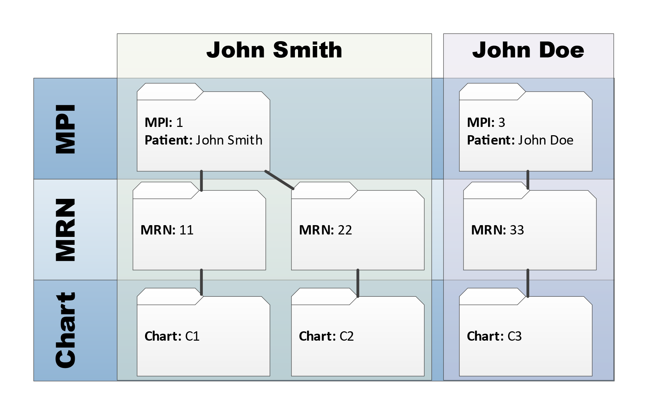

MRN – Medical Record Number – (which keeps changing) - unique identifiers (within the hospital) assigned by MPI to identify patients and link their records across different systems

Each EHR has their own unique numbering system, so it would be IMPOSSIBLE to keep the same MRN

Patient – Nikhil MPI – 11

A HOSPITAL LAB PHARMACY

MPI – 11 MPI – 11 MPI – 11

MRN -22222 MRN – N33333 MRN – 4444G

Patient – Nikhil Patient – Nikhil Patient – Nikhil

SORE THROAT SALIVA TEST AZITHROMICE 500MG

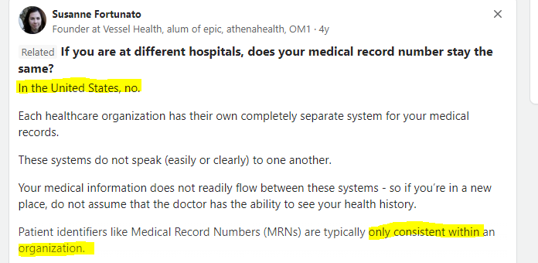

MPI VS SSN (Social security number)

MPI FOR MEDICAL RECORDS, SSN FOR FINANCIAL RECORDS AND TAX DETAILS

EMPI - enterprise master patient index

What it is –

It’s database that is used to maintain consistent and accurate information about each patient registered by a healthcare organization.

What it does –

uses algorithms to constantly look for duplicate records in a healthcare organization's registration system.

Like - for example, their name, address, medical record number, Social Security number, insurance company or healthcare provider.

How it’s done – Uses two algorithms deterministic and probabilistic

1. Deterministic matching, - exact match logic

For example, = two records will match if they agree on elements such as the patient's first and last name and phone number.

Elements that do not match exactly, such as a nickname or maiden name, will likely cause a rejection.

Example R1 R2

Nikhil Garud Nikhil Garud

Nik Eagle

1. Probabilistic matching = assigns a rank to different data elements and scores the likelihood that two or more records belong to the same patient.

The higher the score, the higher the probability that there is a match between two records.

Example R1 R2 R3

Garud Garu 80% Gar 60%