

**GOANYWHERE TROUBLESHOOTING GUIDE**:

This document helps on how to troubleshoot GoAnywhere alerts and steps needs to be taken before reaching out to on-call support. (Note: DEV alerts can be ignored until next business hours unless multiple alerts are triggered.)

1. Acknowledge the alert.
2. Check why we’re receiving alerts (Monitor failed, schedule job failed etc.).
3. Check the logs for further details.
4. Follow standard troubleshooting guide and get the details.
5. In case of disk space issues on following servers:

sykpsftp02v→ Production

swbzsftp02v→Disaster Recovery

sykdsftp01v→ Development

sykpsftpdz01v→ Production gateway

swbzsftpdz01v→ Disaster Gateway

sykdsftpdz01v→ Development Gateway

Follow the steps below.

1. Raise a P2 ticket to GoAnywhere group and assign ticket and inform to on-call support.
2. Send email to [**ISIntegrationSupportGroup@northwell.edu**](mailto:ISIntegrationSupportGroup@northwell.edu) with the ticket details.

**How to find contact details and priority:**

1. Find the project in the applications and note the change request number (mentioned in project description).
2. Open the change order and find the attached GoAnywhere request form file.
3. Open the attached GoAnywhere request form where you will find the source and destination vendor information. If a group is also mentioned, assign the ticket to them and email informing about the ticket created keeping ISIntegration in CC. While creating a ticket, also type “GoAnywhere” in the summary following with the issue. If a group is not found, assign the ticket to on-call support in GoAnywhere group.
4. The priority of the tracking ticket will be same as the change order priority.

**Links:**

Production application:

[https://sykpsftp02v.nslijhs.net:9001/goanywhere/auth/Login.xhtml;jsessionid=61841D3C0BC45B9F18A](https://sykpsftp02v.nslijhs.net:9001/goanywhere/auth/Login.xhtml;jsessionid=61841D3C0BC45B9F18AF9DFCE14A579D)

[F9DFCE14A579D](https://sykpsftp02v.nslijhs.net:9001/goanywhere/auth/Login.xhtml;jsessionid=61841D3C0BC45B9F18AF9DFCE14A579D)

Development application:

<https://sykdsftp01v.nslijhs.net:9001/goanywhere/auth/Login.xhtml>



**Below are the examples:**

1. No file(s) were found

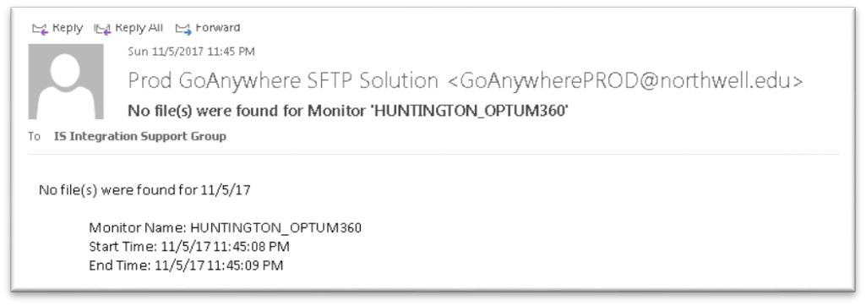

This alert is generated when the job finds no file for transfer between the scheduled run time. (Note: Inform and confirm from the source contact person via email about no files were sent for that particular job). Ops will follow the above process for all No file found notification.

Steps Need to Follow:

1. For Other Jobs, If we get No file found , Please create P4 Incident .
2. Create an Incident and assign to Source CA Group and if there is no source group, assign Incident to GoAnywhere Oncall in In Progress State.
3. Email Source, Destination and ISIntegrationSupportGroup of No File Found alert(Source ,Destination Information can be found from the Job Config File )
4. Please Include Incident Number in Email Chain.
5. Attach Email Chain to the Incident.

Note : Please add the Incident in transition, if not resolved.

1. No file(s) were found

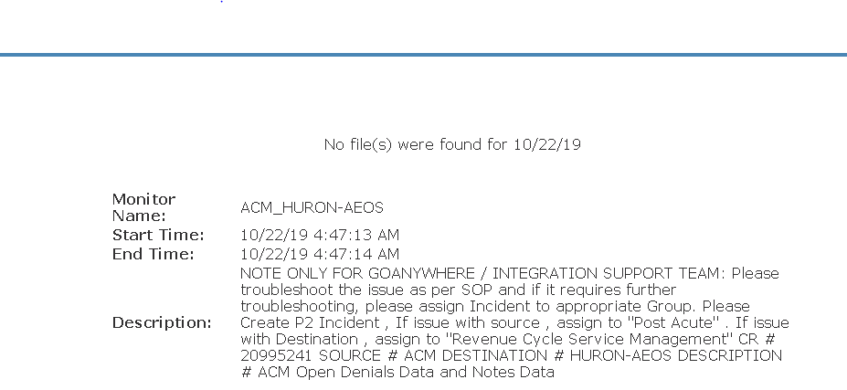

Steps Need to Follow:

1. If you receive no file found alert like above given , Please create Incident and its priority as mentioned in an alert.
2. Create an Incident and assign to the respective Source CA group and if there is no source group, assign Incident to GoAnywhere Oncall in In Progress State.
3. Email Source, Destination and ISIntegrationSupportGroup of No File Found alert(Source ,Destination Information can be found from the Job Config File )
4. Please Include Incident Number in Email Chain.
5. Attach Email Chain to the Incident.

Note : Please add the Incident in transition, if not resolved.

**HIGH PRIORITY jobs: If we Receive Above alerts for Below Jobs:**

|  |
| --- |
| 1. SIEMENS-CERNER_INVISION-MH |
| 1. HEALTHPAY24-835_GECB-BILLING |
| 1. SUTHERLAND-LIJCCMC_GECB |
| 1. OB_SUTHERLAND_TO_OPENLINK-Man |
| 1. ENSEMBLE-PROD_EAGLE-MUSE |
| 1. MUSE_INVISION |
| 1. ENSEMBLE-PROD_EAGLE-CRW |
| 1. ENSEMBLE-ORTHRUS_HCLL |
| 1. ENSEMBLE-PROD_EAGLE-PYXIS |
| 1. SUTHERLAND_OPENLINK-LHH |
| 1. OB_LHH_APOLLO |
| 1. RIS_GECB 2. OPENLINK-SIEMENS_SMM-PHARMACY |
| 1. OMNICELL_OPENLINK-INVISION 2. EAGLE-LIJ_HURON-AEOS 3. SSI_HURON-AEOS 4. SSI-PAYERRESPONSE_HURON-AEOS 5. SSI-BILLHOLD_HURON-AEOS 6. INVISION_HURON-AEOS 7. OPTIMUM-LIJVS_HURON-AEOS 8. ACM_HURON-AEOS 9. RCR-FACS_HURON-AEOS 10. HURON-AEOS_EAGLE-LIJ 11. HURON-AEOS_OPTIMUM-LIJVS 12. HURON-AEOS_ACM 13. VERACITY_HURON-AEOS 14. BLUEMARK-RACTRACKER_HURON-AEOS 15. O360-BILLHOLDS_HURON-AEOS 16. O360-MRT_HURON-AEOS 17. HURON-AEOS_OPENLINK-INVISION   Steps Need to Follow:   1. For **High Priority Jobs (Above Listed Jobs )**, If we get No file found , Please create P2 Incident . 2. Create an Incident and assign to Source CA Group and if there is no source group, assign Incident to GoAnywhere Oncall in Progress State and reduce the Priority to P3. 3. Email Source, Destination and ISIntegrationSupportGroup of No File Found alert(Source ,Destination Information can be found from the Job Config File ) 4. Please Include Incident Number in Email Chain. 5. Attach Email Chain to the Incident. 6. Please add the Incident in transition, if not resolved. |
|  |

1. Monitor failed: Session.connect: java.net.ConnectException: Connection timed out: connect;

Permission denied

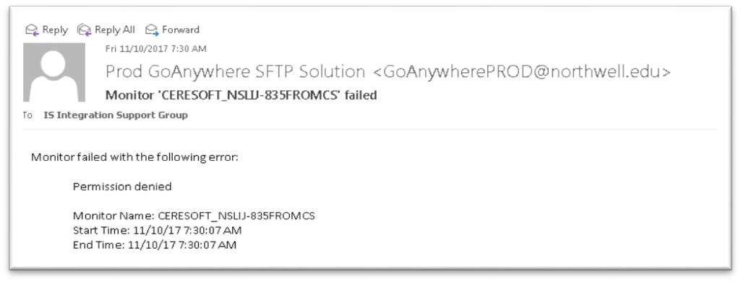

This alert is generated whenever the GoAnywhere connection with external sftp server fails. To troubleshoot alert, follow below steps:

1. Go to **Workflows tab->Monitors**
2. Search the monitor.
3. Find the SFTP Resource.
4. Go to Resources tab, find the resource and test the connection and verify if we are able to connect successfully or not.
5. If resource test is successful, Check source directory from monitor for pending files. If there are pending files then wait for next run. Check if file get transferred automatically in next run or not if not , then force sync the file (Reach out to on-call for force sync).
6. 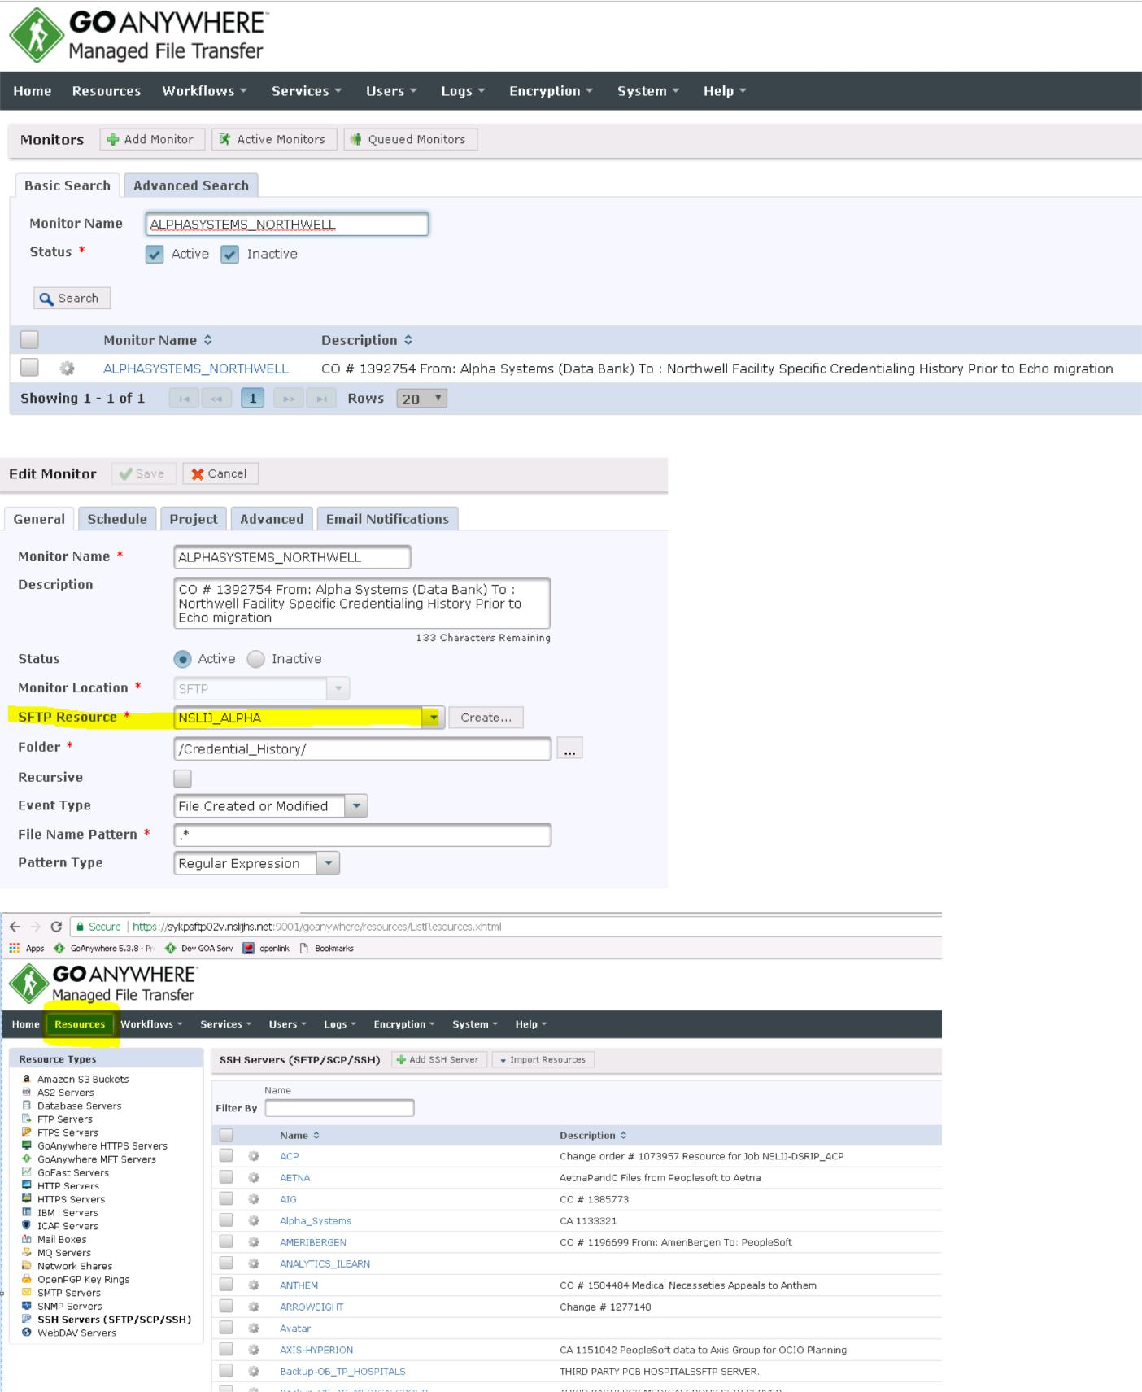If resource test fails , send an email to vendor and create an incident and assign the ticket to GoAnywhere group Primary On-call support person. (The priority of incident depends on the job priority which can be found in the change request). Change the status to “Waiting for vendor”.

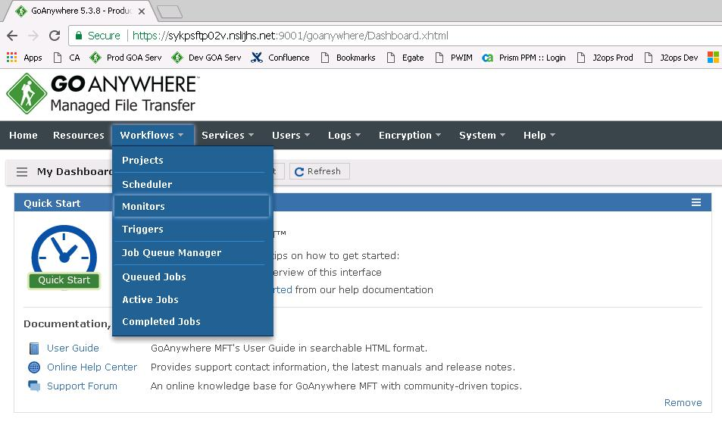

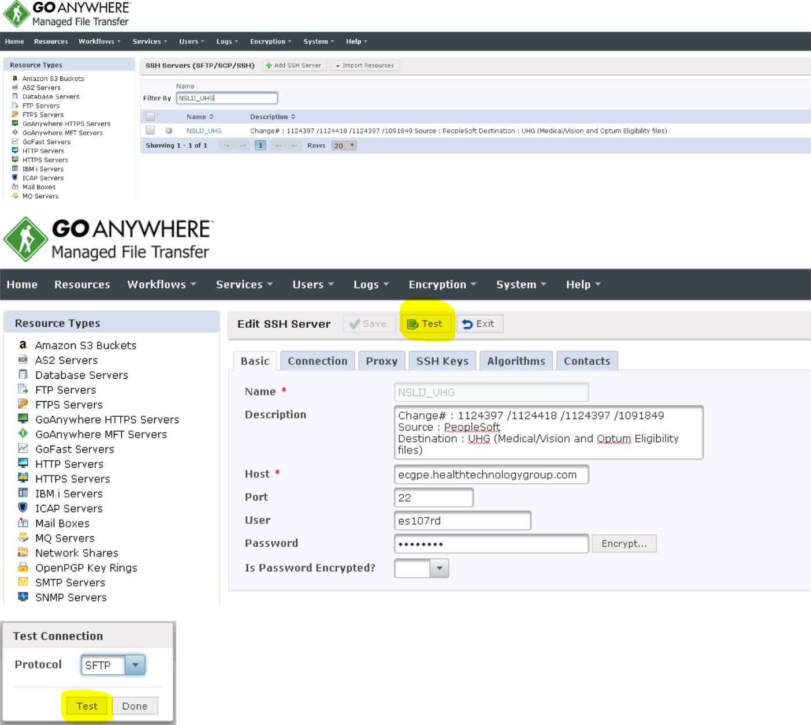



NO FILE

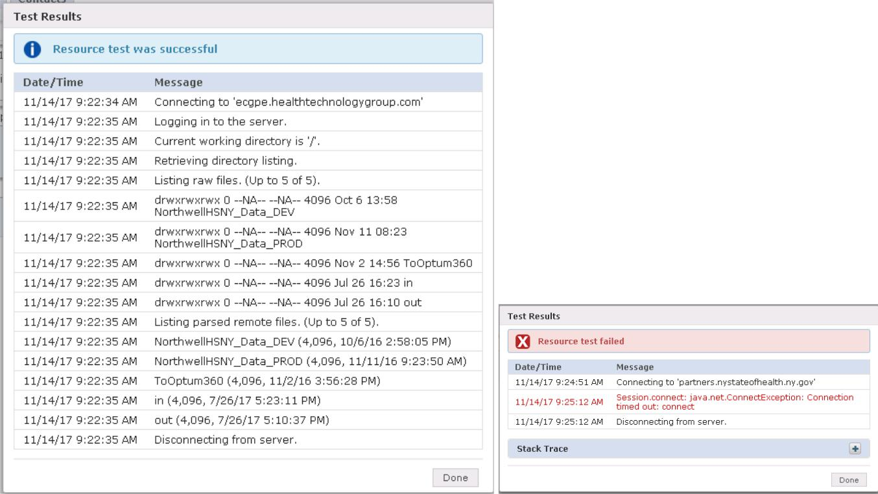

**Connection Successful Connection fail**

1. Monitor job failed: [9001 - Raise Error] ISSUE HAS BEEN ENCOUTNERED! Errors encountered while transferring files to destination. Check the logs for job TransferFilesProjectV3 to determined why they failed. Parent Job ID for that job is 1000002919460

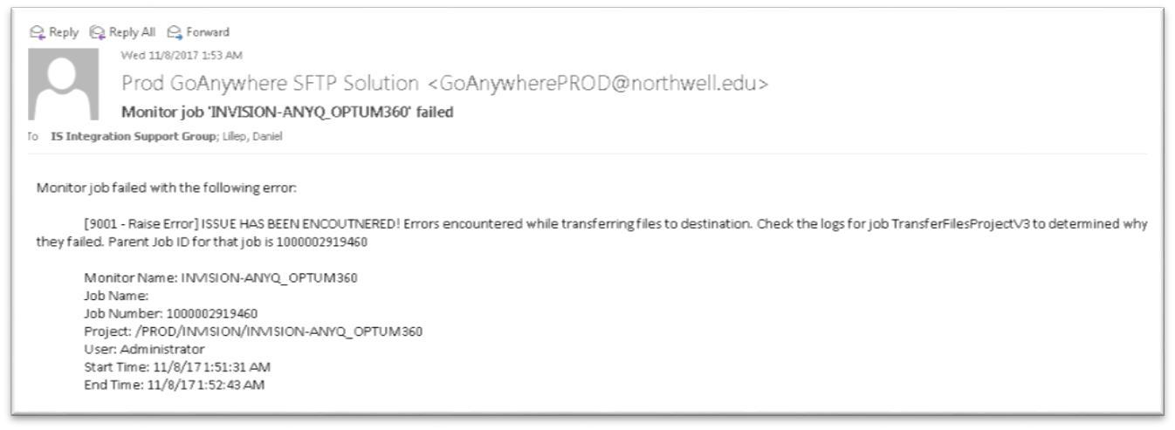

This alert is generated when the transfer fails. Check the logs and find out the error.

Below steps to be followed on how to check logs:

1. Go to **Reporting tab**-> **Audit logs**.
2. On Left panel click on Completed Jobs.



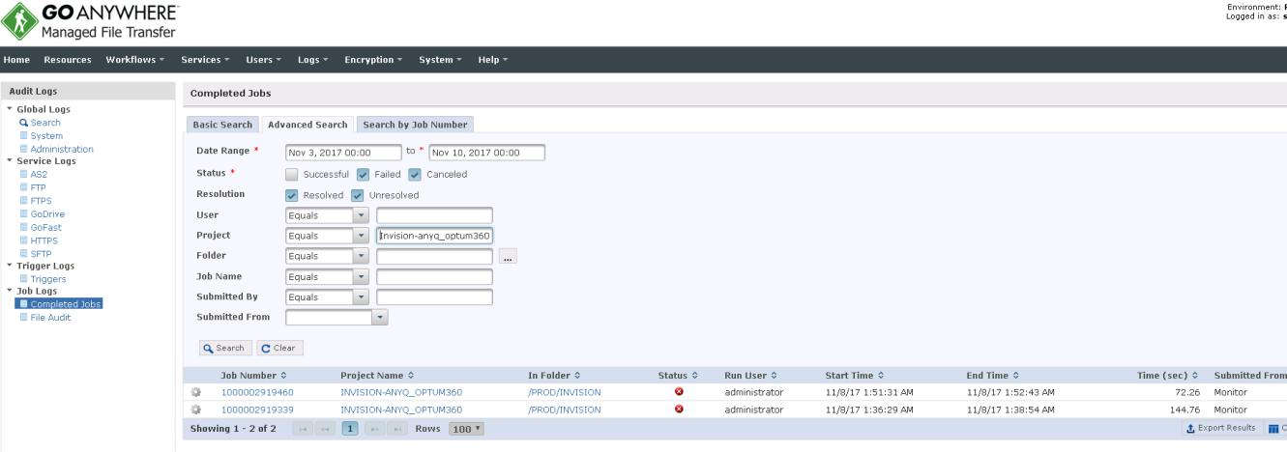

* 1. Fill the search criteria.
     + **Date Range:** Type date and time when the alert was generated.
     + **Project:** It will consist of Monitor/Scheduler mentioned in alert.

Alternate option->We can also search by using Job Number that is present in the alert.

1. Click on **Search** -> **Click on Job number** and find the error that caused the failure.



The above error says “Check the logs for job TransferFilesProjectV3”. In that case, repeat step 3 and 4. (In project type “transfer” and date and time depends on when the transfer job failed).

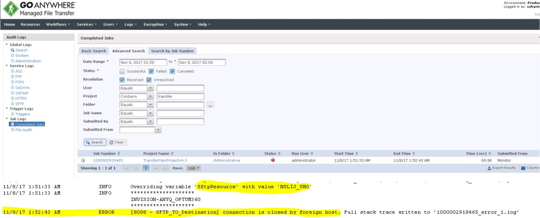

The above log states the connection failure with NSLIJ_UHG. Follow steps mentioned in section 2. After the connection is successful, we have to transfer the files manually. (Follow steps given in section on How to Transfer files manually)

1. Monitor failed: Folder does not exist

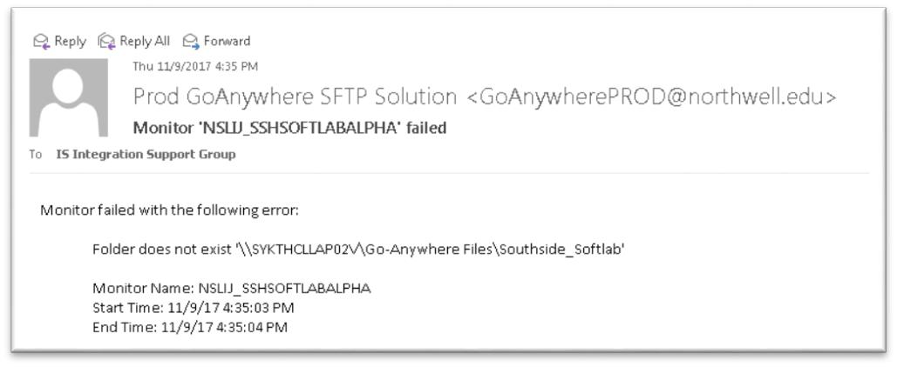

This alert is generated when the source directory is not accessible. Follow below troubleshooting steps:

1. Go to **Workflows tab**-> **Monitor**-> **Search using Monitor name**
2. Try to access the directory by clicking on Browse button. If **not** accessible, notify the source contact person via an email stating the issue and raise an incident for tracking purpose (priority depends on job priority).

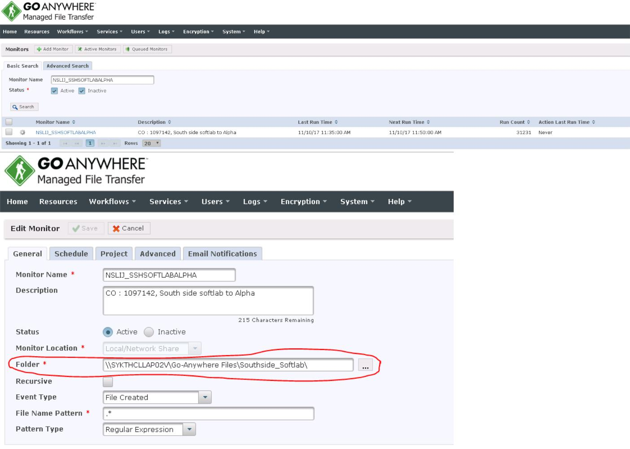

1. Production Upload Has Failed. Or GoAnywhere Production Alert Trigger Failed

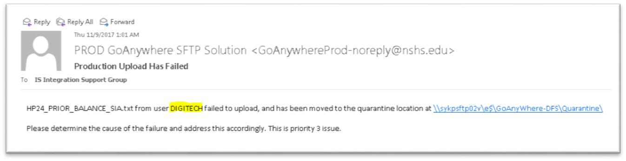

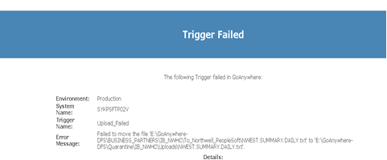

The above alert is generated when the web user (Here, DIGITECH) fails to upload file to GoAnywhere server. Follow below steps:

1. Go to **Reporting Tab-> Audit logs**.
2. On Left Panel select SFTP.
3. Fill the search criteria.
   * **User**: Web user.
   * **Command**: Drop Down and check only upload and uncheck other commands.
   * **Physical Path**: Drop down and select Contains and search by keeping the file name.
4. Click on () icon detailed description.
5. Check the Remarks in the next window. You will find why the upload failed.
6. Also, verify the file is uploaded in the next run or not. If, yes reply on alert the file was uploaded successfully in the next run .
7. **It there Is a file in the source location and another file is uploaded to same location . The 1st file will be going to Quarantine location , As overwrite permission is not granted and failure alert will be generated . please reach to On-Call support.**
8. Note : Quarantine location -> \\sykpgoadb01v\GoAnyWhere-DFS\Quarantine\ . In Quarantine folder search Web User and check upload folder.

(Note: Status of upload for different signs are:

 → Upload failed

→ Upload successful



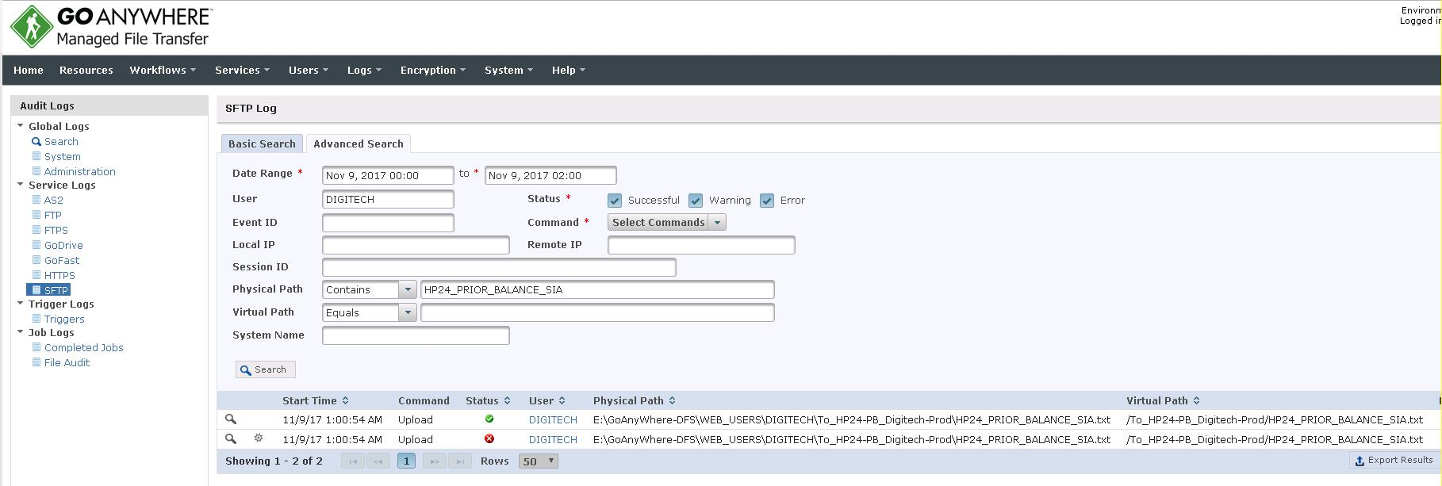

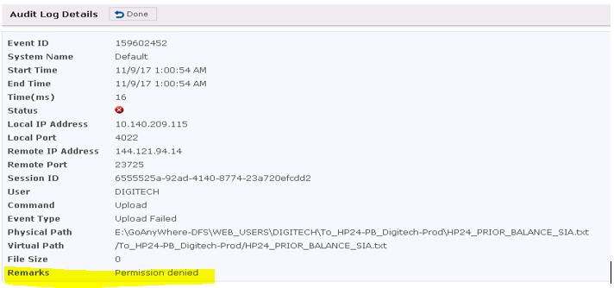

1. GoAnywhere Prod Failure - SFTP User Failed to Delete File.

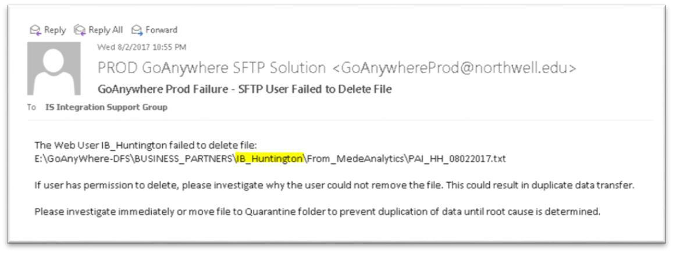

The above alert is generated when the web user (here, IB_Huntington) fails to delete file (here,

PAI_HH_08022017.txt) from specific folder (Here, From_Medeanalytics) from GoAnywhere server. Follow below steps:

1. Go to **Reporting Tab-> Audit logs**.
2. On Left Panel select SFTP.
3. Fill the search criteria.
   * **User**: Web user.
   * **Command**: Drop Down and check only delete and uncheck other commands.
   * **Physical Path**: Keep the file name.
4. Click on () icon for detailed description.
5. Check the Remarks in the next window. You will find why the delete failed.
6. Also, verify the file is deleted in the next run or not. If, yes reply on alert the file was deleted successfully in the next run.

(Note: Status of delete for different signs are:

 → Delete failed

 → Delete successful



1. Scheduled job failed: [9001 - Raise Error] ISSUE HAS BEEN ENCOUTNERED! "Cannot create NAS filelist. Check the Source System"

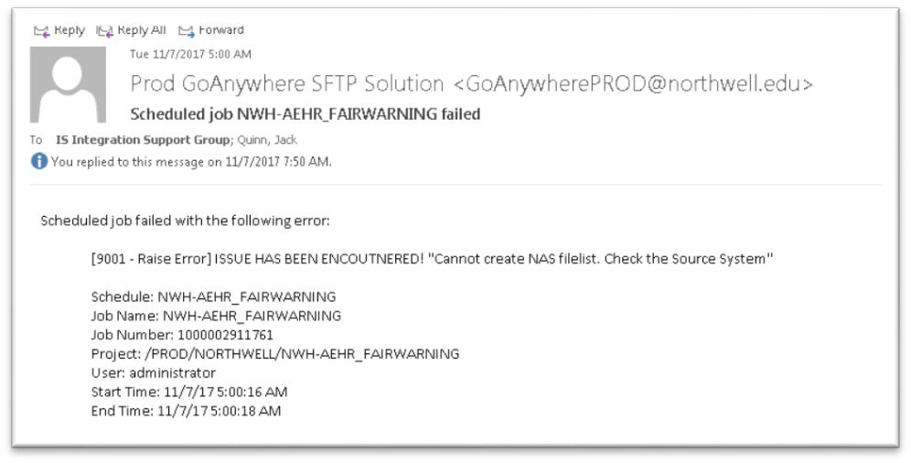

This alert is generated when files are not completely picked up from source directory. Create an incident for tracking purpose and reach out to on-call support informing the ticket number.

1. Scheduled job failed: Project not found

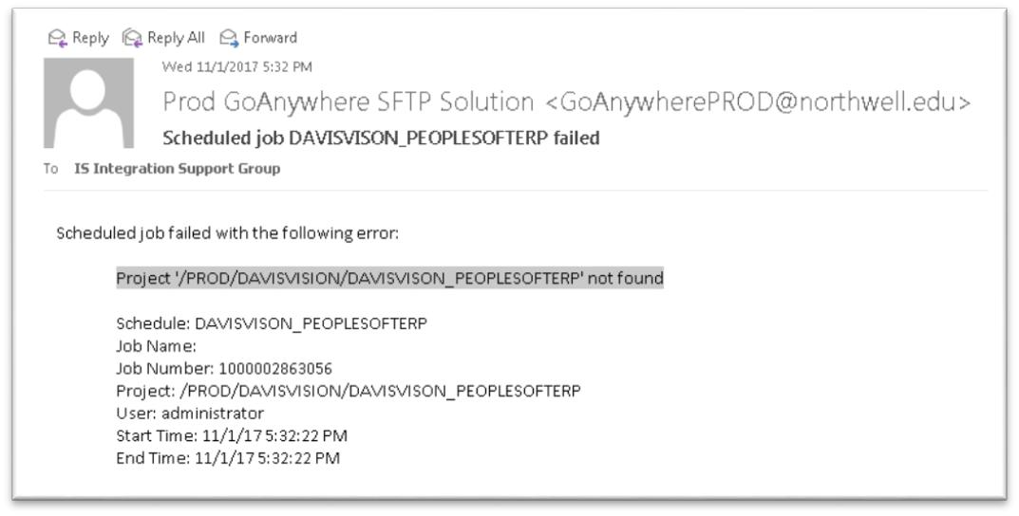

This alert is generated when GoAnywhere project is not found. Reach out to on-call support.



1. Scheduled job Automated_Project_Tracker failed

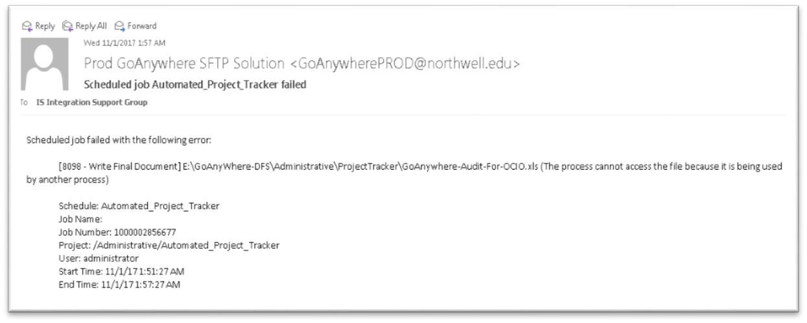

This alert is generated when the file GoAnywhere-Audit-For-OCIO.xls is opened by a user. This alert will be generated every half an hour until the file is closed.

1. Move to Inbound:

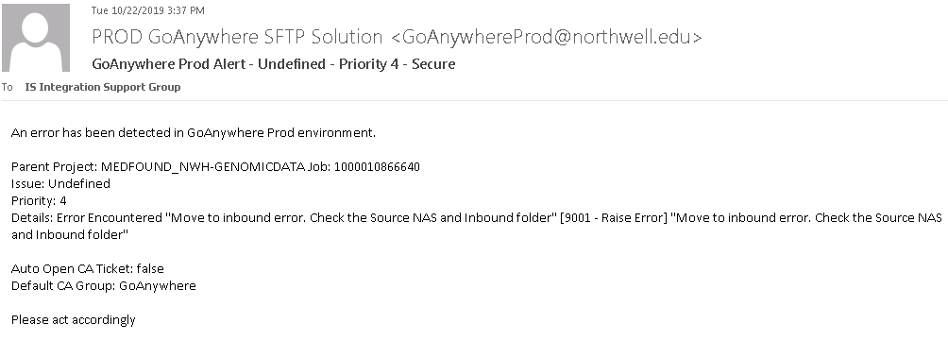



This alert is generated when the project fails to move files from source directory to our inbound folder. Follow below troubleshooting steps:

1. Go to **Workflows tab**-> **Monitor**-> **Search using Monitor name**
2. Try to access the directory by clicking on Browse button. Check whether file is available in the source directory or not (with date modified).
3. Also check if files present in Inbound folder of GoAnywhere DFS respective folder.
4. Wait for next run. If the file get transferred in next run then send transfer logs from execution history.
5. If no - If files are available at both locations or only at source directory then we need to “Force Sync” the files. Please reach out to On call support if the files are supposed to be forced sync.
6. If files are available only at inbound folder then Rerun the project manually. Click on the button which is called “normal execution. Please refer below screenshot.



**How to transfer Files manually:**

1. Go to Projects.
2. Search the Project name.
3. Check if files present in Processing folder of that particular GOA job folder.
4. Delete Marker files created during the run (these are 1 kb files that needs to be removed. If not removed, the next run will again throw an error). One file will be named as GoAnywhere Marker file present in Processing folder (with actual files that are transferred) and other will be present in Inbound_<destination> folder. Delete these 1 kb files.
5. Check file transfer report named as ReportFile.txt (It is in the same folder where Inbound, Processing and other folders are located for that GOA job) and transfer only those files which have been failed to transfer. Failed files will be shown with Error not Transferred label and transferred files will be shown with Transferred label. Only move already transferred files from Processing folder to Outbound folder. Keep failed files in Processing folder. Please refer screenshots on next page.

Note: If you see multiple destinations in report file then reach out GOA on-call for assistance.

1. Rerun the project manually. Click on the button which is called “normal execution”.
2. In case the files are present in source directory, we need to “Force Sync” the files. Please reach out to On call support if the files are supposed to be forced sync.

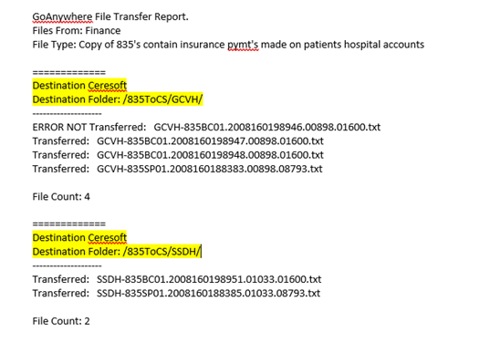

* Single Destintion

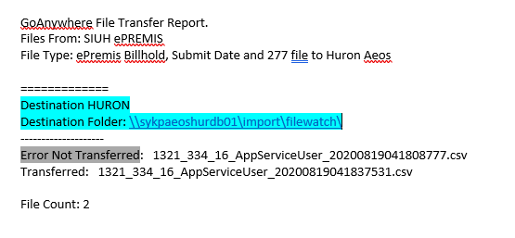

* Multiple Destinations

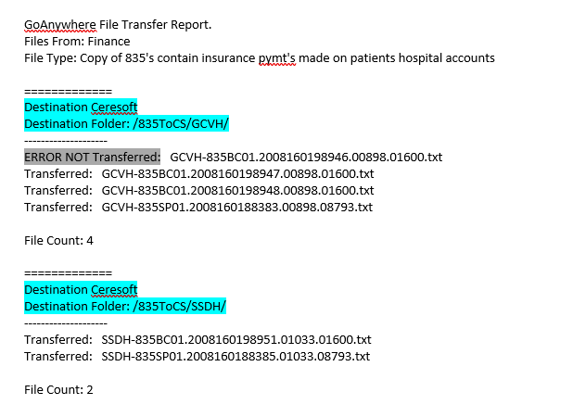

In case of multiple dstinations we may need to transfer file to failed destintions only and so need to make some changes in GOA configuuration so plese reach out GOA on call before performing any task.

**How to ForceSync Files manually:**

1. Go to Projects.
2. Search the Project name.
3. Check if files present in Inbound folder of GoAnywhere DFS respective folder.
4. Go to **Workflows tab**-> **Projects**-> **Search using Project name**
5. Click on **gear icon->Execute Advanced**
6. Change value of CheckStatus field from **false to true**
7. click on **Execute**
8. Click on View Job logs at top
9. Check is there any file name shown in logs
10. Click on Done
11. If yes,Change value of CheckStatus field from **true to false**
12. Change value of ForceSync field from **false to true**
13. Click on Execute
14. Click on view Job logs at top and share these logs on email.
15. If No, click on **Done->Cancel**

**Please refer below screenshots for steps.**

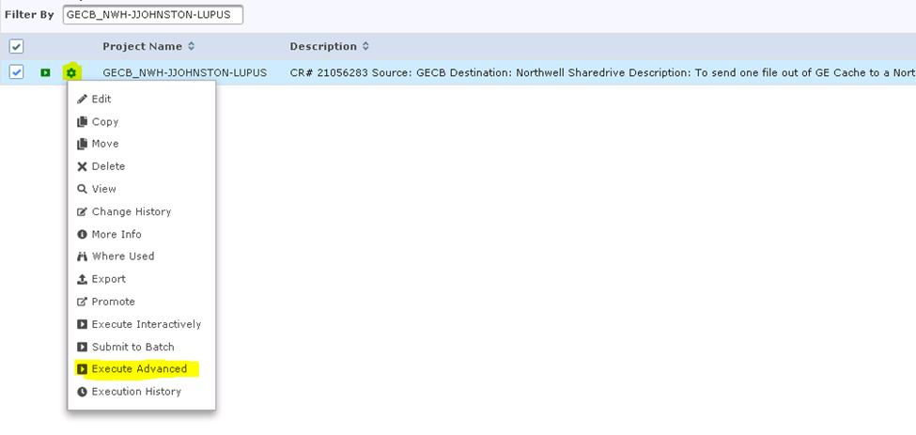

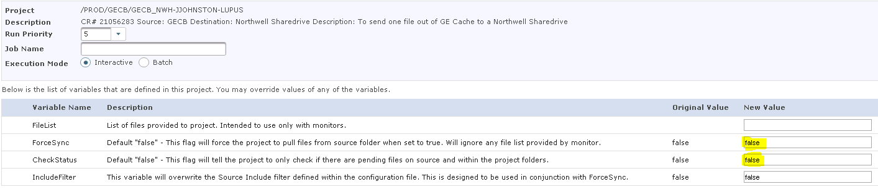

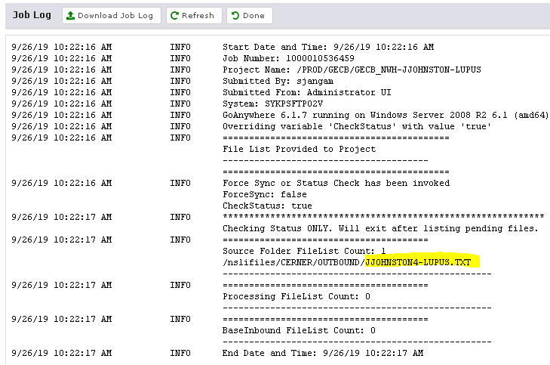

**GOAnywhere Document for Openlink Alert**

1. **Cannot access file: (Troubleshooting to be done by Goanywhere Team and Ops Team )**

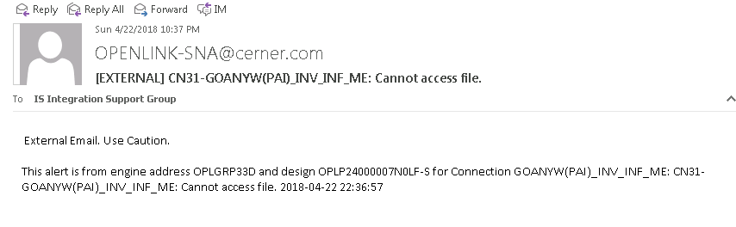

1. Login to Openlink -> OpLGRP33D (It may vary to A, B , C , D Schema)
2. Click on the Interface GOANYW_PAI_ME (You will find Interface name in alert)
3. Hover on Inbound Interface GOANYW(PAI)_INV_INF_ME
4. Check the file location, Will find the path eg .\From_MedeAnalytics .
5. Browse to \\sykpgoadb01v\GoAnyWhere-DFS\BUSINESS_PARTNERS\IB_OPENLINK ,
6. Check in the folder eg . \From_MedeAnalytics
7. Check if there is any 0 KB file, Delete the file.
8. If there is no file, Then Check the Openlink logs **(Further troubleshooting done by Ops Team)**
9. Right click on Inbound Interface
10. Click on Monitor -> Click on View logs
11. Check the logs.
12. According to logs Restart the interface or Reach out to Openlink On Call.
13. **File Moved to Error Directory (Troubleshooting done by Ops Team)**

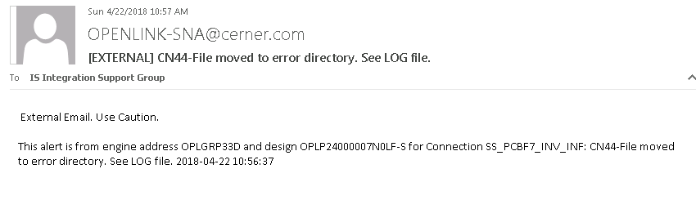

1. Login to Openlink -> OpLGRP33D (It may vary to A, B, C, D Schema)
2. Click on the Interface SS_PCBF7_INV. (You will find Interface name in alert)
3. Please follow up Pat Hill Instruction **(Further needs to be Troubleshoot by Ops Team)**



**HealthPay 24**

**Job List:**

|  |  |  |  |  |
| --- | --- | --- | --- | --- |
| Site | Job Name | Source Directory | Destination directory | File Name |
| LIJ | EAGLE_ENSEMBLE-HP24 | \\sykpgoadb01v\GoAnywhereSFTP\Eagle\To_HP24\ | /app01/prd/int/healthshare/data/ORTHRUS/EntPriorBalancesFile/ | HP24_PRIOR_BALANCE_LIJ.txt |
| GECB | GECB-PP_ENSEMBLE-HP24 | E:\GoAnyWhere-DFS\BUSINESS_PARTNERS\IB_GECB\To_HP24-PB_GECB-Prod\ | /app01/prd/int/healthshare/data/ORTHRUS/EntPriorBalancesFile/ | HP24-PRIOR-BALANCE-PP.TXT |
| GECB-BAD_ENSEMBLE-HP24 | E:\GoAnyWhere-DFS\BUSINESS_PARTNERS\IB_GECB\To_HP24-PB_GECB-Prod\ | /app01/prd/int/healthshare/data/ORTHRUS/EntPriorBalancesFile/ | HP24-PRIOR-BALANCE-BAD.TXT |
| MH-SY | INVISION_ENSEMBLE-HP24 | E:\GoAnyWhere-DFS\BUSINESS_PARTNERS\IB_OPENLINK\To_HP24-PB_DSS-Prod\ | /app01/prd/int/healthshare/data/ORTHRUS/EntPriorBalancesFile/ | HP24_PRIOR_BALANCE_MH-SY.txt |
| LH | /app01/prd/int/healthshare/data/ORTHRUS/EntPriorBalancesFile/ | HP24_PRIOR_BALANCE_LH.txt |
| PV | /app01/prd/int/healthshare/data/ORTHRUS/EntPriorBalancesFile/ | HP24_PRIOR_BALANCE_PV.txt |
| GC | /app01/prd/int/healthshare/data/ORTHRUS/EntPriorBalancesFile/ | HP24_PRIOR_BALANCE_GC.txt |
| SS | /app01/prd/int/healthshare/data/ORTHRUS/EntPriorBalancesFile/ | HP24_PRIOR_BALANCE_SS.txt |
| FH | /app01/prd/int/healthshare/data/ORTHRUS/EntPriorBalancesFile/ | HP24_PRIOR_BALANCE_FH.txt |
| PMHC | NWHC-PMHC_ENSEMBLE-HP24_PB | E:\GoAnywhere-DFS\BUSINESS_PARTNERS\IB_NWHC\To_HP24-PB_Meditech-Prod\ | /app01/prd/int/healthshare/data/ORTHRUS/EntPriorBalancesFile/ | HP24_PRIOR_BALANCE_PMHC.txt |
| NWHC | /app01/prd/int/healthshare/data/ORTHRUS/EntPriorBalancesFile/ | HP24_PRIOR_BALANCE_NWH.txt |
| PBMC | PBMC_ENSEMBLE-HP24_PB | E:\GoAnywhere-DFS\PROJECT_FOLDERS\PROD\PECONIC_BAY\PBMC_ENSEMBLE-HP24_PB\ | /app01/prd/int/healthshare/data/ORTHRUS/EntPriorBalancesFile/ | HP24_PRIOR_BALANCE_PBMC.txt |
| SIUH | SI-Series_ENSEMBLE-HP24 | \\N2K3WB972FTP01\ftproot\FTPSIUH\HealthPay\prod\OpenBal\ | /app01/prd/int/healthshare/data/ORTHRUS/EntPriorBalancesFile/ | HP24_PRIOR_BALANCE_SI.txt |
| HH | HH-Series_HP24 | E:\GoAnyWhere-DFS\BUSINESS_PARTNERS\IB_Huntington\To_HP24-PB_HH-Series-PROD\ | /app01/prd/int/healthshare/data/ORTHRUS/EntPriorBalancesFile/ | HP24_PRIOR_BALANCE_HH.txt |
| LHA  AMB  SIA  EMSLH  EMSNS  EMSSI | DIGITECH_HIE-HP24 | E:\GoAnyWhere-DFS\WEB_USERS\DIGITECH\To_HP24-PB_Digitech-Prod | /app01/prd/int/healthshare/data/ORTHRUS/FileIn/  E:\GoAnyWhere-DFS\WEB_USERS\DIGITECH\To_HP24-PB_Digitech-Prod\Backup\ | HP24_PRIOR_BALANCE_LHA.txt  HP24_PRIOR_BALANCE_AMB.txt  HP24_PRIOR_BALANCE_SIA.txt  HP24_PRIOR_BALANCE_EMSLH.txt  HP24_PRIOR_BALANCE_EMSNS.txt  HP24_PRIOR_BALANCE_EMSSI.txt |
| DIGITECH-ENSEMBLE_HP24-PB | E:\GoAnyWhere-DFS\WEB_USERS\DIGITECH\To_HP24-PB_Digitech-PROD\Backup | /app01/prd/int/healthshare/data/ORTHRUS/EntPriorBalancesFile/ |
| VS | OPTIMUM_ENSEMBLE-HP24 | E:\GoAnyWhere-DFS\WEB_USERS\optimum-frk\To_HP24-PB_Optimum-PROD\ | /app01/prd/int/healthshare/data/ORTHRUS/EntPriorBalancesFile/ | HP24_PRIOR_BALANCE_VS.txt |
| XIFIN | XIFIN_HP24-PB | /prod/from_xifin/incremental_extract/ | /app01/prd/int/healthshare/data/ORTHRUS/EntPriorBalancesFile/ | HP24_PRIOR_BALANCE_CORELABS.TXT |
| SOUTH OAKS | SOUTHOAKS-MEDITECH_ENSEMBLE-HP24_PB | \\lihfile04\sharedata\finance\ar\soh\Healthpay24\PB | /app01/prd/int/healthshare/data/ORTHRUS/EntPriorBalancesFile/ | HP24_PRIOR_BALANCE_SOHS.TXT |
| All | ENSEMBLE_HP24-PB | /app01/prd/int/healthshare/data/ORTHRUS/SftpOut/HealthPay24/ | /798592-Northwel/interface/PROD/incoming/flatfile/ | HP24_(.*) |

**Process**:

1. Ensemble will drop files in a location where GoAnywhere is polling.
2. GOA job is configured to poll from 3:10 AM to 3:30 AM with 5 min interval and sends files to HP24 along with backup directories.
3. If any of the file from billing systems is not generated, GOA will send previous day file to HP24 and notification (attached below) will be sent to users.
4. After the notification was sent, we need to check the logs on whether file for that site was sent or not.
5. Upon confirmation, we need to inform that file was not delivered to us during the time and create P3 Incident and assign to respective group.
6. Note : While transferring the file Manually , Please make sure the file does not have a number ahead of site . e.g HP24_PRIOR_BALANCE_VS86.txt should be HP24_PRIOR_BALANCE_VS.txt



**Issues :**

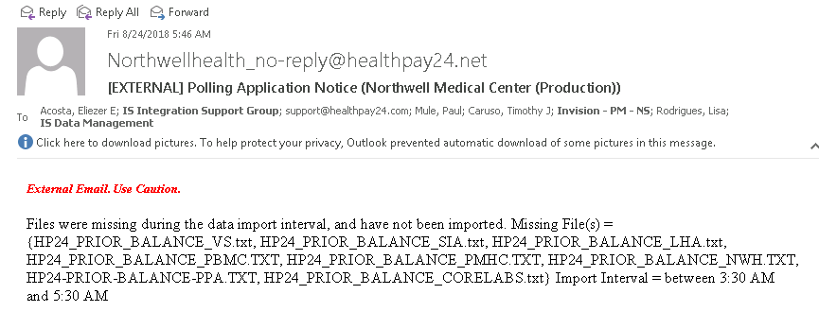

**Steps to follow :**

Please reach out to GOA on-call for any HP24 related issues.

**Cluster Management:**

Clustering allows two or more GoAnywhere MFT systems to work together to allow workloads to be distributed horizontally across multiple GoAnywhere MFT installations. In a clustered environment, two or more GoAnywhere MFT systems within a cluster can connect to the same product database and user files at the same time. This allows these systems to share security settings, trading partner user accounts, configurations, audit logs and other product tables. If one GoAnywhere MFT system fails, the remaining systems in the cluster will automatically continue to process workloads and file transfer requests. This active-active clustered environment also provides the best high availability option for handling potential system failures.

GoAnywhere servers:

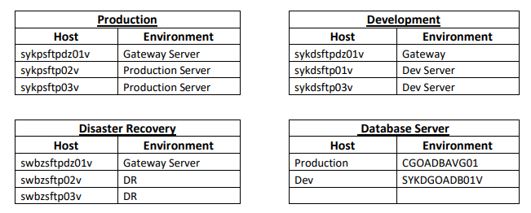

**GoAnywhere default clustering**:

Coordinator🡪 SWBZSFTP02V

Participant 1🡪 SWBZSFTP03V,

Participant 2🡪 SYKPSFTP02V,

Participant 3🡪 SYKPSFTP03V

**Note: If one GoAnywhere MFT system fails, the remaining systems in the cluster will automatically continue to service the trading partners. If a co-ordinator leaves the cluster, one of the participants will assume the co-ordinator role. The next co-ordinator is selected as per the “Round Robin” algorithm.**

.

**Alert: GoAnywhere Production Alert Coordinator Left Cluster**

Below is a flow of notification that will be received:

**When services go down:**

Gateway disconnected🡪Services down for the server🡪 Server leaves the cluster and participant assumes the co-ordinator role.

**When the services are restarted below notifications will be received:**

Server joins the cluster but now as a participant🡪Server is started🡪 Gateway connected

Below are the notifications received whenever a server is down and restarted again:

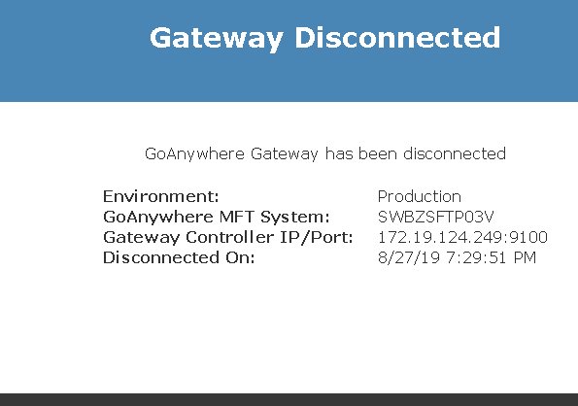

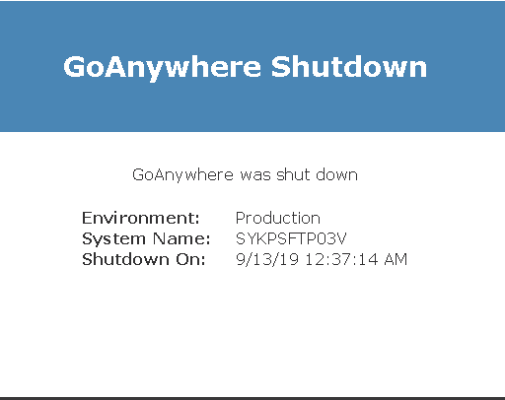

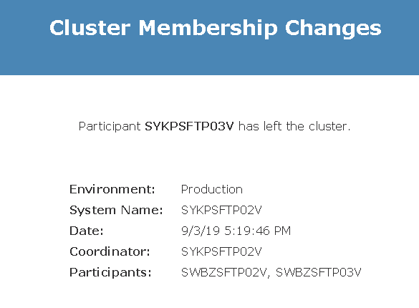

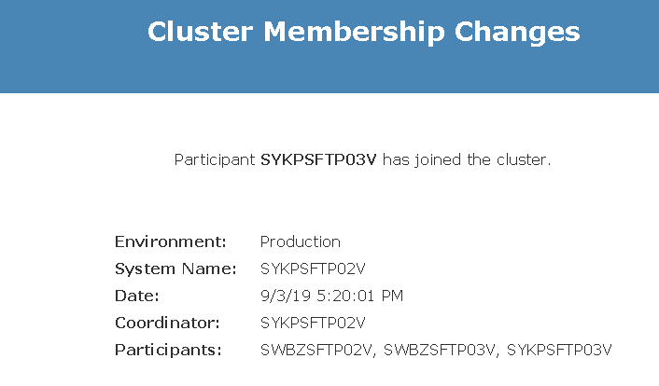

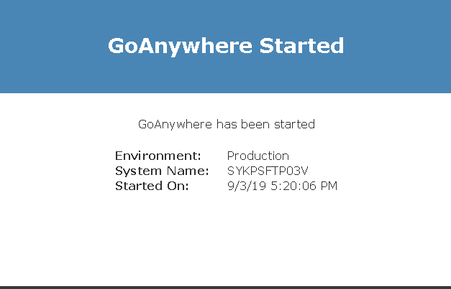

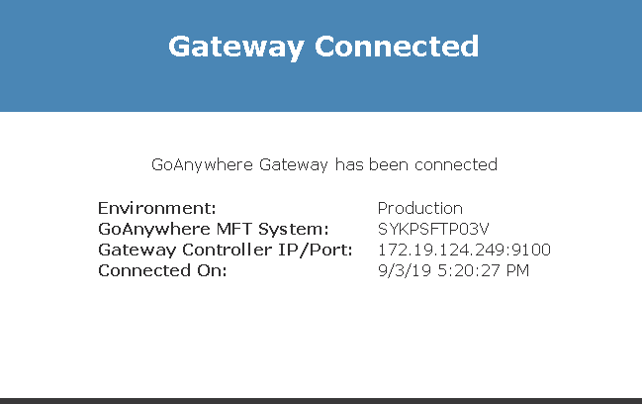

**Troubleshooting steps (to be done by Ops team):**

In case GoAnywhere services shuts down during off business hours, please follow below steps:

1. Wait for a minute. If you receive “GoAnywhere started” notification then check if the portal is working for the server for which the alert was generated.
2. If not, reach out to On-call support to troubleshoot and create a P3 incident and assign to On-call in “Acknowledge” status.
3. GoAnywhere on-call will verify the logs and find root cause and escalate if services need to be restarted.

|  |  |  |
| --- | --- | --- |
| Escalation | Resource | Email address |
| 1st Escalation | Oswal Pratik | Poswal@northwell.edu |
| 2nd Escalation | Abhishek Chaturvedi | AChaturvedi@northwell.edu |
| Onsite Escalation | Elhalaby, Hassan | HElhalaby@northwell.edu |
| Onsite Escalation Backup |  |  |

Note: Ops do not reach out to Onsite directly.

**GoAnywhere Database Maintenance Optimization Job SOP**

**Description:** Every Sunday a Maintenance job is ran at exactly 8 pm to check the health of the database. While the job is running the GoAnywhere MFT system and the database optimization job often fight for control of the database causing database blocking. Since GoAnywhere has jobs that run by the minute every day, there is no time frame effectively clear of jobs for this job to complete without interruption. In an effort to eliminate possible interruptions, please use this SOP moving forward until a more permanent solution (automated) is in place.

Step 1 – At exactly 7:50 PM on Sunday, please stop all GoAnywhere Engines. DO NOT stop services. Only the engines should be stopped. All 3 Engines should be stopped (Scheduler, Triggers, and Monitors)

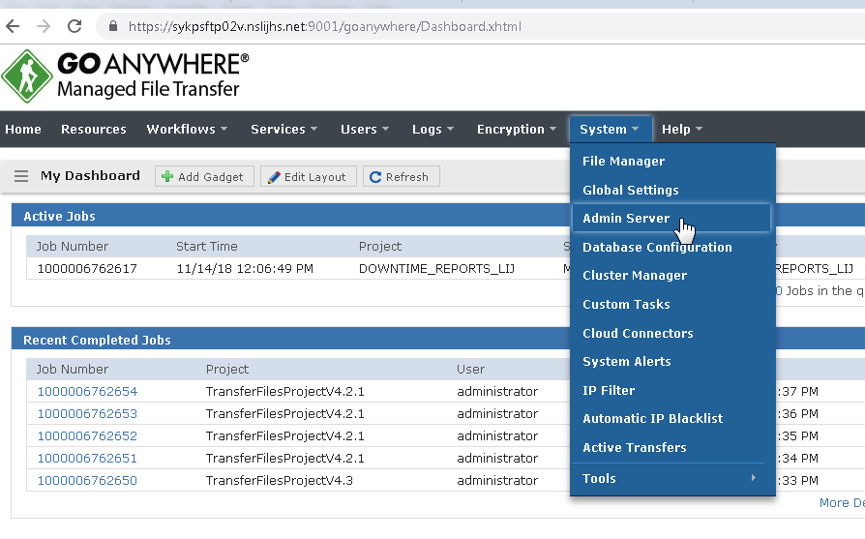

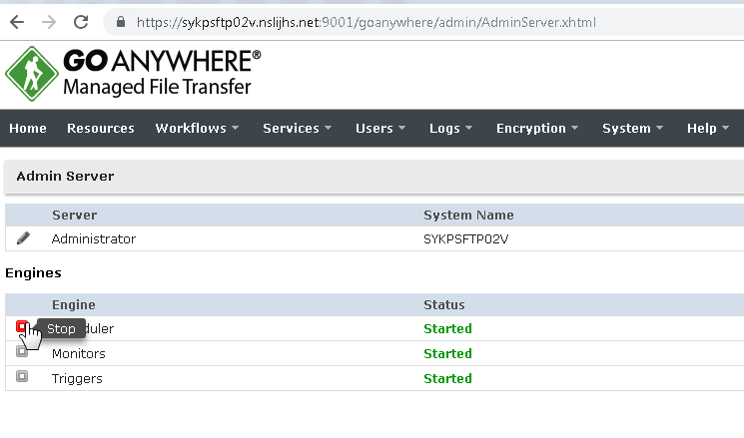

Step 2 – The maintenance job completes in approximately 30-35 minutes. An email of this format will be sent to IS Integration Support Group when the maintenance job is completed.

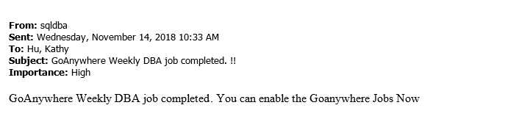

Step 3 – After the email is received, start engines again promptly. If you do not receive an email no later than 8:45 PM, please send an email to the DBA Team requesting more information on whether the job succeeded or not.

Conclusion: This will be a temporary solution until a more permanent fix is available (Automated Scheduled Engine Halt) - ASEH

THE END