

HiE Monitoring tool

SOP Document



January 1, 2024

Northwell Health

**Table of contents**

1. Homepage
2. Manage Incidents
3. Monitor

* Inbound Inactivity
* Queues
* Scheduled Tasks
* Database Size
* Mirror Status

1. Production Items
2. IP Port List
3. Galileo
4. Administration

* Do Not Monitor
* Alert Rule
* Action Group

**How to check Productions Items, Queues, and inactivity in HMT**

Log in to the **Monitoring Tool** with Northwell Credentials using the link below –

[**https://monitoringtool.northwell.io/dashboard**](https://monitoringtool.northwell.io/dashboard)

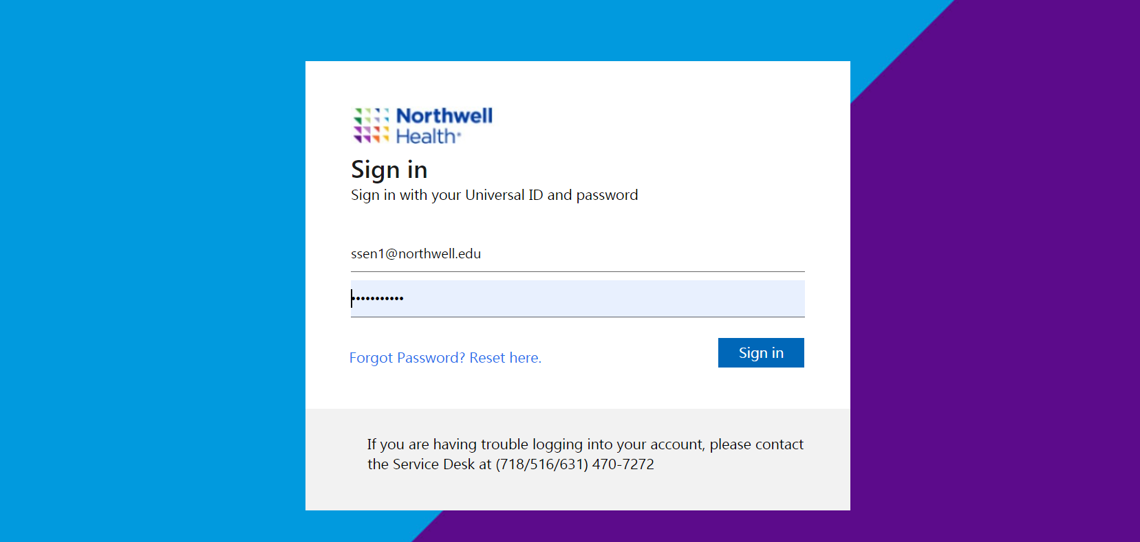

You will find the below **Home Page** –

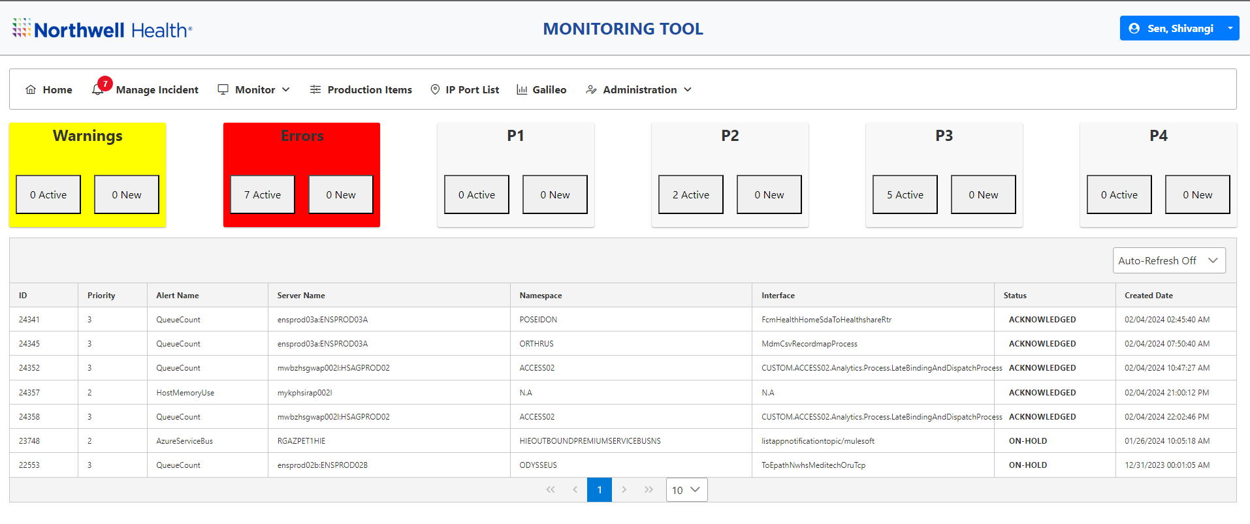

Table of Contents

**MANAGAE INCIDENTS:** **HOME**

Click on **the Manage Incidents tab** in the navigation bar, then you will get the page given below.

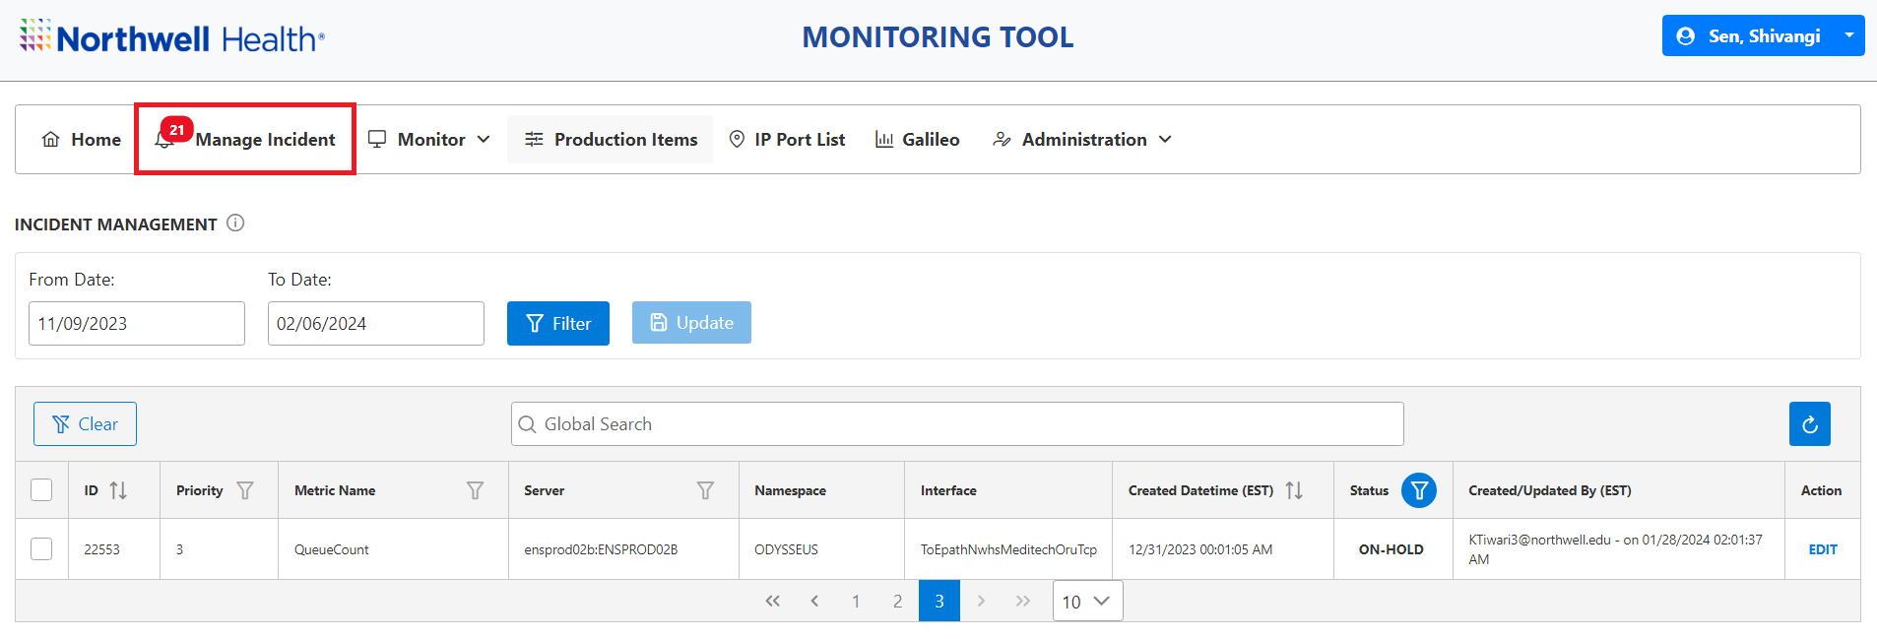

Select the date criteria in **from** (Start Date) and **to** (End Date).

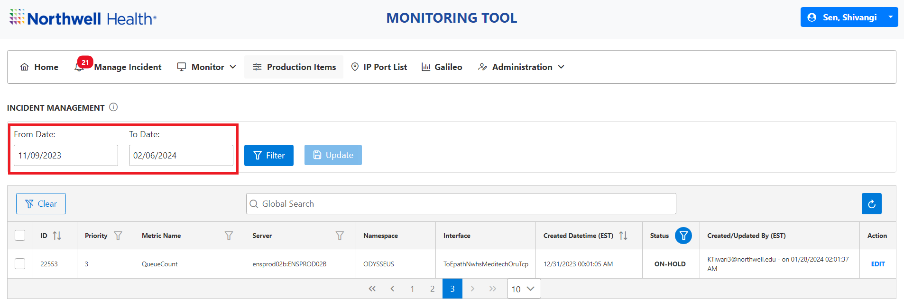

If you click on the **filter** option, you will be able to see the incidents related to the particle date you had chosen.

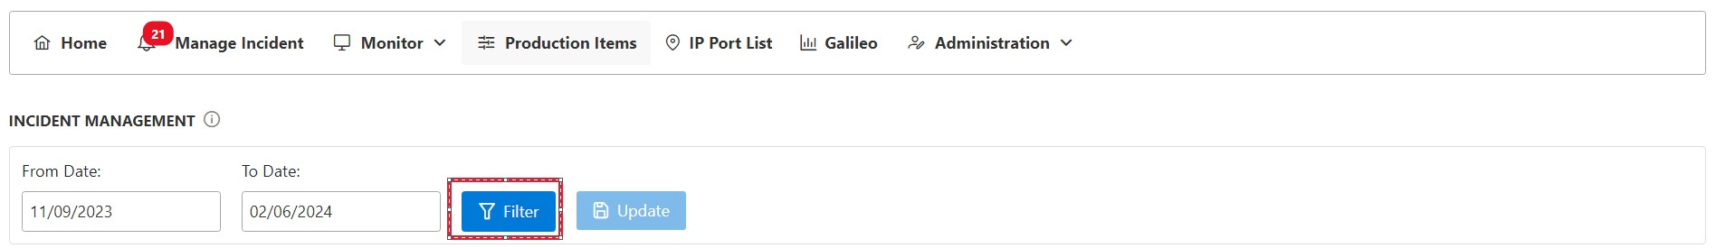

Next, we have multiple options highlighted below:

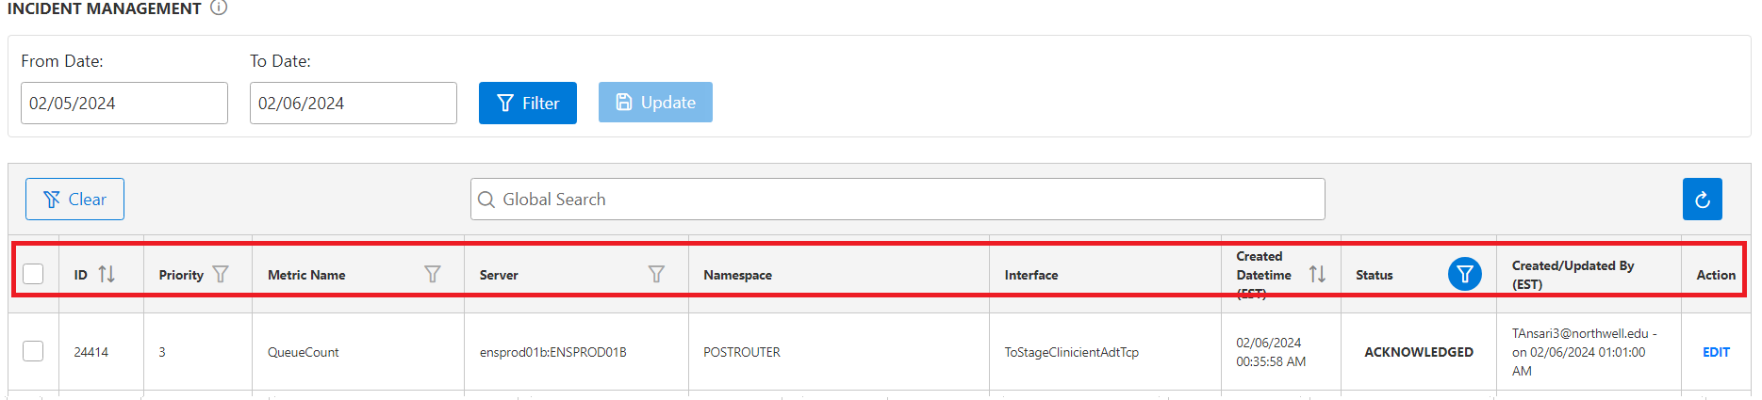

**Status:**

Here you can check ongoing events, for example –

* + If any interface is down, we already have an active ticket for it.
  + If any interface has pending queues, it will appear in the Incident Management section.
  + Also, if we receive any P2 alert related to Server Storage, Azure, Cache Production and Cache Locks process it will be visible in the Incident Management section.

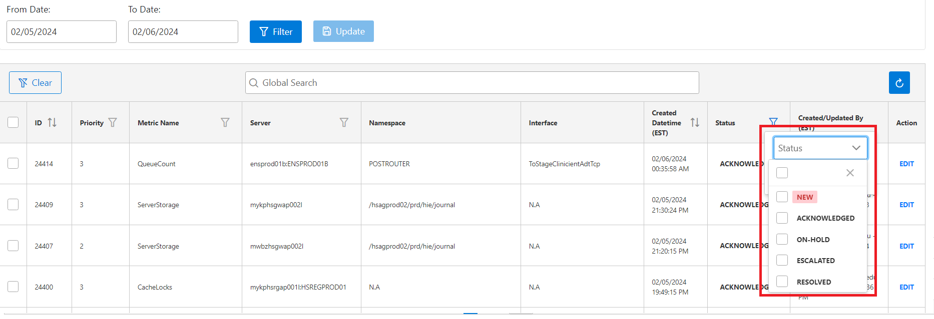

If we receive any alert on email and HMT it will be reflected in the **NEW** status.

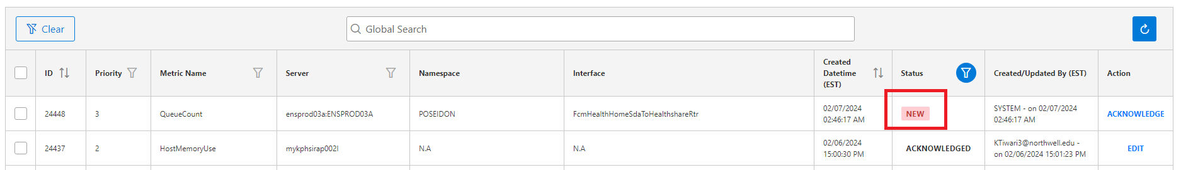

Click on **Acknowledge** and then you can update the status.

You also have the option to **edit** the status.

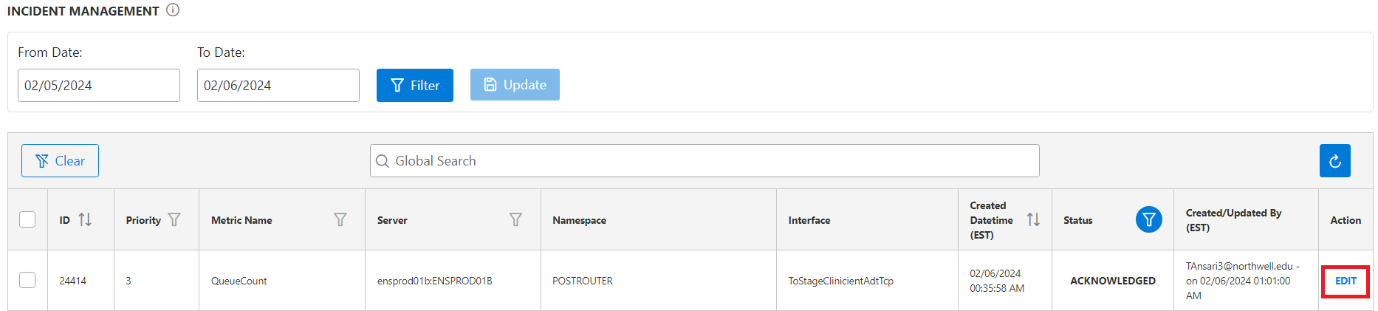

Click on the **edit button**. This will open a window where you can select the status **(On Hold, Escalated and Resolved).**

* For example: If the queues for an interface have been processed successfully then we can select the **Resolved** option and mention the same reason in the box.

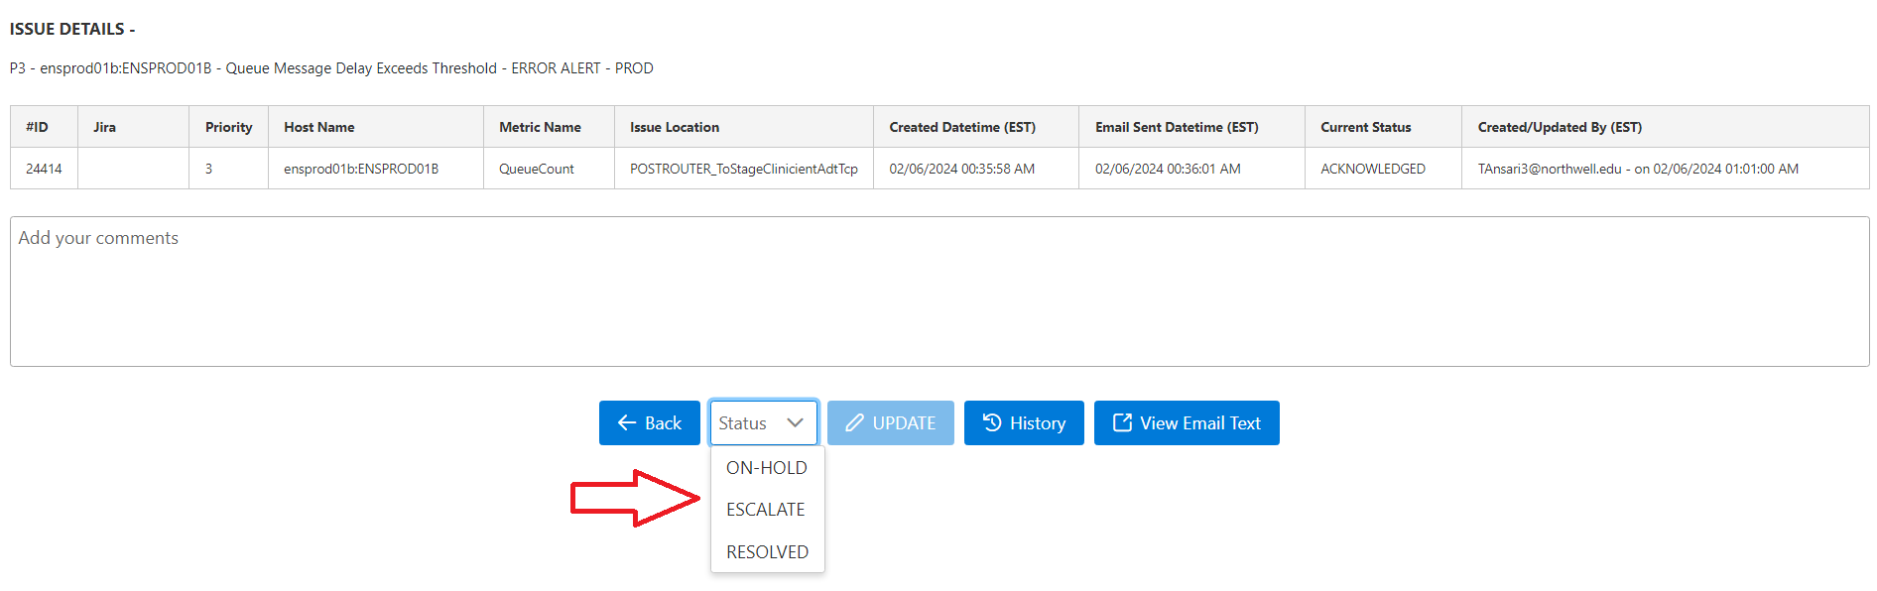

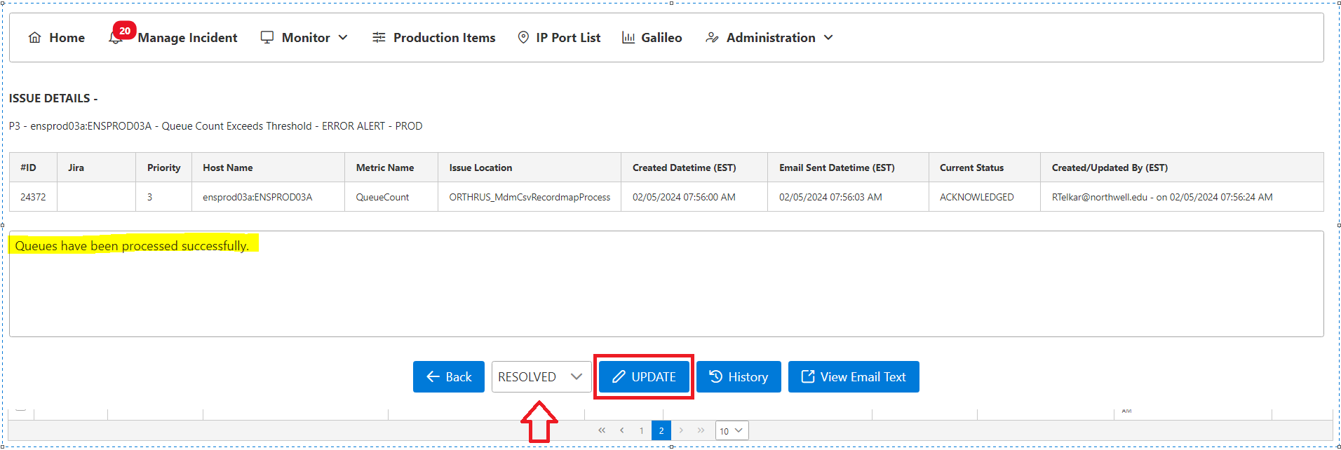

This will automatically generate the box to double check then we can click on the **OK** button to confirm.

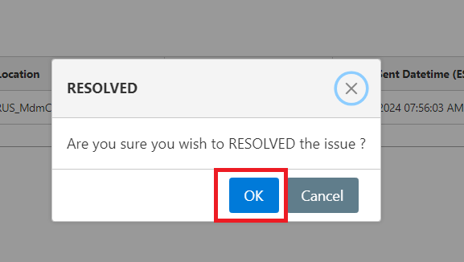

After this you will get the message of success for status updating on the top right corner. See the screenshot below-

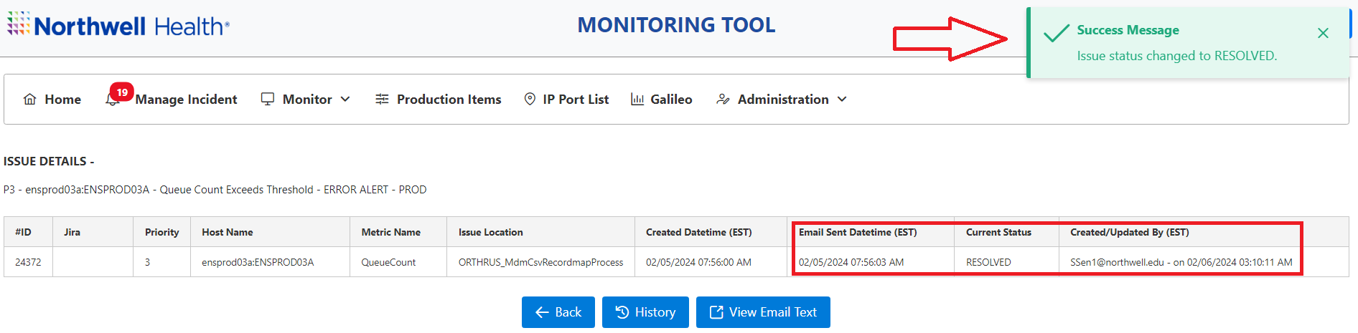

It will also give you the option to review the history related to that interface.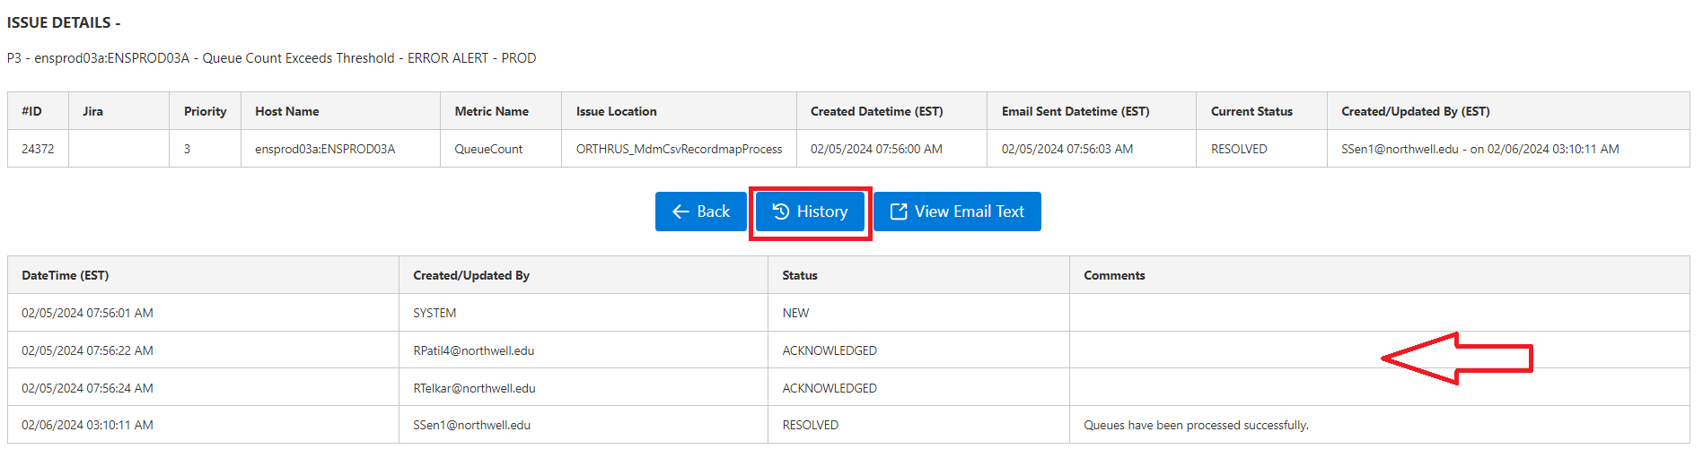

******************

Table of Contents

**MONITOR:**

Click on the Monitor Tab in the N

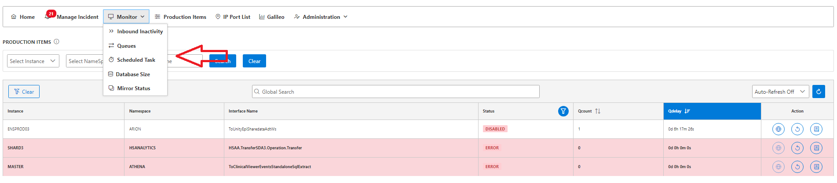

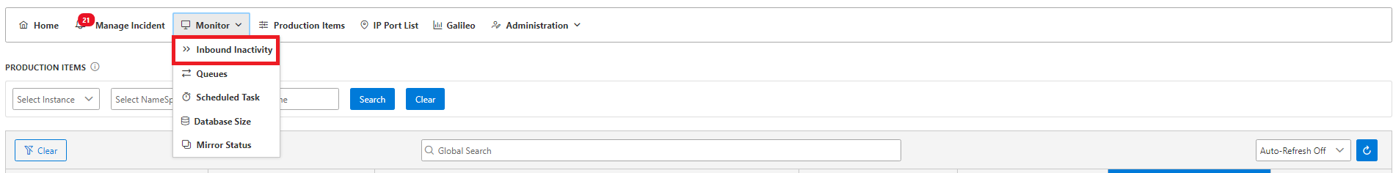

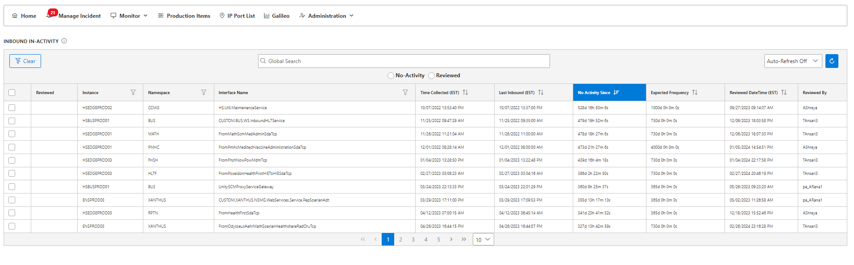

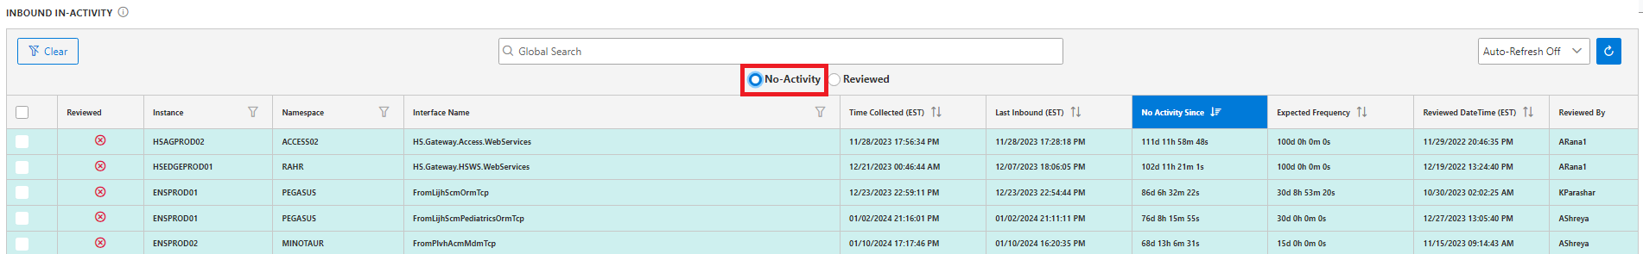

Reviewed

Instance

Namespace

Interface Name

Time Collected (EST)

Last Inbound (EST)

No Activity Since

Expected Frequency

Reviewed Date Time (EST)

Reviewed By

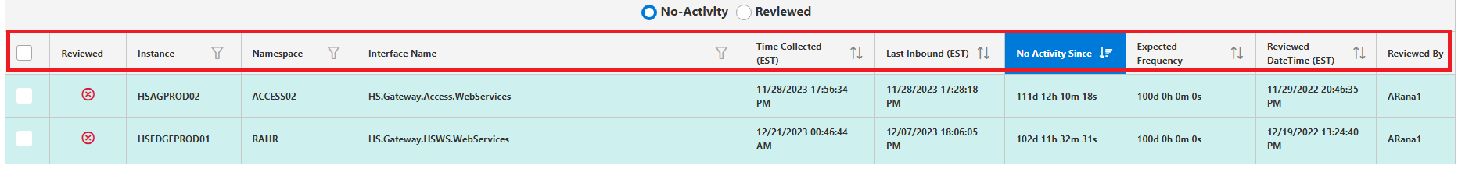

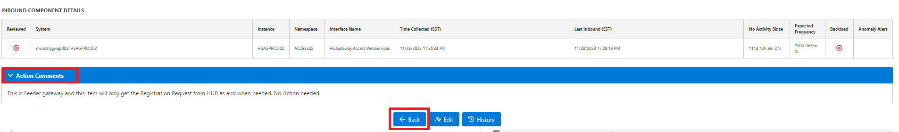

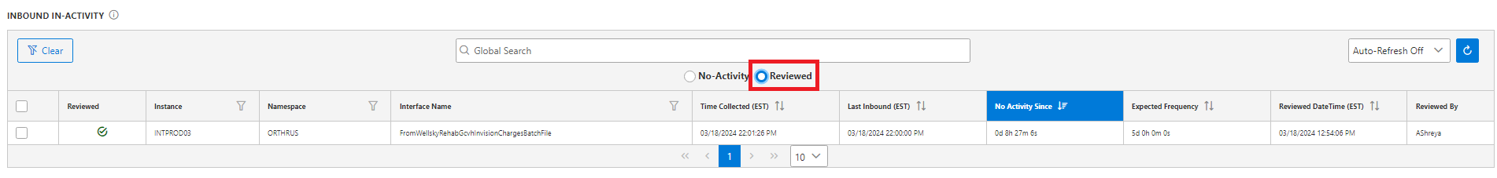

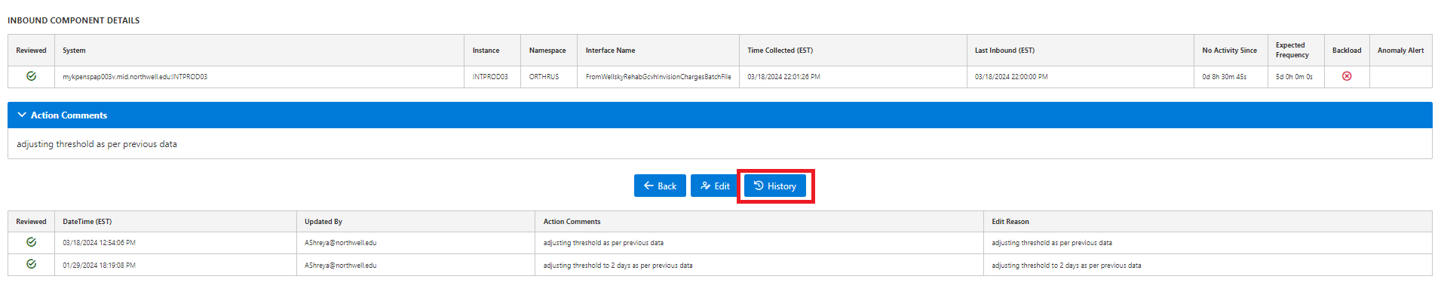

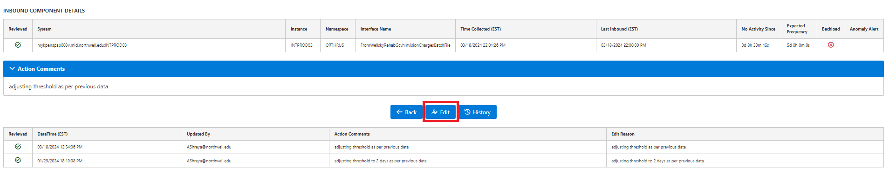

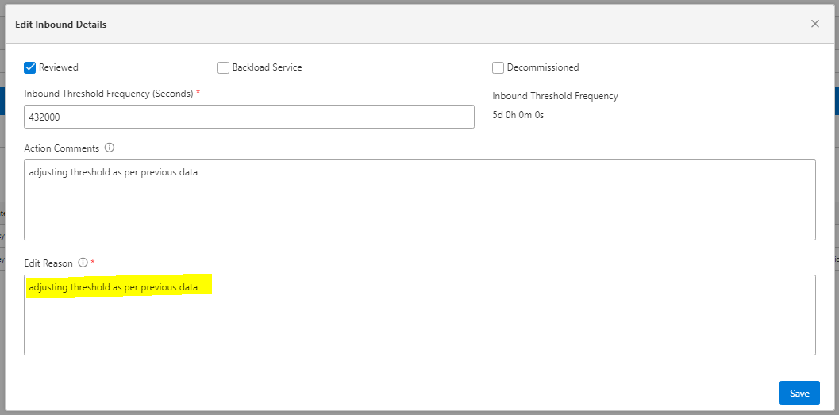



**PRODUCTION ITEMS:**

Click on the **Production Items Tab** in the Navigation bar, then you will get the page given below.

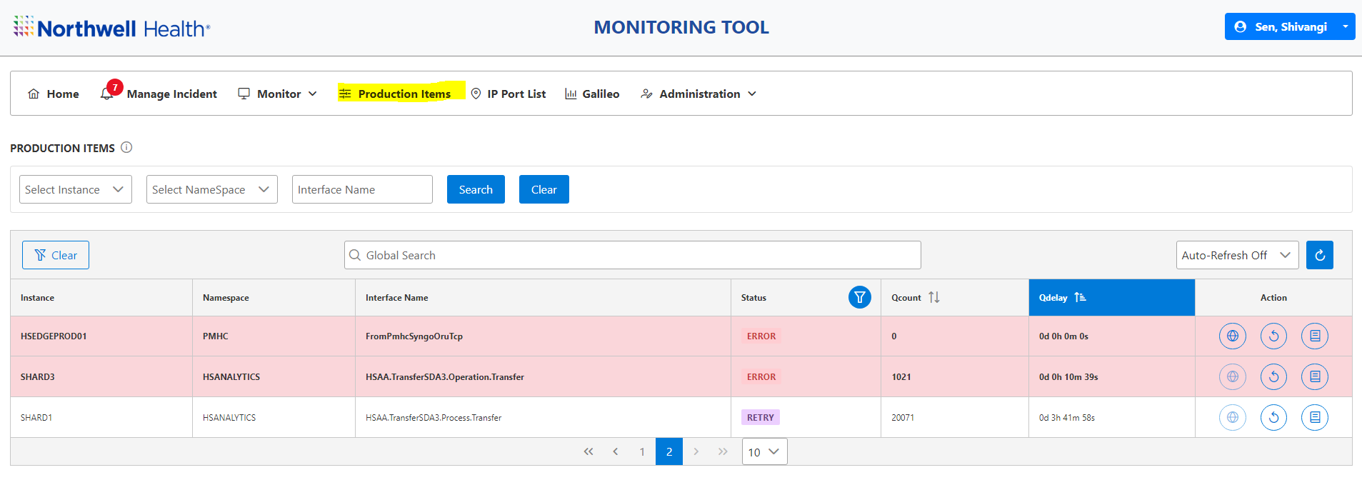

Here you can see the details given below under multiple columns.

* **Instance:** This option will show you the name of the server.
* **Namespace:** This option will show the namespaces associated with that server.
* **Interface Name**: This option will show the name of the interface.
* **Status:** This option will show you the status of the interface if it is in enabled and disabled state.
* **Queue-Count:** This option will show you the exact queue count of the interface if it goes down.
* **Q-Delay:** This option will show you the exact time since the interface was down **(disabled).**
* **Action**: Using this option, you can directly recycle the interface. 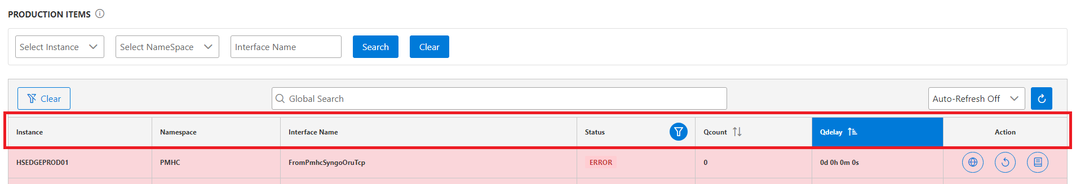

**Global Search:**

Here you also have Global Search option using which you can directly locate the interface status.

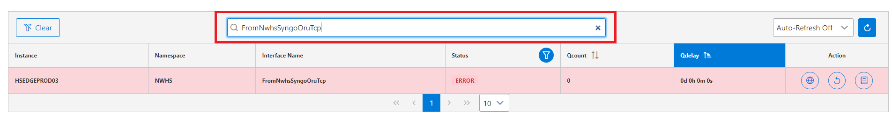

Table of Contents

**Auto-Refresh:**

In HMT (HIE (Health Information Exchange) Monitoring Tool), you have an auto-refresh option.

Here you can set the time to refresh the production page, you have multiple time limits like 1, 5, 15 and 30 minutes.

You can also turn off this feature by selecting **Auto Refresh Off** option and then you can manually refresh the production page.

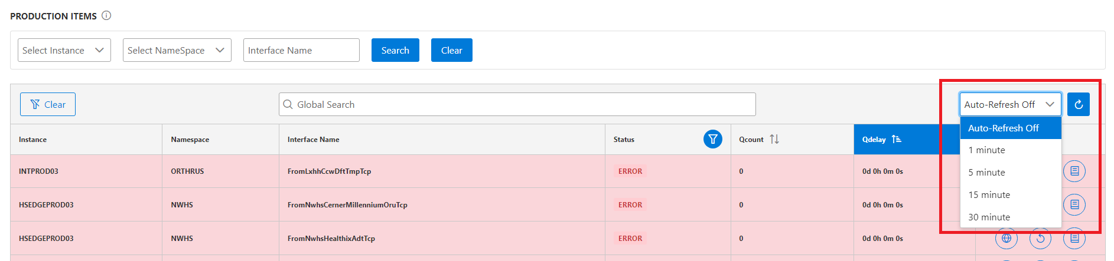

Select the server’s name from drop down menu and click on the search button. Then you will be able to see the interface details related to that server.

Here you can also select the namespace for which you want to search the interface details.

Click on the search bar.

You can also manually enter the interface name to find the details.  
  
  
  
 Table of Contents

**Clear Button**:

By using this option, you can clear the details entered in the drop-down menu.

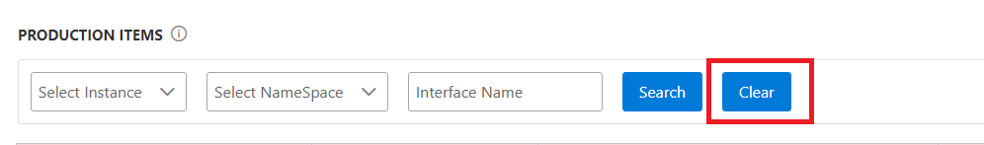

**Status Tab:**

Click on the **Status Tab** then you will get several options in the drop-down menu from where you can check the status of the interface.

* Disabled – This option will show you the interfaces that are in disabled state **(Down).**
* Enabled – This option will show you the interfaces that are running properly.
* Error – This option will show you interfaces that are in error state **(For ex: Connection/Message and Cache error)**
* Inactive – This option will show you interfaces that are in an inactive state **(Note: you will not get live data for that interface).**
* Retry – This option will show you the interfaces that are in retry state **(Note: You can directly recycle that interface in HMT).**
* Unconfigured – This option will show the newly launched interface and no configuration has been done to it at that time. **(Note: We can ignore this part).**

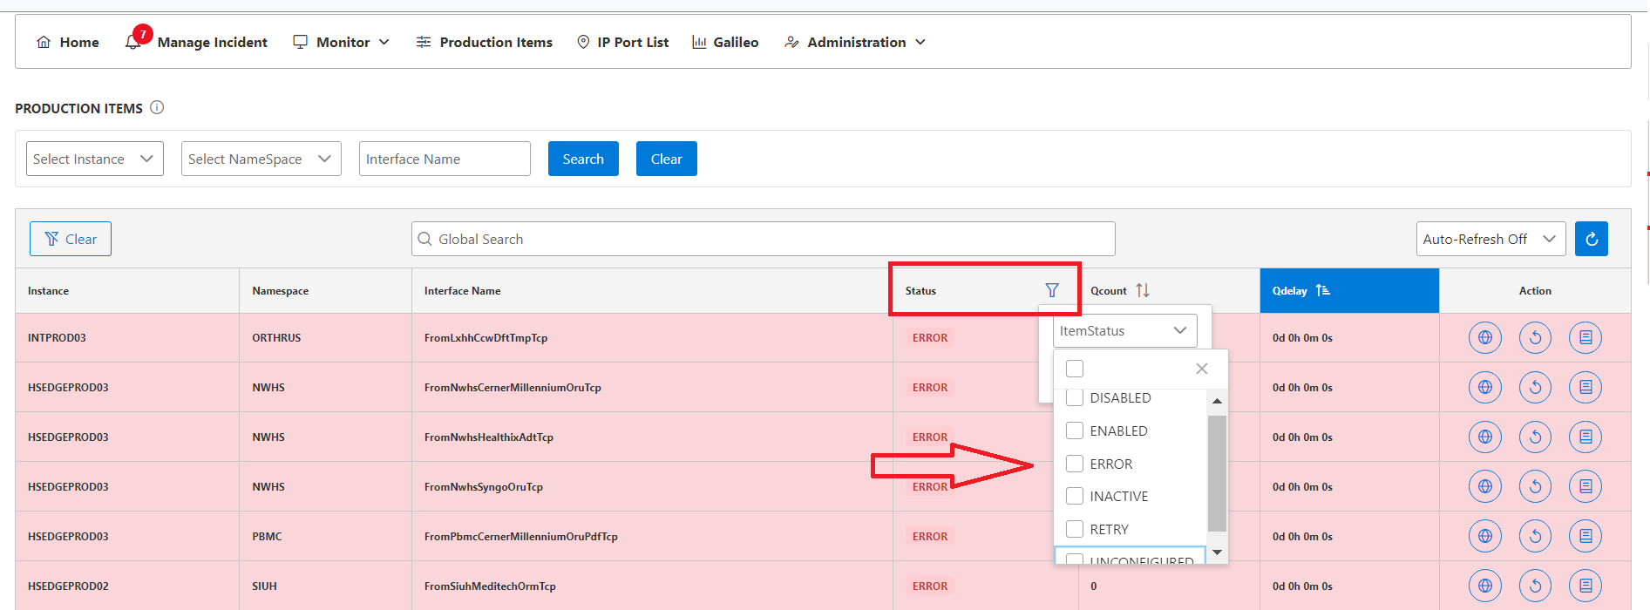  
 Table of Contents

**Action Tab:**

In this step, you can see the option named **Action** on the right side.

Click on the first option highlighted below, this will take you directly to the **IACL** where you can find the interface's priority and other useful details.

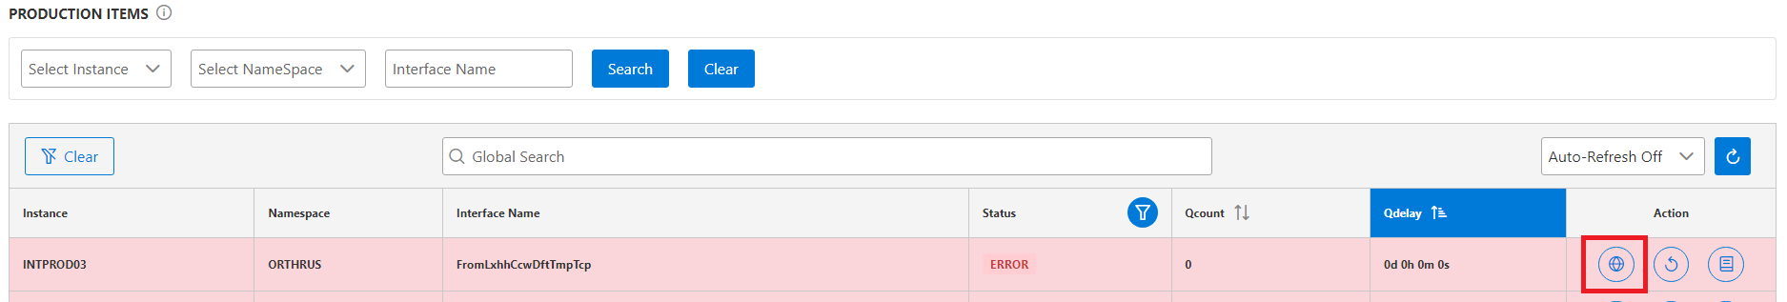

After this, when you click on the second highlighted option, the interface will recycle directly without going to the server.

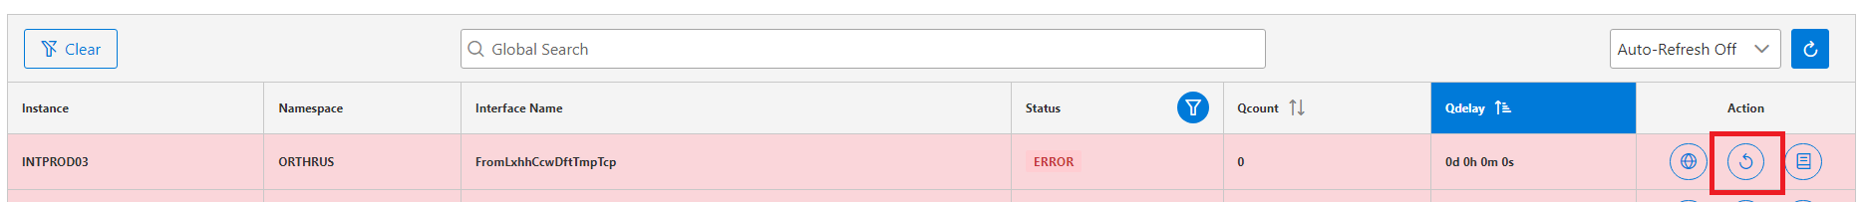

Using the third option, you can check the logs.

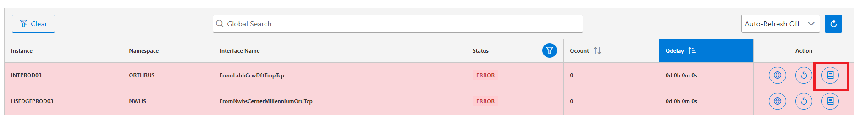

Table of Contents

Click on the Logs icon, it will automatically open a separate box in which you can see the log type and date to get the details.

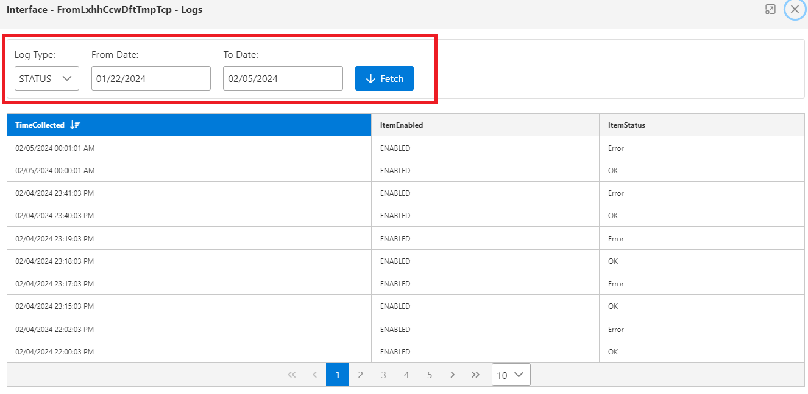

In log type you have two options, first is **status** and second is **recycle.**

* Click on the **Status** button and then select date criteria in **from** (Start Date) and **to** (End Date).
* Next click on Fetch button, it will show you the status details.

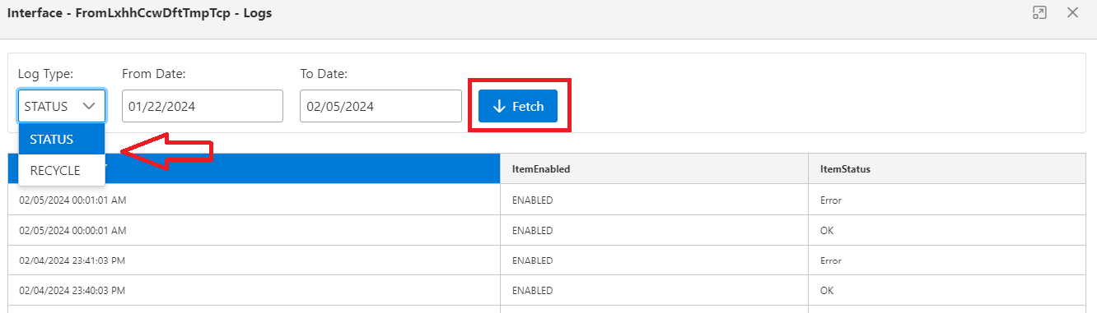

After this you can select the **Recycle option** from the drop-down menu.

* Select the date in the From and To option and then click on the Fetch button.
* It will show you the recycle status of who recycled the interface and at what time.

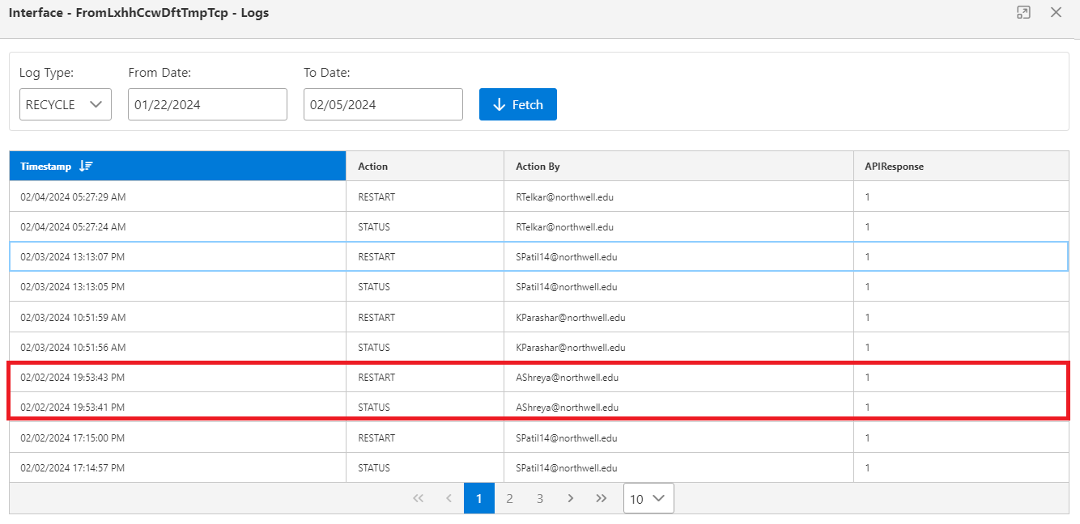

******************

**IP PORT LIST:** **HOME**

Click on **IP Port List** **Tab** in navigation bar, you will get below page.

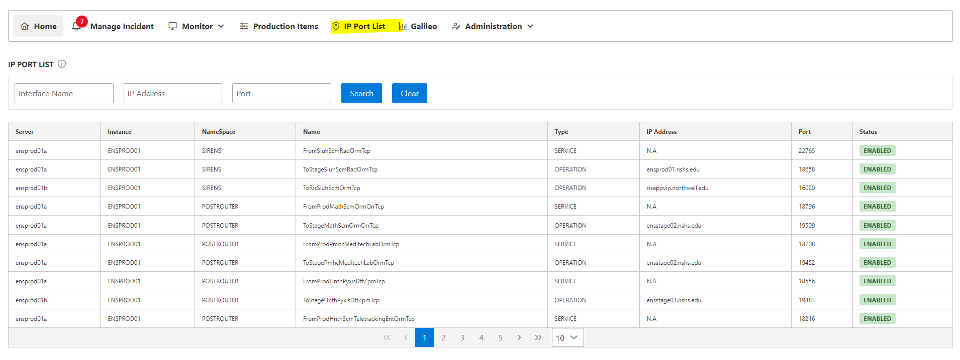

In the search bar, you can manually enter the interface name.

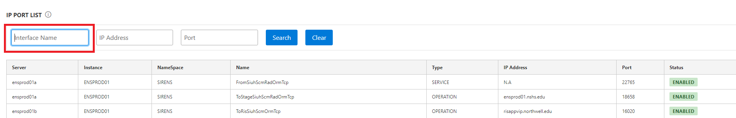

Enter the interface name and then click the **Search** button. You will find the interface details mentioned below:

* Server – This option will show you the name of the server in production.
* Instance – This option will show the server instance.
* Namespace – This option will show you the namespaces associated with that server.
* Interface Name – Using this option you can check the interface description.
* Type – This option will show the type **(for example – Operation)**
* IP Address – This option will show the IP address for that interface.
* Port – This option will show you the Port details for the interface.
* Status – This option will show you the status of the interface **(disabled and enabled).**

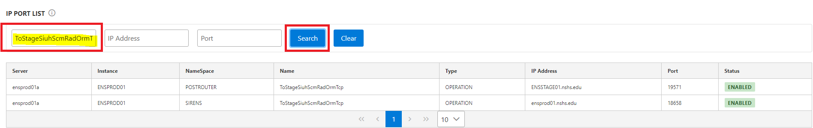

Now you can see the IP address and port details below:

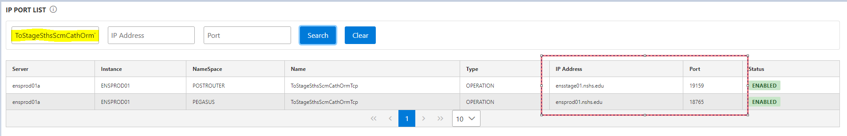

You can also enter **IP Address** and **Port** on the search column and then find the interface details given below.

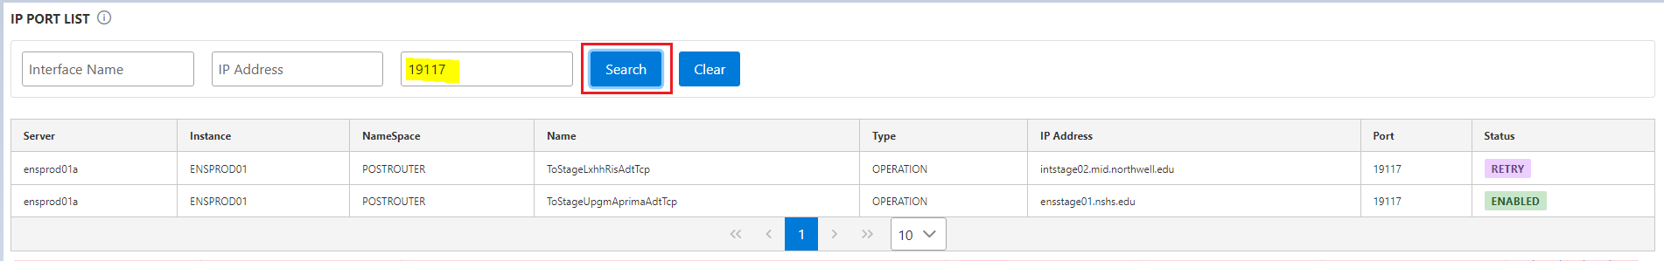

Table of Contents

******************

**GALILEO:** **HOME**

Click on **Galileo Tab** in the navigation bar, you will get the below page.

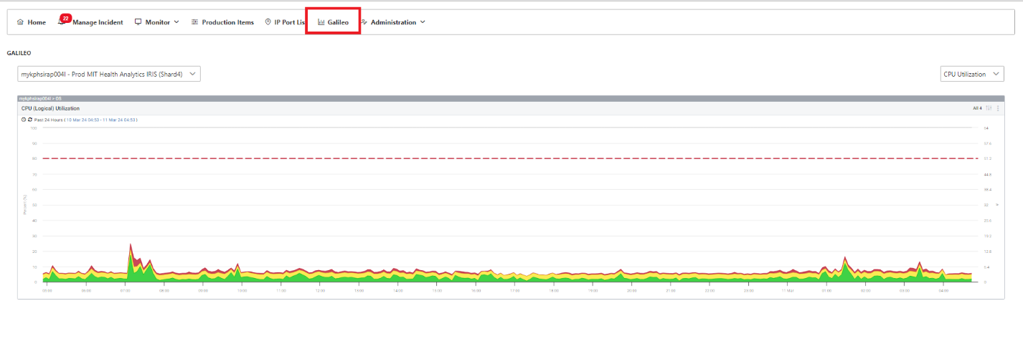

On the right side, you will find a drop-down menu with the following options available.

* CPU utilization.
* Memory usage percentage.
* Host file system percentage used.

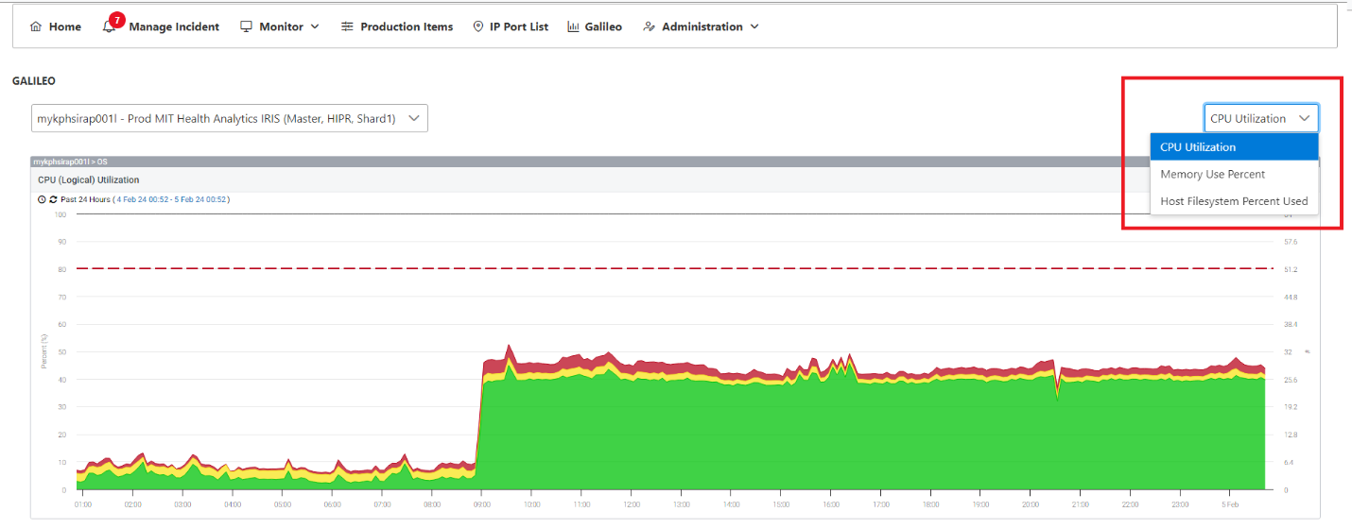

**Memory usage percentage -**

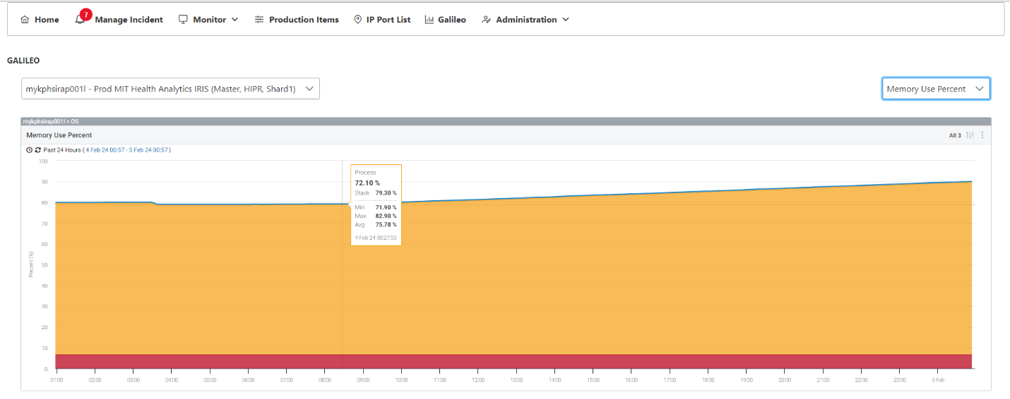

**Host file system percentage used -**

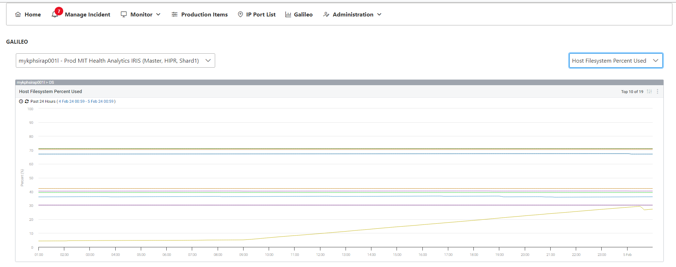

In the next step you will be able to see several options including the name of the server on the left menu.

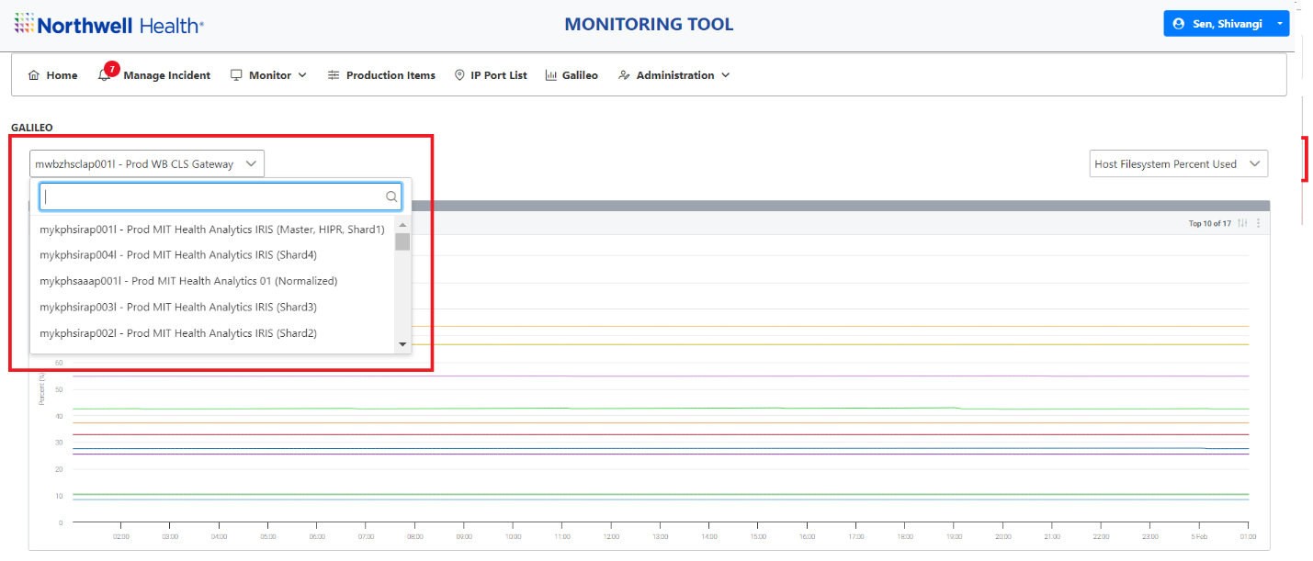

****************** Table of Contents

**Administration:** **HOME**

Click on **the Administration Tab** in the Navigation bar, you will find the drop down below.

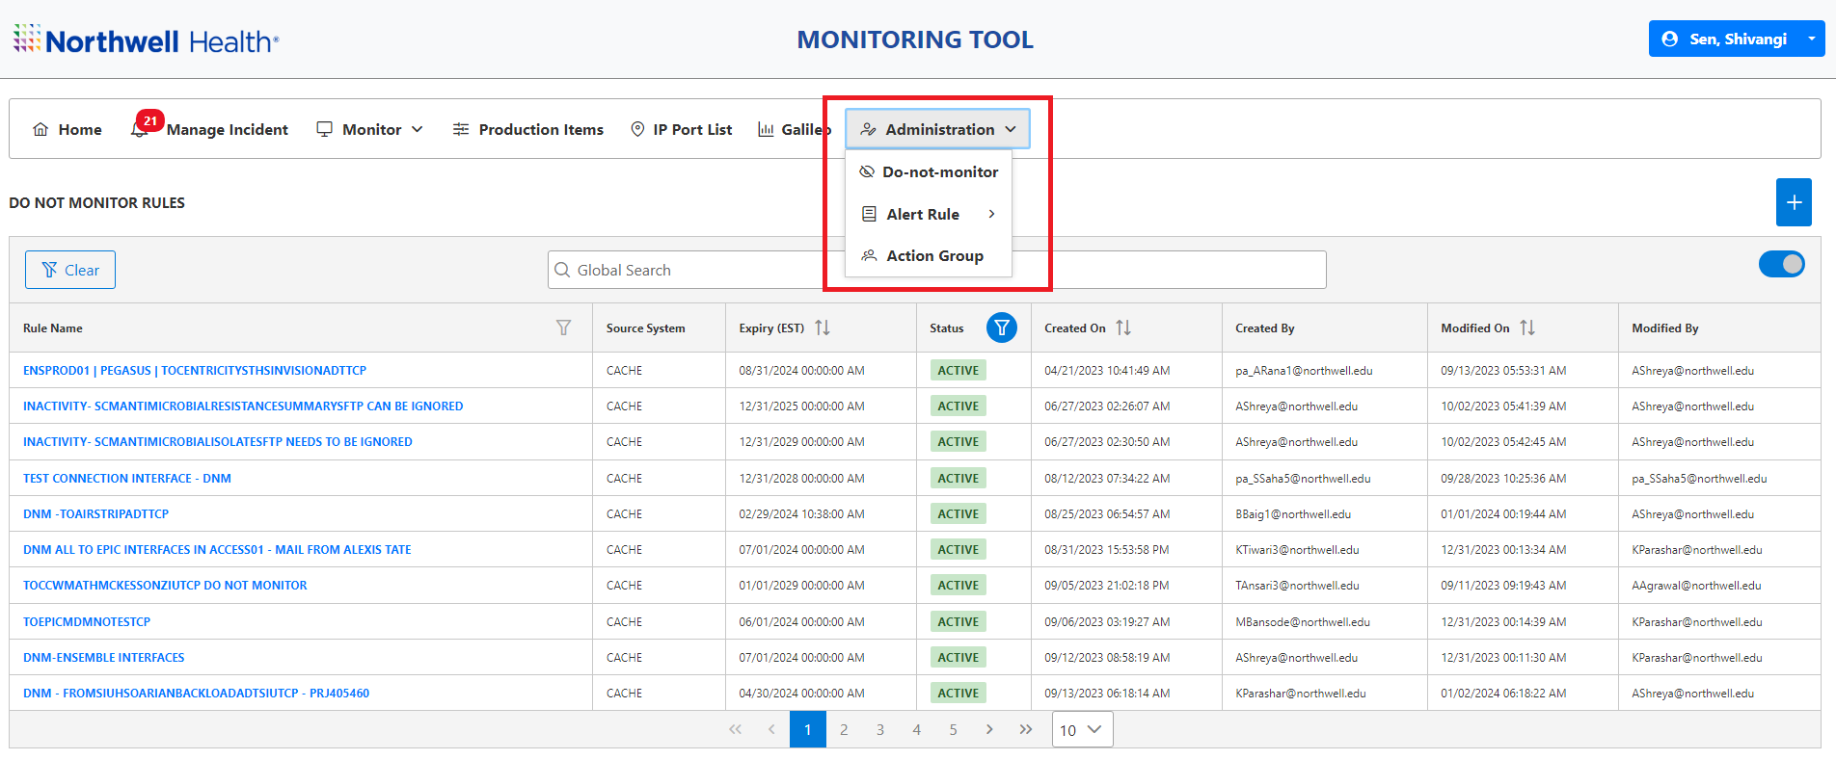

Click on **the Do-not-monitor** option.

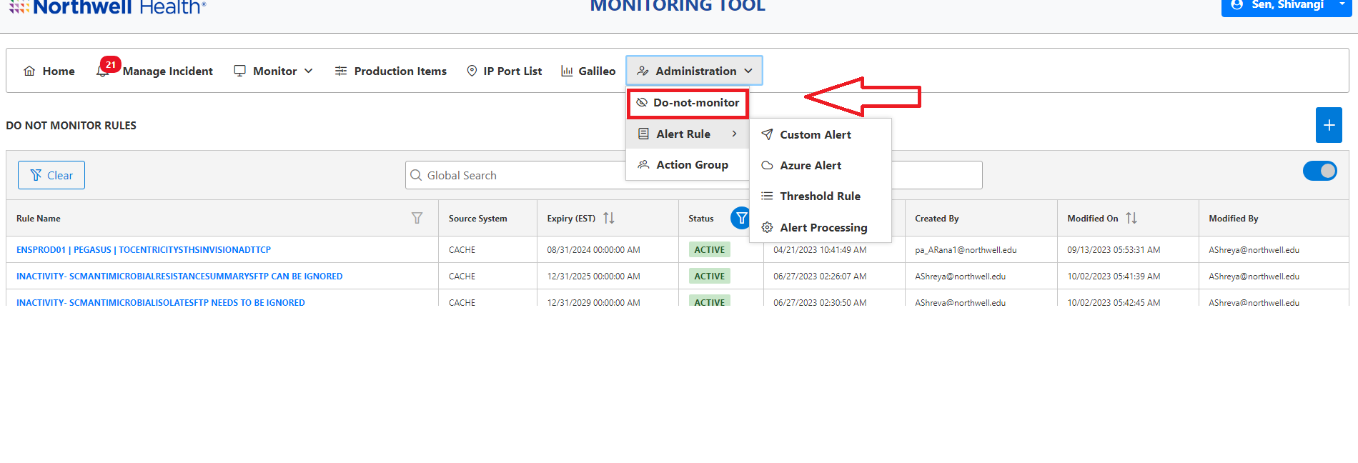

Here you will find the **Status** button where three options are available.

**Active, Inactive & Expired.**

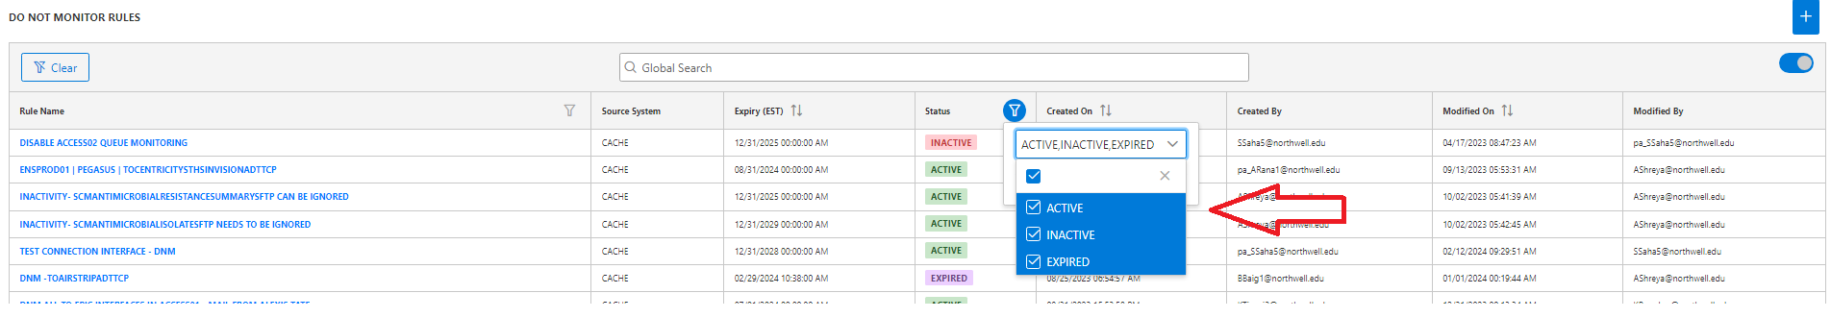

To make the new DNM rule, click on the given **+** button on the right.

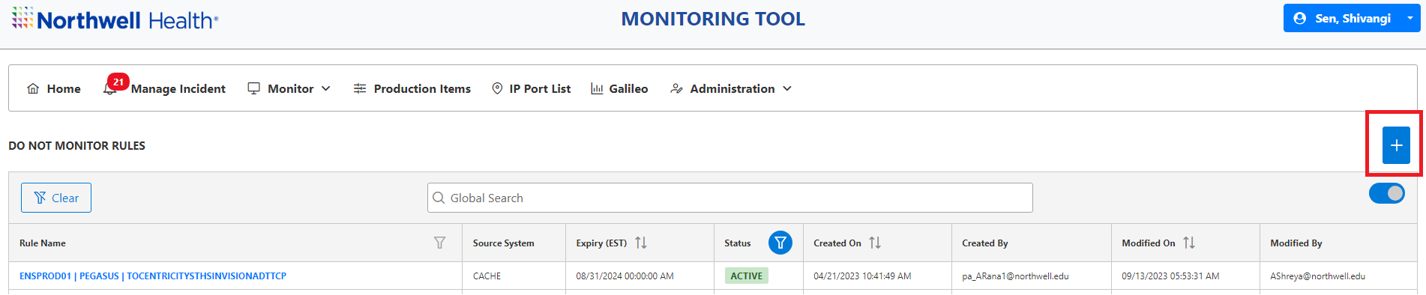

You will then get the page below.

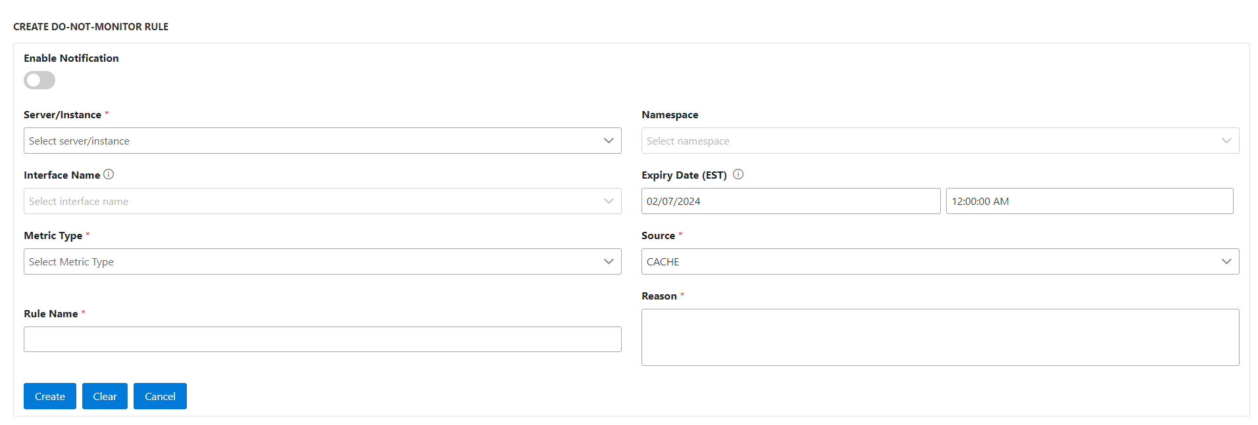

Now fill in the required details as shown below to add the interface to DNM.

* Server/Instance - Select the Server/Instance **(Ex: Ensprod01/ Hsagprod01)**
* Namespace - Add the Namespace of interface **(Ex: Arion/Sirens/Minotaur)**
* Interface Name - Add the Interface name from the dropdown menu.
* **Expiry Date (EST)** - If the interface is disabled for the specific period, select that specific date.
* Metric Type - **Select all** the options to disable the alerts for the interface.
* Source - Usually we select Cache option to add the interfaces in DNM.
* Rule Name - Enter the Rule Name **(For Ex: DNM ALL TO EPIC INTERFACES IN ACCESS01)**
* Reason - Add email details or updates that we received regarding the interface.

Check all the entered details and then click on **Create** button to submit the DNM rule.

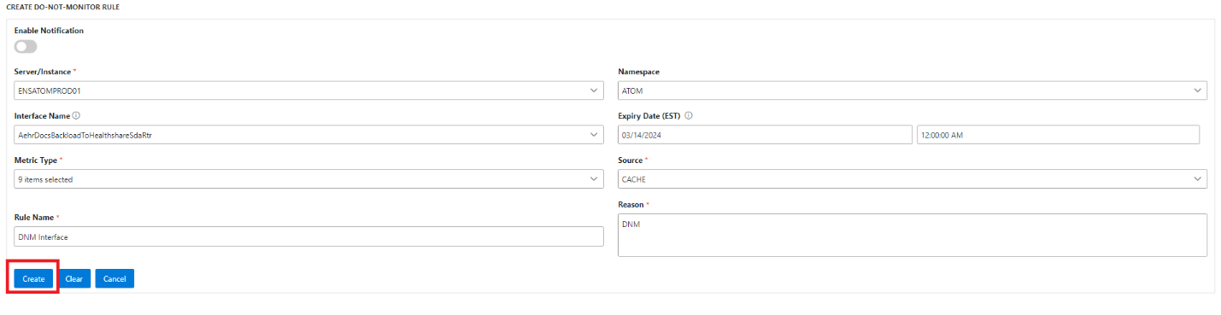

Once you have successfully completed these steps, you will find the interface in the DNM list and will be removed from all the Monitoring Tool Alerts.



If you want to start monitoring the interface again then to remove the interface from the DNM list you can simply change the date and time, then it will be removed from the active DNM list.

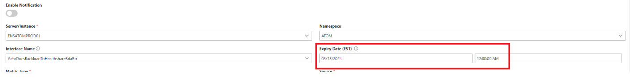

Refer the screenshot below:

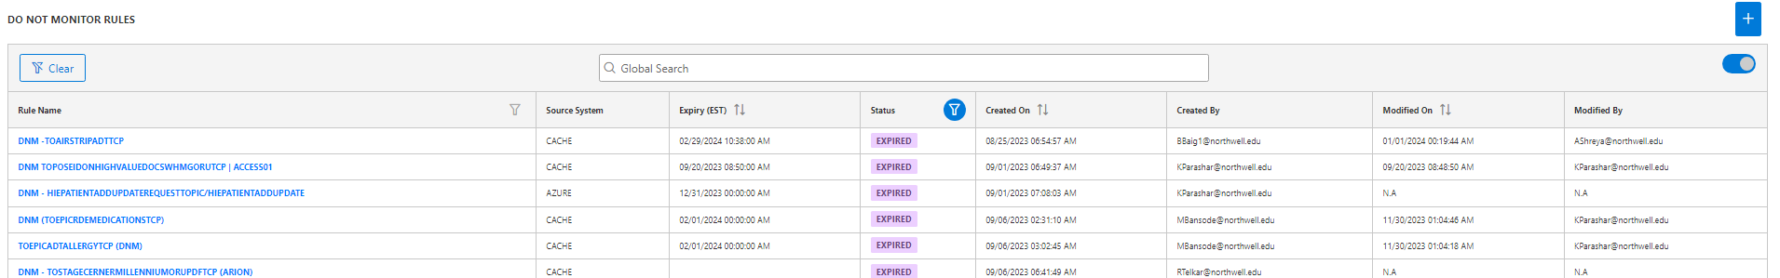

******************

**DAILY CHECKES FOR HMT –**