**LIST OF ISSUESB AT CURRENT PHASE ON WEB PORTAL AND MOBILE APPLICATION**

1. Currently, Web Portal running on Public View [ http://117.247.91.44:8080/ezdebt/public/login ] and Local View [ http://192.168.0.200:8080/ezdebt/public/login ] but we are facing uncertain issues in Web Portal.

After entering User Name & Password in Web Portal Login Page. Portal showing blow error page.

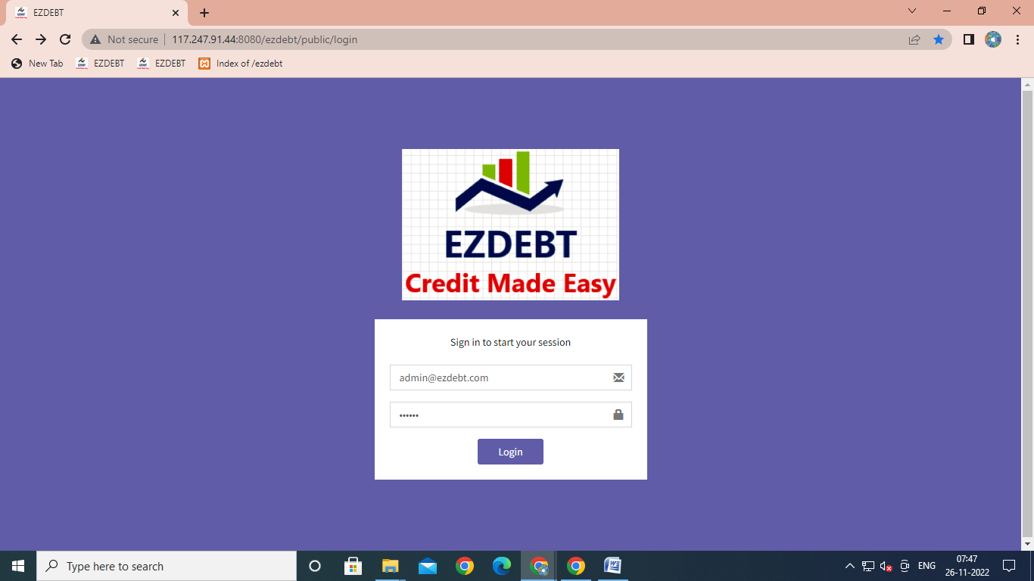

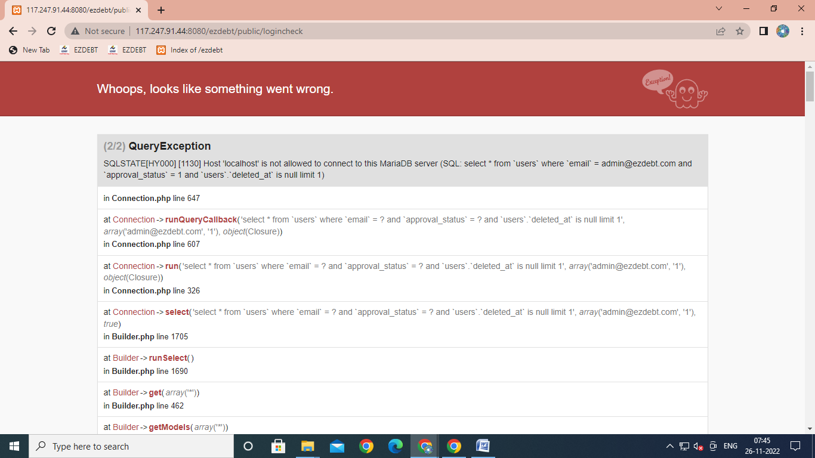

This issue was not earlier. Recently, this issue occurred.

User Name – [admin@ezdebt.com](mailto:admin@ezdebt.com)

Password – 123456

1. Cases Uploading issue. For same above User

User Name – [admin@ezdebt.com](mailto:admin@ezdebt.com)

Password – 123456

Once Cases Upload on Portal then after same Cases Update and upload again from same user account where customer name is same but categories are get updated not reflecting

For Example – At First Time Upload Category for particular Customer was Not Picking Up Call and At Second Time Upload same Category convert to Settlement.

1. Upload cases using Excel Sheet from as mention above User Account have limitation of records up to 500 cases only if User want to upload more then 3000 records using excel sheet then Web Portal not allowing.
2. Currently, Web Portal running on Public View [ http://117.247.91.44:8080/ezdebt/public/login ] and Local View [ http://192.168.0.200:8080/ezdebt/public/login ] but it is not fully use because of the mobile application is not working which was working earlier.

Current Static IP Address – 117.247.91.44

Old Static IP Address – 117.218.185.90

1. Currently, in Web Portal Database not opening which was opening earlier?

