|  |
| --- |
| C2C Marketplace |
| Architecture Design Document |
|  |
|  |
| **<<date>>** |
| **<<architect>>** |

This document is an Architecture Design Document for developing **C2C Marketplace**.

Revision History

|  |  |  |  |
| --- | --- | --- | --- |
| Version | Date | Author | Description |
| 0.1 | <<date>> | <<architect>> | Initial document creation |
|  |  |  |  |
|  |  |  |  |
|  |  |  |  |
|  |  |  |  |
|  |  |  |  |
|  |  |  |  |
|  |  |  |  |

1. Overview 3

2. Requirements 4

2.1. Functional Requirements 4

2.2. Non-functional Requirements 4

2.3. Quality Attributes 5

3. Architecture 6

4. Modules 7

Appendix 8

A. Domain Model 9

B. Quality Scenarios 10

C. Quality Scenario Analysis 11

D. Candidate Architectures 12

E. Candidate Architecture Evaluation 13

F. Architecture Design 14

G. Architecture Evaluation(ATAM) 15

# Overview

// A1. System Definition

// C1-1. Is the defined system boundary clear?

// C1-2. Is there sufficient explanation of the system’s operation and business environment as business drivers?

* 1. **Introduction**

A Customer-to-Customer (C2C) Marketplace is a platform that allows users to **safely buy and sell** both used and new products. At a high level, a C2C marketplace:

1. **On-boards and verifies** buyers & sellers (authentication, KYC, fraud checks, peer ratings, policy Compliance).
2. **Publishes and Discovers listings via** content moderation, catalog indexing, advanced search, and personalized recommendations.
3. **Enables Communication and Negotiation flows** between buyers & sellers (secure chat, offers/counter-offers, order initiation).
4. **Offers Moderation and Fraud Detection** across listings, messages, and payments (image/text moderation, ML-based risk scoring and dispute resolution).
   1. **System Definition**

Customer (C2C) Marketplace is a platform that allows users to **safely buy and sell** both used and new products. At a high leveldasdaf akjfdsghnafdgad

The purpose of this project is to deliver a multi-region, production-grade marketplace supporting new/used goods, enabling **listing → discovery → negotiation → payment (escrow) → fulfillment → rating/dispute** with strong trust & compliance.

The figure below depicts the system boundary which shows how the system will interact with outside components and actors:

1. Iuhhgdsfaiuydshgfauyds
2. Dassd

//Decide if buyer and seller to be mentioned individually or tagged as User in general

**System boundary — “Marketplace Platform” includes:**

* **Client apps & public APIs** (web/mobile, partner APIs).
* **Core services**: Identity/Auth/KYC, Listings, Search/Recommendations, Messaging/Offers, Checkout/Escrow, Fulfillment, Reviews, Disputes, Moderation, Risk/Fraud.
* **Data/ML & Observability**: event streaming, lakehouse/feature store, A/B testing, metrics/logs/traces, audit.
* **Admin/Operations**: policy & catalog governance, promotions/fees, experiments, support console.

**External actors/systems:**

* **Payments & Escrow**, **KYC/Identity**, **Content Moderation**, **Logistics/Carriers**, **Tax/Compliance**, **CRM/Marketing**, **Analytics/Attribution**.

**Figure 1 (conceptual, analogous to your reference)**

1. **Client entry**: User opens app/site → CDN/edge → API Gateway → Marketplace Platform.
2. **Primary interactions**: Buyers/Sellers act only through clients—browse/search, list/manage, message/offer, pay, confirm delivery, rate, raise disputes.
3. **Operational integrations**: External providers exchange events/webhooks; operators configure policies, promos, and rollouts in an admin console.  
   *(Maps to the boot ROM → bootloader → kernel chain, but with clients → platform → external providers.)*
   1. **Business Context & Drivers**

Our marketplace serves buyers and sellers across regions, devices, and network conditions. Inventory is user-generated and long-tail, with uneven titles, images, and metadata; demand is spiky and intent can fade quickly. Shoppers expect instant, relevant answers and smooth handoffs from search to chat to checkout.

The peer-to-peer nature also introduces real risks—counterfeits, scams, off-platform payments—that must be contained without adding friction. Success therefore hinges on surfacing the right items fast, keeping interactions responsive, and building enough trust for people to complete the deal. These realities lead directly to the following business drivers:

1. **Speed & Responsiveness:** Keep page, search, and checkout interactions fast; ensure new listings index quickly.
2. **Relevance & Recommendations:** Return highly relevant results and personalized recs to boost discovery and intent.
3. **Trust & Safety:** Protect buyers/sellers with strong fraud prevention, content moderation, secure payments, and fair disputes.
4. **Conversion:** Maximize search-to-purchase completion by removing friction across discovery, negotiation, checkout, and fulfillment.

# Requirements

## Functional Requirements

// A2. Functional Requirement Specification

// C2-1. Is there sufficient functional requirement specification to affect the system’s architecture?

// C2-2. Is the relationship between use cases clear?

// C2-3. Is the division of use cases explicit?

Nikhil Checkpoints:

Check if pre & post-Conditions are to be detailed as points, or only semicolon separated keywords.

Pending : Common Use case Diagram

|  |  |
| --- | --- |
| **UC_01** | Listing Management |
| Description | Listing Creation & Management — create/update/pause/delete listings with AI assist & policy checks. |
| Actor | User (Seller) |
| Pre-condition | 1. Seller is signed-in (with minimum KYC done). |
| Post-condition | 1. New Listing is persisted & moderation/risk outcome stored.  2. Listing indexed for search/recs; events emitted. |
| Basic Flow | 1. Seller uploads images and basic details.  2. System suggests category/attributes.  3. Run content moderation and risk checks in-line.  4. Seller reviews and publishes. [Check Order between 3 & 4)  5. Index listing to search/vector stores; emit ItemC  reated. |
| Additional Flow | 1. Draft autosave/restore; bulk upload.  2. Policy violation → explain, fix, or appeal queue.  3. Edit/pause/delete propagates to indexes within seconds. |

UC_01 : possibly need to add more masala to reflect the depth of the indexing engine running in background

|  |  |
| --- | --- |
| **UC_02** | Advanced Search |
| Description | Advanced Item Search & Discovery — blended semantic/keyword/geo search with fast, relevant results. |
| Actor | User (Buyer) |
| Pre-condition | 1. Listings are already created and are indexed  2. User Locale & location are available |
| Post-condition | 1. Results returned with categorical breakdowns  2. Search/engagement events logged. |
| Basic Flow | 1. Buyer enters query or opens home feed.  2. System executes lexical + vector (semantic) + geo search.  3. Apply policy/availability filters; de-duplicate.  4. Re-rank with personalization and popularity signals.  5. Return paginated results and aggregates; log telemetry. |
| Additional Flow | No results → relax filters, semantic expansion, similar items.  Saved search → subscribe and notify on new matches.  Degraded network → fallback to cached/trending near user. |

|  |  |
| --- | --- |
| **UC_03** | Personalized Recommendations |
| Description | Proactive, context-aware recommendations dynamically that will be shown across home feed, similar or related items (on Product Display Page & Cart) adapting to page context, recent behavior, location, and availability that boost discovery and purchase intent. |
| Actor | User (Buyer) |
| Pre-condition |  |
| Post-condition | Personalized items shown; recs impressions/clicks logged for learning. |
| Basic Flow | 1. Buyer lands on a surface that supports recommendations (home, PDP, cart, inbox/push).  2. System assembles candidates (similar items, trending near buyer, recently viewed, and complementary items).  3. Apply eligibility/policy filters (availability, region/category rules, blocked sellers, deduplication).  4. Rank candidates using session intent, user/item similarity, diversity, price/condition fit, and distance (for local).  5. Render cards with brief explanations (e.g., “Because you viewed X”) and CTAs (View, Save, Make Offer, Buy Now).  6. Log impressions/clicks/add-to-cart/offer events and update session features for future requests. |
| Additional Flow | 1. Cold start: Use trending, editorial collections, and location-aware bestsellers.  2. Saved signals: Trigger saved-search reminders and price-drop alerts when inventory changes.  3. Latency guardrails: Degrade gracefully to cached/trending if ranking exceeds budget; suppress widget if empty.  4. Trust alignment: Exclude prohibited/risky items per policy; respect user blocks and privacy/consent settings.  5. Experimentation: A/B variants with guardrails (no harm to speed/checkout); frequency caps and diversity constraints. |

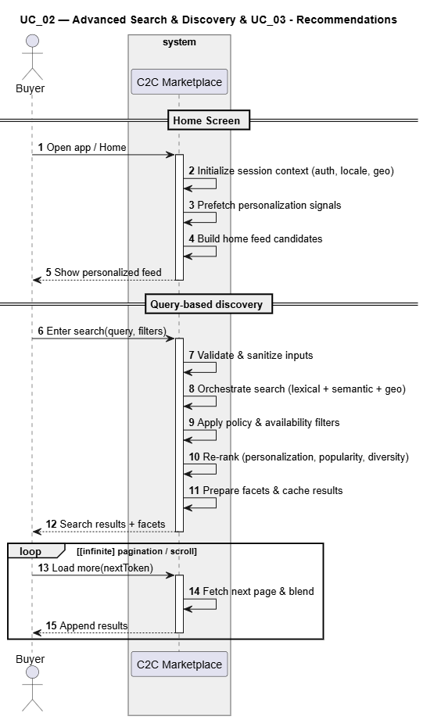

|  |  |
| --- | --- |
| **UC_04** | Secure Chat Messenger |
| Description | Buyer–Seller Messaging & Offers — secure chat and structured offers/counteroffers. |
| Actor | Buyer, Seller; Risk/Moderation (supporting) |
| Pre-condition | Valid accounts; listing exists; messaging permitted per policy. |
| Post-condition | 1. Messages/offers stored and audited.  2. Accepted offer creates an order draft. |
| Basic Flow | 1. Buyer opens chat on a listing and sends a message  2. Buyer or seller sends an offer with price  3. Counter/accept/decline handled; acceptance creates order draft.  4. Notifications sent to the counterparty. |
| Additional Flow | 1. Safety filters block off-platform payment solicitations/scams.  2. Report/block user; rate limits applied for spam/abuse. |

|  |  |
| --- | --- |
| **UC_05** | Checkout & Escrow |
| Description |  |
| Actor |  |
| Pre-condition |  |
| Post-condition |  |
| Basic Flow |  |
| Additional Flow |  |

|  |  |
| --- | --- |
| **UC_06** | Fraud & Risk |
| Description |  |
| Actor |  |
| Pre-condition |  |
| Post-condition |  |
| Basic Flow |  |
| Additional Flow |  |

## Non-functional Requirements

// A5. Quality Requirement Specification

// C5-2. Is the specification of quality requirements appropriate?

// C5-3. Is quality requirement measurable?

// C5-4. Is the allowance of non-functional requirement clear?

|  |  |  |
| --- | --- | --- |
| **NFR_01** |  |  |
| Description |  | |
| Environment |  | |
| Stimulus |  | |
| Response |  | |
| Measure |  | |
| Allowance |  | |

## Quality Attributes

// A5. Quality Requirement Specification

// C5-2. Is the specification of quality requirements appropriate?

// C5-3. Is quality requirement measurable?

|  |  |  |
| --- | --- | --- |
| **QA_01** |  |  |
| Description |  | |
| Environment |  | |
| Stimulus |  | |
| Response |  | |
| Measure |  | |

# Architecture

// A8. Architecture Documentation

// C8-1. Is allocation of processes, etc. appropriate? (deployment)

// C8-2. Is grouping appropriate in terms of components? (component & connector)

// C8-3. Is the description of the system architecture appropriate?

# Modules

// A9. Module Specification

// C9-1. Is component specification sufficient to develop?

// C9-2. Is grouping appropriate in terms of module?

// C9-3. Is it appropriate to design dependencies between modules?

// C9-4. Is the work assignment appropriate?

Appendix

A. Domain Model 9

B. Quality Scenarios 10

C. Quality Scenario Analysis 11

D. Candidate Architectures 12

E. Candidate Architecture Evaluation 13

F. Architecture Design 14

G. Architecture Evaluation(ATAM) 15

1. Domain Model

// A3. Domain Model Design

// C3-1. Is domain model sufficiently sub-divided?

// C3-2. Does domain model reflect architecture decisions?

1. Quality Scenarios

// A4. Quality Scenario Elicitation

// C4-1. Is there sufficient scenario elicitation affecting the architecture?

// C4-2. Is there sufficient review of the quality related to performance?

// C4-3. Is there sufficient review of the quality related to modifiability?

1. Quality Scenario Analysis

// A5. Quality Requirement Specification

// C5-1. Is quality scenario analysis appropriate? (evidence)

1. Candidate Architectures

// A6. Candidate Architecture Design

// C6-1. Are quality analysis and solution candidate appropriate?

// C6-2. Are performance analysis and solution candidate appropriate?

// C6-3. Are modifiability analysis and solution candidate appropriate?

1. Candidate Architecture Evaluation

// A7. Architecture Design

// C7-1. Is comparison analysis of colliding candidates appropriate? (evidence)

// C7-2. Is there sufficient complement of the selected candidate?

1. Final Architecture

// A7. Architecture Design

// C7-3. Is there right integration into the final architecture?

// C7-4. Is there appropriate risk management of the final architecture?

1. Architecture Evaluation(ATAM)

// A10. Architecture Evaluation

// C10-1. Are there sufficient quality scenarios evaluating architecture?

// C10-2. Are there sufficient architectural decisions identified?

// C10-3. Is the analysis of design decisions appropriate? (evidence)

// C10-4. Are the mitigation plans to the risk factors appropriate?