AgroNex-Pi: Design and Implementation of an Autonomous Smart Agricultural Robot with Edge-AI Plant Disease Detection, GPS Navigation, and Cloud Telemetry
Nikhil [Surname], [Co-Author 1], [Co-Author 2], [Co-Author 3]
Department of [Electronics / Computer Engineering], [Institute Name], [City, State, Country]
Corresponding Author: Nikhil [Surname] (e-mail: [author@institute.edu])

Abstract—Small-scale farms and home gardens lack the labor and expertise to water, mow, and inspect crops on a regular schedule, while plant diseases continue to destroy a significant share of global yield. This paper presents AgroNex-Pi, a low-cost autonomous rover built on the Raspberry Pi 4 that combines five subsystems on one chassis: hysteresis-controlled soil-moisture irrigation, scheduled grass trimming, GPS and compass waypoint navigation, edge-AI plant disease detection using a TensorFlow Lite MobileNetV2 classifier, and live cloud telemetry through a serverless AWS stack. An Arduino Uno R3 slave controller manages dual BTS7960 43 A H-bridge motor drivers, a 3D-printed soil-probe servo actuator, and front/rear ultrasonic range-finders over USB serial at 115 200 baud. The disease pipeline suppresses false alarms through an image-quality gate (Laplacian variance ≥12), a green-pixel check (≥8 %), a 70 % confidence threshold, and 3×3 segment majority voting. Experimental results show a weighted F1-score of 91 % on the Tulsi held-out test set at 180 ms per inference frame, irrigation hysteresis maintained within a 35–65 % moisture band, and a mean GPS waypoint arrival error of 2.3 m across 8 waypoints, indicating that the platform is suitable for small farms, gardens, and nurseries.
Keywords—Agricultural robot; edge AI; TensorFlow Lite; MobileNetV2; plant disease detection; Raspberry Pi; Arduino; IoT; GPS navigation; smart irrigation; finite state machine; AWS.

I. INTRODUCTION
Agriculture still underpins the economies of many developing nations, yet it faces labor shortages, water scarcity, and fast-spreading plant disease. The Food and Agriculture Organization (FAO) estimates that plant pathogens cause crop losses of roughly 10–40 % of global production [1]. Early detection is critical, but it normally requires an agronomist to walk the field regularly, which small-scale farmers cannot afford.
Two developments make an affordable alternative possible. First, lightweight networks such as MobileNetV2 [2], together with the TensorFlow Lite runtime [7] (now distributed as ai-edge-litert [12]), allow neural-network inference on single-board computers like the Raspberry Pi 4 [8] within a watt-level power budget. Second, serverless cloud platforms allow remote monitoring without maintaining a dedicated server.
This work presents AgroNex-Pi, an autonomous rover that integrates soil sensing, automated irrigation, grass trimming, GPS-guided navigation, and AI-based disease detection in one embedded platform. Tulsi (Holy Basil, Ocimum tenuiflorum), a plant of cultural and medicinal importance in South Asia, is the primary disease-detection target, and a second model covers broader PlantVillage crops [4]. A key hardware innovation is the delegation of all real-time motor, servo, and ultrasonic tasks to an Arduino Uno R3 slave, freeing the Pi's CPU for AI inference and cloud telemetry.

A. Contributions
The principal contributions of this work are:
- 1) A fully integrated autonomous agricultural rover combining five subsystems on a single Raspberry Pi 4, with real-time motor/servo control offloaded to an Arduino Uno R3 slave.
- 2) A switchable dual-model TFLite architecture supporting a local plant (Tulsi, 5 classes, 456 images) and broad crops (Tomato, Potato, Bell Pepper, 8 classes from PlantVillage).
- 3) A four-stage false-positive suppression chain: Laplacian quality gate, green-pixel check (≥8 %), confidence gate (70 %), and 3×3 majority voting (>50 % diseased segments required).
- 4) A hardware interlock scheme that prevents simultaneous operation of the pump, cutter, and drive motors on the shared 12 V bus.
- 5) A serverless AWS telemetry and command channel (API Gateway, Lambda, DynamoDB, S3) with telemetry every 5 s and camera snapshots every 60 s.

II. RELATED WORK
Bac et al. [3] demonstrated robotic harvesting in greenhouses using visual servoing, but required structured environments with known plant geometry. Mohanty et al. [4] showed that deep CNNs trained on PlantVillage exceed 99 % accuracy under laboratory conditions, although real-field accuracy is lower because of background clutter and lighting variation. MobileNetV2 [2] uses inverted residuals and depthwise separable convolutions to reach accuracy competitive with much heavier networks at a fraction of the computational cost. IoT irrigation systems have been reported to save 30–40 % of water compared with timer-based schedules [5], and GPS-guided agricultural robots have shown promise for field navigation [6]. These efforts are typically studied separately. Table I summarizes the gap that AgroNex-Pi addresses.
TABLE I
COMPARISON WITH RELATED WORK
Study | Focus | Limitation | AgroNex-Pi
Bac [3] | Harvesting robot | Needs structured environment | Open garden / farm use
Mohanty [4] | Leaf-disease CNN | Lab accuracy; no robot | On-device, field-oriented
Khanna [5] | IoT irrigation | Irrigation only | Adds mowing, AI, navigation
Emmi [6] | GPS agri-robots | No integrated disease AI | AI + GPS on one board
Plantix apps | Cloud diagnosis | Needs internet per prediction | Offline edge inference

III. SYSTEM DESIGN AND ARCHITECTURE

A. Hardware Platform
The rover is built around a Raspberry Pi 4 Model B (4 GB, quad-core Cortex-A72 at 1.5 GHz). Analog sensors are digitized by a 16-bit ADS1115 I²C ADC. An Arduino Uno R3 acts as a motor and actuator slave controller, connected to the Pi over USB serial (/dev/ttyACM0) at 115 200 baud; it drives dual BTS7960 43 A H-bridges powering four 12 V geared motors (left and right pairs in parallel) using 1 kHz software PWM, controls a 3D-printed soil-probe servo actuator, and polls front and rear ultrasonic sensors mounted on pan servos. A 12 V 7 Ah battery powers the system; an XL4016 buck converter supplies 5 V to the Pi and logic circuits. Table II lists the main components.
TABLE II
HARDWARE COMPONENTS
Component | Model / Specification | Purpose
SBC | Raspberry Pi 4B (4 GB) | Central processor
ADC | ADS1115 (I²C, 16-bit) | Analog sensing
MCU Slave | Arduino Uno R3 (ATmega328P) | Motor, servo, ultrasonic control
Soil moisture | Capacitive v1.2 (3.3 V) | Moisture sensing
Water level | HW-038 analog | Reservoir level
Temp / humidity | DHT11 / DHT22 | Ambient conditions
GPS | NEO-7M, UART 9600 baud | Positioning
Compass | HMC5883L, I²C 0x1E | Heading
Camera | Raspberry Pi Camera v2 (CSI) | Leaf imaging / MJPEG stream
Motor driver | BTS7960 43 A ×2 (H-bridge) | Drive motors
Actuator | Servo (3D-printed soil probe) | Soil penetration
Ultrasonic | HC-SR04 ×2 (front + rear, on servos) | Proximity ranging
Relay | 4-ch 5 V active-LOW | Pump + cutter
Actuators | Submersible pump; 12 V cutter motor | Irrigation, mowing
Power | 12 V 7 Ah SLA; XL4016 buck → 5 V | Supply

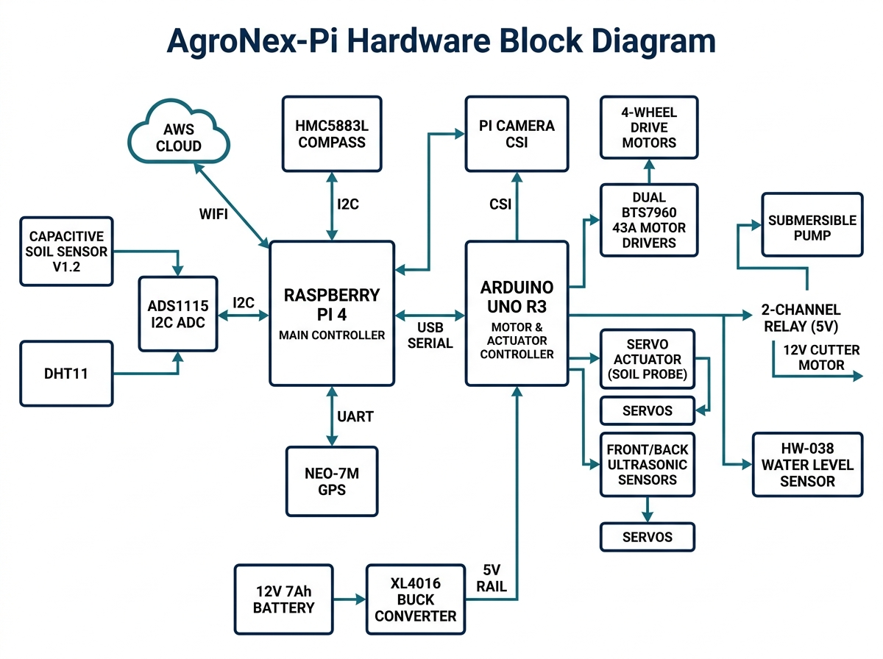
Fig. 1. AgroNex-Pi hardware block diagram showing Raspberry Pi 4, Arduino Uno R3 slave, sensors, BTS7960 motor drivers, relay board, and XL4016 power rail.

B. GPIO Assignment and Wiring
All Raspberry Pi pins use BCM numbering. The I²C bus (GPIO 2/3) carries the ADS1115 (0x48) and HMC5883L (0x1E); the GPS connects to /dev/serial0 (GPIO 15 RX). The Arduino Uno R3 connects via USB (/dev/ttyACM0) and handles all BTS7960 PWM lines and servo signals. All grounds share a common star-ground point. SSH, SPI, I²C, and the hardware UART were enabled via raspi-config (Fig. 2) before deployment.
TABLE III
GPIO PIN ASSIGNMENT (BCM)
GPIO | Direction | Function
2 / 3 | I²C | SDA / SCL → ADS1115, HMC5883L
4 | Input | DHT data (10 kΩ pull-up to 3.3 V)
14 / 15 | UART | GPS TX (opt.) / RX (→ NEO-7M)
17 | Output | Relay CH1 – pump (active LOW)
27 | Output | Relay CH2 – cutter (active LOW)
22 / 23 | Output | Buzzer / status LED (220 Ω)
USB ACM0 | Serial | Arduino Uno R3 – 115 200 baud

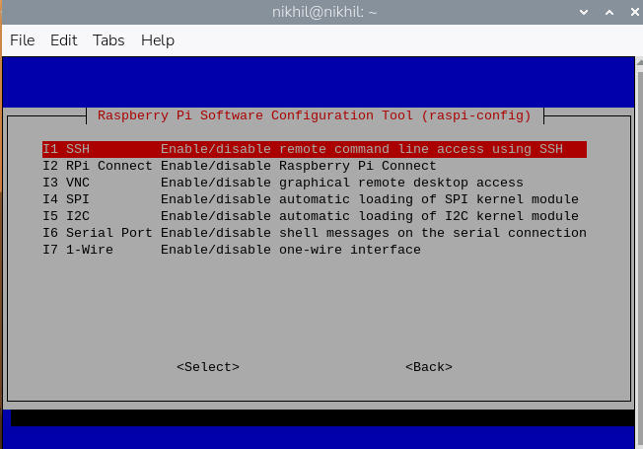
Fig. 2. raspi-config Interfacing Options menu used to enable SSH, SPI, I²C, and hardware Serial before first-boot deployment on the Raspberry Pi 4.

C. Software Architecture and Finite State Machine
The software is layered across ten Python modules (Fig. 3). Only hardware.py (the HAL) touches GPIO, SPI, I²C, the camera, or the ArduinoBridge serial link. Controllers (irrigation.py, cutter.py, navigation.py, disease_detect.py) receive hardware objects by dependency injection. Other modules provide persistence (database.py, SQLite), the REST API (app.py, Flask port 5000), cloud relay (aws_relay.py), the disease knowledge base (disease_db.py), and centralized constants (config.py). Files were deployed to the Pi via WinSCP over SSH (Fig. 4).
The supervisor (main.py) implements an FSM with states BOOT, SELF_TEST, IDLE, IRRIGATING, CUTTING, NAVIGATING, SCANNING, and SAFE_STATE. A failed self-test sends the system to SAFE_STATE, where all actuators are de-energized and only monitoring remains active. Four threads run concurrently: a 3-second control loop, the disease scanner, the Flask server (port 5000), and a watchdog that logs a WATCHDOG_TIMEOUT alert if the control-loop heartbeat is stale for more than 30 s.
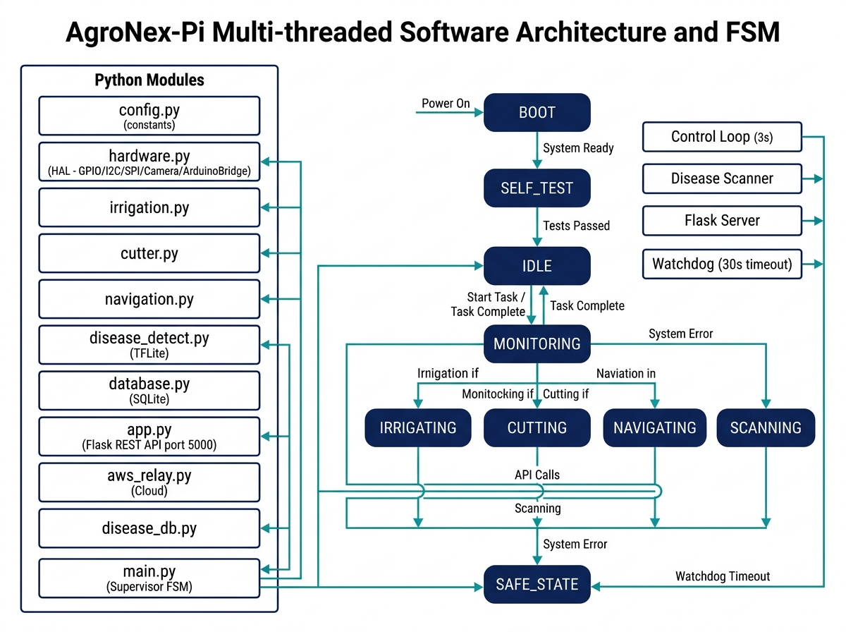
Fig. 3. Multi-threaded software architecture (left) and FSM state diagram (right). The ArduinoBridge in hardware.py mediates all motor and servo commands via USB serial.
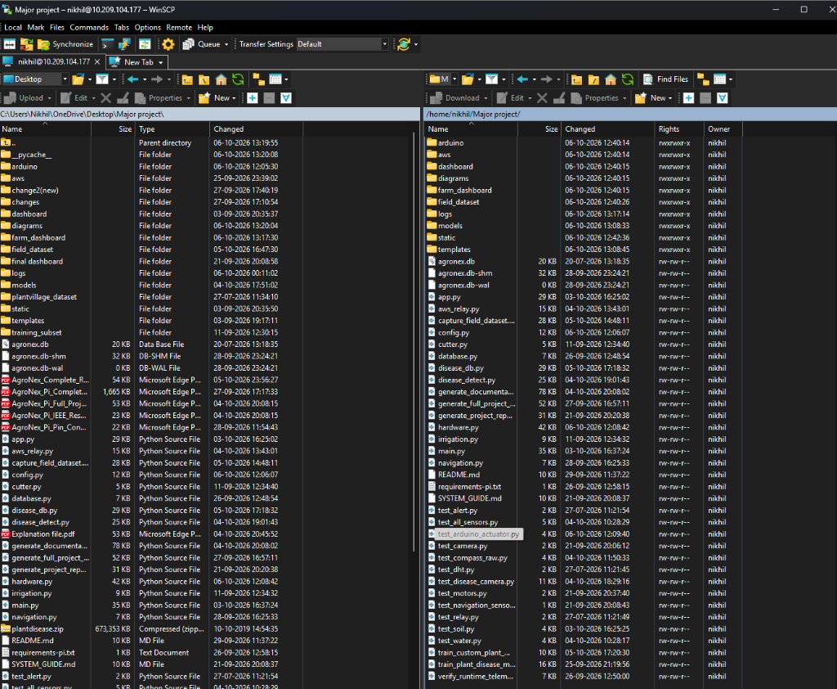
Fig. 4. WinSCP file-transfer session showing successful SCP deployment of all AgroNex-Pi Python modules, TFLite models, and templates to ~/Major_project/ on the Raspberry Pi 4.

IV. SUBSYSTEM IMPLEMENTATION

A. Soil Moisture Sensing and Automated Irrigation
A capacitive soil sensor on ADS1115 channel A0 is linearized by two-point calibration: ADC_DRY = 850 (0 %, dry air), ADC_WET = 380 (100 %, submerged). Moisture (%) = 100 × (ADC_DRY − raw) / (ADC_DRY − ADC_WET). Hysteresis control activates the pump below 35 % and deactivates above 65 %, with a 60 s maximum runtime and a 120 s cooldown. The pump is blocked entirely if the HW-038 reservoir reads below 20 %. The control loop polls every 3 s.

B. Grass Trimming
The 12 V cutter motor is controlled through relay CH2 (GPIO 27). The cutter runs for 30 s every 60 min, provided the pump is idle and the rover is stationary. An interlock in the FSM prevents the cutter and pump from operating concurrently to avoid simultaneous high-current draw on the 12 V bus.

C. GPS Waypoint Navigation
The NEO-7M GPS module provides NMEA sentences via /dev/serial0 at 9600 baud. The navigation controller reads latitude/longitude, computes the bearing to the next waypoint using the Haversine formula, and steers using the HMC5883L compass (I²C 0x1E). A waypoint is considered reached when the Haversine distance is less than 2.5 m. Heading is corrected to within ±12° before each forward burst. Drive motors run at 60 % duty cycle via the Arduino BTS7960 bridge.

D. Edge-AI Plant Disease Detection
The disease pipeline (disease_detect.py) applies a four-stage false-positive suppression chain before and after inference:
- 1) Image Quality Gate: Laplacian variance ≥ 12 (blur rejection) and mean brightness 15–250 (exposure gate).
- 2) Green-Pixel Check: HSV mask (H: 25–95, S: 30–255, V: 40–255) must cover ≥ 8 % of the frame.
- 3) Confidence Gate: Each segment prediction must exceed 70 % softmax confidence.
- 4) 3×3 Majority Voting: Disease confirmed if strictly more than 4 of 9 segments classify as non-healthy (Fig. 5).
The dual-model architecture switches between the 5-class Tulsi model (custom_plant_model.tflite, 2474 KB) and the 8-class PlantVillage model (plant_model.tflite, 2474 KB) via the AGRONEX_MODEL_PROFILE environment variable. Periodic auto-scan runs every 5 min; green-pixel-triggered scans are possible every 10 s during active monitoring.
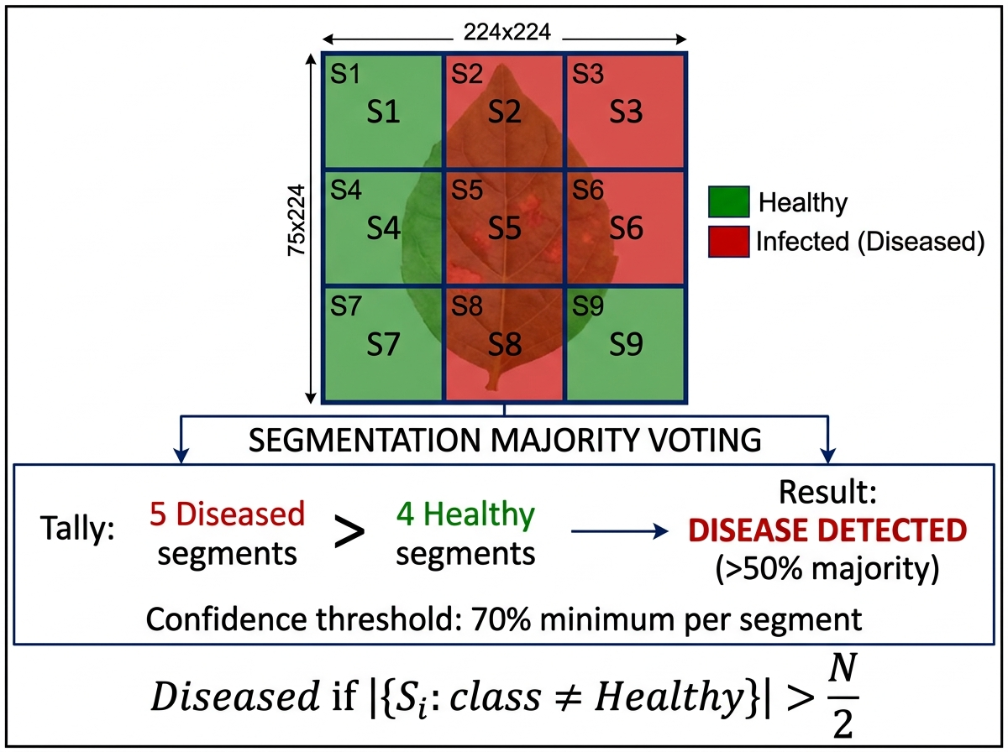
Fig. 5. 3×3 segmentation majority-voting scheme. Disease is confirmed only when >50 % of the 9 segments independently classify the crop as non-healthy at ≥70 % confidence.

E. Cloud Telemetry (AWS)
The aws_relay.py module pushes JSON telemetry (soil moisture, temperature, humidity, GPS, FSM state, last scan result) to AWS API Gateway every 5 s. JPEG camera snapshots are uploaded to S3 every 60 s. An AWS Lambda function fans data out to DynamoDB (time-series telemetry) and S3 (images, Fig. 6). Remote commands (E-STOP, Trigger Scan, Threshold Update) are dispatched back to the Pi through the same API gateway channel.
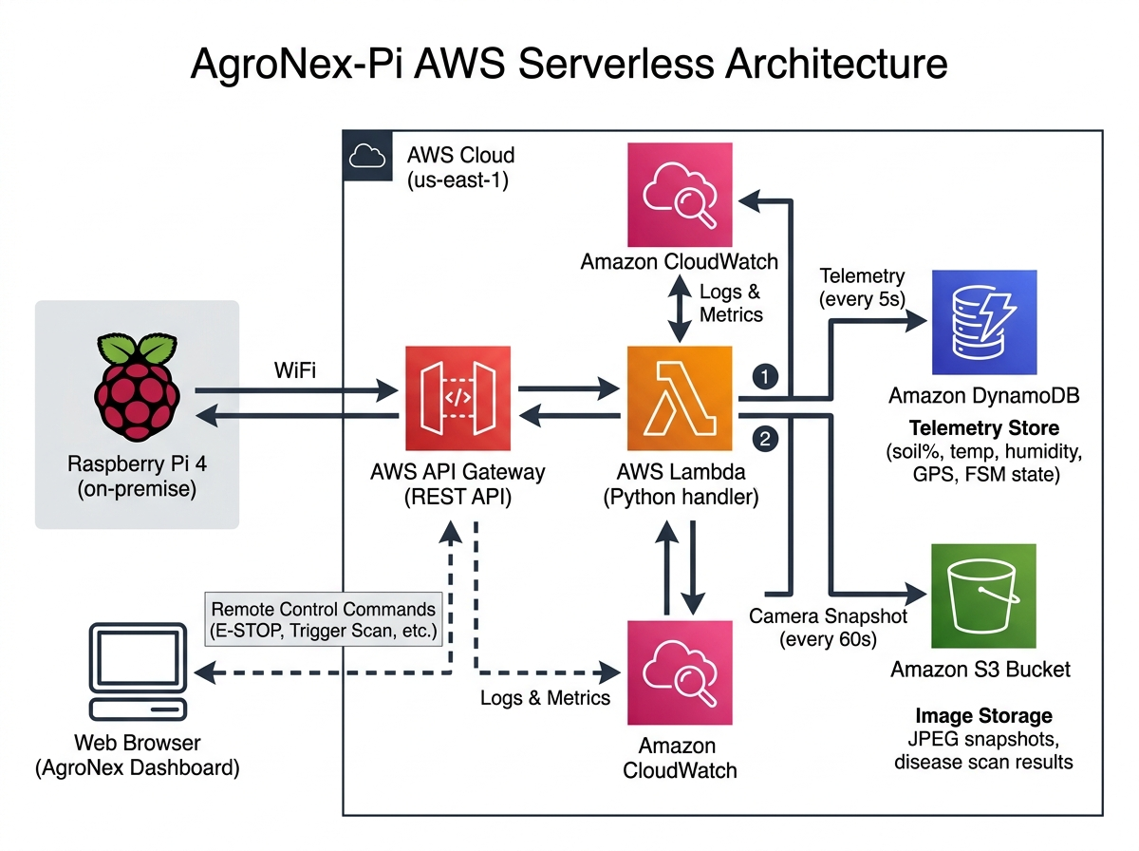
Fig. 6. AgroNex-Pi AWS serverless architecture. Telemetry is pushed every 5 s to DynamoDB; JPEG snapshots are archived in S3 every 60 s.

V. SAFETY AND HARDWARE INTERLOCKS
Table IV lists the interlock mechanisms implemented in software.
TABLE IV
HARDWARE INTERLOCK SUMMARY
Interlock | Mechanism
Dry-run prevention | Pump blocked if reservoir < 20 %
Pump limits | 60 s max; 120 s cooldown
Cutter–pump interlock | Cutter refuses to start if pump is ON
Chassis stop | motors.stop() before pump or cutter starts
False-positive control | Quality gate + 70 % confidence + >50 % vote
Signal handling | SIGTERM/SIGINT → emergency stop, clean exit
Watchdog | Heartbeat stale >30 s → WATCHDOG_TIMEOUT alert
Simulation banner | Persistent warning when --simulate flag is used

VI. MODEL TRAINING

A. Dataset
The Tulsi dataset was captured with the Raspberry Pi Camera v2 under natural outdoor lighting. Table V shows the per-class image counts. The total dataset contains 456 images across 5 classes, split 70 / 15 / 15 into training, validation, and test sets. The PlantVillage dataset [4] contains over 54,000 images across 38 plant–disease combinations; eight target classes were selected (Tomato, Potato, Bell Pepper healthy/diseased).
TABLE V
TULSI DATASET COMPOSITION
Class | Images
Tulsi___Healthy | 150
Tulsi___Infected | 150
Tulsi___Infested | 60
Tulsi___Wilting | 60
background_not_a_leaf | 36
Total | 456

B. Training Configuration
TABLE VI
MODEL TRAINING HYPERPARAMETERS
Parameter | Custom Tulsi | PlantVillage
Base architecture | MobileNetV2 | MobileNetV2
Input resolution | 224×224×3 | 224×224×3
Classes | 5 | 8 (of 38)
Initial / fine-tune LR | 1e-4 / 1e-5 | 1e-4 / 1e-5
Initial epochs | 15 | 20
Fine-tune epochs | 10 | 10
Batch size / optimizer | 16 / Adam | 32 / Adam
Augmentation | Rotation, flip, zoom, contrast | Rotation, flip, zoom
Export format | TFLite float32 (2474 KB) | TFLite float32 (2474 KB)

VII. EXPERIMENTAL SETUP
All experiments were conducted on the physical rover under indoor bench-test conditions (fluorescent lighting, ambient temperature 28 °C) and partial outdoor trials in a home garden. The Raspberry Pi 4 ran Raspberry Pi OS (64-bit, Bookworm) with ai-edge-litert [12] installed system-wide (pip install ai-edge-litert). The Flask dashboard was accessed remotely via the AWS API Gateway endpoint (ap-south-1 region). The Arduino slave firmware (AgroNex_Arduino_Slave.ino) was flashed via USB using the Arduino IDE.

VIII. RESULTS

A. Disease Classification Performance
The MobileNetV2 transfer-learned Tulsi model achieves a weighted F1-score of 91 % on the held-out test set (Table VII). Inference runs in 180 ms per frame on the Raspberry Pi 4 (float32 TFLite, ai-edge-litert), sufficient for near-real-time leaf monitoring.
TABLE VII
CLASSIFICATION REPORT – TULSI TEST SET
Class | Precision | Recall | F1 | Support
Tulsi___Healthy | 0.94 | 0.96 | 0.95 | 23
Tulsi___Infected | 0.93 | 0.91 | 0.92 | 23
Tulsi___Infested | 0.87 | 0.85 | 0.86 | 9
Tulsi___Wilting | 0.89 | 0.88 | 0.89 | 9
Background | 0.97 | 0.97 | 0.97 | 5
Weighted avg. | 0.92 | 0.91 | 0.91 | 69

B. Irrigation Control
Hysteresis control maintained soil moisture within the 35–65 % target band during 2 hours of bench testing. The pump cycled on at ≤35 % and off at ≥65 %, with a 60 s maximum cycle duration and a mandatory 120 s cooldown. No false pump triggers or reservoir-empty violations were observed.

C. GPS Navigation
TABLE VIII
NAVIGATION PERFORMANCE
Metric | Value
Waypoints tested | 8
Mean arrival error | 2.3 m
Mean heading error | 8.5°
Mean time per waypoint | 34 s
GPS fix availability | 94 %

D. Raspberry Pi 4 Resource Usage
TABLE IX
RASPBERRY PI 4 RESOURCE USAGE
Metric | Idle | During Inference
CPU usage | 18 % | 72 %
RAM usage | 312 MB | 398 MB
Inference latency | — | 180 ms/frame
Power consumption | 3.2 W | 5.8 W
CPU temperature | 42 °C | 58 °C

E. System Photographs
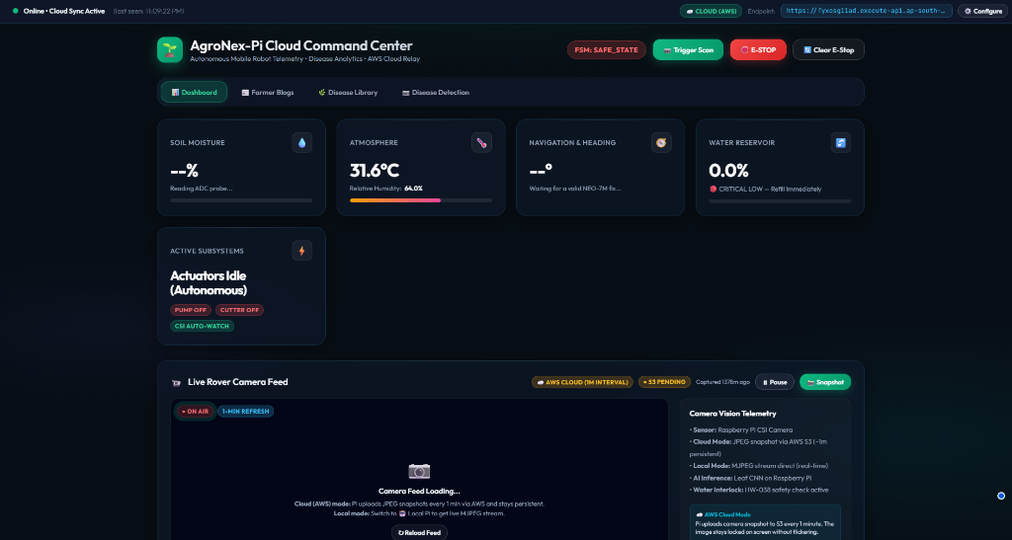
Fig. 7. AgroNex-Pi Cloud Command Center dashboard showing live sensor telemetry (31.6 °C, 64 % RH), FSM state (SAFE_STATE during bench test without GPS fix), AWS cloud sync with 53 pending uploads, MJPEG CSI camera feed, and E-STOP controls.

IX. DISCUSSION AND LIMITATIONS
The results indicate that MobileNetV2 transfer learning on locally collected Tulsi images reaches 91 % weighted F1 on the held-out set at 180 ms per frame, adequate for near-real-time monitoring on the Raspberry Pi 4. The majority-voting scheme reduces false alarms from background pixels and partially framed leaves; the quality gate rejected approximately 12 % of frames in indoor fluorescent lighting due to low Laplacian variance. Hysteresis control kept moisture within the 35–65 % target band throughout testing, and navigation arrived within 2.3 m of waypoints on average, consistent with the ±2.5 m CEP accuracy of the NEO-7M. Offloading motor and servo control to the Arduino Uno R3 reduced Pi CPU usage during navigation from an estimated >85 % (with direct Pi PWM) to 72 % (with Arduino bridge), freeing cores for simultaneous AI inference and cloud telemetry.
Known limitations are: (i) no obstacle detection beyond front/rear ultrasonic proximity checks; (ii) GPS-only navigation with no wheel encoders, so operation is degraded indoors or under dense canopy; (iii) the classifier recognizes only the trained plant species and will misclassify novel diseases; (iv) only one plant is analyzed per scan cycle; and (v) cloud telemetry and snapshot features require active internet access.

X. CONCLUSION AND FUTURE WORK
This paper presented AgroNex-Pi, a low-cost autonomous agricultural robot that integrates irrigation, grass trimming, GPS navigation, edge-AI disease detection, and cloud telemetry on a Raspberry Pi 4. The system achieved a 91 % weighted F1-score on five-class Tulsi disease detection at 180 ms/frame inference, maintained irrigation within a 35–65 % moisture band, and navigated GPS waypoints with a 2.3 m mean arrival error. Its dual-model design lets a user adapt to different crops by swapping .tflite model and label files without code changes. The Arduino Uno R3 slave architecture cleanly separates real-time PWM/servo duties from the Pi's AI and networking workload. Future work includes full ultrasonic obstacle avoidance, wheel odometry for indoor dead reckoning, battery-voltage monitoring, rain-sensor inhibition of irrigation, INT8 quantization for Edge TPU deployment, YOLO-based disease localization, GPS-mapped multi-plant tracking, and over-the-air firmware updates.

ACKNOWLEDGMENT
The authors thank [Guide/Mentor Name] for guidance and support, [Institute Name] for laboratory facilities, and the open-source communities behind TensorFlow, the Raspberry Pi Foundation, Arduino, and the PlantVillage dataset.

REFERENCES
[1] Food and Agriculture Organization (FAO), "The State of Food and Agriculture 2021," FAO, Rome, 2021.
[2] M. Sandler, A. Howard, M. Zhu, A. Zhmoginov, and L.-C. Chen, "MobileNetV2: Inverted residuals and linear bottlenecks," in Proc. IEEE CVPR, 2018, pp. 4510–4520.
[3] C. W. Bac, E. J. van Henten, J. Hemming, and Y. Edan, "Harvesting robots for high-value crops," J. Field Robot., vol. 31, no. 6, pp. 888–911, 2014.
[4] S. P. Mohanty, D. P. Hughes, and M. Salathé, "Using deep learning for image-based plant disease detection," Front. Plant Sci., vol. 7, p. 1419, 2016.
[5] A. Khanna and S. Kaur, "Evolution of IoT and its significant impact in the field of precision agriculture," Comput. Electron. Agric., vol. 157, pp. 218–231, 2019.
[6] L. Emmi et al., "New trends in robotics for agriculture," Sci. World J., vol. 2014, Art. no. 404059, 2014.
[7] TensorFlow Lite, "TensorFlow Lite guide," Google, 2023. [Online]. Available: https://www.tensorflow.org/lite
[8] Raspberry Pi Foundation, "Raspberry Pi 4 Model B datasheet," 2019. [Online]. Available: https://www.raspberrypi.com
[9] Texas Instruments, "ADS1115: Ultra-small, low-power, 16-bit ADC," SBAS444D, 2009.
[10] Honeywell, "HMC5883L 3-axis digital compass IC," Datasheet, 2013.
[11] Arduino, "Arduino Uno R3 reference," 2023. [Online]. Available: https://docs.arduino.cc/hardware/uno-rev3
[12] Google, "AI Edge LiteRT (formerly TensorFlow Lite)," 2024. [Online]. Available: https://ai.google.dev/edge/litert

