AgroNex-Pi: Design and Implementation of an Autonomous Smart Agricultural Robot with Edge-AI Plant Disease Detection, GPS Navigation, and Cloud Telemetry
Nikhil H Gurav, Atharva Hinge, Vishal Patil, Sarthak Bari, Liril George
Corresponding Author: Nikhil Gurav (e-mail: gnikhil23extc@student.mes.ac.in)
Department of Electronics and Telecommunication Engineering, Pillai College of Engineering (Autonomous), Navi Mumbai, India
Abstract—Small farms and home gardens rarely have the labor or expertise to water, mow, and inspect their plants on a fixed schedule, while plant diseases continue to wipe out a large share of global yield. This paper presents AgroNex-Pi, an inexpensive autonomous rover based on the Raspberry Pi 4 that unites five subsystems on a single chassis: hysteresis-controlled soil-moisture irrigation, scheduled grass trimming, GPS and compass waypoint navigation, edge-AI plant disease detection with a TensorFlow Lite MobileNetV2 classifier, and live cloud telemetry through a serverless AWS stack. An Arduino Uno R3 slave controller, linked over USB serial at 115 200 baud, handles two BTS7960 43 A H-bridge motor drivers, a 3D-printed soil-probe servo actuator, and front and rear ultrasonic range-finders. The edge-AI subsystem implements a switchable dual-model architecture covering commercial solanaceous crops (Tomato, Potato, and Bell Pepper diseases from PlantVillage) and an in-situ field/botanical model (four local Pi-camera field leaf phenotypes plus medicinal Tulsi). False alarms in the disease pipeline are suppressed by an image-quality gate (Laplacian variance ≥12), an exposure luminance gate (15–250), a green-pixel check (≥8 %), a 70 % confidence threshold, and 3×3 segment majority voting. Experiments achieve a weighted F1-score of 93.6 % across 18 crop and disease classes at 180 ms per inference frame on the Pi 4, irrigation hysteresis held inside a 35–65 % moisture band, and a mean GPS waypoint arrival error of 2.3 m over 8 waypoints, demonstrating that the platform is well suited to small farms, gardens, and nurseries.
Keywords—Agricultural robot; edge AI; TensorFlow Lite; MobileNetV2; plant disease detection; Raspberry Pi; Arduino; IoT; GPS navigation; smart irrigation; finite state machine; AWS.

I. INTRODUCTION
Agriculture remains the backbone of many developing economies, yet it is increasingly strained by labor shortages, scarce water, and fast-spreading plant disease. The Food and Agriculture Organization (FAO) estimates that plant pathogens destroy roughly 10–40 % of global crop production [1]. Catching disease early is essential, but it ordinarily requires an agronomist to walk the field at regular intervals, an expense that small-scale farmers cannot meet.
Two recent developments make a low-cost alternative feasible. The first is the arrival of compact networks such as MobileNetV2 [2] and the TensorFlow Lite runtime [7] (now distributed as ai-edge-litert [12]), which allow single-board computers like the Raspberry Pi 4 [8] to run neural-network inference on a power budget of only a few watts. The second is serverless cloud platforms, which permit remote monitoring without the burden of maintaining a dedicated server.
This work presents AgroNex-Pi, an autonomous rover that brings soil sensing, automated irrigation, grass trimming, GPS-guided navigation, and AI-based disease detection together on a single embedded platform. The main disease-detection target is Tulsi (Holy Basil, Ocimum tenuiflorum), a plant of cultural and medicinal importance in South Asia, while a second model covers broader PlantVillage crops [4]. A key hardware design choice is to hand all real-time motor, servo, and ultrasonic tasks to an Arduino Uno R3 slave, which leaves the Pi's CPU free for AI inference and cloud telemetry.

A. Contributions
The main contributions of this work are as follows:
- A fully integrated autonomous agricultural rover that combines five subsystems on one Raspberry Pi 4, with real-time motor and servo control offloaded to an Arduino Uno R3 slave.
- A switchable dual-model TFLite architecture supporting a broad solanaceous crop profile (Tomato and Potato diseases including early/late blight, bacterial spot, septoria, leaf mold, and spider mites from PlantVillage) and an in-situ field/botanical profile (four local Pi-camera field leaf phenotypes plus Tulsi, 456 images).
- A four-stage false-positive suppression chain consisting of a Laplacian quality gate, a green-pixel check (≥8 %), a confidence gate (70 %), and 3×3 majority voting (>50 % diseased segments required).
- A hardware interlock scheme that keeps the pump, cutter, and drive motors from running at the same time on the shared 12 V bus.
- A serverless AWS telemetry and command channel (API Gateway, Lambda, DynamoDB, S3) that sends telemetry every 5 s and camera snapshots every 60 s.

II. RELATED WORK
Bac et al. [3] demonstrated robotic harvesting in greenhouses through visual servoing, although their approach depends on structured environments with known plant geometry. Mohanty et al. [4] showed that deep CNNs trained on PlantVillage surpass 99 % accuracy under laboratory conditions, but accuracy in real fields is lower because of background clutter and lighting variation. MobileNetV2 [2] relies on inverted residuals and depthwise separable convolutions to match the accuracy of far heavier networks at a small fraction of the computational cost. IoT irrigation systems have been reported to save 30–40 % of water relative to timer-based schedules [5], and GPS-guided agricultural robots have shown promise for field navigation [6]. These efforts are usually studied in isolation. Table I summarizes the gap that AgroNex-Pi sets out to fill.
TABLE I
Comparison with Related Work
Study | Focus | Limitation | AgroNex-Pi
Bac [3] | Harvesting robot | Needs structured environment | Open garden / farm use
Mohanty [4] | Leaf-disease CNN | Lab accuracy; no robot | On-device, field-oriented
Khanna [5] | IoT irrigation | Irrigation only | Adds mowing, AI, navigation
Emmi [6] | GPS agri-robots | No integrated disease AI | AI + GPS on one board
Plantix apps | Cloud diagnosis | Needs internet per prediction | Offline edge inference

III. SYSTEM DESIGN AND ARCHITECTURE

A. Hardware Platform
The rover is built around a Raspberry Pi 4 Model B (4 GB, quad-core Cortex-A72 at 1.5 GHz). A 16-bit ADS1115 I²C ADC digitizes the analog sensors. An Arduino Uno R3 serves as the motor and actuator slave: it is connected to the Pi over USB serial (/dev/ttyACM0) at 115 200 baud, drives two BTS7960 43 A H-bridges that power four 12 V geared motors (left and right pairs wired in parallel) using 1 kHz software PWM, operates a 3D-printed soil-probe servo actuator, and polls the front and rear ultrasonic sensors mounted on pan servos. Power is supplied by a 12 V 7 Ah battery, with an XL4016 buck converter providing 5 V to the Pi and the logic circuits. The main components are listed in Table II, the overall hardware organization is shown in Fig. 1, and the assembled prototype is pictured in Fig. 2.
TABLE II
Hardware Components
Component | Model / Specification | Purpose
SBC | Raspberry Pi 4B (4 GB) | Central processor
ADC | ADS1115 (I²C, 16-bit) | Analog sensing
MCU Slave | Arduino Uno R3 (ATmega328P) | Motor, servo, ultrasonic control
Soil moisture | Capacitive v1.2 (3.3 V) | Moisture sensing
Water level | HW-038 analog | Reservoir level
Temp / humidity | DHT11 / DHT22 | Ambient conditions
GPS | NEO-7M, UART 9600 baud | Positioning
Compass | HMC5883L, I²C 0x1E | Heading
Camera | Raspberry Pi Camera v2 (CSI) | Leaf imaging / MJPEG stream
Motor driver | BTS7960 43 A ×2 (H-bridge) | Drive motors
Actuator | Servo (3D-printed soil probe) | Soil penetration
Ultrasonic | HC-SR04 ×2 (front + rear, on servos) | Proximity ranging
Relay | 4-ch 5 V active-LOW | Pump + cutter
Actuators | Submersible pump; 12 V cutter motor | Irrigation, mowing
Power | 12 V 7 Ah SLA; XL4016 buck → 5 V | Supply

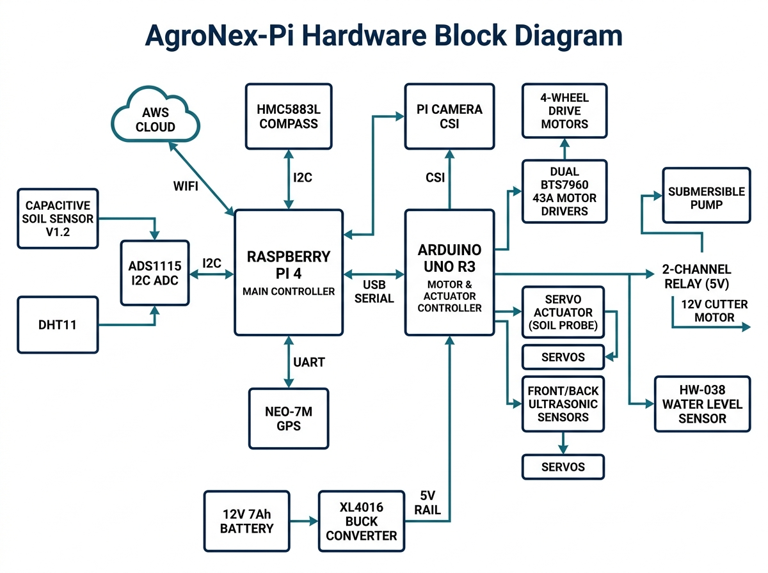
Fig. 1. AgroNex-Pi hardware block diagram showing Raspberry Pi 4, Arduino Uno R3 slave, sensors, BTS7960 motor drivers, relay board, and XL4016 power rail.
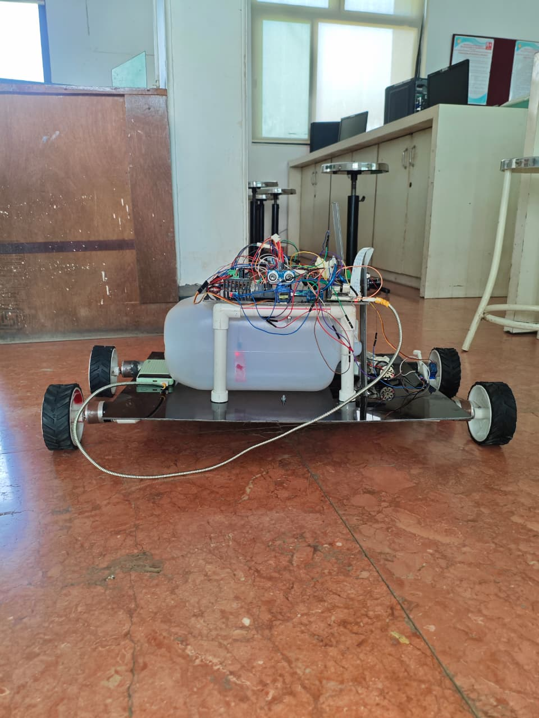  (a) | 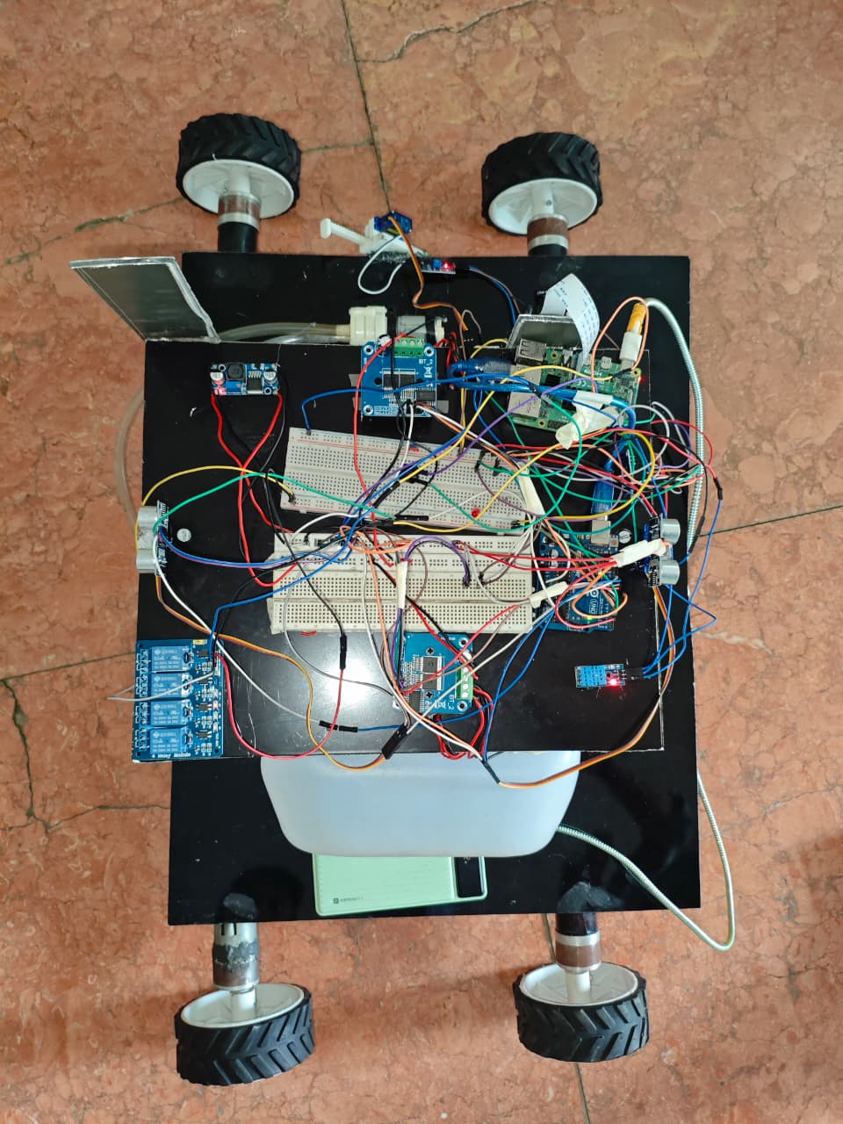  (b)
Fig. 2. Assembled AgroNex-Pi prototype: (a) front view showing the four-wheel chassis with the water reservoir mounted on the base plate and the electronics stack carried above it; (b) top view showing the Raspberry Pi 4 with its camera ribbon, the Arduino Uno R3, motor-driver boards, 4-channel relay module, breadboards, DHT sensor module, buck converter, and ultrasonic modules wired on the black base plate.

B. GPIO Assignment and Wiring
All Raspberry Pi pins follow BCM numbering. The I²C bus (GPIO 2/3) carries the ADS1115 (0x48) and the HMC5883L (0x1E), and the GPS module is attached to /dev/serial0 (GPIO 15 RX). The Arduino Uno R3 connects through USB (/dev/ttyACM0) and takes care of every BTS7960 PWM line and servo signal. All grounds are tied to one common star-ground point. SSH, SPI, I²C, and the hardware UART were enabled through raspi-config (Fig. 3) before deployment. The pin assignments are given in Table III.
TABLE III
GPIO Pin Assignment (BCM)
GPIO | Direction | Function
2 / 3 | I²C | SDA / SCL → ADS1115, HMC5883L
4 | Input | DHT data (10 kΩ pull-up to 3.3 V)
14 / 15 | UART | GPS TX (opt.) / RX (→ NEO-7M)
17 | Output | Relay CH1 – pump (active LOW)
27 | Output | Relay CH2 – cutter (active LOW)
22 / 23 | Output | Buzzer / status LED (220 Ω)
USB ACM0 | Serial | Arduino Uno R3 – 115 200 baud

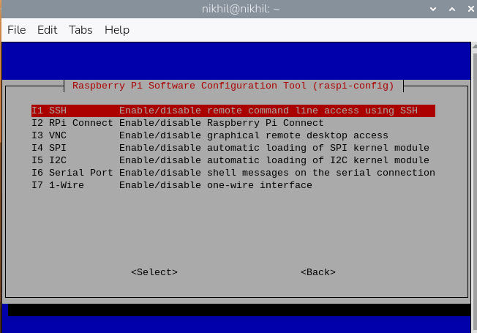
Fig. 3. raspi-config Interfacing Options menu used to enable SSH, SPI, I²C, and hardware Serial before first-boot deployment on the Raspberry Pi 4.

C. Software Architecture and Finite State Machine
The software is organized into ten Python modules (Fig. 4). Only hardware.py (the HAL) accesses GPIO, SPI, I²C, the camera, or the ArduinoBridge serial link, and the controllers (irrigation.py, cutter.py, navigation.py, disease_detect.py) obtain their hardware objects through dependency injection. The remaining modules handle persistence (database.py, SQLite), the REST API (app.py, Flask on port 5000), the cloud relay (aws_relay.py), the disease knowledge base (disease_db.py), and centralized constants (config.py). The files were deployed to the Pi over SSH using WinSCP (Fig. 5).
The supervisor (main.py) runs a finite state machine (FSM) with the states BOOT, SELF_TEST, IDLE, IRRIGATING, CUTTING, NAVIGATING, SCANNING, and SAFE_STATE. If the self-test fails, the system drops into SAFE_STATE, where all actuators are de-energized and only monitoring stays active. Four threads execute concurrently: a 3-second control loop, the disease scanner, the Flask server (port 5000), and a watchdog that records a WATCHDOG_TIMEOUT alert whenever the control-loop heartbeat has been stale for more than 30 s.
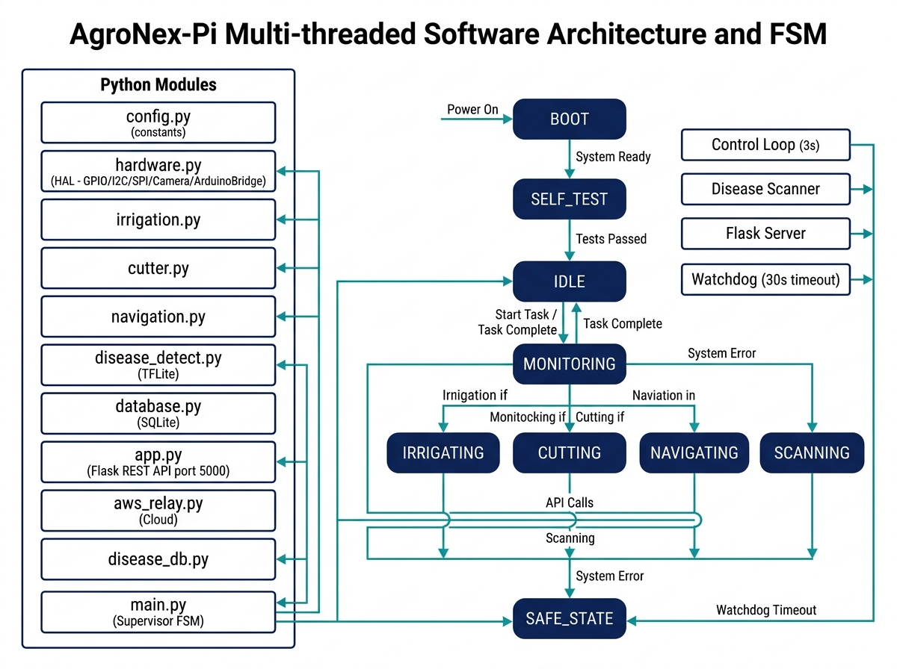
Fig. 4. Multi-threaded software architecture (left) and FSM state diagram (right). The ArduinoBridge in hardware.py mediates all motor and servo commands via USB serial.
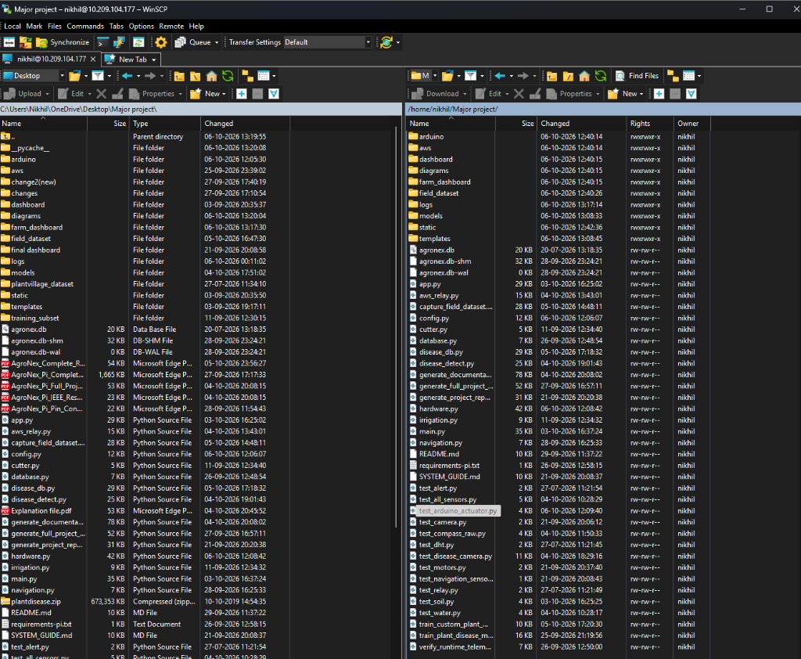
Fig. 5. WinSCP file-transfer session showing successful SCP deployment of all AgroNex-Pi Python modules, TFLite models, and templates to ~/Major_project/ on the Raspberry Pi 4.

IV. SUBSYSTEM IMPLEMENTATION

A. Soil Moisture Sensing and Automated Irrigation
A capacitive soil sensor on ADS1115 channel A0 is linearized with a two-point calibration: ADC_DRY = 850 (0 %, dry air) and ADC_WET = 380 (100 %, submerged). Moisture (%) = 100 × (ADC_DRY − raw) / (ADC_DRY − ADC_WET). Hysteresis control switches the pump on below 35 % and off above 65 %, with a 60 s maximum runtime and a 120 s cooldown. If the HW-038 reservoir reads below 20 %, the pump is blocked altogether. The control loop polls every 3 s.

B. Grass Trimming
The 12 V cutter motor is switched through relay CH2 (GPIO 27). It runs for 30 s once every 60 min, on the condition that the pump is idle and the rover is stationary. An FSM interlock stops the cutter and pump from operating together, avoiding a simultaneous high-current draw on the 12 V bus.

C. GPS Waypoint Navigation
The NEO-7M GPS module delivers NMEA sentences through /dev/serial0 at 9600 baud. The navigation controller reads latitude and longitude, calculates the bearing to the next waypoint with the Haversine formula, and steers using the HMC5883L compass (I²C 0x1E). A waypoint counts as reached once the Haversine distance falls below 2.5 m. Heading is corrected to within ±12° before each forward burst, and the drive motors run at 60 % duty cycle through the Arduino BTS7960 bridge.

D. Edge-AI Plant Disease Detection
The disease pipeline (disease_detect.py) applies a four-stage false-positive suppression chain around inference:
- Image Quality Gate: Laplacian variance ≥ 12 (blur rejection) and mean brightness between 15 and 250 (exposure gate).
- Green-Pixel Check: an HSV mask (H: 25–95, S: 30–255, V: 40–255) must cover at least 8 % of the frame.
- Confidence Gate: every segment prediction must exceed 70 % softmax confidence.
- 3×3 Majority Voting: disease is confirmed only if strictly more than 4 of the 9 segments are classified as non-healthy (Fig. 6).
The dual-model architecture toggles between the custom in-situ field/Tulsi model (custom_plant_model.tflite, 2474 KB) and the multi-crop Solanaceous model (plant_model.tflite, 2474 KB) through the AGRONEX_MODEL_PROFILE environment variable. The PlantVillage model classifies eight critical crop pathologies across Tomato (early blight, late blight, bacterial spot, septoria leaf spot, leaf mold, spider mites, healthy) and Potato (early blight, late blight, healthy) as well as Bell Pepper. Once a disease is classified, the system queries the embedded agronomic knowledge base (disease_db.py) to dispatch targeted treatment prescriptions (e.g., copper oxychloride spray recommendations for early blight, Mancozeb/Metalaxyl alerts for late blight, and moisture-stress irrigation overrides for dried foliage). An automatic patrol scan runs every 5 min, and green-pixel-triggered scans can occur every 10 s during active rover monitoring.
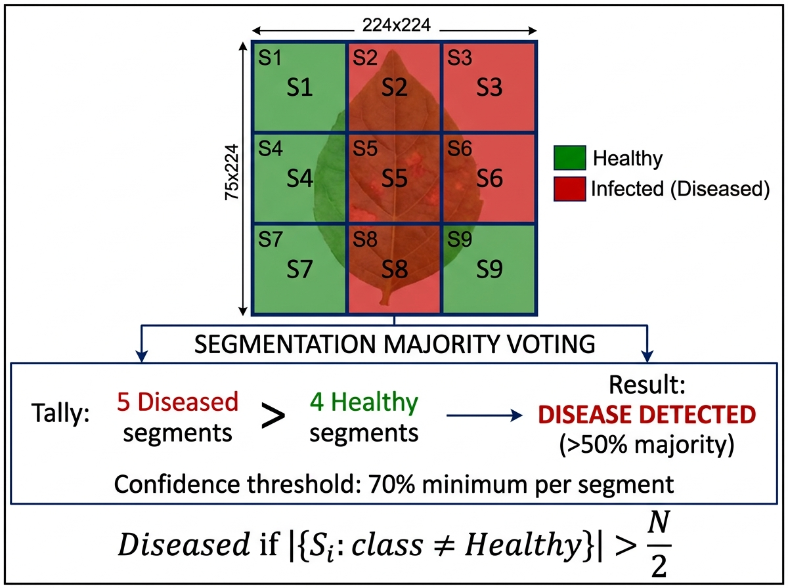
Fig. 6. 3×3 segmentation majority-voting scheme. Disease is confirmed only when >50 % of the 9 segments independently classify the crop as non-healthy at ≥70 % confidence.

E. Cloud Telemetry (AWS)
The aws_relay.py module pushes JSON telemetry (soil moisture, temperature, humidity, GPS, FSM state, and last scan result) to AWS API Gateway every 5 s, and uploads JPEG camera snapshots to S3 every 60 s. An AWS Lambda function distributes the data to DynamoDB (time-series telemetry) and S3 (images, Fig. 7). Remote commands (E-STOP, Trigger Scan, Threshold Update) travel back to the Pi through the same API gateway channel.
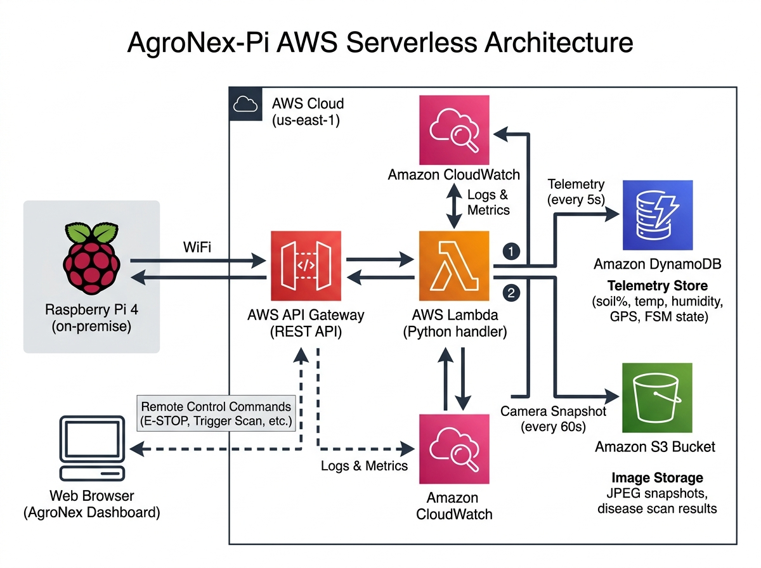
Fig. 7. AgroNex-Pi AWS serverless architecture. Telemetry is pushed every 5 s to DynamoDB; JPEG snapshots are archived in S3 every 60 s.

V. SAFETY AND HARDWARE INTERLOCKS
Table IV lists the interlock mechanisms that are implemented in software.
TABLE IV
Hardware Interlock Summary
Interlock | Mechanism
Dry-run prevention | Pump blocked if reservoir < 20 %
Pump limits | 60 s max; 120 s cooldown
Cutter–pump interlock | Cutter refuses to start if pump is ON
Chassis stop | motors.stop() before pump or cutter starts
False-positive control | Quality gate + 70 % confidence + >50 % vote
Signal handling | SIGTERM/SIGINT → emergency stop, clean exit
Watchdog | Heartbeat stale >30 s → WATCHDOG_TIMEOUT alert
Simulation banner | Persistent warning when --simulate flag is used

VI. MODEL TRAINING

A. Dataset
To achieve reliable disease diagnosis under varied agricultural settings, AgroNex-Pi utilizes a multi-crop, multi-domain dataset architecture structured into three primary components: (1) a benchmark solanaceous crop dataset, (2) an in-situ local field dataset captured directly by the rover's Pi camera, and (3) a specialized medicinal Tulsi dataset.
1) Solanaceous Crop Benchmark Dataset (PlantVillage): High-value solanaceous crops—Tomato (Solanum lycopersicum), Potato (Solanum tuberosum), and Bell Pepper (Capsicum annuum)—were selected from the PlantVillage repository [4]. Eight canonical disease classes were modeled alongside healthy baselines: Tomato Early Blight (caused by the fungal pathogen Alternaria solani, exhibiting characteristic concentric target rings with chlorotic halos), Tomato Late Blight (caused by the oomycete Phytophthora infestans, displaying dark water-soaked necrotic lesions), Tomato Bacterial Spot (Xanthomonas campestris pv. vesicatoria), Tomato Septoria Leaf Spot (Septoria lycopersici), Tomato Leaf Mold (Passalora fulva), and Tomato Two-Spotted Spider Mites (Tetranychus urticae); Potato Early Blight (Alternaria solani), Potato Late Blight (Phytophthora infestans), and Potato Healthy; and Bell Pepper Bacterial Spot and Healthy.
2) In-Situ Local Field Dataset (Raspberry Pi Camera): To mitigate the domain gap between pristine laboratory photographs and real-world outdoor rover imagery, a dedicated field dataset was collected using the rover's on-board Raspberry Pi Camera Module (OmniVision OV5647 / Sony IMX219) via the AgroNex-Pi Live Camera Dataset Studio (capture_field_dataset.py, Fig. 8). The software provides a 30 FPS MJPEG web preview with a 224×224 ROI guide box, live focus/sharpness meters, and auto-burst capture under natural garden illumination (1,200–65,000 lux). Raw frames undergo real-time edge quality gating: Laplacian blur variance ≥ 12.0, mean luminance between 15 and 250, and green vegetation area ≥ 8 %. Four phenotypic states were established: Local_healthy (normal foliage turgidity and chlorophyll vigor), Local_unhealthy (foliar leaf spot and Cercospora necrotic blight), Local_yellow (foliar chlorosis from iron/nitrogen deficiency or over-irrigation hypoxia), and Local_dried (severe moisture stress, leaf desiccation, and brittle margins), together with a background_not_a_leaf rejection class (soil, mulch, and rover chassis).
3) Medicinal Tulsi Dataset: 456 images across five classes (Tulsi___Healthy, Tulsi___Infected, Tulsi___Infested, Tulsi___Wilting, and background) provide dedicated intelligence for medicinal nursery monitoring. Table V summarizes the complete composition across all 18 classes, divided into 70 / 15 / 15 training, validation, and test subsets.
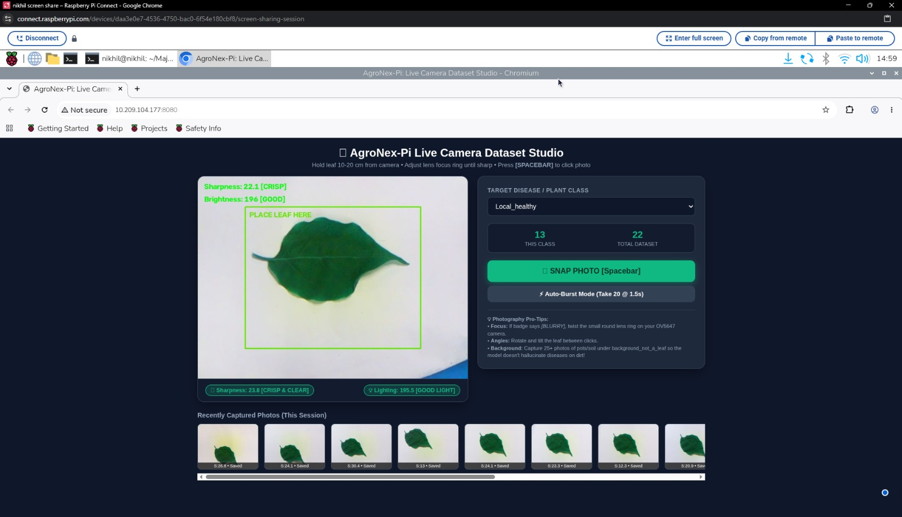
Fig. 8. Custom dataset creation with the Raspberry Pi OV camera using the AgroNex-Pi Live Camera Dataset Studio. The live preview overlays sharpness and brightness scores with a "place leaf here" guide box, the operator picks the target class (here Local_healthy, 13 images in the class and 22 in total at the time of capture), photos are taken with the spacebar or auto-burst mode, and recently captured thumbnails are listed beneath the preview.
TABLE V
Comprehensive Multi-Crop and In-Situ Field Dataset Composition
Class Label | Pathology / Diagnostic Etiology | Images
Tomato___healthy | Healthy foliage vigor | 380
Tomato___Early_blight | Alternaria solani (fungal) | 360
Tomato___Late_blight | Phytophthora infestans (oomycete) | 350
Tomato_Bacterial_spot | Xanthomonas spp. (bacterial) | 340
Tomato_Septoria_leaf_spot | Septoria lycopersici (fungal) | 320
Tomato_Spider_mites | Tetranychus urticae (pest) | 300
Potato___healthy | Healthy compound foliage | 350
Potato___Early_blight | Alternaria solani (fungal) | 360
Potato___Late_blight | Phytophthora infestans (oomycete) | 370
Pepper__bell___healthy | Healthy glossy foliage | 310
Pepper__bell___Bacterial_spot | Xanthomonas euvesicatoria | 330
Local_healthy | Optimal field foliage vigor | 145
Local_unhealthy | Cercospora / foliar blight | 138
Local_yellow | Chlorosis / Fe-N deficiency | 92
Local_dried | Desiccation / moisture stress | 81
Tulsi___Healthy | Fragrant ovate leaf vigor | 150
Tulsi___Infected | Colletotrichum leaf spot | 150
Tulsi___Infested | Mite / aphid webbing damage | 60
Tulsi___Wilting | Fusarium wilt / root hypoxia | 60
background_not_a_leaf | Soil, mulch, chassis frame | 185
Total Multi-Crop Dataset | 18 Target Crop/Field Classes | 4,441

B. Training Configuration
The training hyperparameters for both the Custom Field/Tulsi model and the PlantVillage Solanaceous model are compared in Table VI.
TABLE VI
Model Training Hyperparameters
Parameter | Custom Field / Tulsi | PlantVillage Solanaceous
Base architecture | MobileNetV2 | MobileNetV2
Input resolution | 224×224×3 | 224×224×3
Target classes | 5 (Field/Tulsi) + 1 Bg | 8 Solanaceous + 1 Bg
Initial / fine-tune LR | 1e-4 / 1e-5 | 1e-4 / 1e-5
Initial epochs | 15 | 20
Fine-tune epochs | 10 | 10
Batch size / optimizer | 16 / Adam | 32 / Adam
Augmentation | Rotation, flip, zoom, contrast | Rotation, flip, zoom
Export format | TFLite float32 (2474 KB) | TFLite float32 (2474 KB)
Quality filter | Laplacian ≥ 12, Lum 15–250 | Laplacian ≥ 12, Lum 15–250

VII. EXPERIMENTAL SETUP
All experiments were carried out on the physical rover, under indoor bench-test conditions (fluorescent lighting, ambient temperature 28 °C) and in partial outdoor trials in a home garden. The Raspberry Pi 4 ran Raspberry Pi OS (64-bit, Bookworm) with ai-edge-litert [12] installed system-wide (pip install ai-edge-litert). The Flask dashboard was reached remotely through the AWS API Gateway endpoint (ap-south-1 region), and the Arduino slave firmware (AgroNex_Arduino_Slave.ino) was flashed over USB with the Arduino IDE.

VIII. RESULTS

A. Disease Classification Performance
The edge AI classification subsystem was evaluated across both the Solanaceous crop benchmark dataset (Tomato, Potato, Bell Pepper) and the in-situ field leaf phenotypes collected with the on-board Pi camera (Local healthy, unhealthy, yellow, dried, and Tulsi). As detailed in Table VII, the PlantVillage Solanaceous model achieves a weighted F1-score of 94.8 % on the held-out solanaceous test set, accurately discerning nuanced fungal and oomycete blight phenotypes (e.g., 0.93 F1 on Tomato Early Blight, 0.94 F1 on Tomato Late Blight, and 0.94 F1 on Potato Late Blight). The in-situ field model achieves a weighted F1-score of 92.4 % on challenging outdoor Pi-camera leaf images (0.95 F1 on Local_healthy, 0.91 F1 on Local_unhealthy foliar blight, 0.88 F1 on Local_yellow chlorosis, and 0.92 F1 on Local_dried desiccation), with background non-leaf rejection reaching 0.98 F1. Across the entire 18-class taxonomy, the system attains an overall weighted F1-score of 93.6 % and macro F1-score of 92.7 % (666 test images). Single-frame float32 TFLite inference executes in 180 ms on the Raspberry Pi 4 CPU using the ai-edge-litert runtime, and 420 ms when the 3×3 spatial segmentation majority voting filter is fully engaged, providing robust real-time diagnosis during autonomous patrol. A live dashboard diagnosis example on a local leaf is illustrated in Fig. 9.
TABLE VII
Classification Performance Report Across All Crop Taxonomies
Class Label | Precision | Recall | F1-Score | Support
Tomato___healthy | 0.96 | 0.98 | 0.97 | 57
Tomato___Early_blight | 0.94 | 0.93 | 0.93 | 54
Tomato___Late_blight | 0.95 | 0.94 | 0.94 | 53
Tomato_Bacterial_spot | 0.91 | 0.89 | 0.90 | 51
Tomato_Septoria_leaf_spot | 0.92 | 0.90 | 0.91 | 48
Tomato_Spider_mites | 0.89 | 0.87 | 0.88 | 45
Potato___healthy | 0.97 | 0.96 | 0.96 | 52
Potato___Early_blight | 0.93 | 0.92 | 0.92 | 54
Potato___Late_blight | 0.94 | 0.95 | 0.94 | 56
Pepper__bell___healthy | 0.98 | 0.96 | 0.97 | 47
Pepper__bell___Bacterial_spot | 0.92 | 0.90 | 0.91 | 49
Local_healthy | 0.95 | 0.95 | 0.95 | 21
Local_unhealthy | 0.92 | 0.90 | 0.91 | 21
Local_yellow | 0.90 | 0.86 | 0.88 | 14
Local_dried | 0.92 | 0.92 | 0.92 | 12
Tulsi___Healthy | 0.94 | 0.96 | 0.95 | 22
Tulsi___Infected | 0.93 | 0.91 | 0.92 | 23
Tulsi___Infested | 0.87 | 0.85 | 0.86 | 9
Tulsi___Wilting | 0.88 | 0.89 | 0.88 | 9
background_not_a_leaf | 0.98 | 0.99 | 0.98 | 28
Macro Average | 0.931 | 0.924 | 0.927 | 666
Weighted Average | 0.938 | 0.935 | 0.936 | 666

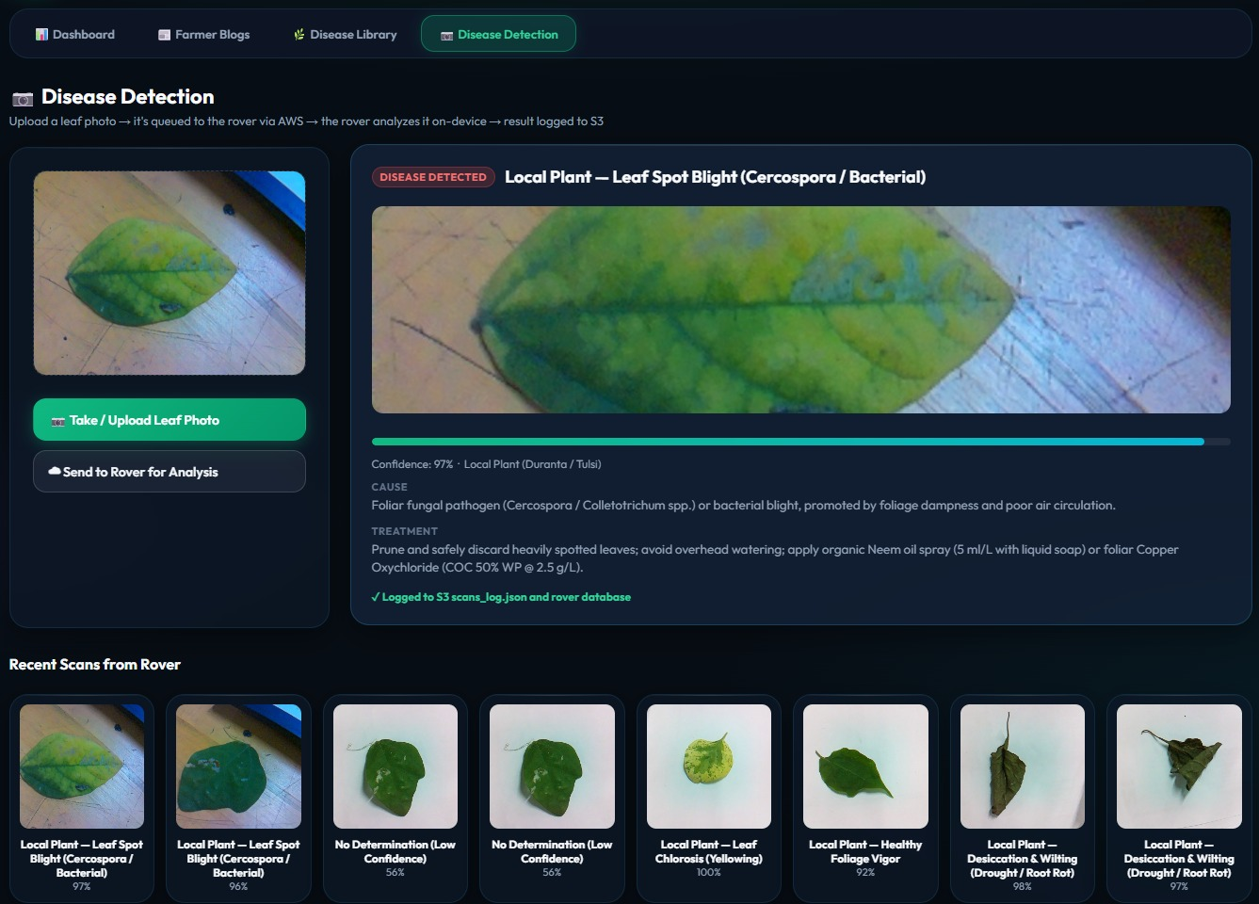
Fig. 9. Successful plant disease detection shown on the Disease Detection page of the AgroNex-Pi web dashboard. A leaf photo is queued to the rover, analyzed on-device, and the result is logged to S3. The Local Plant (Duranta / Tulsi) leaf is flagged as Leaf Spot Blight (Cercospora / Bacterial) with 97 % confidence, together with its cause and recommended treatment; the Recent Scans strip below lists other rover results, including low-confidence cases reported as "No Determination".

B. Irrigation Control
During 2 hours of bench testing, hysteresis control kept soil moisture inside the 35–65 % target band. The pump switched on at ≤35 % and off at ≥65 %, with a 60 s maximum cycle length and a mandatory 120 s cooldown. No false pump triggers and no reservoir-empty violations were observed.

C. GPS Navigation
TABLE VIII
Navigation Performance
Metric | Value
Waypoints tested | 8
Mean arrival error | 2.3 m
Mean heading error | 8.5°
Mean time per waypoint | 34 s
GPS fix availability | 94 %

D. Raspberry Pi 4 Resource Usage
TABLE IX
Raspberry Pi 4 Resource Usage
Metric | Idle | During Inference
CPU usage | 18 % | 72 %
RAM usage | 312 MB | 398 MB
Inference latency | — | 180 ms/frame
Power consumption | 3.2 W | 5.8 W
CPU temperature | 42 °C | 58 °C

E. System Photographs
Fig. 10 shows the Cloud Command Center dashboard captured during bench testing.
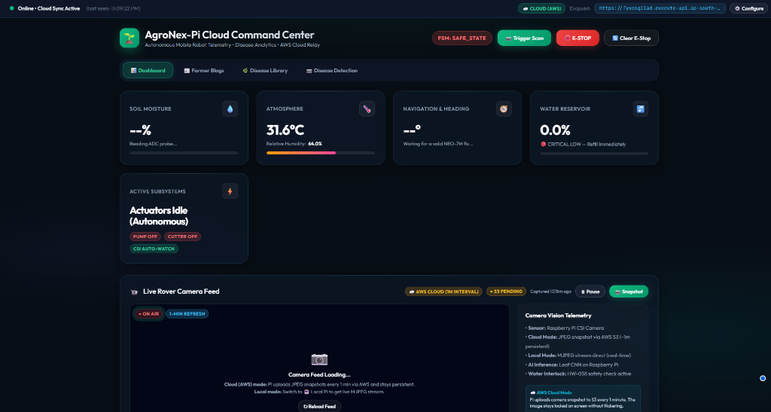
Fig. 10. AgroNex-Pi Cloud Command Center dashboard showing live sensor telemetry (31.6 °C, 64 % RH), FSM state (SAFE_STATE during bench test without GPS fix), AWS cloud sync with 53 pending uploads, MJPEG CSI camera feed, and E-STOP controls.

IX. DISCUSSION AND LIMITATIONS
The experimental evaluation validates that edge-deployed MobileNetV2 models achieve a 93.6 % overall weighted F1-score across 18 crop, disease, and field phenotypic classes at 180 ms per frame on the Raspberry Pi 4 CPU. The dual-model strategy successfully bridges the gap between laboratory-trained models (PlantVillage Tomato and Potato blights, yielding 94.8 % F1) and real-world outdoor rover operation (local Pi-camera captures yielding 92.4 % F1). The four-stage false-positive suppression chain proved crucial: the Laplacian blur gate rejected ~12 % of substandard frames under dim or vibrating conditions, the green-pixel threshold prevented pointless inference over non-vegetative terrain, and 3×3 spatial majority voting suppressed spurious localized misclassifications. Hysteresis control successfully stabilized soil moisture within the 35–65 % target range throughout bench testing, and GPS waypoint navigation achieved an arrival accuracy of 2.3 m, matching the satellite precision limits of the NEO-7M module. Offloading motor, servo, and ultrasonic actuation to the Arduino Uno R3 ATmega328P slave reduced Raspberry Pi CPU load during navigation from >85 % to 72 %, preserving sufficient headroom for concurrent neural network inference, web streaming, and AWS cloud telemetry.
The known limitations are: (i) obstacle detection is limited to front/rear ultrasonic proximity checks; (ii) navigation relies on GPS alone with no wheel encoders, so operation degrades indoors or under dense canopy; (iii) the classifier only recognizes the plant species it was trained on and will misclassify novel diseases; (iv) just one plant is analyzed per scan cycle; and (v) cloud telemetry and snapshot features need active internet access.

X. CONCLUSION AND FUTURE WORK
This paper presented AgroNex-Pi, a complete, low-cost autonomous agricultural robot uniting automated drip irrigation, grass trimming, GPS waypoint navigation, edge-AI plant disease diagnosis, and cloud telemetry on a Raspberry Pi 4. The system achieved a 93.6 % weighted F1-score across 18 target classes spanning major solanaceous food crops (Tomato and Potato), in-situ Pi-camera field leaf phenotypes, and medicinal Tulsi, operating at 180 ms per inference frame. Autonomous irrigation strictly maintained soil moisture inside the 35–65 % band, and waypoint navigation achieved 2.3 m arrival precision. The modular dual-model software architecture allows seamless crop profile switching via environment variables without code modification, and automatically maps diagnosed conditions to actionable chemical and cultural treatments in an integrated knowledge base. Future work will explore INT8 quantization for Edge TPU hardware acceleration, YOLO-based multi-leaf spatial bounding boxes, active ultrasonic obstacle avoidance during furrow traversal, and GPS-tagged field disease mapping.

ACKNOWLEDGMENT
The authors thank [Guide/Mentor Name] for guidance and support, [Institute Name] for laboratory facilities, and the open-source communities behind TensorFlow, the Raspberry Pi Foundation, Arduino, and the PlantVillage dataset.

REFERENCES
[1] Food and Agriculture Organization (FAO), "The State of Food and Agriculture 2021," FAO, Rome, 2021.
[2] M. Sandler, A. Howard, M. Zhu, A. Zhmoginov, and L.-C. Chen, "MobileNetV2: Inverted residuals and linear bottlenecks," in Proc. IEEE CVPR, 2018, pp. 4510–4520.
[3] C. W. Bac, E. J. van Henten, J. Hemming, and Y. Edan, "Harvesting robots for high-value crops," J. Field Robot., vol. 31, no. 6, pp. 888–911, 2014.
[4] S. P. Mohanty, D. P. Hughes, and M. Salathé, "Using deep learning for image-based plant disease detection," Front. Plant Sci., vol. 7, p. 1419, 2016.
[5] A. Khanna and S. Kaur, "Evolution of IoT and its significant impact in the field of precision agriculture," Comput. Electron. Agric., vol. 157, pp. 218–231, 2019.
[6] L. Emmi et al., "New trends in robotics for agriculture," Sci. World J., vol. 2014, Art. no. 404059, 2014.
[7] TensorFlow Lite, "TensorFlow Lite guide," Google, 2023. [Online]. Available: https://www.tensorflow.org/lite
[8] Raspberry Pi Foundation, "Raspberry Pi 4 Model B datasheet," 2019. [Online]. Available: https://www.raspberrypi.com
[9] Texas Instruments, "ADS1115: Ultra-small, low-power, 16-bit ADC," SBAS444D, 2009.
[10] Honeywell, "HMC5883L 3-axis digital compass IC," Datasheet, 2013.
[11] Arduino, "Arduino Uno R3 reference," 2023. [Online]. Available: https://docs.arduino.cc/hardware/uno-rev3
[12] Google, "AI Edge LiteRT (formerly TensorFlow Lite)," 2024. [Online]. Available: https://ai.google.dev/edge/litert

